Seasonal Watering Plan 2024-25

Acknowledgement of Traditional Owners
The Victorian Environmental Water Holder (VEWH) proudly acknowledges Victoria’s Traditional Owners and their rich culture and pays our respect to Elders past and present, whose knowledge and wisdom have ensured the continuation of culture and traditional practices.
We acknowledge and respect Victorian Traditional Owners as the original custodians of Victoria’s land and waters, their unique ability to care for Country and deep spiritual connection to it.
We are committed to genuinely partner and meaningfully engage with Victoria’s Traditional Owners and Aboriginal communities to support the protection of Country, the maintenance of spiritual and cultural practices and their broader aspirations in the 21st century and beyond.
The VEWH sees the meaningful intersection between the aims of the environmental watering program — healthy waterways, healthy communities — and the deep and enduring obligations Traditional Owners have to Country and to Aboriginal people. We deeply value the ongoing contribution that Traditional Owners and Aboriginal knowledge systems are making to planning and managing water for the environment. We recognise that this contribution is largely through frameworks and processes that have not been determined by Traditional Owners, and contribution does not imply endorsement of those frameworks and processes. More can be done to increase Traditional Owners’ power and agency and enable progress towards self-determination within the environmental watering program.
Adequately recognising and strengthening the rights of Traditional Owners in water management is critical for achieving self-determination and healthy waterways into the future. The VEWH is committed to an active role in supporting and enabling this within its power and capability.

Acknowledgement of program partners
The VEWH acknowledges that the seasonal watering plan is based on the significant contributions and hard work of Victoria’s catchment management authorities and Melbourne Water in consultation with their communities.
- Corangamite CMA
- East Gippsland Catchment Management Authority
- Glenelg Hopkins CMA
- Goulburn Broken Catchment Management Authority
- Mallee Catchment Management Authority
- Melbourne Water
- North Central CMA
- North East Catchment Management Authority
- West Gippsland Catchment Management Authority
- Wimmera CMA

Contents
Section 1: Introduction 3
Section 2: Gippsland region 27
Section 3: Central region 88
Section 4: Western region 174
Section 5: Northern region 238
Section 6: Further information 473

Section 1: Introduction
1.1 The seasonal watering plan 4
1.1.1 What ‘seasonal’ means 5
1.1.2 How the seasonal watering plan fits into planning environmental flows 5
1.1.3 Who contributes to the seasonal watering plan 8
1.1.4 Changes to the seasonal watering plan 8
1.1.5 When a formal variation to the seasonal watering plan is not required 9
1.2 Implementing the seasonal watering plan 10
1.2.1 How watering decisions are made throughout the year 11
1.2.2 When the VEWH commits and authorises the use of water for the environment 12
1.2.3 How the VEWH prioritises different watering actions when there is not enough available water for the environment 13
1.2.4 How seasonal conditions affect the use of water for the environment 16
1.2.5 Traditional Owner cultural values and uses, and recreational, social and economic benefits from water for the environment 19
1.2.6 Self-determination for Traditional Owners in the management of water for the environment 20
1.2.7 How risks are managed 21
1.2.8 How environmental watering emergencies are managed 22
1.3 How to read the seasonal watering plan 23
The Victorian environmental watering program is the ongoing, collaborative management of water for the environment used to improve the health of Victoria’s rivers and wetlands and of the native plants and animals that depend on them.

Where can I find more information about the Victorian environmental watering program?
Information about the Victorian environmental watering program is on the Victorian Environmental Water Holder’s (VEWH’s) website at vewh.vic.gov.au or available from the VEWH on (03) 9637 8951 or by email to general.enquiries@vewh.vic.gov.au.
This includes general information such as:
- what water for the environment is
- why water for the environment is important
- what the environmental watering program aims to achieve
- what delivery of water for the environment involves
- how we know if water for the environment is successful
- what environmental water trading is.
You can get more detailed information about water for the environment in your region by contacting your local catchment management authority or Melbourne Water (waterway manager): the contact details are in section 6.3.

1.1 The seasonal watering plan
The seasonal watering plan is a statewide plan that guides decisions about delivering water for the environment in Victoria. It outlines how water for the environment is likely to be used across the state under different climate scenarios and tells our program partners, stakeholders and communities what to expect during the water year.
In this section...
1.1.1 What ‘seasonal’ means
1.1.2 How the seasonal watering plan fits into planning environmental flows
1.1.3 Who contributes to the seasonal watering plan
1.1.4 Changes to the seasonal watering plan
1.1.5 When a formal variation to the seasonal watering plan is not required
This plan publicly describes all the potential watering actions that could be carried out using water available under all environmental water entitlements held in Victoria. This includes water available under the VEWH’s environmental water entitlements and water held by other environmental water holders for use in Victoria.
The VEWH releases the seasonal watering plan for the upcoming water year by 30 June each year. The plan and any variations are valid for the whole water year, which runs from 1 July to 30 June, or until the next seasonal watering plan is released.

1.1.1 What ‘seasonal’ means
‘Seasonal’ refers to various climate conditions in a given year, including normal differences between summer, autumn, winter and spring and whether a year is estimated to be drier or wetter than average.
Seasonal conditions affect the health and needs of plants and animals, water availability and the environmental watering actions that may be delivered in a given year.
When we plan water for the environment, it is important to consider potential seasonal conditions ranging from drought to wet and related water availability scenarios for the year.
This scenario planning enables the VEWH and waterway managers to plan environmental flows before the start of the water year and adapt to seasonal conditions as they occur throughout the year. For example, watering actions may be delivered under a dry scenario at the start of a water year and then shift to delivering in an average or wet scenario if conditions become significantly wetter. There is more on how seasonal conditions influence environmental flows planning and delivery in subsection 1.2.4.
Sections 2 to 5 of the seasonal watering plan have more details about potential watering actions likely to be delivered in each river and wetland system during the year under different climatic conditions.

1.1.2 How the seasonal watering plan fits into planning environmental flows
Waterway managers scope potential environmental watering actions in seasonal watering proposals to deliver water for the environment in their regions for the coming year. Seasonal watering proposals draw on environmental flows studies and environmental water management plans, regional waterway strategies and regional catchment strategies, and each year seek knowledge and advice from Traditional Owners, stakeholders and local communities.
The VEWH reviews the proposed watering actions in each seasonal watering proposal and works with waterway managers to identify the potential watering actions for each region and across the state. This seasonal watering plan is a summary of agreed actions from all the seasonal watering proposals.
The different stages of environmental flows planning are shown in Figure 1.1.1. More information about the strategies and plans in the figure (such as environmental flows studies and environmental water management plans for Victorian waterways) is available at vewh.vic.gov.au. Regional waterway strategies and regional catchment strategies are published on the relevant waterway manager’s website.
Figure 1.1.1 Victorian environmental watering program planning framework
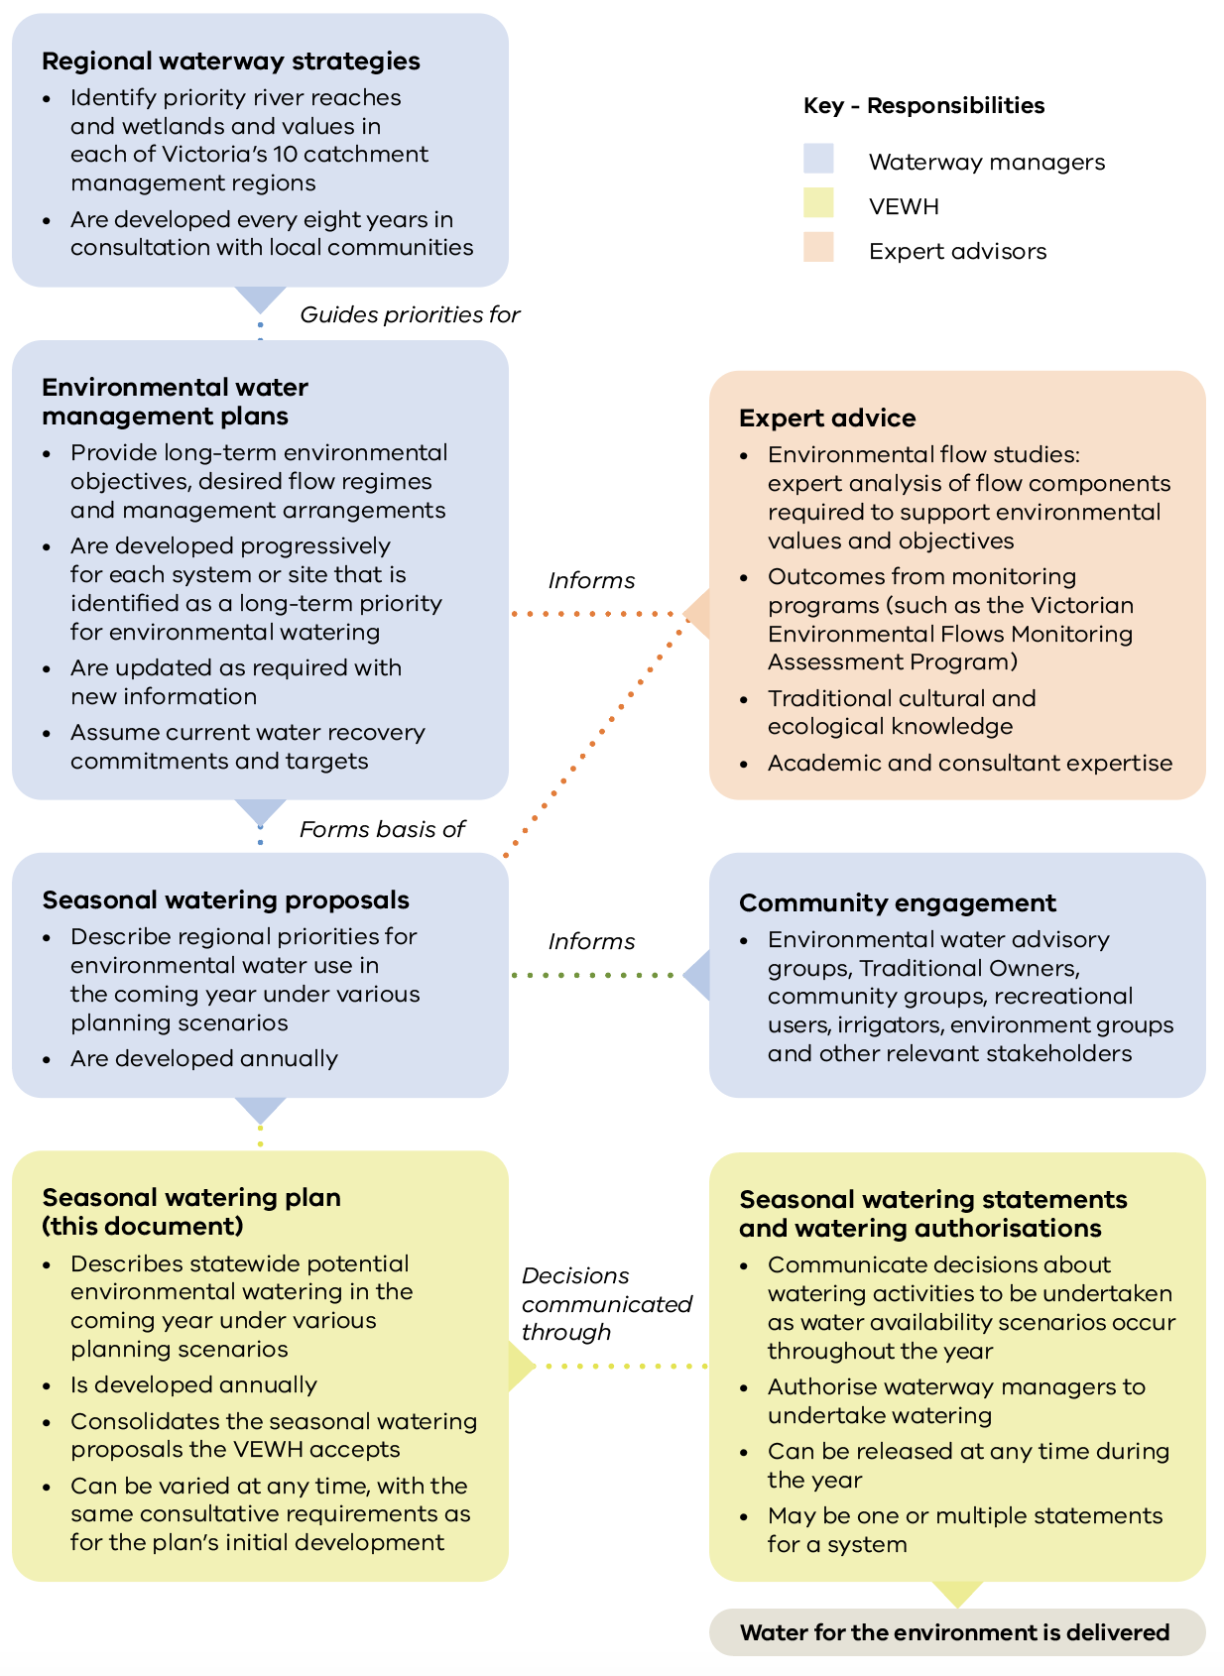

1.1.3 Who contributes to the seasonal watering plan
Program partners in the environmental watering program are those with some implementation responsibility, while stakeholders are those organisations or individuals with an interest in the environmental watering program.
The VEWH’s program partners include Victoria’s waterway managers, the Department of Energy, Environment and Climate Action (DEECA), other environmental water holders, storage managers and land managers. Traditional Owners also increasingly partner in the environmental watering program.
Many stakeholders are engaged in discussions about potential actions to deliver water for the environment as seasonal watering proposals are being developed. Levels and methods of engagement vary, depending on different water systems, watering actions and stakeholders across Victoria and regional preferences. Traditional Owners, irrigators, farmers, people living close to or interested in a specific waterway and members of recreational and environmental groups are among the stakeholders who get involved.
There are formal environmental watering advisory groups in some regions for waterway managers and stakeholders who are members of the local community to talk about potential environmental flows in their system for the coming year. In other systems, there is one-on-one engagement between waterway managers and interested stakeholders. Land managers and storage managers endorse seasonal watering proposals. This makes sure that releases of water for the environment align with land and storage management objectives, can feasibly be delivered through planned system operations, and risks can be adequately managed.

1.1.4 Changes to the seasonal watering plan
Under the Water Act 1989, the VEWH can only authorise the use of water for the environment if it is consistent with the seasonal watering plan. This makes sure there is transparency about the planning and management of environmental flows.
The Act allows the VEWH to vary any section of the seasonal watering plan to incorporate new knowledge or address circumstances that were not identified before the start of the water year. This enables flexibility to adapt to changing conditions. Any variations are publicly available at vewh.vic.gov.au as separate attachments to the current seasonal watering plan.

1.1.5 When a formal variation to the seasonal watering plan is not required
Sometimes there may be an unforeseen circumstance that calls for the use of water for the environment that does not require a variation to the seasonal watering plan. This includes:
- a minor operational adjustment to a specific water delivery action
- water for the environment being used for environmental emergency management purposes
- a small volume of water for the environment being used for a technical investigation or infrastructure maintenance
- help to deliver water for the environment held by other water holders for downstream, non-Victorian objectives.
The VEWH cannot anticipate these specific circumstances or include details about them in this plan. Waterway managers must consult the VEWH in all situations where releases of water for the environment do not align with the seasonal watering plan.

Minor operational adjustments
There may occasionally be minor operational adjustments to actions to deliver water for the environment. The targeted river reaches, flow rates, timings, magnitudes and durations detailed in sections 2 to 5 may need slight adjustments because of changes in predicted rainfall, other water orders, delivery infrastructure constraints, emerging environmental knowledge or the timing of specific ecological triggers (such as bird breeding).
In all cases, actions will still aim to optimise environmental outcomes to meet the seasonal watering plan’s objectives.
Any changes to the timing, magnitude or length of a planned watering action must be approved by the VEWH Commission through a formal variation when the proposed action requires additional water or funding to support the delivery, or by the VEWH CEO for minor variations relating to the use of water already allocated in the seasonal watering plan.

Environmental emergency management situations
Water for the environment may be needed for an environmental emergency management situation, like mitigating a toxic water quality event. Section 1.2.8 describes how environmental watering emergencies are managed and authorised.

Small technical investigations and maintenance
There may be situations where a small volume of water for the environment is used for research and development or for small-scale infrastructure testing or maintenance. These are considered on a case-by-case basis and must aim to improve knowledge and management of water for the environment. They must not compromise the potential to achieve the environmental objectives in the seasonal watering plan.

Facilitating the delivery of water held by other water holders for downstream objectives
Some water held by other water holders is stored in Victorian storages and may be required to meet downstream demands, such as for the Coorong, Lower Lakes and Murray Mouth area in South Australia. Sometimes this water needs to be delivered at a time and flow rate that was not specified in section 5 of this seasonal watering plan. The VEWH authorises and makes these deliveries possible as long as risks like potential harm to Victoria’s rivers, wetlands and floodplains are managed appropriately.

1.2 Implementing the seasonal watering plan
The seasonal watering plan scopes the potential delivery of water for the environment for the coming year, but many factors influence decisions about what water is committed and delivered.
In this section…
1.2.1 How watering decisions are made throughout the year
1.2.2 When the VEWH commits and authorises the use of water for the environment
1.2.3 How the VEWH prioritises different watering actions when there is not enough available water for the environment
1.2.4 How seasonal conditions affect the use of water for the environment
1.2.5 Traditional Owner cultural values and uses, and recreational, social and economic benefits from water for the environment
1.2.6 Self-determination for Traditional Owners in the management of water for the environment
1.2.7 How risks are managed
1.2.8 How environmental watering emergencies are managed
Factors that influence decisions about committing and delivering water for the environment are:
- seasonal conditions, weather forecasts and catchment conditions
- river and system operations like unregulated flows, catchment inflows, storage levels, other water users’ needs and potential delivery constraints
- environmental or biological factors and triggers like plant and animal responses to natural flows or temperature
- water availability
- risks or costs associated with an action to deliver water for the environment
- the opportunity to deliver shared benefits, such as for Traditional Owner and recreational values.
It is important there is flexibility to respond to these different factors because they can have a big influence on the environmental outcomes and shared benefits that we can achieve.

1.2.1 How watering decisions are made throughout the year
Many of the uncertainties about seasonal conditions, water availability and the consequential impacts of system operating rules become clearer as the season unfolds. This clarity informs decisions about which environmental flows go ahead and when. Many on-ground factors do not become clear until much closer to the anticipated water delivery.
The VEWH takes a flexible and adaptive approach to decisions with program partners and relevant stakeholders, then reviews and adjusts them so that water for the environment is used efficiently for the best environmental outcomes across Victoria.
Waterway, storage and land managers advise the necessary watering actions that can be delivered in each region during the year. Environmental water holders use that information to decide which actions to authorise. All program partners have a role in identifying potential watering actions and enabling the release of water for the environment, as explained in subsection 1.2.3.
The VEWH can also ask for more scientific or community contributions if planned watering actions need to change significantly during the season to respond to unforeseen circumstances.
Updated information about current and anticipated deliveries of water for the environment is published regularly at vewh.vic.gov.au.

1.2.2 When the VEWH commits and authorises the use of water for the environment
The VEWH aims to commit as much water as realistically and as early as possible to give waterway managers certainty to go ahead with planned actions to deliver water for the environment.
The VEWH can commit its water at any point before or during the water year. It commits this water through seasonal watering statements that authorise waterway managers to release water for the environment and are published at vewh.vic.gov.au.
Depending on the nature of the system and the entitlement being used, the VEWH may make one or multiple statements for a system during the water year. Before issuing a seasonal watering statement, the VEWH must be sure the required delivery arrangements, including risk management measures, are in place and that any related costs are acceptable.
Decisions to commit water for the environment may need more thorough consideration if delivery of the water across different systems requires access to the same environmental or bulk entitlement. One river, wetland or flow component may have to be prioritised over another.
The VEWH may sometimes commit water very close to the anticipated date of release. This may be necessary because of a sudden demand for water caused by environmental, operational or weather conditions. For example, a colonial waterbird nesting event in Barmah Forest may trigger a need for water to maintain shallow flooding long enough for the birds to grow and fly from the nest.
The Commonwealth Environmental Water Holder (CEWH) and the Southern Connected Basin Environmental Watering Committee (for the Living Murray program) commit water for use in Victoria, and the VEWH formally authorises that use through seasonal watering statements.
When water in Victorian accounts held by the CEWH and the Living Murray program needs to be delivered to non-Victorian sites, the VEWH enables that use through a watering authorisation. These authorisations generally include the same conditions and requirements as seasonal watering statements, but the water must be ordered and delivered by the VEWH instead of a waterway manager.

When environmental water holders and waterway managers can change their plans after a seasonal watering statement or watering authorisation has been issued
The VEWH can withdraw a seasonal watering statement or watering authorisation at any point during the year to address emerging risks or changes in operating conditions or water availability. It consults with the relevant waterway manager, storage manager and any other relevant environmental water holder for that river or wetland system before withdrawing a seasonal watering statement or watering authorisation.
A waterway manager or storage manager may decide, in consultation with the VEWH, not to go ahead with delivering water for the environment after a seasonal watering statement has been issued. This could be due to environmental triggers indicating the water was no longer required, resourcing constraints or new information that the potential environmental or public risk of watering is too high.

1.2.3 How the VEWH prioritises different watering actions when there is not enough available water for the environment
When the VEWH decides to trade or carry water over to get the best possible outcomes for the health of Victoria’s rivers, wetlands, estuaries and floodplains, it works with program partners on where the available water for the environment and funding can be used.
It is essential to recognise the dynamic nature of delivering water for the environment when putting the program into action. Seasonal conditions can vary greatly between years, affecting the demand for water for the environment for particular sites and the supply of available water for the environment.
There can be a deficit in supply because of large, high-value demands for water for the environment or low water availability.
The VEWH may use tools like carryover and trade to avoid a deficit. If a deficit can’t be avoided, the VEWH works with waterway managers and other relevant water holders to prioritise actions to deliver water for the environment. There is more information about trade in the annual VEWH Allocation Water Trading Strategy at vewh.vic.gov.au.

Criteria used to guide prioritisation decisions
The VEWH considers criteria, shown in Figure 1.2.1, when making trade-off decisions and prioritising specific watering actions. Waterway managers provide information in their seasonal watering proposals about how different watering actions meet these criteria and about opportunities for shared benefits.
When the VEWH decides how to use its available Water Holdings in any given year, it also considers:
- decisions by other water holders about the use of their water for the environment
- decisions by the Victorian and Commonwealth governments about water resource policy
- the resources, knowledge and capability of the VEWH and its program partners
- storage managers meeting their obligations to the environment as part of the right to harvest and distribute water sustainably
- complementary works and measures being undertaken
- the availability of funds to pay the costs of water delivery and/or storage
- the merit of selling available water allocation to resource activities, strategic projects, complementary works and measures, research and knowledge to improve the performance of the environmental watering program
- services associated with managing Water Holdings and delivering water for the environment.
Figure 1.2.1 Criteria for prioritising actions to deliver water for the environment
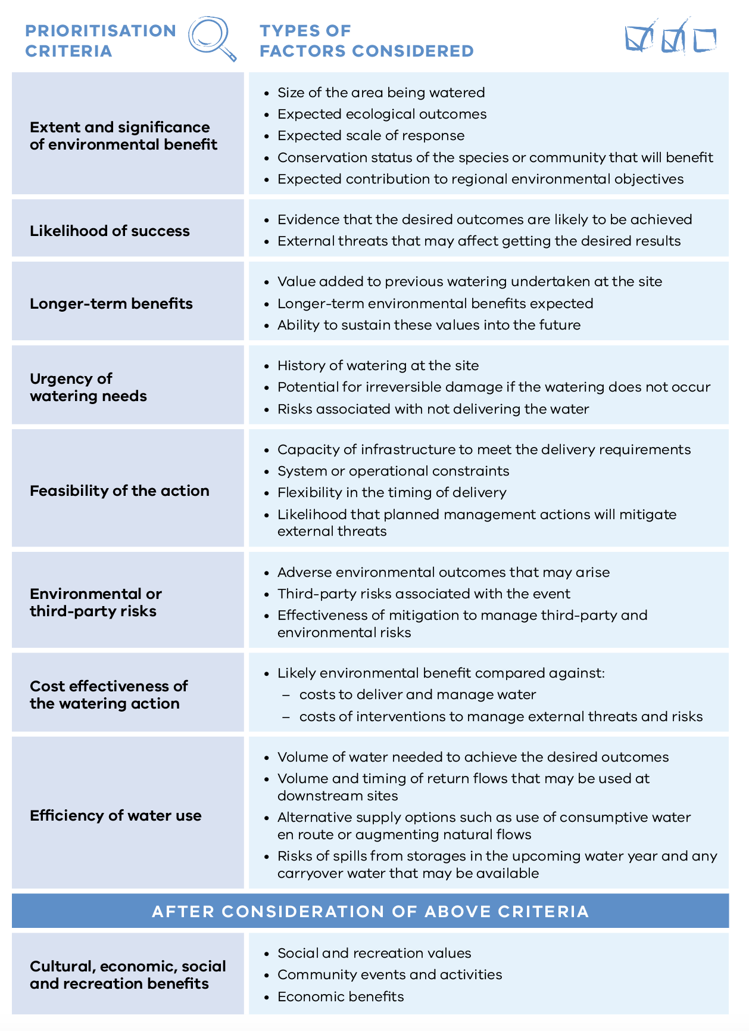

Who is involved in the prioritisation process
Waterway managers, environmental water holders, storage managers, land managers, Traditional Owners and stakeholders, including recreational users, environmental and farming groups and interested landholders and community members, all have a role in prioritising actions to deliver water for the environment, depending on the nature and scale of the decisions being made.
Waterway managers engage with stakeholders and communities and advise about the extent and significance of actions to deliver water for the environment and the highest priorities in their region.
The VEWH and other environmental water holders resolve watering priorities across regions. The VEWH collaborates with waterway managers and other program partners to decide on the best possible environmental outcomes for Victoria.
Storage managers’ advice is important to help understand how practical it is to water at a particular time within potential operational constraints. Storage managers endorse deliveries of environmental flows through their delivery network. They advise on deliveries after considering likely operational and maintenance activities and the risks associated with the watering actions.
Land managers consent to the delivery of environmental flows on their land. They advise about this after considering land management activities, public access and the risks and benefits of the proposed watering actions.
Waterway managers draw on specialist and local knowledge when prioritising environmental watering actions. Where environmental outcomes are not compromised, they can consider shared benefits for cultural values (in addition to healthy Country where these values align with environmental objectives) as well as social, recreational and economic values.

1.2.4 How seasonal conditions affect the use of water for the environment
Different climatic conditions influence how water for the environment is managed, just as rainfall patterns influence how we water our gardens or paddocks. Seasonal conditions, as explained in subsection 1.1.1, influence what water will be available during the water year and how that water may be best used to realise environmental objectives. Waterway managers take seasonal conditions into account when planning environmental watering actions for sites in their seasonal watering proposals. Seasonal planning scenarios describe the range of watering actions that could occur under drought to very wet conditions.
Waterway managers work with the program partners to get the best possible outcomes from water for the environment by considering:
- environmental water management objectives under each climatic scenario, plus any essential needs for water for the environment
- how rainfall, natural flooding and delivering water for operational and/or consumptive use can help achieve or impact short-term management objectives and longer-term environmental objectives
- how water for the environment can build on natural flows or irrigation deliveries to meet environmental needs
- natural climatic cues that might help produce an environmental outcome: for instance, a drying wetland.
Planning scenarios are presented in the seasonal watering plan as a basis for adaptively managing water use as the season unfolds. They also give an early indication of how much water may be used at different sites and whether the VEWH may need to trade water during the season to meet identified environmental needs.
Figure 1.2.2 shows how different planning scenarios can influence decisions about how water for the environment is managed in a year.
Figure 1.2.2 Example planning scenarios under a range of climatic conditions
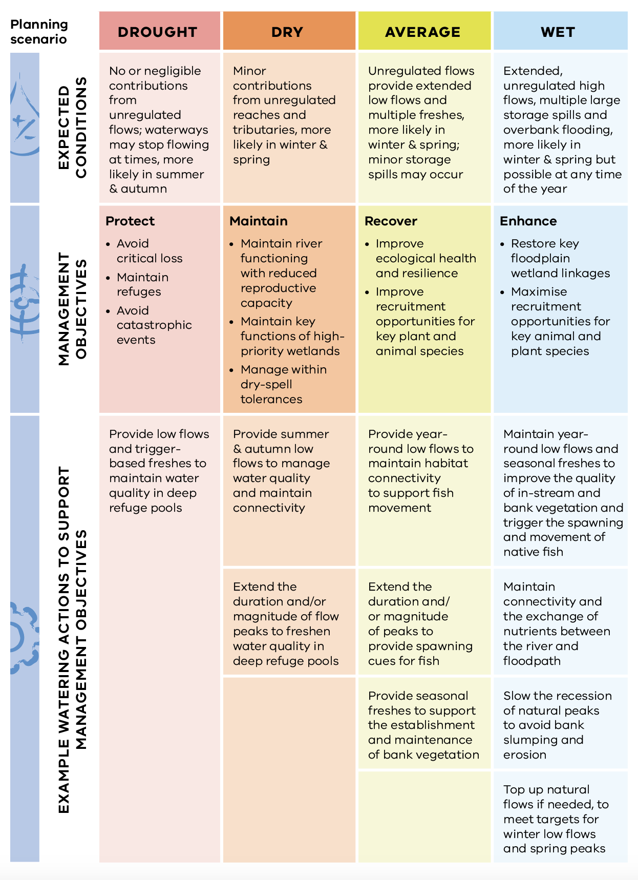

1.2.5 Traditional Owner cultural values and uses, and recreational, social and economic benefits from water for the environment
Waterway managers identify Traditional Owner cultural values and uses of waterways through ongoing engagement with Traditional Owners to determine how seasonal watering proposals may contribute to cultural objectives for healthy Country.
As well as waterway managers’ engagement with Traditional Owner Nations, the VEWH is progressively engaging directly with First Nations when this is their preferred method of engagement to support their increased leadership, decision-making and self-governance about water management.
The VEWH recognises current government frameworks for managing water for the environment have not been determined by Traditional Owners, and it is committed to progressing Traditional Owner self-determination in the environmental watering program as set out in the Victorian Government’s Water is Life: Traditional Owner Access to Water Roadmap and the VEWH’s position statement on its commitment to progress Traditional Owner self- determination. There is more information about this in subsection 1.2.6.
Water delivered for the environment improves the health of rivers, wetlands and floodplains and provides many social, recreational and economic benefits to users, local communities and beyond. It helps to increase populations of fish species (including those popular with anglers), support bird breeding events that bird watchers enjoy, contribute to healthy Country for Traditional Owners and boost experiences for the many people who gravitate to healthier waterways for relaxation and wellbeing.
Waterway managers work with Traditional Owners, stakeholders and communities to identify environmental, social, economic and recreational values and uses of waterways. They consider opportunities to support cultural, social, recreational and economic values and uses wherever possible when planning environmental water deliveries, as long as the delivery does not compromise environmental outcomes. Longer-term benefits for the environment — and community — sometimes involve short-term inconvenience. For example, floodplain watering in Hattah Lakes may limit access, which can inconvenience campers in the short term, but the environmental benefits of watering boost tourism and recreational experiences in the longer term and add to the experience of connecting with nature. Where short-term inconveniences may happen, waterway managers work with land managers to limit the disruption to users.
Values and uses considered during planning for environmental flows are authorised in each system shown in sections 2 to 5. Specific watering actions planned to align with a social or recreational objective or be delivered in partnership with Traditional Owners to support Aboriginal cultural values and uses are identified by the icons shown in Figure 1.2.3.
Figure 1.2.3 Cultural, social and recreational objectives icons
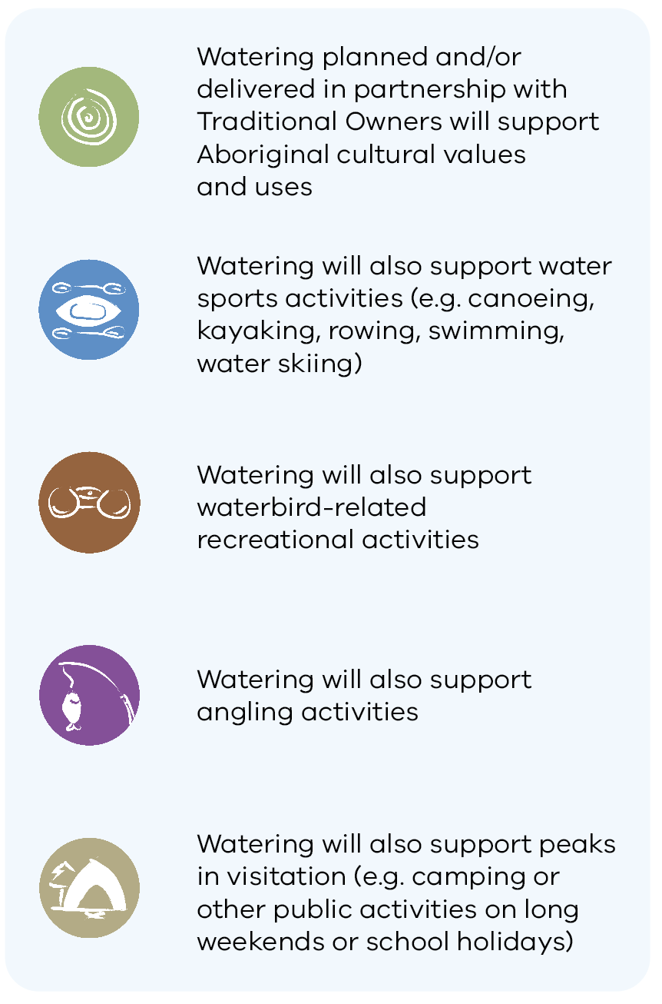

1.2.6 Self-determination for Traditional Owners in the management of water for the environment
The Seasonal Watering Plan 2024-25 represents existing legislative requirements to take Aboriginal cultural values into account when preparing seasonal watering proposals. While this is based mainly on engagement with waterway managers, the VEWH is committed to increasing the agency and self-determination of Traditional Owners in the Victorian environmental watering program and to supporting Traditional Owners to access and manage water on their own terms.
Early in 2022, the VEWH published its position statement outlining its commitment to progressing Traditional Owner self-determination. The Victorian Government’s 2022 Water is Life: Traditional Owner Access to Water Roadmap sets out short, medium and long-term policy actions to reform existing government frameworks and processes for the management of water on Traditional Owner Country, including water for the environment. The VEWH is working with Traditional Owners, DEECA and waterway, land and storage managers to progress these policy actions. This has included starting trials for Traditional Owner-led seasonal watering proposals. Additional watering actions that may result from the trials can be approved by the VEWH Commission through a variation to the seasonal watering plan.

1.2.7 How risks are managed
Risk management is essential in managing water for the environment, and program partners consider risks continually during annual and longer-term planning, implementation and review.
The VEWH and its program partners have a risk management framework that addresses interagency risk, respects each partner’s practices, and it documents roles and responsibilities for operating arrangements.
The seasonal watering proposals that are the basis for this seasonal watering plan identify potential risks with specific watering actions proposed for the coming water year. Partners jointly assess risks and identify and commit to mitigation actions when developing proposals to manage the shared risks of delivering water for the environment.
The main shared risks are shown in Table 1.2.1. Program partners consider and assess these and other potential risks as the season unfolds and planned watering actions are about to start.
Some risks may only happen at the time of delivery, such as forecast heavy rain that coincides with a planned environmental flow that could increase the risk of nuisance flooding. Program partners review risks immediately before a planned environmental flow and take agreed measures to mitigate the risks. Program partners identify and agree on mitigation actions through operational risk workshops and endorsement of seasonal watering proposals and/or delivery plans. Watering actions will not be carried out if unacceptable risks to the public or environment cannot be mitigated.
Table 1.2.1 Main shared risks of delivering water for the environment
Type of risk | Example mitigating actions
Delivering water for the environment contributes to third-party impacts | Identify and understand the capacities of water systems and monitor water levels at key locations to inform daily water release decisions to mitigate potential risks  Take into account the potential catchment run-off from forecast rainfall before deciding on the timing, duration and volume of releases of water for the environment  Put a communication plan into action (for example, including media releases, public notices and signage) before environmental flows to make sure people are informed about significant deliveries; this includes early liaison with stakeholders who may be affected  Restrict access by closing gates and tracks
Inability to achieve or demonstrate environmental outcomes from delivering water for the environment | Do intervention monitoring with available resources to identify the environmental response and consider longer-term environmental responses.  Conduct research to better understand responses to water for the environment.  Share the outcomes of monitoring and apply learnings to future deliveries.  Identify complementary works to help achieve the environmental objectives of delivering water for the environment.
Delivering water for the environment has negative effects on the environment (such as bank erosion and the spread of weeds) | Plan the timing, frequency, length and variability of environmental flows to limit negative effects.  Monitor the outcomes of deliveries of water for the environment and adapt future deliveries and/or scientific recommendations and learnings if necessary.
Even with the best risk management controls, there may be unintended effects from environmental flows or situations where those flows cannot be delivered as planned. In these situations, program partners work together to respond to incidents and then learn and adapt their risk management. The VEWH has developed an agreed approach to incident management to help program partners report, investigate and respond to risks.

1.2.8 How environmental watering emergencies are managed
An emergency watering action is where water for the environment may be necessary to prevent, mitigate or respond to an acute environmental threat.
Common threats are:
- impacts on water quality from low oxygen levels, toxic levels of blue-green algae, high temperatures or high salinity
- falling water levels at a refuge habitat or breeding site that are an immediate risk to native aquatic plants and animals.
Acute environmental threats are unpredictable, so potential emergency watering actions may not be specified in sections 2 to 5 of this plan. The VEWH has developed a procedure for emergency watering actions to be taken at short notice.

Emergency watering procedure
Emergency actions to deliver water for the environment are usually one or other of the following scenarios:
- the necessary watering action is not described adequately or at all in the current seasonal watering plan, but there is a valid seasonal watering statement with water available that covers other watering actions for the affected system and authorises a total volume that is enough for the proposed emergency watering action, or
- there is no authorised seasonal watering statement for the affected system, or there is not enough water available under the seasonal watering statement to cover the proposed emergency watering action.
Under the first scenario, waterway managers can re-prioritise watering actions authorised under the existing seasonal watering statement to allow the emergency watering action to be taken without affecting the overall resource.
Under the second scenario, waterway managers must ask for an emergency seasonal watering statement from the VEWH before water for the environment can be used for an emergency watering action. The VEWH has administrative processes to support emergency decisions to deliver water and to expedite requests for emergency seasonal watering statements.

1.3 How to read the seasonal watering plan
Under the Victorian Water Act 1989, the VEWH can only authorise the use of water for the environment where it is consistent with a seasonal watering plan. This is to maintain transparency about the planning and management of environmental flows.
The plan must make sure that the scope, objectives and potential watering activities for each waterway are clear and that decisions about possible water use are made effectively and transparently.
Four broad geographic areas in Victoria’s Gippsland, central, western and northern regions are represented in sections 2 to 5 of the seasonal watering plan with overviews that include:
- a description of the region
- an acknowledgement of the Traditional Owners of the area
- a description of communities and program partners engaged
- examples of integrated catchment management in the region
- a description of how risks are managed
- a seasonal outlook for the region.
Each region is divided into system sections for waterways and wetlands supplied with water for the environment from an environmental entitlement. Each section presents the system’s environmental values, environmental objectives and planned actions for the year.
The system sections include:
- a system introduction page with the names of the one or more waterway managers, storage managers and/or environmental water holders for the system
- a system overview describing the system’s location, its waterways and major features
- environmental values outlining the main water-dependent species, communities, ecological processes and habitats that rely on healthy waterways and form the basis for environmental objectives
- environmental objectives in the system, which Figure 1.3.1 shows, that summarises the measurable outcomes sought for each environmental value in the system. Each objective usually relies on one or more continuing watering actions and complementary actions, like controlling invasive species or installing fishways. It may take years or several decades to achieve targeted outcomes
- Traditional Owner and recreational values considered in planning for environmental flows, along with opportunities to support these values, as long as environmental outcomes are not compromised
- the scope of deliveries of water for the environment, which Figure 1.3.2 shows, that sets out potential actions to deliver water in 2024-25, the expected physical or biological effects of the actions and the longer-term environmental objectives they support. Achieving each environmental objective relies on one or more potential actions and their expected watering effects
- scenario planning, which Figure 1.3.3 shows, indicating in a table the range and priority of potential actions to deliver water for the environment in the coming year under different climate and water availability scenarios. The text with the table describes the rationale or need for the proposed combination of potential actions under each scenario. Climate scenarios considered are mostly drought, dry, average and wet, but occasionally more or fewer scenarios are used. Section 1.2.4 explains how seasonal conditions are considered in planning.
Figure 1.3.1 Example environmental objectives table
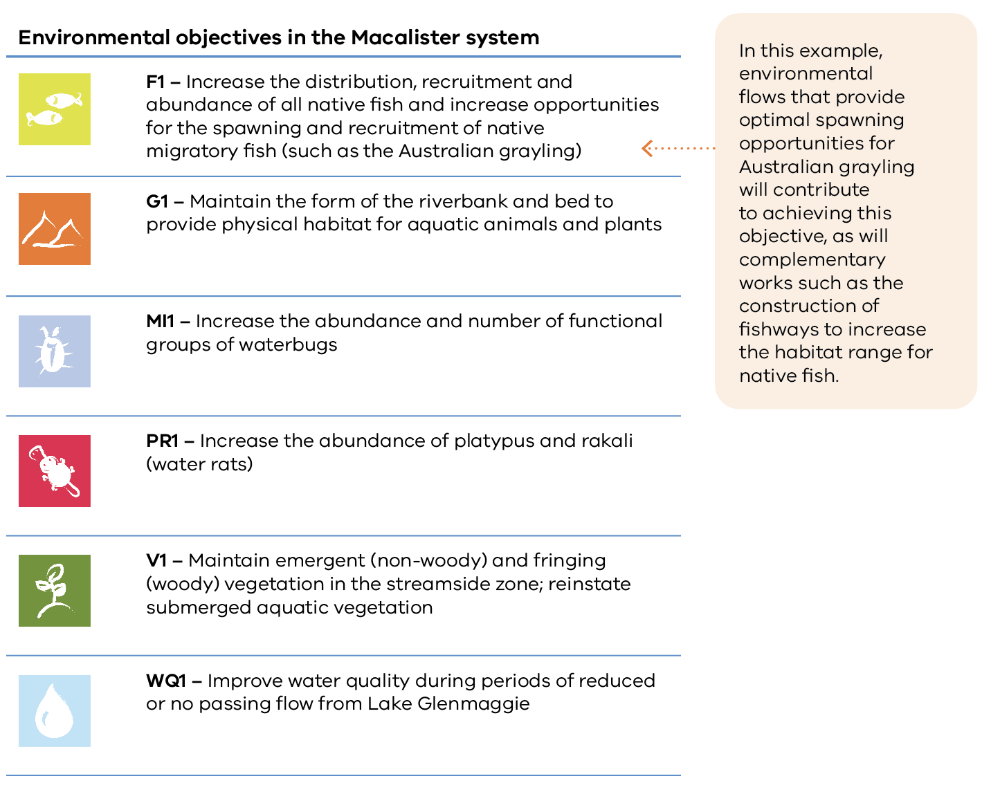
Figure 1.3.2 Example potential actions to deliver water for the environment and objectives table
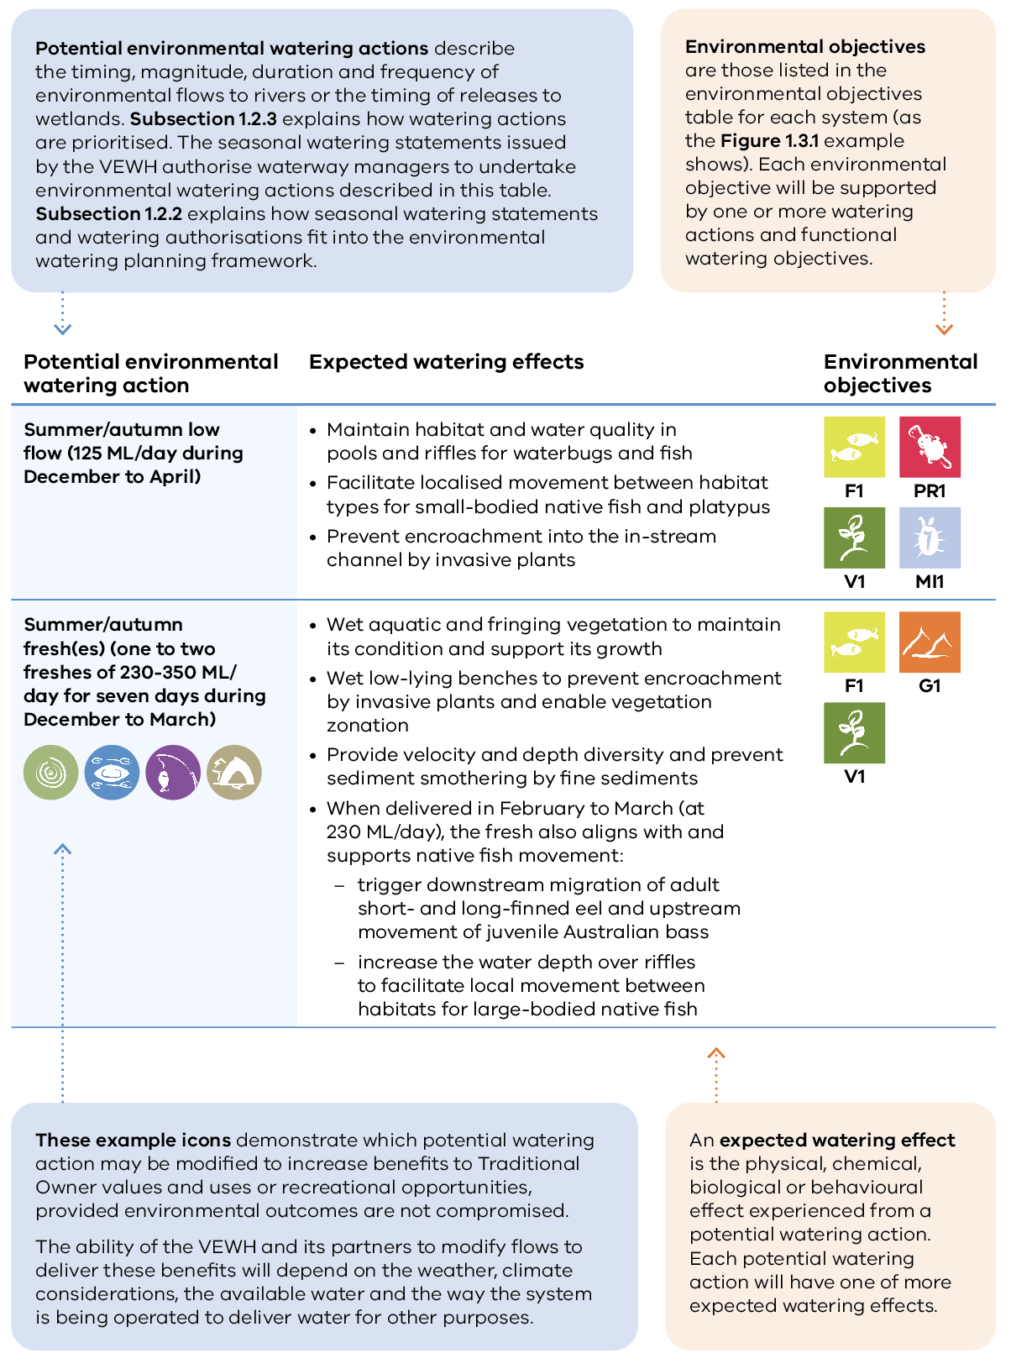
Figure 1.3.3 Example scenario planning table
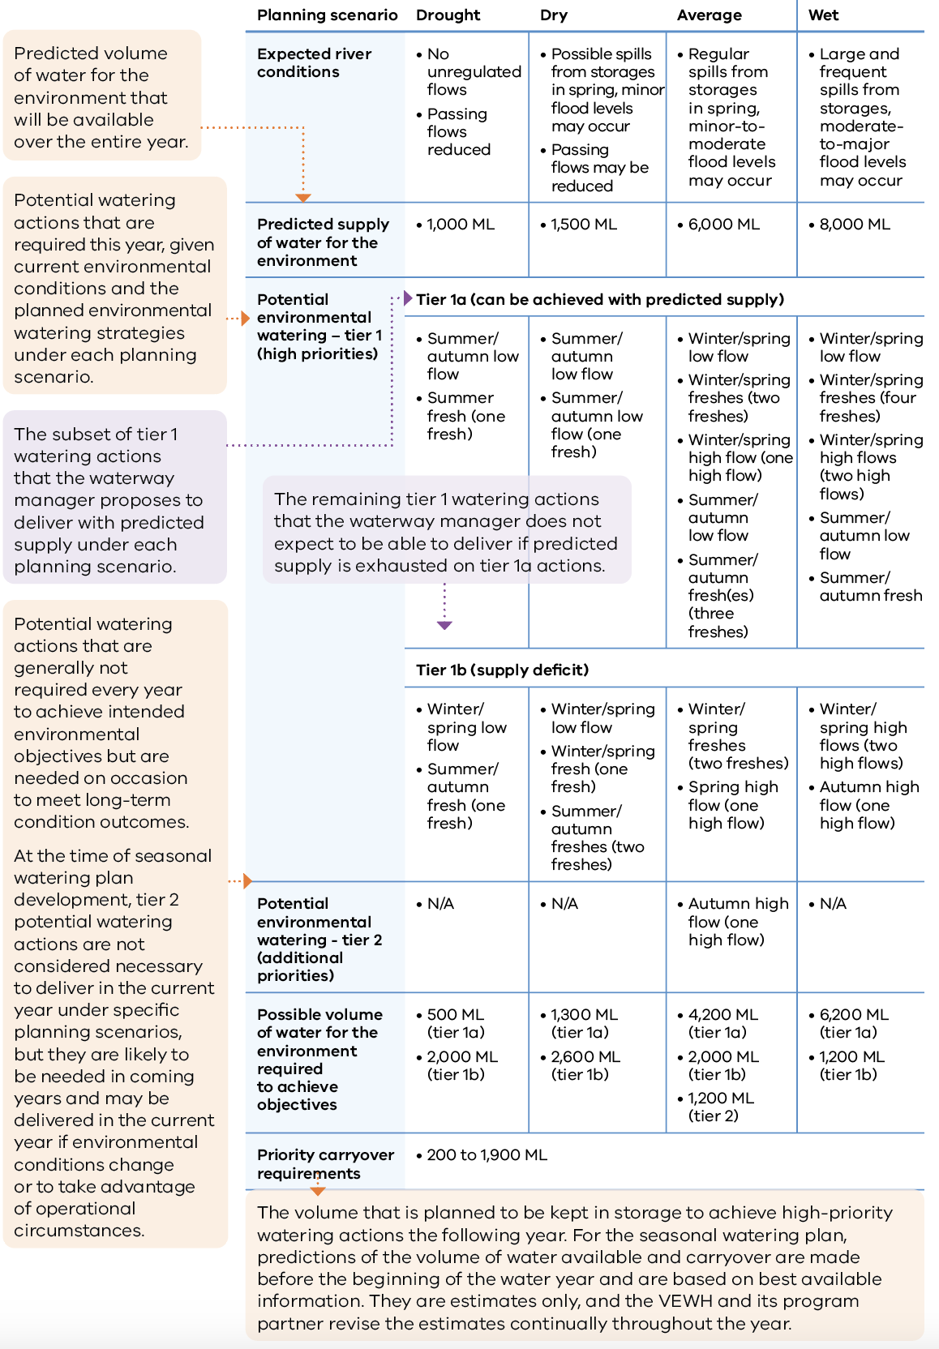

Section 2: Gippsland region
2.1 Gippsland region overview 28
2.2 Latrobe system 34
2.2.1 Latrobe River 34
2.2.2 Lower Latrobe wetlands 46
2.3 Thomson system 58
2.4 Macalister system 72
2.5 Snowy system 84

2.1 Gippsland region overview
The systems in the Gippsland region that can receive water from the VEWH’s environmental entitlements are Durt-Yowan (Latrobe River), lower Latrobe wetlands, Carran Carran (Thomson River), Heyfield wetlands and Wirn wirndook Yeerung (Macalister River). The Snowy River also receives an environmental flow, which the New South Wales Department of Climate Change, Energy, the Environment and Water manages.
Environmental values, objectives, and planned actions for delivering water for the environment for each system in the Gippsland region are presented in the system sections that follow.

Traditional Owners in the Gippsland region
Traditional Owners in the Gippsland region have a deep connection to Country that has endured for tens of thousands of years. This includes inherent rights and cultural obligations to Country and community.
The Gunaikurnai Land and Waters Aboriginal Corporation (GLaWAC), on behalf of the Gunaikurnai people, holds native title, has a Recognition and Settlement Agreement with the Victorian Government and is a Registered Aboriginal Party (RAP) (through the Commonwealth Native Title Act 1993, the Victorian Traditional Owner Settlement Act 2010 and the Victorian Aboriginal Heritage Act 2006). Gunaikurnai Country extends over an area from Warragul in the west to the Snowy River in the east and from the Great Dividing Range in the north to the coast in the south. This area includes Durt-Yowan (Latrobe River), Carran Carran (Thomson River), Wirn wirndook Yeerung (Macalister River), the lower Latrobe wetlands and west of the Snowy River covered by this section of the seasonal watering plan
Other RAPs in the Gippsland region are the Bunurong Land Council Aboriginal Corporation and Wurundjeri Woi Wurrung Cultural Heritage Aboriginal Corporation. Their RAP boundaries do not extend to the waterways managed with water for the environment in the Gippsland region.
Traditional Owners with links to the Snowy River system include the Gunaikurnai, Monero Ngarigo and Bidawal peoples.
The Victorian Government is committed to self-determination for Traditional Owners through Treaty negotiations, policies such as Water is Life: Traditional Owner Access to Water Roadmap 2022 and actions in the Central and Gippsland Region Sustainable Water Strategy 2022. The VEWH and its program partners are working with Traditional Owners to embed the outcomes of government policy into the Victorian environmental watering program. Program partners in the environmental watering program are aware that structural changes (such as legislative, policy and governance changes) to how water is managed may be made in the future in recognition of Aboriginal water rights. Program partners have heard that Traditional Owners want empowerment and agency in water management, and in many cases, they want to manage water on Country on their terms.

Engagement
Engagement with Traditional Owners, stakeholders, and local communities informs the environmental watering program. Program partners engage in extensive engagement at the local level to understand community priorities for the delivery of water for the environment in the coming year.
Program partners also seek to understand how cultural, social, economic and recreational values, uses and objectives may be supported by delivering an environmental flow. Opportunities to support these values, uses and objectives are incorporated into watering decisions where possible, provided they do not compromise environmental outcomes. The following system sections present cultural, social, economic and recreational values considered for each system in the Gippsland region.
Engagement through other strategies, plans and processes also informs environmental objectives. These include regional catchment strategies, regional waterway strategies and technical studies (such as environmental flows studies and environmental water management plans). Traditional Owner cultural objectives for environmental flows may refer to cultural flows studies, Aboriginal Waterway Assessments, Traditional Owner Country Plans and other tools. These strategies, plans and technical reports describe a range of environmental, economic, social and Traditional Owner perspectives and longer-term objectives that influence actions and priorities for water for the environment.
Table 2.1.1 Program partners and stakeholders that engaged with the West Gippsland CMA to develop seasonal watering proposals and key documents informing the proposals for the Latrobe, lower Latrobe wetlands, Thomson and Macalister systems and other key foundation documents that directly informed the proposals (in alphabetical order)
 | Latrobe system | Lower Latrobe wetlands | Thomson system | Macalister system
Community groups and environment groups | - Friends of Latrobe Water  - Friends of Tyers Park  - Greening Australia  - Trust for Nature | - Birdlife Australia  - Latrobe Catchment Landcare Network  - Latrobe Valley Field Naturalist Club Inc.  - Trust for Nature  - WaterWatch Volunteers | - Heyfield Wetlands Committee of Management | - EcoGipps  - Friends of Bellbird Corner  - Greening Australia  - Native Fish Australia
Government agencies | - Gippsland Water  - Southern Rural Water  - Victorian Environmental Water Holder | - Department of Energy, Environment and Climate Action  - East Gippsland CMA  - Parks Victoria  - Victorian Environmental Water Holder | - Gippsland Water  - Melbourne Water  - Southern Rural Water  - Victorian Environmental Water Holder | - Gippsland Water  - Southern Rural Water  - Victorian Environmental Water Holder
Landholders/farmers | - Individual landholders and irrigators  - Latrobe River Irrigators | - Field & Game Australia (Heart Morass)  - Individual landholders | - Individual irrigators  - Individual landholders | - Individual landholders  - Macalister Irrigation District irrigators/diverters
Local businesses |  | - Frog Gully Cottages  - Port of Sale Heritage River Cruises
Recreational users | - Recreational users  - VRFish | - Field & Game Australia (Dowd Morass and Sale Common)  - Recreational users | - Recreational fishing community  - Recreational users  - VRFish  - Whitehorse Canoe Club | - Recreational users  - VRFish
Technical experts | - Arthur Rylah Institute |  | - Arthur Rylah Institute | - Arthur Rylah Institute
Traditional Owners | - Gunaikurnai Land and Waters Aboriginal Corporation | - Gunaikurnai Land and Waters Aboriginal Corporation | - Gunaikurnai Land and Waters Aboriginal Corporation | - Gunaikurnai Land and Waters Aboriginal Corporation

Integrated catchment management
Altered water regimes are one of many threats to the health of Victoria’s waterways. Many of the environmental objectives of water for the environment in the Gippsland region are complemented by simultaneously addressing issues such as barriers to fish movement, high nutrient loads, loss of streambank vegetation and invasive species.
Victorian and Commonwealth government agencies, Traditional Owner groups, community groups and private landholders implement programs to protect and improve the environmental condition and function of land, soils and waterways throughout Victoria’s catchments.
Examples of complementary programs that support the outcomes of environmental flows in the Gippsland region include:
- works to protect and enhance stream banks along priority reaches of rivers and their tributaries, including fencing to exclude stock, revegetation of riverbanks, willow removal and erosion control
- work with farmers along the Thomson and Macalister rivers on grazing and soil management and on nutrient and water-use efficiency projects that help to improve water quality and river health
- construction of a fishway on the Thomson River to improve fish passage near the heritage-listed Horseshoe Bend Tunnel, completed in August 2019. The fishway now allows Australian grayling (specifically targeted with releases of water for the environment) and other migratory fish to access over 200 km of river habitat from the upper reaches of the Aberfeldy River down to the Latrobe River
- construction of a fishway on the Macalister River to allow fish passage through the Maffra Weir, due to commence in 2024.
For more information about integrated catchment management programs in the Gippsland region, refer to the West Gippsland and East Gippsland regional catchment strategies and regional waterway strategies.

Risk management
When developing seasonal watering proposals for the Latrobe, Thomson and Macalister systems, environmental watering program partners assessed risks associated with the potential delivery of water for the environment in 2024-25 and identified appropriate mitigating strategies. Risks and mitigating actions are continually assessed by program partners throughout the year (see subsection 1.2.7).
In the Snowy system, when weather conditions increase the risk of flooding, the New South Wales Department of Climate Change, Energy, the Environment and Water works with the Bureau of Meteorology, the East Gippsland CMA, New South Wales State Emergency Service and the VEWH to inform the community about the management of planned releases. Releases may be cancelled or rescheduled to limit flood impacts on private land.

Seasonal outlook 2024-25
A fourth consecutive year of above-average rainfall across the west Gippsland region triggered floods throughout the Latrobe, Thomson and Macalister systems during 2023-24. The largest event occurred in early October 2023, when heavy rainfall over two days at Glenmaggie caused major flooding downstream of the weir. Parts of the catchment received more than twice their average rainfall during December 2023 and January 2024, and Thomson Dam spilled for the second consecutive year and only the second time since 1996. Rainfall in east Gippsland during 2023-24 was closer to the long-term average, with no significant floods. Temperatures throughout the Gippsland region were very much above average during 2023-24.
Delivery of water for the environment in rivers and wetlands within the West Gippsland CMA region was managed in line with the wet planning scenarios in 2023-24, and all planned watering actions were achieved. Natural flow from spilling reservoirs and local catchment run-off met most of the planned watering actions during the year. Water for the environment was used to supplement the winter/spring low flow and deliver a spring fresh in the Thomson River to help fish and other animals move freely between different habitats. Water for the environment was not needed in the Macalister River or the Latrobe River from July 2023 to early autumn 2024 because the natural flow met or exceeded flow recommendations. Still, drier conditions in late summer and autumn 2024 meant some water for the environment was used to supplement the low flow and deliver autumn freshes in the Macalister system. The three lower Latrobe wetlands (Sale Common, Dowd Morass and Heart Morass) were flushed by the natural flow for a third consecutive year, and salinity levels in Lake Wellington remain low. Water for the environment was used to partially fill Heyfield wetlands in September 2023, but those deliveries ceased at the start of October when natural inflows filled the site.
The Snowy River received high allocations of water for the environment for the third consecutive year. Releases from Lake Jindabyne were used to mimic seasonal snow melt patterns to enhance the river’s environmental and physical conditions.
The Bureau of Meteorology has forecast average rainfall and above-average temperatures for the Gippsland region during winter 2024. High storage levels mean the risk of flooding remains for the Gippsland region in the first half of 2024-25. It also means there will be high allocations to environmental entitlements in the Gippsland systems. Forecast allocations and remaining carryover volumes should be sufficient to deliver planned watering actions in all climate scenarios during 2024-25.
The environmental watering program in the Gippsland region aims to maintain enough flow in dry times to minimise stresses on existing plant and animal populations and deliver greater flows in wetter conditions to enhance the condition of and increase recruitment in those populations. Over the last four years, wet conditions have resulted in strong native fish recruitment in all the Gippsland systems that receive water for the environment. While certain flows may be delivered at a lower magnitude in drier climate scenarios in 2024-25, the forecast high water availability means there should be sufficient supply in all planning scenarios to deliver the flows required to consolidate the last four years’ environmental gains and support additional recruitment. Efforts to boost migratory fish populations in the Latrobe, Thomson and Macalister rivers are particularly important because the larvae and juveniles of these species spend time in the ocean and can subsequently colonise other coastal rivers. Increasing the total number of larvae and juveniles in waters along the Gippsland coast may help recover native fish populations in river systems that were affected by the 2019-20 bushfires.
Delivery of water for the environment in the lower Latrobe wetlands in 2024-25 will aim to consolidate and, where possible, improve the environmental gains of the last four years. This will involve keeping Sale Common, Dowd Morass and Heart Morass at least partially full during winter and spring and allowing a natural partial drawdown during the warmer months in all climate scenarios.
The water year for the Snowy system starts in May and finishes in April the following year, which differs from how water is managed in the other Gippsland systems. In March 2024, the Snowy Advisory Committee endorsed the total volume for release and daily release targets for the Snowy River from May 2024 to April 2025. The agreed daily releases will not vary unless the flow increases the risk of flooding downstream or operational constraints prevent delivery.

2.2 Latrobe system
Waterway manager – West Gippsland Catchment Management Authority
Storage manager – Southern Rural Water
Environmental water holder – Victorian Environmental Water Holder
The Latrobe system includes Durt-Yowan (Latrobe River) and lower Latrobe wetlands: Sale Common, Heart Morass and Dowd Morass.

2.2.1 Latrobe River

System overview
Durt-Yowan (Latrobe River) originates near the Baw Baw Plateau and passes through relatively flat to undulating plains, largely cleared for agriculture, before flowing into Lake Wellington (the westernmost point of the Gippsland Lakes) (Figure 2.2.1). Notable tributaries include the Tanjil River, Narracan Creek, Morwell River, Tyers River, Traralgon Creek and Carran Carran (Thomson River).
Water for the environment is supplied to the Latrobe River from Blue Rock Reservoir on the Tanjil River. Blue Rock Reservoir also supplies water for irrigation, urban supply, electricity generators and a paper mill in the Latrobe Valley.
The Latrobe River from Kilmany to the Thomson River confluence (reach 5) is a high-priority reach for delivering water for the environment because it contains endangered plant communities with good potential for rehabilitation. Capacity constraints within reach 5 mean that some of the larger freshes required to meet environmental objectives in reaches 4, 5 and 6 cannot be delivered without flooding private land. Until this can be resolved, environmental flows will be managed to within-channel levels. Where possible, flows in the Latrobe River are coordinated with freshes in the Thomson River to meet targets for the Latrobe River estuary.
Options to deliver water for the environment to the Latrobe River via the Tyers River may be investigated in 2024-25. These options include a physical transfer of water from Blue Rock Reservoir to Moondarra Reservoir via existing infrastructure operated by Gippsland Water or a temporary administrative transfer arrangement. Delivering water via the Tyers River would increase the proportion of the Latrobe catchment that could receive water for the environment without compromising outcomes in the main target reaches of the Latrobe River. If adopted, these options are expected to benefit native in-stream and streamside vegetation and non-migratory fish within the Tyers River.
Figure 2.2.1 The Latrobe system
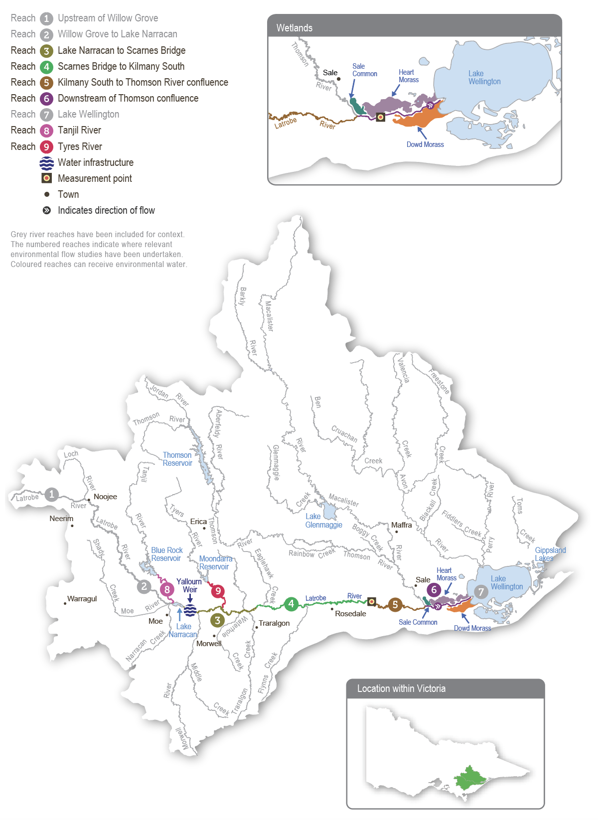

Environmental values
The upper reaches of the Latrobe River flow through state forest and are relatively intact and ecologically healthy. They have continuous stands of river red gums and intact streamside vegetation, and they support native animals, including barred galaxias, river blackfish, Gippsland spiny crayfish and nankeen night herons.
Below Lake Narracan, the Latrobe River is regulated and highly degraded due to historic river management practices. Most large woody habitat has been removed from the river, and many sections have been artificially straightened. These practices have caused significant erosion and widened the channel, reducing the quality and quantity of habitat for aquatic plants and animals.
There is endangered and vulnerable vegetation in all but the most modified sections of the Latrobe River. The banks along the lower reaches support stands of swamp scrub, characterised by swamp paperbark and tea tree. Mature river red gums grow adjacent to the lower Latrobe wetlands and provide nesting habitat for sea eagles and other birds of prey that hunt in the wetlands. The Latrobe River supports native estuarine and freshwater fish, including black bream, Australian bass, Australian grayling and short- and long-finned eel. The river also provides habitat and supports feeding and breeding conditions for platypus, rakali (water rats) and freshwater turtles.
The Latrobe River and its tributaries provide an essential source of freshwater to the Gippsland Lakes system, of which the lower Latrobe wetlands are an important component.
Environmental objectives in the Latrobe River
F1 | Increase the native fish (migratory, resident and estuary) population
G1 | Increase in-stream geomorphic diversity
M1 | Increase the abundance of all macro- and micro-invertebrates
PR1 | Increase the extent of platypus and rakali (water rat) populations
T1 | Maintain the abundance of the freshwater turtle population
V1 | Improve the condition and increase the extent and diversity of submerged, emergent and streamside native vegetation
V2 | Reduce the extent and density of invasive plants
WQ1 | Avoid adverse water quality conditions (such as high salinity) in the lower reaches of the Latrobe River and its estuary

Traditional Owner cultural values and uses
The Gunaikurnai have had a continued connection to Country for tens of thousands of years, including with the waterways in the Latrobe system. For the Gunaikurnai as Traditional Owners, there are immense challenges to heal, protect and manage Country, which has been drastically altered since colonisation.
“As Gunaikurnai, we see our land (Wurruk), waters (Yarnda), air (Watpootjan) and every living thing as one. All things come from Wurruk, Yarnda and Watpootjan, and they are the spiritual life-giving resources, providing us with resources and forming the basis of our cultural practices. We have a cultural responsibility to ensure that all of it is looked after.”
– Water is Life: Traditional Owner Access to Water Roadmap 2022 - Gunaikurnai Nation Statement
This cultural landscape is dependent on culture and Aboriginal management.
The objective for the Latrobe system is to provide and maintain healthy Country. Healthy Country includes the importance of place and the health of the entire ecosystem, including maintaining water quality, controlling pest species and maintaining a natural, seasonal flow regime and overbank flood events.
Water is Life acknowledged that cultural water is not environmental water. Until Traditional Owners manage cultural water flows, environmental objectives for the delivery of water for the environment should take a cultural landscape approach. Environmental watering requirements should therefore consider the following points to support cultural values and uses:
- collaboration with Gunaikurnai Land and Waters Aboriginal Corporation (GLaWAC) regarding the timing of the delivery of water for the environment to support a seasonal flow regime and wet and dry periods that embody healthy Country
- maintain freshwater supply to the Durt-Yowan (Latrobe River) estuary, Dowd Morass, Sale Common, Heart Morass and associated freshwater habitats
- provide connectivity between reaches and onto floodplains and maintaining water quality to support cultural values and uses of significance to the Gunaikurnai.
The Latrobe system supports many keystone species important to the Gunaikurnai. Borun (pelican) and Tuk (musk duck) are the father and mother in the Gunaikurnai creation story. If Borun and Tuk are living and breeding within the Latrobe system, it is a sign that Country is healthy. If they are not, flows should be provided to promote required habitat and ecosystem services. Yeerung and Djeetgun (fairy-wren) are also a totem species. While they are not considered water-dependent and environmental flows may not directly support them, a diversity of flows supporting shrubs and streamside vegetation will provide habitat for fairy-wren. For example, when flooding inundates wetlands, bush birds (including Yeerung and Djeetgun and other species) are known to increase in abundance and diversity.
Other birds are important for woorngan (hunting) and food, including nalbong (water hens), gidai (black swans), boyangs (eggs) and koortgan (ducks except for tuk). Gidai require submerged and softer emergent vegetation to make nest mounds, placing them on a small island or floating them in deeper water. Gidai breed in late winter to early spring after the water level rises. Actions that fill the large wetlands and support the growth of loombrak (water ribbon) and submerged aquatic plants will support gidai. Ensuring that the lower wetlands and floodplain depressions (for example, billabongs) receive freshwater flows in winter/spring will provide the conditions for submerged and emergent aquatic plants to grow and provide food and nesting materials for the waterbirds.
GLaWAC is developing a strategic Water Plan that aligns with the Gunaikurnai Whole-of-Country Plan. The Water Plan will consider:
- healthy Country: reflecting the spiritual and cultural values of the Gunaikurnai custodians; healthy Country contributes to the wellbeing of the Gunaikurnai
- water access: access to water is crucial for many cultural values, including identity and relational values, future economic values and place values, among many others. Access to water, through ownership or management, means that water is made available to the Gunaikurnai on the Latrobe and Thomson systems to provide freshwater to the wetlands. Every effort should be made to maintain freshwater-dependent values, which in turn deliver cultural values
- cultural and economic use: returning to cultural practices and Gunaikurnai-informed management at the lower Latrobe wetlands is key to returning to a more freshwater habitat for cultural uses and cultural species. It will also provide for water-based tourism, cultural education and ecotourism (camping) experiences
- connection: GLaWAC takes its responsibility to work closely with the people it represents on management decisions concerning Country and the health of Country very seriously. Gunaikurnai cultural obligations reflect Gunaikurnai views on healthy Country and, in turn, help the Gunaikurnai continue their ongoing connection to the land and waters of Country
- climate change: the Gunaikurnai have cared for Country for thousands upon thousands of years through many cycles of climatic change, and they understand how to manage the landscape as it too changes. When cared for using traditional knowledge, Country can be healed. Mitigation of climate change impacts affecting the lakes, rivers and other waterways of the lower Latrobe wetlands can be effective with resources and empowerment provided to the Gunaikurnai.
GLaWAC’s Water team and engagement with Community through the completion of Aboriginal Waterway Assessments have played a vital role in understanding cultural water values. These engagement sessions will continue in 2024-25 and contribute to the development of the Water Plan, due by the end of 2025.
Increasing the involvement of Traditional Owners in managing environmental flows and progressing opportunities towards self-determination in the environmental watering program is a core commitment of the VEWH and its program partners. This is reinforced by legislation and policy commitments, including the Water Act 1989, the Victorian Aboriginal Affairs Framework, the 2016 Water for Victoria, the 2022 Water is Life: Traditional Owner Access to Water Roadmap, and, in some cases, agreements under the Traditional Owner Settlement Act 2010.

Social, recreational and economic values and uses
In planning the potential environmental watering actions in Table 2.2.1, the West Gippsland CMA considered how environmental flows could support values and uses, including:
- water-based recreation (such as fishing and water skiing)
- riverside recreation and amenity (such as birdwatching and game hunting)
- socioeconomic benefits (such as commercial fishing, tourism and improved water quality for domestic, irrigation and stock use).
Planned environmental flows may be modified to align with a community benefit so long as environmental outcomes are not compromised. The West Gippsland CMA works with the storage operator to ensure releases of water for the environment do not affect Lake Narracan’s water levels during water skiing events held between January and March. This is acknowledged in Table 2.2.1 with an icon (as explained in Figure 1.2.3).
 | Watering planned to support water sports activities (e.g. water skiing)

Scope of environmental watering
The term ‘environmental watering’ refers to the active delivery of held environmental water to support particular environmental objectives by altering the flow in a river or water level in a wetland. While other terms are sometimes used to describe the delivery of environmental water, ‘environmental watering’ is deliberately used here and in seasonal watering statements to ensure consistency in the legal instruments that authorise the use of environmental water in Victoria.
Table 2.2.1 describes the potential environmental watering actions in 2024-25, their expected watering effect (that is, the intended physical or biological effects of the watering action) and the longer-term environmental objectives they support. Each environmental objective relies on one or more potential environmental watering actions and their associated physical or biological effects.
Table 2.2.1 Latrobe River potential environmental watering actions, expected effects and environmental objectives
Potential environmental watering action | Expected watering effects | Environmental objectives
Latrobe River (targeting reach 5)
Winter/spring low flow (620 ML/day during July to November 2024 and June 2025) | - Wet benches to maintain habitat, support the growth of emergent macrophyte vegetation and limit the encroachment of terrestrial vegetation  - Maintain oxygen levels in pools and maintain sediment (sands and silts) in suspension to prevent pools from filling and depositing on substrates, helping to maintain habitat for waterbugs, turtles, aquatic mammals and breeding substrate for river blackfish  - Maintain longitudinal connectivity to allow movement/dispersal of native fish, turtles, platypus and rakali (water rats) | F1  G1  PR1  T1  V1  V2  MI1  WQ1
Summer/autumn low flow (440 ML/day during December to May) | - Maintain an adequate depth in pool habitat to support native fish, turtles, platypus and rakali (water rats) and submerged vegetation  - Limit encroachment by terrestrial vegetation and support the growth of emergent macrophyte vegetation  - Mix pools to maintain oxygen levels suitable for aquatic animals | F1  PR1  T1  V1  V2  MI1  WQ1
Spring/summer/autumn river freshes (five to nine freshes of 980 ML/day for one to five days during November to May) | Water-quality fresh (one-day duration):  - freshen water quality in pools to support fish, waterbug and zooplankton communities  - provide sufficient velocity to turn over and flush sediments (sands and silts) from pools, scour algae from hard surfaces and clean fine sediment from substrates, including river blackfish nesting habitats  Fish and vegetation fresh (three to five days duration)  - Objectives listed for the one-day fresh and additional objectives:  - wet benches to support the growth of emergent macrophyte vegetation  - provide longitudinal connectivity (including over benches for Australian grayling) for native fish, platypus and rakali (water rats) | F1  G1  PR1  V1  MI1  WQ1
Latrobe River (targeting reach 6)
Summer/autumn estuary fresh(es) (one to three freshes of 2,200 ML/day for seven to 10 days during December to May)  Note: this is a combined magnitude with the Thomson River over the equivalent period; a contribution of at least 1,220 ML/day from the Thomson River is required | - Upper estuary: fully flush with freshwater to support submerged vegetation, provide adequate oxygen levels to support aquatic animals, transport silt, wet benches and deliver freshwater to connected wetlands  - Mid-estuary: partially/fully flush the upper layer of the water column to improve water quality, support emergent macrophytes, provide freshwater habitat and associated food sources for freshwater fish and provide breeding opportunities for estuary fish  - Lower estuary: partially flush the upper layer of the water column; a flow of this magnitude will also provide opportunities to fill the lower Latrobe wetlands | F1  G1  V1  MI1  WQ1

Scenario planning
Table 2.2.2 outlines potential environmental watering and expected water use in a range of planning scenarios. Multiple flood events occurred in the Latrobe catchment during spring and summer 2023-24, which resulted in the flow exceeding 5,000 ML per day at Kilmany on at least four occasions and kept large parts of the Latrobe River floodplain inundated for many months. These floods, combined with three previous wet years, have meant the Latrobe River estuary and the lower Latrobe wetlands continue to be the freshest they have been for many years. This has improved the condition and extent of streamside and wetland vegetation across the system. Maintaining this level of freshness in the Latrobe River estuary on the back of four wet years to improve vegetation condition will again be a high priority in 2023-24. As seen over the past four years, natural tributary inflows are likely to achieve most of the planned watering actions in wetter planning scenarios, so all tier 1 actions proposed in the average and wet planning scenarios can be achieved with the available supply. High volumes of water carried over into 2024-25 also means that tier 1 actions proposed in the drought and dry planning scenarios can be achieved with the available supply.
Maintaining target low flows throughout the year to provide habitat for native fish, turtles, platypus and rakali (water rats) and support vegetation growth are high priorities in all planning scenarios. Delivering spring/summer/autumn freshes to reach 5 and the estuary is also a high priority in all planning scenarios to maintain water quality, provide specific opportunities for fish movement and consolidate environmental gains in the Latrobe River estuary associated with multiple years of wet conditions.
The freshes will be delivered at the recommended magnitude where possible, but four consecutive years of high overbank flows have changed the geomorphology of the lower reaches of the Latrobe River, and it is uncertain whether the recommended flow rates will still achieve their intended physical and biological effects. There is also a risk that some of the larger freshes may exceed the channel capacity in the lower reaches and inundate parts of the adjacent floodplain. The West Gippsland CMA is undertaking monitoring to assess the channel capacity of the lower reaches of the Latrobe River and will adjust the size of planned freshes if needed to avoid flooding private land.
Freshes with larger magnitudes and longer durations (up to 10 days) may be coordinated with the flow in the Thomson River in all planning scenarios to meet environmental flow objectives in the Latrobe River estuary (reach 6). Summer/autumn estuary freshes also achieve the objectives of river freshes in reach 5 and will likely be met naturally in the wet and possibly average planning scenarios. In the drier planning scenarios, estuary freshes are achieved by extending the duration of summer/autumn river freshes.
Most of the recommended flows are likely to be fully achieved through a combination of natural events, operational releases, passing flows and environmental deliveries in the average and wet planning scenarios. There will be less natural inflow and lower operational releases in the drought and dry planning scenarios, and available water for the environment will be used to deliver low flows and freshes at their lower recommended magnitude, duration and frequency to maintain rather than improve current environmental conditions in the Latrobe River. It is expected that even in the drought and dry planning scenarios, passing flows and natural inflows from unregulated tributaries will provide some flow through the system during winter and spring.
There are no true carryover provisions in the Latrobe system. Rather, the VEWH maintains an ongoing share of storage capacity in Blue Rock Reservoir. It will be important to ensure a minimum of 5,000 ML is maintained in storage at the end of 2024-25 in drought or dry conditions and 3,000 ML in average conditions to help deliver critical watering actions in early 2025-26.
Table 2.2.2 Latrobe River environmental watering planning scenarios
Planning scenario | Drought | Dry | Average | Wet
Expected conditions | - Small contributions to low flows from unregulated reaches and tributaries  - Passing flows likely reduced over summer/autumn | - Possible spills from storages in spring, minor flood levels may occur  - Some natural flows contributing to low flows and freshes  - Passing flows likely reduced over summer | - Regular spills from storages in spring and minor to moderate flood levels may occur  - Natural flow and/or passing flows likely to meet low-flow requirements | - Large and frequent spills from storages and moderate to major flood levels may occur  - Natural flow and/or passing flows likely to meet low-flow requirements
Expected availability of water for the environment | - 25,800 ML | - 28,400 ML | - 31,500 ML | - 36,200 ML
Latrobe River
Potential environmental watering – tier 1 (high priorities) | Tier 1a (can be achieved with predicted supply)
 | - Winter/spring low flow  - Summer/autumn low flow  - Summer/autumn river freshes (four of lower duration and one of mid-duration [four days])  - Summer/autumn estuary freshes (two of lower duration) | - Winter/spring low flow  - Summer/autumn low flow  - Summer/autumn river freshes (five of lower duration and two of mid-duration [three days])  - Summer/autumn estuary freshes (two of upper duration) | - Winter/spring low flow  - Summer/autumn low flow  - Summer/autumn river freshes (six of lower duration and three of mid-duration [four days])  - Summer/autumn estuary freshes (three of upper duration) | - Winter/spring low flow  - Summer/autumn low flow  - Summer/autumn river freshes (six of lower duration and three of upper duration [five days])  - Summer/autumn estuary freshes (three of upper duration)
Possible magnitude of water for the environment required to achieve objectives | - 16,400-20,600 ML (tier 1a) | - 16,900-22,100 ML (tier 1a) | - 22,700-30,200 ML (tier 1a) | - 15,800-35,600 ML (tier 1a)
Priority carryover requirements for 2025-26 | - 5,000 ML |  | - 3,000 ML | - 0 ML

2.2.2 Lower Latrobe wetlands

System overview
The lower Latrobe wetlands (Dowd Morass, Heart Morass and Sale Common) are an important component of the internationally recognised Gippsland Lakes Ramsar site and provide habitat for waterbirds of state, national and international conservation significance. The wetlands are located on the floodplain of Durt-Yowan (Latrobe River) between its confluence with Carran Carran (Thomson River), and they form part of the Gippsland Lakes system.
River regulation and water extraction from the Latrobe, Thomson and Macalister rivers have reduced the frequency of small and medium-sized floods that naturally wet the lower Latrobe wetlands. The construction of levees and drains and the filling of natural depressions have also altered water movement into and through the wetlands. The drainage and flooding regime in all three wetlands is now managed to some extent with regulators connected to the Latrobe River.

Environmental values
Sale Common is one of only two remaining freshwater wetlands in the Gippsland Lakes system. It provides sheltered feeding, breeding and resting habitat for various waterbird species, including the Australasian bittern.
Dowd Morass is a large, brackish wetland that regularly supports rookeries of colonial nesting waterbirds, including Australian white ibis, straw-necked ibis, little black and little pied cormorants, royal spoonbills and great egrets.
Heart Morass is also a large brackish wetland, with open expanses providing shallow feeding habitat for waterbirds, including black swans, Eurasian coots and various duck species. The lower Latrobe wetlands function as a diverse and complementary environmental system. Colonial nesting waterbirds breed among swamp paperbark trees at Dowd Morass in spring. Migratory shorebirds feed on the mudflats that are exposed as the wetlands draw down and dry over the summer. Waterfowl and fish-eating birds use open-water habitat at the wetlands year-round. The wetlands also support threatened vegetation communities, including swamp scrub, brackish herbland and aquatic herbland.
Environmental objectives in the lower Latrobe wetlands
A1 | Maintain the abundance of the frog population
CN1 | Enable carbon and nutrient cycling between the wetland and river through connectivity
T1 | Maintain the abundance of the freshwater turtle population
V1 | Maintain the diversity, condition and/or extent of native streamside vegetation fringing wetlands and the variety of self-sustaining submerged and emergent aquatic vegetation types
V2 | Discourage the introduction and reduce the extent and density of undesirable/invasive plants (Sale Common)
B1 | Enhance waterbird breeding, recruitment, foraging and sheltering opportunities
MI1 | Maintain the abundance of all macro- and micro-invertebrates
WQ1 | Provide suitable physio-chemical conditions to support aquatic life
WQ2 | Avoid catastrophic water quality conditions (i.e. avoid acid sulfate soil exposure [Heart Morass] or dilute salt concentrations [Dowd Morass])

Traditional Owner cultural values and uses
The lower Latrobe wetlands are a place of spiritual and cultural connection for the Gunaikurnai people. Over many thousands of years, customs and lore have been passed orally between generations about the cultural values and uses of the wetlands and their importance to all Gunaikurnai people. The wetlands are on the lands of the Brayakaulung clan of the Gunaikurnai.
For the Gunaikurnai, the overarching objective for the wetlands is to provide and maintain healthy Country. Healthy Country includes the importance of place and the health of the entire ecosystem, including maintaining water quality, controlling pest species and maintaining a natural, seasonal flow regime and overbank flood events.
Water is Life acknowledged that cultural water is not environmental water. Until Traditional Owners manage cultural water flows, environmental objectives for the delivery of water for the environment for the lower Latrobe wetlands should take a cultural landscape approach. Environmental watering requirements should therefore consider the following points to support cultural values and uses:
- collaboration with GLaWAC regarding the timing of the delivery of water for the environment to support a seasonal flow regime and wet and dry periods that embody healthy Country
- maintain freshwater supply to the Durt-Yowan (Latrobe River) estuary, Dowd Morass, Sale Common, Heart Morass and associated freshwater habitats
- provide connectivity between reaches and onto floodplains and maintaining water quality to support cultural values and uses of significance to the Gunaikurnai.
The lower Latrobe wetlands support many keystone species important to the Gunaikurnai. Borun (pelican) and Tuk (musk duck) are the father and mother in the Gunaikurnai creation story. If Borun and Tuk live and breed within the wetlands, it is a sign that Country is healthy. If they are not, flows should be provided to promote required habitat and ecosystem services. Yeerung and Djeetgun (fairy-wren) are also a totem species. While they are not considered water-dependent and environmental flows may not directly support them, a diversity of flows supporting shrubs and streamside vegetation will provide habitat for fairy-wren. For example, when flooding inundates wetlands, bush birds (including Yeerung and Djeetgun and other species) are known to increase in abundance and diversity.
Other birds are important for woorngan (hunting) and food, including nalbong (water hens), gidai (black swans), boyangs (eggs) and koortgan (ducks except for tuk). Gidai require submerged and softer emergent vegetation to make nest mounds, placing them on a small island or floating them in deeper water. Gidai breed in late winter to early spring after the water level rises. Actions that fill the large wetlands and support the growth of loombrak (water ribbon) and submerged aquatic plants will support gidai. Ensuring that the lower wetlands and floodplain depressions (for example, billabongs) receive freshwater flows in winter/spring will provide the conditions for submerged and emergent aquatic plants to grow and provide food and nesting materials for the waterbirds.
GLaWAC is developing a strategic Water Plan that will align with the Gunaikurnai Whole-of-Country Plan. The plan is due to be completed by the end of 2025. Until then, GLaWAC and the West Gippsland CMA will continue to explore opportunities to align environmental flows with Gunaikurnai outcomes in the lower Latrobe wetlands. A joint GLaWAC WGCMA hosted Community event is planned for the end of 2023-24. Additional on-Country Community events will occur in 2024-25, including an event to coincide with the delivery of water for the environment, and it will involve water quality and fish monitoring.
Increasing the involvement of Traditional Owners in managing environmental flows and progressing opportunities towards self-determination in the environmental watering program is a core commitment of the VEWH and its program partners. This is reinforced by legislation and policy commitments, including the Water Act 1989, the Victorian Aboriginal Affairs Framework, the 2016 Water for Victoria, the 2022 Water is Life: Traditional Owner Access to Water Roadmap, and, in some cases, agreements under the Traditional Owner Settlement Act 2010.

Social, recreational and economic values and uses
In planning the potential environmental watering actions in Table 2.2.3, the West Gippsland CMA considered how environmental flows could support values and uses, including:
- water-based recreation (such as canoeing and fishing)
- riverside recreation and amenity (such as birdwatching, bushwalking, camping and duck hunting)
- socioeconomic benefits (such as commercial eel and carp fishing and tourism).

Scope of environmental watering
The term ‘environmental watering’ refers to the active delivery of held environmental water to support particular environmental objectives by altering the flow in a river or water level in a wetland. While other terms are sometimes used to describe the delivery of environmental water, ‘environmental watering’ is deliberately used here and in seasonal watering statements to ensure consistency in the legal instruments that authorise the use of environmental water in Victoria.
Table 2.2.3 describes the potential environmental watering actions in 2024-25, their expected watering effect (that is, the intended physical or biological effects of the watering action) and the longer-term environmental objectives they support. Each environmental objective relies on one or more potential environmental watering actions and their associated physical or biological effects.
Table 2.2.3 Lower Latrobe wetlands potential environmental watering actions, expected effects and environmental objectives
Potential environmental watering action | Expected watering effects | Environmental objectives
Dowd Morass
Top-up (any time, following bird breeding event if required) | - Prolong wetting of reed beds to maintain habitat and food resources for waterbirds and protect chicks from predators, following an observed breeding event | B1
Fill to control salinity (anytime) | - Dilute salt concentrations within the wetland that may be caused by king tides from Lake Wellington (likely occurring between March to May) or other sources  - This watering action is likely to be triggered if electrical conductivity rises above 7,000 µS/cm | WQ2
Partial fill (with top-ups as required to maintain a water depth of 0.3 m AHD during July to December 2024 and April to June 2025) | - Provide seasonal variation in water depth throughout the wetland to encourage the growth and flowering of semi-aquatic plants.  - Wet vegetation and soils at middle elevations within the wetland to increase the abundance of waterbugs and other food resources for frogs, turtles and waterbirds  - Provide connectivity between the river and wetlands and between wetlands, increasing available habitat for frogs and turtles  - Encourage bird breeding (when delivered in spring/early summer following earlier fill) by maintaining wetted habitat around reed beds | A1  MI1  V1  B1  T1
Fill (with top-ups as required to maintain a water depth of 0.6 m AHD during August to November) | - Wet reed beds and deep water next to reedbeds to provide waterbird nesting habitat and stimulate bird breeding  - Wet high-elevation banks and the streamside zone to support the growth of vegetation, creating nesting habitat for waterbirds  - Wet vegetation and soils at higher elevations to stimulate ecosystem productivity and increase the abundance of waterbugs and other food resources for frogs, turtles and waterbirds  - Provide connectivity between the river and wetlands and between wetlands, increasing available habitat and food resources for frogs and turtles  - Reduce the impact of saltwater incursion from Lake Wellington | A1  T1  WQ1  B1  V1
Partial drawdown (during January to March) | - Oxygenate sediments to enable aquatic vegetation to germinate and recruit  - Provide water level fluctuations for emergent vegetation reproduction and expansion (particularly swamp scrub and tall marsh)  - Break down organic matter and promote nutrient cycling  - Expose mudflats and create shallows to facilitate waterbird foraging | B1  V1  CN1
Heart Morass
Top-up to permanently maintain water level above -0.3 m AHD (anytime) | - Minimise the risk of acid sulfate soils developing by keeping known high-risk areas wet  - Respond to decreasing pH from the rewetting of exposed acid sulfate soils, most likely during high-wind events  - Dilute salt concentrations within the wetland that king tides from Lake Wellington or other sources may cause. This watering action is likely to be triggered if wetland overtopping appears likely, based on rising water levels at Lake Wellington reaching or exceeding +0.5 m AHD | WQ2
Top-up (anytime up to 0.5 m AHD, following bird breeding event if required) | - Prolong wetting of reed beds to maintain habitat and food resources for waterbirds and protect chicks from predators, following an observed breeding event | B1
Fill and partial flushing flow (during July to November) | - Wet high-elevation banks and streamsides to support the growth of vegetation, create nesting and foraging habitat for waterbirds and provide food resources for terrestrial birds  - Provide connectivity between the river and wetlands and between wetlands, increasing available habitat and providing food resources for frogs and turtles  - Export accumulated salts and sulfates and transport nutrients, dissolved organic carbon and seeds between the Latrobe River and Heart Morass | A1  CN1  B1  T1  V1  WQ1
Partial fill (with top-ups as required to maintain a minimum water depth of 0.3 m AHD during August to December) | - Support the growth and flowering of semi-aquatic plants  - Provide appropriate wetland fringing habitat for frogs and turtles  - Provide conditions that support waterbug communities and food resources for frogs, turtles and waterbirds | A1  MI1  V1  B1  T1
Partial drawdown (during January to March) | - Oxygenate sediments to enable aquatic vegetation to germinate and recruit  - Provide water level fluctuations for emergent vegetation reproduction and expansion (particularly swamp scrub and tall marsh)  - Break down organic matter and promote nutrient cycling  - Expose mudflats and create shallows to facilitate waterbird foraging | B1  V1  CN1
Sale Common
Top-up (anytime, following bird breeding event if required) | - Prolong the wetting of reed beds to maintain habitat and food resources for nesting waterbirds and protect chicks from predators | B1
Partial fill with top-ups as required to maintain a minimum water height of 0.3 AHD (July to December) | - Encourage the growth and flowering of semi-aquatic plants  - Provide appropriate wetland habitat for frogs and turtles  - Provide conditions that support waterbug communities and food resources for waterbirds | A1  MI1  V1  B1  T1
Fill (with top-ups as required during August to November to maintain a water depth of 0.4 m AHD for two months) | - Wet the outer boundaries of the wetland to support the growth and flowering of streamside and fringing wetland plants, increasing foraging opportunities for waterbirds  - Encourage bird and turtle breeding by providing nesting habitat  - Provide connectivity between the river and wetlands and increase habitat and feeding opportunities for frogs and turtles | A1  T1  B1  V1
Trigger-based fill or top-up to 0.5 m AHD (during December to January)  Trigger: requirement to drown out invasive vegetation | - Wet key habitats within the wetland for a sufficient duration to discourage invasive plants, particularly the excessive spread of giant rush | V2
Partial drawdown (during January to March) | - Oxygenate sediments to enable aquatic vegetation germination and recruitment  - Provide fluctuations in water levels so emergent vegetation (particularly swamp scrub and tall marsh) can reproduce and expand  - Break down organic matter and promote nutrient cycling  - Expose mudflats and create shallows to facilitate waterbird foraging | B1  V1  CN1

Scenario planning
Table 2.2.4 outlines potential environmental watering and expected water use in various planning scenarios.
Wet conditions over the last four years have caused natural flooding and flushing flows through all of the lower Latrobe wetlands, which have improved the condition and extent of most native wetland vegetation and triggered significant waterbird breeding. The main environmental watering priorities in 2024-25 will be partially filling each wetland in winter/spring to prevent complete drying over summer and autumn. The proposed watering actions aim to consolidate environmental outcomes from the past four wet years and build ecosystem resilience ahead of future dry periods. The wetlands can only be filled when water levels and water quality in the lower reaches of the Latrobe River are suitable. Therefore, the timing and extent of water delivery will be influenced by natural climatic conditions and flow in the Latrobe River. Only partial fills will likely be possible in the drought planning scenario, and natural overbank floods are likely at any time of year in the wet planning scenario. Trigger-based inflows to address a potential acid sulfate soil risk, support a natural waterbird breeding event or control invasive vegetation will be delivered when needed and possible, even if the timing of these actions compromises other planned wetting or partial drawdown events. Specific watering plans for each wetland in different planning scenarios are described below.

Dowd Morass
The plan at Dowd Morass is to maintain the water level above 0.3 m AHD from July to December 2024 and April to June 2025 and allow the wetland to partially draw down (without completely drying) between January and March 2025. This proposed watering regime will provide sufficient variation in the water level to support the needs of a range of vegetation communities within and beside the wetland and provide habitat and food for native frogs, turtles and waterbirds. After several wet years, the partial drawdown over summer will be important to facilitate carbon and nutrient cycling in drying soils and provide foraging habitat for wading shorebirds. It was previously thought that prolonged inundation was causing stress and dieback of the swamp paperbark trees, but investigations have shown that their poor condition is due to infestations of sawfly larvae on the plants. These natural infestations have likely been exacerbated by cooler-than-normal temperatures allowing the invertebrate to proliferate. Therefore, more extensive wetland drying is not considered necessary. Warmer temperatures, experienced in mid-to-late summer, caused extensive mortality of the larvae and defoliation was reduced. Recovery of the affected plants is highly probable without any management intervention.
The proposed watering regime described above may need to be modified if wet conditions naturally fill the wetlands or additional water is needed to support a large waterbird breeding event or dilute saline water from king tides. Completely filling Dowd Morass is a lower priority in 2024-25 because multiple natural floods have met the environmental objectives for this action in recent years.

Heart Morass
Acidity and salination represent a high risk to environmental values at Heart Morass,and maintaining water levels above -0.3 m AHD at all times is a high priority to avoid exposing potential acid sulfate soils. Heart Morass has filled and fully flushed in each of the last three years, removing accumulated salts and sulfides and reducing the immediate risk of acid sulfate soils. Filling and providing flushing flows through the wetland are a low priority in 2024-25 but may still be considered in all planning scenarios if they can be delivered in combination with a natural flood to lower the risk of acid sulfate soils occurring in subsequent years.
The preferred watering strategy in all planning scenarios involves partially filling the wetland from winter to early summer and maintaining the water level above -0.3 m AHD for the rest of the year. The partial fill in winter and spring will support established wetland plant communities and increase the available habitat and food for frogs, turtles and waterbirds. Allowing the wetland to partially draw down through summer and autumn is a high priority in all planning scenarios, although a partial drawdown may be compromised by natural inflows in the average-to-wet planning scenarios. The partial drawdown aims to expose shoreline habitat to increase the diversity of vegetation communities, allow nutrient cycling and provide foraging habitat for shorebirds.

Sale Common
The plan for Sale Common is to partially fill the wetland in winter and provide top-ups as needed to maintain the water level above 0.3 m AHD throughout the year, which will wet about half of Sale Common. Maintaining at least a partial fill is considered ecologically important to support wetland plant communities and provide habitat for frogs, turtles and waterbirds. Completely filling the wetland is a low priority in 2024-25 because it has filled naturally in each of the past four years.
Allowing the wetland to partially draw down naturally over the warmer months to promote the germination of emergent vegetation is a high priority in all planning scenarios, although there may be a limited drawdown in the average and wet planning scenarios. A managed drawdown (by opening regulator gates) of Sale Common is not proposed in 2024-25 because the risk and benefit assessment identified that while the risk to native fish is negligible (due to the proximity of the wetland, other refuge areas and the types of plants and animals that the wetland regularly supports), there is an increased risk of the expansion of giant rush in the wetland. Giant rush has established in the wetland and is difficult to control. There is a risk that if a prolonged wetland inundation does not immediately follow the managed drawdown, the giant rush will further expand. For these reasons, a natural drawdown was considered a lower risk than a managed drawdown, but it may be replaced by a top-up in December or January if monitoring indicates higher water levels are needed to prevent further expansion of the giant rush.
Table 2.2.4 Lower Latrobe wetlands environmental watering planning scenarios
Planning scenario | Drought | Dry | Average | Wet
Expected conditions | - No natural inflow from the Latrobe River, and wetlands are likely to be dry completely | - Minor natural inflow from the Latrobe River in winter/spring; expect moderate to substantial drying in summer | - Moderate winter/spring flow in the Latrobe River is likely to fill or partially fill the wetlands; expect minor drying in summer | - Major flow in the Latrobe River in winter/spring and possibly autumn/winter is likely to fill all wetlands with very little drying in summer
Dowd Morass
Potential environmental watering – tier 1 (high priorities) | - Top-up (any time following bird breeding)  - Fill (any time to control salinity)  - Partial fill (with top-ups as required to 0.3 m AHD during July to December 2024 and April to June 2025)  - Partial drawdown (during January to March)
Potential environmental watering – tier 2 (additional priorities) | - Fill (with top-ups as required during August to November)
Heart Morass
Potential environmental watering – tier 1 (high priorities) | - Top-up (any time to permanently maintain water level above -0.3 m AHD)  - Top-up to 0.5 m AHD (anytime following bird breeding)  - Partial fill (with top-ups as required during August to December)  - Partial drawdown (during January to March)
Potential environmental watering – tier 2 (additional priorities) | - Fill and partial flushing flow (during July to November)
Sale Common
Potential environmental watering – tier 1 (high priorities) | - Top-up (anytime following bird breeding)  - Partial fill (with top-ups as required during July to December)  - Trigger-based fill or top-up to 0.5 m AHD (during December to January, if required)  - Partial drawdown through evaporation (during December to March)
Potential environmental watering – tier 2 (additional priorities) | - Fill (with top-ups as required during August to November)

2.3 Thomson system
Waterway manager – West Gippsland Catchment Management Authority
Storage manager – Melbourne Water (Thomson Reservoir), Southern Rural Water (Cowwarr Weir)
Environmental water holder – Victorian Environmental Water Holder

System overview
Carran Carran (Thomson River) flows from the slopes of the Baw Baw Plateau to join Durt-Yowan (Latrobe River) south of Sale (Figure 2.3.1). The major tributaries of the Thomson River are the Aberfeldy and Jordan rivers in the upper reaches and Wirn wirndook Yeerung (Macalister River) in the lowest reach. Two major structures regulate flow in the Thomson River: Thomson Reservoir — the largest water supply storage for metropolitan Melbourne — and Cowwarr Weir — a regulating structure that supplies irrigation water to parts of the Macalister Irrigation District.
Thomson Reservoir harvests most of the flow from the upper catchment of Thomson River and significantly affects the flow in all downstream reaches. The Aberfeldy River now provides most of the natural flow variation to the Thomson River below Thomson Reservoir and is essential for providing natural freshes and a high flow.
Water for the environment is held in the Thomson Reservoir and released into the river as required. Reach 3 of the Thomson River (from the Aberfeldy River confluence to Cowwarr Weir) is the highest priority for delivery of water for the environment due to its heritage river status, high-value native streamside vegetation, high-quality in-stream habitat and low abundance of exotic fish species.
At Cowwarr Weir, the Thomson River splits into the old Thomson River course (reach 4a) and Rainbow Creek (reach 4b) (see Figure 2.3.1). Passing flows throughout the year are split two-thirds down reach 4a and one-third down reach 4b to avoid impacts to irrigators located on Rainbow Creek. Water for the environment is primarily delivered to the old Thomson River course (reach 4a) to support fish migration, as Cowwarr Weir impedes fish movement through Rainbow Creek.
The Heyfield wetlands is a cluster of pools located between Thomson River and the township of Heyfield. The construction of levees and weirs along Thomson River means that river water rarely enters the wetlands, and while the largest pool receives stormwater from the Heyfield township, smaller ponds rely on rainfall or pumped water for the environment to maintain environmental values. These values include wetland plant communities planted in recent years as part of a comprehensive revegetation program.
Figure 2.3.1 The Thomson system
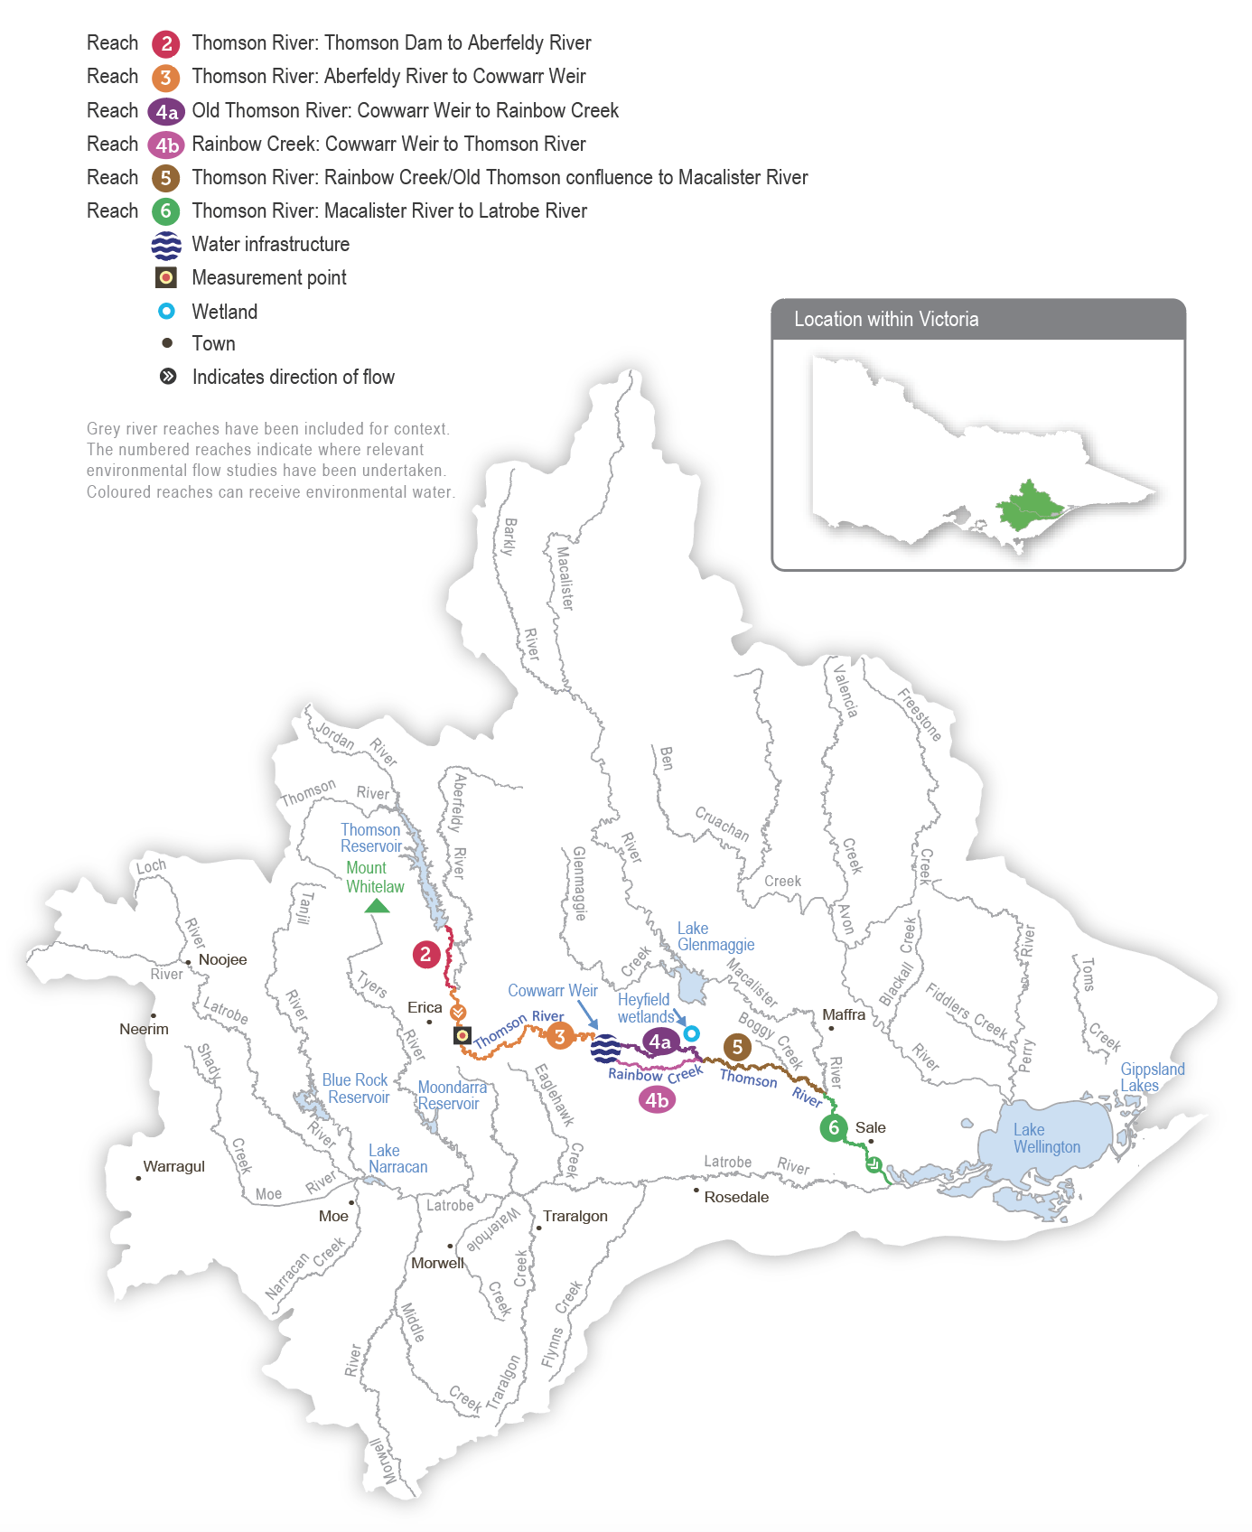

Environmental values
The Thomson River supports native species of migratory fish that need to move between the sea and freshwater environments to complete their life cycles, including Australian grayling, tupong, short- and long-finned eel, Australian bass and pouched and short-headed lamprey. A focus for environmental flows management is the Australian grayling, which is a threatened species in Victoria. Australian graylings spawn in response to autumn freshes, and the larvae and juveniles spend time at sea before returning to the freshwater sections of coastal rivers. A flow that supports key migration periods for Australian grayling also provides spawning and recruitment opportunities that benefit the broader native fish assemblage.
The composition and condition of streamside vegetation varies throughout the Thomson River catchment. The vegetation is intact and in near-natural condition above Thomson Reservoir in the Baw Baw National Park. Streamside vegetation between Thomson Reservoir and Cowwarr Weir is mostly in good condition but is affected by exotic weeds, including blackberry and gorse. Below the Cowwarr Weir, the vegetation is degraded due to stock access and widespread weed invasion.
The Heyfield wetlands are one of the few remaining freshwater wetland sites in the Gippsland Plains landscape. They provide habitat for aquatic and terrestrial animals, including threatened migratory birds that prefer shallow, slow-moving water bodies.
Environmental objectives in the Thomson system
A1 | Maintain the existing frog population and provide suitable habitat for it
B1 | Provide freshwater habitat for migratory and non-migratory wetland birds within the Gippsland Plains landscape
CN1 | Restore carbon and nutrient cycling within Heyfield wetlands to increase ecosystem productivity
F1 | Increase the distribution, recruitment and abundance of all native fish, and increase opportunities for the spawning and recruitment of native migratory fish (such as Australian grayling)
G1 | Maintain the physical form of the channel to provide a variety of channel features and habitats for aquatic animals
G1 | Enhance river function by maintaining substrate condition and enabling carbon cycling
MI1 | Maintain the natural invertebrate community
PR1 | Increase the abundance of platypus
V1 | Maintain the structural diversity and appropriate distribution (zonation) of streamside vegetation along the riverbank and reduce terrestrial encroachment and invasion in the Thomson River
V2 | Increase the recruitment and growth of native in-stream, fringing and streamside vegetation in the Thomson River
V3 | Maintain the existing vegetation and promote the growth, establishment and resilience of semi-aquatic species in the Heyfield wetlands
WQ1 | Improve water quality in the Thomson River estuary

Traditional Owner cultural values and uses
The Gunaikurnai have had a continued connection to Gunaikurnai Country for many thousands of years, including with the waterways in the Latrobe system, into which Carran Carran (Thomson River) feeds. For the Gunaikurnai as Traditional Owners, there are immense challenges to heal, protect and manage Country, which has been drastically altered since colonisation.
“As Gunaikurnai, we see our land (Wurruk), waters (Yarnda), air (Watpootjan) and every living thing as one. All things come from Wurruk, Yarnda and Watpootjan, and they are the spiritual life-giving resources, providing us with resources and forming the basis of our cultural practices. We have a cultural responsibility to ensure that all of it is looked after.”
– Water is Life: Traditional Owner Access to Water Roadmap 2022 - Gunaikurnai Nation Statement
This cultural landscape is dependent on culture and Aboriginal management.
The Gunaikurnai Land and Waters Aboriginal Corporation (GLaWAC) is working with the West Gippsland CMA to determine how to express Gunaikurnai objectives for water in a way that contributes to seasonal watering proposals from the perspective of traditional custodians with traditional knowledge.
GLaWAC Cultural Water Officers have completed Aboriginal Waterways Assessments on Carran Carran and are assessing how to protect and further the river’s cultural values and uses. Traditionally, Carran Carran was an important meeting place and a place to camp. Today, most of Carran Carran is inaccessible to the Gunaikurnai, making it difficult to meet and yarn along the river.
Assessments for watering requirements of Carran Carran for the Gunaikurnai have been based on cultural indicators, including:
- the condition of the lower Latrobe wetlands (which Carran Carran helps supply)
- the condition and prevalence of plants and animals with cultural values and uses
- species known to be indicators of water quality, water regimes and healthy Country.
GLaWAC is working with the West Gippsland CMA to share traditional knowledge of plant and animal species of cultural significance in and around the waterways of the Latrobe Valley and the importance of specific watering decisions to support them.
Watering requirements to support cultural values and uses include:
- timing of deliveries of water for the environment planned in partnership with GLaWAC to support a seasonal flow regime and wet and dry periods that contribute to healthy Country
- maintaining freshwater supply to the Durt-Yowan (Latrobe River) estuary, Dowd Morass, Sale Common and Heart Morass and associated freshwater habitats; the lower Latrobe wetlands are an important resource for the Gunaikurnai
- providing connectivity between reaches and onto floodplains to support dependent plants and animals with cultural values and uses of significance to the Gunaikurnai
- maintaining water quality to support the health of native plants and animals with cultural values and uses of significance to the Gunaikurnai.
GLaWAC is developing a Strategic Water Plan which is due for completion by the end of 2025.
Increasing the involvement of Traditional Owners in managing environmental flows and progressing opportunities towards self-determination in the environmental watering program is a core commitment of the VEWH and its program partners. This is reinforced by legislation and policy commitments, including the Water Act 1989, the Victorian Aboriginal Affairs Framework, the 2016 Water for Victoria, the 2022 Water is Life: Traditional Owner Access to Water Roadmap, and, in some cases, agreements under the Traditional Owner Settlement Act 2010.

Social, recreational and economic values and uses
In planning the potential environmental watering actions in Table 2.3.1, the West Gippsland CMA considered how environmental flows could also support values and uses, including:
- water-based recreation (such as kayaking, canoeing, fishing and swimming)
- riverside recreation and amenity (such as birdwatching, camping, hiking and duck hunting)
- community events and tourism (such as community education, events at the Heyfield wetlands and visitation by locals and non‑locals)
- socioeconomic benefits (such as maintaining bankside vegetation and preventing erosion and the potential loss of private and public land).
Planned environmental flows may be modified to align with a community benefit so long as environmental outcomes are not compromised. Autumn, winter and spring freshes in the Thomson River create ideal conditions for whitewater rafting, kayaking and canoeing. The timing of environmental flows may be adjusted to optimise opportunities to support these recreation activities, where it does not compromise environmental outcomes. For example, a fresh that aims to cue the migration of Australian grayling and other native fish may be timed to coincide with recreation events or holiday periods when people take advantage of favourable rafting or kayaking conditions.
In addition, kayaking and rafting activities have inherent risks, and large environmental flows are ramped up and down over several days to avoid sudden changes in water levels that may affect river users. This is acknowledged in Table 2.3.1 with an icon (as explained in Figure 1.2.3).
 | Watering planned to support water sports activities (e.g. canoeing and kayaking)
 | Watering planned to support peaks in visitation
The West Gippsland CMA notifies the public of planned large releases of water for the environment to alert river users about potential increases in the water’s level and velocity. People can register on the West Gippsland CMA website to be notified of upcoming watering events.

Scope of environmental watering
The term ‘environmental watering’ refers to the active delivery of held environmental water to support particular environmental objectives by altering the flow in a river or water level in a wetland. While other terms are sometimes used to describe the delivery of environmental water, ‘environmental watering’ is deliberately used here and in seasonal watering statements to ensure consistency in the legal instruments that authorise the use of environmental water in Victoria.
Table 2.3.1 describes the potential environmental watering actions in 2024-25, their expected watering effect (that is, the intended physical or biological effects of the watering action) and the longer-term environmental objectives they support. Each environmental objective relies on one or more potential environmental watering actions and their associated physical or biological effects.
Table 2.3.1 Thomson system potential environmental watering actions, expected effects and environmental objectives
Potential environmental watering action | Expected watering effects | Environmental objectives
Thomson River (targeting reach 3)
Year-round low flow (125-350 ML/day) | - Maintain a minimum level of habitat and maintain water quality in pools and riffles for waterbugs and fish  - Provide greater longitudinal connectivity to support the movement of native fish during autumn/spring (when delivered at the upper magnitude)  - Regulate the water temperature and wet large woody debris to provide food and shelter for waterbugs and fish  - Maintain sufficient water depth to facilitate platypus and fish movement between localised habitats and increase foraging opportunities (further enhanced when delivered at greater magnitudes)  - Wet low-lying benches (when delivered at a greater magnitude) to prevent encroachment by invasive plants and permit seed dispersal  - Additional benefits to the Thomson River estuary (reach 6) are expected when provided at 350 ML/day:  - partially flush the upper water column, helping to sustain waterbug communities and fish by maintaining oxygen levels  - prevent high salinity levels, helping to maintain emergent macrophyte vegetation  - provide freshwater to the Latrobe system | F1  PR1  V1  MI1  WQ1
Spring fresh (800-900 ML/day for five to seven days during September to November) | - Trigger the migration of adult and juvenile native fish (in particular, the upstream migration of juvenile Australian grayling and Australian bass from marine/estuarine habitats)  - Improve and maintain streamside vegetation by inundating the benches and providing variable water levels for plant zonation  - Carry plant seeds from the upper catchment for deposition downstream  - Prevent infilling of pools by mobilising fine sediments and depositing them on existing bars and benches to provide a substrate for vegetation  - Scour substrates to remove accumulated fine sediment and biofilms to improve habitat and food for waterbugs  - Additional benefits to Thomson River and its estuary (reach 6) are expected when provided at 900 ML/day:  - wet vegetation on higher benches  - partially flush the upper water column in the Thomson River estuary, helping to sustain waterbug communities and fish by maintaining oxygen levels  - prevent high salinity levels, helping to maintain emergent macrophyte vegetation  - provide freshwater to the Latrobe system | F1  G1  G2  V1  V2  MI1  WQ1
Summer/autumn fresh(es) (one to two freshes of 230-350 ML/day for seven days during December to March) | - Wet aquatic and fringing vegetation to maintain its condition and support its growth  - Wet low-lying benches to prevent encroachment by invasive plants and enable vegetation zonation  - Provide velocity and depth diversity and prevent sediment from smothering hard substrates  - When delivered in February-March (at 230 ML/day), the fresh also aligns with and supports native fish movement:  - trigger downstream migration of adult short- and long-finned eel and upstream movement of juvenile Australian bass  - increase the water depth over riffles to facilitate local movement between habitats for large-bodied native fish | F1  G2  V1  V2
Autumn fresh (800 ML/day for five to seven days during April to May) | - Trigger the migration of adult and juvenile native fish, in particular:  - the downstream migration and spawning of adult Australian grayling (April)  - the downstream migration of adult tupong and upstream migration of adult and juvenile Australian bass (May)  - Carry plant seeds and propagules from the upper catchment for deposition downstream and help maintain the zonation of vegetation  - Prevent infilling of pools by mobilising fine sediments and depositing them on existing bars and benches to provide substrate for vegetation  - Scour substrates to remove accumulated fine sediment | F1  G1  G2  V1  V2
Heyfield wetlands
Fill (during August to September) | - Wet ponds to capacity to stabilise the banks and support the spring growth of semi-aquatic vegetation  - Provide freshwater habitat for waterbirds and frogs (such as growling grass frogs and golden bell frogs) | A1  B1  CN1  V3
Top-ups as required to maintain water level (during October to May) | - Top up ponds before summer to maintain vegetation and enhance recruitment by triggering the release of seeds  - Top up ponds in late summer to ensure the survival of newly planted wetland vegetation  - Maintain habitat for waterbirds and frogs (such as growling grass frogs and golden bell frogs)  - Note: when delivered in April to May, top-ups provide drought refuge habitat for waterbirds and frogs following prolonged dry conditions
Partial drawdown (during April to May) | - Oxygenate surface soils, break down accumulated organic matter and cycle nutrients  - Enhance waterbird food availability by exposing the mudflats and providing access to burrowing invertebrates

Scenario planning
Table 2.3.2 outlines potential environmental watering and expected water use in various planning scenarios.
The Thomson River has experienced wet conditions for the last four years, and Thomson Dam spilled in 2022-23 and 2023-24, the only spills since 1996. These natural flows, combined with water for the environment, have created ideal conditions for native fish to breed and disperse throughout the system. Planned environmental flows for the Thomson River in 2024-25 will focus on supporting the migration, spawning and recruitment of native fish to boost their populations.
It is important to deliver a mix of a low flows and freshes throughout the year in the Thomson River, but the magnitude, duration and frequency of these events will generally be lower in the drought and dry planning scenarios than in the average and wet planning scenarios. More events with higher magnitude and longer duration may be delivered in all planning scenarios if enough water is available, noting that recent spills from Thomson Dam reduced carryover for a second consecutive year. As seen in recent years, natural tributary inflows will likely achieve many of the planned watering actions in the wetter climate scenarios. Therefore, most or all tier 1a actions proposed for the Thomson River in the wet and possibly average planning scenarios should be achievable with available supply.
In all planning scenarios, the highest-priority watering actions for the Thomson River are 800 ML per day freshes in autumn (in April/May) and spring (in September/November) to support migratory fish to move into or out of the system. These events are essential to cue the spawning and recruitment of the threatened Australian grayling population and other native migratory fish species, which have had high recruitment in recent years. These events are necessary every year in the average and wet climate scenarios to ensure regular recruitment and to align with environmental cues in the broader landscape. They are generally less important in the dry or drought planning scenarios, but they are considered important to deliver even in drier conditions in 2024-25 to consolidate recent population growth. Where possible, the spring and autumn freshes may be timed to coincide with long weekends to provide additional recreational benefits for river users. Delivering summer/autumn freshes in all planning scenarios will be important to clear fine silt and biofilms from in-stream habitat and facilitate the movement of native fish and platypus. The number and magnitudes of these freshes will vary depending on climate conditions.
Delivery of a low flow throughout the year is expected to change depending on the planning scenario. A 125 ML per day flow in reach 3 is the target magnitude from December to April, which is expected to be delivered with the operational passing flows in all planning scenarios.
Increasing the low-flow magnitude to at least 230 ML per day between May and July and 350 ML per day in November (following a spring fresh) is recommended in all planning scenarios to improve water quality in the Thomson estuary. The upper magnitude of 350 ML per day during May to July is preferred in all planning scenarios to improve outcomes for fringing and streamside vegetation. However, it will only be possible if enough water for the environment is available. The magnitude of the low flow throughout these months is reduced to 230 ML per day in the drought planning scenario and 300 ML per day in the dry and average planning scenarios, which is still at a rate that allows fish and platypus to move throughout the reach at critical breeding and dispersal times.
The recommended water regime for the Heyfield wetlands is the same in the dry and average planning scenarios because the wetlands are expected to hold water for most of the year in these planning scenarios. Filling the wetlands in late winter or early spring and providing top-ups through summer and early autumn aims to help recently planted semi-aquatic and terrestrial fringing plants become established and promote the natural recruitment of native wetland species. A partial drawdown in mid-to-late autumn in the dry and average planning scenarios will replicate a natural drying event and allow the breakdown of accumulated organic matter, promote nutrient cycling and provide mudflat habitats for waterbirds to feed. Natural inflow is expected to keep the wetlands near-full in the wet planning scenario, so a partial drawdown will not be possible. The planned autumn drawdown will be replaced by ongoing top-ups in the drought planning scenario to maintain some aquatic habitat for frogs and waterbirds in the local area. In the average and wet climate scenarios, natural run-off will likely meet some or all of the recommended watering actions at the Heyfield wetlands.
There are no carryover targets in the Thomson system for 2024-25. Spills from storage and natural inflows are again expected to meet many of the planned watering actions in the Thomson River in 2024-25, meaning enough water for the environment will likely be available to meet early-season demands in 2025-26.
Table 2.3.2 Thomson system environmental watering planning scenarios
Planning scenario | Drought | Dry | Average | Wet
Expected conditions | - Spill from Thomson Reservoir unlikely  - Passing flow and limited natural flow from Aberfeldy River and other tributaries contribute to low flow  - A large magnitude of consumptive water is released from storage | - Spill from Thomson Reservoir unlikely  - Passing flow and natural flow from Aberfeldy River and other tributaries contribute to low flow and some freshes  - A moderate magnitude of consumptive water is released from storage | - Spill from Thomson Reservoir possible  - Passing flow and natural flow from Aberfeldy River and other tributaries contribute to low flow and periods of high flow and freshes  - A small magnitude of consumptive water is released from storage | - Spill from Thomson Reservoir likely  - Natural flow from Aberfeldy River and other tributaries is expected to meet most low-flow requirements, provide large freshes and sustain high flow  - Minimal magnitude of consumptive water released from storage
Expected availability of water for the environment | - 18,600 ML | - 20,700 ML | - 21,900 ML | - 28,000 ML
Thomson River (targeting reach 3)
Potential environmental watering – tier 1 (high priorities) | Tier 1a (can be achieved with predicted supply)
 | - Year-round low flow (230 ML/day continuous during May-July)  - Spring fresh  - Summer/autumn freshes  - Autumn fresh | - Year-round low flow (300 ML/day continuous during May-July)  - Spring fresh  - Summer/autumn freshes  - Autumn fresh | - Year-round low flow (300-350 ML/day continuous during May-July)  - Spring fresh  - Summer/autumn freshes  - Autumn fresh | - Year-round low flow (350 ML/day continuous during May-July)  - Spring fresh  - Summer/autumn freshes  - Autumn fresh
 | Tier 1b (supply deficit)
 | - Year-round low flow (350 ML/day continuous during May to July) | - Year-round low flow (350 ML/day continuous during May to July) | - Year-round low flow (350 ML/day continuous during May to July) | - N/A
Heyfield wetlands
Potential environmental watering – tier 1 (high priorities) | Tier 1a (can be achieved with predicted supply)
 | - Fill  - Top-ups as required to maintain water level | - Fill  - Top-ups as required to maintain water level  - Partial drawdown |  | - Fill  - Top-ups as required to maintain water level
Possible magnitude of water for the environment required to achieve objectives | - 18,100 ML (tier 1a)  - 11,200 ML (tier 1b) | - 20,700 ML (tier 1a)  - 4,600 ML (tier 1b) | - 21,100 ML (tier 1a)  - 1,600 ML (tier 1b) | - 28,000 ML (tier 1a)  - N/A (tier 1b)
Priority carryover requirements for 2025-26 | - 0 ML

2.4 Macalister system
Waterway manager – West Gippsland Catchment Management Authority
Storage manager – Southern Rural Water
Environmental water holder – Victorian Environmental Water Holder

System overview
Wirn wirndook Yeerung (Macalister River) flows from Mt Howitt in the Alpine National Park and joins Carran Carran (Thomson River) south of Maffra (Figure 2.4.1). The river winds its way to the southeast through mostly forested, confined valleys and narrow floodplains above Lake Glenmaggie. The downstream reaches flow through wide alluvial floodplains that have been cleared for agriculture. The Wellington River and Glenmaggie Creek are the main tributaries of the Macalister River.
Lake Glenmaggie is the major water harvesting storage regulating the Macalister River. Maffra Weir is a small diversion weir located further downstream in Maffra.
Before the construction of Lake Glenmaggie, the Macalister River would regularly receive high and medium flows in winter and spring. Although Lake Glenmaggie regularly spills, a high flow is less frequent than natural because the storage captures much of the water. A notable impact of irrigation and water harvesting is the reversed seasonality of the flow between Lake Glenmaggie and Maffra Weir. The summer flow through this reach is much greater than natural due to the delivery of irrigation water. Winter flow in this reach is lower than natural because a large proportion of the inflows are captured, and there are no irrigation demands over winter. Most irrigation water is diverted at Maffra Weir, and the flow downstream of the weir is lower than natural year-round. The changed hydrology restricts fish migration, limits the growth and recruitment of in-stream and streamside plants and reduces the quality of in-stream habitat.
Water for the environment is stored in Lake Glenmaggie and released to the Macalister River. The river is divided into two reaches for the purposes of managing environmental flows: Lake Glenmaggie to Maffra Weir (reach 1) and Maffra Weir to the Thomson River (reach 2).
Maffra Weir is a major barrier to fish movement along the river, so delivery of water for the environment for migratory fish objectives mainly focuses on reach 2. All other objectives apply to reaches 1 and 2. Construction of a new fish ladder on Maffra Weir to improve fish passage is scheduled to commence in the next few years, and it is not expected to affect deliveries of water for the environment in 2024-25.
Figure 2.4.1 The Macalister system
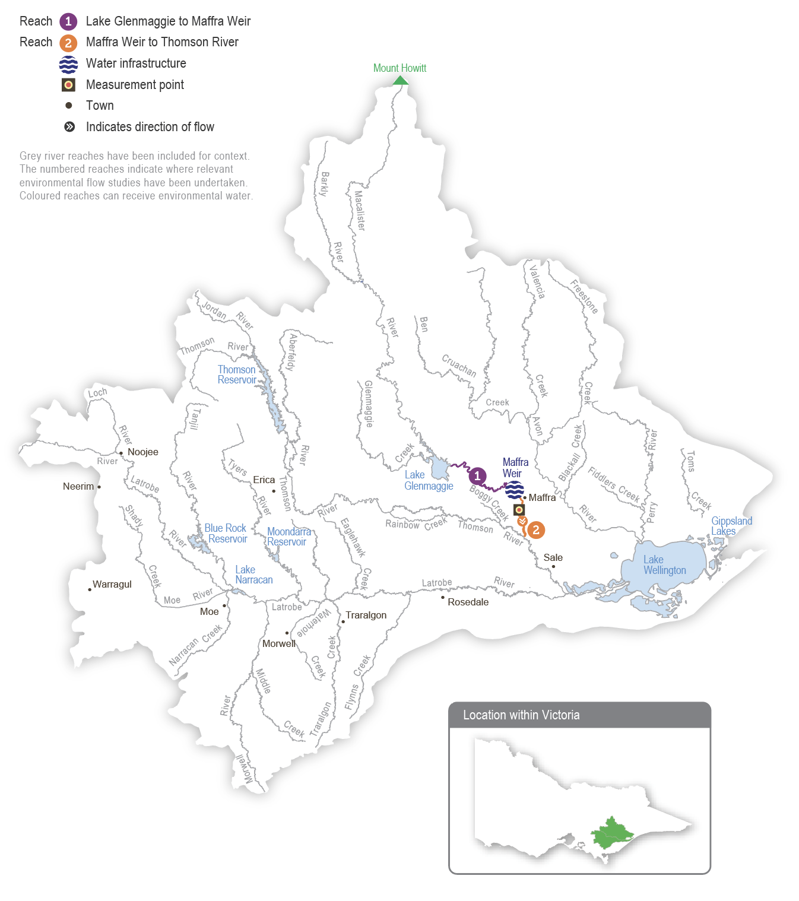

Environmental values
Seven migratory native fish species move between the Macalister River, the estuary and the sea to complete their life cycle. These species include the Australian grayling, short-finned eel, long-finned eel, tupong, Australian bass, short-headed lamprey and common galaxias. Yellow-eye mullet, an estuarine species, has been recorded in the river. Platypus and rakali (water rats) are widely distributed through the Macalister River and its tributaries.
The streamside vegetation corridor along the regulated reaches of the Macalister River is fragmented. Immediately below Lake Glenmaggie, the vegetation is in good condition. It includes remnant river red gums and good-quality stands of shrubs, particularly in areas where revegetation has occurred in combination with stock exclusion. Further downstream, the vegetation is degraded. In recent years, the cover of in-stream vegetation has declined, possibly due to increased water turbidity, erosion and a lack of an appropriate water regime to encourage plant growth. The cover of non-woody plants (such as reeds, sedges and rushes) along the river’s fringes is patchy.
Environmental objectives in the Macalister system
F1 | Increase the distribution, recruitment and abundance of all native fish, and increase opportunities for the spawning and recruitment of native migratory fish (such as Australian grayling)
G1 | Maintain the form of the riverbank and bed to provide physical habitat for aquatic animals and plants
PR1 | Increase the abundance of platypus and rakali (water rats)
V1 | Maintain emergent (non-woody) and fringing (woody) vegetation in the streamside zone
V2 | Reinstate submerged aquatic vegetation
MI1 | Increase the abundance and number of functional groups of waterbugs
WQ1 | Improve water quality during periods of reduced or no passing flow from Lake Glenmaggie
WQ2 | Improve water quality in the Thomson River estuary

Traditional Owner cultural values and uses
Wirn wirndook Yeerung (Macalister River) is a very important river to the Gunaikurnai people. It is a pathway that connects the Snow Country to the heart of Gippsland, and to ceremonial grounds and to a known special men’s place to Elders. Its traditional name is Wirn wirndook Yeerung, which translates to ‘song of the male fairy-wren’.
Yeerung is the men’s totem. This river has many cultural resources and extensive important sites along the whole system.
The Gunaikurnai have had a continued connection to Gunaikurnai Country for over 50,000 years, including with the waterways in the Latrobe system into which Wirn wirndook Yeerung feeds. For the Gunaikurnai as Traditional Owners, there are immense challenges to heal, protect and manage Country, which has been drastically altered since colonisation.
“As Gunaikurnai, we see our land (Wurruk), waters (Yarnda), air (Watpootjan) and every living thing as one. All things come from Wurruk, Yarnda and Watpootjan, and they are the spiritual life-giving resources, providing us with resources and forming the basis of our cultural practices. We have a cultural responsibility to ensure that all of it is looked after.”
- Water is Life: Traditional Owner Access to Water Roadmap 2022 - Gunaikurnai Nation Statement
This cultural landscape is dependent on culture and Aboriginal management.
The Gunaikurnai Land and Waters Aboriginal Corporation (GLaWAC) is working with the West Gippsland CMA to determine how to express Gunaikurnai objectives for water in a way that contributes to seasonal watering proposals from the perspective of traditional custodians with traditional knowledge. GLaWAC has membership on the Macalister Environmental Water Advisory Group.
GLaWAC has expressed that more water needs to go down Wirn wirndook Yeerung between Lake Glenmaggie and Lake Wellington to improve water quality, including to address the threat of salinity and to support plants and animals that have cultural values and uses.
GLaWAC has also questioned the timing of watering events and expressed a desire to provide increased water depth to promote downstream fish migration and spawning, deeper water pools to prevent water quality degradation and more variation in water levels to mimic natural conditions better.
Traditionally, the landscape, which includes Wirn wirndook Yeerung and branches and associated floodplains, has been a rich source of food, medicine and resources for the Gunaikurnai people. In the area, there are many sites of cultural significance near the river and around Lake Glenmaggie. The Gunaikurnai have moved through the landscape along the waterways for thousands of years, sourcing food and plants along the way.
From the perspective of the Gunaikurnai, the land and waterways flowing to the Gippsland Lakes are interconnected and cannot be considered separately where decisions can impact downstream areas. The lower Latrobe wetlands and the rivers that feed them, including Wirn wirndook Yeerung, have important cultural significance to the Gunaikurnai.
Watering requirements to support cultural values and uses include:
- timing the delivery of water for the environment planned in partnership with GLaWAC to support a seasonal flow regime and wet and dry periods that embody healthy Country
- maintaining freshwater supply to the Durt-Yowan (Latrobe River) estuary, Dowd Morass, Sale Common and Heart Morass, and associated freshwater habitats. The lower Latrobe wetlands are an important resource for the Gunaikurnai
- providing connectivity between reaches and onto floodplains to support dependent plants and animals with cultural values and uses of significance to the Gunaikurnai
- maintaining water quality to support the health of native plants and animals with cultural values and uses of significance to the Gunaikurnai.
GLaWAC is developing a Strategic Water Plan which is due for completion by the end of 2025.
Increasing the involvement of Traditional Owners in managing environmental flows and progressing opportunities towards self-determination in the environmental watering program is a core commitment of the VEWH and its program partners. This is reinforced by legislation and policy commitments, including the Water Act 1989, the Victorian Aboriginal Affairs Framework, the 2016 Water for Victoria, the 2022 Water is Life: Traditional Owner Access to Water Roadmap, and, in some cases, agreements under the Traditional Owner Settlement Act 2010.

Social, recreational and economic values and uses
In planning the potential environmental watering actions in Table 2.4.1, the West Gippsland CMA considered how environmental flows could support values and uses, including:
- water-based recreation (such as canoeing, kayaking and swimming)
- riverside recreation and amenity (such as fishing)
- socioeconomic benefits (such as preventing erosion and potentially losing private and public land).
Watering actions, particularly over summer, may improve the water quality in waterholes and improve swimming conditions. Freshes throughout the year also increase the longitudinal connectivity of the river, improving conditions for canoeing and kayaking.
Winter and spring freshes encourage the spawning and recruitment of fish species (such as Australian bass, a popular recreational fishing species).
The West Gippsland CMA notifies the public of planned large releases of water for the environment to alert river users about potential increases in the water’s level and velocity. People can register on the West Gippsland CMA website to be notified of upcoming watering events.

Scope of environmental watering
The term ‘environmental watering’ refers to the active delivery of held environmental water to support particular environmental objectives by altering the flow in a river or water level in a wetland. While other terms are sometimes used to describe the delivery of environmental water, ‘environmental watering’ is deliberately used here and in seasonal watering statements to ensure consistency in the legal instruments that authorise the use of environmental water in Victoria.
Table 2.4.1 describes the potential environmental watering actions in 2024-25, their expected watering effect (that is, the intended physical or biological effects of the watering action) and the longer-term environmental objectives they support. Each environmental objective relies on one or more potential environmental watering actions and their associated physical or biological effects.
Table 2.4.1 Macalister system potential environmental watering actions, expected effects and environmental objectives
Potential environmental watering action | Expected watering effects | Environmental objectives
Macalister River (targeting reach 2)¹
Year-round low flow (60-90 ML/day) | - Maintain pool and riffle habitat for waterbugs and a minimum depth over riffles to allow fish to move throughout the reach  - Provide connectivity throughout the river for the local movement of platypus and rakali (water rats), as well as protection from predation and access to food  - Provide low-velocity flow and clear water to enable the establishment of submerged vegetation  - Note: At 90 ML/day, expected watering effects are met in reach 1 and 2. At 60 ML/day, expected watering effects are met in reach 2 only  - Maintain a minimum depth in pools in the event of reduced passing flows to allow for turnover of water and to slow degradation of water quality to support aquatic life | F1  PR1  V2  MI1  WQ1
Winter/spring low flow (300 ML/day for at least 120 days during July to November 2024 and June 2025) | - Provide permanent wetted habitat for waterbugs and maintain water depth over riffles to enable fish passage between local habitats  - Provide sustained wetting of low-level benches to limit the encroachment of terrestrial vegetation | F1  V1  MI1
Spring fresh (one fresh of 700 ML/day for five days during September to November) | - Cue the upstream migration of adult fish (e.g. short-headed lamprey) and the recruitment of juveniles (e.g. Australian grayling, tupong, common galaxias, Australian bass and short- and long-finned eels) from marine/estuarine environments  - Wet mid-level benches to water woody vegetation, limit the encroachment of terrestrial vegetation and facilitate the dispersal of emergent and fringing vegetation seeds and propagules throughout the reach | F1  V1
Spring/summer fresh following spill (one fresh peaking at 1,500-1,800 ML/day for three to 10 days during September to December) | - Extend the duration and slow the recession of spills above 1,500 ML/day to:  - inundate emergent and woody vegetation on mid and high-level benches, move organic matter into the channel and transport food resources downstream  - provide a flow with sufficient shear stress to scour biofilms and flush fine sediment from pools and small gaps in the substrate to improve geomorphic habitat and food resources for waterbugs  - cue the upstream migration of adult fish (e.g. short-headed lamprey) and the recruitment of juveniles (e.g. Australian grayling, tupong, common galaxias, Australian bass and short- and long-finned eels) from marine/estuarine environments | F1  G1  V1  MI1
Summer/autumn fresh(es) (one to three freshes of 140 ML/day for three days during December to March) | - Increase water depth to allow fish to move throughout the reach  - Provide a flow with sufficient shear stress to flush fine sediment from small gaps to improve geomorphic habitat  - Flush substrates and improve the quality of existing waterbug habitat and food supply  - Wet low benches to facilitate the dispersal of seeds and propagules from emergent vegetation throughout the reach  - Flush pools to maintain water quality for aquatic animals | F1  G1  V1  MI1  WQ1
Autumn fresh (one fresh of 350 ML/day for five days during April to May) | - Cue the downstream migration of Australian grayling towards the estuary for spawning  - When delivered for more than three days and combined with freshes in the Thomson River, fully flush the upper Thomson River estuary and contribute freshwater to the lower reaches of the Latrobe River and wetlands | F1  WQ2
Autumn/winter fresh (one fresh of 700 ML/day for five days during July to August 2024 or May to June 2025) | - Cue the downstream migration of Australian bass and tupong towards the estuary for spawning/breeding  - Increase the wetted area and improve water quality by flushing pools, providing habitat and conditions for waterbugs  - Wet low and mid-level benches to facilitate the dispersal of emergent and fringing vegetation seeds and propagules throughout the reach | F1  V1  MI1
1 All freshes target reach 2 specifically. A low flow targets both reach 1 and 2, but the targeted volumes apply to both reaches.

Scenario planning
Table 2.4.2 outlines potential environmental watering and expected water use in various planning scenarios.
The Macalister River has experienced wet conditions for the fourth consecutive year, with the natural flow and storage spills from Lake Glenmaggie meeting or exceeding environmental flow recommendations throughout winter and spring 2023. Planned environmental watering actions in 2024-25 will continue to focus on supporting the migration, spawning and recruitment of native fish within the system. They are generally the same in all planning scenarios, but the duration and magnitude may vary depending on water availability throughout the year.
Providing a year-round low flow to maintain critical habitat, habitat connectivity and food for native fish and platypus in the Macalister River is the highest-priority watering action in all planning scenarios. Year-round operational passing flows of 60 ML per day will meet the minimum low-flow objectives for reach 2. Increasing the flow to 90 ML per day will meet the minimum low-flow objectives for reaches 1 (which has a wider channel) and 2 and will provide more habitat and food to help grow waterbugs, fish and platypus populations and exclude terrestrial vegetation from the main channel. A higher-magnitude low flow is therefore preferred and may be partly met by operational releases and natural inflows at certain times. Water for the environment will be used where possible to deliver a higher-magnitude low flow but will be prioritised in November in all planning scenarios when operational and consumptive water deliveries are expected to be low. In the wet planning scenario, the low flow may be increased to 300 ML per day during winter and spring to wet the lower benches over a sustained period to discourage the encroachment of terrestrial vegetation.
Summer/autumn freshes to maintain the quality of pool habitats that will serve as important refuges for native fish and platypus will be delivered in all planning scenarios. They are especially important to deliver in the drier planning scenarios when poor water quality could be an issue. The West Gippsland CMA will monitor water quality during dry and drought scenarios and adapt the flow as necessary to limit stress on aquatic animals.
Delivering at least one fresh of 350 ML per day in autumn and 700 ML per day in spring (both for five days) is a high priority in all planning scenarios to provide a migration trigger for native fish to move into or out of the system to complete their life cycles. The higher-magnitude spring fresh will inundate vegetation higher up the bank, improving the condition of flood-tolerant species. The autumn fresh will likely improve water quality in the Thomson and the Latrobe estuary, which can deteriorate at the end of summer. These events are necessary yearly in the average and wet climate scenarios to ensure regular recruitment and align with environmental cues in the broader landscape. They are generally a lower priority in dry or drought planning scenarios when environmental allocations are low, but they are important to deliver even in drier conditions in 2024-25 to consolidate recent population growth following four previous wet years. An additional 700 ML per day fresh may be delivered in late autumn or winter in the dry-to-wet planning scenarios to increase fish migration and boost fish recruitment when climatic conditions are favourable. However, this event may be difficult to deliver in the drought planning scenario with the expected availability of water for the environment. Several other large freshes are recommended to slow the recession following spills from Lake Glenmaggie in the wet planning scenario, but they are a lower priority and will likely be at least partly met by operational releases if the reservoir spills.
As in recent years, natural inflows and operational releases to manage storage levels may fully or partially achieve many of the planned watering actions in the wetter planning scenarios. Therefore, some tier 1b actions proposed for the Macalister River in the wet planning scenario may be achievable with the available supply.
A minimum carryover target of 1,900 ML has been prioritised in the dry and average planning scenarios to support early-season low-flow requirements in the Macalister River in 2025-26. There is no carryover target in the drought planning scenario as water for the environment will be prioritised for use to meet critical watering events in 2024-25 in this planning scenario. In the wet planning scenario, opening allocations in 2025-26 are expected to be high enough to meet early-season low-flow requirements.
Table 2.4.2 Macalister system environmental watering planning scenarios
Planning scenario | Drought | Dry | Average | Wet
Expected conditions | - Limited natural flow; freshes or high flow are unlikely  - Passing flows at Maffra Weir may be reduced | - Possible spills from Lake Glenmaggie in spring, minor flood levels may occur  - Passing flows at Maffra Weir may be reduced | - Regular spills from Lake Glenmaggie in spring, minor to moderate flood levels may occur | - Large and frequent spills from Lake Glenmaggie, moderate to major flood levels may occur
Expected availability of water for the environment | - 13,600 ML | - 16,400 ML¹ | - 17,300 ML¹ | - 21,700 ML¹
Potential environmental watering – tier 1 (high priorities) | Tier 1a (can be achieved with predicted supply)
 | - Year-round low flow (delivered at upper magnitude in November following fresh and April to mid-June; lower volume at other times)  - Spring fresh (one fresh)  - Summer/autumn freshes (three freshes)  - Autumn fresh (one fresh) | - Year-round low flow (delivered at upper magnitude in November following fresh and April to mid-June; lower volume at other times)  - Spring fresh (one fresh)  - Summer/autumn freshes (three freshes)  - Autumn fresh (one fresh)  - Autumn/winter fresh (one fresh) | - Year-round low flow (delivered at upper magnitude in November following fresh and April to mid-June; lower volume at other times)  - Spring fresh (one fresh)  - Summer/autumn freshes (three freshes)  - Autumn fresh (one fresh)  - Autumn/winter fresh (one fresh) | - Year-round low flow (delivered at upper magnitude in November following fresh and April to June; lower volume at other times)  - Spring fresh (one fresh)  - Summer/autumn freshes (three freshes)  - Autumn fresh (one fresh)  - Autumn/winter fresh (one fresh)
 | Tier 1b (supply deficit)
 | - Year-round low flow (upper magnitude continuous)  - Autumn/winter fresh (one fresh) | - Year-round low flow (upper magnitude continuous) | - Year-round low flow (upper magnitude continuous) | - Winter/spring low flow  - Year-round low flow (upper magnitude continuous)
Potential environmental watering – tier 2 (additional priorities) | - N/A |  |  | - Spring/summer fresh following spill (one fresh)
Possible volume of water for the environment required to achieve objectives | - 11,900 ML (tier 1a)  - 11,000 ML (tier 1b) | - 16,700 ML (tier 1a)  - 6,300 ML (tier 1b) | - 17,300 ML (tier 1a)  - 6,000 ML (tier 1b) | - 17,500 ML (tier 1a)  - 30,200 ML (tier 1b)  - 6,500 ML (tier 2)
Priority carryover requirements for 2025-26 | - 0 ML | - 1,900 ML |  | - 0 ML
1 Carryover from 2023-24 may be forfeited in the event of spill releases from Lake Glenmaggie.

2.5 Snowy system
Waterway manager – East Gippsland Catchment Management Authority and New South Wales Department of Climate Change, Energy, the Environment and Water
Storage manager – Snowy Hydro Limited
Environmental water holders – Victorian Environmental Water Holder and New South Wales Department of Climate Change, Energy, the Environment and Water

System overview
The Snowy River originates on the slopes of Mount Kosciuszko. It flows from its headwaters on the eastern slopes of the Snowy Mountains in New South Wales through the Snowy River National Park in Victoria and into Bass Strait (Figure 2.5.1).
Four major dams and multiple diversion weirs in the upper Snowy River catchment capture and divert water to the Murrumbidgee and Murray River valleys. The hydrological effects of the Snowy Mountains Scheme are substantial, but they are partly alleviated by the contribution of flows from tributaries (such as the Delegate River in NSW and the Buchan and Brodribb rivers in Victoria).
The construction and operation of the Snowy Mountains Hydro-electric Scheme previously diverted 99 per cent of the Snowy River’s mean annual natural flow at Jindabyne. The loss of flow changed the structure and function of the river, reduced the opening of the Snowy River entrance to Bass Strait and resulted in a decline in environmental values.
The Victorian, NSW and Commonwealth governments agreed to recover some water and, in 2002, delivered the first environmental flow to the Snowy River below Jindabyne Dam to help restore the damage done by decades of limited flow. The Victorian share of water for the environment available for use in the Snowy system is held in the Victorian Murray, Goulburn and Loddon systems. The NSW share of water for the environment available for use in the Snowy system is held in the NSW Murray and Murrumbidgee systems. Collectively, the water is made available for environmental flows in the Snowy River via a substitution method, whereby water for the environment allocated in Victoria and NSW replaces water earmarked for transfer from the Snowy to Victoria and NSW to support irrigation demands. The NSW Department of Climate Change, Energy, the Environment and Water plans environmental flows in the Snowy River in consultation with the Snowy Advisory Committee. The committee includes representatives of the Aboriginal community, the local community, the Victorian Government, the NSW Government and environmental experts. The committee brings together local knowledge and expert advice to help inform the management and delivery of water for environmental outcomes.
The water year in the Snowy system runs from 1 May to 30 April, and the daily flow regime is planned in advance by the Snowy Advisory Committee. Water for the environment is released daily from Jindabyne Dam into the Snowy River. The annual allocation of water for the environment varies based on water availability, rainfall and inflows. Environmental releases aim to deliver an average of 212,000 ML per year, the equivalent of 21 per cent of the average annual natural flow before the construction of the Jindabyne Dam.
Figure 2.5.1 The Snowy system
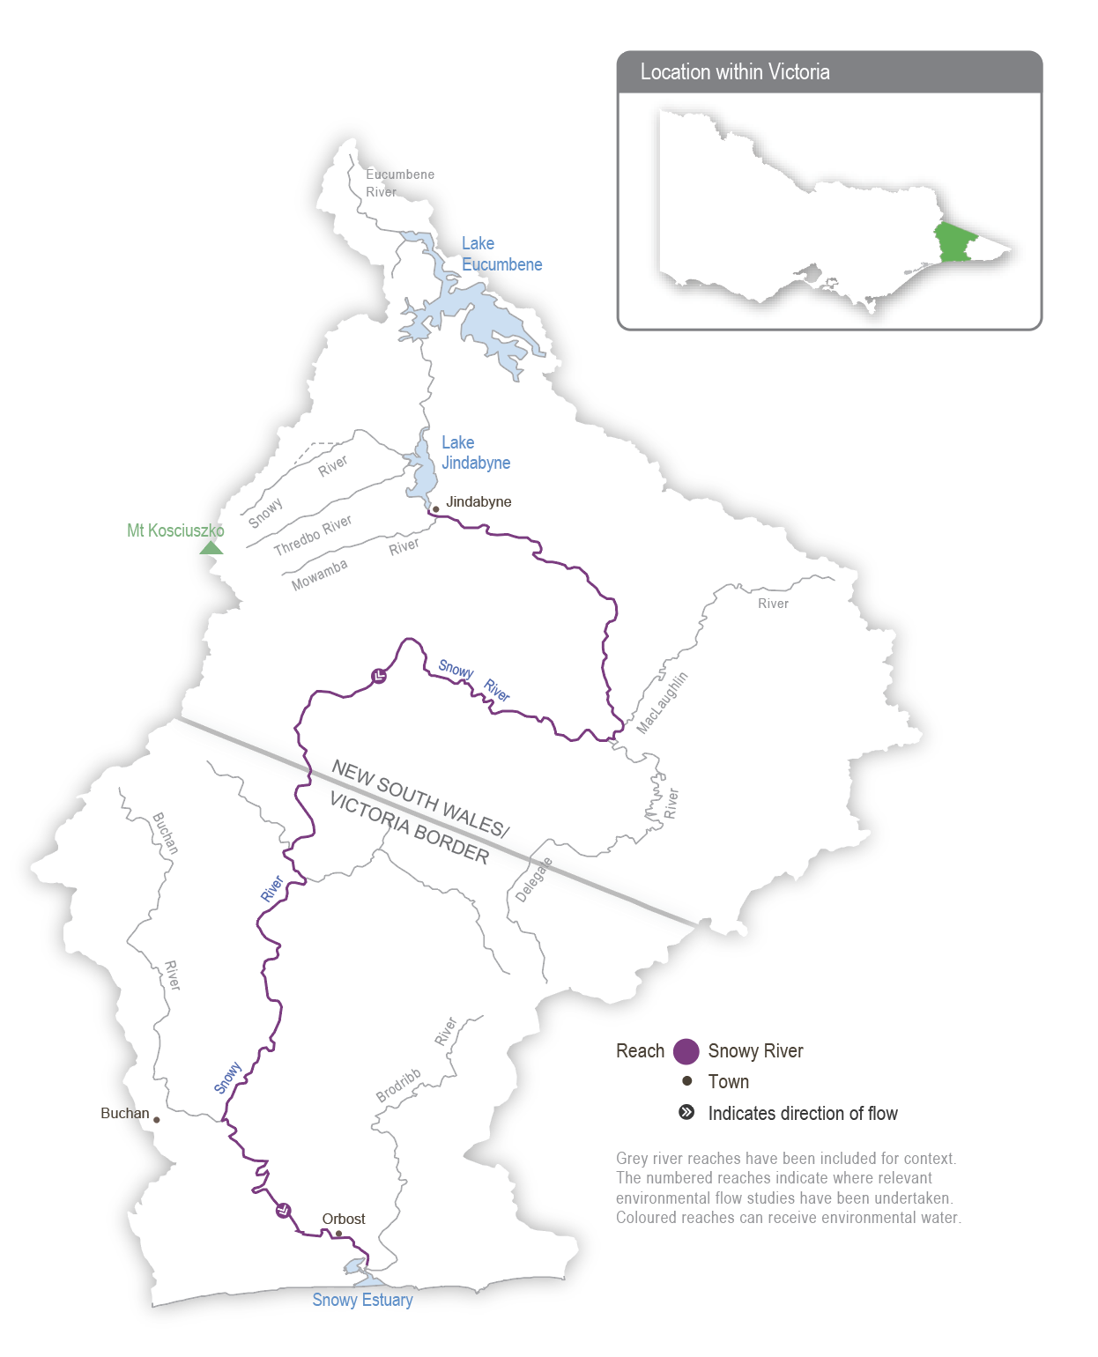

Environmental values
The upper reaches and tributaries of the Snowy River support water-dependent plants and animals, including freshwater native fish (such as river blackfish and Australian grayling), platypus and frogs. The lower reaches support estuary perch and Australian bass that move between saltwater and freshwater systems. The estuary contains estuarine and saltwater species (such as flathead and black bream). The floodplain wetlands of the Snowy River near Marlo provide feeding and breeding areas for wetland and migratory birds.

Traditional Owner cultural values and uses
Traditional Owners with links to the Snowy River system include the Ngarigo, Bidawal and Gunaikurnai peoples.
The river and its associated systems and lands have significant cultural values including as a functional and spiritual connective pathway. The Snowy River has enduring cultural importance as a place for the gathering of different Nations, ceremonies, access to food, fibre and other resources, stories, spirituality and songlines.
The Gunaikurnai Land and Waters Aboriginal Corporation (GLaWAC) holds Native Title, a recognition and settlement agreement under the Traditional Owner Settlement Act 2010 and Registered Aboriginal Party status under the Aboriginal Heritage Act 2006 in East Gippsland, including the lower Snowy River, associated with the Krauatungalung clan. This landscape was largely a transitionary landscape, with people migrating seasonally from the high country to the coast and back, depending on the availability of different food sources throughout the year. Many trade routes travel through freshwater river systems (such as the Snowy River system).
GLaWAC provided input to the draft Snowy River Estuary Flow Study.
GLaWAC will continue to take Gunaikurnai community members on Country around the Snowy River system to complete Aboriginal Waterway Assessments, building knowledge of what is important for the future and stories from the past.
Increasing the involvement of Traditional Owners in managing environmental flows and progressing opportunities towards self-determination in the environmental watering program is a core commitment of the VEWH and its program partners. This is reinforced by legislation and policy commitments, including the Water Act 1989, the Victorian Aboriginal Affairs Framework, the 2016 Water for Victoria, the 2022 Water is Life: Traditional Owner Access to Water Roadmap, and, in some cases, agreements under the Traditional Owner Settlement Act 2010.

Scope of environmental watering
The total volume available for release to the Snowy River in 2024-25 is 204,963 ML. Due to operating rules in the system, the daily flow regime that will be delivered in 2024-25 is pre-planned. The storage manager will make daily releases of varying volumes from Lake Jindabyne between May 2024 and April 2025 to mimic the typical flow patterns of a mixed snowmelt/rainfall river system characteristic of the Snowy Mountains. A ‘natural flow scaling’ approach is applied, and the continuous daily releases aim to support environmental processes in the Snowy River below Jindabyne Dam and maintain a healthy river that is much smaller than the natural channel that existed before the river was regulated.
The past four consecutive wet years mean there will be high water availability, which will allow for many high-flow releases in 2024-25. These freshes will help improve environmental conditions and build additional resilience into the system. The flow pattern is similar to previous years and mimics a snowmelt river, with greater flow during winter and spring. Five high-flow events exceeding 2,500 ML per day are scheduled between June and November 2024 to move sediment and improve in-stream habitat for native fish, platypus, frogs and waterbugs. The largest release, known as a ’flushing flow’, will occur in October 2024 if Lake Jindabyne is high enough to enable delivery through the required infrastructure. It has a target peak flow rate of at least 5,000 ML per day, which will be held for about eight hours to flush fine sediment and wet high benches and backwaters. Other peaks in the flow will mimic winter rainfall and spring snowmelt events. Moderate-to-high flow rates will be sustained from the end of May to December 2024 to mix water in the estuary to benefit plants and fish (such as Australian bass). Based on the recently completed Snowy River Estuary Flow Study recommendations, a trial of different flow rates will be conducted from January to April 2025, with planned releases of 150-200 ML per day aiming to prevent the estuary entrance from closing. Where possible, a flow with peaks exceeding 1,000 ML per day will also be provided between January to April 2025.
For further information, visit the Snowy and montane rivers | NSW Environment and Heritage website.

Section 3: Central region
3.1 Central region overview 89
3.2 Yarra system 99
3.3 Tarago system 112
3.4 Maribyrnong system 122
3.5 Werribee system 129
3.6 Moorabool system 141
3.7 Barwon system 155
3.7.1 Upper Barwon River 156
3.7.2 Lower Barwon wetlands 165

3.1 Central region overview
The systems in the central region that can receive water from the VEWH’s environmental entitlements are Birrarung (Yarra River) and Tarago River in the east and Weariby Yallok (Werribee River), Moorabool River, upper Barwon River and lower Barwon wetlands in the west. The VEWH does not hold an environmental entitlement in the Maribyrnong system, but in some years the VEWH purchases allocation to allow delivery of water for the environment in selected reaches of the Maribyrnong system.
Environmental values, objectives and planned actions for delivering water for the environment for each system in the central region are presented in the system sections that follow.

Traditional Owners in the central region
Traditional Owners in the central region have a deep connection to Country that has endured for tens of thousands of years. This includes inherent rights and cultural obligations to Country and community.
The Bunurong Land Council Aboriginal Corporation, Eastern Maar Aboriginal Corporation, Wadawurrung Traditional Owners Aboriginal Corporation and Wurundjeri Woi Wurrung Cultural Heritage Aboriginal Corporation are the Registered Aboriginal Parties (RAPs) under the Victorian Aboriginal Heritage Act 2006 for the areas incorporating waterways covered by this section of the seasonal watering plan.
The Eastern Maar Aboriginal Corporation holds Registered Aboriginal Party (RAP) status under the Victorian Aboriginal Heritage Act 2006 over a large portion of land in south-west Victoria. Eastern Maar gained formal recognition of their rights under the Commonwealth Native Title Act 1993 for over half of the RAP area and in March 2024, the Federal Court of Australia handed down a third native title determination. In relation to this seasonal watering plan, the Eastern Maar native title covers parts of the Barwon River catchment. The native title determinations acknowledge Eastern Maar’s ongoing connection and intrinsic relationship to Country in south-western Victoria.
Water from the Country of the Gunaikurnai Land and Waters Aboriginal Corporation (GLaWAC) and the Taungurung Land and Waters Council (TLaWC) can be diverted into the central region. GLaWAC is a RAP and native title holder within the central region geographic area and has a Recognition and Settlement Agreement with the Victorian Government. Gunaikurnai waterways managed with water for the environment are covered in the Gippsland region section of this seasonal watering plan. TLaWC is a RAP and has a Recognition and Settlement Agreement with the Victorian Government. Taungurung waterways managed with water for the environment are covered in the northern region section of this plan.
Traditional Owner objectives for water in the central region have been acknowledged in several strategies and plans recently, including the Rivers of the Barwon (Barre Warre Yulluk) Action Plan, the Waterways of the West Action Plan, the Yarra Strategic Plan (Burndap Birrarung burndap umarkoo), and the Central and Gippsland Region Sustainable Water Strategy.
The Victorian Government is committed to self-determination for Traditional Owners through Treaty negotiations and policies such as Water is Life: Traditional Owner Access to Water Roadmap 2022. The VEWH and its program partners are working with Traditional Owners to embed the outcomes of government policy in the Victorian environmental watering program. Program partners in the environmental watering program are aware that structural changes (such as legislative, policy and governance changes) to how water is managed may be made in the future in recognition of Aboriginal water rights. Program partners have heard that Traditional Owners want empowerment and agency in water management and, in many cases, want to manage water on Country on their own terms.

Engagement
Engagement with Traditional Owners, stakeholders and local communities informs the environmental watering program. Program partners undertake extensive engagement at the local level to understand community priorities for the delivery of water for the environment in the coming year.
Program partners also seek to understand how cultural, social, economic and recreational values, uses and objectives may be supported by delivering environmental flows. Opportunities to support these values, uses and objectives are incorporated into watering decisions where possible, provided they do not compromise environmental outcomes. The following system sections present cultural, social, economic and recreational values for each system in the central region.
Engagement, including through other strategies, plans and processes, also informs environmental objectives. These include regional catchment strategies, regional waterway strategies and technical studies such as environmental flows studies and environmental water management plans. Traditional Owner cultural objectives for environmental flows may refer to cultural flows studies, Aboriginal Waterway Assessments, Traditional Owner Country Plans and other tools. These strategies, plans and technical reports describe a range of environmental, economic, social and Traditional Owner perspectives and longer-term objectives that influence actions and priorities for water for the environment.
Table 3.1.1 Program partners and stakeholders that engaged with the Corangamite CMA to develop seasonal watering proposals and key documents informing the proposals for the Moorabool system, upper Barwon River and lower Barwon wetlands (in alphabetical order)
 | Moorabool system | Upper Barwon River | Lower Barwon wetlands
Community groups and environment groups | - Corangamite Waterwatch  - Geelong Landcare Network  - Moorabool Catchment Landcare Group  - People for A Living Moorabool | - Birregurra Landcare Group  - Environment Victoria  - Friends of the Barwon  - Geelong Field Naturalists Club  - Land and Water Resources Otway Catchment  - Otway Agroforestry Network Ltd  - Upper Barwon Landcare Network  - Winchelsea Land and Rivercare Group | - EstuaryWatch  - Friends of the Barwon  - Geelong Environment Council  - Geelong Field Naturalists Club
Government agencies | - Barwon Water  - Central Highlands Water  - Department of Energy, Environment and Climate Action  - Parks Victoria  - Southern Rural Water  - Victorian Environmental Water Holder | - Barwon Water  - Colac Otway Shire Council  - Department of Energy, Environment and Climate Action  - Southern Rural Water  - Victorian Environmental Water Holder | - Barwon Water  - City of Greater Geelong  - Department of Energy, Environment and Climate Action  - Parks Victoria  - Southern Rural Water  - Victorian Environmental Water Holder  - Victorian Fisheries Authority
Landholders/farmers | - Landholders on the Moorabool Stakeholder Advisory Committee | - Individual landholders | - Individual landholders
Local businesses | - Adelaide Brighton Cement |  | - Commercial eel fishers
Recreational users |  | - Individual users | - Field and Game Australia (Geelong Branch)  - Geelong Gun and Rod Association Inc.  - VRFish
Traditional Owners | - Wadawurrung Traditional Owners Aboriginal Corporation | - Wadawurrung Traditional Owners Aboriginal Corporation  - Eastern Maar Aboriginal Corporation | - Wadawurrung Traditional Owners Aboriginal Corporation
Table 3.1.2 Program partners and stakeholders that engaged with Melbourne Water to develop seasonal watering proposals and key documents informing the proposals for the Yarra, Tarago, Maribyrnong and Werribee systems (in alphabetical order)
 | Yarra system | Tarago system | Maribyrnong system | Werribee system
Community groups and environment groups | - Abbotsford Riverbankers  - Collingwood Children’s Farm  - Environment Victoria  - Friends of Yarra Flats Park  - Friends of Yarran Dheran Nature Reserve  - Independent community members  - Native Fish Australia  - Waterwatch Coordinators  - Warringal Conservation Society  - Yarra Riverkeeper | - Cardinia Environment Coalition  - Environment Victoria  - Friends of Mt Cannibal Flora and Fauna Reserve  - Friends of Robin Hood Reserve  - Bunyip Landcare  - Independent community members  - Native Fish Australia  - Waterwatch coordinators | - Environment Victoria  - Friends of Holden Flora Reserve  - Friends of the Maribyrnong Valley Inc.  - Independent community members  - Jacksons Creek EcoNetwork  - Friends of Steele Creek  - Maribyrnong River and Waterways Association  - Native Fish Australia  - Waterwatch Coordinators | - Ecolinc  - Environment Victoria  - Friends of Toolern Creek Reserve  - Friends of Werribee Gorge & Long Forest Mallee Inc.  - Independent community members  - Moorabool Environment Group/Platypus Alliance – Bacchus Marsh  - Native Fish Australia  - NatureWest  - Pinkerton Landcare and Environment Group  - Waterwatch Coordinator  - Werribee Riverkeeper  - Western Region Environment Centre
Government | - Banyule City Council  - City of Boroondara  - City of Melbourne  - City of Whittlesea  - Commissioner for Environmental Sustainability Victoria  - Department of Energy, Environment and Climate Action  - Environment Protection Authority Victoria  - First Peoples – State Relations  - Manningham City Council  - Melbourne Water (Service Delivery)  - Nillumbik Shire Council  - Parks Victoria  - Victorian Fisheries Authority  - Victorian Freshwater Fish Habitat & Flows Roundtable  - Yarra City Council  - Yarra Ranges Shire Council | - Baw Baw Shire Council  - Cardinia Shire Council  - Commissioner for Environmental Sustainability Victoria  - Department of Energy, Environment and Climate Action  - Environment Protection Authority Victoria  - First Peoples – State Relations  - Melbourne Water (Service Delivery)  - Parks Victoria  - Southern Rural Water  - Victorian Fisheries Authority  - Victorian Freshwater Fish Habitat & Flows Roundtable | - Commissioner for Environmental Sustainability Victoria  - Department of Energy, Environment and Climate Action  - Environment Protection Authority Victoria  - First Peoples – State Relations  - Greater Western Water  - Hume City Council  - Maribyrnong City Council  - Melbourne Water (Service Delivery)  - Moonee Valley City Council  - Parks Victoria  - Southern Rural Water  - Victorian Fisheries Authority | - Commissioner for Environmental Sustainability Victoria  - Department of Energy, Environment and Climate Action  - Environment Protection Authority Victoria  - First Peoples – State Relations  - Greater Western Water  - Melbourne Water (Service Delivery)  - Melton City Council  - Parks Victoria  - Southern Rural Water  - Victorian Fisheries Authority  - Wyndham City Council
Landholders/farmers | - Individual landholders  - Licensed diverters | - Individual landholders | - Licensed diverters from the Maribyrnong River at Keilor | - Individual landholders  - Zoos Victoria
Local businesses | - Doon Reserve Caravan Park  - East Coast Kayaking  - Melbourne Adventure Hub  - Sea Kayak Australia  - Warburton Holiday Park  - Warrior Spirit Adventures | - Glen Cromie Reserve | - Atlas Ecology Pty Ltd  - Blackbird Cruises | - Camp Sunnystones
Recreational users | - Kirinari Kayak Club  - Paddle Victoria  - Patterson Lakes Canoe Club  - Victorian Sea Kayak Club  - VRFish  - Whitehorse Canoe Club Inc. | - VRFish | - VRFish | - VRFish  - Werribee & District Anglers Club
Technical experts | - Aquatic Pollution Prevention Partnership  - Arthur Rylah Institute  - Australian Platypus Conservancy  - Cesar Australia  - Melbourne Water subject matter experts  - Research collaborators at Melbourne University | - Aquatic Pollution Prevention Partnership  - Arthur Rylah Institute  - Australian Platypus Conservancy  - Cesar Australia  - Melbourne Water subject matter experts  - Research collaborators at Melbourne University | - Aquatic Pollution Prevention Partnership  - Arthur Rylah Institute  - Australian Platypus Conservancy  - Cesar Australia  - Melbourne Water subject matter experts  - Research collaborators at Melbourne University | - Aquatic Pollution Prevention Partnership  - Arthur Rylah Institute  - Australian Platypus Conservancy  - Cesar Australia  - Melbourne Water subject matter experts  - Research collaborators at Melbourne University
Traditional Owners | - Gunaikurnai Land and Waters Aboriginal Corporation  - Taungurung Land and Waters Council Aboriginal Corporation  - Wurundjeri Woi Wurrung Cultural Heritage Aboriginal Corporation | - Bunurong Land Council Aboriginal Corporation  - Wurundjeri Woi Wurrung Cultural Heritage Aboriginal Corporation | - Bunurong Land Council Aboriginal Corporation  - Wurundjeri Woi Wurrung Cultural Heritage Aboriginal Corporation | - Bunurong Land Council Aboriginal Corporation  - Wadawurrung Traditional Owners Aboriginal Corporation  - Wurundjeri Woi Wurrung Cultural Heritage Aboriginal Corporation

Integrated catchment management
Altered water regimes are one of many threats to the health of Victoria’s waterways. Many of the environmental objectives of water for the environment in the central region are complemented by simultaneously addressing issues such as barriers to fish movement, high nutrient loads, loss of streambank vegetation and invasive species.
Victorian and Commonwealth government agencies, Traditional Owner groups, community groups and private landholders implement programs to protect and improve the environmental condition and function of land, soils and waterways throughout Victoria’s catchments.
Examples of complementary programs that support the outcomes of environmental flows in the central region include:
- works to protect and enhance streambanks along priority reaches, including willow removal, revegetation and fencing to exclude stock
- urban billabong restoration along the lower Yarra River using Western and Traditional Owner ecological knowledge
- an update to the Werribee Diversion Weir (proposed in the Central and Gippsland Regional Sustainable Water Strategy) to improve fish passage and delivery of environmental flows.
For more information about integrated catchment management programs in the central region, refer to the Corangamite CMA and Melbourne Water regional catchment strategies, the Melbourne Water Healthy Waterways Strategy and the Corangamite Waterway Strategy.

Risk management
When developing seasonal watering proposals for the Yarra, Tarago, Maribyrnong, Werribee, Moorabool and Barwon systems, environmental watering program partners assessed risks associated with potential environmental flows for 2024-25 and identified appropriate mitigating strategies. Risks and mitigating actions are continually assessed by program partners throughout the year (see subsection 1.2.7).

Seasonal outlook 2024-25
Total rainfall across the central region in 2023-24 was slightly below the long-term average but was highly variable between seasons. All systems had below-average rainfall between July and September 2023, with the Werribee, Moorabool and Barwon systems receiving their lowest September rainfall on record. October, December and January were all much wetter than average, but drier conditions returned in February 2024, and parts of the Barwon, Moorabool, Werribee and Maribyrnong systems experienced the lowest March rainfall on record. Wet conditions in previous years meant all storages across the central region were near-full. Tarago Reservoir spilled continuously from July 2023 to February 2024, and Melton Reservoir spilled from August to October and December to January. Lal Lal Reservoir peaked at 99.5 per cent in September 2023 but did not spill. The VEWH purchased water from licence holders in the Maribyrnong system to deliver environmental flows in Jacksons Creek.
The Bureau of Meteorology has forecast below-median rainfall and above-median temperatures during winter 2024 across the central region, but storage levels remain high, so all environmental entitlements are expected to receive close to full allocations in 2024-25. Forecast available supply in the Yarra, Tarago and Werribee systems should be sufficient to deliver the planned potential environmental watering actions in all climate scenarios to build on environmental outcomes achieved over recent wet years.
A near-full Rosslynne Reservoir will likely create an opportunity to purchase water to deliver environmental flows in the Maribyrnong system. However, outcomes in upper Jacksons Creek continue to be limited by infrastructure delivery constraints.
Options for delivering water for the environment in the Moorabool and Barwon systems in 2024-25 will be heavily influenced by local climatic conditions due to their smaller and more variable environmental allocations. Greater flows in the Moorabool and upper Barwon systems rely on significant contributions from local rainfall and are, therefore, only likely to be achieved in average or wet climatic conditions. Natural inflows will also have a significant bearing on the low flows and freshes in the Moorabool and upper Barwon systems, and summer and autumn flows may need to be delivered at the lower end of their recommended range to conserve available environmental supply if those seasons are dry. Delivery of water for the environment in the lower Barwon wetlands is not affected by annual allocations of water for the environment, and the proposed fill in winter/spring and partial drawdown in summer/autumn should be possible in all climate scenarios if river levels allow.

3.2 Yarra system
Waterway manager – Melbourne Water
Storage manager – Melbourne Water
Environmental water holder – Victorian Environmental Water Holder
The Yarra system includes Birrarung (Yarra River), the Plenty River and Yarra Billabongs.

System overview
Birrarung (Yarra River) flows west from the Yarra Ranges above Warburton through the Yarra Valley and then opens out into a wider plain as it meanders through the suburbs and city of Melbourne before entering Port Phillip Bay (Figure 3.2.1). Over time, the Yarra River below Warrandyte has been straightened, widened and cleared of fallen trees and other natural habitat features as Melbourne has developed.
Up to 400,000 ML per year (long-term average diversion limit) can be harvested from the Yarra system for consumptive use in Melbourne and surrounding areas. The Upper Yarra, O’Shannassy and Maroondah reservoirs harvest water from headwater tributaries, and a pump station at Yering Gorge is used to harvest water from the Yarra River to Sugarloaf Reservoir.
Tributaries, including Armstrong Creek, McMahons Creek, Starvation Creek, Woori Yallock Creek and the Watts and Little Yarra rivers, influence the flow in the upper reaches of the Yarra River. Urbanised tributaries (such as Olinda Creek, Mullum Mullum Creek, Diamond Creek, Plenty River and Merri Creek) provide additional water to the middle and lower reaches of the Yarra River.
Water for the environment can be released from the Upper Yarra, Maroondah and O’Shannassy reservoirs to support environmental processes and outcomes in downstream river reaches and wetlands. Requests can also be made to cease harvest from the Yarra River at the Yering Gorge Pumping Station, allowing the flow to pass down the whole river system. The priority Yarra River reaches for environmental watering are 2 and 5, shown in Figure 3.2.1. Reach 6 is also a priority in summer and autumn to manage poor water quality upstream of Dights Falls, as flow targets in reach 5 may not be sufficient. Water for the environment delivered to reaches 2 and 5 will help meet flow targets in other reaches. Occasionally, watering actions met naturally in reaches 2 and beyond are not achieved in reach 1 due to the lack of unregulated tributary inflows immediately downstream of Upper Yarra Reservoir. In those cases, water for the environment can be used to meet flow targets in reach 1.
The Plenty River rises from the slopes of Mount Disappointment in the Great Dividing Range about 50 km north of Melbourne. It flows downstream through rural and semi-rural areas and Plenty Gorge before joining the Yarra River near Viewbank, east of Banyule Flats Reserve. Yan Yean Reservoir is located off the waterway north of Plenty Gorge, and it receives a flow from Toorourrong Reservoir via a channel. The Plenty River has not received managed environmental flows before, but there may be opportunities to deliver water for the environment from Yan Yean Reservoir in the coming years.
Figure 3.2.1 The Yarra system
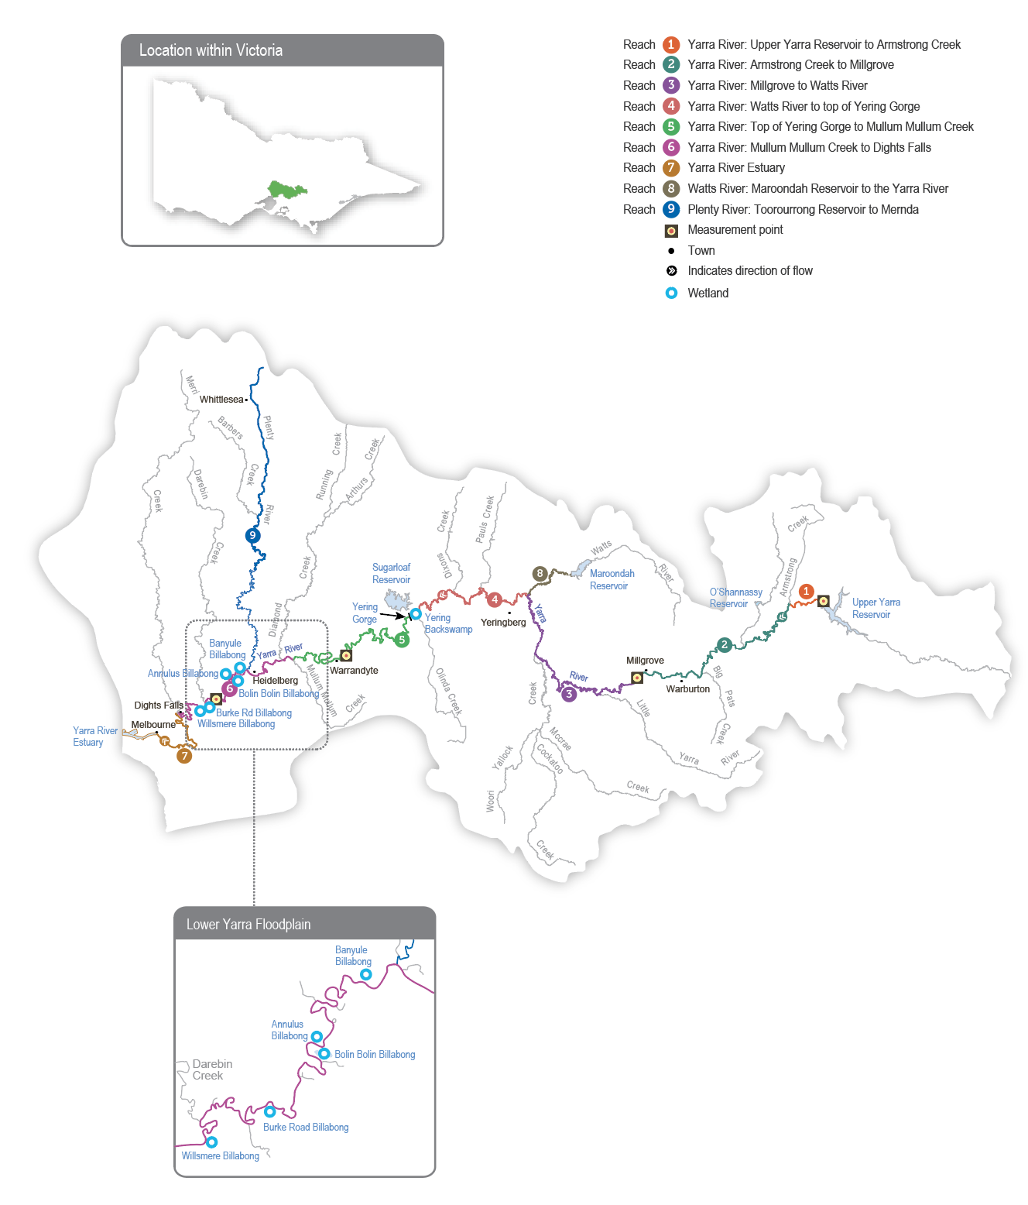

Environmental values
The upper reaches of the Yarra River (reaches 1-3) have good-quality streamside and aquatic vegetation and provide habitat for native fish species, including river blackfish, mountain galaxias and common galaxias. The middle and lower reaches of the Yarra River (reaches 4-6) flow through forested gorges, cleared floodplains and some highly urbanised areas, and they support the native fish population, including Australian grayling, river blackfish, Macquarie perch and tupong. Macquarie perch were introduced to the Yarra River last century, and its population is now considered one of Victoria’s largest and most important.
The Plenty River (reach 9) provides habitat for waterbugs and native fish species (such as common galaxias). Platypus have been detected in the Plenty River in the past, but none were recorded in recent surveys.
Billabongs are an important feature of the lower Yarra River floodplain between Heidelberg and Dights Falls and further upstream near Yarra Glen and Woori Yallock. The billabongs support distinct vegetation communities and provide foraging and breeding habitat for waterbirds and frogs. Except in times of high flow, most billabongs are disconnected from the Yarra River.
Environmental objectives in the Yarra system
A1 | Maintain the frog population, particularly on the mid-Yarra River floodplain
CN1 | Provide sufficient rates of carbon and nutrient production and processing to support native fish and waterbug communities
F1 | Protect and increase the native fish population, including threatened species (such as the Australian grayling, Macquarie perch and river blackfish)
G1 | Maintain the form of the river channel
G2 | Scour silt from riffles and clean cobbles
M1 | Maintain the diversity and increase the abundance of waterbugs to support aquatic food webs
PR1 | Maintain the resident platypus population
V1 | Maintain native streamside and aquatic vegetation on the riverbank and in the channels
V2 | Increase the growth of threatened wetland plant species to rehabilitate shallow marsh, deep marsh and freshwater meadows on the floodplain and billabongs
WQ1 | Improve water quality in river pools, ensuring adequate oxygen concentration in the water to support fish, crustaceans and waterbugs

Traditional Owner cultural values and uses
Melbourne Water is working with the Registered Aboriginal Parties (RAPs) within the Yarra River (Birrarung) system — the Wurundjeri Woi Wurrung Cultural Heritage Aboriginal Corporation and the Bunurong Land Council Aboriginal Corporation — as well as the Taungurung Land and Waters Council Aboriginal Corporation and Gunaikurnai Land and Waters Aboriginal Corporation, from whose Country water is diverted to the Birrarung system. The work is to develop and strengthen relationships and increase Traditional Owner involvement in the planning and delivery of water for the environment.
Melbourne Water is in discussions with each of the Traditional Owner corporations towards developing overarching partnership agreements, with formal partnership agreements already signed with Gunaikurnai Land and Waters Aboriginal Corporation (GLaWAC) and Wadawurrung Traditional Owners Aboriginal Corporation. A key priority within GLaWAC’s partnership agreement is how Melbourne Water could recognise Gunaikurnai water is leaving Country. In terms of environmental water management, the intent is for Traditional Owners of the Birrarung (Yarra River), and its tributaries, including the Plenty River, to be active partners in the planning, delivery and monitoring of all deliveries of water.
The part of the lower Birrarung floodplain included in the environmental watering program is on Wurundjeri Woi wurrung Country upstream of Chandler Highway. The parts of the lower Birrarung floodplain on Bunurong Country are not currently in the environmental watering program. Wallaby Creek on Taungurung Country is connected to the Plenty River catchment via Yan Yean Reservoir and is also not currently in the environmental watering program.
In 2021 Registered Aboriginal Party (RAP) determinations saw the lower Birrarung from just upstream of Moonee Ponds Creek to Port Phillip Bay included in the Bunurong Land Council Aboriginal Corporation’s RAP boundaries. The Bunurong Land Council Aboriginal Corporation is working with the Bunurong people to determine the cultural objectives for the Birrarung on Bunurong Country.
Where possible, Melbourne Water and the Wurundjeri Woi Wurrung Cultural Heritage Aboriginal Corporation work together to link water for the environment on the lower Birrarung floodplain with cultural outcomes for the Wurundjeri Woi wurrung people. Environmental water management on the lower Birrarung floodplain generally aligns with a landscape-scale approach for billabong watering, developed in consultation with the Wurundjeri Woi Wurrung Cultural Heritage Aboriginal Corporation.
The management of water for the environment (including wetting and drying) at many billabongs in lower Birrarung (such as Annulus, Banyule and Bolin Bolin billabongs) is closely aligned with Wurundjeri Woi wurrung aspirations.
Increasing the involvement of Traditional Owners in environmental water management and progressing opportunities towards self-determination in the environmental watering program is a core commitment of the VEWH and its program partners. This is reinforced by legislation and policy commitments, including the Victorian Water Act 1989, the Victorian Aboriginal Affairs Framework, Water for Victoria 2016, the Central and Gippsland Region Sustainable Water Strategy 2022, and Water is Life: Traditional Owner Access to Water Roadmap 2022.
Where Traditional Owners are more deeply involved in the planning and/or delivery of environmental water for a particular site, their contribution is acknowledged in Table 3.2.1 with an icon (as explained in Figure 1.2.3). The use of this icon is not intended to indicate that these activities are meeting all the needs of Traditional Owners but is used in the spirit of valuing that contribution.
 | Watering planned and/or delivered in partnership with Traditional Owners to support cultural values and uses
There are many places of tangible and intangible cultural significance for the Wurundjeri Woi wurrung people and the Bunurong people on the lower Birrarung floodplain.
A monitoring project continues at the billabongs with the Wurundjeri Woi Wurrung Cultural Heritage Aboriginal Corporation’s Narrap (‘Country’) Unit, the University of Melbourne and Melbourne Water. The group has been monitoring vegetation, birds, eels and water quality outcomes from environmental water and held an on-Country knowledge-sharing day in 2023 to discuss their learnings. Activities like these enable the Narrap Unit to build capacity to inform environmental water delivery to Wurundjeri Woi Wurrung Country.
The intent is to further the role and leadership of the Wurundjeri Woi wurrung people in managing the billabongs, including vegetation management, research and being partners in decision-making processes.
In 2024-25, filling Bolin Bolin Billabong in the average and wet scenarios will provide an exit strategy for eels that have entered the billabong while connected with the Yarra River (Birrarung). The Wurundjeri Woi Wurrung Cultural Heritage Aboriginal Corporation Water Unit suggested this watering action to support the landscape-scale approach to watering floodplain billabongs. The Narrap Unit will collaborate on Bolin Bolin billabong water delivery and monitoring, depending on the unit’s availability in 2024-25.

Social, recreational and economic values and uses
In planning the potential environmental watering actions in Table 3.2.1, Melbourne Water considered how environmental flows could support values and uses, including:
- water-based recreation (such as kayaking, canoeing, fishing and swimming)
- riverside recreation and amenity (such as birdwatching, camping, picnicking, cycling, running and walking)
- community events and tourism (such as the Moomba Festival and the Inflatable Regatta)
- socioeconomic benefits (such as for diverters for irrigation, stock needs and domestic use: water levels and water quality can rely on the delivery of water for the environment, particularly in summer).

Scope of environmental watering
The term ‘environmental watering’ refers to the active delivery of held environmental water to support particular environmental objectives by altering the flow in a river or water level in a wetland. While other terms are sometimes used to describe the delivery of environmental water, ‘environmental watering’ is deliberately used here and in seasonal watering statements to ensure consistency in the legal instruments that authorise the use of environmental water in Victoria.
Table 3.2.1 describes the potential environmental watering actions in 2024-25, their expected watering effect (that is, the intended physical or biological effects of the watering action) and the longer-term environmental objectives they support. Each environmental objective relies on one or more potential environmental watering actions and their associated physical or biological effects.
Table 3.2.1 Yarra system potential environmental watering actions, expected effects and environmental objectives
Potential environmental watering action | Expected watering effects | Environmental objectives
Yarra River – reach 1
Winter/spring high flow (one high flow for three days during June-September) reach 1: 300 ML/d | - Scour sediment and biofilm from gravel in riffles  - Provide prolonged wetting to favour flood-tolerant streamside native vegetation  - Draw in and transport organic material to support carbon cycling | CN1  V1  G2
Yarra River – reach 2 and 5
Winter/spring low flow (June to November) reach 2: 80-350 ML/day reach 5: 350-750 ML/day | - Physically mix pools to minimise the risk of stratification and low oxygen  - Maintain access to habitats for fish, waterbugs and platypus  - Wet bank vegetation to promote growth | F1  MI1  PR1  V1  WQ1
Winter/spring freshes (two freshes for three to seven days during June to September) reach 2: 700 ML/day reach 5: 1,300-2,500 ML/day | - Scour sediment and biofilm from gravel in riffles to improve spawning opportunities for Macquarie perch  - Wet native streamside vegetation on the banks of the river to promote growth  - Provide cues for upstream migration of juvenile migratory fish (e.g. Australian grayling and tupong) and spawning of Macquarie perch  - Draw in and transport organic material to support carbon cycling | CN1  F1  G2  V1
Spring high flow (one high flow for 14 days during September to October) reach 2: 700 ML/day reach 5: 2,500 ML/day | - Scour sediment and biofilm from gravel in riffles  - Provide prolonged wetting to favour flood-tolerant native vegetation in the streamside zone  - Provide cues for upstream migration of juvenile migratory fish (e.g. Australian grayling and tupong)  - Improve spawning opportunities of Macquarie perch  - Draw in and transport organic material to support carbon cycling | CN1  G2  F1  V1
Summer/autumn low flow (December to May) reach 2: 80 ML/day reach 5: 200 ML/day reach 6: 300-450 ML/day | - Physically mix pools to minimise the risk of stratification and low oxygen  - Maintain riffle and pool habitats for fish, waterbugs and platypus | F1  MI1  PR1  WQ1
Summer/autumn freshes (three freshes for two days during December to May) reach 2: 350 ML/day reach 5: 750 ML/day | - Flush pools to prevent a decline in water quality  - Scour sediment and biofilm from gravel in riffles and pools to maintain habitat quality for fish and waterbugs  - Provide opportunities for the localised movement of fish and platypus  - Wet the banks of the river to maintain flood-tolerant vegetation on the banks | F1  MI1  V1  G2  PR1  WQ1
Autumn high flow (one high flow for seven to 14 days during April to May) reach 2: 560 ML/day reach 5: 1,300 ML/day | - Cue the migration of Australian grayling  - Scour sediment and biofilm from gravel in riffles and pools to maintain habitat quality for fish and waterbugs | F1  G2
Yarra Billabongs
Bolin Bolin Billabong (fill in spring) | - Fill the wetland to full supply level to engage the inlet/outlet channel to the Yarra River as an exit strategy for eels  - Allow to draw down over summer and autumn to support the growth of threatened wetland plant species and encourage the regeneration of spreading aquatic herbs  - Maintain a permanent pool to provide habitat for frogs, waterbugs and any remaining eels  - Provide an exit for eels to return to the Yarra | A1  F1  MI1  V2
Yering Backswamp (fill in autumn/winter/spring) | - Wet the deepest parts of the wetland to about 80 cm to provide habitat for frogs  - Wet remaining areas of the wetland to about 40-60 cm to support the growth of threatened wetland plant species and encourage the regeneration of spreading aquatic herbs | A2  V2

Scenario planning
Table 3.2.2 outlines potential environmental watering and expected water use in various planning scenarios.
In the Yarra system, dry, average and wet planning scenarios are considered. A drought planning scenario for the Yarra has not been included as the actions would be almost identical to the dry planning scenario and because drought conditions don’t normally affect the allocation of water for the environment.
The Yarra system has received above-average inflows for each of the last four years, which has resulted in all planned environmental watering actions being met or exceeded. Recent monitoring and anecdotal observations indicate that the wetter conditions have supported Australian grayling recruitment. Recruits have been found in each of the last two years, the first confirmed records of recruitment since targeted monitoring began in 2018-19. The conditions have also helped increase the abundance of Macquarie perch and improved the health of vegetation communities within and surrounding billabongs. Environmental watering actions planned for 2024-25 aim to maintain and, where possible, enhance the environmental gains observed in recent years.

Yarra River
The environmental watering priority for the Yarra River in all planning scenarios is to deliver a low flow in the recommended range and small-to-medium freshes in reaches 2 and 5 throughout the year to maintain high-quality habitat for native fish, platypus and macroinvertebrates and flow variability in the lower parts of the channel to facilitate fish dispersal and water fringing vegetation. The extent to which the flow is likely to be met by natural tributary inflows varies in the dry, average and wet planning scenarios, and water for the environment will be used to fill the main deficits in each planning scenario, where possible.
In the average and wet planning scenarios, the autumn high flow is a high priority to trigger Australian grayling to migrate downstream to the estuary to spawn. Australian graylings live for about three to four years and require spawning opportunities in two out of every three years to sustain healthy populations. Delivering this flow is always a high priority in average and wet years and will ensure that spawning is cued to other appropriate conditions in the landscape. It is also a high priority in dry years if it hasn’t been delivered in the preceding one or two years. Although an autumn high flow has occurred in each of the last four years, Melbourne Water may still deliver one in 2024-25 in the dry planning scenario if there is sufficient supply or to piggyback on a natural event.
Lower-priority actions for the Yarra River in 2024-25 include the winter/spring high flow in reach 1, which may be delivered in any planning scenario and the spring high flow targeting reaches 2 and 5, which may be delivered in the average or wet planning scenarios. The winter/spring high flow in reach 1 is not required in 2024-25, given that the high flow in the last four years has mobilised sediments and prevented terrestrial vegetation from encroaching on the stream channel. The spring high flow for reaches 2 and 5 has the same magnitude as the winter/spring fresh in those reaches but has a longer recommended duration to drown out terrestrial vegetation growing on the banks and encourage the growth of flood-tolerant native plant species. Recent monitoring suggests that the spring high flow has a negligible effect on plants growing on the water’s edge and is, therefore, a lower priority to deliver in 2024-25. It may be delivered in average or wet conditions to further assess its effect with a view to potentially modifying the recommendation in future, but it will only be delivered if supply is available and suitable monitoring is in place.

Yarra Billabongs
Given recent wet conditions, all billabongs filled naturally in 2023-24, and most will be allowed to draw down naturally to provide foraging habitat for birds and other animals to support important dry-phase ecosystem processes. Watering of Yering Backswamp is a high priority in all planning scenarios in 2024-25. The distinct vegetation community at Yering Backswamp has adapted to frequent or near-permanent inundation at given times. As such, it is the only managed wetland on the Yarra floodplain that is actively watered every year. Filling of Bolin Bolin Billabong is identified as a high priority in the average and wet planning scenarios to allow short-finned eels that are currently in the billabong to move into the main river channel and migrate to the Coral Sea to spawn. Members of the Wurundjeri Woi Wurrung Cultural Heritage Aboriginal Corporation Water Unit suggested this watering action. Tagged eels and acoustic monitoring will help the Arthur Rylah Institute for Environmental Research determine the likelihood of eels being trapped when the billabong is disconnected from the river.
A carryover target of 11,000 ML has been set for the dry planning scenario to ensure sufficient supply in 2025-26 to deliver an autumn high flow if it isn’t delivered in 2024-25.
Table 3.2.2 Yarra system environmental watering planning scenarios
Planning scenario | Dry | Average | Wet
Expected conditions | - Low streamflow year-round  - Lack of unregulated freshes and high flow  - Passing flow is not likely to meet the minimum environmental flow recommendations  - Potential poor water quality, particularly in summer  - Pools may stratify | - Low-flow recommendations are likely to be met by passing flow  - Natural flow may provide some freshes, but its duration and/or magnitude will likely be less than the recommended environmental flow  - Potentially poor water quality, particularly in summer  - Pools may stratify  - Small reservoirs may spill  - Overbank flow is not likely, although some billabongs may engage in the lower reaches | - Low-flow recommendations are likely to be met by passing flow  - High, natural flow will occur, most likely in winter/spring  - Major spills from reservoirs may occur  - Most billabongs are likely to fill naturally
Expected availability of water for the environment | - 37,400 ML | - 37,400 ML | - 37,400 ML
Potential environmental watering – tier 1 (high priorities) | Tier 1a (can be achieved with predicted supply)
 | - Winter/spring low flow  - Winter/spring freshes (two freshes)  - Summer/autumn low flow  - Summer/autumn freshes (three freshes)  - Billabong watering (Yering Backswamp) | - Winter/spring low flow  - Winter/spring freshes (two freshes)  - Summer/autumn low flow  - Summer/autumn freshes (three freshes)  - Autumn high flow (one high flow)  - Billabong watering (Bolin Bolin Billabong and Yering Backswamp) | - Winter/spring low flow  - Winter/spring freshes (two freshes)  - Summer/autumn low flow  - Summer/autumn freshes (three freshes)  - Autumn high flow (one high flow)  - Billabong watering (Bolin Bolin Billabong and Yering Backswamp)
 | Tier 1b (supply deficit)
 | - Autumn high flow (one high flow)
Potential environmental watering – tier 2 (additional priorities) | - Winter/spring high flow (reach 1) | - Winter/spring high flow (reach 1)  - Spring high flow (one high flow) | - Winter/spring high flow (reach 1)  - Spring high flow (one high flow)
Possible volume of water for the environment required to achieve objectives | - 25,900 ML (tier 1a)  - 11,600 ML (tier 1b)  - 1,400 ML (tier 2) | - 20,550 ML (tier 1a)  - 0 ML (tier 1b)  - 8,400 ML (tier 2) | - 5,950 ML (tier 1a)  - 0 ML (tier 1b)  - 3,900 ML (tier 2)
Priority carryover requirements for 2025-26 | - 11,000 ML

3.3 Tarago system
Waterway manager – Melbourne Water
Storage manager – Melbourne Water
Environmental water holder – Victorian Environmental Water Holder

System overview
The Tarago River rises in the Tarago State Forest and flows into the Tarago Reservoir at Neerim (Figure 3.3.1). The reservoir harvests inflows from all upstream tributaries to supply towns on the Mornington Peninsula and around the Western Port area. Water is released from the reservoir to supply downstream irrigators. Below the reservoir, the Tarago River flows close to Rokeby before meeting the Bunyip River at Longwarry North. From there, the Bunyip River flows through a modified, straightened channel called Bunyip Main Drain that discharges into Western Port. The Bunyip Main Drain supplies many irrigators in the catchment.
Water available under the Tarago and Bunyip Rivers Environmental Entitlement 2009 is stored in and released from Tarago Reservoir. This water is primarily used to meet environmental objectives in reach 2, between the reservoir and the confluence of the Tarago and Bunyip rivers, as Figure 3.3.1 shows. Water for the environment delivered to reach 2 also supports environmental flow recommendations in reach 6 (Bunyip Main Drain).
Year-round passing flows in the Bunyip and Tarago rivers are stipulated under both the environmental entitlement and Melbourne Water’s bulk entitlement. These passing flows contribute toward meeting the minimum low-flow requirements in summer/autumn and winter/spring, but they are less than the recommended minimum flows. The passing flows do not provide any of the freshes or greater flows that are needed throughout the year to support environmental outcomes.
Water released to meet irrigation demands can create variable flow patterns in the Tarago and Bunyip rivers throughout the year. The magnitude and timing of these releases can influence environmental outcomes, and Melbourne Water continues to work with Southern Rural Water to optimise the shared value derived from irrigation releases.
Figure 3.3.1 The Tarago system
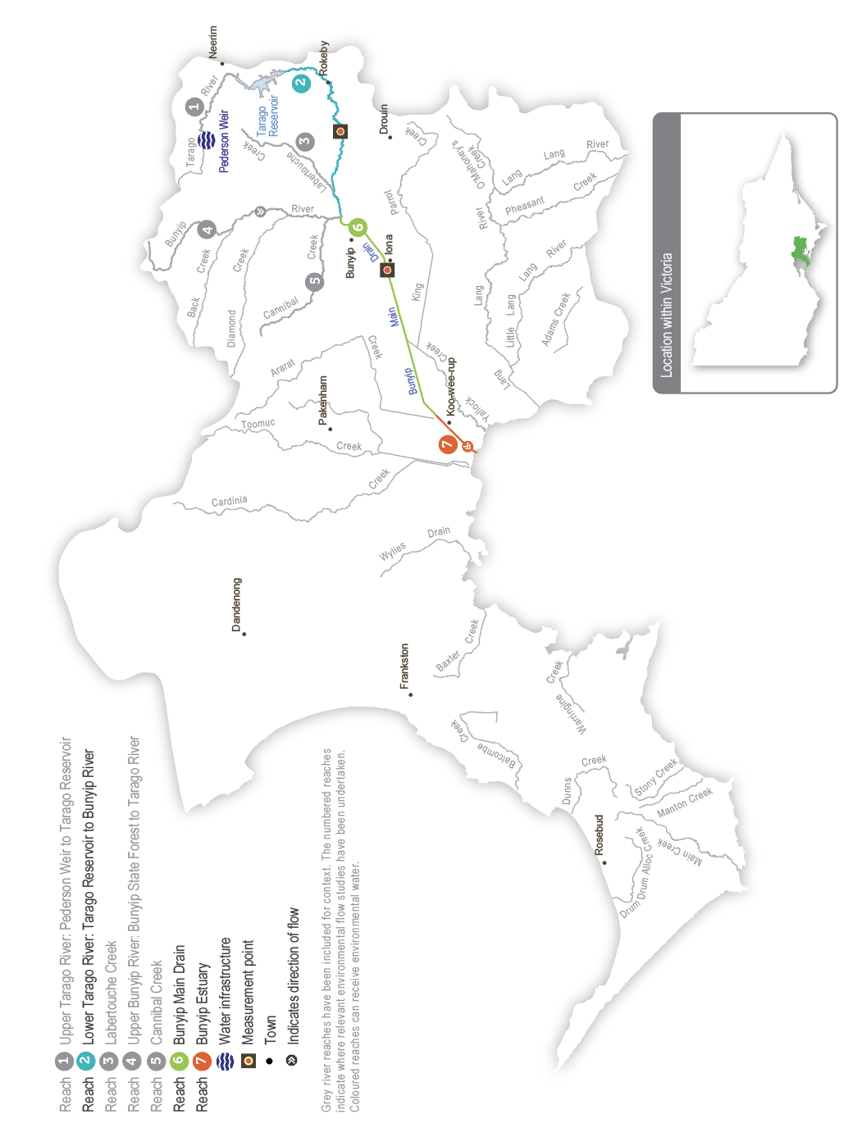

Environmental values
The Tarago system contains several significant and threatened native animal and plant species, including Australian grayling. The upper catchment (reach 2) has healthy streamside vegetation and diverse in-stream habitat that supports platypus and native fish, including river blackfish, tupong, short-finned eels and mountain galaxias. The lower catchment (reach 6) has been highly modified but still contains patches of remnant vegetation and is a key migration pathway for Australian grayling. It also has healthy platypus populations.
Environmental objectives in the Tarago system
F1 | Increase the native fish populations, including threatened species (such as Australian grayling)
G1 | Maintain channel form and structure
MI1 | Increase the diversity and biomass of waterbugs to support aquatic food webs
PR1 | Increase the platypus population
V1 | Increase native streamside and aquatic plant communities on the riverbank and in the channel
WQ1 | Improve water quality in river pools, ensuring adequate oxygen concentration in the water to support fish, crustaceans and waterbugs

Traditional Owner cultural values and uses
Melbourne Water is working with the Registered Aboriginal Party (RAP) within the Tarago system — the Bunurong Land Council Aboriginal Corporation — and other interested Traditional Owner groups to develop and strengthen relationships and increase Traditional Owner involvement in the planning and delivery of water for the environment.
Partnership agreements have been finalised between Melbourne Water and two RAPs within the Port Phillip and Westernport region framing relations and obligations between the organisations. Discussions with the Bunurong Land Council Aboriginal Corporation will determine whether a similar partnership agreement would benefit Bunurong. The intent is for Traditional Owners to be active partners in planning, delivering and monitoring water for the environment associated with the Tarago and Bunyip rivers.
There are more opportunities for Melbourne Water and the VEWH to work with Traditional Owner groups to identify and integrate cultural values and their flow requirements into the environmental watering program on an ongoing basis. During development of the seasonal watering proposal, Melbourne Water met with staff from Bunurong Land Council Aboriginal Corporation to discuss how environmental watering can support Traditional Owners’ cultural objectives and identify opportunities to use environmental water to support these. The Bunurong Land Council Aboriginal Corporation has expressed a desire to be more involved in environmental flow planning and management in the Tarago River.
Melbourne Water and the VEWH will continue to work with the Traditional Owner groups to identify and integrate cultural values and their flow requirements into the environmental watering program on an ongoing basis.
Increasing the involvement of Traditional Owners in managing environmental flows and progressing opportunities towards self-determination in the environmental watering program is a core commitment of the VEWH and its program partners. This is reinforced by legislation and policy commitments, including the Water Act 1989, the Victorian Aboriginal Affairs Framework, the 2016 Water for Victoria, the 2022 Water is Life: Traditional Owner Access to Water Roadmap, and, in some cases, agreements under the Traditional Owner Settlement Act 2010.

Social, recreational and economic values and uses
In planning the potential environmental watering actions in Table 3.3.1, Melbourne Water considered how environmental flows could support values and uses, including:
- water-based recreation (such as fishing and swimming)
- riverside recreation and amenity (such as cycling, camping, caravanning, short- and long-term visiting and walking)
- community events and tourism (such as visiting and residing in the Glen Cromie Reserve caravan park)
- socioeconomic benefits (such as for diverters for irrigation, stock needs and domestic use: water levels and water quality can rely on the delivery of water for the environment, particularly in summer).
Planned environmental flows may be modified to align with a community benefit so long as environmental outcomes are not compromised. Melbourne Water may time the release of a summer fresh in the Tarago River to coincide with long weekends in January or March, so visitors and residents of the Glen Cromie Reserve caravan park can enjoy the increased flow in the river. This would also benefit social and recreational uses along the many public areas on the river, which is acknowledged in Table 3.3.1 with an icon (as explained in Figure 1.2.3).
 | Watering planned to support peaks in visitation (e.g. camping or other public activities on long weekends or school holidays)

Scope of environmental watering
The term ‘environmental watering’ refers to the active delivery of held environmental water to support particular environmental objectives by altering the flow in a river or water level in a wetland. While other terms are sometimes used to describe the delivery of environmental water, ‘environmental watering’ is deliberately used here and in seasonal watering statements to ensure consistency in the legal instruments that authorise the use of environmental water in Victoria.
Table 3.3.1 describes the potential environmental watering actions in 2024-25, their expected watering effect (that is, the intended physical or biological effects of the watering action) and the longer-term environmental objectives they support. Each environmental objective relies on one or more potential environmental watering actions and their associated physical or biological effects.
Table 3.3.1 Tarago system potential environmental watering actions, expected effects and environmental objectives
Potential environmental watering action | Expected watering effects | Environmental objectives
Tarago River (targeting reach 2)
Winter/spring low flow (75 ML/day or natural during June to November) | - Prevent the encroachment of terrestrial vegetation in the channel  - Wet the banks to promote the growth of streamside vegetation  - Maintain an adequate depth through riffles to allow access to habitats for fish and platypus  - Mix pools to maintain water quality and increase habitat for fish and macroinvertebrates during wetter months | F1  MI1  PR1  V1
Winter/spring fresh(es) (one to two freshes with a peak of 100-200 ML/day for two days during June to September) | - Flush sediment and scour biofilm from stream substrate and large woody debris to maintain habitat for macroinvertebrates and fish, including river blackfish  - Create extra depth to allow greater fish movement between pools and reaches  - Cue the downstream migration of species, including eel and tupong  - Wet the banks and low benches to maintain the fringing aquatic vegetation | F1  MI1  V1
Spring high flow (one high flow with a peak of 200-300 ML/day for two days in a seven-to-10-day duration during September to October) | - Form and maintain scour holes around large wood  - Prevent the encroachment of terrestrial vegetation into the channel  - Cue the upstream migration of juvenile diadromous fish (e.g. Australian grayling) from the sea or estuary into the river  - Wet the higher benches to maintain the fringing aquatic vegetation and ensure vertical zonation of the fringing vegetation  - Encourage female platypus to select a nesting burrow higher up the bank to reduce the risk of greater flow later in the year flooding the burrow when juveniles are present | F1  G1  PR1  V1
Summer/autumn low flow (20 ML/day or natural during December to May) | - Maintain adequate depth through riffles to support waterbugs and allow access to habitats for fish and platypus  - Maintain adequate foraging habitat in pools for fish and platypus  - Maintain water quality (especially oxygen concentration) in pools | F1  MI1  PR1  WQ1
Summer/autumn freshes (three to five freshes of 75 ML/day for two days during December to May)   | - Flush fine silt from hard substrates and around large woody debris to maintain habitat for native fish in low‑flow periods  - Allow the localised movement of native fish  - Prevent terrestrial vegetation growth on sandbars  - Maintain water quality by aeration in times of low flow | F1  V1  WQ1
Autumn high flow (one high flow with a peak of 100 ML/day for two days in a minimum seven-day duration during April to May) | - Cue the downstream migration and spawning of diadromous fish (e.g. Australian grayling)  - Assist the dispersal of juvenile platypus | F1  PR1

Scenario planning
Table 3.3.2 outlines potential environmental watering and expected water use in a range of planning scenarios.
The Tarago River generally requires similar watering actions every year, but the volume of its low flow and the frequency of its high flow are less in the drought and dry planning scenarios than in the wet or average planning scenarios. Natural catchment inflows, passing flow and reservoir spills will meet many of the required watering actions and provide natural-flow variation throughout the year, especially in the wet planning scenario. Water for the environment will be used where possible to deliver critical flow components not met by other means. Melbourne Water will monitor water levels and water quality throughout the year and adjust releases as necessary to limit stress on existing plants and animals.
The drought planning scenario would be triggered by a combination of the Bureau of Meteorology’s reported El Niño status, below-average inflows to Tarago Reservoir and low streamflow projections. In the drought planning scenario, the passing flows and natural inflows are expected to meet the low-flow recommendation partially. Water for the environment will be used primarily in this planning scenario to deliver up to five summer/autumn freshes to regularly top up water levels and improve water quality to ensure native fish and platypus have adequate habitat and are not stressed for too long.
Passing flows and natural inflows are expected to meet a greater proportion of the recommended low flow in the dry, average and wet planning scenarios, and water for the environment will be used to deliver a combination of freshes and a high flow in those planning scenarios. Fewer summer/autumn freshes are planned in the dry planning scenario compared to the drought planning scenario because the low flow will be closer to the recommended level, and the available water supplies will be used to deliver a range of other flows throughout the year. Overall, the number of planned freshes and a high flow increases from the dry-to-wet planning scenarios to reflect natural hydrological conditions and to improve environmental outcomes by providing more food and better breeding opportunities for native fish and platypus.
An autumn high flow is needed to trigger Australian grayling movement and spawning. Australian graylings need favourable breeding conditions at least two of every three years to maintain and grow their population. Wet conditions have delivered a high autumn flow in the Tarago River in each of the last five years, so an additional flow is not essential in 2024-25. However, it will be delivered if the available supply can help consolidate the recent population increases. Winter/spring freshes are needed to cue and facilitate fish movement, including the downstream migration of tupong and eels, and to support the growth of new fringing vegetation. The dry planning scenario includes one winter/spring fresh to maintain the current condition of native fish populations and streamside vegetation, and the average and wet planning scenarios include extra freshes to enhance native fish and plant communities. The spring high flow may be delivered in the average and wet planning scenarios to water vegetation higher up the bank and cue the upstream migration of juvenile fish, including Australian grayling.
Seasonal inflows influence water supply in the Tarago system during the year, so carryover requirements vary significantly between planning scenarios. In the drought planning scenario, carrying over at least 400 ML at the end of 2024-25 will be important to ensure sufficient water for summer/autumn freshes in 2025-26. Carryover is a low priority in all other planning scenarios because allocations in 2025-26 will likely be sufficient to meet priority watering demands in that year.
Table 3.3.2 Tarago system environmental watering planning scenarios
Planning scenario | Drought¹ | Dry | Average | Wet
Expected conditions | - Very low streamflow  - Reduction in passing flow  - Increased surface water loss to groundwater  - Irrigation releases likely | - Low streamflow  - Some reduction in passing flow  - Increased surface water loss to groundwater  - Irrigation releases likely | - Average streamflow  - Partial freshes naturally provided  - Some irrigation releases likely | - Above-average streamflow  - Partial or full freshes naturally provided  - Irrigation releases unlikely  - Tarago Reservoir spills
Expected availability of water for the environment | - 3,000 ML | - 3,500 ML | - 3,500 ML | - 3,000 ML
Tarago River (targeting reach 2)
Potential environmental watering – tier 1 (high priorities) | Tier 1a (can be achieved with predicted supply)
 | - Summer/autumn low flow  - Summer/autumn freshes (five freshes) | - Winter/spring low flow (partial compliance)  - Winter/spring fresh (one fresh)  - Summer/autumn low flow  - Summer/autumn freshes (three freshes)  - Autumn high flow | - Winter/spring low flow (partial compliance)  - Winter/spring freshes (two freshes)  - Spring high flow  - Summer/autumn low flow  - Summer/autumn freshes (five freshes)  - Autumn high flow | - Winter/spring low flow  - Winter/spring freshes (two freshes)  - Spring high flow  - Summer/autumn low flow  - Summer/autumn freshes (five freshes)  - Autumn high flow
 | Tier 1b (supply deficit)
 | - Winter/spring low flow | - Winter/spring low flow | - Winter/spring low flow
Potential environmental watering – tier 2 (additional priorities) | - Winter/spring fresh (one fresh)  - Spring high flow  - Autumn high flow | - Spring high flow | - N/A | - N/A
Possible volume of water for the environment required to achieve objectives | - 3,000 ML (tier 1a)  - 4,350 ML (tier 1b)  - 1,550 ML (tier 2) | - 3,000 ML (tier 1a)  - 2,835 ML (tier 1b)  - 550 ML (tier 2) | - 3,500 ML (tier 1a)  - 515 ML (tier 1b)  - 0 ML (tier 2) | - 1,885 ML (tier 1a)  - 0 ML (tier 1b)  - 0 ML (tier 2)
Priority carryover requirements for 2025-26 | - 400 ML | - 0 ML | - 0 ML | - 0 ML
1 The drought planning scenario was first added for 2023-24 to demonstrate target actions in conditions where the recommended watering actions for the dry planning scenario could not be met due to further reduced streamflow.

3.4 Maribyrnong system
Waterway manager – Melbourne Water
Storage manager – Southern Rural Water
Environmental water holder – Not applicable

System overview
The Maribyrnong catchment is located to the northwest of Melbourne. The main waterways in the catchment are Jacksons Creek, which flows southeast from Mount Macedon, and Deep Creek, which flows south from Lancefield (Figure 3.4.1). These tributaries join at Keilor North to form Mirrangbamurn (Maribyrnong River), which flows south to join Birrarung (Yarra River) at Yarraville before flowing into Port Phillip Bay.
Rosslynne Reservoir is in the upper reaches of Jacksons Creek near Gisborne and is the only major storage in the Maribyrnong catchment. The reservoir has a maximum release capacity of 20 ML per day in ideal conditions, which significantly constrains the environmental outcomes that can be achieved in the Maribyrnong system. Water for the environment is primarily used to support environmental outcomes in Jacksons Creek between Rosslynne Reservoir and the confluence with Riddles Creek (that is, delivery of water for the environment to reach 6, as shown in Figure 3.4.1). Jacksons Creek is a known groundwater-dependent ecosystem on the national Groundwater Dependent Ecosystems Atlas and a priority groundwater-dependent ecosystem in the Melbourne Water groundwater-dependent ecosystem program. This means environmental components in the system rely on groundwater at least some of the time.
The VEWH does not hold an environmental entitlement in the Maribyrnong system, and it relies on opportunistic, temporary trade to meet demands. Melbourne Water (as diversion manager) and the VEWH work with local diversion licence holders to purchase unused water when it is available to support environmental outcomes. This arrangement is negotiated each year, is subject to water availability in the bulk entitlement and storage capacity, and only occurs with all parties’ agreement.
Figure 3.4.1 The Maribyrnong system
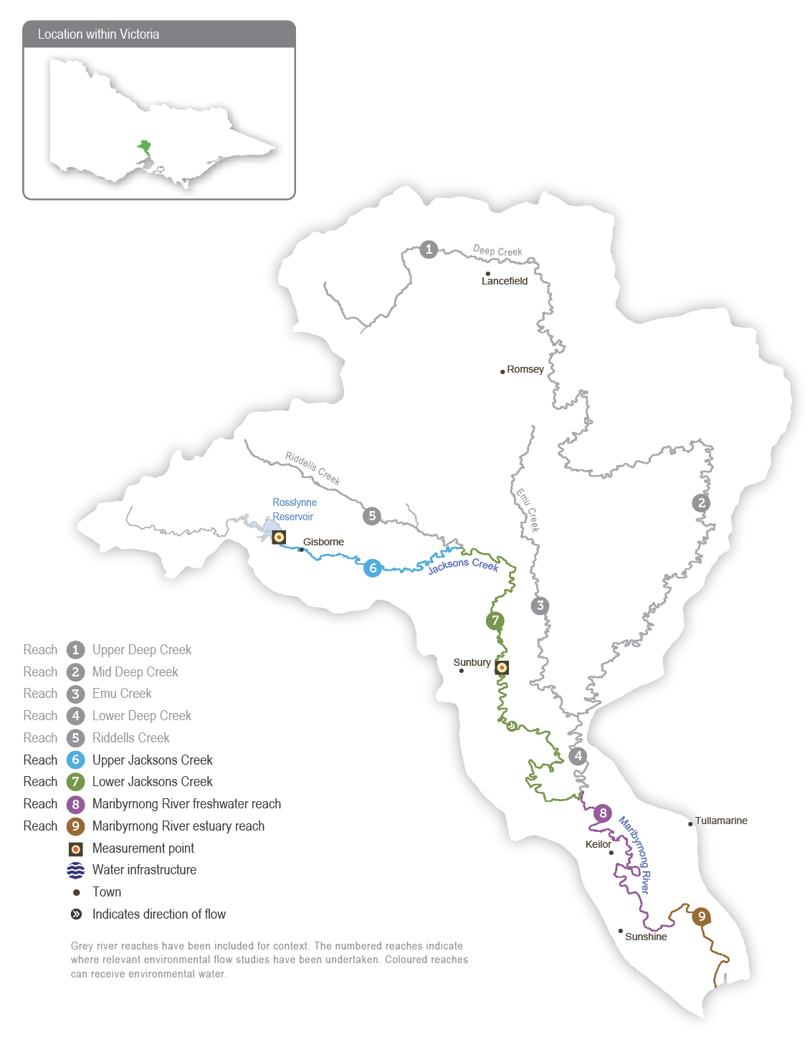

Environmental values
The upper Maribyrnong catchment contains areas of intact streamside vegetation, which provide important habitat for native fish, including migratory short-finned eels, common and ornate galaxias, flathead gudgeon, tupong and Australian smelt.
A diverse and abundant waterbug community provides food for a significant platypus population in several reaches of the Maribyrnong system.
Environmental objectives in the Maribyrnong system
F1 | Protect the native small-bodied fish population
MI1 | Support a wide range and high biomass of waterbugs to break down dead organic matter and support the river’s food chain
PR1 | Protect the platypus population
V1 | Maintain the condition, abundance, diversity and structure of in-stream and streamside vegetation
WQ1 | Maintain water quality, particularly oxygen concentrations

Traditional Owner values and uses
Melbourne Water is working with the Registered Aboriginal Parties (RAPs) within the Maribyrnong system — the Wurundjeri Woi Wurrung Cultural Heritage Aboriginal Corporation and the Bunurong Land Council Aboriginal Corporation — to strengthen relationships and increase Traditional Owner involvement in the planning and delivery of water for the environment.
There are many opportunities for Melbourne Water and the VEWH to work with Traditional Owner groups to identify and integrate cultural values and their flow requirements into the environmental watering program on an ongoing basis.
When developing its seasonal watering proposal, Melbourne Water met with both the Wurundjeri Woi Wurring Cultural Heritage Aboriginal Corporation and Bunurong Land Council Aboriginal Corporation to discuss how environmental watering may support Traditional Owner cultural objectives and to identify opportunities. Due to the uncertainty about the volume of water that will be able to be secured via temporary trade in 2024-25 and the constraints in delivering environmental flows from Rosslynne Reservoir, there are currently limited opportunities to deliver water for the environment to support Traditional Owners to achieve objectives for water on Country.
Increasing the involvement of Traditional Owners in managing environmental flows and progressing opportunities towards self-determination in the environmental watering program is a core commitment of the VEWH and its program partners. This is reinforced by legislation and policy commitments, including the Water Act 1989, the Victorian Aboriginal Affairs Framework, the 2016 Water for Victoria, the 2022 Water is Life: Traditional Owner Access to Water Roadmap, and, in some cases, agreements under the Traditional Owner Settlement Act 2010.

Social, recreational and economic values and uses
In planning the potential environmental watering actions in Table 3.4.1, Melbourne Water considered how environmental water could support social values (such as community connection and amenity) by planning flows that will maintain healthy habitat and improve water quality.
Opportunities for enhancing shared social, recreational and economic benefits through modification of environmental water deliveries are highly constrained by the volume of environmental water available and the outlet of Rosslynne Reservoir. Despite this, summer/autumn fresh releases may be made to coincide with public holiday long weekends (January 26 public holiday) when there are high levels of visitation at parks along Jacksons Creek at Gisborne and Sunbury. Increased flows will target delivery of shared benefits over these periods by improving amenity for park users and visitors to the waterway.
Planned environmental flows may be modified to align with a community benefit so long as environmental outcomes are not compromised.
The possibility of achieving shared benefits over the January 26 public holiday period is acknowledged in Table 3.4.1 with an icon (as explained in Figure 1.2.3).
 | Watering planned to support peaks in visitation (e.g. camping or other public activities on long weekends or school holidays)

Scope of environmental watering
The term ‘environmental watering’ refers to the active delivery of held environmental water to support particular environmental objectives by altering the flow in a river or water level in a wetland. While other terms are sometimes used to describe the delivery of environmental water, ‘environmental watering’ is deliberately used here and in seasonal watering statements to ensure consistency in the legal instruments that authorise the use of environmental water in Victoria.
Table 3.4.1 describes the potential environmental watering actions in 2024-25, their expected watering effect (that is, the intended physical or biological effects of the watering action) and the longer-term environmental objectives they support. Each environmental objective relies on one or more potential environmental watering actions and their associated physical or biological effects.
Table 3.4.1 Maribyrnong system potential environmental watering actions, expected effects and environmental objectives
Potential environmental watering action | Expected watering effects | Environmental objectives
Jacksons Creek (targeting reach 6)
Winter/spring low flow (15 ML/day during June to November) | - Maintain depth in pools and riffles to provide habitat for small-bodied native fish, platypus and waterbugs  - Prevent terrestrial vegetation encroachment | F1  MI1  PR1  V1
Summer/autumn low flow (4-6 ML/day during December to May) | - Maintain the availability of pool habitat for small-bodied fish and platypus during low-flow periods  - Maintain a > 0.1 m median depth over riffles to provide macroinvertebrate habitat and inundate in-stream vegetation  - Maintain continuous flow to limit pool stratification and maintain water quality | F1  MI1  PR1  V1  WQ1
Summer/autumn freshes (five freshes of 15 ML/day for four days every four to six weeks during December to May)   | - Increase depth over riffles to provide local movement of small-bodied native fish and platypus during the low-flow period  - Maintain habitat and food resources for waterbugs  - Flush pools to maintain water quality | F1  MI1  PR1  WQ1

Scenario planning
Table 3.4.2 outlines potential environmental watering and expected water use in a range of planning scenarios.
There is no permanent environmental entitlement in the Maribyrnong system, so water for the environment can only be delivered in 2024-25 if other entitlement holders are willing to sell some of their annual allocations to the VEWH.
An adequate low flow throughout the year and summer/autumn freshes are a high priority in all planning scenarios to maintain habitat for native fish and platypus and to prevent poor water quality. In the average and wet planning scenarios, local catchment run-off, tributary inflows and groundwater contributions will likely meet and exceed these requirements in lower Jacksons Creek (reach 7). However, in all planning scenarios, the mandated passing flow and water for the environment will be needed to achieve these watering actions in upper Jacksons Creek (reach 6).
The VEWH cannot carry over water in the Maribyrnong system to support multi-year planning.
Table 3.4.2 Maribyrnong system environmental watering planning scenarios
Planning scenario | Dry | Average | Wet
Expected river conditions | - Low volumes of unregulated flow  - Passing flow may meet some low-flow objectives  - Some baseflow from groundwater contributions in Jacksons Creek | - Unregulated flow meets some objectives  - Passing flow may meet several low-flow objectives  - Groundwater contributions provide baseflow in Jacksons Creek | - Unregulated flow meets most objectives  - Passing flow may meet most low-flow objectives  - Groundwater contributions provide baseflow in Jacksons Creek
Expected availability of water for the environment | - There is no environmental entitlement in the Maribyrnong system. Water will need to be traded with willing irrigators to support watering actions.
Jacksons Creek (targeting reach 6)
Potential environmental watering – tier 1 (high priorities) | Tier 1a (can be achieved with predicted supply)
 | N/A
 | Tier 1b (supply deficit)
 | - Winter/spring low flow  - Summer/autumn low flow  - Summer/autumn freshes (five freshes) | - Winter/spring low flow  - Summer/autumn low flow  - Summer/autumn freshes (five freshes) | - Winter/spring low flow  - Summer/autumn low flow  - Summer/autumn freshes (five freshes)
Possible volume of water for the environment required to achieve objectives | - 0 ML (tier 1a)  - 2,400 ML (tier 1b) | - 0 ML (tier 1a)  - 2,400 ML (tier 1b) | - 0 ML (tier 1a)  - 2,400 ML (tier 1b)

3.5 Werribee system
Waterway manager – Melbourne Water
Storage manager – Southern Rural Water
Environmental water holder – Victorian Environmental Water Holder

System overview
The Werribee River flows southeast from the Wombat State Forest near Ballan, through the Werribee Gorge to Bacchus Marsh and into Port Phillip Bay at Werribee (Figure 3.5.1). The Lerderderg River is a major tributary that joins the river at Bacchus Marsh. The main storages in the Werribee system are Pykes Creek Reservoir, Melton Reservoir and Merrimu Reservoir.
The four reaches in the Werribee system that can receive water for the environment are Pyrites Creek between Lake Merrimu and Melton Reservoir (reach 6), the Werribee River between Melton Reservoir and the Werribee Diversion Weir (reach 8), Werribee River between the Werribee Diversion Weir and Werribee Park Tourism Precinct (reach 9) and the Werribee River estuary below the Werribee Park Tourism Precinct.
Environmental flows that target environmental objectives in reach 9 and the estuary are delivered from Melton Reservoir and therefore also benefit reach 8. Water for the environment released from Lake Merrimu is re-harvested in Melton Reservoir, where it can be held and released at an appropriate time to achieve environmental objectives in the lower Werribee River.
Figure 3.5.1 The Werribee system
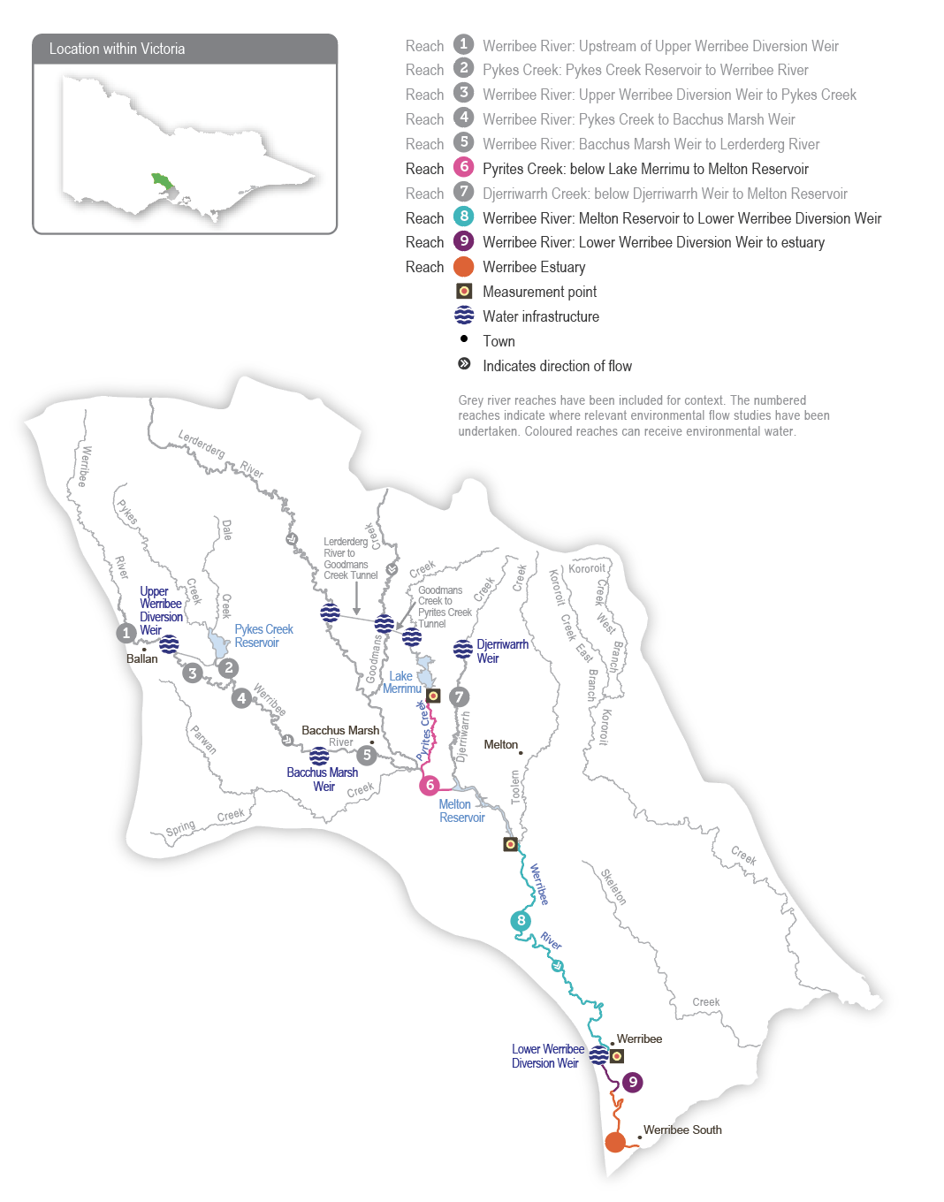

Environmental values
The Werribee system supports a range of native fish, including Australian grayling, river blackfish, flathead gudgeon, short-finned eel, tupong, Australian smelt, several species of galaxiids and a large black bream population in the estuary. Several species of frogs, a diverse waterbug community and platypus inhabit the upper and lower reaches. The freshwater-saltwater interface of the Werribee River estuary is a regionally significant ecosystem due to the many aquatic plants and animals it supports, and it provides a nursery habitat for juvenile freshwater and estuarine fish species (such as black bream).
Environmental objectives in the Werribee system
A1 | Maintain the native frog population
F1 | Protect and increase the native freshwater fish population, including galaxiids, Australian grayling and tupong
F2 | Protect and support the black bream population in the estuary
G1 | Maintain channel beds and pool habitats
G2 | Maintain clean substrate surfaces to support biological processes
MI1 | Maintain and enhance the waterbug population to help break down dead organic matter and support the river’s food chain
PR1 | Maintain the platypus population
V1 | Maintain the health and increase the cover of in-stream, streamside and estuary plants
V2 | Limit the spread of terrestrial plants and promote the recruitment of native water-dependent plant species on the banks and benches of waterways
WQ1 | Maintain oxygen and salinity levels in pools

Traditional Owner cultural values and uses
Melbourne Water is working with the Registered Aboriginal Parties (RAPs) within the Werribee system — the Wadawurrung Traditional Owners Aboriginal Corporation (WTOAC), the Wurundjeri Woi Wurrung Cultural Heritage Aboriginal Corporation and the Bunurong Land Council Aboriginal Corporation — to strengthen relationships and increase Traditional Owners’ involvement in the planning and delivery of water for the environment.
A partnership agreement is in place between Melbourne Water and Wadawurrung Traditional Owners Aboriginal Corporation to frame relations and obligations between the organisations. Melbourne Water is also is in discussions with Wurundjeri Woi Wurrung Cultural Heritage Aboriginal Corporation and the Bunurong Land Council Aboriginal Corporation to work towards developing similar partnership agreements. The intent is for Traditional Owners to be active partners in planning, delivering and monitoring deliveries of water for the environment associated with the Werribee River.
The Bunurong Land Council Aboriginal Corporation is working with the Bunurong people to determine the cultural objectives for Werribee River — Weariby Yallok in Bunurong language — on Bunurong Country. There are concerns about the low flow in the lower reaches and that fish of cultural importance to the Bunurong are not supported by the flow and are restricted in movement. This concern may be partially addressed through the implementation of Action 8-10 in the Central and Gippsland Region Sustainable Water Strategy, which aims to improve fish passage and the delivery of water for the environment to the lower Werribee River on Bunurong Country.
The Wadawurrung Traditional Owners Aboriginal Corporation has reviewed the environmental values of the Werribee River system. It has identified environmental values that have cultural significance to Wadawurrung Traditional Owners, which the table below shows. Further work is required to understand how potential environmental watering actions can support these cultural values.
Table 3.5.1 Wadawurrung cultural values and uses, Werribee River system
Reach | Extent | Key environmental values with cultural significance to the Wadawurrung
8 | Werribee River | F1, PR1
9 | Werribee River between Wyndham Vale and Bluestone Ford | F1, V1, F1
Estuary | Werribee River downstream of Bluestone Ford | F1, V1
WTOAC has been working with waterway managers through the development of seasonal watering proposals, to improve outcomes on Country in line with the Paleert Tjaara Dja Wadawurrung Country Plan and the Wadawurrung Nationa Statement on water:
‘Wadawurrung Yaluks and waterway ecosystems flowing freely and are healthy’.
Increasing the involvement of Traditional Owners in managing environmental flows and progressing opportunities towards self-determination in the environmental watering program is a core commitment of the VEWH and its program partners. This is reinforced by legislation and policy commitments, including the Water Act 1989, the Victorian Aboriginal Affairs Framework, the 2016 Water for Victoria, the 2022 Water is Life: Traditional Owner Access to Water Roadmap, and, in some cases, agreements under the Traditional Owner Settlement Act 2010.

Social, recreational and economic values and uses
In planning the potential environmental watering actions in Table 3.5.2, Melbourne Water considered how environmental flows could support values and uses, including:
- water-based recreation (such as canoeing, fishing, kayaking and swimming)
- riverside recreation and amenity from urban cooling (such as camping, walking, cycling and picnicking)
- community events and tourism (such as Werribee Zoo).
- timing of environmental releases to avoid the dispersal of blue-green algae to the lower Werribee River, a valued recreation area.

Scope of environmental watering
The term ‘environmental watering’ refers to the active delivery of held environmental water to support particular environmental objectives by altering the flow in a river or water level in a wetland. While other terms are sometimes used to describe the delivery of environmental water, ‘environmental watering’ is deliberately used here and in seasonal watering statements to ensure consistency in the legal instruments that authorise the use of environmental water in Victoria.
Table 3.5.2 describes the potential environmental watering actions in 2024-25, their expected watering effect (that is, the intended physical or biological effects of the watering action) and the longer-term environmental objectives they support. Each environmental objective relies on one or more potential environmental watering actions and their associated physical or biological effects.
Table 3.5.2 Werribee system potential environmental watering actions, expected effects and environmental objectives
Potential environmental watering action | Expected effects | Environmental objectives
Pyrites Creek (targeting reach 6)
Winter/spring/summer low flow (2 ML/day or natural during June to December) | - Provide sufficient water depth in riffle habitats for macroinvertebrates and native fish  - Maintain habitat for frogs at the margin of the stream channel  - Provide sufficient water depth to support the growth of flood-tolerant vegetation and limit the growth of terrestrial vegetation within the stream channel  - Provide sufficient water depth to allow for native fish to move between pools | A1  F1  MI1  V1  V2
Winter/spring freshes (three to five freshes of 30-40 ML/day for two days during June to November) | - Drown terrestrial plants that encroach into the waterway  - Increase the growth and recruitment of streamside and in-stream vegetation  - Transport carbon to drive aquatic food webs  - Scour silt, biofilms and algae from substrates to maintain the quality and quantity of food and habitat for waterbugs  - Improve water quality and the quantity of food and habitat for waterbugs, frogs and native fish  - Wet depressions adjacent to the stream that frogs can use for breeding | A1  F1  G2  MI1  V1  V2  WQ1
Spring high flow (one high flow of 70-130 ML/day for one to two days during September to October) | - Maintain access to food and habitat for waterbugs, native fish and frogs  - Increase the growth and recruitment of streamside vegetation  - At 130 ML/day, the effects above plus:  - Inundate the full width of the channel and high backwaters to flush accumulated organic matter and promote the growth and recruitment of streamside vegetation | A1  F1  MI1  V1
Werribee River (targeting reaches 8, 9 and estuary)
Winter/spring low flow (80 ML/day during June to November) | - Provide sufficient depth to allow fish to move upstream past natural and artificial barriers  - Facilitate the downstream movement of diadromous fish to the estuary  - Drown terrestrial plant species and support the growth and recruitment of water-dependent streamside vegetation  - Maintain permanent pools and increase the extent of habitat for waterbugs, fish, platypus and frogs  - Maintain flow through pool habitats to allow mixing or suppression/dilution of saline groundwater | A1  F1  F2  MI1  PR1  V1  V2  WQ1
Winter/spring freshes (two to four freshes of 350 ML/day for three days during June to October) | - Support the growth and recruitment of water-dependent streamside vegetation  - Flush silt and scour biofilms and algae from substrates on the stream bed and maintain pools and channel dimensions  - Provide movement cues and enough flow for fish to move upstream past natural and artificial barriers  - Maintain water quality and quantity of food and habitat for waterbugs and platypus  - Wet depressions adjacent to the stream that frogs can use for breeding | A1  F1  F2  G1  G2  MI1  PR1  V1  V2  WQ1
Summer/autumn low flow (10 ML/day during December to May) | - Maintain habitat for in-stream and water-dependent streamside vegetation  - Maintain access to habitat and improve water quality for native fish, frogs, platypus and waterbugs  - Maintain flow through pool habitats to allow mixing or suppression/dilution of saline groundwater intrusion | A1  F1  F2  MI1  PR1  V1  WQ1
Summer/autumn freshes (three to five freshes of 135-215 ML/day for one to two days during December to May) | - Increase the growth and recruitment of water-dependent streamside vegetation  - Flush silt and scour biofilms and algae from substrates on the stream bed and maintain pools and channel dimensions  - Maintain access to habitat and improve water quality for native fish, frogs and platypus  - Provide enough flow for native fish to move downstream past natural or artificial barriers  - Maintain the quality of water within pools by dispersing azolla and blue-green algae blooms | A1  F1  F2  G1  G2  MI1  PR1  V2  WQ1

Scenario planning
Table 3.5.3 outlines potential environmental watering and expected water use in a range of planning scenarios.
Pyrites Creek is naturally ephemeral; it stops flowing for several months from late summer in most years and has longer periods without a flow in dry years. The reach has numerous permanent deep pools that support populations of native fish, frogs and some waterbugs during cease-to-flow periods. The Pyrites Creek catchment downstream of Merrimu Reservoir relies on environmental flows to maintain key components of the creek’s flow regime, and while the specific volume and duration of flow events may vary from year to year, the recommended type of watering actions do not vary significantly between years or planning scenarios.
Water for the environment will be used to deliver a low flow during winter, spring and summer to maintain enough pool and riffle habitat to allow existing fish, macroinvertebrate and aquatic vegetation populations to persist. A sustained low flow during these seasons is also critical to support aquatic and flood-tolerant plants and prevent encroachment by terrestrial plant species. Winter/spring freshes and a spring high flow may also be delivered to achieve geomorphological objectives, improve the condition of in-stream and streamside vegetation and help grow native fish and frog populations.
The forecast available supply will not be sufficient to deliver all the required flow in the dry planning scenario, so the winter/spring/summer low flow will be delivered for a shorter duration to conserve water for other deliveries (such as regular freshes needed to top up and maintain permanent pools). The timing and duration of the winter/spring/summer low flow in the dry planning scenario will be based on commence and cease-to-flow triggers in the neighbouring Lerderderg River, which is also naturally short‑lived.
The lower Werribee River relies heavily on the passing flow, operational deliveries and environmental flows to achieve many of the requirements for a low flow and freshes. In wet years, unregulated spills from Melton Reservoir, downstream tributary inflows and local run-off, including stormwater from urbanised areas of Werribee, boost the flow and deliver many of the larger flow components that cannot be provided through a managed environmental flow. In all planning scenarios, the passing flow and operational deliveries for irrigators are expected to meet low-flow requirements in the lower Werribee River partially. Water for the environment will be used to supplement other flows when needed to achieve the low flow target throughout the year and deliver summer/autumn freshes to manage water quality and control potential algal blooms. In all planning scenarios, there is insufficient water for the environment to meet low-flow demands year-round. In the dry and average planning scenarios, the demands are so large compared to the predicted supply that the demands would not be fully met even if all available water was prioritised for this purpose. For this reason, partial compliance with the low flow is the target under tier 1a. Water for the environment will be used to top up natural and operational flows as needed to manage the water quality or provide longitudinal connectivity for fish and platypus.
More work to define critical triggers for action has been identified as a priority area for monitoring in the lower Werribee River. Winter/spring freshes will be delivered as needed and as supply allows in the average and wet planning scenarios to support the movement and recruitment of native fish and platypus and to support streamside vegetation. There is unlikely to be enough supply to deliver winter/spring freshes in the dry planning scenario. The winter/spring low flow is a lower priority in all planning scenarios because it is likely to be at least partially met by natural inflows, which should maintain minimum habitat requirements. There is also a lower risk of adverse water quality outcomes under a lower-than-recommended flow during winter and spring, compared to summer and autumn.
In all planning scenarios, a minimum of 400 ML will be carried over to ensure high-priority flows can be delivered to Pyrites Creek (reach 6) and the lower Werribee River in 2025-26. Maintaining sufficient carryover in Lake Merrimu and Melton Reservoir will be prioritised over the delivery of tier 1b potential environmental watering actions in 2024-25.
Table 3.5.3 Werribee system environmental watering planning scenarios
Planning scenario | Dry | Average | Wet
Expected conditions | - Regulated flow conditions below Melton Reservoir year-round  - Minimal passing flow to reach 6, possible operational water transfers during summer  - Consumptive releases out of storage into reach 8 in summer/autumn | - Some spills from Melton Reservoir in winter/spring and periods of unregulated flow in reaches 8 and 9 and the estuary  - Most low flow in reach 6 met by passing flow  - Consumptive releases out of storage into reach 8 in summer/autumn | - Regular large spills from Melton Reservoir in winter/spring and long periods of unregulated flow in reaches 8 and 9 and the estuary  - All low flow in reach 6 provided by passing flow  - Consumptive releases out of storage into reach 8 in summer/autumn
Expected availability of water for the environment | - 1,300 ML | - 2,300 ML | - 3,400 ML
Pyrites Creek (targeting reach 6)
Potential environmental watering – tier 1 (high priorities) | Tier 1a (can be achieved with predicted supply)
 | - Winter/spring/summer low flow (partial compliance)  - Winter/spring freshes (three freshes)  - Spring high flow | - Winter/spring/summer low flow  - Winter/spring freshes (four freshes)  - Spring high flow | - Winter/spring/summer low flow  - Winter/spring freshes (five freshes)  - Spring high flow
 | Tier 1b (supply deficit)
 | - Winter/spring/summer low flow (full compliance) | - N/A | - N/A
Werribee River (targeting reaches 8, 9 and estuary)
Potential environmental watering – tier 1 (high priorities) | Tier 1a (can be achieved with predicted supply)
 | - Summer/autumn low flow (partial compliance)  - Summer/autumn freshes (three freshes) | - Winter/spring fresh (one fresh)  - Summer/autumn low flow (partial compliance)  - Summer/autumn freshes (five freshes) | - Winter/spring freshes (three freshes)  - Summer/autumn low flow (partial compliance)  - Summer/autumn freshes (five freshes)
 | Tier 1b (supply deficit)
 | - Winter/spring low flow  - Winter/spring freshes (two freshes)  - Summer/autumn low flow (full compliance) | - Winter/spring low flow  - Winter/spring freshes (three freshes)  - Summer/autumn low flow (full compliance) | - Winter/spring fresh (one fresh)  - Summer/autumn low flow (full compliance)  - Winter/spring low flow
- Possible volume of water for the environment required to achieve objectives | - 1,300 ML (tier 1a)  - 18,700 ML (tier 1b) | - 2,360 ML (tier 1a)  - 10,100 ML (tier 1b) | - 3,400 ML (tier 1a)  - 7,000 ML (tier 1b)
- Priority carryover requirements for 2025-26 | - 400 ML | - 400 ML | - 400 ML

3.6 Moorabool system
Waterway manager – Corangamite Catchment Management Authority
Storage manager – Central Highlands Water
Environmental water holder – Victorian Environmental Water Holder

System overview
The Moorabool River is a tributary of the Barwon River. It flows south from the Central Highlands between Ballarat and Ballan to join the Barwon River at Fyansford, just north of Geelong (Figure 3.6.1). The Moorabool catchment is highly regulated with major storages, including Lal Lal, Moorabool and Bostock reservoirs.
The lower section of the Moorabool River between She Oaks and Batesford has nine private diversion weirs that are significant barriers to fish. These barriers have increased the extent of slow-flowing habitat and reduced habitat diversity.
Water allocated to the Moorabool River environmental entitlement is stored in Lal Lal Reservoir. The entitlement references passing flow, a significant component of annual streamflow, and helps maintain a low flow through winter. The use of environmental water in the Moorabool system is limited by inflows to the reservoir and by a use cap specified in the entitlement. The priority reaches for deliveries of water for the environment are between Lal Lal Reservoir and She Oaks Weir (reaches 3a and 3b, as shown in Figure 3.6.1), as that is where the available water can have the most benefit. Environmental flows may also benefit flow-dependent values in the reach between She Oaks Weir and the confluence with the Barwon River.
The Moorabool system is a water supply catchment for Barwon Water and Central Highlands Water. Releases from Lal Lal Reservoir for urban water supply contribute to environmental outcomes in reaches 3a and 3b (above Barwon Water’s diversion point at She Oaks) and allow more efficient delivery of water for the environment to reach 4. Barwon Water and the Corangamite CMA coordinate operational and environmental releases, where possible, to optimise these benefits.
Figure 3.6.1 The Moorabool system
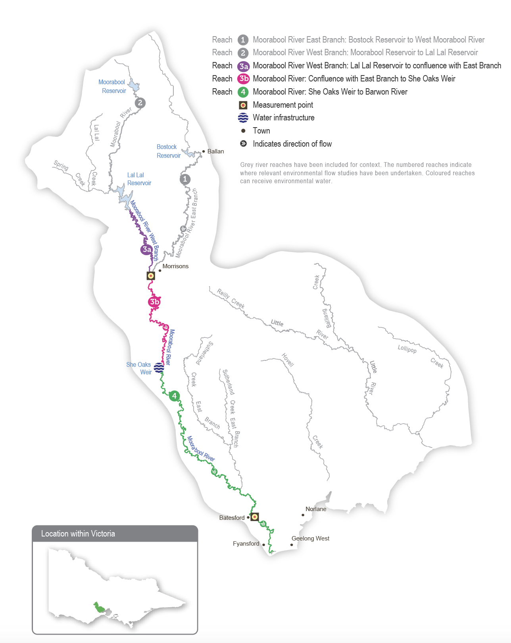

Environmental values
The Moorabool River is home to native fish species, including the Australian grayling, river blackfish, Australian smelt, flat-headed gudgeon, southern pygmy perch, short-finned eel, spotted galaxias and tupong. The system also contains extensive areas of endangered remnant vegetation, including streambank shrubland and streamside woodland ecological vegetation communities. Platypus, rakali (water rats) and a range of waterbugs are also present. The Moorabool River flows into the Barwon River, connecting it to the Ramsar-listed lower Barwon wetlands.
Environmental objectives in the Moorabool system
F1 | Increase the distribution, abundance and diversity of migratory species (tupong, short-finned eel, common galaxias, spotted galaxias, short-headed lamprey and Australian grayling)
F2 | Increase the distribution, abundance and diversity of non-migratory species (flat-headed gudgeon, Australian smelt, southern pygmy perch and river blackfish)
PR1 | Maintain a self-sustaining, breeding platypus population and support the dispersal of juveniles and the movement of adults
V1 | Maintain in-stream macrophyte communities
V2 | Maintain streamside vegetation communities and promote recruitment
MI1 | Maintain the abundance and diversity of waterbug communities
WQ1 | Maintain water quality
WQ2 | Prevent hypoxic blackwater events

Traditional Owner cultural values and uses
The Wadawurrung are the Traditional Owners of the land of Moorabool River and parts of the Barwon, Leigh and Yarrowee rivers. Wadawurrung Traditional Owners Aboriginal Corporation (WTOAC) are the statutory authority for the management of Aboriginal heritage values and culture, under the Victorian Aboriginal Heritage Act 2006.
Wadawurrung Traditional Owners have a strong connection to the Moorabool River and place high cultural value on it. They are a key partner in advocating for additional water recovery to help support a healthy river and associated cultural water objectives.
In 2020, the Wadawurrung Traditional Owners Aboriginal Corporation (WTOAC) released Paleert Tjaara Dja Let’s make Country good together 2020-2030 Wadawurrung Country Plan. The plan identifies waterways, rivers, estuaries and wetlands as key values to look after. WTOAC worked with waterway managers through the development of seasonal watering proposals to improve outcomes on Country in line with the Paleert Tjaara Dja Wadawurrung Country Plan and the Wadawurrung Nation Statement on water:
‘Wadawurrung Yaluks and waterway ecosystems flowing freely and are healthy’.
In 2019, WTOAC partnered with the Corangamite CMA to complete an environmental flows study for the upper Barwon, Yarrowee and Leigh rivers. The 2019 flows study also identified cultural values in all waterways within Wadawurrung Country, including the Moorabool River, including:
- significant aquatic species such as platypus, short-finned eel, native trout galaxias spp, tupong, river blackfish, common reed and cumbungi/typha latifolia, which are traditional sources of food, materials and medicines
- waterway confluences and deep pools, which are places for meeting, ceremonies, trade and marking clan boundaries.
Table 3.6.1 Traditional Owner values and uses, Moorabool River
Objectives & opportunities | Values & uses | What environmental watering aims to do
Maintain or improve the abundance, breeding and recruitment of platypus | - Meat and pelt | - Provide pool habitat and connectivity between reaches
Maintain or improve the abundance of eels | - Meat, an important food source sometimes smoked  - Large gatherings during the eel run at Buckley’s Falls | - Provide water for pools, habitat and food sources, and water over riffles to allow eels to migrate
Maintain or improve the abundance of native trout galaxias spp | - Meat | - Provide water for pools, habitat and food sources, and water over riffles to allow fish to move between pools and breed, feed and find new habitat
Maintain or improve the abundance of river blackfish | - Meat
Maintain or improve the abundance of water ribbons (Triglochin procera) | - Plant food: finger-shaped tubers are crisp and sweet and cooked in a ground oven | - Maintain an adequate depth of water in channels
Maintain or improve the condition, extent and abundance of common reed (Phragmites australis), pale rush (Juncus pallidus) and cumbungi (Typha latifolia) | - Common reed (Phragmites australis). Weapon-stems used for spear shafts for fishing. Reed cut while still green to make necklaces, weaving bags and baskets. Also, a food plant.  - Weaving baskets  - Fluff is used to pack wounds under a paperbark bandage | - Maintain an adequate depth of water to limit terrestrial encroachment into aquatic habitats. This will also support growth on terraces, channel edges and lower banks
Maintain or improve the abundance of river red gum (Eucalyptus camaldulensis) | - The bark is removed for canoe, shelter and tools  - Bowls  - Nectar drink  - Medicinal uses: the gum or sap was used for burns to shrink or seal them; the sap is high in tannin  - Leaves are used for steam baths
Maintain or improve the abundance of manna gum (Eucalyptus viminalis) and swamp wallaby grass (Amphibromus reservatus) | - Timber is used for making clubs and shields  - The sap-sucking lerp bug was gathered each season  - Young leaves were fed onto a fire near the patient, and a poultice of well-chewed leaves was applied for backache  - Quail flocks were attracted to manna gums  - Leaves were split, dried out and re-constituted in running water  - Fibres were twisted into rope to make long nets for game hunting | - Environmental watering cannot be considered in 2024-25 due to various constraints (such as an insufficient entitlement)
Deep pools | - Deep pools have cultural significance | - Help fill and ensure connectivity to pools where possible
Confluences (e.g. Moorabool and Barwon rivers) | - Confluences have high cultural value due to their historical use as meeting places for three different clans | - Maintain an adequate depth of water for connectivity
Holding cultural events on the Moorabool River | - Celebrations of culture, family events, fishing days and cultural festivals | - Summer/autumn freshes and some winter/spring freshes can be delivered to coincide with cultural events. This can support significant cultural values and species for a lead-up to or duration of an event.

Increasing the involvement of Traditional Owners in managing environmental flows and progressing opportunities towards self-determination in the environmental watering program is a core commitment of the VEWH and its program partners. This is reinforced by legislation and policy commitments, including the Water Act 1989, the Victorian Aboriginal Affairs Framework, the 2016 Water for Victoria, the 2022 Water is Life: Traditional Owner Access to Water Roadmap, and, in some cases, agreements under the Traditional Owner Settlement Act 2010.

Social, recreational and economic values and uses
In planning the potential environmental watering actions in Table 3.6.2, the Corangamite CMA considered how environmental watering could support cultural, social, recreational and economic values and uses, including peak recreational use as required in the Victorian Water Act 1989, as long as the delivery did not compromise environmental outcomes.
Social and recreational activities that may benefit from environmental water releases in the Moorabool system include camping, canoeing, kayaking, rowing, swimming and angling.
Summer/autumn freshes will increase the Moorabool River’s low flow and improve riverside and water-based recreation opportunities, particularly camping and fishing. Delivery of these freshes may coincide with school and public holidays, but the timing or management of planned 2024-25 environmental flows will not be specifically modified to align with holiday periods.

Scope of environmental watering
The term ‘environmental watering’ refers to the active delivery of held environmental water to support particular environmental objectives by altering the flow in a river or water level in a wetland. While other terms are sometimes used to describe the delivery of environmental water, ‘environmental watering’ is deliberately used here and in seasonal watering statements to ensure consistency in the legal instruments that authorise the use of environmental water in Victoria.
Table 3.6.2 describes the potential environmental watering actions in 2024-25, their expected watering effect (that is, the intended physical or biological effects of the watering action) and the longer-term environmental objectives they support. Each environmental objective relies on one or more potential environmental watering actions and their associated physical or biological effects.
Table 3.6.2 Moorabool system potential environmental watering actions, expected effects and environmental objectives
Potential environmental watering action | Expected watering effects | Environmental objectives
Moorabool River (targeting reach 3a)
Winter/spring low flow (5-60 ML/day during June to November) | At 5 to 10 ML/day:  - Maintain in-stream vegetation  - Maintain connectivity and allow fish movement through the reach  - Maintain pool and riffle habitat for platypus and native fish  A higher continuous flow of 60 ML/day would inundate the full extent of the channel bed and reduce intrusion by terrestrial vegetation into the stream bed | F1  F2  PR1  V1
Winter fresh (one fresh of 80-90 ML/day for five to 10 days during June to August) | - Provide connectivity between riffle and pool habitats to support fish and platypus movement through the reach  - Trigger the downstream spawning migration of tupong  - Maintain a clear flow path and control intrusions by terrestrial vegetation  - Flush silt, scour pools and remove biofilms from hard substrates and the stream bed to maintain waterbug communities, and transport organic matter to prevent blackwater events | F1  F2  MI1  PR1  V1  V2
Spring fresh(es) (one to two freshes of 80-90 ML/day for five to 10 days during September to November) | - Provide connectivity between riffle and pool habitats to support fish and platypus movement through the reach  - Trigger the upstream migration of juvenile galaxias, tupong, short-finned eel and Australian grayling  - Temporarily inundate the lower part of the riverbank to maintain the diversity of fringing vegetation species and promote the growth and recruitment of streamside vegetation  - Flush silt, scour pools and remove biofilms from hard substrates and the stream bed to maintain waterbug communities and transport organic matter to prevent blackwater events | F1  F2  MI1  PR1  V1  V2
Summer/autumn low flow (5-40¹ ML/day during December to May) | At 5 to 10 ML/day:  - Maintain refuge pools and riffle habitat for fish, waterbugs and platypus and submerged aquatic vegetation  - Maintain water quality for aquatic life by reducing periods of low oxygen, high temperature and high salinity  - Flow above 30 ML/day water fringing vegetation | F1  F2  MI1  PR1  V1  WQ1
Small summer/autumn fresh (one fresh of 30-60 ML/day for three days during February to March) | - Allow fish and platypus movement through the reach  - Maintain clear flow path and control intrusions by terrestrial vegetation  - Flush silt and scour biofilms and algae from the stream bed and transport organic matter to improve habitat and food for waterbugs  - Water fringing vegetation | F1  F2  MI1  PR1  V2
Large summer/autumn fresh(es) (one to two freshes of 60-80 ML/day for five days during January to May) | - Trigger the downstream spawning migration of adult short-finned eel (January-February) and Australian grayling (April-May)  - Maintain pool and riffle habitat and the condition of streamside vegetation, and promote recruitment  - Allow fish and platypus to move through the reach to access habitat  - Flush silt and scour biofilms and algae from the stream bed and substrates to improve habitat quality for waterbugs  - Maintain water quality by reducing periods of low-oxygen water, high water temperature and salinity | F1  F2  MI1  PR1  V2
Year-round freshes (trigger-based, of 30 ML/day for three days)  Triggers:  - oxygen below 5 mg/L  - electrical conductivity above 10,000 µs/cm  - water temperature above 25°C | - Maintain water quality by reducing periods of low oxygen, high water temperature and salinity | WQ1  WQ2
1 The flow will generally target between 5 and 10 ML per day at the compliance point, but 40 ML per day could be achieved in combination with Barwon Water’s transfer to She Oaks Weir and passing flow.

Scenario planning
Table 3.6.3 outlines potential environmental watering and expected water use in various planning scenarios.
There is limited variation in the proposed watering regime year to year due to restrictions on how much water for the environment can be used each year. The Moorabool River Environmental Entitlement 2010 stipulates that a maximum of 7,500 ML can be used over three consecutive years. This effectively limits environmental water use to 2,500 ML a year because a larger volume could only be delivered in one year if less water had been delivered in the previous two years, and it would reduce the volume that could be used in the two subsequent years.
The Moorabool River requires a continuous low flow throughout the year and periodic freshes in all planning scenarios to achieve the intended environmental outcomes.
In the drought and dry planning scenarios, the main objective is to deliver a sufficient flow to maintain enough habitat to prevent significant declines in existing populations of native fish and platypus. There will be limited natural inflow to the river in these planning scenarios, so water for the environment will be used to deliver a low flow at the lower end of the recommended range (5 ML per day) to maintain a continuous flow throughout reach 3a for as long as possible. Water for the environment may be added to operational transfers to increase flow variability downstream of Lal Lal Reservoir and maintain some flow in the reaches downstream of She Oaks Weir once operational water is diverted. Even with these proposed watering actions, sections of the Moorabool River are likely to periodically cease flowing in the dry or drought planning scenarios, which would reduce the river’s environmental condition and the size of plant and animal populations. In the drought planning scenario, water quality will be regularly monitored to inform the delivery of trigger-based, year-round freshes as needed.
In the average and wet planning scenarios, most of the recommended flow is expected to be provided through a combination of the natural flow, passing flow and operational releases, which will mean water for the environment can be used to deliver additional freshes to improve environmental conditions and increase populations of native plants and animals.
Delivering one large summer/autumn fresh in April/May is a high priority in all planning scenarios to trigger Australian grayling migration and spawning. In the average and wet planning scenarios, an additional large summer/autumn fresh is proposed for January/February to trigger the downstream spawning migration of short‑finned eel.
Winter and spring freshes are a lower priority than summer/autumn freshes and consequently depend on water availability in drought and dry conditions. A winter fresh would be delivered to trigger the downstream spawning migration of adult tupong, whereas spring freshes will aim to trigger the upstream migration of juvenile galaxias, tupong, short-finned eel and Australian grayling.
Although environmental flows in the Moorabool River primarily target outcomes in reaches 3a and 3b, deliveries will be planned where possible to also provide benefits in reach 4.
The environmental entitlement for the Moorabool system caps use at 7,500 ML over three years. Use in 2024-25 will be capped at 2,500 ML, leaving sufficient allocation to support watering actions in 2025-26.
Table 3.6.3 Moorabool system environmental watering planning scenarios
Planning scenario | Drought | Dry | Average | Wet
Expected conditions | - Little rainfall with no inflow to Lal Lal Reservoir  - Regular periods of no flow | - Below-average rainfall and inflow to Lal Lal Reservoir  - Cease-to-flow events | - Moderate inflows to Lal Lal Reservoir, especially during winter and spring  - Low flow over summer and high peaks in winter months | - Lal Lal Reservoir is likely to fill and spill  - Continuous flow year-round  - Overbank flow in some parts during winter/spring
Expected availability of water for the environment | - 2,500 ML¹
Moorabool River (targeting reach 3a)
Potential environmental watering – tier 1 (high priorities) | Tier 1a (can be achieved with predicted supply)
 | - Winter/spring low flow (5 ML/day)  - Summer/autumn low flow (5 ML/day)  - Large summer/autumn fresh (one fresh of 60 ML/day)  - Year-round fresh(es) (if required) | - Winter/spring low flow (5 ML/day)  - Spring fresh (one fresh for five days of 80 ML/day)  - Summer/autumn low flow (5 ML/day)  - Large summer/autumn fresh (one fresh of 60 ML/day) | - Winter/spring low flow (5 ML/day)  - Winter fresh (one fresh for five days of 80 ML/day)  - Spring fresh (one fresh for five days of 80 ML/day)  - Summer/autumn low flow (5 ML/day)  - Small summer/autumn fresh (one fresh of 30 ML/day)  - Large summer/autumn freshes (two freshes of 60 ML/day) | - Winter/spring low flow (of greater than 10 ML/day)  - Winter fresh (one fresh for five days of 80 ML/day)  - Spring freshes (two freshes for five days of 80 ML/day)  - Summer/autumn low flow (of greater than 10 ML/day)  - Small summer/autumn fresh (one fresh of 30 ML/day)  - Large summer/autumn freshes (two freshes of 60 ML/day)
 | Tier 1b (supply deficit)
 | - Winter fresh (one fresh for five days of 80 ML/day)  - Spring fresh (one fresh for five days of 80 ML/day) | - Winter fresh (one fresh for five days of 80 ML/day) | - Spring fresh (one additional fresh for five days of 80 ML/day) | - N/A
Potential environmental watering – tier 2 (additional priorities) | - Winter/spring low flow (tier 1a delivered at increased magnitude: 10 ML/day)  - Summer/autumn low flow (tier 1a delivered at increased magnitude: 10 ML/day)  - All other tier 1a and 1b watering actions delivered at the upper end of the recommended magnitude range |  | - Tier 1a and 1b watering actions delivered at the upper end of the recommended volume range
Possible volume of water for the environment required to achieve objectives | - 2,493 ML (tier 1a)  - 1,130 ML (tier 1b)  - 3,076 ML (tier 2) | - 2,508 ML (tier 1a)  - 565 ML (tier 1b)  - 3,076 ML (tier 2) | - 2,400 ML (tier 1a)  - 495 ML (tier 1b)  - 15,369 ML (tier 2) | - 780 ML (tier 1a)  - 0 ML (tier 1b)  - 9,140 ML (tier 2)
Priority carryover requirements for 2025-26 | - The environmental entitlement for the Moorabool system caps use at 7,500 ML over three years. Use in 2024-25 will be capped at 2,500 ML, leaving sufficient allocation to support watering actions in 2025-26.
1 Up to 7,086 ML can be stored under the Moorabool River Environmental Entitlement 2010. However, the entitlement is subject to delivery rules — a maximum of 7,500 ML over three consecutive years — which restricts delivery of water to 2,500 ML per year.

3.7 Barwon system
Waterway manager – Corangamite Catchment Management Authority/Melbourne Water
Storage manager – Barwon Water
Environmental water holder – Victorian Environmental Water Holder
The Barwon system includes the upper Barwon River and lower Barwon wetlands.
The Barwon River flows east from the Otway Ranges, passing the towns of Forrest, Birregurra, Winchelsea, Inverleigh and the City of Geelong before discharging into Bass Strait at Barwon Heads. The Leigh and Moorabool rivers are major tributaries, joining the Barwon River at Inverleigh and Fyansford, respectively. Other tributaries, including Birregurra, Boundary, Callahan, Dewing, Matthews, Pennyroyal, Deans Marsh and Gosling creeks, flow into the Barwon River above Winchelsea. The main storages in the Barwon River catchments are the West Barwon and Wurdee Boluc reservoirs.
The Barwon estuary contains a Ramsar-listed system of wetlands and lakes collectively called the lower Barwon wetlands. Water for the environment can be used to manage the flow in the upper Barwon River and manage water levels in Reedy Lake and Hospital Swamps, which connect to the lower Barwon River.

3.7.1 Upper Barwon River

System overview
The operation of the West Barwon Reservoir regulates flows in the upper Barwon River. Water can be released directly from the reservoir into the west or east branches via a diversion tunnel. The junction of the two branches is near Boundary Creek. Downstream of the reservoir, operational water can be diverted into the Wurdee Boluc inlet channel, a 57 km concrete-lined channel that transfers water to Wurdee Boluc Reservoir.
Barwon Water releases passing flow in the order of 1-5 ML per day in both the upper east and west branches from the West Barwon Reservoir. These releases may increase to 15 ML per day in September in a wet year. When the West Barwon and Wurdee Boluc reservoirs collectively hold more than 40,000 ML, all the natural flow is passed down the east branch between January and March. Flood spills from the reservoir and natural inflows from unregulated and regulated tributaries add to the passing flow in the west branch. Regulated and unregulated tributaries add to the passing flow in the east branch.
The Upper Barwon River Environmental Entitlement 2018 enables water for the environment to be made available from the West Barwon Reservoir. The entitlement provides an average of 1,000 ML per year and up to 2,000 ML of the total storage capacity at full supply. Water for the environment was first delivered to the upper Barwon River in 2018-19. The current entitlement provides only enough water to meet the highest-priority potential environmental watering actions in the upper Barwon east branch (reach 4) and the upper Barwon west branch (reach 3) in particular climatic conditions.
Figure 3.7.1 The Barwon system
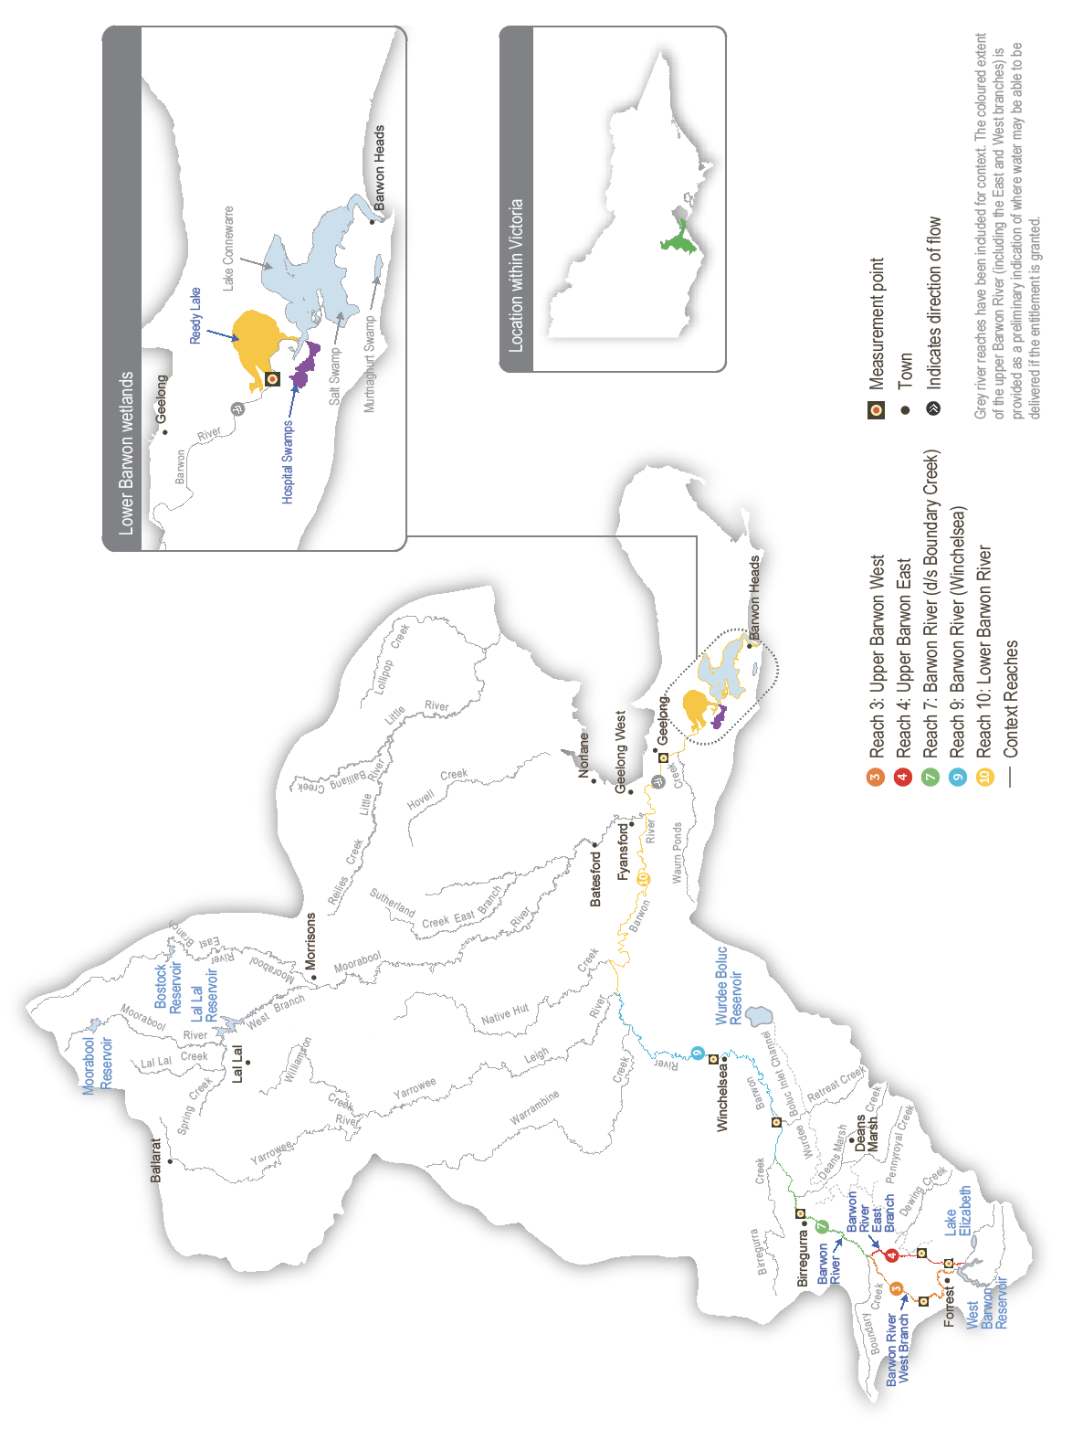

Environmental values
The upper Barwon River is home to platypus and native fish species, including the river blackfish, short-finned eel, southern pygmy perch, Australian smelt and various galaxias. The system retains some submerged aquatic vegetation, undercut banks, overhanging vegetation and riffle-pool sequences, which provide essential habitat for fish and other aquatic animals.
Long-term environmental objectives for the upper Barwon system are based on delivering watering actions recommended in the Upper Barwon, Yarrowee and Leigh rivers FLOWS study. These include improving the breeding and recruitment of various fish, platypus and macroinvertebrate species, as well as improving the condition, extent and diversity of in-stream, emergent, streamside and floodplain vegetation. However, due to the limited size of the environmental entitlement and channel constrictions, the flow magnitudes for the potential watering actions described in this plan have been adjusted to be less than the known channel constraints. The watering actions presented in this plan aim to maintain rather than improve current ecological conditions within the upper Barwon River. Significant improvements in ecological condition are unlikely until complementary actions are taken to address channel constraints and other factors (such as unrestricted livestock access and weed infestation).
Environmental objectives in the upper Barwon River
F1 | Maintain the abundance of migratory fish species, including short-finned eels and tupong
F2 | Maintain the abundance of resident freshwater fish, including several species of galaxias, Australian smelt, big-headed gudgeon, Yarra pygmy perch, southern pygmy perch and river blackfish
MI1 | Maintain the abundance of waterbugs as a food source for the native fish, frog and platypus populations
PR1 | Maintain the abundance of the platypus population
V1 | Maintain the condition and extent of in-stream vegetation to provide structural habitat for waterbugs and various fish species
V2 | Maintain the condition, extent and diversity of emergent macrophyte vegetation and streamside vegetation to provide structural habitat and stabilise the channel and lower banks
WQ1 | Maintain water quality for native fish, waterbugs, other water-dependent animals and aquatic vegetation

Traditional Owner cultural values and uses
The reaches of the Barwon River that can be most influenced by water delivered from the West Barwon Reservoir sit on Eastern Maar Country.
In February 2020, the Eastern Maar Aboriginal Corporation (EMAC) received Registered Aboriginal Party (RAP) status under the Victorian Aboriginal Heritage Act 2006 over a large portion of land in south-west Victoria, including the Barwon River upstream of Winchelsea. In 2023 Eastern Maar gained formal recognition of their rights under the Commonwealth Native Title Act 1993 for over half of the RAP area and on the 21st of March 2024, the Federal Court of Australia handed down a third native title determination, marking a significant milestone since their initial recognition in 2011 under the Native Title Act. Further areas remain in negotiation. Native Title determination acknowledges Eastern Maar’s ongoing connection and intrinsic relationship to Country across south-west Victoria, including parts of the Barwon River catchment.
Eastern Maar obligations to Country and objectives for Country are described in the Eastern Maar Country Plan Meerreengeeye Ngakeepoorryeeyt (EMAC, 2015). Eastern Maar assertions for parreeyt (water) are further documented in Eastern Maar’s Nation Statement in Water is Life: Traditional Owner Access to Water Roadmap (DEECA 2022).
The current environmental entitlement can have the most effect on the river reaches between the West Barwon Reservoir and Winchelsea, with diminishing benefits to the reaches downstream. The reaches of the river downstream of Winchelsea sit on Wadawurrung Country. The Corangamite CMA is working with the Wadawurrung Traditional Owners Aboriginal Corporation (WTOAC) to understand opportunities to provide for cultural values and uses and other aspirations for the management of water for the environment in the Barwon River downstream of Winchelsea, on Country where WTOAC holds Registered Aboriginal Party status. In early 2024, the Corangamite CMA met with WTOAC to discuss seasonal watering proposals in the Corangamite catchment.
The Eastern Maar Aboriginal Corporation and WTOAC have formal plans for how to heal Country in the region, and the Corangamite CMA continues to work with each Traditional Owner group to identify their cultural objectives and associated values and uses that align with environmental flows.
WTOAC has been working with waterway managers through the development of seasonal watering proposals, to improve outcomes on Country in line with the Paleert Tjaara Dja Wadawurrung Country Plan and the Wadawurrung Nationa Statement on water:
- By 2030, the water in the waterways of the Barree Warree Yulluk is clean enough to drink
- By 2025, the waterways of the Barree Warree Yulluk will have sufficient cultural flows and connectivity to support culturally important species
- Wadawurrung Yaluks and waterway ecosystems are flowing freely and are healthy.
Increasing the involvement of Traditional Owners in managing environmental flows and progressing opportunities towards self-determination in the environmental watering program is a core commitment of the VEWH and its program partners. This is reinforced by legislation and policy commitments, including the Water Act 1989, the Victorian Aboriginal Affairs Framework, the 2016 Water for Victoria, the 2022 Water is Life: Traditional Owner Access to Water Roadmap, and, in some cases, agreements under the Traditional Owner Settlement Act 2010.

Social, recreational and economic values and uses
The adjacent land use of the upper Barwon River is dominated by grazing for livestock (beef, sheep and dairy) and forestry and is of significant economic value. Limited public access to the river frontage limits the upper Barwon’s social and recreational values and uses.
In planning the potential environmental watering actions, the Corangamite CMA considered how environmental flows could support values and uses, including:
- water-based recreation (such as swimming and fishing, particularly for river blackfish)
- riverside recreation and amenity (such as birdwatching, camping, trail running, mountain bike riding and walking)
- socioeconomic benefits (such as for diverters for stock needs and domestic use; water levels and water quality can rely on the delivery of water for the environment, particularly in summer).
Although the watering actions listed in this proposal may support social, recreational and economic values and uses, watering actions in the upper Barwon are not actively modified to accommodate such values and uses. Social and recreational uses of the upper Barwon River include recreational fishing and riverside activities (such as bike riding, walking and running). The river also supports economic benefits for stock and domestic users. Environmental watering supports a healthy system and connectivity, allowing fish to move. It also supports water quality that delivers active and passive benefits, including for stock and domestic uses.

Scope of environmental watering
The term ‘environmental watering’ refers to the active delivery of held environmental water to support particular environmental objectives by altering the flow in a river or water level in a wetland. While other terms are sometimes used to describe the delivery of environmental water, ‘environmental watering’ is deliberately used here and in seasonal watering statements to ensure consistency in the legal instruments that authorise the use of environmental water in Victoria.
Table 3.7.1 describes the potential environmental watering actions in 2024-25, their expected watering effect (that is, the intended physical or biological effects of the watering action) and the longer-term environmental objectives they support. Each environmental objective relies on one or more potential environmental watering actions and their associated physical or biological effects.
Table 3.7.1 Upper Barwon River potential environmental watering actions, expected effects and environmental objectives
Potential environmental watering action | Expected effects | Environmental objectives
Upper Barwon River (targeting reach 3 – west branch)
Winter/spring low flow (3-15 ML/day during June to November) | - Maintain permanent water in the channel/pools to provide habitat to support resident and migratory fish and platypus  - Maintain an adequate depth of permanent water in the channel to promote the recruitment of aquatic and streamside plants and to limit the encroachment of terrestrial species | F1  F2  PR1  V1  V2
Summer/autumn low flow (3-15 ML/day during December to May)
Upper Barwon River (targeting reach 4 – east branch)
Winter/spring low flow (1-9 ML/day during June to November) | - Maintain an adequate depth of permanent water in the channel and pools to provide habitat for resident and migratory fish and platypus  - Maintain an adequate depth of permanent water in the channel to promote the recruitment of aquatic and streamside plants and to limit the encroachment of terrestrial species  - Provide sufficient flow velocity to mix pools | F1  F2  PR1  V1  V2  WQ1
Summer/autumn low flow (0.5-5 ML/day during December to May) | - Maintain an adequate depth of permanent water in the channel/pools to provide habitat for resident and migratory fish and platypus  - Maintain an adequate depth of permanent water in the channel to promote the recruitment of aquatic and streamside plants and to limit the encroachment of terrestrial species  - Provide a minimum velocity to mix pools | F1  F2  PR1  V1  V2  WQ1
Summer/autumn freshes (two to three freshes of 6-9 ML/day for two days during December to May) | - Increase the water depth in the channel and pools to allow for the movement of resident and migratory fish and platypus  - Provide a mosaic of wetted areas to maintain in-stream, emergent and streamside vegetation  - Provide minimum velocity to mix pools and improve habitat quality for fish and waterbugs | F1  F2  MI1  PR1  V1  V2  WQ1

Scenario planning
Table 3.7.2 outlines potential environmental watering and expected water use in various planning scenarios.
Planned watering actions for the upper Barwon River are derived from recommendations in the Upper Barwon, Yarrowee and Leigh rivers FLOWS study. Many of the flow magnitudes recommended in the study cannot be delivered due to the size of the environmental entitlement and the risk of inundating private land.
The planned watering actions presented in Table 3.7.2 are deliberately less than the known channel capacity constraints and would provide a lower environmental benefit than the recommended environmental flows. Given this limitation, the main aim of watering actions is to deliver enough flow through the system to maintain pool habitat and food (waterbugs) for aquatic animals. A low flow will aim to prevent or limit cease-to-flow events, and small freshes will be delivered as needed in the east branch during summer and autumn to manage potential water quality issues. The overall approach to environmental flows in the upper Barwon River in 2024-25 will help maintain existing populations of native fish, platypus and waterbugs, and it relies on natural events to deliver the greater flows needed to facilitate the movement and potential breeding of fish and platypus.
The Corangamite CMA will monitor conditions during deliveries of water for the environment in 2024-25 so that release rates can be promptly adjusted to avoid inundating private land. The Corangamite CMA will continue to work with relevant agencies and landholders to investigate options that will allow future deliveries of water for the environment to be closer to their recommended magnitude and avoid affecting private land without consent. The Barwon Flagship Project is a newly established, integrated catchment management project working with stakeholders to address flow restrictions through streamside management and to improve the overall health of the upper Barwon River.
The carryover reserve for 2024-25 for the upper Barwon River is 500 ML, the drought reserve amount agreed with the Upper Barwon Surface Water Advisory Group.
Table 3.7.2 Upper Barwon River environmental watering planning scenarios
Planning scenario | Dry | Average | Wet
Expected conditions | - Disconnected pools during summer and autumn  - Cease-to-flow events | - Low flow in summer and autumn  - Peak flow in winter and spring | - Continuous flow throughout the year  - Reservoir spills are likely, especially during winter and spring
Expected availability of water for the environment | - 2,180 ML | - 2,250 ML | - 2,350 ML
Upper Barwon River (targeting reach 3 – west branch)
Potential environmental watering – tier 1 (high priorities) | Tier 1a (can be achieved with predicted supply)
 | - Summer/autumn low flow (delivered at a lower magnitude in the range) | - Summer/autumn low flow (delivered at a lower magnitude in the range) | - Summer/autumn low flow  - Winter/spring low flow
 | Tier 1b (supply deficit)
 | - Winter/spring low flow (delivered at a lower magnitude in the range) | - Winter/spring low flow (delivered at a lower magnitude in the range)
Potential environmental watering – tier 2 (additional priorities) | - N/A
Upper Barwon River (targeting reach 4 – east branch)
Potential environmental watering – tier 1 (high priorities) | Tier 1a (can be achieved with predicted supply)
 | - Summer/autumn low flow (delivered at a lower magnitude in the range)  - Summer/autumn freshes (two freshes) | - Summer/autumn low flow (delivered at a lower magnitude in the range)  - Summer/autumn freshes (two freshes) | - Summer/autumn low flow  - Summer/autumn freshes (three freshes)  - Winter/spring low flow
 | Tier 1b (supply deficit)
 | - Winter/spring low flow | - Winter/spring low flow
Potential environmental watering – tier 2 (additional priorities) | - N/A
Possible volume of water for the environment required to achieve objectives | - 1,264 ML (tier 1a)  - 2,340 ML (tier 1b) | - 1,086 ML (tier 1a)  - 1,170 ML (tier 1b) | - 900 ML (tier 1a)  - 0 ML (tier 1b)
Priority carryover requirements for 2025-26 | - 500 ML

3.7.2 Lower Barwon wetlands

System overview
The estuarine reach of the Barwon River contains a system of wetlands and lakes, including Lake Connewarre, Reedy Lake and Hospital Swamps, Salt Swamp and Murtnaghurt Lagoon (Figure 3.7.1). For thousands of years, the system has been a place of great significance to the Wadawurrung Traditional Owners. Paleert Tjaara Dja Let’s make Country good together 2020-2030 Wadawurrung Country Plan acknowledges the system’s special place in their Dreaming.
Water for the environment can be used to manage water levels in Reedy Lake and Hospital Swamps, which connect to the Barwon River. The environmental entitlement for the lower Barwon wetlands does not provide access to water held in storage. Instead, it allows water to be diverted from the Barwon River into Reedy Lake and Hospital Swamps when river levels are above 0.7 m AHD. High water levels in the Barwon River can also result in the natural wetting of the wetlands.

Environmental values
Reedy Lake and Hospital Swamps form part of the internationally recognised Port Phillip Bay (Western Shoreline) and Bellarine Peninsula Ramsar site, which is used by many thousands of migratory birds from around the world. The wetlands support 47 known threatened plant and animal species and communities. These include some of Victoria’s rarest species (such as the brolga, orange-bellied parrot, Australasian bittern, growling grass frog, Australian grayling, and dwarf galaxias) and subtropical and temperate coastal saltmarsh communities. Reedy Lake also supports a range of vegetation communities, including coastal saltmarsh, herbfields and reed beds.
Reedy Lake was naturally a partly ephemeral system, but river regulation meant the lake was nearly permanently wet from the 1970s until 2016. Wetting and drying regimes are now recommended to maintain the lake’s ecological character and diverse habitats.
Following a four-year (2016-17 to 2019-20) watering regime trial at Reedy Lake, the Lower Barwon Review in 2020 proposed to implement a long-term, seasonally adaptive water regime that avoids complete drying. At Reedy Lake, this means having the wetland full for a quarter of all years and having a partial drawdown in summer and autumn in three-quarters of all years. The review’s recommendations have informed 2024-25 watering actions and future directions.
Hospital Swamps comprises five wetland basins that support important ecological processes and significant environmental values, including large areas of threatened coastal saltmarsh and diverse waterbird communities. Hospital Swamps has retained a more natural wetting and drying pattern. As a result, the swamp’s vegetation community has remained essentially unchanged since the 1980s.
Environmental objectives in the lower Barwon wetlands
B1 | Provide suitable feeding and breeding habitat for waterbirds, including mudflats and shallow water for wading birds, flooded vegetation and wetland fringes
CN1 | Maintain nutrient cycling and improve lake productivity
F1 | Provide habitat for fish breeding and growth and improved conditions for migration and dispersal when wetlands are connected to the Barwon River
F2 | Reduce the carp population
MI1 | Increase the waterbug population and its biomass
V1 | Increase the diversity of ecological vegetation communities in the wetlands and increase the recruitment of aquatic vegetation
V2 | Increase the growth and extent of coastal saltmarsh, herbfields and lignum shrubland ecological vegetation communities
V3 | Retard colonisation of tall reed in low-lying areas and increase open-water habitat
WQ1 | Remove accumulated salts
WQ2 | Maintain surface water and groundwater interactions

Traditional Owner cultural values and uses
The lower Barwon wetlands are part of Wadawurrung Country. The Corangamite CMA is continuing to work with the Wadawurrung Traditional Owners Aboriginal Corporation (WTOAC) to support their values and uses of the wetlands and to refine the CMA’s understanding of how the water regimes in the lower Barwon wetlands can support Wadawurrung aspirations.
The Corangamite CMA met with WTOAC in early 2024 at the beginning of the seasonal watering proposal planning process. WTOAC reviewed and approved the relevant section content in the lower Barwon wetlands seasonal watering proposal and the proposed watering. WTOAC is also part of the broader lower Barwon community advisory committee.
Wadawurrung people place a high cultural value on the Barwon River. Many Wadawurrung people in the region have a connection and long history with the river. Under the Aboriginal Heritage Act 2006 and the Aboriginal Heritage Regulations (2007), any waterway or Ramsar-listed site is recognised as culturally sensitive.
In 2018, the Corangamite CMA engaged representatives from WTOAC to inform part of the upper Barwon, Yarrowee and Leigh rivers FLOWS study update (Alluvium, 2021) and to assist in capturing Aboriginal values relevant to Wadawurrung Country in each of the waterway reaches. Many of these values, notably culturally significant species, are also common to wetlands of the Barwon River system.
WTOAC’s 2020 Paleert Tjaara Dja Let’s make Country good together 2020-2030 Wadawurrung Country Plan identifies important cultural values and recommendations for the lower Barwon wetlands, including:
- culturally significant wetland species (such as brolga, black duck, black swan, short-finned eel, common reed and bull rush)
- recognition of wetlands as meeting, ceremony and trade places
- maintaining water holes and refuge pools
- maintaining access to culturally important story places and ceremonial places
- protection of artefact sites
- use of appropriate Wadawurrung language for places of cultural importance
- increased opportunities for the Wadawurrung to be involved in monitoring and evaluation activities
- inclusion of the Wadawurrung in all communications about releases of water for the environment and other wetland-related activities.
Paleert Tjaara Dja acknowledges Reedy Lake and Hospital Swamps as special places in Wadawurrung Dreaming.
“The chain of ponds from the Barwon River to Reedy Lake, Hospital Lake, Lake Connewarre and Estuary Bay is connected through water and Black Swan Dreaming”.
WTOAC has been working with waterway managers through the development of seasonal watering proposals, to improve outcomes on Country in line with the Paleert Tjaara Dja Let’s make Country good together 2020-2030 Wadawurrung Country Plan and the Wadawurrung Nation Statement. Objectives in these documents include:
- By 2030, the water in the waterways of the Barree Warree Yulluk is clean enough to drink
- By 2025, the waterways of the Barree Warree Yulluk will have sufficient cultural flows and connectivity to support culturally important species
- Wadawurrung Yaluks and waterway ecosystems are flowing freely and are healthy.
Increasing the involvement of Traditional Owners in managing environmental flows and progressing opportunities towards self-determination in the environmental watering program is a core commitment of the VEWH and its program partners. This is reinforced by legislation and policy commitments, including the Water Act 1989, the Victorian Aboriginal Affairs Framework, the 2016 Water for Victoria, the 2022 Water is Life: Traditional Owner Access to Water Roadmap, and, in some cases, agreements under the Traditional Owner Settlement Act 2010.

Social, recreational and economic values and uses
In planning the potential environmental watering actions in Table 3.7.3, the Corangamite CMA consulted widely with stakeholders to ensure it considered shared benefits, including social, economic and recreational values relevant to environmental flows management in the lower Barwon wetlands. Opportunities for social, recreational and economic values and uses are incorporated into planning and watering decisions if they do not compromise environmental outcomes.
Expert advice (such as the 2012 environmental flows study for the lower Barwon wetlands and the 2020 Lower Barwon Review) emphasised that the entire lower Barwon recommended watering regime — providing a fill to the wetlands and allowing water levels to draw down at the right times — would have to be implemented to improve biodiversity and protect the long-term health of the wetlands. This may mean it is not possible to meet some community expectations for shared benefits that don’t maintain or improve environmental outcomes. The Corangamite CMA manages water levels in the wetlands to meet environmental requirements which have shared benefits that support a range of social, economic and recreational values and uses, including:
- water-based recreation (such as boating, duck hunting and fishing)
- wetlands recreation and amenity (such as birdwatching and spending time outdoors)
- community events (including Traditional Owner events) and tourism
- socioeconomic benefits (such as commercial fishing).

Scope of environmental watering
The term ‘environmental watering’ refers to the active delivery of held environmental water to support particular environmental objectives by altering the flow in a river or water level in a wetland. While other terms are sometimes used to describe the delivery of environmental water, ‘environmental watering’ is deliberately used here and in seasonal watering statements to ensure consistency in the legal instruments that authorise the use of environmental water in Victoria.
Table 3.7.3 describes the potential environmental watering actions in 2024-25, their expected watering effect (that is, the intended physical or biological effects of the watering action) and the longer-term environmental objectives they support. Each environmental objective relies on one or more potential environmental watering actions and their associated physical or biological effects.
Table 3.7.3 Lower Barwon wetlands potential environmental watering actions, expected effects and environmental objectives
Potential environmental watering action | Expected watering effects | Environmental objectives
Reedy Lake
Autumn/winter/spring fill (April to November) and top-ups as required (year-round) (targeting 0.8 m AHD) | - Maintain a mosaic of water depths and resources across the wetland to support waterbird breeding events  - Inundate fringing wetland vegetation to provide foraging habitat for waterbirds  - Maintain a sufficient depth of water around wetland vegetation to provide fish breeding habitat  - Temporarily inundate the outer edges of the wetland to initiate the growth and recruitment of diverse vegetation communities while permanently inundating the inner wetland vegetation communities  - Allow fish to move between the river, lake and estuary  - Stimulate waterbug communities to breed for waterbird feeding  - Dilute soil and surface water salts and initiate the decomposition of organic matter | B1  CN1  F1  MI1  V1  WQ1  WQ2
Summer/autumn drawdown (December to May) (targeting 0.3 m AHD) | - Dry out wetland fringing vegetation to reduce potential waterlogging of saltmarsh communities to support germination  - Expose mudflats and margins to provide feeding habitat for wading/migratory waterbirds  - Manage reed colonisation of low-lying areas by allowing drying and saline groundwater intrusion to reduce reed growth  - Support a drying phase for vegetation communities that require drying to grow and recruit  - Restrict carp movement and access to habitat  - Allow vegetation to decay and soils to oxidise and release nutrients to improve lake productivity and maintain biogeochemical processes  - Enable surface water/groundwater interaction by allowing saline groundwater to discharge to the wetland bed | B1  CN1  F2  V1  V2  V3  WQ2
Hospital Swamps
Autumn/winter/spring fill (April to November) and top-up as required (year-round) (targeting 0.5 m AHD) | - Maintain a mosaic of water depths and resources across the wetland, inundate various vegetation communities and create nesting, breeding and feeding opportunities for waterbirds, fish and waterbugs  - Increase water levels to trigger fish spawning and waterbird breeding; high water levels will allow fish to access the wetland from the river  - Increase freshwater to dilute the salt in the soil and surface water over winter  - Initiate the decomposition of organic matter  - Inundate the outer edges and margins to initiate the growth and maintain the condition of important wetland vegetation communities | B1  CN1  F1  MI1  V1  WQ1  WQ2
Summer/autumn drawdown (December to May) (targeting 0.1-0.3 m AHD) | - Dry out the wetland fringing vegetation and expose mudflats and margins to support the feeding of wading/migratory waterbirds  - Manage reed colonisation of low-lying areas by allowing drying and saline groundwater intrusion to reduce reed growth  - Support a drying phase for vegetation communities that require drying to grow and recruit  - Restrict carp movement and access to habitat  - Allow vegetation to decay and soils to oxidise and release nutrients to improve lake productivity and maintain biogeochemical processes  - Enable the interaction of surface water and groundwater by allowing saline groundwater to discharge to the wetland bed | B1  CN1  F2  V1  V3  WQ2

Scenario planning
Table 3.7.4 outlines potential environmental watering and expected water use in various planning scenarios.
A 2020 independent review of environmental watering at the lower Barwon wetlands recommended that Reedy Lake be partially drawn down on average in three out of four years and Hospital Swamps partially drawn down in most years. It also recommended the timing of planned drawdowns should be adapted to avoid disrupting significant waterbird breeding events.
Wet conditions in recent years have restricted planned drawdowns in the lower Barwon wetlands. The target drawdown at Reedy Lake has only been achieved once since 2019-20. Hospital Swamps has been drawn down more frequently but remained full during 2022-23. Drawing both wetlands down is a high priority where possible in all planning scenarios in 2024-25 to achieve environmental objectives in line with the 2020 watering regime review.
Wetland filling is proposed to commence as early as April but can occur at any point until November. Further top-ups may be needed throughout the year to achieve and maintain target water levels, particularly if waterbirds are breeding, and to provide some variability. Planned drawdowns can commence from December and continue until the following May at the latest to mimic natural seasonal patterns, but they will be delayed where required to avoid disrupting breeding waterbirds.
The planned wetland drying may be difficult to implement in the wet planning scenario, especially if there are multiple high-flow events in the Barwon River during summer and autumn. The planned wetland fill might also be difficult to achieve in the drought-dry planning scenario due to the wetland’s potential disconnection from the Barwon River for long periods.
Table 3.7.4 Lower Barwon wetlands environmental watering planning scenarios
Planning scenario | Drought-dry | Average | Wet
Expected conditions | - Limited to no flow from the Barwon River in winter/spring  - Disconnection between wetlands and the Barwon River for a long period  - Natural drawdown may begin earlier than planned | - Some natural inflow from the Barwon River in winter/spring  - More gradual lowering of water levels during drawdown | - Wetlands will be filled by overbank flow from the Barwon River  - Stormwater inflow and local rain/run-off will provide regular top-ups  - Drying of the wetland is unlikely
Reedy Lake
Potential environmental watering – tier 1 (high priorities) | - Reedy Lake fill¹ and top-up (as required)  - Reedy Lake drawdown | - Reedy Lake fill and top‑up (as required)  - Reedy Lake drawdown | - Reedy Lake fill and top‑up (as required)  - Reedy Lake drawdown²
Hospital Swamps
Potential environmental watering – tier 1 (high priorities) | - Hospital Swamps fill¹ and top-up (as required)  - Hospital Swamps drawdown | - Hospital Swamps fill and top-up (as required)  - Hospital Swamps drawdown | - Hospital Swamps fill and top-up (as required)  - Hospital Swamps drawdown²
1 The planned wetland fill might be difficult to achieve in the drought-dry planning scenario due to the wetland’s potential disconnection from the Barwon River for long periods.
2 The planned wetland drying may be difficult to implement in the wet planning scenario, especially if there are multiple high-flow events in the Barwon River during summer and autumn.

Section 4: Western region
4.1 Western region overview 174
4.2 Glenelg system 183
4.3 Wimmera system 202
4.4 Wimmera-Mallee wetlands system 224

4.1 Western region overview
The systems in the western region that can receive water from the VEWH’s environmental entitlements are Bochara-Bogara-Pawur (Glenelg River), the Wimmera River system and the Wimmera-Mallee wetlands. The Wimmera River system and Wimmera-Mallee wetlands are part of the Murray-Darling Basin, although Barringgi Gadyin (Wimmera River) ends in terminal lakes without directly flowing into the Murray River.
Water for the environment in the western region is supplied from the Wimmera-Mallee System Headworks, which is a series of on-stream reservoirs, off-stream storages and connecting channels that harvest water (mainly near the Grampians) and distribute it to entitlement holders throughout the Wimmera catchment and parts of the Avoca, Loddon, Glenelg and Mallee catchments.
The Wimmera and Glenelg systems share water available under the Wimmera and Glenelg Rivers Environmental Entitlement 2010, and the VEWH works with the Wimmera and Glenelg Hopkins CMAs to determine how available allocation will be used in each river system in a given year. Additional water is available to the Glenelg River as a compensation flow account.
The Commonwealth Environmental Water Holder (CEWH) also holds entitlement in the Wimmera system that can be used to supply the Wimmera River and lower Mount William Creek systems. Water for the environment available to the Wimmera-Mallee wetlands is provided under the same entitlement but not shared with the Glenelg system. Instead, the water is available for use in small wetlands supplied by the Wimmera-Mallee Pipeline across the Wimmera, Mallee and North Central CMA areas.
The following system sections present the environmental values, objectives and planned actions for each system in the western region.

Traditional Owners in the western region
Traditional Owners and their Nations in the western region have deep connections to Country that have endured for tens of thousands of years. These include inherent rights and cultural obligations to Country and community.
Barengi Gadjin Land Council Aboriginal Corporation (BGLC) represents Traditional Owners from the Wotjobaluk, Jaadwa, Jadawadjali, Wergaia and Jupagalk peoples, who were recognised in a 2005 Native Title Consent Determination under the Commonwealth Native Title Act 1993. In 2022 the Victorian Government and BGLC signed agreements under the Traditional Owner Settlement Act 2010 and related legislation. BGLC is a Registered Aboriginal Party (RAP) under the Victorian Aboriginal Heritage Act 2006, for the area from Ouyen in the north, to Ararat in the south, and from the South Australia-Victoria border in the west, to Donald in the east.
In 2007, the Gunditjmara people, represented by the Gunditj Mirring Traditional Owners Aboriginal Corporation (GMTOAC), were granted native title rights and interests over almost 140,000 ha of Crown land, national parks, reserves, rivers, creeks and sea in south-west Victoria, bounded in the west by the Glenelg River and in the north by the Wannon River. GMTOAC is a RAP under the Aboriginal Heritage Act 2006.
The Eastern Maar are Traditional Owners of south-western Victoria, with land extending to the north in Ararat and encompassing Warrnambool, Port Fairy and the Great Ocean Road areas. The Eastern Maar Aboriginal Corporation represents the Eastern Maar people and manages their native title rights. It is also the RAP within the geographic area. In 2011, the Federal Court of Australia determined that both the Traditional Owners represented by GMTOAC and the Eastern Maar Aboriginal Corporation are the native title holders for the land and waters between the Shaw and Eumeralla rivers from Deen Maar to Lake Linlithgow. In 2023, formal recognition of Eastern Maar’s rights under the Commonwealth Native Title Act 1993 was extended to include much of the coastline of the Great Ocean Road and part of the Great Otway National Park. In 2024, a third native title determination was handed down.
The Burrandies Aboriginal Corporation (based in South Australia) works in partnership with the South East Aboriginal Focus Group (SEAFG), which, as First Nations from south-east South Australia, have ancestral connections across Bunganditj/Boandik Country from the Limestone Coast region in South Australia to the western parts of the Bochara-Bogara-Pawur (Glenelg River) catchment in Victoria. The SEAFG’s ancestral connections include Tanganekald (Southern Clans), Tatiara/Ngarkat, Meintangk/Moandik/Mootatunga/Thangal, Potaruwutij/Pinejunga, Wichantunga/Wattunga and Bunganditj/Boandik.
Some parts of the Wimmera-Mallee wetlands are on the Country of the Dja Dja Wurrung people (Djaara), and on land of significance to the Barapa Barapa people. In 2013 the Dja Dja Wurrung Clans Aboriginal Corporation (trading as DJAARA) on behalf of the Dja Dja Wurrung people (Djaara) entered into a Recognition and Settlement Agreement under the Traditional Owner Settlement Act 2010 in Victoria. Under the agreement, Djaara have rights to access and use water for traditional purposes, providing the take of water does not affect other parties. DJAARA is an appointed RAP.
The Victorian Government is committed to self-determination for Traditional Owners through Treaty negotiations and policies such as Water is Life: Traditional Owner Access to Water Roadmap. The VEWH and its program partners are working with Traditional Owners to embed government policy outcomes into the Victorian environmental watering program. Program partners in the environmental watering program are aware that structural changes (such as legislative, policy and governance changes) to how water is managed may be made in the future in recognition of Aboriginal water rights. Program partners have heard that Traditional Owners want empowerment and agency in water management, and in many cases, they want to manage water on Country on their own terms.
Engagement through other strategies, plans and processes also informs environmental objectives. These include regional catchment strategies, regional waterway strategies and technical studies (such as environmental flows studies and environmental water management plans). Traditional Owner cultural objectives for environmental flows may refer to cultural flows studies, Aboriginal Waterway Assessments, Traditional Owner Country Plans and other tools. These strategies, plans and technical reports describe a range of environmental, economic, social and Traditional Owner perspectives and longer-term objectives that influence actions and priorities for water for the environment.
Table 4.1.1 Program partners and stakeholders that engaged with the Glenelg Hopkins CMA to develop the seasonal watering proposal and key documents informing the proposal for the Glenelg system (in alphabetical order)
Partner/stakeholder | Glenelg system
Community groups and environment groups | - Friends of the Glenelg River Inc.  - Glenelg River User Group  - Upper Glenelg Landcare
Government agencies | - Department of Energy, Environment and Climate Action  - Grampians Wimmera Mallee Water  - Limestone Coast Landscape Board  - Natural Resources Southeast (South Australia)  - Parks Victoria  - Victorian Fisheries Authority  - Victorian Environmental Water Holder  - Wimmera CMA
Landholders/farmers | - Individual landholders
Local businesses | - Glenelg River Boat Cruises  - Harrow Discovery Centre  - Nelson Boat and Canoe Hire  - Paestan Canoe Hire  - Vickery Bros (sand extraction)
Recreational users | - Casterton Angling Society Inc.  - Dartmoor Angling club  - Individual anglers  - Kayakers  - VRFish
Traditional Owners/Aboriginal corporations | - Barengi Gadjin Land Council  - Burrandies Aboriginal Corporation  - Gunditj Mirring Traditional Owner Corporation  - Winda-Mara Aboriginal Corporation
Table 4.1.2 Program partners and stakeholders that engaged with the Wimmera CMA to develop the seasonal watering proposal and key documents informing the proposal for the Wimmera system (in alphabetical order)
Partner/stakeholder | Wimmera system
Community groups and environment groups | - Friends of Bungalally and Burnt Creek Group  - Lake Lonsdale Action Group  - Yarriambiack Creek Advisory Committee
Government agencies | - Commonwealth Environmental Water Office  - Department of Energy, Environment and Climate Action  - Glenelg Hopkins CMA  - Grampians Wimmera Mallee Water  - Hindmarsh Shire Council  - Horsham Rural City Council  - Murray-Darling Basin Authority  - Northern Grampians Shire Council  - Parks Victoria  - Victorian Environmental Water Holder  - Victorian Fisheries Authority  - Yarriambiack Shire Council
Landholders/farmers | - Wimmera community members, especially landholders and stock and domestic water users
Recreational users | - Dimboola Boat and Water Ski Club  - Dimboola Fishing Classic  - Dimboola Rowing Club  - Field and Game  - Hindmarsh Ski Club  - Horsham Fishing Competition Inc.  - Horsham Triathlon Committee  - Jeparit Anglers Club  - Natimuk Field and Gane  - Natimuk Lake Water Ski Club  - Paddle Victoria  - VRFish  - Wimmera Anglers Association
Traditional Owners | - Barengi Gadjin Land Council
Table 4.1.3 Program partners and stakeholders that engaged with the Mallee, North Central and Wimmera CMAs to develop the seasonal watering proposal and key documents informing the proposal for the Wimmera-Mallee wetlands (in alphabetical order)
Partner/stakeholder | Wimmera-Mallee wetlands
Community groups and environment groups | - Banyena Landcare Group  - Birchip Landcare Group  - Donald Landcare Group  - Mallee CMA Aboriginal Reference Group  - Mallee CMA Land and Water Advisory Committee  - Wimmera Glenelg Storage Manager Reference Group  - Wimmera-Mallee Pipeline Wetlands Environmental Water Advisory Group  - Wimmera-Mallee Wetland Prioritisation Advisory Group
Government agencies | - Buloke Shire Council  - Commonwealth Environmental Water Office  - Department of Energy, Environment and Climate Action  - Grampians Wimmera Mallee Water  - Mildura Rural City Council  - Parks Victoria  - Victorian Environmental Water Holder  - Yarriambiack Shire Council
Landholders/farmers | - Private landholders  - Wimmera-Mallee Pipeline Environmental Water Advisory Group (North Central CMA)
Recreational users | - Natimuk & District Field & Game Inc.  - Recreational users in the local community
Traditional Owners | - Barapa Barapa Nation Aboriginal Corporation  - Barengi Gadjin Land Council  - Dja Dja Wurrung Clans Aboriginal Corporation

Integrated catchment management
Altered water regimes are one of many threats to the health of Victoria’s waterways. Many of the environmental objectives of water for the environment in the western region are complemented by simultaneously addressing issues such as barriers to fish movement, high nutrient loads, loss of streambank vegetation and invasive species.
Victorian and Commonwealth government agencies, Traditional Owner groups, community groups and private landholders implement programs to protect and improve the environmental condition and function of land, soils and waterways throughout Victoria’s catchments.
Examples of complementary programs that support environmental flows outcomes in the western region include:
- fish passage works at Sandford Weir, Dergholm Gauge and Warrock are used in combination with the delivery of water for the environment to facilitate the movement of migratory fish from the estuary to the upstream reaches of the Glenelg and Wannon rivers
- installation of artificial wetland pontoons in the Dimboola weir pool and a regulating structure to reconnect Langlands Anabranch in the Horsham weir pool, as well as walking tracks to manage recreational access along the Wimmera River to reduce bank erosion
- weed and rabbit control to prevent bank erosion in the upper Wimmera catchment to improve water quality and stream form and increase native biodiversity
- stock-exclusion fencing along priority waterways throughout the Wimmera and Glenelg catchments to support the re‑establishment of streamside and in‑stream vegetation
- sand management, removal of excess bedload sand to improve the availability and quality of habitat for native fish, platypus and crayfish
- carp management activities in the Wimmera and Glenelg systems to reduce the number of carp and to better understand their behaviour in both rivers
- restoration of complex habitat for native fish by installing large wood in reach 2 of the Glenelg River using red gum trunks and root balls
- control of invasive species and stock-exclusion fencing in the Wimmera-Mallee wetlands.
For more information about integrated catchment management programs in the western region, refer to the Glenelg Hopkins, Mallee, North Central and Wimmera CMA’s regional catchment strategies and regional waterway strategies.

Risk management
When developing seasonal watering proposals for the Glenelg, Wimmera and Wimmera-Mallee wetland systems, environmental watering program partners assessed risks associated with potential environmental flows for 2024-25 and identified appropriate mitigating strategies. Risks and mitigating actions are continually assessed by program partners throughout the year (see subsection 1.2.7).

Seasonal outlook 2024-25
Rainfall across the western region in 2023-24 was below average but varied seasonally and geographically. In the Glenelg system, rainfall was below the long-term average for most of winter and spring, with water for the environment needed to help maintain a continuous flow from Rocklands Reservoir to the estuary from late August 2023 to June 2024. Total rainfall across the Wimmera system in 2024-25 was also below the long-term average, although December and January were wetter than usual, and the natural flow during those months supported environmental flow objectives in the Wimmera River. Other parts of the Wimmera system had few natural events, and inflows to the catchment’s storages were low. Water for the environment was used to maintain low flows in the MacKenzie River and Burnt Creek from early October 2023 and to provide freshes in the Wimmera River in February and March 2024. Small volumes of environmental water were delivered in upper Mount William Creek during November 2023 to top up refuges.
Water storages across the Wimmera-Mallee System Headworks were collectively at 71 per cent capacity at the start of 2023-24, rose to about 76 per cent in September 2023 and dropped to 59 percent capacity at the end of March 2024. The Wimmera and Glenelg Rivers Environmental Entitlement 2010 reached 87 per cent allocation in April 2024. The CEWH did not receive any new allocation in the Wimmera system, but its carryover from 2022-23 was 21,725 ML. New allocation combined with carryover meant about 105,000 ML of water for the environment was available in 2023-24 across the CEWH’s and the VEWH’s entitlements.
Recent fish surveys detected large numbers of juvenile tupong in the Glenelg River for the second consecutive year, providing evidence that the increased flow has provided conditions suitable for population growth. Sampling in the Glenelg also identified good numbers of river blackfish. Wimmera system sampling indicated the recent recruitment in golden perch populations, indicating the positive effects of the recent higher flow.
The Bureau of Meteorology has forecast below-average rainfall across the western region during winter 2024. At the time of writing, Grampians Wimmera Mallee Water had not issued an allocation outlook for 2024-25. However, given storage levels, the VEWH expects a modest opening allocation in July 2024. The CEWH is not likely to receive any allocation in 2024-25 unless storage inflows are significantly above the long-term average. The VEWH expects to carry over about 67,700 ML in the Wimmera and Glenelg rivers environmental entitlement and 1,000 ML for use in the Wimmera-Mallee wetlands on 1 July 2024. The CEWH is expecting to carry over about 20,650 ML. These combined carryover volumes will help support environmental watering actions in 2024-25 and subsequent years if dry conditions develop and persist.
Carryover requirements are regularly a key consideration in the western region and influence the range of environmental watering actions that are authorised and delivered. The relatively full storages and high allocations received in the last two years have significantly boosted environmental water supplies for the short-to-medium term. This means that additional environmental watering actions can potentially be delivered in 2024-25 to increase the size and condition of native plant and animal communities in rivers and wetlands across the western region, improving their resilience ahead of the next dry period. The Glenelg Hopkins and Wimmera CMAs have planned potential environmental watering actions for 2024-25 to consolidate recent improvements in environmental conditions without setting a target carryover volume for 2025-26. The VEWH will monitor allocations and forecast climatic conditions during winter and spring and work with the Glenelg Hopkins and Wimmera CMAs to set a carryover target for 2025-26 if necessary.
The Wimmera-Mallee Pipeline wetland portion of the environmental entitlement is only likely to receive an allocation in 2024-25 if storage inflows are close to or greater than the long-term average. The planned watering actions for the wetlands in 2024-25 are expected to use up to 340 ML of available carryover, which will leave about 694 ML to support watering actions in future years. The current supply for the Wimmera-Mallee wetlands may allow essential watering actions to at least the end of 2026-27 without new allocations.

4.2 Glenelg system
Waterway manager – Glenelg Hopkins Catchment Management Authority
Storage manager – Grampians Wimmera Mallee Water
Environmental water holder – Victorian Environmental Water Holder

System overview
The Glenelg River (Bochara in Dhauwurd Wurrung, Pawur in Bunganditj and Bogara in Wergaia-Jadawadjali languages) rises in Gariwerd (the Grampians National Park) and flows west through Harrow and then south to Casterton and Dartmoor (Figure 4.2.1). The Glenelg River estuary flows through South Australia for a short distance before returning to Victoria and flowing into the sea at Nelson. At over 500 km, the Glenelg River is one of the longest rivers in Victoria.
Moora Moora Reservoir and Rocklands Reservoir are Wimmera-Mallee System Headworks water storages in the Glenelg River system that contribute to the supply of water to towns and properties across the Wimmera, Mallee, Glenelg, Loddon and Avoca catchments. Water for the environment is actively managed in the Glenelg River below Rocklands Reservoir. There are passing flow rules for the Glenelg River and upper Wannon River.
The priority reaches of the Glenelg River for deliveries of water for the environment are:
- Moora Moora Reservoir to Rocklands Reservoir (reach 0)
- Rocklands Reservoir to 5-Mile Outlet (reach 1a),
- 5-Mile Outlet to the confluence with the Chetwynd River (reach 1b),
- Chetwynd River to the Wannon River (reach 2), and
- Wannon River to the tidal extent just below the confluence with Crawford River (reach 3).
Water for the environment in the Glenelg system is released from Moora Moora Reservoir for reach 0, Rocklands Reservoir for reach 1a via the reservoir wall outlet and for reaches 1b, 2 and 3 via the 5-Mile and 12-Mile outlets.
The Glenelg River estuary benefits from environmental flows released to upstream reaches, but releases do not currently target the estuary. The Glenelg Hopkins CMA has investigated the importance of water for the environment in the Glenelg River estuary, listed as a heritage river reach and a site of international significance under the Ramsar Convention. Environmental flows provide landscape-scale benefits that support estuarine values.
Figure 4.2.1 The Glenelg system
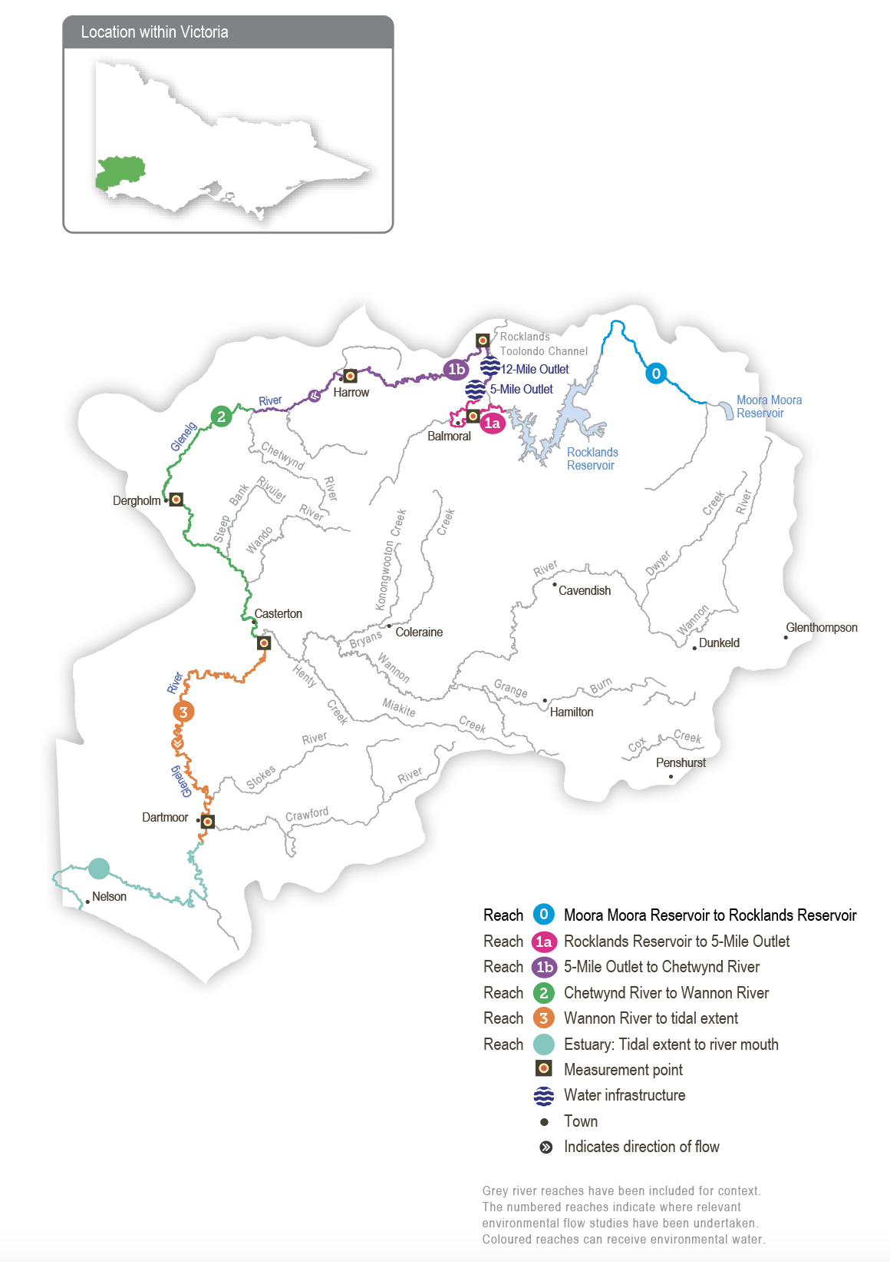

Environmental values
The Glenelg River starts in Gariwerd (the Grampians National Park) and flows to the sea through the Lower Glenelg National Park. The lower reaches of the Glenelg River are part of a landscape recognised as one of 15 national biodiversity hotspots, and the Glenelg Estuary and Discovery Bay site was listed under the Ramsar Convention as a site of international significance in February 2018.
The Glenelg River supports a range of rare and unique aquatic life, including the endangered Glenelg freshwater mussel, Glenelg spiny crayfish and a newly described species of river blackfish. It is also home to platypus and populations of native fish, including estuary perch, short-finned eel, tupong and three species of pygmy perch, including the threatened variegated pygmy perch and Yarra pygmy perch. Some of these fish species migrate long distances to and from the Glenelg River estuary to complete their life cycles. Sand extraction currently occurs around the Casterton to Dergholm reaches to provide deep pools, habitats and drought refuge areas, important to fish species and the macroinvertebrates that feed them.
Frasers Swamp is another important feature of the upper Glenelg system and is home to a healthy growling grass frog population. The swamp also meets the habitat requirements for the Australasian bittern, and investigations are underway to determine if they use this habitat.
The Glenelg River supports a variety of streamside vegetation communities and species, including the endangered Wimmera bottlebrush. Streamside and floodplain vegetation comprises river red gum woodlands with paperbark, bottlebrush and tea tree understorey.
Environmental objectives in the Glenelg system
F1 | Protect, maintain, and, where possible, enhance endemic fish populations, including threatened and diadromous species
G1 | Maintain deep pool habitats and connectivity along the river
MI1 | Maintain a wide range and large number of waterbugs to break down organic matter and support the river’s food chain
PR1 | Maintain the platypus population
V1 | Maintain healthy and diverse mosaics of water-dependent vegetation (such as river red gums and Wimmera River bottlebrush)
V2 | Prevent the establishment of terrestrial plans in the stream bed
WQ1 | Maintain water quality for native fish, waterbugs, other water-dependent animals and aquatic vegetation

Traditional Owner cultural values and uses
The Glenelg River, known as Bochara in Dhauwurd Wurrung, Pawur in Bunganditj and Bogara in Wergaia-Jadawadjali languages, is a significant feature in the cultural landscape of south-west Victoria. The river features in Traditional Owner creation stories. The Glenelg River continues to be an important place for Traditional Owners, who have been custodians of the area for thousands of years, using the rich resources available along the river and the associated habitats.
In planning for environmental flows in the Glenelg River, several on-Country meetings have been held to increase Traditional Owner involvement in environmental watering. There has also been an increase in communicating operational changes to water deliveries. When planning for the Glenelg River seasonal watering proposal, the Gunditj Mirring Traditional Owners Aboriginal Corporation, Barengi Gadjin Land Council and Burrandies Aboriginal Corporation, together with the Glenelg Hopkins CMA, have considered:
- supporting the health of cultural heritage sites (such as scar trees, ring trees, stone structures, middens and rock paintings) and native plants, which are sources of traditional foods and medicines
- that improving the health and abundance of totem species and their habitat by delivering water for the environment also benefits Traditional Owners’ spiritual wellbeing
- supporting contemporary cultural events such as the Johnny Mullagh cricket match in March each year. A summer fresh is delivered to support environmental outcomes, but it also supports this event on the river.
Traditional Owners across the Glenelg catchment have retained a strong identity and connection to the traditional lands for which they have custodial rights and responsibilities. Cultural values in the Glenelg River system align strongly with environmental values. Cultural values are holistic and interrelated: they are bound up with the health of the river system overall and the Country of which the river is part. Traditional Owners’ wellbeing is connected to the health of the river and of Country.
Gunditjmara Traditional Owners have identified that it is a priority to spend time on the river and increase cultural practices and connection to Country. They have highlighted the importance of increasing ceremonial and on-Country gatherings along the river, including at Casterton and the Glenelg Estuary.
The Glenelg River Yarns website was launched in late 2021 as part of the Glenelg River Cultural Flows project. The website shares cultural values and stories on a virtual tour and welcomes all visitors to Country.
Figure 4.2.2 Glenelg River Environmental Flow Seasonal Calendar
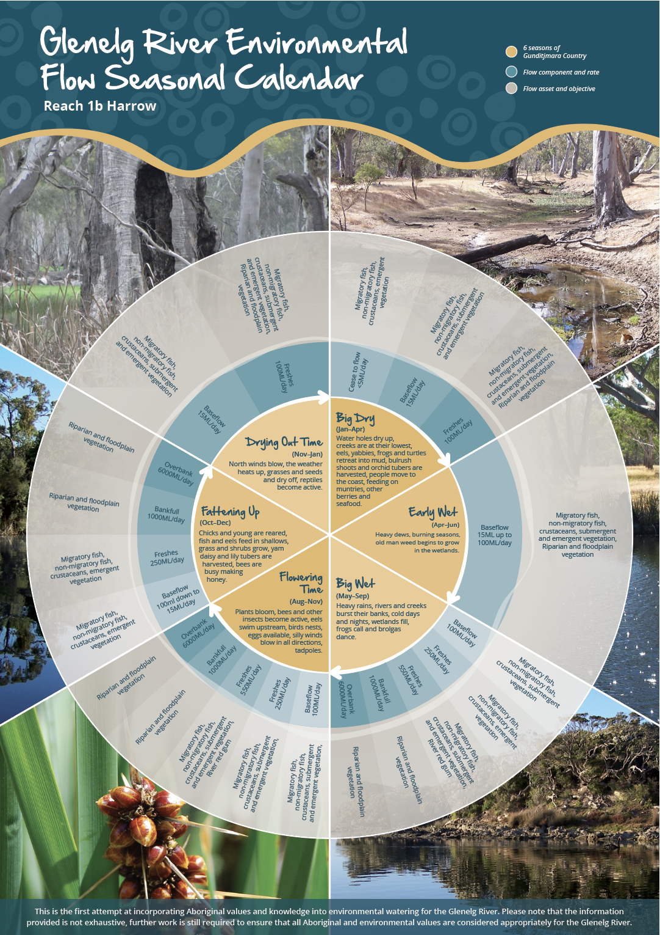
Figure 4.2.2 was produced by the Gunditj Mirring Traditional Owners Aboriginal Corporation and describes the six seasons of Gunditjmara Country. The northern part of the river upstream of the Harrow area is in Jadawadjali Country, and the south-west part of the system is in Boandik Country. The calendar describes the six seasons alongside flow components for reach 1b of the Glenelg River – from 5-Mile Outlet to Chetwynd River — and aligns them with corresponding watering effects and objectives. The calendar reflects the seasonal flow conditions that all Glenelg River system Traditional Owner groups recognise.
The value of the calendar is in its clear visual depiction of Traditional Owners’ knowledge, developed over many generations, of how varying flows correspond to seasonal conditions and broader environmental patterns. The six seasons will be embedded in future environmental flow recommendations and scenario planning.
Increasing the involvement of Traditional Owners in planning and managing environmental flows and ultimately progressing Traditional Owner self-determination in the environmental watering program is a core commitment of the VEWH and the Glenelg Hopkins CMA. This is reinforced by legislation and policy commitments, including the Water Act 1989, the Victorian Aboriginal Affairs Framework, the 2016 Water for Victoria, the 2022 Water is Life: Traditional Owner Access to Water Roadmap, and, in some cases, agreements under the Traditional Owner Settlement Act 2010.
Planned environmental flows may be modified to align with cultural benefits so long as environmental outcomes are not compromised. The timing of the summer/autumn fresh for the Glenelg River is planned to support the annual Johnny Mullagh Cup cricket match between Gunditj Mirring and Barengi Gadjin Traditional Owners.
Where Traditional Owners are more deeply involved in the planning and/or delivery of environmental water for a particular site, their contribution is acknowledged in Table 4.2.1 with an icon (as explained in Figure 1.2.3). This icon does not intend to indicate that these activities are meeting all the needs of Traditional Owners.
 | Watering planned and/or delivered in partnership with Traditional Owners to support cultural values and uses

Social, recreational and economic values and uses
In planning the potential environmental watering actions in Table 4.2.1, the Glenelg Hopkins CMA considered how environmental flows could support values and uses, including:
- water-based recreation (such as canoeing and fishing)
- community events and tourism (such as the Johnny Mullagh Cup and visitation)
- socioeconomic benefits (such as for diverters for stock needs and domestic use: water levels and water quality can rely on the delivery of water for the environment, particularly in summer).
Planned environmental flows may be modified to align with a community benefit so long as environmental outcomes are not compromised. Environmental flow releases support the spawning and recruitment of popular angling species like estuary perch and bream. Local anglers continue to report increased fish activity associated with the delivery of freshes, improving fishing opportunities in the river. Releases also support numerous fishing competitions, including the annual Casterton Angling Society carp competition and the tandanus catfish competition, partnering with local angling clubs, the Victorian Fisheries Authority and the North Central CMA.
The planning of the summer freshes improves accessibility, water quality and amenity for canoeists planning trips on the Glenelg River over the summer holiday period.
Summer and spring freshes improve conditions at popular riverside campgrounds in the upper reaches of the Glenelg River, including Fulham Reserve near Balmoral and the Johnny Mullagh Reserve at Harrow. This is acknowledged in Table 4.2.1 with the following icons (as explained in Figure 1.2.3).
 | Watering planned to support angling activities
 | Watering planned to support water sports activities (e.g. canoeing)
 | Watering planned to support peaks in visitation (e.g. camping or other public activities on long weekends or school holidays)

Scope of environmental watering
The term ‘environmental watering’ refers to the active delivery of held environmental water to support particular environmental objectives by altering the flow in a river or water level in a wetland. While other terms are sometimes used to describe the delivery of environmental water, ‘environmental watering’ is deliberately used here and in seasonal watering statements to ensure consistency in the legal instruments that authorise the use of environmental water in Victoria.
Table 4.2.1 describes the potential environmental watering actions in 2024-25, their expected watering effect (that is, the intended physical or biological effects of the watering action) and the longer-term environmental objectives they support. Each environmental objective relies on one or more potential environmental watering actions and their associated physical or biological effects.
Table 4.2.1 Glenelg system potential environmental watering actions, expected effects and environmental objectives
Potential environmental watering action | Expected watering effects | Environmental objectives
Winter/spring low flow in reach 1a (60 ML/day or natural during June to November) | - Maintain water quality for fish and waterbugs  - Wet aquatic vegetation to maintain its condition and prevent encroachment by terrestrial species  - Maintain shallow-water habitat for fish, waterbugs and platypus | F1  MI1  PR1  V1  V2
Winter/spring low flow in reach 1b (100 ML/day or natural during June to November)
Winter/spring low flow in reach 2 (160 ML/day or natural during June to November)
Winter/spring fresh(es) in reach 1b (one to five freshes of 250 ML/day for one to five days during June to November) | - Wet benches to improve the condition of emergent vegetation and vegetation on the riverbanks to support recruitment and growth and maintain habitat diversity  - Provide adequate water depth for fish passage and to cue fish movement  - Encourage female platypus to select nesting burrows higher up the bank to reduce the risk of a greater flow later in the year flooding burrows when juveniles are present  - Scour sand from pools to improve the quality of fish habitat | F1  G1  PR1  V1
Winter/spring fresh(es) in reach 2 (one to five freshes of 300 ML/day for one to five days during June to November)
Summer/autumn low flow in reach 1a (10 ML/day during December to May)   | Protect against a rapid decline in water quality in the low-flow period  Maintain edge habitats, pools and shallow-water habitat for fish, waterbugs and platypus  Maintain a near-permanent wetted stream channel to promote the growth of in-stream vegetation and prevent encroachment by terrestrial plants | F1  PR1  V1  V2  WQ1
Summer/autumn low flow in reach 1b (15 ML/day during December to May)
Summer/autumn low flow in reach 2 (25 ML/day during December to May)

Summer/autumn low flow in reach 3 (80 ML/day during December to May)
Summer/autumn low flow in reach 0 (0.5 ML/day during December to May) | - Maintain edge habitats, pools and shallow-water habitat for fish, waterbugs (western swamp crayfish) and platypus  - Maintain a near-permanent wetted stream channel to promote the growth of in-stream vegetation and prevent encroachment by terrestrial plants | F1  MI1  PR1  V1  V2
Summer/autumn fresh(es) in reach 1a (one to two freshes of 60 ML/day for two to three days during December to May)   | - Flush fine silt from the stream bed and hard substrate to improve the quality of the fish and waterbug habitat  - Wet emergent vegetation on the lower banks to improve its condition  - Flush pools to improve water quality and lower temperatures  - Provide sufficient flow to allow native fish and platypus to access habitat | F1  G1  PR1  V1  WQ1
Summer/autumn fresh(es) in reach 1b (one to two freshes of 100 ML/day for two to three days during December to May)

Summer/autumn fresh(es) in reach 2 (one to two freshes of 150 ML/day for two to three days during December to May)

Summer/autumn fresh(es) in reach 3 (one to two freshes of 150 ML/day for three days each or natural during December to May)

Scenario planning
Table 4.2.2 outlines potential environmental watering and expected water use in a range of planning scenarios.
Rainfall across the Glenelg catchment in 2023-24 was close to the long-term average, and natural run-off combined with managed passing flows helped meet many of the planned watering actions during the year. These flows and contributions from environmental water releases helped consolidate the improvements to native fish and vegetation populations that resulted from the widespread floods in 2022-23.
Environmental watering actions in the Glenelg River typically target reaches 1b and 2 because that is where managed flows can have the greatest environmental effect. The high supply of environmental water in 2024-25 will allow a wide range of watering actions to be delivered in the Glenelg system for the second consecutive year. In particular, the greater supply will likely allow summer/autumn freshes in reach 1a in the drier planning scenarios, winter/spring freshes in reach 2 and potential releases in reach 0.
The priority environmental objectives for environmental flows in 2024-25 are to:
- maintain channel form and water quality
- maintain connectivity and provide migration opportunities for native fish
- support juvenile recruitment of native fish
- promote in-stream vegetation and edge habitat for macroinvertebrates, fish and platypus.
- prevent the establishment of terrestrial plans in the stream bed
Delivering a summer/autumn low flow to maintain a continuous flow in reaches 1a, 1b and 2 is the highest-priority environmental watering action in all planning scenarios. Monitoring in recent years has demonstrated that maintaining a continuous flow and so avoiding cease-to-flow events is the most effective way of preventing declines in the abundance and condition of native fish and platypus populations in the Glenelg River. A summer/autumn low flow is proposed among other watering actions for reaches 1a, 1b and 2 in all planning scenarios and is the only environmental watering action proposed for reach 2 in the drought planning scenario. In the drought planning scenario, another flow is not planned for reach 2 because it could not be delivered with the forecast available supply and would likely have less environmental benefit than a flow delivered in reaches 1a and 1b. Water for the environment will not be used to deliver a low flow to reach 3 in any planning scenario because a low flow release from Rocklands Reservoir is unlikely to have much effect so far downstream in the drought-to-dry planning scenarios, and low flow objectives in that reach should be met by tributary inflows in average and wet conditions.
Summer/autumn freshes are the next-highest-priority watering action in the Glenelg River and are needed to vary the flow, support fish migration and improve water quality outcomes. In the drought planning scenario, summer/autumn freshes will only be delivered to reaches 1a and 1b because environmental water can be efficiently delivered to those reaches via the Rocklands wall, Five Mile and 12 Mile outlets, and they support some of the Glenelg River’s most flow-sensitive environmental values. The increased availability of environmental water compared to other years allows summer/autumn freshes to be delivered to reach 2 in the very dry planning scenario and to all reaches (including reach 3) in the dry-to-wet planning scenarios.
Environmental watering actions in reach 1a are significantly constrained by releases that can be made from the Rocklands Reservoir wall and the hydraulic interactions at Frasers Swamp. Reach 1a is immediately downstream of Rocklands Reservoir, meaning it has little natural inflow and relies heavily on mandated passing flow and managed environmental flows. However, large releases from Rocklands Reservoir can potentially flood private land adjacent to Frasers Swamp. A winter/spring low flow is the largest flow proposed to be delivered to reach 1a in the dry-to-wet planning scenarios if sufficient water is available. While a greater flow would likely have an environmental benefit, it is not planned due to the potential risk of flooding private land.
Winter/spring freshes will be delivered in reach 1b and reach 2 where possible in the average and wet planning scenarios to trigger fish and platypus movement, wet vegetation higher up the bank and scour sand from some pool substrates to improve habitat quality for fish and macroinvertebrates. Similar flows are likely to occur at least partially in reach 3 by tributary inflows and local catchment run-off in the average and wet planning scenarios.
Water for the environment has been delivered occasionally to reach 0 in recent years. These releases have partly addressed specific environmental requirements and have also been used to help understand what flow magnitudes can be achieved via managed flow releases from Moora Moora Reservoir. A summer/autumn low flow may be delivered to reach 0 in 2024-25 in average or wet planning scenarios to further test environmental responses to managed releases, but this flow is a lower priority than planned deliveries to reaches 1a, 1b and reach 2.
During the scenario planning process, the Glenelg Hopkins CMA used a flow delivery model to inform decisions about the volumes of environmental water required. The model cannot accurately predict the contribution of passing flow to proposed environmental watering actions, contributions that are potentially significant in the average and wet planning scenarios. Therefore, the volumes in Table 4.2.2 will likely be greater than needed in average and wet planning scenarios.
Carryover will be vital to ensure sufficient water availability to deliver the highest-priority flows during summer and autumn 2025-26 if there are low allocations during the year. The VEWH will work with the Wimmera and Glenelg Hopkins CMAs to refine a carryover target for 2025-26 once winter and spring storage inflows are known and the potential resource outlook for the following year is clear.
Table 4.2.2 Glenelg River system environmental watering planning scenarios
Planning scenario | Drought | Very dry | Dry | Average | Wet
Expected availability of water for the environment¹ | - 62,813 ML | - 69,303 ML | - 80,660 ML | - 90,394 ML | - 98,100 ML
Glenelg River (targeting reach 1a)
Potential environmental watering – tier 1 (high priorities) | Tier 1a (can be achieved with predicted supply)
 | - Summer/autumn low flow  - Summer/autumn fresh (one fresh) | - Summer/autumn low flow  - Summer/autumn freshes (two freshes) | - Winter/spring low flow  - Summer/autumn low flow  - Summer/autumn freshes (two freshes) | - Winter/spring low flow  - Summer/autumn low flow  - Summer/autumn freshes (two freshes) | - Winter/spring low flow  - Summer/autumn low flow  - Summer/autumn freshes (two freshes)
 | Tier 1b (supply deficit)
 | - N/A
Potential environmental watering – tier 2 (low priority) | - Winter/spring low flow  - Summer/autumn fresh (one fresh) | - Winter/spring low flow | - N/A
Glenelg River (targeting reach 1b)
Potential environmental watering – tier 1 (high priorities) | Tier 1a (can be achieved with predicted supply)
 | - Summer/autumn low flow  - Summer/autumn fresh (one fresh) | - Summer/autumn low flow  - Summer/autumn freshes (two freshes) | - Summer/autumn low flow  - Summer/autumn freshes (two freshes) | - Winter/spring freshes (three freshes)  - Summer/autumn low flow  - Summer/autumn freshes (two freshes) | - Winter/spring low flow  - Winter/spring freshes (three freshes)  - Summer/autumn low flow  - Summer/autumn freshes (two freshes)
 | Tier 1b (supply deficit)
 | - N/A
Potential environmental watering – tier 2 (low priority) | - Winter/spring low flow  - Winter/spring fresh (one fresh)  - Summer/autumn fresh (one fresh) | - Winter/spring low flow  - Winter/spring fresh (one fresh) | - Winter/spring low flow  - Winter/spring freshes (two freshes) | - Winter/spring low flow
Glenelg River (targeting reach 2)
Potential environmental watering – tier 1 (high priorities) | Tier 1a (can be achieved with predicted supply)
 | - Summer/autumn low flow | - Summer/autumn low flow  - Summer/autumn freshes (two freshes) | - Summer/autumn low flow  - Summer/autumn freshes (two freshes) | - Winter/spring freshes (three freshes)  - Summer/autumn low flow  - Summer/autumn freshes (two freshes) | - Winter/spring freshes (five freshes)  - Summer/autumn low flow  - Summer/autumn freshes (two freshes)
 | Tier 1b (supply deficit)
 | N/A
Potential environmental watering – tier 2 (low priority) | - Winter/spring low flow  - Winter/spring fresh (one fresh)  - Summer/autumn freshes (two freshes) | - Winter/spring low flow  - Winter/spring fresh (one fresh) | - Winter/spring low flow  - Winter/spring freshes (two freshes) | - Winter/spring low flow | - Winter/spring low flow
Glenelg River (targeting reach 3)
Potential environmental watering – tier 1 (high priorities) | Tier 1a (can be achieved with predicted supply)
 | - N/A |  | - Summer/autumn freshes (two freshes) | - Summer/autumn freshes (two freshes) | - Summer/autumn freshes (two freshes)
 | Tier 1b (supply deficit)
 | - N/A
Potential environmental watering – tier 2 (low priority) | - Summer/autumn freshes (two freshes) | - Summer/autumn freshes (two freshes)
Glenelg River (targeting reach 0)
Potential environmental watering – tier 1 (high priorities) | Tier 1a (can be achieved with predicted supply)
 | - N/A |  |  | - Summer/autumn low flow | - Summer/autumn low flow
 | Tier 1b (supply deficit)
 | - N/A
Potential environmental watering – tier 2 (low priority) | - Summer/autumn low flow | - Summer/autumn low flow | - Summer/autumn low flow | - N/A
Possible volume of water for the environment required to achieve objectives | - 11,781 ML (tier 1a)  - 42,177 ML (tier 2) | - 12,010 ML (tier 1a)  - 40,128 ML (tier 2) | - 13,635 ML (tier 1a)  - 38,503 ML (tier 2) | - 25,843 ML (tier 1a)  - 32,265 ML (tier 2) | - 26,159 ML (tier 1a)  - 30,133 ML (tier 2)
Priority carryover requirements for 2025-26 | - The VEWH will work with the Wimmera and Glenelg Hopkins CMAs to refine a carryover target for 2025-26 once winter and spring storage inflows are known and the potential resource outlook for the following year is clear.
1 Volume represents the available water for the Wimmera and Glenelg systems under the shared Wimmera and Glenelg Rivers Environmental Entitlement 2010 and is the sum of carryover and estimated new allocations

4.3 Wimmera system
Waterway manager – Wimmera Catchment Management Authority
Storage manager – Grampians Wimmera Mallee Water
Environmental water holders – Victorian Environmental Water Holder and Commonwealth Environmental Water Holder

System overview
Barringgi Gadyin (Wimmera River) rises in the Pyrenees Ranges near Elmhurst and flows through Horsham, Dimboola and Jeparit before terminating at Lake Hindmarsh, which is Victoria’s largest freshwater lake and the first of a series of terminal lakes. The Wimmera River receives flows from several regulated tributaries, including the MacKenzie River, Mount William Creek and Burnt Creek (Figure 4.3.1). These tributaries, plus Bungalally Creek and the Wimmera River below Mount William Creek, can receive water for the environment. In exceptionally wet periods, Lake Hindmarsh will overflow into Outlet Creek and then to Lake Albacutya, an internationally recognised Ramsar-listed wetland. Many wetlands beyond Lake Albacutya have not filled with water for decades.
Water in the Wimmera system is stored in three on-stream reservoirs (Lake Wartook on the MacKenzie River, Lake Lonsdale on Mount William Creek and Lake Bellfield on Fyans Creek) and in several off-stream storages (Taylors Lake, Lake Fyans and Toolondo Reservoir). A channel system enables water to be moved between storages. Water can also be transferred from Rocklands Reservoir in the Glenelg system to the Wimmera system via the Rocklands-Toolondo Channel and from Moora Moora Reservoir via the Moora Channel. The connected storages and channels are collectively called the Wimmera-Mallee System Headworks. Water harvested in the system headworks is used for town, stock and domestic supply throughout the Wimmera catchment and parts of the Avoca, Hopkins, Loddon, Glenelg and Mallee catchments. Passing flows are provided to the Wimmera River and lower Mount William and Fyans creeks.
Priority reaches in the Wimmera system that can receive water for the environment are Wimmera River reaches 3 and 4, MacKenzie River reaches 2 and 3, upper and lower Mount William Creek, upper and lower Burnt Creek and Bungalally Creek.
Yarriambiack Creek is a distributary of the upper Wimmera River that would have naturally received a flow during high-flow or flood events. Lower reaches of the Wimmera River have priority for environmental water, which means no water is diverted for environmental watering to this creek. Grampians Wimmera Mallee Water provides recreational entitlements via the Wimmera-Mallee Pipeline to the creek at the Warracknabeal, Brim and Beulah weir pools.
Downstream of Jeparit, the Wimmera River reaches the terminal lakes, including Lake Hindmarsh, a wetland of national significance and Lake Albacutya, recognised internationally under the Ramsar Convention. These lakes do not usually receive environmental water but rely mainly on passing flows and/or unregulated flows to provide suitable inundation to achieve environmental outcomes. However, in a wet year, regulated releases are of some value for raising the levels of terminal lakes and improving environmental outcomes.
Dock Lake, near Horsham, would have naturally filled via spills from nearby Green Lake when there was significant run-off from the northern edge of the Grampians. In the 1930s, Dock Lake was modified to allow it to be used as a water storage for irrigation supply in the Wimmera-Mallee system. Dock Lake was removed from the supply system after the Wimmera-Mallee Pipeline was completed in 2010. Water can be delivered to Dock Lake from Green Lake via a gravity-fed channel when there is sufficient water in Green Lake.
Ranch Billabong, near Dimboola, is an anabranch of the Wimmera River at Dimboola. It is on land managed by Barengi Gadjin Land Council Aboriginal Corporation. The anabranch was disconnected from the Wimmera River by changes to a road that traverses land between the river and the billabong. Restoring elements of the natural water regime at Ranch Billabong aims to improve habitat for native animal and plant communities and is an important outcome for Traditional Owners.
Figure 4.3.1 The Wimmera system
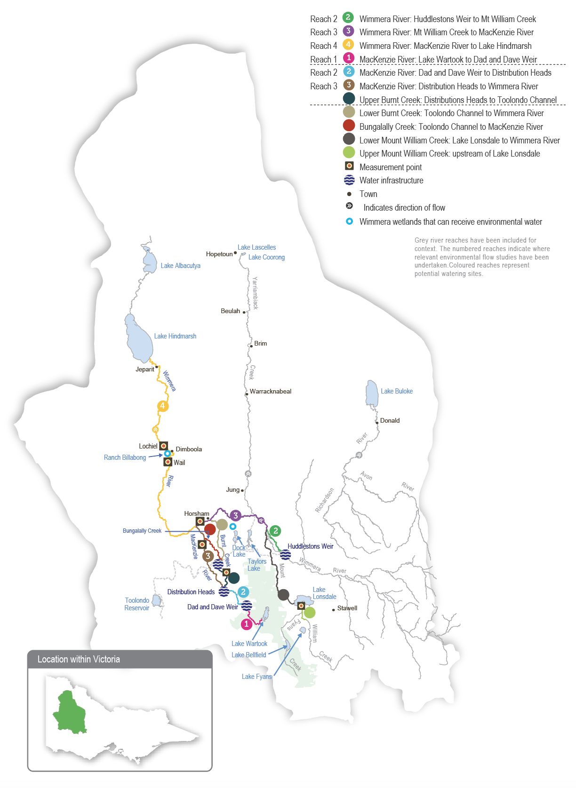

Environmental values
The Wimmera River supports abundant native fish populations, including one of Victoria’s few self-sustaining populations of freshwater catfish. The Wimmera River also supports native waterbird, turtle, frog and rakali (water rat) populations.
The MacKenzie River contains the only confirmed remaining platypus population in the Wimmera system and supports locally important populations of native fish, including river blackfish and southern pygmy perch. It also supports populations of threatened Glenelg spiny crayfish, western swamp crayfish and turtles, as well as the critically endangered Wimmera bottlebrush. Managed releases from Lake Wartook for urban supplies and an environmental flow maintain a regular flow in the middle and upper reaches of the MacKenzie River and provide refuges for regionally important populations during dry periods.
Vegetation along Burnt and Bungalally creeks provides habitat corridors for terrestrial wildlife. Upper Burnt Creek contains an important native fish community and a threatened western swamp crayfish population, which is also becoming established in lower Burnt Creek. Mount William Creek supports regionally important populations of obscure galaxias, southern pygmy perch and rakali (water rats).
Dock Lake is a natural wetland that was modified and used as part of the Wimmera-Mallee System Headworks until 2010. When wet, Dock Lake provides feeding and breeding habitat for large numbers of waterbirds and frogs.
Ranch Billabong is a small wetland near Dimboola that supports river redgums, various aquatic plant species, waterbirds and frogs. It also includes a range of culturally significant plant species (such as sneezeweed).
In very high flow periods, the Wimmera River discharges Lake Hindmarsh and Lake Albacutya, large sub-terminal lakes. Lake Albacutya is a Ramsar-listed wetland, and Lake Hindmarsh is Victoria’s largest freshwater lake. Both provide significant habitat for waterbirds when wet.
Environmental objectives in the Wimmera system
A1 | Maintain the frog population by providing feeding and breeding habitat
B1 | Maintain the waterbird population by providing roosting, feeding and breeding habitat in floodplain wetlands
F1 | Protect and increase the native fish population, including one of Victoria’s few self-sustaining freshwater catfish populations
G1 | Maintain the channel’s capacity and diversity
MI1 | Increase the abundance and diversity of waterbugs to break down dead organic matter and support the waterway’s food web
MI2 | Maintain the crayfish population by providing feeding and breeding habitat
PR1 | Increase the abundance and distribution of the platypus population by providing places to breed and feed, as well as opportunities for juveniles to disperse
T1 | Maintain the turtle population by providing feeding and breeding habitat
V1 | Improve the condition, abundance and diversity of native aquatic, emergent and streamside vegetation
V2 | Prevent the establishment of terrestrial plans in the stream bed
WQ1 | Maintain water quality to provide suitable conditions for waterbugs, native fish and other water-dependent animals and plants

Traditional Owner cultural values and uses
The Wimmera’s waterways are the life blood of the Wotjobaluk, Jaadwa, Jadawadjali, Wergaia and Jupagulk people, collectively known as the Wotjobaluk Nations and represented by the Barengi Gadjin Land Council Aboriginal Corporation (BGLC).
In August 2022, the Victorian Government and the Wotjobaluk Nations entered into a Recognition and Settlement Agreement (RSA). In the RSA the Victorian Government recognised the Wotjobaluk Nations have a special relationship with Barringgi Gadyin, and that the river has a central place in their culture. The Victorian Government acknowledged in the RSA the aspirations of the Traditional Owners in regard to water, including to monitor and manage cultural and environmental flows associated with waterways. In December 2005, the Federal Court made its first determination that native title existed in south-east Australia, including in much of the lower Barringgi Gadyin.
In planning for environmental flows in Barringgi Gadyin, BGLC and the Wimmera CMA work together to support cultural objectives and values, including supporting contemporary cultural events (such as the Wimmera River Challenge).
Planned environmental flows may be modified to align with cultural benefits so long as environmental outcomes are not compromised. Where Traditional Owners are more deeply involved in the planning and/or delivery of environmental flows for a particular site, their contribution is acknowledged in Table 4.3.1 with an icon (as outlined in Figure 1.2.3). In the Wimmera system, Wimmera CMA and BGLC work in partnership to support cultural values at Ranch Billabong. The delivery of water for the environment at Ranch Billabong aims to provide a more natural flooding regime, restore indigenous plant species (such as old man weed and sneezeweed) and animal habitats, control selected weed species and improve amenity and suitability for gatherings and events (such as earth oven and bark-canoe cultural activities).
Water for the environment was delivered to Ranch Billabong in 2018, 2019, 2020 and 2021. In 2022, Ranch Billabong filled naturally by flooding. Watering during the past five years has improved water quality and vegetation condition, consistent with the cultural objectives of the Traditional Owners. BGLC manages the site and has controlled weed species and enhanced accessibility by building walking tracks and culvert crossings around the billabong. In 2023, a jetty was built and there were improvements to the surrounding area. A piped system is planned to permanently reconnect Barringgi Gadyin (Wimmera River) to the Ranch Billabong anabranch.
Increasing the involvement of Traditional Owners in managing environmental flows and progressing opportunities towards self-determination in the environmental watering program is a core commitment of the VEWH and its program partners. This is reinforced by legislation and policy commitments, including the Water Act 1989, the Victorian Aboriginal Affairs Framework, the 2016 Water for Victoria, the 2022 Water is Life: Traditional Owner Access to Water Roadmap, and, in some cases, agreements under the Traditional Owner Settlement Act 2010.
Where Traditional Owners are more deeply involved in the planning and/or delivery of environmental water for a particular site, their contribution is acknowledged in Table 4.3.1 with an icon (as explained in Figure 1.2.3). The use of this icon is not intended to indicate that these activities are meeting all the needs of Traditional Owners, but is used in the spirit of valuing that contribution.
 | Watering planned and/or delivered in partnership with Traditional Owners to support cultural values and uses

Social, recreational and economic values and uses
In planning the potential environmental watering actions in Table 4.3.1, the Wimmera CMA considered how environmental flows could support shared benefits, for example:
- water-based recreation (such as canoeing, fishing, rowing, and water skiing)
- riverside recreation and amenity (such as birdwatching, cycling, running, and walking)
- community and tourism events (such as fishing competitions at Dimboola, Jeparit and Horsham, rowing at Dimboola, the Kannamaroo Festival at Horsham, including the Wimmera River Duck Race, the Wimmera River Park Run, the Peter Taylor Memorial Barefoot Water Ski Tournament and Night Jump at Dimboola; and supporting small business, including chartered river cruises, pop-up food vendor caravans and general visitation)
- socioeconomic benefits (such as for diverters for irrigation, stock needs and domestic use: water levels and water quality, which can rely on the delivery of water for the environment, particularly in summer, and associated tourism events).
Planned environmental flows may be modified to align with a community benefit so long as environmental outcomes are not compromised. Water for the environment can temporarily raise water levels in Horsham, Dimboola and Jeparit weir pools to improve conditions for community events, including fishing competitions and water skiing and rowing events. Water for the environment held in the weir pools is released after community events to support environmental objectives further downstream when required.
The Wimmera CMA, in consultation with stakeholders, also refrains from releasing environmental water from water storages at peak recreational times. It does so only when this does not compromise environmental outcomes in Wimmera waterways to ensure maximum water levels in these storages. This is acknowledged in Table 4.3.1 with the following icons (as explained in Figure 1.2.3).

Scope of environmental watering
The term ‘environmental watering’ refers to the active delivery of held environmental water to support particular environmental objectives by altering the flow in a river or water level in a wetland. While other terms are sometimes used to describe the delivery of environmental water, ‘environmental watering’ is deliberately used here and in seasonal watering statements to ensure consistency in the legal instruments that authorise the use of environmental water in Victoria.
Table 4.3.1 describes the potential environmental watering actions in 2024-25, their expected watering effect (that is, the intended physical or biological effects of the watering action) and the longer-term environmental objectives they support. Each environmental objective relies on one or more potential environmental watering actions and their associated physical or biological effects.
Table 4.3.1 Wimmera system potential environmental watering actions, expected effects and environmental objectives
Potential environmental watering action | Expected watering effects | Environmental objectives
Wimmera River (reach 4)
Winter/spring low flow (30 ML/day during June to November)¹   | - Maintain access to habitat for native fish, waterbugs and in-stream vegetation | F1  MI1  V1
Small winter/spring fresh(es) (one to five freshes of 70 ML/day for one to four days during June to November) | - Increase water depth to provide a stimulus for fish movement  - Provide flow variability to maintain water quality and diversity of fish habitats | F1  WQ1
Medium winter/spring fresh(es) (one to three freshes of 200-300 ML/day for one to three days during June to November) | - Provide variable flow during the high-flow season for fish movement  - Provide flow variability to maintain water quality and diversity of fish habitats  - Wet lower benches to support native streamside vegetation, draw in and transport organic debris and maintain habitat for waterbugs and fish  - Flush surface sediments from hard substrates for macroinvertebrates | F1  MI1  V1  WQ1
Trial large spring fresh(es) (one to two freshes of 500-1,300 ML/day for two to three days during September to November) | - Cue fish spawning and movement | F1
Summer/autumn low flow (15 ML/day or natural during December to May¹) | - Maintain edge habitats in deeper pools and in-stream habitat to support native fish populations and waterbugs  - Maintain soil moisture for streamside vegetation and a near-permanent, inundated stream channel for aquatic vegetation  - Prevent the growth of terrestrial plants in the stream bed | F1  MI1  V1  V2
Summer/autumn fresh(es) (one to three freshes of 70 ML/day for two to seven days during December to May) | - Flush pools to prevent a decline in water quality and to maintain habitat for fish and waterbugs  - Provide fish passage to allow fish to move through the reach | F1  MI1  WQ1
MacKenzie River (reach 3)
Winter/spring low flow (10 ML/day or natural during June to November)¹ | Maintain edge habitats and deeper pools and runs for waterbugs, platypus, native fish and crayfish populations  Maintain soil moisture for streamside vegetation and near-permanent inundated stream channel for aquatic vegetation and prevent the growth of terrestrial plants in the stream bed | F1  MI1  MI2  PR1  V1  V2
Winter/spring fresh(es) (one to three freshes of 15-60 ML/day for two to seven days during June to November) | At 15 ML/day:  - Provide a variable flow to maintain habitats at times that a continuous minimum low flow cannot be provided to support fish, platypus and waterbugs  At above 35 ML/day:  - Increase flow rates and water depth to facilitate fish movement  - Flush pools to prevent a decline in water quality  - Maintain soil moisture for streamside vegetation | F1  MI1  PR1  V1  WQ1
Summer/autumn low flow (5-10 ML/day or natural during December to May) | - Maintain pool habitat for native fish and crayfish populations  - Maintain edge habitats and deeper pools and runs for waterbugs and platypus  - Maintain soil moisture for streamside vegetation and near-permanently inundated stream channel for aquatic vegetation and prevent the growth of terrestrial plants in the stream bed | F1  MI1  MI1  PR1  V1  V2
Summer/autumn freshes (three to four freshes of 35 ML/day for two to seven days each during December to May) | - Provide a variable flow during the low-flow season for fish movement  - Flush pools and provide flow variability to maintain water quality  - Flush sediments from hard substrates to increase biofilm production and food for waterbugs | F1  MI1  WQ1
Upper Burnt Creek
Winter/spring low flow (1 ML/day or natural during June to November) | - Maintain edge habitats and shallow-water habitat for waterbugs  - Maintain soil moisture for streamside vegetation and a near-permanently inundated stream channel for aquatic vegetation and prevent the growth of terrestrial plants in the stream bed  - Maintain a sufficient area of pool habitat for native fish and crayfish populations | F1  MI1  MI2  V1  V2
Winter/spring fresh(es) (one to five freshes of 15-60 ML/day for three to seven days during June to November) | - Allow fish to move throughout the reach  At above 30 ML/day, the above plus:  - Flush sediments from hard substrates to increase biofilm production and food for waterbugs | F1  MI1
Summer/autumn low flow (1 ML/day or natural during December to May) | - Maintain edge habitats and shallow-water habitat for waterbugs  - Maintain soil moisture for streamside vegetation and a near-permanently inundated stream channel for aquatic vegetation and prevent the growth of terrestrial plants in the stream bed  - Maintain a sufficient area of pool habitat for native fish and crayfish populations | F1  MI1  MI2  V1  V2
Summer/autumn freshes (three freshes of 30 ML/day for two to seven days each during December to May) | - Prevent a decline in water quality by flushing pools in the low-flow season  - Allow fish to move throughout the reach  - Flush sediments from hard substrates to increase biofilm production and food for waterbugs | F1  MI1  WQ1
Lower Burnt Creek
Bankfull fresh (one fresh of 45 ML/day for two days at any time) | - Inundate streamside vegetation to maintain plant condition and facilitate recruitment  - Move organic debris in the channel to support waterbugs  - Maintain the structural integrity of the channel and prevent the loss of channel capacity | G1  MI1  V1
Fresh(es) (four freshes of 15 ML/day for three to seven days at any time) | - Maintain water quality  - Maintain a sufficient area of pool habitat for native fish and crayfish populations | F1  MI2  WQ1
Bungalally Creek
Bankfull fresh (one fresh of 60 ML/day for two days at any time) | - Inundate the streamside zone to maintain its condition and facilitate the recruitment of streamside vegetation communities  - Maintain the structural integrity of the channel and prevent the loss of channel capacity | G1  V1
Lower Mount William Creek
Year-round low flow (5 ML/day or natural) | - Maintain edge habitats and shallow-water habitat for waterbugs and endemic fish  - Maintain soil moisture for streamside vegetation and a near-permanently inundated stream channel for aquatic vegetation and prevent the growth of terrestrial plants in the stream bed | F1  V1  V2  MI1
Winter/spring fresh(es) (one to five freshes of 100 ML/day for three to seven days during June to November) | - Wet benches to draw in and transport organic debris and allow native fish to move throughout the reach  - Flush surface sediments from hard substrates to support waterbugs  - Inundate the streamside zone to maintain its condition and facilitate the recruitment of streamside vegetation communities | F1  MI1  V1
Summer/autumn freshes (three freshes of 20-30 ML/day for two to seven days during December to May) | - Prevent a decline in water quality by flushing pools during low flow  - Flush surface sediments from hard substrates to support waterbugs  - Provide a variable flow and allow the movement of fish throughout the reach during the low-flow season | F1  MI1  WQ1
Upper Mount William Creek
Top-up pools (summer/autumn) | - Maintain edge and shallow-water habitat for native fish and waterbugs  - Maintain water quality | F1  MI1  WQ1
Dock Lake
Winter/spring partial fill | - Trigger the growth and germination of wet-phase wetland vegetation communities  - Support feeding and breeding habitat for waterbirds, frogs, waterbugs and turtles | A1  B1  MI1  T1  V1
Ranch Billabong
Fill and top-ups year-round   | - Inundate wetland vegetation to maintain the condition of plants and facilitate their recruitment  - Improve water quality for frogs and waterbirds | A1  B1  V1
1 These potential watering actions may, in select circumstances and with the oversight of the Wimmera River Operational Advisory Group (comprising Wimmera CMA, VEWH and CEWH representatives), be augmented and targeted at a higher-than-recommended rate to have the best chance of water reaching lakes Hindmarsh and Albacutya and achieving the desired environmental outcomes.

Scenario planning
Table 4.3.2 outlines potential environmental watering and expected water use in a range of planning scenarios.
Rainfall across the Wimmera catchment in 2023-24 was close to the long-term average, and natural run-off combined with the managed passing flows helped meet many of the planned watering actions that the Wimmera CMA chose to deliver during the year. These flows, as well as contributions from environmental water, maintained a continuous flow in the Wimmera River from winter to the end of summer and helped consolidate the improvements to native fish populations and vegetation communities that resulted from the widespread floods in 2022‑23. A large supply of environmental water in 2024-25 will provide scope to deliver potential watering actions to maintain the Wimmera system’s currently good environmental values in drought-to-dry conditions and continue to improve environmental conditions if there is average or above-average rainfall.

Wimmera River
In all planning scenarios, the highest-priority potential watering actions in the Wimmera River include low flows and small freshes throughout the year to maintain diverse aquatic habitats and suitable water quality throughout the length of the river and opportunities for fish to move to access various resources or breed. In the drought and very dry planning scenarios, low flows may be delivered below the recommended magnitude to conserve water, but it may be increased at any time or supplemented with freshes if needed to manage potential water quality issues. In the average and wet planning scenarios, there should be enough water to deliver low flows at their recommended magnitude year-round and additional freshes to boost the river’s environmental health.
The Wimmera CMA may temporarily restrict or cease the river’s flow during the spring low-flow period to encourage carp to congregate below the Horsham weir (and potentially at other suitable locations) so they can be removed using electrofishing. Any cease-to-flow event would have a short duration and be followed by a fresh to avoid water quality problems and prevent harm to native fish. Restricting the flow to manage carp will only be attempted in the cooler seasons to avoid potential water quality problems and may not be possible in wetter conditions.
Winter/spring low flow actions planned for the Wimmera and MacKenzie rivers may, in select circumstances and with the oversight of the Wimmera River Operational Advisory Group (comprised of Wimmera CMA, VEWH and CEWH representatives), be augmented and targeted at a higher-than-recommended rate to provide the best chance of water reaching lakes Hindmarsh and Albacutya and achieving the desired environmental outcomes.
Increased water availability and greater contributions from natural run-off in dry, average and wet conditions will allow larger freshes to be delivered to provide opportunities for more widespread fish movement, improve the composition and condition of vegetation on banks and benches within the channel and wash organic matter into the river to support riverine food webs. More and larger freshes will likely be delivered in average and wet conditions, although they may also occur naturally.
A large spring fresh may be trialled in average and wet conditions in 2024-25 to trigger golden perch spawning. A regular stocking program mainly sustains the golden perch population in the Wimmera River, but numerous fish exhibited spawning behaviour in response to a large natural event in November 2021, and the Wimmera CMA is keen to see if natural spawning and recruitment can be supported with environmental watering. The flow volume to trigger golden perch spawning in the Wimmera River is unknown, and there is also some uncertainty about the maximum environmental flow that can be delivered through reach 4 of the Wimmera River. The Wimmera CMA aims to work with Grampians Wimmera Mallee Water (the storage manager) to coordinate releases from multiple storages to deliver the largest possible flow to reach 4 (within current system constraints) during the spring golden perch breeding season. The trial will only proceed if suitable monitoring is used to assess fish responses. The peak flow volume will also be measured to understand the largest flow that can be delivered through the system and to inform future flow plans.

MacKenzie River/Burnt Creek/Bungalally Creek
In the MacKenzie River and upper Burnt Creek, water for the environment will be used to deliver a low flow year-round and small to medium freshes in summer/autumn and winter/spring. The low flow will aim to maintain habitat for native fish, platypus and crayfish that recruited or improved their condition in recent years, and the freshes will aim to improve water quality, transport organic material, support fish and platypus dispersal and water streamside vegetation. In the drought-to-dry planning scenarios, freshes are only delivered as needed to prevent poor water quality and are likely to be delivered at the lower end of the planned magnitude and duration to conserve the available supply. In the average and wet planning scenarios, freshes in the MacKenzie River may be delivered at their full recommended magnitude and duration to increase opportunities for native fish and platypus to disperse and to increase the quality and quantity of their food to improve their condition and provide potential breeding opportunities. The target volume of winter/spring freshes in the MacKenzie River and upper Burnt Creek will vary depending on the weather and the observed environmental conditions, including the vegetation’s response to wetting. Watering actions for reach 3 of the MacKenzie River typically provide a suitable flow to meet objectives in reach 2.
A bankfull flow may be delivered to Bungalally Creek and lower Burnt Creek in the dry-to-wet planning scenarios to maintain the channel’s form and improve the health of the streamside vegetation. Freshes of 15 ML per day may also be delivered to the lower Burnt Creek to top up and refresh refuge pools in the same planning scenarios. These flows can only be delivered during periods of high natural flow throughout the system, so they are not included in the drier planning scenarios.

Mount William Creek
Water from Lake Lonsdale is expected to be used to help meet environmental flow targets in the Wimmera River throughout 2024-25 in all planning scenarios. This water will be delivered via lower Mount William Creek and is expected to meet the planned environmental watering actions for lower Mount William Creek en route.
Water from Lake Fyans may be used in any planning scenario in 2024-25 to top up refuge pools in upper Mount William Creek to improve water quality and habitat availability for native fish populations.

Ranch Billabong and Dock Lake
Water for the environment will likely be used to top up water levels in Ranch Billabong in drought, very dry and dry conditions to maintain water quality and support the ongoing recovery of the river red gum and associated understorey vegetation surrounding the billabong. In wet and average conditions, the billabong is expected to fill naturally.
Environmental flow objectives for Dock Lake require large volumes of water that can only be achieved with significant contributions from natural events and only when Green Lake is full. These conditions will only likely be met in the wet (and possibly average) planning scenarios in 2024-25.

Carryover
Carryover will be vital to ensure sufficient water is available to deliver the highest-potential watering actions during summer and autumn 2025-26 if there are low allocations during the year. The VEWH will work with the Wimmera and Glenelg Hopkins CMAs to set a carryover target for 2025-26 once winter and spring storage inflows are known and the potential resource outlook for the following year is clear.
Table 4.3.2 Wimmera system environmental watering planning scenarios
Planning scenario | Drought | Very dry | Dry | Average | Wet
Expected river conditions | - Infrequent, unregulated flow for reach 2 of the MacKenzie River, upper Burnt Creek and lower Mt William Creek  - Regulated releases provide flow at other times and locations | - Periodic, unregulated flow for reach 2 of the MacKenzie River, upper Burnt Creek and lower Mt William Creek  - Regulated releases provide flow at other times and locations | - Periodic, unregulated flow for reach 2 of the MacKenzie River, upper Burnt Creek and lower Mt William Creek  - Regulated releases provide flow at other times and locations, apart from the modest passing flow | - Regular, unregulated flow for reach 2 of the MacKenzie River, upper Burnt Creek and lower Mt William Creek  - Regular passing flow and unregulated releases for the Wimmera River and lower Mt William Creek  - Regulated releases provide flow at other times and locations | - Regular, unregulated flow for reach 2 of the MacKenzie River, upper Burnt Creek and lower Mt William Creek  - Frequent passing flow and unregulated releases for the Wimmera River and lower Mt William Creek  - Regulated releases provide flow at other times and locations
Predicted supply of water for the environment under the Wimmera-Glenelg environmental entitlement¹ | - 62,813 ML | - 69,303 ML | - 80,660 ML | - 90,394 ML | - 98,100 ML
Predicted supply of water for the environment under the CEWH’s entitlement² | - 17,553 ML | - 17,553 ML | - 17,553 ML | - 17,553 ML | - 17,553 ML
Wimmera River (targeting reach 4)
Potential environmental watering – tier 1 (high priorities) | Tier 1a (can be achieved with predicted supply)
 | - Winter/spring low flow (partially delivered at lower magnitude)  - Small winter/spring fresh (one fresh for one day)  - Summer/autumn low flow (partially delivered at lower magnitude)  - Summer/autumn fresh (one fresh) |  | - Winter/spring low flow  - Small winter/spring freshes (two freshes for two days each)  - Medium winter/spring fresh (one fresh for one day)  - Summer/autumn low flow  - Summer/autumn freshes (two freshes) | - Winter/spring low flow  - Small winter/spring freshes (three freshes for three days each)  - Medium winter/spring freshes (two freshes for two days each)  - Large spring fresh (one fresh for two days)  - Summer/autumn low flow  - Summer/autumn freshes (two freshes) | - Winter/spring low flow  - Small winter/spring fresh (one fresh for four days)  - Medium winter/spring freshes (three freshes for three days each)  - Large spring freshes (two freshes for two days each)  - Summer/autumn low flow  - Summer/autumn freshes (three freshes)
 | Tier 1b (supply deficit)
- Winter/spring low flow (full magnitude)
- Summer/autumn low flow (full volume)
MacKenzie River (targeting reach 3)
Potential environmental watering – tier 1 (high priorities) | Tier 1a (can be achieved with predicted supply)
 | - Winter/spring low flow (partially delivered at lower magnitude)  - Winter/spring freshes (four fresh for four days each)  - Summer/autumn low flow (partially delivered at lower magnitude)  - Summer/autumn freshes (three freshes) |  |  | - Winter/spring low flow  - Winter/spring freshes (five freshes for five days each)  - Summer/autumn low flow  - Summer/autumn freshes (four freshes) | - Winter/spring low flow  - Winter/spring freshes (five freshes for seven days each)  - Summer/autumn low flow  - Summer/autumn freshes (four freshes)
 | Tier 1b (supply deficit)
- Winter/spring low flow (full magnitude)
- Summer/autumn low flow (full magnitude)
Upper Burnt Creek
Potential environmental watering – tier 1 (high priorities) | Tier 1a (can be achieved with predicted supply)
 | - Winter/spring low flow  - Winter/spring freshes (two freshes for three days each)  - Summer/autumn low flow  - Summer/autumn freshes (three freshes) |  | - Winter/spring low flow  - Winter/spring freshes (three freshes for three days each)  - Summer/autumn low flow  - Summer/autumn freshes (three freshes) | - Winter/spring low flow  - Winter/spring freshes (five freshes for five days each)  - Summer/autumn low flow  - Summer/autumn freshes (three freshes) | - Winter/spring low flow  - Winter/spring freshes (five freshes for seven days each)  - Summer/autumn low flow  - Summer/autumn freshes (three freshes)
 | Tier 1b (supply deficit)
Lower Burnt Creek
Potential environmental watering – tier 1 (high priorities) | - N/A |  | - Freshes (three freshes)  - Bankfull fresh | - Freshes (two freshes)  - Bankfull fresh
Bungalally Creek
Potential environmental watering – tier 1 (high priorities) | - N/A |  |  | - Bankfull fresh
Lower Mount William Creek³
Potential environmental watering – tier 1 (high priorities) | - Year-round low flow  - Summer/autumn freshes (three freshes of two to seven days) |  |  | - Year-round low flow  - Summer/autumn freshes (three freshes of two to seven days) | - Year-round low flow  - Winter/spring fresh (one fresh)  - Summer/autumn freshes (three freshes of three to seven days)
Upper Mount William Creek
Potential environmental watering – tier 1 (high priorities) | - Top up pools
Dock Lake
Potential environmental watering – tier 1 (high priorities) | - N/A |  |  |  | - Winter/spring partial fill
Ranch Billabong
Potential environmental watering – tier 1 (high priorities) | - Fill and top-ups (year-round)
Possible volume of water for the environment required to achieve objectives | - 21,099 ML (tier 1a)  - 3,863 ML (tier 1b) | - 21,099 ML (tier 1a)  - 3,863 ML (tier 1b) | - 27,405 ML (tier 1a)  - 6,703 ML (tier 1b) | - 28,116 ML (tier 1a)  - 5,387 ML (tier 1b) | - 23,922 ML (tier 1)4  - 3,799 ML (tier 1b)
Priority carryover requirements for 2025-26 | The VEWH will work with the Wimmera and Glenelg Hopkins CMAs to refine a carryover target for 2025-26 once winter and spring storage inflows are known and the potential resource outlook for the following year is clear.
1 Volumes represent the available water for the Wimmera and Glenelg systems under the shared Wimmera and Glenelg Rivers Environmental Entitlement 2010 and are the total of carryover and estimated new allocations.
2 Volumes represent the available water for the Wimmera system held by the Commonwealth Environmental Water Holder under the Bulk Entitlement (Wimmera and Glenelg Rivers – GWMWater) Order 2010 and are the total of carryover and estimated new allocations.
3 All deliveries targeting Wimmera River reach 4 are expected to provide a flow that meets the requirements of this reach. Demands for water for the environment for these actions are zero as a result.
4 Models used to estimate the possible volume of water for the environment required to achieve objectives are insufficiently specific about the required volume in the wetter planning scenarios, and they likely overstate the potential demands. Demands in wet conditions would likely be much lower than this as the natural flows would meet the requirements for most actions.

4.4 Wimmera-Mallee wetlands system
Waterway manager – Mallee, North Central and Wimmera catchment management authorities
Storage manager – Grampians Wimmera Mallee Water
Environmental water holder – Victorian Environmental Water Holder

System overview
The Wimmera-Mallee wetlands include 52 sites on public and private land spread across north-west Victoria (Figure 4.4.1). From the early 20th century until the construction of the Wimmera-Mallee Pipeline Project (WMPP) in 2010, the deeper areas of these wetlands received water most years from the open channels associated with the Wimmera Mallee Domestic and Stock Channel System.
The WMPP replaced stock and domestic supply dams with tanks and the open-channel distribution system with pipelines to improve water efficiency. A portion of the water savings from the WMPP was converted to an environmental entitlement to improve the condition of the area’s flow-stressed rivers, creeks and wetlands; the rest was used to create regional development opportunities and boost supply reliability for other users. The WMPP reduced the amount of open-water habitat in predominantly agricultural areas formerly supplied by the open-channel system, so a separate 1,000 ML environmental entitlement was created to water some of the wetlands that were previously supplied through the channel system. Fifty-two priority wetlands can receive water from this environmental entitlement.
Water for the environment can only be delivered to the wetlands when there is sufficient capacity in the Wimmera-Mallee Pipeline system, which can be affected by demand from other pipeline customers. The North Central, Mallee and Wimmera CMAs work closely with Grampians Wimmera Mallee Water and land managers (including Parks Victoria, the Department of Energy, Environment and Climate Action and private landowners) to take account of pipeline capacity constraints when ordering environmental deliveries to wetlands.
Figure 4.4.1 The Wimmera-Mallee wetlands
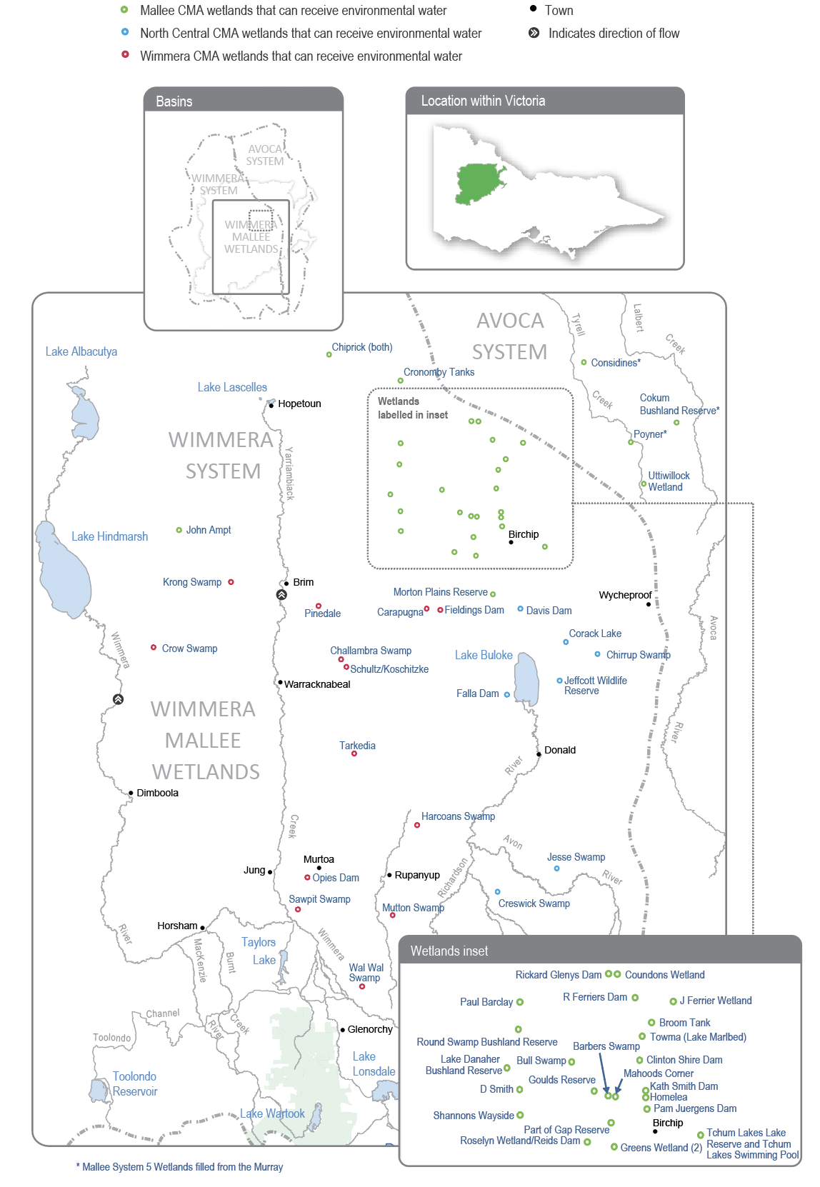

Environmental values
There are many wetland types in the Wimmera-Mallee wetlands system, including freshwater meadows, open freshwater lakes and freshwater marshes. This diversity provides various wetland habitats for plants and animals across the Wimmera-Mallee region. The wetlands also vary in size and support different vegetation communities. Some support native waterbird populations, including brolgas, egrets, blue-billed ducks, freckled ducks, Australian painted snipes and glossy ibis. The vulnerable growling grass frog, turtles and many other native animals may use the wetlands as drought refuges and drinking holes. Rare and vulnerable vegetation species (such as spiny lignum, ridged water-milfoil, chariot wheels, cane grass and the recently reintroduced marbled marshwort) are also present in some wetlands.
Falla Dam is being trialled as a reserve site for critically endangered Murray hardyhead as part of the Murray Hardyhead Native Fish Recovery Plan. Some Murray hardyhead were introduced to Falla Dam in November 2023 with the intention of them surviving and being used to restock populations at sites outside the Wimmera-Mallee wetlands system that are adversely impacted by drought or other disturbances in the future.
Environmental objectives in the Wimmera-Mallee wetlands
A1 | Maintain the frog population
B1 | Maintain populations of waterbirds and other native birds by providing resting, feeding and breeding habitat
F1 | Maintain the translocated small-bodied native fish population
T1 | Maintain the turtle population
TA1 | Provide watering holes for native animals and terrestrial birds across the landscape
V1 | Maintain the condition of aquatic and fringing plants, including lignum, river red gum and black box communities and improve the diversity of wetland vegetation communities

Traditional Owner cultural values and uses
The broad geographic area that includes the Wimmera-Mallee wetlands has a longstanding cultural connection for the Traditional Owners of the region, including groups represented by the Barengi Gadjin Land Council Aboriginal Corporation and the Dja Dja Wurrung Clans Aboriginal Corporation (DJAARA) and Barapa Barapa Traditional Owners. Some sites have artefacts and scar trees recorded in or adjacent to them, and further cultural surveys could better inform the management of water for the environment at those sites.
The Barengi Gadjin Land Council (BGLC) is the Registered Aboriginal Party for a significant land area of the Wimmera-Mallee wetlands. The Barengi Gadjin Land Council represents the Wotjobaluk, Jaadwa, Jadawadjali, Wergaia and Jupagalk peoples.
In May 2022, the BGLC and the North Central CMA undertook a cultural values assessment at Creswick Swamp. Cultural values identified at the site include river red gums and eastern grey kangaroos. In September 2023, the BGLC and the North Central CMA met at Creswick Swamp with Parks Victoria, the Department of Energy, Environment and Climate Action and Banyena Landcare. The group conducted a site assessment and discussed how a cultural burn at Creswick Swamp in 2024-25 could complement environmental watering by suppressing weeds and encouraging native vegetation.
BGLC provided the following statement to the North Central CMA after exploring Creswick Swamp.
“We are strengthening our commitment to caring for the Country and preserving its ecological balance. The information we gather and share will prove instrumental in safeguarding the survival of the various species that call this area home. Even during our walk, we witnessed the presence of lizards and even encountered a tiger snake within the wildlife reserve. Such encounters emphasise the importance of our collective efforts in maintaining the welfare of these species.”
In early 2024, BGLC and the Wimmera, North Central and Mallee CMAs attended a Wimmera-Mallee wetlands community field day. They visited six sites along the Wimmera-Mallee Pipeline and discussed proposed environmental watering for 2024-25. The day provided an opportunity for BGLC to communicate important cultural values and discuss how environmental water can help protect those values.
The Mallee CMA’s engagement with BGLC has increased to include discussions about healing Country and seasonal watering proposals for 2024-25.
In recent years, the BGLC water officers and the Wimmera CMA have undertaken monitoring at Sawpit Swamp Wildlife Reserve, Wal Wal Swamp Wildlife Reserve, Carapugna (Watchem Bushland Reserve) and Mutton Swamp Wildlife Reserve, helping to understand environmental flow deliveries and values at the sites.
The Barengi Gadjin Land Council has discussed the significance of the wetlands and their aspiration to undertake work at these sites in future and provided the following statement to the Mallee CMA when discussing environmental watering.
“The Wimmera-Mallee is living cultural landscape, and there is a lack of recorded data regarding the cultural values over many sections of the Wimmera-Mallee Pipeline. Several highly significant places are outlined through our Country Plan, but like all places across our Country, the rivers, creeks, lakes, wetlands and swamps and all other landscape features in this area are of high cultural significance. We wish to care for Country again through our traditional land management practices and revive and share the ancient narrative of this area. Mapping the cultural values of places along the Wimmera-Mallee Pipeline will be essential in contributing to integrated catchment management.
“We are unable to identify places of particular cultural values and uses confidently until Aboriginal Water Assessment/ Cultural Heritage Surveys are systematically undertaken across Wimmera-Mallee Pipeline sites. All the swamps, wetlands and soaks of this area are of high cultural significance as they are linked to Traditional trading routes that extend in all directions. It is essential that all of these places are managed correctly and water quality and biodiversity are improved.”
Increasing the involvement of Traditional Owners in managing environmental flows and progressing opportunities towards self-determination in the environmental watering program is a core commitment of the VEWH and its program partners. This is reinforced by legislation and policy commitments, including the Water Act 1989, the Victorian Aboriginal Affairs Framework, the 2016 Water for Victoria, the 2022 Water is Life: Traditional Owner Access to Water Roadmap, and, in some cases, agreements under the Traditional Owner Settlement Act 2010.

Social, recreational and economic values and uses
In planning the potential environmental watering actions in Table 4.4.1, the Mallee, North Central and Wimmera CMAs considered how environmental flows could support values and uses, including:
- water-based recreation (such as fishing, swimming and yabbying)
- riverside recreation and amenity (such as birdwatching, duck and quail hunting, photography, camping, picnicking and walking)
- community events and tourism (such as orienteering and citizen science, including collecting data about bird species and abundance, frog species and microbat recordings).

Scope of environmental watering
The term ‘environmental watering’ refers to the active delivery of held environmental water to support particular environmental objectives by altering the flow in a river or water level in a wetland. While other terms are sometimes used to describe the delivery of environmental water, ‘environmental watering’ is deliberately used here and in seasonal watering statements to ensure consistency in the legal instruments that authorise the use of environmental water in Victoria.
Table 4.4.1 describes the potential environmental watering actions in 2024-25, their expected watering effect (that is, the intended physical or biological effects of the watering action) and the longer-term environmental objectives they support. Each environmental objective relies on one or more potential environmental watering actions and their associated physical or biological effects.
Delivery of water for the environment to the Wimmera-Mallee wetlands is affected by various constraints associated with delivery infrastructure, surrounding private land and competing demands on pipeline capacity. This means most sites don’t have a target wetting and drying cycle, which shapes planning for most other wetlands in this plan. Instead, the expected watering effects outlined here describe the overall outcomes expected from watering multiple wetlands across each CMA region during 2024-25.
Some sites have a deep central dam that can provide a near-permanent water source for aquatic vegetation, frogs, waterbirds and turtles, as well as shallow marsh or floodplain woodland areas that are inundated when the dam overtops. In some circumstances, water for the environment may be used to overtop the central dams to support wetland vegetation and create additional foraging opportunities in the surrounding wetland/floodplain habitats.
Table 4.4.1 Wimmera-Mallee wetlands potential environmental watering actions, expected effects and environmental objectives
Potential environmental watering action | Expected effects | Environmental objectives
Mallee wetlands
Barbers Swamp | - Stimulate the growth of aquatic and fringing vegetation and allow the plants, including ridged water-milfoil, black box and spiny lignum, to complete their life cycles  - Provide a permanent water source for refuge and to support feeding and breeding opportunities for frogs, turtles, waterbirds and terrestrial species | A1  B1  T1  TA1  V1
Broom Tank
Bull Swamp
Chiprick
Clinton Shire Dam
Cokum Bushland Reserve
Considines
Coundons Wetland
Cronomby Tanks
D Smith Wetland
Goulds Reserve
Greens Wetland
Homelea
J Ferrier Wetland
John Ampt
Kath Smith Dam
Lake Danaher Bushland Reserve
Mahoods Corner
Morton Plains Reserve
Newer Swamp | - Stimulate the growth of aquatic and fringing vegetation and allow the plants, including ridged water-milfoil, black box and spiny lignum, to complete their life cycles  - Provide a permanent water source for refuge and to support feeding and breeding opportunities for frogs, turtles, waterbirds and terrestrial species | A1  B1  T1  TA1  V1
Pam Juergens Dam
Part of Gap Reserve
Paul Barclay
Poyner
R Ferriers Dam
Rickard Glenys Dam
Roselyn Wetland
Shannons Wayside
Tchum Lake – dam (Tcham Lakes Lake Reserve)
Tchum Lake – wetland (Tcham Lakes Lake Reserve)
Uttiwillock Wetland
- North Central wetlands
Chirrup Swamp | - Provide a permanent water source for refuge and to support feeding and breeding opportunities for frogs, waterbirds and turtles  - Maintain varying depths of water to support aquatic and fringing plants’ life cycles  - Maintain varying depths of water to support a variety of feeding habitats for waterbirds  - Maintain water levels to prolong wetting and ensure successful waterbird breeding events if they start  - Wet black box and rare cane grass to allow plants to complete their life cycles and support juvenile plants  - Maintain varying depths of water to support the life cycles of aquatic and fringing plants | A1  T1  B1  V1  TA1
Corack Lake
Creswick Swamp
Davis Dam
Jeffcott Wildlife Reserve
Jesse Swamp
Falla Dam | - Maintain the permanent water and submerged vegetation (ruppia) in a condition that can support translocated Murray hardyhead | F1
Wimmera wetlands
Carapugna | - Provide a permanent water source for refuge and to support feeding and breeding opportunities for frogs, turtles, waterbirds and terrestrial species  - Stimulate the growth of aquatic and fringing vegetation and allow the plants, including chariot wheels, sneezeweed, ridged water-milfoil and spiny lignum, to complete their life cycles | A1  B1  T1  TA1  V1
Challambra Swamp
Crow Swamp
Fieldings Dam
Harcoans Swamp
Krong Swamp
Mutton Swamp
Opies Dam
Pinedale
Sawpit Swamp
Schultz/Koschitzke
Tarkedia Dam
Wal Wal Swamp

Scenario planning
Table 4.4.2 outlines potential environmental watering and expected water use in a range of planning scenarios.
Rainfall in the Wimmera-Mallee during 2023-24 was close to the long-term average, and many of the Wimmera-Mallee wetlands received some local catchment run-off and retained water from 2022-23 due to lower evaporation rates. Wetlands that dropped below target levels in summer 2023-24 were topped up using environmental water in autumn 2024. As a result, most Wimmera-Mallee wetlands are expected to start 2024-25 with moderate-to-high water levels.
The wetlands proposed to be watered in each planning scenario in 2024-25 were determined according to the following principles. In drought conditions, the highest priority is to maintain permanent water in the deeper sections of the wetlands to provide drought refuge for waterbirds, frogs, turtles and terrestrial animals and to support the growth and life cycles of wetland plants. In wetter planning scenarios, water for the environment may be delivered, depending on pipeline system capacity, to water larger areas of a wetland. Large rainfall events and catchment inflows partially or entirely fill some wetlands in the average and wet planning scenarios, and water for the environment may be used in those cases to top up, fill or overtop wetlands to improve fringing wetland plant communities and provide additional habitat for waterbirds, frogs and turtles.
Kath Smith Dam and Sawpit Swamp received significant inflows during 2022-23 and 2023-24 and spilled into surrounding wetland areas. These sites are expected to hold water through winter/spring 2024-25 and not be actively watered in any planning scenario during 2024-25 to allow them to draw down and dry through the remainder of the year.
Five sites have been added to planning for 2024-25 after being deliberately drawn down in 2023-24. Part of Gap Reserve (Stephen Smith Dam), Round Swamp Bushland Reserve (Marlbed Lake Swamp/Newer Swamp) and Towma (Lake Marlbed) are all expected to receive environmental water in all planning scenarios, while Shannons Wayside and Goulds Reserve will receive water in the dry-to-wet and average and wet planning scenarios, respectively.
Falla Dam is now being managed to support a translocated population of endangered Murray hardyhead. Therefore, it must be topped up yearly, as it is in all planning scenarios. The proposed water regime at Falla Dam aims to maintain a permanent body of water with adequate salinity levels and submerged vegetation (ruppia) to provide cover and breeding habitat for the fish. Twenty-eight other wetlands are also likely to be watered in all planning scenarios to achieve individual objectives at those sites and to maintain a range of wetland habitats across the region.
Broom Tank, Chiprick Bushland Reserve, Coundons Wetland, Homelea, Lake Danaher Bushland Reserve, Shannons Wayside and Tchum Lake – Dam (Tcham Lakes Lake Reserve) will potentially be topped up in dry-to-wet conditions but are a low priority for watering in the drought planning scenario because they generally dry up quickly in very hot and dry conditions and are not effective drought refuges. Krong Swamp is also a poor drought refuge and will only potentially be watered in wet conditions.
The high water levels in many wetlands at the start of the year and high environmental water allocations will provide an opportunity to overtop some of the Wimmera-Mallee wetlands to improve the condition of surrounding wetland vegetation communities and provide additional feeding and breeding opportunities for frogs and possibly waterbirds. Overtopping flows may be provided at four wetlands in all planning scenarios to consolidate the environmental benefits of recent wet conditions. If sufficient environmental water is available, additional wetlands will be overtopped in the dry and average (nine further sites) and wet planning scenarios (10 further sites).
Allocations to the environmental entitlement that supplies the wetlands in the Wimmera-Mallee wetland system are highly unreliable, averaging just 381 ML a year over the life of the entitlement. The ability to carry over water from one year to another allows waterway managers and the VEWH to manage the system in dry periods effectively. Experience shows that high allocations in wet and average years (such as 100 per cent in 2022-23 and 49 per cent in 2023-24) are needed to support watering actions for multiple years if dry conditions return. The forecast carryover volume at the end of 2023-24 will help meet expected demands across the Wimmera-Mallee wetlands for at least the next two years in all planning scenarios. The North Central, Mallee and Wimmera CMAs and the VEWH will monitor climatic conditions and seasonal allocation outlooks during 2024-25 to inform a carryover target in the Wimmera-Mallee wetland system for 2025-26.
Table 4.4.2 Wimmera-Mallee wetland system environmental watering planning scenarios
Planning scenario | Drought | Dry | Average | Wet
Predicted supply of water for the environment | - 1,034 ML | - 1,034 ML | - 1,284 ML | - 2,034 ML
Potential environmental watering – tier 1 (high priorities) | - Barbers Swamp  - Bulls Swamp  - Carapugna (Watchem Bushland Reserve)  - Challambra Swamp  - Chirrup Swamp*  - Clinton Shire Dam  - Cokum Bushland Reserve  - Corack Lake*  - Creswick Swamp  - Cronomby Tanks  - Crow Swamp  - D Smith Wetland  - Davis Dam*  - Falla Dam  - Fieldings Dam  - Greens Wetland  - Harcoans Swamp (Burrereo Bushland Reserve)  - J Ferrier Wetland  - Jeffcott Wildlife Reserve  - Jesse Swamp*  - John Ampt (House Dam)  - Mahoods Corner  - Morton Plains Reserve  - Mutton Swamp  - Opie’s Dam  - Pam Juergens Dam  - Part of Gap Reserve (Stephen Smith Dam)  - Paul Barclay  - Pinedale  - Poyner  - R Ferriers Dam  - Rickard Glenys Dam  - Roselyn Wetland/Reids Dam  - Round Swamp Bushland Reserve (Marlbed Lake Swamp/Newer Swamp)  - Schultz/Koschitzke  - Tarkedia Dam  - Towma (Lake Marlbed)  - Uttiwillock Wetland  - Wal Wal Swamp | - Barbers Swamp  - Broom Tank  - Bulls Swamp  - Carapugna (Watchem Bushland Reserve)*  - Challambra Swamp*  - Chirrup Swamp*  - Chiprick Bushland Reserve  - Clinton Shire Dam  - Cokum Bushland Reserve  - Corack Lake*  - Coundons Wetland  - Creswick Swamp  - Cronomby Tanks  - Crow Swamp*  - D Smith Wetland  - Davis Dam*  - Falla Dam  - Fieldings Dam  - Greens Wetland  - Harcoans Swamp (Burrereo Bushland Reserve)*  - Homelea  - J Ferrier Wetland  - Jeffcott Wildlife Reserve  - Jesse Swamp*  - John Ampt (House Dam)  - Lake Danaher Bushland Reserve  - Mahoods Corner  - Morton Plains Reserve  - Mutton Swamp*  - Opie’s Dam  - Pam Juergens Dam  - Part of Gap Reserve (Stephen Smith Dam)  - Paul Barclay  - Pinedale*  - Poyner  - R Ferriers Dam  - Rickard Glenys Dam  - Roselyn Wetland/Reids Dam  - Round Swamp Bushland Reserve (Marlbed Lake Swamp/Newer Swamp)  - Schultz/Koschitzke*  - Shannons Wayside  - Tarkedia Dam*  - Tchum Lake – Dam (Tcham Lakes Lake Reserve)  - Towma (Lake Marlbed)  - Uttiwillock Wetland  - Wal Wal Swamp* | - Barbers Swamp  - Broom Tank  - Bulls Swamp*  - Carapugna (Watchem Bushland Reserve)*  - Challambra Swamp*  - Chirrup Swamp*  - Chiprick Bushland Reserve  - Clinton Shire Dam  - Cokum Bushland Reserve  - Considines  - Corack Lake*  - Coundons Wetland  - Creswick Swamp  - Cronomby Tanks  - Crow Swamp*  - D Smith Wetland  - Davis Dam*  - Falla Dam  - Fieldings Dam  - Goulds Reserve  - Greens Wetland  - Harcoans Swamp (Burrereo Bushland Reserve)*  - Homelea  - J Ferrier Wetland  - Jeffcott Wildlife Reserve  - Jesse Swamp*  - John Ampt (House Dam)  - Lake Danaher Bushland Reserve  - Mahoods Corner  - Morton Plains Reserve  - Mutton Swamp*  - Opie’s Dam  - Pam Juergens Dam  - Part of Gap Reserve (Stephen Smith Dam)  - Paul Barclay  - Pinedale*  - Poyner  - R Ferriers Dam  - Rickard Glenys Dam  - Roselyn Wetland/Reids Dam  - Round Swamp Bushland Reserve (Marlbed Lake Swamp/Newer Swamp)  - Schultz/Koschitzke*  - Shannons Wayside  - Tarkedia Dam*  - Tchum Lake – Dam (Tcham Lakes Lake Reserve)  - Tchum Lake – Wetland (Tcham Lakes Lake Reserve)  - Towma (Lake Marlbed)  - Uttiwillock Wetland*  - Wal Wal Swamp* | - Barbers Swamp  - Broom Tank  - Bulls Swamp*  - Carapugna (Watchem Bushland Reserve)*  - Challambra Swamp*  - Chirrup Swamp*  - Chiprick Bushland Reserve  - Clinton Shire Dam  - Cokum Bushland Reserve  - Considines  - Corack Lake*  - Coundons Wetland  - Creswick Swamp  - Cronomby Tanks  - Crow Swamp*  - D Smith Wetland  - Davis Dam*  - Falla Dam  - Fieldings Dam  - Goulds Reserve*  - Greens Wetland  - Harcoans Swamp (Burrereo Bushland Reserve)*  - Homelea  - J Ferrier Wetland  - Jeffcott Wildlife Reserve  - Jesse Swamp*  - John Ampt (House Dam)  - Krong Swamp*  - Lake Danaher Bushland Reserve  - Mahoods Corner  - Morton Plains Reserve  - Mutton Swamp*  - Opie’s Dam  - Pam Juergens Dam  - Part of Gap Reserve (Stephen Smith Dam)  - Paul Barclay  - Pinedale*  - Poyner  - R Ferriers Dam  - Rickard Glenys Dam  - Roselyn Wetland/Reids Dam  - Round Swamp Bushland Reserve (Marlbed Lake Swamp/Newer Swamp)  - Schultz/Koschitzke*  - Shannons Wayside  - Tarkedia Dam*  - Tchum Lake – Dam (Tcham Lakes Lake Reserve)  - Tchum Lake – Wetland (Tcham Lakes Lake Reserve)  - Towma (Lake Marlbed)  - Uttiwillock Wetland*  - Wal Wal Swamp*
Possible volume of water for the environment required to achieve objectives | - 121 ML | - 173 ML | - 284 ML | - 340 ML
Priority carryover requirements for 2025-26 | - 800 ML
* Delivery to the site is expected to provide temporary, shallow inundation of at least part of the surrounding wetland or floodplain.

Section 5: Northern region
5.1 Northern region overview 239
5.2 Victorian Murray system 260
5.2.1 Upper Murray wetlands 261
5.2.2 Barmah Forest 270
5.2.3 Gunbower Forest and Creek 282
5.2.4 Central Murray wetlands 301
5.2.5 Hattah Lakes 313
5.2.6 Lower Murray wetlands 321
5.2.7 Lindsay, Mulcra and Wallpolla islands 337
5.3 Ovens system 351
5.4 Goulburn system 360
5.4.1 Goulburn River 360
5.4.2 Goulburn wetlands 375
5.5 Broken system 382
5.5.1 Broken River and upper Broken Creek 383
5.5.2 Lower Broken Creek 394
5.5.3 Broken wetlands 401
5.6 Campaspe system 405
5.6.1 Campaspe River 406
5.6.2 Coliban River 429
5.7 Loddon system 438
5.7.1 Loddon River system (including Serpentine and Pyramid Creeks) 438
5.7.2 Boort wetlands 460
5.7.3 Birchs Creek 467

5.1 Northern region overview
The northern region has six river systems, four major floodplain sites and many wetlands that can receive water for the environment. The Broken, Campaspe, Goulburn, Loddon and Ovens river systems are tributaries of the Murray River. The four major floodplain sites along the Murray River corridor are Barmah Forest, Gunbower Forest, Hattah Lakes and Lindsay, Mulcra and Wallpolla islands. The other wetlands are distributed across the Broken, Goulburn, Loddon and Murray floodplains. The Goulburn Broken, Mallee, North Central and North East CMAs manage the rivers and wetlands in the northern region.
Many of the water systems in the northern region are connected through infrastructure (such as Goulburn Weir and the Waranga Western Channel), which allows water to be physically delivered from the Goulburn River to the Loddon and Campaspe systems. Water trading can also transfer allocation between systems. Within the limitations of each mechanism, water for the environment can be moved between systems for delivery to environmental sites across northern Victoria, although most water for the environment is used to provide benefits in the systems in which the water is held.
Environmental values, objectives and planned actions for each system in the northern region are presented in the following system sections.

Traditional Owners in the northern region
Traditional Owners in the northern region have a deep connection to Country that has endured for tens of thousands of years. This includes inherent rights and cultural obligations to Country and community.
The Traditional Owner groups in northern Victoria include Barapa Barapa, Bangerang, Dja Dja Wurrung, Duduroa, Dhudhuroa, Latji Latji, Ngintait, Nyeri Nyeri, Taungurung, Tati Tati, Wadi Wadi, Wamba Wemba, Waywurru, Weki Weki, Yorta Yorta and Yaithmathang.
Several formal agreements with the Victorian Government are in place with Traditional Owners in the northern region.
In 2004, the Victorian Government entered into a cooperative management agreement with the Yorta Yorta Nation Aboriginal Corporation to improve collaboration in the management of Yorta Yorta Country, including Barmah State Forest and reserves along the Goulburn River.
In 2010, Yorta Yorta signed the Traditional Owner Land Management Agreement under the Conservation, Forests and Lands Act 1987 over Barmah National Park, enabling the Yorta Yorta Traditional Owner Land Management Board to manage Barmah National Park jointly. In 2020, the Joint Management Plan for Barmah National Park, prepared by the Yorta Yorta Traditional Owner Land Management Board, was publicly released. The plan guides the strategic management of Barmah National Park to 2030.
In 2013, Dja Dja Wurrung Clans Aboriginal Corporation (trading as DJAARA) on behalf of the Djaara people entered into a Recognition and Settlement Agreement, and in 2020 the Taungurung Land and Waters Council entered into a Recognition and Settlement agreement with the Victorian Government under the Traditional Owner Settlement Act 2010.
The Victorian Government is committed to self-determination for Traditional Owners through Treaty negotiations and policies such as Water is Life: Traditional Owner Access to Water Roadmap. The VEWH and its program partners are working with Traditional Owners to embed government policy outcomes into the Victorian environmental watering program. Program partners in the environmental watering program are aware that structural changes (such as legislative, policy and governance changes) to how water is managed may be made in the future in recognition of Aboriginal water rights. Program partners have heard that Traditional Owners want empowerment and agency in water management, and in many cases, they want to manage water on Country on their own terms.

Engagement
Engagement with Traditional Owners, stakeholders, and local communities informs the environmental watering program. Program partners undertake extensive engagement at the local level to understand community priorities for the delivery of water for the environment for the coming year.
Program partners also seek to understand how cultural, social, economic and recreational values, uses and objectives may be supported by delivering environmental flows. Opportunities to support these values, uses and objectives are incorporated into watering decisions where possible, provided they do not compromise environmental outcomes. The following system sections present cultural, social, economic and recreational values considered for each system in the northern region.
Engagement through other strategies, plans and processes also informs environmental objectives. These include regional catchment strategies, regional waterway strategies and technical studies (such as environmental flows studies and environmental water management plans). Traditional Owner cultural objectives for environmental flows may refer to cultural flows studies, Aboriginal Waterway Assessments, Traditional Owner Country Plans and other tools. These strategies, plans and technical reports describe a range of environmental, economic, social and Traditional Owner perspectives and longer-term objectives that influence actions and priorities for water for the environment.
Table 5.1.1 Program partners and stakeholders that engaged with the Goulburn Broken CMA to develop seasonal watering proposals and key documents informing the proposals for the Barmah Forest, Goulburn River, Goulburn wetlands and Broken wetlands, Broken River and upper Broken Creek and lower Broken Creek systems (in alphabetical order)
Partner/stakeholder | Barmah Forest | Goulburn system | Goulburn wetlands | Broken wetlands | Broken River and upper Broken Creek | Lower Broken Creek
Community groups and environment groups | - Goulburn Broken Environmental Water Wetland Advisory Group members | - Goulburn Valley Environment Group | - Goulburn Broken Environmental Water Wetland Advisory Group members  - Goulburn Valley Environment Group  - Turtles Australia | - Goulburn Valley Environment Group  - Turtles Australia | - Goulburn Valley Environment Group | - Goulburn Valley Environment Group
Government agencies | - Commonwealth Environmental Water Office  - Goulburn-Murray Water  - Moira Shire Council  - NSW National Parks and Wildlife Service  - Parks Victorian Environmental Water Holder | - Commonwealth Environmental Water Office  - Goulburn-Murray Water  - Murray-Darling Basin Authority/The Living Murray  - Parks Victoria  - Victorian Environmental Water Holder  - Victorian Fisheries Authority | - Goulburn-Murray Water  - Greater Shepparton City Council  - Parks Victoria  - Victorian Environmental Water Holder | - Goulburn-Murray Water  - Greater Shepparton City Council  - Moira Shire Council  - Parks Victoria  - Victorian Environmental Water Holder | - Commonwealth Environmental Water Office  - Goulburn-Murray Water  - Parks Victoria  - Victorian Environmental Water Holder | - Commonwealth Environmental Water Office  - Goulburn-Murray Water  - Parks Victoria  - Victorian Environmental Water Holder
Landholders/farmers | - None in Victoria (NSW consults with Bullatale Creek landholders) | - Goulburn Environmental Water Advisory Group | - Landowners who adjoin wetlands that receive water for the environment | - Individual landholders who are on the Broken Environmental Water Advisory Group or Goulburn Broken Environmental Water Wetland Advisory Group | - Individual landholders who are on the Broken Environmental Water Advisory Group | - Individual landholders who are on the Broken Environmental Water Advisory Group
Local businesses |  | - Local ecotourism operator  - Trellys Fishing and Hunting | - Trellys Fishing and Hunting | - Trellys Fishing and Hunting
Recreational users | - Goulburn Broken Environmental Water Wetland Advisory Group members |  |  |  | - Individual community members on the Broken Environmental Water Advisory Group | - Individual community members on the Broken Environmental Water Advisory Group
Technical experts |  | - Goulburn to Murray Trade Review Scientific Advisory Panel  - Scientific leads from the CEWO Monitoring, Evaluation and Research Program – Goulburn River
Traditional Owners | - Yorta Yorta Nation Aboriginal Corporation | - Taungurung Land and Waters Council  - Yorta Yorta Nation Aboriginal Corporation | - Taungurung Land and Waters Council  - Yorta Yorta Nation Aboriginal Corporation | - Taungurung Land and Waters Council  - Yorta Yorta Nation Aboriginal Corporation | - Taungurung Land and Waters Council  - Yorta Yorta Nation Aboriginal Corporation | - Taungurung Land and Waters Council  - Yorta Yorta Nation Aboriginal Corporation
Table 5.1.2 Program partners and stakeholders that engaged with the Mallee CMA to develop seasonal watering proposals and key documents informing the proposals for the Hattah Lakes, lower Murray wetlands and Lindsay, Mulcra and Wallpolla islands systems (in alphabetical order)
Partner/  stakeholder | Hattah Lakes | Lower Murray wetlands | Lindsay, Mulcra and Wallpolla islands
Community groups and environment groups | - Mallee CMA Land and Water Advisory Committee  - Mid-Murray Field Naturalists  - Mildura 4WD Club  - Wider community | - Friends of Merbein Common  - Mallee CMA Land and Water Advisory Committee  - Mid-Murray Field Naturalists  - OzFish Unlimited  - Wider community | - Mallee CMA Land and Water Advisory Committee  - OzFish Unlimited  - Wider community
Government agencies | - Commonwealth Environmental Water Office  - Department of Energy, Environment and Climate Action  - Goulburn-Murray Water  - Mildura Rural City Council  - Murray-Darling Basin Authority  - Parks Victoria  - Victorian Environmental Water Holder | - Department of Energy, Environment and Climate Action  - Lower Murray Water  - Mildura Rural City Council  - New South Wales Department of Climate Change, Energy, the Environment and Water  - Parks Victoria  - Swan Hill Rural City Council  - Victorian Environmental Water Holder  - Victorian Murray Floodplain Restoration Project Team | - Commonwealth Environmental Water Office  - Department of Energy, Environment and Climate Action  - Lower Murray Water – Victorian Murray Floodplain Restoration Project Team  - Mildura Rural City Council  - Murray-Darling Basin Authority  - New South Wales Department of Climate Change, Energy, the Environment and Water  - Parks Victoria  - Victorian Environmental Water Holder
Landholders/farmers | - Landholders and farmers who live around the Hattah Lakes | - Neighbouring landholders (Bridge Creek, Bullock Swamp North, Burra South Proper, Lakes Powell and Carpul, and Outlet Creek) | - Lindsay Point irrigators
Local businesses | - Hattah Lakes Store  - Mallee Tours  - Mildura Visitor Information and Booking Centre  - Murray Offroad Adventures  - Sunraysia Apiarists’ Association  - Visit Mildura  - Wildside Outdoors | - Mallee Tours  - Mildura Visitor Information and Booking Centre  - Murray Offroad Adventures  - Sunraysia Apiarists’ Association  - Visit Mildura  - Wildside Outdoors | - Lake Cullulleraine Store  - Mallee Tours  - Mildura Visitor Information and Booking Centre  - Murray Offroad Adventures  - Sunraysia Apiarists’ Association  - Visit Mildura  - Wildside Outdoors
Recreational users | - Mildura 4WD Club  - Sunraysia Bushwalking Club | - Cabarita Community Inc.  - Mildura Birdlife Club  - Mildura 4WD club  - Sunraysia Bushwalkers Inc. | - BirdLife Mildura  - Mildura 4WD Club  - Sunraysia Bushwalkers Inc.
Traditional Owners | - Cupra Milli  - Latje Latje Mumthelang  - Munatunga Elders  - Pearce Family  - Tati Tati Tati Land & Water  - Tati Tati Wadi Wadi Land & Water  - Wadi Wadi  - Weki Weki | - Aboriginal community members  - First People of the Millewa-Mallee Aboriginal Corporation  - Traditional Owners | - Aboriginal community members  - First People of the Millewa-Mallee Aboriginal Corporation
Table 5.1.3 Program partners and stakeholders that engaged with the North Central CMA to develop seasonal watering proposals and key documents informing the proposals for the Gunbower Creek and Forest, central Murray wetlands and Boort wetlands, Campaspe River, Coliban River, Loddon River, Birchs Creek and Guttrum Forest systems (in alphabetical order)
Partner/stakeholder | Gunbower Creek and Forest | Central Murray wetlands | Campaspe system | Coliban River | Loddon system (including Boort wetlands) | Birchs Creek
Community groups and environment groups | - Individual community members | - Birdlife Australia  - Turtles Australia | - Ashbourne Landcare  - Strathallan Family Landcare | - Malmsbury and District Landcare Group | - Birdlife Australia  - Lake Meran Committee of Management  - Turtles Australia | - Tullaroop Catchment Restoration Project
Government agencies | - Campaspe Shire Council  - Commonwealth Environmental Water Office  - Department of Energy, Environment and Climate Action  - Forestry Corporation of NSW  - Gannawarra Shire Council  - Goulburn-Murray Water  - Murray-Darling Basin Authority  - Parks Victoria  - Victorian Environmental Water Holder  - Vic Forests | - Department of Energy, Environment and Climate Action  - Goulburn-Murray Water  - Parks Victoria  - Victorian Environmental Water Holder | - Commonwealth Environmental Water Office  - Department of Energy, Environment and Climate Action  - Goulburn-Murray Water  - Victorian Environmental Water Holder | - Coliban Water  - Commonwealth Environmental Water Office  - Victorian Environmental Water Holder | - Commonwealth Environmental Water Office  - Department of Energy, Environment and Climate Action  - Goulburn-Murray Water  - Parks Victoria  - Victorian Environmental Water Holder | - Department of Energy, Environment and Climate Action  - Goulburn-Murray Water  - Parks Victoria  - Victorian Environmental Water Holder
Landholders/farmers | - Individual landholders  - Enhancing Northern Waterways Advisory Group | - Individual landholders and community members  - Enhancing Northern Waterways Advisory Group | - Individual landholders and community members, including via the Campaspe Environmental Water Advisory Group | - Coliban Water’s Rural Advisory Group  - Individual landholders and community members | - Individual landholders and community members, including via the Loddon Environmental Water Advisory Group | - Birchs Environmental Water Advisory Group  - Individual landholders and community members  - Tullaroop Catchment Restoration Project
Recreational users |  | - Field & Game Australia | - Game Management Authority  - Local canoe clubs  - VRFish | - VRFish | - Boort Angling Club  - Field & Game Australia | - VRFish
Technical experts | - Vegetation, fish and bird ecologists
Traditional Owners | - Barapa Barapa and Wamba Wemba Steering Committee  - Barapa Country Aboriginal Corporation  - Yorta Yorta Nation Aboriginal Corporation | - Barapa Barapa and Wamba Wemba Steering Committee  - Barapa Country Aboriginal Corporation  - Yorta Yorta Nation Aboriginal Corporation | - Dja Dja Wurrung Clans Aboriginal Corporation  - Taungurung Land and Waters Council | - Dja Dja Wurrung Clans Aboriginal Corporation | - Barapa Barapa Traditional Owners  - Dja Dja Wurrung Clans Aboriginal Corporation’s Kapa Gatjin (Dja Dja Wurrung water knowledge group)  - Wamba Wemba Traditional Owners | - Dja Dja Wurrung Clans Aboriginal Corporation’s Kapa Gatjin (Dja Dja Wurrung water knowledge group)
Table 5.1.4 Partners and stakeholders engaged by North East Catchment Management Authority in developing the seasonal watering proposal for the Ovens system and other key foundation documents that directly informed the proposal (grouped in alphabetical order)
Partner/stakeholder | Ovens system
Community groups and environment groups | - Mullinmur Management Committee  - Wangaratta Landcare and Sustainability Inc.
Government agencies | - Commonwealth Environmental Water Office  - Department of Energy, Environment and Climate Action  - Goulburn-Murray Water  - Parks Victoria  - Rural City of Wangaratta  - Victorian Environmental Water Holder
Landholders/farmers | - Borinya Community Partnership School  - Galen Catholic College
Technical experts | - Arthur Rylah Institute  - Sally Mann (wetland botanist)
Traditional Owners | - Bangerang Aboriginal Corporation  - Taungurung Land and Waters Council  - Yorta Yorta Nation Aboriginal Corporation

Integrated catchment management
Altered water regimes are one of many threats to the health of Victoria’s waterways. Many of the environmental objectives of water for the environment in the northern region are complemented by simultaneously addressing issues such as barriers to fish movement, high nutrient loads, loss of streambank vegetation and invasive species.
Victorian and Commonwealth government agencies, Traditional Owner groups, community groups and private landholders implement programs to protect and improve the environmental condition and function of land, soils and waterways throughout Victoria’s catchments.
The following are examples of complementary programs that support environmental flow outcomes in the northern region.
A strategic action plan to protect floodplain marshes in Barmah Forest is being implemented to address key threats to the delicate floodplain vegetation. Specific actions include removing feral horses and other invasive animals and controlling invasive plants. Parks Victoria and the Yorta Yorta Nations jointly manage Barmah National Park.
Implementation of the native fish recovery plan for the North Central CMA region continues to progress, with the construction of a fishway on Taylors Creek Weir, just north of Kow (Ghow) Swamp. The fishway is another element of a fish ‘super highway’, allowing native fish to migrate up and down rivers in the region and supporting diverse, healthy populations. It follows on from other projects, including the construction of fishways at Koondrook and Cohuna weirs in Gunbower Creek in 2021, fishways at Box Creek and Kerang weir and fish screens installed in Gunbower Creek to reduce the number of native fish lost to irrigation channels.
An additional 270 km of native fish habitat and refuge was opened up to native fish in the Ovens River with the construction of the Tea Garden Weir fishway in April 2023.
Multiple approaches, including planting native aquatic plants and reintroducing woody habitat (such as snags) in lower Broken Creek, are helping accelerate the recovery of in-stream vegetation, which provides shelter and foraging habitat for native fish, platypus and other aquatic animals. The creek is being restocked with native fish, including the reintroduction of native catfish, to help recover populations reduced by recent hypoxic blackwater fish death events.
For more information about integrated catchment management programs in the northern region, see the Goulburn Broken, Mallee, North Central and North East CMAs’ regional catchment strategies and regional waterway strategies.

Risk management
When developing seasonal watering proposals for the northern region systems, environmental watering program partners assessed risks associated with potential environmental flows for 2024-25 and identified appropriate mitigating strategies. Risks and mitigating actions are continually assessed by program partners throughout the year (see subsection 1.2.7).
What is the Basin Plan 2012?
Northern Victoria is a part of the Murray-Darling Basin, and deliveries of water for the environment in the northern region are subject to the requirements of the Basin Plan 2012, also known as the Murray-Darling Basin Plan or just the Basin Plan.
The Murray-Darling Basin Authority developed the Basin Plan under the Commonwealth Water Act 2007, and it became law in November 2012. The Water Amendment (Restoring our Rivers) Act 2023 commenced in December 2023 and made some changes to parts of the Commonwealth Water Act and Basin Plan. The Basin Plan sets legal limits on the amount of water that can be taken from the Murray-Darling Basin’s surface and groundwater resources. Chapter 8 of the Basin Plan sets out a high-level environmental watering plan, which defines environmental objectives to protect, restore and build the resilience of water-dependent ecosystems and their associated functions. The VEWH’s environmental planning and delivery are consistent with the requirements of the Basin Plan. The potential environmental flows outlined in sections 4 and 5 of this seasonal watering plan fulfil Victoria’s obligations to identify annual priorities for the delivery of water for the environment for Victoria’s water resource areas under section 8.26 of the Basin Plan.
What is River Murray Increased Flows (RMIF)?
River Murray Increased Flows (RMIF) is water for the environment that has been recovered as part of the Snowy Water Initiative, established in 2002 to address environmental impacts associated with the operation of the Snowy Mountains Scheme. RMIF is stored in Snowy Hydro Limited’s storages and released to maintain and improve environmental values for the Murray River. RMIF held in the Snowy may become available in the Murray when:
- Snowy Hydro Limited releases more than its nominated annual release volume as part of its power-generation operations and/or
- managers of water for the environment request additional RMIF be made available when volumes in Snowy storages exceed specified limits.
The Southern Connected Basin Environmental Watering Committee coordinates the call for and use of RMIF, which must be authorised by the VEWH and NSW Department of Climate Change, Energy, the Environment and Water for delivery.
What is River Murray Unregulated Flows (RMUF)?
River Murray Unregulated Flows (RMUF) is the remaining unregulated water in the Murray system once Victoria and New South Wales have exercised their rights to use unregulated flows. The Murray-Darling Basin Authority formally declares unregulated flow events when there is more water in the river than is needed to meet demands or can be captured in storage at the time. The use of RMUF is coordinated by the Southern Connected Basin Environmental Watering Committee for environmental outcomes.

Northern Victoria and the southern Murray-Darling Basin
Rivers, creeks and floodplains in northern Victoria form part of the southern connected Murray-Darling Basin. Water flows directly from the Victorian rivers and floodplains into the Murray River, which means that environmental flows delivered in northern Victorian systems can achieve environmental objectives at multiple sites throughout the Murray-Darling Basin. For example, water for the environment delivered in the Goulburn River flows into the Murray River and can be managed to ensure it flows all the way to the Lower Lakes and Coorong in South Australia, providing environmental outcomes at Gunbower Forest, Hattah Lakes, Lindsay Island and the Chowilla floodplain along the way.

Planning
The Basin Plan 2012 and the Basin-wide environmental watering strategy (second edition, 2019) guide the long-term planning of water for the environment in the Murray-Darling Basin. Under the Basin Plan, environmental objectives are met by achieving outcomes for connectivity, native vegetation, waterbirds and native fish.
Objectives and outcomes under the Basin Plan reflect local site and state-based objectives, though site-based objectives are often broader in scope and cover additional values (such as frogs, turtles, waterbugs and physical processes like sediment movement). Watering actions that support Basin Plan outcomes have significant benefits for many other species that rely on the surrounding landscape (such as squirrel gliders living along the lower Campaspe River or flocks of regent parrots moving into the Hattah Lakes floodplain after watering).
The VEWH coordinates its activities with other environmental water holders and managers in northern Victoria, NSW and South Australia to achieve environmental outcomes at the southern connected Murray-Darling Basin scale. Collaborative planning focuses on how upstream and downstream objectives align and how the broader operation of the Murray River system can help support environmental outcomes. The Murray Lower Darling River Indigenous Nations’ Statement on environmental water use is important for understanding Traditional Owner objectives and desired outcomes.
Annual planning is documented in basin annual environmental watering priorities (by the Murray-Darling Basin Authority under the Basin Plan), in annual portfolio management plans (by the Commonwealth Environmental Water Office) and in the VEWH’s annual seasonal watering plan (this document). The Southern Connected Basin Environmental Watering Committee publishes its annual operational scenarios for environmental flows coordination in the Murray River. In Victoria, all water for the environment must be delivered in line with the VEWH’s seasonal watering plan, meaning coordination during annual planning is fundamental to successful basin-scale outcomes.

Delivery coordination and monitoring
Environmental water holders and managers in the Murray-Darling Basin increasingly emphasise the coordination of water deliveries to achieve landscape-scale environmental outcomes. Examples include:
- delivering a winter fresh in the Goulburn River, which subsequently passed through to the Lower Lakes in South Australia and through the barrages to the Coorong to trigger upstream migration of fish (such as lamprey)
- delivering a spring flow from Hume Dam to support floodplain sites (such as Barmah-Millewa Forest) that meets downstream tributary flows from the Goulburn, Murrumbidgee and lower Darling rivers to support the river channel from the mid-Murray to the lower Murray all the way to the Lower Lakes and Coorong in South Australia. This event carries carbon and nutrients from the floodplain to the river and transports them through the system, increasing food availability, helping native fish to move and breed and supporting native aquatic plants.
To assess the effectiveness of landscape-scale responses to environmental flows, the Southern Connected Basin Environmental Watering Committee developed the River Murray Channel Monitoring Plan 2021-22 to 2025-26. The plan focuses on productivity and fish indicators to inform the management of environmental flows. This monitoring complements site-based monitoring programs across the Murray system.

Water holder partnerships and collaboration
The VEWH holds Victorian environmental entitlements for water recovered under interstate projects and agreements — Living Murray and RMIF entitlements — and these require coordinated decision-making about where they are used. The primary objective of Living Murray entitlements is to support Murray icon sites, which include the Barmah Forest, Gunbower Forest, Hattah Lakes and the Lindsay-Mulcra-Wallpolla islands in Victoria. RMIF also supports environmental objectives along the Murray system in Victoria, NSW and South Australia. The Southern Connected Basin Environmental Watering Committee decides where the Living Murray allocation, RMIF and RMUF should be used and guides overall delivery coordination across the southern basin.
The VEWH partners with the Commonwealth Environmental Water Office to optimise the benefits of water for the environment held by the Commonwealth Environmental Water Holder (CEWH) and delivered in Victoria. Delivery of the Living Murray’s and the Commonwealth’s environmental Water Holdings to meet Victorian environmental flows objectives is included in relevant system sections in the following pages of this plan.
Water for the environment delivered through northern Victorian waterways can often be re-used to achieve further environmental benefits downstream, known as ‘return flows’. If return flows are not re-used at Victorian environmental sites, VEWH, the Living Murray and CEWH return flows continue to flow across the border to South Australia, where they will be used to provide environmental benefits along the lower Murray River, floodplain sites and in the Coorong, Lower Lakes and Murray Mouth icon site.
The VEWH may order or authorise relevant waterway managers to order Living Murray and Commonwealth water for the environment for environmental outcomes at downstream (non-Victorian) sites. This occurs under river operating rules that help improve environmental outcomes while maintaining the reliability of entitlements for all water users. In previous years, this has included deliveries to the lower Darling River and Great Darling Anabranch and orders for delivery to the Murray River from Lake Victoria and Hume Reservoir.

Murray system-scale planning and Traditional Owners in the southern Murray-Darling Basin
Environmental water holders and managers in the southern Murray-Darling Basin consider the objectives and cultural values of Traditional Owners in the Murray-Darling Basin and seek to support these values where possible. The health of the Murray-Darling Basin benefits from meaningful partnerships with Traditional Owners and their involvement in water management and planning, coordination and delivery.
In April 2021, a forum on Latji Latji Country in Mildura brought together Traditional Owner representatives from many parts of the southern Murray-Darling Basin to share information about the health of Country and to discuss the preferred outcomes of the management of environmental flows. Participants produced the Murray Lower Darling River Indigenous Nations’ Statement on environmental water use which is important for understanding Traditional Owner objectives and desired outcomes.

Seasonal outlook 2024-25

Climate summary
Northern Victoria experienced warm temperatures (1-2 degrees above average) and average rainfall during 2023-24, but conditions were highly variable from month to month. High river flows through winter generated by average rainfall in June were followed by a dry late winter/early spring. Heavy falls in October caused major storages to spill and inundate floodplains, although not to the extent of 2022-23. Summer storms in January delivered record falls in central Victoria and caused unseasonally high summer flows and floods across the Goulburn, Campaspe and Loddon systems.
Floodplain inundation benefits many native plant and animal species, including river red gums, black box trees, aquatic (wetland) plants, waterbugs, frogs, turtles, native fish and waterbirds. The connections of floodplains and wetlands to river channels facilitate many critical ecological processes (such as the movement of seeds, nutrients and fish) that support riverine ecosystems during drier times.
The unseasonal summer floods triggered low oxygen levels in some waterways, including the Boosey/lower Broken Creek and the Loddon and Goulburn rivers. While no widespread fish deaths were observed in these catchments, these conditions can cause significant stress for aquatic animals. Water quality was less affected in the Ovens and Campaspe rivers, and these systems potentially provided refuges for fish.
Drier conditions from late summer triggered small inter-valley transfers from the Goulburn system to the Murray. Prolonged high inter-valley transfers during the irrigation season can drown streamside vegetation and make the riverbanks more susceptible to erosion. The low volumes of inter-valley transfers over the last three (wet) years have allowed some streamside vegetation to recover.
Water for the environment was managed in line with the average planning scenario across northern Victoria in 2023-24. The natural flow met or exceeded the planned watering actions for many systems in winter and spring, but water for the environment was used in waterways, including the Campaspe, Loddon and Goulburn rivers, to deliver spring freshes and cue fish spawning. Environmental water was also delivered via the irrigation network into the Goulburn River and lower Broken Creek to provide local refuges of better-quality water during low-oxygen events.
As of May 2024, the Bureau of Meteorology’s outlook for winter and early spring 2024 predicted a high chance (greater than 80 per cent) of the northern region exceeding median maximum temperatures, a below-average chance (less than 40 per cent) of exceeding median rainfall in north-east Victoria and around a 50 per cent chance of other parts of the northern region exceeding median rainfall. Reliable forecasts beyond spring 2024 were not available at the time of writing.

Water Holdings outlook
The allocation outlook provided by the Northern Victoria Resource Manager in May 2024 indicated all systems would reach 100 per cent high-reliability allocation in 2024-25 in average-to-wet conditions. The Campaspe system holds sufficient water to allocate 100 per cent at the beginning of July. In drier conditions, smaller systems (such as the Broken system) are forecast to reach around 50 per cent high-reliability allocation, with severely low allocations under an extreme dry scenario (3 per cent high-reliability allocation). Larger systems with more reserves to smooth out annual variability are forecast to reach at least 66 per cent allocation to high-reliability water shares, even in an extremely dry scenario.
In May 2024, the Northern Victoria Resource Manager indicated the spill risk to be greater than 90 per cent in the Murray and Goulburn systems and above 70 per cent in the Campaspe system for 2024-25 at the start of July. This spill risk and the high forecast allocations for 2024-25 reduce the need for carryover to meet environmental watering demands in winter and early spring.

Demands outlook
Environmental watering actions across northern Victoria in 2024-25 have been planned to consolidate and, where possible, build on the environmental gains of the natural flooding in the previous two years. The forecast water availability is expected to be sufficient to support the planned watering actions in all planning scenarios.
Most wetlands across the northern region have filled multiple times over the last two years. Many of these wetlands need to draw down to support important dry-phase ecological processes and are not likely to receive water for the environment in 2024-25. This will reduce the total environmental watering demand for the year, but water for the environment will still be used to top up some wetlands that can tolerate or require more frequent inundation to maintain a variety of wetland habitats and foraging habitats for waterbirds across the landscape. These include sites that support native fish populations (such as the endangered Murray hardyhead) and sites that need additional top-ups to help establish native vegetation that naturally recruited during the floods or have been planted since the floods.
The key environmental watering objectives for rivers throughout northern Victoria during 2024-25 will be to maintain the water quality and fish habitat and encourage native fish to disperse and migrate. Bank and in-channel vegetation will also be supported across the region, including in the lower Goulburn, to build on the widespread recovery of bank vegetation in 2023-24.
In the drier planning scenarios, significant deliveries of operational water from Hume Dam or the Goulburn inter-valley trade account may reduce the use of environmental water, potentially limiting opportunities to use return flows for environmental outcomes further downstream in the Murray system and South Australia. In the average or wet planning scenarios, there is a moderate-to-high likelihood that full reservoirs will spill and cause high river flows and floodplain inundation.

5.2 Victorian Murray system
Waterway manager – Goulburn Broken, Mallee, North Central and North East catchment management authorities
Storage managers – Goulburn-Murray Water, Lower Murray Water, Murray-Darling Basin Authority (River Murray Operations), SA Water and Water NSW
Environmental water holders – Victorian Environmental Water Holder (including the Living Murray program) and Commonwealth Environmental Water Holder
The lands and waters of the Murray River system are central to the culture of the many Traditional Owner groups that have lived along the Murray River for tens of thousands of years. Traditional Owners along the Murray have distinct cultural boundaries, languages and cultural practices. The Murray River has many different names in Aboriginal languages; for example, the Yorta Yorta people know the Murray as Dhungulla. The Victorian Murray system referred to in this plan includes waterways, storages, weirs, locks and regulators managed under state and Commonwealth Government legislation. This system overlays many Traditional Owner boundaries.
Within the Victorian Murray system, there are many significant floodplains and wetland systems within the areas of the North East, Goulburn Broken, North Central and Mallee CMAs. They are sites of significance for Traditional Owners, with tangible and intangible cultural connections dating back thousands of years and continuing to the present day. The Barmah Forest, Kerang wetlands and the Hattah Lakes are internationally recognised Ramsar-listed sites due to the significance of their wetland types and the abundance and range of waterbird species that use them. Many other wetlands in the system are either nationally or regionally significant.
Water for the environment can be supplied to the Victorian Murray system from various sources. These include entitlements held by the VEWH (a subset of which the VEWH holds on behalf of the Living Murray program), the Commonwealth Environmental Water Holder and re-use of return flows. In some instances, operational water can be delivered to downstream users in a way that helps meet environmental outcomes within the river system en route. The source of water used for individual watering actions and the ability to deliver all watering actions will depend on water availability, water commitments by other environmental water holders and operational requirements. As a result, the following Victorian Murray system sections do not specify the expected availability of water for the environment.

Victorian Murray system water availability
Tier 1 potential environmental watering in each Victorian Murray system subsection is not classified as tier 1a or 1b because the water available for use, including the re-use of supply from upstream watering actions and opportunistic access to unregulated water, is shared across various demands. Consequently, it is not possible to reliably determine the supply specifically available for each Victorian Murray system subsection.
The VEWH works with the Living Murray program and the Commonwealth Environmental Water Holder to supply Victorian Murray system demands, as well as broader southern Murray-Darling Basin demands across other jurisdictions. For more details, see the northern system overview.

5.2.1 Upper Murray wetlands

System overview
The upper Murray wetlands are on the Murray River floodplain between Lake Hume and Lake Mulwala. The wetland system includes the Ryans Lagoon wetland complex, which has two main lagoons: Ryans Lagoon 1 and Ryans Lagoon 2.
The Ryans Lagoon wetland complex is a network of wetlands positioned downstream of Lake Hume and upstream of the Kiewa River confluence with the Murray River.
Flows into the complex are mainly influenced by regulated releases from Lake Hume, which travel via Ryans Creek, an anabranch of the Murray River. The complex begins to fill from Ryans Lagoon Floodway through a culvert when the flow in the Murray River at the Heywoods gauge immediately below Lake Hume exceeds 24,000 ML per day, but sustained flows above 25,000 ML per day are needed to fill both lagoons completely.
It is proposed to use temporary pumps to deliver water for the environment to restore the ecological health of the complex by providing a wetting and drying regime closer to the natural flow regime that existed before the Murray River was regulated. Water can be pumped into Ryans Lagoon 2 from the Ryans Lagoon Floodway when the flow in the Murray River exceeds 20,000 ML per day and fills the floodway to a suitable depth for the pumps to operate.
Victoria, NSW and other stakeholders have been exploring the feasibility of a coordinated spring pulse for the Hume-to-Yarrawonga reach of the Murray, which may fill Ryans Floodway to a sufficient height and duration for pumping.
The North East CMA is investigating options to improve watering regimes at other wetlands along the upper Murray floodplain.
Figure 5.2.1 The upper Murray wetlands
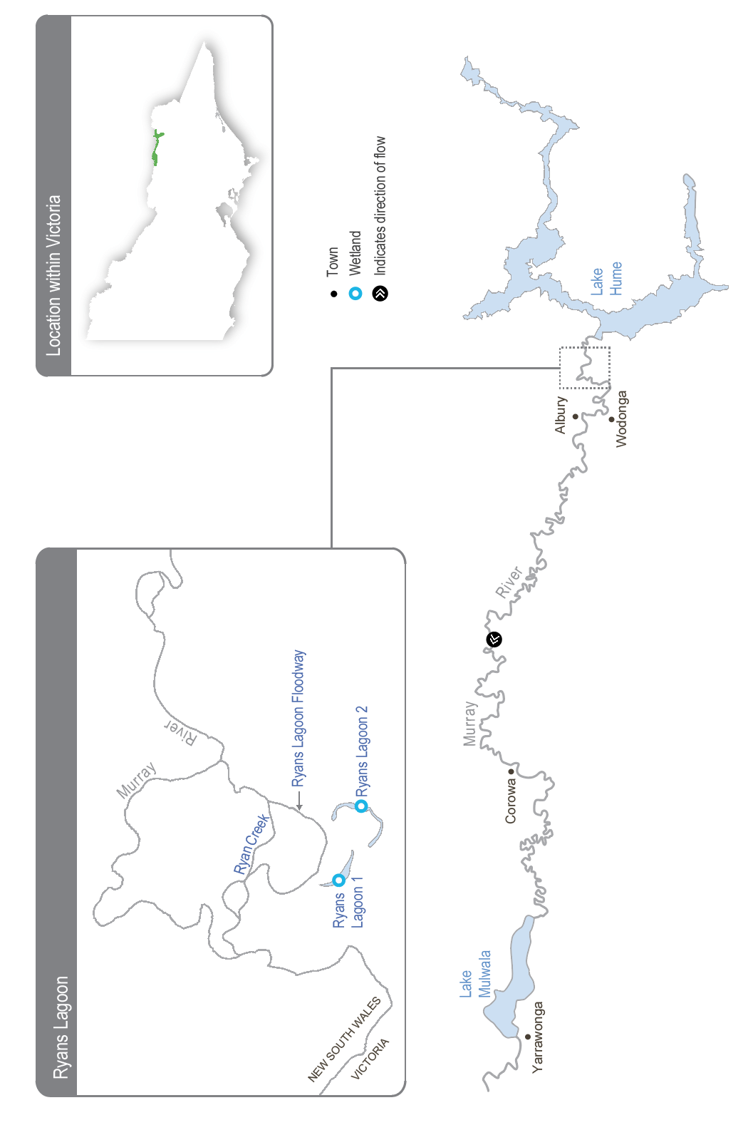

Environmental values
The North East CMA’s North East Waterway Strategy recognises the Ryans Lagoon wetland complex as a high-value wetland system, and it is listed as a nationally significant wetland in the Directory of Important Wetlands in Australia. The complex provides habitat for seven bird, three fish, one frog and one perennial plant species listed under the Commonwealth Environmental Protection and Biodiversity Conservation Act 1999 and/or the Victorian Flora and Fauna Guarantee Act 1988. Ecological surveys conducted at the site since 1975 have recorded 250 species of waterbugs and 29 species of waterbirds, including the Australian white ibis, great egret and rufous night heron. The complex also supports native wetland vegetation communities expected to benefit from a seasonally aligned, more variable watering regime.
Environmental objectives in the upper Murray wetlands
B1 | Provide feeding habitat for a range of waterbird species
CN1 | Restore carbon and nutrient cycling within the wetlands to increase ecosystem productivity
F1 | Increase habitat for native fish and increase their population
MI1 | Increase the abundance and diversity of waterbugs to support aquatic food webs
V1 | Increase the extent of fringing and aquatic vegetation

Traditional Owner cultural values and uses
Traditional Owners have lived on and cared for the upper Murray floodplain for tens of thousands of years. Wetlands in the region have immense cultural value to Traditional Owners. There is no Registered Aboriginal Party for the Ryans Lagoon area, and several Traditional Owner groups are recognised within the upper Murray area, including those represented by the Dhudhuroa and Waywurru Nations, the Dalka Warra Mittung Aboriginal Corporation and the Duduroa Dhargal Aboriginal Corporation. There is no Registered Aboriginal Party for the Ryans Lagoon area.
The North East CMA is building relationships with each Traditional Owner group and aims to collaborate with Traditional Owners on environmental water management at the Ryans Lagoon wetland complex. In the long term, the North East CMA aims to support the defined objectives of Traditional Owners for the complex and Traditional Owners’ obligations to Country more broadly.
Traditional Owners from the Duduroa Dhargal Aboriginal Corporation (DDAC) have received funding to assist in managing Ryans Lagoon Nature Conservation Reserve for three years (2023-26) alongside Parklands Albury Wodonga Ltd. The funding has employed a DDAC Elder as a part-time ranger to undertake management activities, including ecological thinning, weed management, pest control and revegetation of native grasses and wetland plants for traditional uses. The ranger will also train First Nations people in cultural burning, cultural harvesting and cultural education activities. DDAC has also received funding to employ two Aboriginal Water Officers to undertake water management activities for self-determined purposes.
The North East CMA and DDAC met on Country at Ryans Lagoon many times in 2023 and 2024. These meetings provided an opportunity for DDAC to explain important cultural values at Ryans Lagoon and some of their objectives for managing Country, including about water.
DDAC wants environmental water delivered to Ryans Lagoon annually and restoring a more-natural water regime. DDAC would like to improve habitat for wetland plants, birds, frogs and fish, including through the planned environmental water deliveries which will support management actions for the ecological and cultural values of the Duduroa Dhargal people.
“The overall ideological reason (for the on-ground work) is to increase the biomass (meaning increase the native animals and traditional plants in the area for traditional purposes and practices) and create a refuge in the wetlands, ensuring the survival and succession for the future within the catchment.”
– DDAC Program Manager, 2024

“We are water people. We lived on the river and lived on the wetlands. We used these waterways for foods, medicines, and resources. When the wetlands dried up, we would have moved on. We moved to where the water was to sustain life. Water in these wetlands is essential to Cultural connection, learning and sharing knowledge with our people. Without water, we wouldn’t be here today.”
– DDAC Elders, 2024
Planned environmental flows may be modified to align with cultural benefits so long as environmental outcomes are not compromised. The North East CMA and DDAC will work together on the planning and delivery of environmental water to Ryans Lagoon in 2024-25. This includes planning the timing of water deliveries and delivering the water, with DDAC assisting with pumping water to Ryans Lagoon.
Increasing the involvement of Traditional Owners in managing environmental flows and progressing opportunities towards self-determination in the environmental watering program is a core commitment of the VEWH and its program partners. This is reinforced by legislation and policy commitments, including the Water Act 1989, the Victorian Aboriginal Affairs Framework, the 2016 Water for Victoria, the 2022 Water is Life: Traditional Owner Access to Water Roadmap, and, in some cases, agreements under the Traditional Owner Settlement Act 2010.
Where Traditional Owners are more deeply involved in the planning and/or delivery of environmental water for a particular site, their contribution is acknowledged in Table 5.2.1 with an icon (as explained in Figure 1.2.3). The use of this icon is not intended to indicate that these activities are meeting all the needs of Traditional Owners, but is used in the spirit of valuing that contribution.
 | Watering planned and/or delivered in partnership with Traditional Owners to support cultural values and uses

Social, recreational and economic values and uses
In planning the potential environmental watering actions in Table 5.2.1, the North East CMA considered how environmental flows could support values and uses, including:
- recreation and amenity (such as birdwatching)
- community and cultural events (such as visitation by schools, Landcare groups and other community members)
- socioeconomic benefits (such as cultural tours and incidental visitation to local towns and businesses).
Environmental water deliveries will improve the function of the wetland by mimicking the natural flow regime, aiming to improve ecosystem function and provide multiple habitat niches for native plants and animals. This will align with a community benefit for members of the local Landcare group, Parklands Albury Wodonga, who have land management responsibilities and use the site for conservation-based events.

Scope of environmental watering
The term ‘environmental watering’ refers to the active delivery of held environmental water to support particular environmental objectives by altering the flow in a river or water level in a wetland. While other terms are sometimes used to describe the delivery of environmental water, ‘environmental watering’ is deliberately used here and in seasonal watering statements to ensure consistency in the legal instruments that authorise the use of environmental water in Victoria.
Table 5.2.1 describes the potential environmental watering actions in 2024-25, their expected watering effect (that is, the intended physical or biological effects of the watering action) and the longer-term environmental objectives they support. Each environmental objective relies on one or more potential environmental watering actions and their associated physical or biological effects.
Table 5.2.1 Upper Murray wetlands potential environmental watering actions, expected effects and environmental objectives
Potential environmental watering action | Expected watering effects | Environmental objectives
Ryans Lagoon 1 and Ryans Lagoon 2 (fill in winter/spring) | - Mobilise carbon and nutrients within the wetlands to support wetland processes  - Maintain permanent, deep, open-water habitat that supports food resources for waterbirds and native fish  - Inundate wetland margins to provide refuge and feeding habitat for small- and large-bodied native fish  - Increase soil moisture to promote the growth of fringing vegetation and the surrounding river red gum community  - Inundate beds of aquatic and semi-aquatic vegetation to stimulate growth and increase their extent  - Prevent the encroachment of river red gum saplings into deep areas of the wetland  - Inundate wetland margins to provide habitat for waterbugs and foraging opportunities for waterbirds | B1  CN1  F1  MI1  V1

Scenario planning
Table 5.2.2 outlines potential environmental watering and expected water use in various planning scenarios.
In 2022-23, the upper Murray wetlands were added to the VEWH’s seasonal watering plan. However, over the past two years active pumping has not been required because natural floods filled Ryans Lagoon 1 and Ryans Lagoon 2 and other wetlands across the upper Murray floodplain.
The two lagoons would have naturally filled every year before the river was regulated, and they require frequent watering to maintain permanent water that can support native fish and provide a reliable foraging site for waterbirds. For these reasons, the planned winter/spring watering is a high priority in all planning scenarios in 2024-25. Water for the environment, delivered via temporary pumps, will likely be needed to fill both lagoons in drought, dry and average planning scenarios. A high, unregulated flow and natural floods are likely to inundate the wetlands in the wet planning scenario, and water for the environment will only be used in these conditions to top up water levels in each lagoon if they do not fill naturally.
Active pumping is only possible if there is sufficient water depth and duration in Ryans Lagoon Floodway. Therefore, there is a risk that the planned watering actions may not be delivered in drought-to-average scenarios.
Table 5.2.2 Upper Murray wetlands environmental watering planning scenarios
Planning scenario | Drought | Dry | Average | Wet
Expected conditions | - No unregulated flow below Hume Dam  - Regulated flow from Hume Dam may connect the Ryans Lagoon Floodway to allow pumping into Ryans Lagoon 1 and 2 | - Unregulated flow unlikely below Hume Dam  - Regulated flow from Hume Dam may connect the Ryans Lagoon Floodway to allow pumping into Ryans Lagoon 1 and 2  - Possible spring pulse could deliver water to the floodway to allow pumping into Ryans Lagoon 1 and Ryans Lagoon 2 | - Unregulated flow is possible below Hume Dam if storages are near capacity  - Unregulated flow may achieve partial or complete inundation of Ryans Lagoon 1 and 2  - Regulated flow from Hume Dam may connect the Ryans Lagoon Floodway to allow pumping into Ryans Lagoon 1 and 2  - Possible spring pulse could deliver water to the floodway to allow pumping into Ryans Lagoon 1 and Ryans Lagoon 2 | - Periods of unregulated flow below Hume Dam are likely and may provide partial or complete inundation to Ryans Lagoon 1 and 2  - Pumping into Ryans Lagoon 1 and 2 if a complete fill is not achieved could be considered, depending on water levels in the lagoons
Potential environmental watering – tier 1 (high priorities) | - Ryans Lagoon 1 and 2 (fill in winter/spring)
Possible volume of water for the environment required to achieve objectives | - 170 ML (tier 1) |  |  | - 0-170 ML (tier 1)

5.2.2 Barmah Forest

System overview
The Barmah Forest is located within Yorta Yorta’s traditional boundaries. The reserve, which includes the Barmah National Park and part of the adjoining Murray Valley Regional Park, is 29,305 ha. It forms the Victorian component of the broader Barmah-Millewa Forest that covers some 66,000 ha across New South Wales and Victoria between Tocumwal, Deniliquin and Echuca (Figure 5.2.2). The Barmah-Millewa Forest is listed under the Convention on Wetlands of International Importance (the Ramsar Convention) and the Directory of Important Wetlands in Australia, and it is one of the six Living Murray icon sites. The forest’s Victorian components are the Barmah National Park and part of the River Murray Reserve, which provides legislative protection for river red gum forest and associated wetlands that support significant plant and animal species and culturally significant sites.
Flooding in the Barmah-Millewa Forest depends on the flow in the Murray River. A natural narrowing of the river (commonly called the Barmah Choke) restricts the flow and causes overbank flooding when the flow below Yarrawonga Weir exceeds the channel’s capacity. This restriction influences Yarrawonga Weir’s operation and the magnitude of environmental flows that can be delivered to the forests. The Yorta Yorta People see this narrow part of Dhungulla (Murray River) as a culturally significant creation story, and it provides ecosystem services both from a culturally and environmentally significant viewpoint. The name ‘Barmah Choke’ is culturally inappropriate for the Yorta Yorta, and it is seen as a negative way to view their traditional lands and waters. Yorta Yorta People refer to this as the ‘Pama Narrows’, or more simply ‘The Narrows’.
Before the river was regulated, Barmah-Millewa Forest was regularly flooded with high flows from rainfall and snowmelt in winter and spring. These regular floods shaped a rich, productive floodplain. The construction and operation of Hume Dam and Dartmouth Dam have greatly reduced the size and frequency of natural winter/spring floods in Barmah-Millewa Forest.
Operational deliveries that supply water to users downstream of The Narrows can cause unseasonal, low-level floods, which can damage the forest and erode riverbanks, depending on the timing and volume of the flow. Country for the Yorta Yorta People continues to change, but the changes have been rapid post-settlement due to the installation of infrastructure and river regulation. This has changed Country culturally and environmentally for the Yorta Yorta People.
The delivery of irrigation water during summer/autumn is now managed to minimise the unseasonal flooding of the forest. Regulators along the banks of the Murray River that control the flow between the river and the forest remain closed during summer and autumn to restrict the flow through low-lying flood runners to simulate natural conditions. The delivery of water to Barmah-Millewa Forest is also limited by a flow constraint below Yarrawonga Weir that aims to minimise impacts to adjacent farming operations in NSW. The current constraint limits the regulated flow to a maximum river level of 3.3 m at the Tocumwal gauge (subject to various conditions). Until recently, the 3.3 m limit was met with a flow of about 18,000 ML per day downstream of Yarrawonga Weir, but ongoing sediment accumulation has reduced the river capacity. As a result, the height limit is now met with a flow of about 17,000 ML per day. Regulated flows up to a river level of 3.0 m on the Tocumwal gauge (historically about 15,000 ML per day, now about 14,200 ML per day downstream of Yarrawonga Weir) can be delivered at any time during the year and are not subject to conditions. These constraints mean it is currently not possible to achieve the desired flood depth and duration for floodplain marsh vegetation in both forests at the same time without greater natural flooding. Therefore, environmental watering strategies alternate between the Barmah and Millewa forests each year, aiming to deliver water to low-lying wetlands in each forest at least every second year.
Water management at Barmah-Millewa Forest seeks to build on natural flow and deliver consumptive and operational water to optimise environmental outcomes when possible. As Barmah-Millewa Forest is located towards the upper reaches of the regulated portion of the Murray River, water for the environment that passes through the forest and returns to the river can often be used at sites further downstream as part of multi-site watering events.
Figure 5.2.2 The Barmah Forest
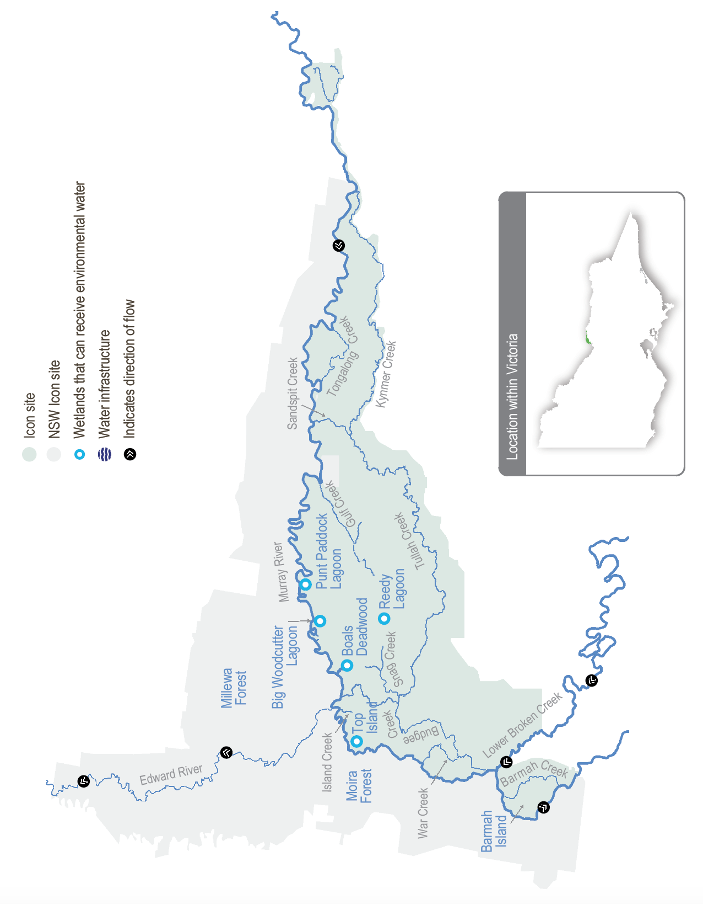

Environmental values
The Barmah-Millewa Forest is the nation’s largest river red gum forest and the most intact freshwater floodplain system along the Murray River. The forest supports important floodplain vegetation communities, including the threatened Moira grass plains. It is an important feeding and breeding site for waterbirds, including bitterns, ibis, egrets, spoonbills and night herons. Significant populations of native fish, frogs and turtles also live in the forest’s waterways. Barmah Forest is known to support 74 plant and animal species protected under state and national legislation.
Environmental objectives in the Barmah Forest
A1 | Increase the frog population
B1 | Support the successful recruitment of colonial nesting waterbirds
CN1 | Enable carbon and nutrient cycling between the floodplain and river through connectivity
F1 | Increase habitat for native fish and increase their population
G1 | Protect forest waterways from increased erosion
T1 | Increase the turtle population
V1 | Enhance the health of river red gum communities and aquatic vegetation in the wetlands and watercourses
V2 | increase the extent and improve the condition of floodplain marsh vegetation communities, particularly Moira grass
WQ1 | Reduce the risk of low-oxygen events in summer

Traditional Owner cultural values and uses
“We are the First People of this place. We were here even before the Murray River flowed through Barmah.”
– Uncle Des Morgan, Yorta Yorta Elder, Joint Management Plan for Barmah National Park
The Yorta Yorta Nation Aboriginal Corporation (YYNAC) manages Barmah National Park with Parks Victoria under a Traditional Owner Land Management Agreement with the State of Victoria. The Joint Management Plan for Barmah National Park and the Yorta Yorta Whole-Of-Country Plan 2021-2030 inform environmental water management in Barmah National Park. Ongoing interaction about land and water management at Barmah also occurs with Yorta Yorta through the Living Murray Indigenous Partnerships Program.
YYNAC continues to pursue the Yorta Yorta People’s inherent rights to water for Country. Rights to water will address their spiritual, cultural, environmental, social and economic needs, in line with the Yorta Yorta Whole-Of-Country Plan 2021-2030.
Yorta Yorta values encompass an inherent and living connection to land (woka), water (wala) and caring for Country. Examples of Yorta Yorta cultural values and uses in Barmah Forest that are supported through deliveries of water for the environment include:
- maintaining refuges that protect turtles, an important totemic species for the Yorta Yorta People
- watering to support floodplain marsh vegetation, which includes important food, fibre and medicinal plants (such as old man weed and weaving sedge)
- improving the health of river red gums, which has benefits for important Yorta Yorta sites and significant markings (such as a scar tree) and furthers connections to Country
- broader restoration to achieving healthy Country.
Increasing the involvement of Traditional Owners in managing environmental flows and progressing opportunities towards self-determination in the environmental watering program is a core commitment of the VEWH and its program partners. This is reinforced by legislation and policy commitments, including the Water Act 1989, the Victorian Aboriginal Affairs Framework, the 2016 Water for Victoria, the 2022 Water is Life: Traditional Owner Access to Water Roadmap, and, in some cases, agreements under the Traditional Owner Settlement Act 2010.

Social, recreational and economic values and uses
In planning the potential environmental watering actions in Table 5.2.3, the Goulburn Broken CMA and the Yorta Yorta and/Parks Victoria joint managers consider how environmental flows could support or affect values and uses, including:
- water-based recreation (such as boating, fishing, kayaking and canoeing)
- riverside recreation and amenity (such as birdwatching, picnicking, photography, camping and the general physical, mental and social benefits of communing with nature)
- community events and tourism
- socioeconomic benefits (such as for apiarists, and including better water quality).
For example, if environmental or operational flows cause creek crossings to be blocked, land managers will erect signs and post notices on the Parks Victoria website to notify site users and the broader public of road closures or restrictions to 4WD only. Water managers also publicise the benefits of flows for fish recruitment and wetland health.

Scope of environmental watering
The term ‘environmental watering’ refers to the active delivery of held environmental water to support particular environmental objectives by altering the flow in a river or water level in a wetland. While other terms are sometimes used to describe the delivery of environmental water, ‘environmental watering’ is deliberately used here and in seasonal watering statements to ensure consistency in the legal instruments that authorise the use of environmental water in Victoria.
Table 5.2.3 describes the potential environmental watering actions in 2024-25, their expected watering effect (that is, the intended physical or biological effects of the watering action) and the longer-term environmental objectives they support. Each environmental objective relies on one or more potential environmental watering actions and their associated physical or biological effects.
Table 5.2.3 Barmah Forest potential environmental watering actions, expected effects and environmental objectives
Potential environmental watering action | Expected watering effects | Environmental objectives
Winter/spring forest low flow to various waterways in Barmah Forest (variable flow rates and duration during July to December 2024 and June 2025) | - Provide a gradual connection of waterways with the Murray River to minimise erosion within those waterways  - Provide flow in forest waterways to ensure adequate refuge pools persist for native fish and turtles  - Provide adequate depth and connection between floodplain waterways and the river to facilitate the movement of native fish  - Remove accumulated organic matter from waterways to cycle carbon to the river system and create a throughflow to minimise the risk of hypoxic blackwater | F1  G1  T1  CN1  WQ1
Winter/spring/summer low flow in the Murray River (greater than 7,500 ML/day below Yarrawonga Weir during August to December) | - Maintain a sufficient water level in the Murray River main channel to prevent Murray cod from abandoning their nests, increase juvenile survival and improve dispersal opportunities | F1
Spring/summer fresh(es) in the Murray River channel (one to three freshes that increase the flow by at least 500 ML/day and maintain it for two to eight days during November to December) | - Provide variable water levels once water temperatures exceed 22°C to trigger the spawning of native fish species, primarily silver perch | F1
Spring/summer/autumn freshes to Gulf and Boals creeks (100 ML/day for three to five days as required during November to April) | - Maintain critical refuge pools to provide habitat for native fish and turtles  - Flush refuge pools to maintain water quality | F1  T1  WQ1
Spring/summer/autumn low flow to floodplain waterways, including Sandspit, Gulf, Big Woodcutter, Boals and Island creeks and Punt Paddock Lagoon (200 ML/day for 30 to 60 days during November to April) | - Replenish refuge pools in permanent waterways to maintain water quality, fish and turtle populations  - Maintain connectivity between the forest and the river  - Remove accumulated organic matter, cycle carbon to the river system and minimise the risk of hypoxic blackwater | F1  T1  CN1  WQ1
Fill or top-up of Boals Deadwood, Harbours Lake, Reedy Lagoon and Top Island wetlands (200-400 ML/day for four and a half months during September to February) | - Provide a cue to initiate waterbird breeding and maintain a depth of at least 0.5 m beneath reed bed nesting breeding colonies  - Maintain wetting duration and depth to grow the wetland vegetation | V1  B1
Spring wetting of floodplain marshes (variable flow rates between 8,300-17,000¹ ML/day below Yarrawonga Weir for three months during September to December) | - Inundate open plains to a sufficient depth and for a sufficient duration to allow the growth of floodplain marsh vegetation  - Inundate forest wetlands and low-lying floodplain areas to create foraging opportunities for waterbirds and increase available habitat for turtles, frogs and small-bodied native fish  - Support waterbird breeding by maintaining a depth of at least 0.5 m beneath reed bed nesting breeding colonies | F1  A1  T1  V2  B1
Autumn/winter low flow in the Murray River (4,000-5,000 ML/day downstream of Yarrawonga during May to June) | - Increase water depth in the Murray River channel to provide habitat for large-bodied native fish in the Murray River and unregulated anabranches in Barmah-Millewa Forest | F1
1 The maximum flow constraint is a level of 3.3 m at the Tocumwal gauge in the Murray River, estimated at 17,000 ML per day downstream of Yarrawonga Weir. The maximum flow rate delivered may vary for this action to target the level.

Scenario planning
Table 5.2.4 outlines potential environmental watering and expected water use in various planning scenarios.
Widespread flooding in 2023-24 inundated more of Barmah-Millewa Forest than can be watered by environmental flows under current delivery constraints. The potential watering actions in this plan are required in most or all years to support the identified environmental values and objectives. For these reasons, the proposed watering actions in each planning scenario are similar to those outlined in previous plans.
The ecological objectives for Barmah-Millewa Forest require a sustained flow in the Murray River through winter and spring. Flow-control structures are used to direct water from the Murray River channel into the forest and to facilitate the later return of most of that water back to the river, transporting carbon and nutrients for use downstream. Current flow constraints mean environmental watering will primarily target Barmah Forest in 2024-25, aiming to meet the depth and duration targets for wetlands. Millewa Forest will still receive a flow, but depth and duration targets for some forest wetlands may not be fully met. These arrangements alternate between the Barmah and Millewa forests each year.
Three tier 1 potential watering actions are required in all climate scenarios. Winter-spring forest low flows enable a gradual and variable connection of the waterways within Barmah Forest to the Murray River to maintain habitat and provide movement opportunities for aquatic animals (such as native fish). Regulators are opened to allow water to move in and out of the forest during winter and spring in response to variations in the flow of the Murray River. The spring/summer freshes in the Murray River specifically aim to trigger silver perch spawning when the water temperature exceeds 22°C and are achieved by varying the flow below Yarrawonga Weir. Spring/summer/autumn freshes to Gulf and Boals creeks are delivered to maintain water quality in forest waterways. Forest regulators are usually closed in summer and autumn (and sometimes in spring if water availability is low) to keep unnaturally high river flows out of the forest and allow a natural drying phase. These freshes to Gulf and Boals creeks may be needed to maintain critical refuge by improving dissolved oxygen levels for aquatic species (such as native fish) using only a small volume of water.
Potential watering actions required in the dry-to-wet planning scenarios include spring/summer/autumn low flows to floodplain waterways that maintain habitat in the forest by providing connectivity to replenish refuge pools and protect water quality. Waterbird breeding is expected in the dry-to-wet planning scenarios, and water for the environment can be delivered to fill or top up wetlands to support colonial nesting species to the end of their breeding event. In dry conditions, colonies are expected only in Boals Deadwood, where ibis and spoonbill nest in most years. In average-to-wet conditions, waterbirds are expected to breed in more locations within the forest, including Harbours Lake, Reedy Lagoon and Top Island wetlands.
Some potential watering actions are only required in the average-to-wet conditions when a greater frequency, duration and volume of unregulated flow events is expected. These actions require large volumes of water that are likely to be partially met by the unregulated flow and are important for building resilience in the system by enhancing environmental responses. An autumn/winter low flow in the Murray River increases habitat for native fish to reduce predation and increase food availability ahead of the breeding season, while winter/spring/summer low flows in the Murray River maintain a higher minimum in-channel flow to support Murray cod nesting. Spring wetting of floodplain marshes maintains an overbank flow to the forest in spring (within operational delivery constraints) to support the health of the river red gum forest and the recovery of wetland habitat, including critical species (such as Moira grass).
Larger watering actions for Barmah Forest benefit the environment both locally and downstream, as most of the water delivered returns to the river. Water for the environment is measured, with use (loss) in the forest deducted and the remaining water shepherded downstream to be re-used for other environmental outcomes. As a result, larger Barmah Forest watering actions can also be delivered as part of a broader Murray River flow event in the drought and dry scenarios (tier 2 actions) when water availability is high. The Barmah Forest benefits by fully or partially achieving environmental objectives for actions, such as spring wetting of floodplain marshes and autumn/winter low flows in the Murray River that are desirable to achieve every year but may not be possible in drier scenarios when there is less water available. Improved local outcomes in Barmah Forest, such as spring/summer/autumn low flows to better maintain the health of forest waterways in drought conditions and fill or top up additional forest wetlands for native vegetation and waterbird outcomes in a dry scenario, may also be achieved with additional water availability. All tier 2 watering actions are possible in 2024-25, subject to coordination planning led by the Southern Connected Basin Environmental Watering Committee, as water availability is expected to be high following a period of consecutive wet years leading into 2024-25.
Table 5.2.4 Barmah Forest environmental watering planning scenarios
Planning scenario | Drought | Dry | Average | Wet
Expected conditions | - Unregulated flow periods are unlikely  - Flow in the Murray River will remain within the channel all year | - Some small, unregulated flow in late winter/spring  - Low chance of overbank flow in late winter/spring | - Likely chance of small-to-medium unregulated flow in winter/spring  - Likely chance of overbank flow in winter/spring | - High probability of moderate to large unregulated flow in winter/spring  - Expected large overbank flow
Potential environmental watering – tier 1 (high priorities) | - Winter/spring forest low flow  - Spring/summer fresh(es) in the Murray River (one to three freshes)  - Spring/summer/autumn freshes to Gulf and Boals creeks | - Winter/spring forest low flow  - Spring/summer fresh(es) in the Murray River (one to three freshes)  - Spring/summer/autumn freshes to Gulf and Boals creeks  - Spring/summer/autumn low flow to floodplain waterways  - Fill or top up Boals Deadwood | - Winter/spring forest low flow  - Winter/spring/summer low flow in the Murray River  - Spring/summer fresh(es) in the Murray River (one to three freshes)  - Spring/summer/autumn fresh(es) to Gulf and Boals creeks  - Spring/summer/autumn low flow to floodplain waterways  - Fill or top up Boals Deadwood, Harbours Lake, Reedy Lagoon and Top Island wetlands  - Spring wetting of floodplain marshes  - Autumn/winter low flow in the Murray River | - Winter/spring forest low flow  - Winter/spring/summer low flow in the Murray River  - Spring/summer fresh(es) in the Murray River (one to three freshes)  - Spring/summer/autumn fresh(es) to Gulf and Boals creeks  - Spring/summer/autumn low flow to floodplain waterways  - Fill or top up Boals Deadwood, Harbours Lake, Reedy Lagoon and Top Island wetlands  - Spring wetting of floodplain marshes  - Autumn/winter low flow in the Murray River
Potential environmental watering – tier 2 (additional priorities)¹ | - Spring/summer/autumn low flow to floodplain waterways  - Spring wetting of floodplain marshes  - Autumn/winter low flow in the Murray River | - Fill or top up additional wetlands (such as Harbours Lake, Reedy Lagoon and Top Island wetlands)  - Spring wetting of floodplain marshes  - Autumn/winter low flow in the Murray River
Possible volume of water for the environment required to achieve objectives² | - 9,000 ML (tier 1) | - 19,000 ML (tier 1) | - 267,000 ML (tier 1) | - 168,000 ML (tier 1)
1 The volume of water for the environment required to deliver the tier 2 watering actions in drought and dry planning scenarios will depend on demands for multi-site environmental events or operational transfers and is therefore not estimated in Table 5.2.4.
2 The possible volumes of water for the environment required in Barmah Forest are estimates and highly variable, depending on factors such as seasonal conditions and the contributions of operational and/or unregulated flows. Much of the water for the environment delivered to Barmah Forest is returned to the Murray River — around 80 percent in the dry-to-wet planning scenarios — and can be re-used at downstream sites.

5.2.3 Gunbower Forest and Creek

System overview
Gunbower Forest is a large, flood-dependent forest situated on the Murray River floodplain in northern Victoria between Torrumbarry and Koondrook (Figure 5.2.3)
Gunbower Forest, which covers 19,450 ha, is bounded by the Murray River to the north and Gunbower Creek to the south. It is an internationally significant site under the Ramsar Convention and forms part of the Living Murray Gunbower-Koondrook-Perricoota Forest Icon Site. Regulation of the Murray River and water extraction has reduced the frequency, duration, and magnitude of flood events in Gunbower Forest over the long term. This has affected the extent and condition of floodplain habitats and the health of native plant and animal communities (such as river red gum and black box communities, native fish, birds, platypus, frogs and turtles) that depend on those habitats.
Gunbower Creek is a natural creek that has been modified to supply irrigation water from the Murray River to the Torrumbarry Irrigation Area. There are 12 lagoons, located mainly in the upper reaches of the creek system, that are permanently or seasonally connected to Gunbower Creek. Water for the environment is used in Gunbower Creek to improve habitat for native fish, especially Murray cod.
The Living Murray environmental works program in the middle and lower forest was completed in 2013-14. The works allow up to 4,500 ha of the wetlands and floodplain to be watered with considerably less water than would be required if the watering infrastructure was not in place. The works enable efficient watering through Gunbower Creek and the forest to maintain the wetland and floodplain condition and provide connectivity between the creek, forest floodplain and the Murray River. Frequent connections between the river and floodplain habitats allow animals to move between habitats and support critical ecosystem functions (such as carbon exchange).
Figure 5.2.3 The Gunbower Forest and Gunbower Creek system
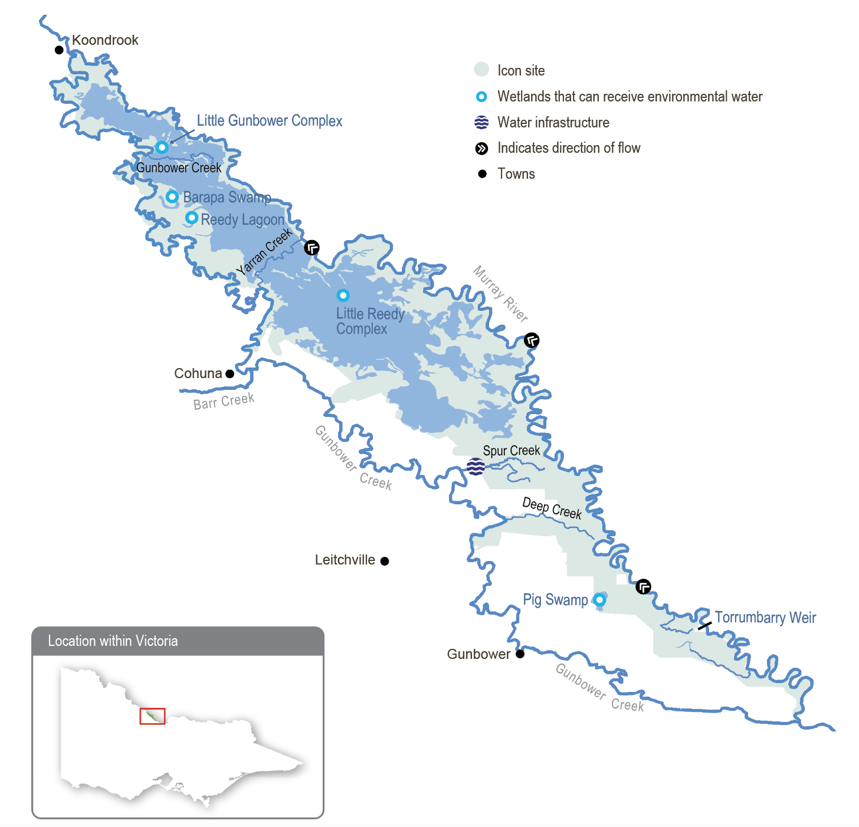

Environmental values
Gunbower Forest contains many important environmental values. It includes rare and diverse wetland habitats and large areas of remnant vegetation communities (such as river red gum forest and woodlands). It is home to vulnerable and endangered plants and animals, including river swamp wallaby grass, wavy marshwort, Murray-Darling rainbowfish and eastern great and intermediate egrets. Gunbower Forest also supports internationally recognised migratory waterbird species.
Gunbower Creek provides important habitat for native fish (such as Murray cod, golden perch and freshwater catfish). It is a valuable refuge for native fish and provides a source of fish to recolonise surrounding waterways.
Environmental objectives in Gunbower Forest and Creek
A1 | Increase the diversity and abundance of native frog species within the forest
B1 | Provide feeding, breeding and refuge habitat for waterbirds, including colonial nesting species (such as egrets, cormorants and herons)
CN1 | Support carbon and nutrient cycles in the forest and wetlands and periodically deliver carbon and nutrients from the forest to adjacent waterways to support riverine food webs
F1 | Provide feeding, breeding and refuge habitat for native fish (such as Murray-Darling rainbow fish) in Gunbower Forest wetlands
F2 | Improve the small-bodied native fish population in the Gunbower Forest wetlands
F3 | Improve the small- and large-bodied native fish (such as Murray cod) population in Gunbower Creek
T1 | Maintain the freshwater turtle population
V1 | Improve the health and increase the abundance of native vegetation in permanent and semi-permanent wetlands
V2 | Improve the health of river red gums on the floodplain
WQ1 | Maintain water quality in Gunbower Creek

Traditional Owner cultural values and uses
Gunbower Forest is recognised as the traditional lands of the Yorta Yorta Nation in the upper area and the Barapa Barapa First Nations People (Barapa Barapa) in the middle and lower areas.
The following text presents knowledge and objectives developed with and provided by Barapa Barapa. The North Central CMA remains committed to working with the Yorta Yorta Nation to support Yorta Yorta People at Gunbower Forest and ensure environmental watering actions are culturally informed and able to support their aspirations for looking after Country.
Barapa Barapa have expressed their aspirations for an active role in the management of land and water to fulfil custodianship obligations and contribute to improvements in the health of Country. Barapa Barapa have partnered with the North Central CMA to deliver the Water for Country project in Gunbower Forest since 2015. The Water for Country project builds on the work of the previous Barapa Barapa Cultural Heritage Mapping of Lower Gunbower Forest project, delivered in 2013-14, to map a catalogue of cultural heritage assets in the forest. The Water for Country project aims to investigate how cultural and spiritual values may be better represented in water management. In 2018, the Water for Country group expanded to include Wamba Wemba First Nations people and continues to focus on Gunbower Forest.
The Barapa Barapa Water for Country project led to the development of the 2017 Barapa Barapa Cultural Watering Objectives Framework, a guiding document to ensure cultural priorities and outcomes are considered and incorporated into environmental watering through seasonal watering proposals. The framework was used for the first time in 2018 to assist with developing cultural objectives for proposed environmental watering actions included in the 2018-19 seasonal watering proposal for Gunbower Forest and Creek and is now used annually to help inform seasonal watering proposal planning. Applying elements of the framework during seasonal watering proposal engagement with Barapa Barapa ensures environmental watering activities incorporate Barapa Barapa’s cultural objectives and that water managers are culturally informed when delivering environmental water.
The cultural objectives that can be supported in 2024-25 have been informed by the Cultural Watering Objectives Framework, seasonal watering proposal engagement and engagement with Barapa Barapa throughout the year. The cultural objectives that can be achieved will depend on which environmental water actions are implemented, depending on climatic conditions.
Increasing the involvement of Traditional Owners in managing environmental flows and progressing opportunities towards self-determination in the environmental watering program is a core commitment of the VEWH and its program partners. This is reinforced by legislation and policy commitments, including the Water Act 1989, the Victorian Aboriginal Affairs Framework, the 2016 Water for Victoria, the 2022 Water is Life: Traditional Owner Access to Water Roadmap, and, in some cases, agreements under the Traditional Owner Settlement Act 2010.
Where Traditional Owners are more deeply involved in the planning and/or delivery of environmental flows for a particular site, their contribution is acknowledged in Table 5.2.6 with an icon (as explained in Figure 1.2.3). The use of this icon is not intended to indicate that these activities are meeting all the Cultural Objectives of Traditional Owners but is used in the spirit of valuing that contribution.
 | Watering planned and/or delivered in partnership with Traditional Owners to support cultural values and uses
The table below explains how environmental water can support cultural objectives at Gunbower Forest and Creek in 2024-25. The objectives are derived from the 2017 Barapa Barapa Cultural Watering Objectives Framework (2017) as well as discussions with Barapa Barapa First Nations people through annual engagement.
Table 5.2.5 Barapa Barapa cultural objectives and how delivery of environmental water may address these in 2024-25 at Gunbower Forest and Gunbower Creek
Cultural objective | Indicator | Measure | How environmental water can support cultural values
- Promote and maintain healthy and abundant native fish communities in Gunbower Creek and Gunbower Forest | - Murray cod and yellow belly are breeding  - Trout cod and catfish are present | - Fish surveys showing a range of ages, including young of year (less than one year) | - Barapa Barapa have expressed the ongoing survival of fish and freshwater mussel populations as standing food resources.  - Continuing in 2024-25, Barapa Barapa put a high priority on protecting and restoring native fish populations in Gunbower Creek, as well as avoiding any further fish deaths due to hypoxic blackwater.  - Delivering the native fish hydrograph will support the recovery of native fish populations in Gunbower Creek, including Murray cod breeding. Gunbower Creek is not known to provide suitable conditions for yellow belly breeding, but recruitment into the creek will be targeted by delivering recolonisation flows. Delivering habitat diversity flows will also improve habitat for trout cod.  - The winter baseflow component of the native fish hydrograph is important to maintain stable water levels in the lagoons for catfish. However, a project in 2023-24 to better understand how catfish populations can be supported has involved engagement with Barapa Barapa. The results of this project will inform future proposals.  - Maintaining fish populations (as hosts for the larval stage of the mussel lifecycle) and water in wetlands will support the survival of adult billabong mussels.
- Maintain permanent water refuges | - Open water in Barapa Swamp and Reedy Lagoon in summer  - Healthy water  - Water enters fishponds associated with mounds | - The presence of remnant pools of sufficient quality water in summer  - No further invasion of river red gums or giant rush | - Providing drought refuges and maintaining areas with healthy wetland habitat is a high priority for Barapa Barapa. Delivering wetland top-ups to Barapa Swamp¹ (Black Swamp) and Reedy Lagoon in spring 2024 will support this value.  - Another Barapa Barapa priority is restoring high-value wetlands (such as Green Swamp) by undertaking revegetation and other activities like carp control. The wetland drawdown and top-ups in 2024-25 will help improve the health of wetland habitat and provide refuge areas for culturally significant animals in high-priority wetlands (such as Barapa Swamp and Reedy Lagoon). The planned drawdown at Green Swamp will enable access to the wetland to undertake restoration works before refilling it.
 |  | - Water test kit — salinity and dissolved oxygen levels suitable for plants and animals  - Groundwater bore levels appropriate -TBD | - Topping up Reedy Lagoon and Barapa Swamp in spring 2024 will help maintain water quality in these high-value wetlands in summer.
 |  | - The presence of water in fishponds (cultural sites) during floods | - Barapa Barapa aspire to reintroduce traditional fish traps into natural creeks within Gunbower Forest and trial them as a carp-control method. The floodrunners around the Little Gunbower complex have been identified in previous years as potential trial sites, so overtopping the complex in spring 2024 will support this objective. Another opportunity identified is to trial traditional fish trap designs for carp control in wetlands (such as Green Swamp). Opportunities to implement these trials may be pursued in 2024-25.
- Promote and maintain healthy cultural plants and resources | - An abundant, healthy old man weed population  - Healthy river red gums with little dieback and new annual growth  - Abundant populations of water ribbons in spring in wetlands and creek  - Abundant healthy populations of nardoo | - Cultural harvest, plant surveys, seed collection and photo points | - This value will be supported by allowing wetlands to draw down naturally in autumn/winter 2024. Allowing slow drawdowns in cool seasons promotes the growth and survival of mudflat plants, including old man weed, which will provide opportunities for cultural practices to continue.
 |  |  | - Extending natural flooding will support objectives for healthy river red gums and provide significant resources to enable abundant harvests of culturally significant plants (such as basket sedge). It will also increase the area of habitat on the floodplain for culturally significant animals (such as waterbirds, turtles and mussels). Topping up and overtopping wetlands will support these values over smaller areas. However, drawing down wetlands will help them to reset and improve the health of aquatic habitat and resources when refilled. These watering actions will provide opportunities for cultural practices to continue.
- Promote healthy waterbird populations | - Waterbird breeding | - Waterbird surveys, spring/summer surveys for eggs | - Little Gunbower complex and Barapa Swamp have supported significant numbers of breeding waterbirds over the past 2-3 years. Delivering water to these wetlands in spring 2024 will provide habitat for waterbirds in summer while the Little Reedy complex continues to draw down. While this watering may not trigger large numbers of waterbirds to breed, breeding is more likely if there is unregulated flooding. If so, extending unregulated flooding and providing wetland top-ups will support waterbirds to breed.
- Barapa Barapa share culture and caring for Country  - Protect and preserve culturally significant sites through appropriate flow regimes | - No new erosion or exposure of cultural sites  - Live scar trees are healthy  - Dead scar trees remain standing | - Photo points at inflow and outfall points, circumference measure/photo points of dead scar trees, tree health scores of live scar trees | - Barapa Barapa value periodic flooding to maintain the health of scar trees and culturally significant trees. Tangible cultural heritage sites (such as scar trees, culturally significant trees, earth mounds and middens) should be recorded and surveyed.  - In 2023-24, registered cultural sites were monitored before, during and after watering to measure the risk of harm to cultural values from delivering environmental water. Protection works were also undertaken at sites considered at greater risk of harm. Extending the duration of natural flooding and topping up and overtopping wetlands is anticipated to support the health of live scar trees and culturally significant trees.
- Cultural practices | - N/A | - N/A | - Barapa Barapa have indicated that a smoking ceremony should be a regular activity each year when water is delivered. It is what their ancestors would have done when the floodwaters arrived and would represent the restoration of an important cultural practice.
1 Barapa Swamp, an alternative placename for Black Swamp, has been adopted by the North Central CMA in discussion with the Barapa Barapa Traditional Owners and subsequently used throughout the Gunbower Forest and Creek Seasonal Watering Proposal 2024-25 and in this seasonal watering plan.

Social, recreational and economic values and uses
In planning the potential watering actions in Table 5.2.6, the North Central CMA considers how environmental flows could support social, recreational and economic values and uses, including:
- water-based recreation (such as boating, hunting, canoeing and fishing)
- recreation and amenity (such as birdwatching, camping, photography and walking)
- community events and tourism (such as park visitation, tour, and activity operators)
- socioeconomic benefits (firewood harvesting, tourism, and education opportunities).
Planned environmental flows may be modified to align with a community benefit so long as environmental outcomes are not compromised. If natural flooding occurs, there is an action to extend the duration of unregulated flooding in the lower forest wetlands and floodplain during winter/spring 2024. If this watering action is delivered, it will not continue beyond November, achieving ecological outcomes while also reducing the likelihood that tracks will be inundated during the peak summer visitation period. This is acknowledged in Table 5.2.6 with the following icon (as explained in Figure 1.2.3).
 | Watering planned to support peaks in visitation (e.g. camping or other public activities on long weekends or school holidays)

Scope of environmental watering
The term ‘environmental watering’ refers to the active delivery of held environmental water to support particular environmental objectives by altering the flow in a river or water level in a wetland. While other terms are sometimes used to describe the delivery of environmental water, ‘environmental watering’ is deliberately used here and in seasonal watering statements to ensure consistency in the legal instruments that authorise the use of environmental water in Victoria.
Table 5.2.6 describes the potential environmental watering actions in 2024-25, their expected watering effect (that is, the intended physical or biological effects of the watering action) and the longer-term environmental objectives they support. Each environmental objective relies on one or more potential environmental watering actions and their associated physical or biological effects.
Table 5.2.6 Gunbower Forest and Creek system potential environmental watering actions, expected effects and environmental objectives
Potential environmental watering action | Expected watering effects | Environmental objectives
Gunbower Forest
Top-up and spill Little Gunbower complex and Barapa Swamp in spring | - Promote the growth of river red gums and understorey vegetation on the floodplain  - Provide diverse feeding and breeding habitat for waterbirds, small-bodied native fish, frogs and turtles in wetlands and the surrounding floodplain | A1  B1  F1  F2  T1  V2
Top-up Reedy Lagoon in spring  Trigger: presence of uncommon, small-bodied native fish | - Maintain water quality and available habitat for uncommon small-bodied native fish species over summer | F1  F2
Top-up and spill Little Gunbower Complex, Barapa Swamp, Reedy Lagoon, and the Little Reedy complex in autumn/winter   | - Support wetland vegetation growth, recruitment and restoration works following an extended drawdown phase (from summer 2024 to autumn 2025) in the Little Reedy complex  - Promote the growth of river red gums and understorey vegetation on the floodplain  - Provide diverse feeding habitat for waterbirds | B1  V1  V2
Top-up Little Gunbower complex, Little Reedy complex, Barapa Swamp and Reedy Lagoon in spring/summer  Trigger: waterbird breeding | - Maintain adequate water levels in breeding and feeding habitats to allow breeding waterbirds to fledge their chicks successfully | B1
Extend the duration of unregulated flooding in the lower forest wetlands and floodplain during winter/spring (ceasing delivery by November)    Trigger: natural flooding that cannot be excluded from the Little Reedy complex | - Promote the growth of river red gums and understorey vegetation on the floodplain  - Provide diverse feeding and breeding habitat for waterbirds, small-bodied native fish, frogs and turtles in wetlands and the surrounding floodplain | A1  B1  F1  F2  T1  V1  V2
Winter/spring fresh in Yarran Creek (variable flow rates and duration based on water levels in Gunbower Forest and flows in the Murray River and Gunbower Creek) | - Connect Gunbower Creek, Gunbower Forest and the Murray River through the Yarran Creek and/or Shillinglaws regulators to increase flowing habitat for the lateral movement of native fish, carbon and nutrients | CN1  F1  F2  F3
Gunbower Creek (targeting Cohuna Weir)
Autumn/winter low flow (200 ML/day during July to August 2024 and April to June 2025) | - Maintain connectivity through the length of Gunbower Creek and between lagoons during the off-irrigation period and prevent sections from drawing down to isolated pools  - Provide access to food resources over the cooler months and reduce predation pressure on juvenile fish | F3
Spring/summer/autumn high flow (300-400 ML/day during September to March) | - Maintain habitat and food resources for native fish and support breeding and larval survival (such as Murray cod) by minimising large variations in the water level during the irrigation season and achieving about 1.5 m depth in deeper pools and 30 cm depth in the shallow connecting the littoral zone to the maintain habitat  - A greater area of habitat will be inundated at the upper magnitude | F3
Year-round opportunistic fresh(es) (300-500 ML/day for one to four weeks) | - Increase flowing habitat in Gunbower Creek to provide preferred flow conditions for native fish | F3
Gunbower Creek (targeting Koondrook Weir)
Spring/summer/autumn opportunistic fresh(es) (200-500 ML/day for one to four weeks, as required) | - Promote the exchange of carbon between Gunbower Creek and the Murray River  - Provide a natural cue to attract native fish (such as Murray cod and golden perch) in spring to recolonise Gunbower Creek, maximising the effects of the fishways at Koondrook and Cohuna weirs | CN1  F3
Trigger-based spring/summer fresh (50-300 ML/day as required during September to February) | - Dilute the low dissolved oxygen return flows from Gunbower Forest at Three Corner Hole to improve water quality (oxygen concentrations) in lower Gunbower Creek if required | WQ1

Scenario planning

Gunbower Forest
Table 5.2.7 outlines potential environmental watering and expected water use in various planning scenarios.
Wet conditions in winter and spring 2022 triggered the largest flood in Gunbower Forest since 1993. Smaller floods in July and October 2023 and January 2024, along with environmental water deliveries in July and September through early October 2023, inundated parts of the floodplain and maintained high water levels in permanent and semi-permanent wetlands.
The wet conditions have had mixed effects on vegetation communities throughout the forest. Annual monitoring has demonstrated that river red gums and associated understorey vegetation on the floodplain are in the best-reported condition since monitoring began in 2005, but the condition of vegetation communities in some wetlands has declined since the 2022 floods. The decline in wetland vegetation is possibly due to the deep inundation experienced during the natural flood events and the high numbers of carp in the wetlands.
In the drought-to-average planning scenarios, maintaining floodplain and waterbird habitat and recovering wetland vegetation are prioritised by the delivery of a water regime that includes a mix of filling and drawdown. The regulating structures that control the flow into the forest from the Murray River may be closed to facilitate wetland drawdown if low-level flooding is predicted.
Different watering regimes will be applied to the wetlands within Gunbower Forest to achieve specific vegetation outcomes at each wetland and create connected habitats that can support fish, frogs, turtles and waterbirds in different stages of their lifecycles. Providing a variety of foraging habitats for waterbirds is especially important to support juvenile birds that hatched and fledged during recent natural floods.
Little Gunbower complex and Barapa Swamp will draw down through to the end of winter 2024 to facilitate drying of the adjoining floodplain and the shallower parts of the wetlands. Environmental water will then be used to re-fill and overtop them in spring. They will be allowed to draw down again in summer and may be topped up again in autumn 2025, subject to an assessment of the climatic conditions, water depth and ecological conditions in early 2025.
Reedy Lagoon is a permanent wetland with high-quality aquatic vegetation, and it supports diverse and abundant small-bodied native fish, including southern pygmy perch, which were reintroduced in 2023. Fish monitoring surveys are planned for autumn 2024. If those surveys detect large numbers of uncommon small-bodied native fish, water for the environment may be delivered in spring 2024 and autumn 2025 to maintain adequate water quality and depth to support the fish.
The semi-permanent Little Reedy complex will be allowed to draw down through to the end of summer 2025 to reduce carp numbers and allow planned revegetation activities to occur. Water for the environment may be delivered to the wetland complex in autumn 2025 once the water level has contracted to small pools.
Waterbird populations across northern Victoria have still not recovered from the Millennium Drought. Therefore, supporting natural breeding events in places such as Gunbower Forest is a high priority and may cause the planned watering actions described here to be modified. If significant waterbird breeding is detected at any of the wetlands described, water for the environment may be used in spring/summer to maintain water levels at breeding colonies. Such actions may mean that the planned draw-down phases are interrupted or that planned autumn watering is unnecessary.
In a wet scenario, it is highly likely that the Murray River will flood and inundate large parts of Gunbower Forest and prevent planned draw-down actions at particular wetlands. In this planning scenario, environmental water may be used to extend the duration of forest flooding to optimise benefits for river red gums and the flood-dependent understorey and sustain feeding, breeding and foraging habitat for waterbirds, small-bodied native fish, frogs and turtles. This will be achieved by closing the Murray River regulators on the tail end of the flood to avoid rapid draining of the forest and then using the lower landscape regulators to deliver environmental water to maintain water levels in selected parts of the forest, including low-lying areas of river red gum floodplain. Environmental watering of the floodplain will not continue beyond November to allow wetlands to draw down following a natural seasonal pattern and avoid scorching the mudflat vegetation. It will also allow wetlands to have a drying phase before they are topped up in autumn/winter/spring 2025. This will also benefit forest users, enabling forest access during the summer peak season. Water for the environment may be used to deliver a flow through Yarran Creek in the wet planning scenario if there is sufficient difference in water levels between Gunbower Creek and the Murray River to create a hydraulic head that will allow a flowing habitat to be created in Yarran Creek. This flow would allow fish and other aquatic animals to move between the Murray River and Gunbower Creek, disperse plant seeds or propagules and facilitate the exchange of carbon and nutrients.

Gunbower Creek
The flow in Gunbower Creek is highly influenced by irrigation demands, which can cause significant fluctuations in the creek’s water level during the irrigation season and provide little or no flow from late autumn to the end of winter. Water for the environment is primarily used to smooth out these flow fluctuations to provide suitable habitat, breeding and dispersal opportunities for native fish.
Over the last two years, natural flooding has contributed to several poor water quality events in Gunbower Creek that are likely to have harmed the native fish community. Delivering a mix of low flows, stable high flows and littoral zone flows throughout the year will be a high priority in all planning scenarios to provide suitable conditions for native fish to feed and breed, helping those populations recover.
The low-flow recommendations for Gunbower Creek are based on the irrigation and non-irrigation seasons. The recommended autumn/winter low flow of 200 ML per day (measured at Cohuna Weir) during the non-irrigation season is considered the minimum flow required to maintain fish habitat within the main channel of Gunbower Creek and the connections between the main channel and the upper lagoons, which support freshwater catfish. For two reasons, the recommended autumn/winter low flow is smaller than the flow that would naturally occur at that time of year and is smaller than the recommended low flow during the irrigation season. First, it is considered sufficient to maintain viable habitat and ecological function and can be met with the available supply of environmental water. Second, providing a lower flow during the non-irrigation season relieves some of the stress imposed on the channel form and its banks by a prolonged near-capacity flow during spring, summer and autumn.
During the irrigation season, high flows of between 300 and 400 ML per day will generally be delivered. The Murray cod breeding season extends from about September to December, depending on the weather and water temperature. The aim will be to maintain stable high flows close to 400 ML per day during this period. Littoral zone flows of at least 300 ML per day during summer/autumn will maintain important nursery habitat to support the recruitment of native fish, particularly Murray cod. From autumn, the flow will gradually be reduced from 300 ML per day to provide a smooth transition between the irrigation and non-irrigation seasons. All low-flow targets will be subject to the environment’s share of channel capacity.
Other opportunistic or trigger-based watering actions may be delivered in Gunbower Creek during 2024-25. In a wet planning scenario, there is a risk that unregulated flows will flood parts of Gunbower Forest and carry water with high concentrations of dissolved organic carbon from the floodplain into lower Gunbower Creek, causing low dissolved oxygen conditions in the creek. If this happens, a trigger-based dilution flow of 50-300 ML per day may be delivered past Koondrook Weir to prevent fish deaths.
In all planning scenarios, opportunistic freshes targeting Cohuna Weir or Koondrook Weir may also be delivered if they can be accommodated within the irrigation operations. These freshes aim to temporarily increase the amount of flowing habitat, which some fish prefer, and encourage fish to move into the system from the Murray River. These freshes are more likely to be delivered during spring and autumn when fish commonly disperse. Ideally, they will coincide with a flow pulse in Murray River to take advantage of system-wide cues for native fish movement.
Gunbower Creek’s channel capacity has declined in recent years, and the magnitude of planned environmental flows has dropped accordingly to achieve the target physical and ecological responses without inundating private land. The relationship between the flow over Cohuna Weir and the downstream water level will continue to be monitored and reviewed in 2024-25 and beyond so that environmental flow targets in Gunbower Creek can meet ecological objectives while also adapting to changes in the channel’s capacity.
In Gunbower Creek, a carryover target of 4,000 ML has been identified in all planning scenarios as guaranteeing sufficient supply to maintain a low flow in Gunbower Creek during the 2025-26 irrigation shutdown season. About 20,000 ML of carryover is required to enable top-ups to the wetlands at Gunbower Forest during winter and spring 2024.
Table 5.2.7 Gunbower Forest and Creek system environmental watering planning scenarios
Planning scenario | Drought | Dry | Average | Wet
Expected conditions | - Natural inflows into Gunbower Forest are unlikely | - Natural inflows into Gunbower Forest are unlikely  - Some run-off-producing rainfall is expected, with inflows into storages unlikely to cause spills and unregulated flow | - Natural inflows into Gunbower Forest during winter/spring are possible and could result in inundation of low-lying creeks and wetlands | - Overbank flow is likely in winter and/or spring  - High inflows into full storages in autumn, winter and/or spring 2024 will likely result in spilling events and unregulated flooding
Gunbower Forest
Potential environmental watering – tier 1 (high priorities) | - Top-up and spill Little Gunbower complex and Barapa Swamp in spring  - Top-up Reedy Lagoon in spring in response to fish surveys  - Top-up Little Gunbower complex, Little Reedy complex, Barapa Swamp and Reedy Lagoon in spring/summer in response to bird breeding  - Top-up and spill Little Gunbower complex, Barapa Swamp, Reedy Lagoon and the Little Reedy complex in autumn/winter  - Top-up Little Gunbower complex, Barapa Swamp and Reedy Lagoon in spring/summer |  |  | - Extend the duration of unregulated flooding in the lower forest wetlands and floodplain  - Top-up Little Gunbower complex, Barapa Swamp and Reedy Lagoon and Little Reedy complex in spring/summer  - Top-up and spill Little Gunbower complex, Barapa Swamp, Reedy Lagoon, and the Little Reedy complex in autumn/winter  - Winter/spring fresh in Yarran Creek
Potential environmental watering – tier 2 (additional priorities) | - N/A
Possible volume of water for the environment required to achieve objectives | - 25,000 ML | - 25,000 ML | - 25,000 ML | - 34,400 ML
Gunbower Creek targeting Cohuna Weir
Potential environmental watering – tier 1 (high priorities) | - Autumn/winter low flow  - Spring/summer high flows  - Spring/summer/autumn opportunistic freshes
Gunbower Creek targeting Koondrook Weir
Potential environmental watering – tier 1 (high priorities) | - Spring/summer/autumn opportunistic freshes |  |  | - Spring/summer/autumn opportunistic freshes  - Trigger-based spring/summer fresh
Potential environmental watering – tier 2 (additional priorities) | - N/A
Possible volume of water for the environment required to achieve objectives | - 23,000 ML | - 18,000 ML | - 18,000 ML | - 19,000 ML
Priority carryover requirements for 2025-26 | - 24,000 ML

5.2.4 Central Murray wetlands

System overview
The central Murray wetlands are located on the lower Loddon River and Murray River floodplains (Figure 5.2.4). The wetland system includes Guttrum state forest, Hird Swamp, Johnson Swamp, Kunat Kunat (Round Lake), Lake Cullen, Lake Elizabeth, Lake Murphy, McDonalds Swamp, Richardson Lagoon and Third Reedy Lake. Muringa wetlands and the Wirra-lo wetland complex have previously received water for the environment, but these wetlands are on private land, and those landowners are currently managing their water regimes. Therefore, they are not included in this year’s seasonal watering plan.
The central Murray wetlands are almost wholly contained within the Torrumbarry Irrigation Area and are all wetlands of regional or international significance. The area has experienced dramatic changes since European settlement with the construction of levees, roads and channels. Most of the wetlands are now cut off from natural flow paths and are rarely filled, except by large natural floods. They rely on water for the environment to support their ecological character and health.
Nine of the central Murray wetlands can receive water for the environment from permanent infrastructure: Hird Swamp, Johnson Swamp, Kunat Kunat, Lake Cullen, Lake Elizabeth, Lake Murphy, McDonalds Swamp, Richardson’s Lagoon and Third Reedy Lake. Temporary pumps are currently used to deliver water for the environment from the Murray River to Reed Bed Swamp in Guttrum Forest when required. More permanent water delivery infrastructure for Guttrum Forest is proposed as part of the Victorian Murray Floodplain Restoration Project.
Figure 5.2.4 The central Murray wetlands system
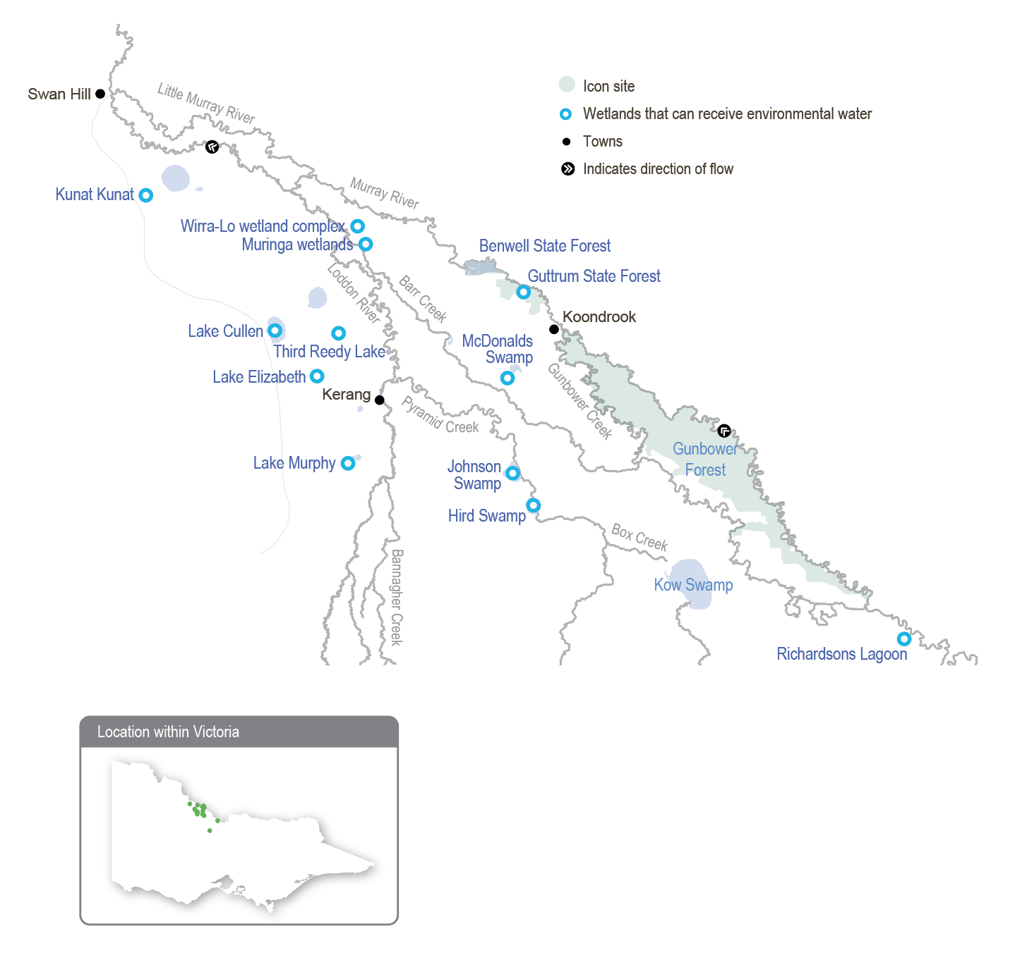

Environmental values
The central Murray wetlands support numerous listed threatened species ranging from vulnerable to critically endangered, including the Australasian bittern, Murray hardyhead, Australian painted snipe, growling grass frog and the southern purple spotted gudgeon, which was presumed extinct in Victoria until it was found at Third Reedy Lake in spring 2019. When the wetlands receive environmental water, they can attract prolific birdlife and provide feeding and breeding habitat for many threatened and endangered bird species (including the eastern great egret and white-bellied sea eagle) listed under legislation and international agreements. Lake Cullen, Hird Swamp, Third Reedy Lake and Johnson Swamp are internationally recognised under the Ramsar Convention, while the other wetlands in the central Murray system have bioregional significance.
Environmental objectives in the Central Murray wetlands
A1 | Maintain the native frog (such as barking marsh frog, Peron’s tree frog and spotted grass frog) population
B1 | Provide resting, feeding and breeding habitat for a variety of waterbirds and threatened species (such as Caspian tern, Australasian bittern, little bittern and brolga)
F1 | Maintain the small-bodied native fish population, including threatened species (such as Murray hardyhead and purple spotted gudgeon)
MI1 | Increase the diversity and biomass of waterbugs
T1 | Maintain the native turtle population (such as the Murray River turtle and the eastern long-necked turtle)
V1 | Restore the extent of wetland trees (such as river red gum and black box)
V2 | Restore the extent of mudflat vegetation communities (such as tall marsh, herblands, rushes and sedges)
V3 | Restore the extent of native aquatic vegetation species (such as tassel, foxtail stonewort, milfoil and pondweed)
V4 | Maintain the extent of native aquatic vegetation species (such as tassel, foxtail stonewort, milfoil and pondweed)
V5 | Reduce the extent and density of invasive plant species
V6 | Support a mosaic of wetland plant communities across the region

Traditional Owner values and uses
The wetlands and surrounding land in the central Murray region hold great significance for the Traditional Owners, the Barapa Barapa, Wamba Wemba and Yorta Yorta peoples. Their traditional knowledge is a living culture evident throughout the landscape in scar trees, significant cultural sites and cultural tools for cultural practices. The rivers and floodplains are a food and fibre source and contain many sites of significance (such as campsites and meeting places).
Environmental watering supports values including native fish, waterbirds and turtles, and it promotes the growth of culturally important plants that provide food, medicine and weaving materials for Traditional Owner groups. The presence of water itself can be a cultural value, as well as the quality of the water: healthy water promotes healthy Country. The cultural benefits that can be achieved in 2024-25 have been informed by seasonal watering plan engagement in February 2024 with Barapa Barapa and Wamba Wemba Traditional Owners and formal and informal engagement with Traditional Owners throughout the year.
The following table shows the cultural benefits of delivering environmental water for Barapa Barapa and Wamba Wemba Traditional Owners at the central Murray wetlands in 2024-25.
Table 5.2.8 Barapa Barapa and Wamba Wemba cultural values and uses, central Murray wetlands
Values, uses, objectives & opportunities | How this opportunity will be considered in environmental watering in 2024-25
Cultural plants and cultural practices | - Water in wetlands from environmental watering and natural flooding supports culturally important plants and allows the continuation of cultural practices, including harvesting food, medicine and weaving plants. Examples include harvesting cotton weed (foxtail stonewort) at Kunat Kunat for starting fires and harvesting black swans for cultural practices.  - Watering actions will support cultural plants that Barapa Barapa and Wamba Wemba Traditional Owners value and provide opportunities for cultural practices to continue.  - Barapa Barapa and Wamba Wemba Traditional Owners recognise the value of resources that occur on the drawdown after wetlands are inundated, providing food for animals as well as cultural plants (such as old man weed). These benefits can be realised by allowing wetlands to draw down naturally after receiving water to expose mudflats.  - Having diverse habitat and vegetation responses is a priority for Barapa Barapa and Wamba Wemba Traditional Owners. They note the importance of having a range of water depths to create a more diverse vegetation response, which results in various resources becoming available over a longer timeframe.  - Barapa Barapa Traditional Owners have undertaken revegetation activities as part of the Decision Support Tool Wetland Revegetation Project at McDonalds Swamp and separate planting works at Third Reedy Lake. Opportunities to have Traditional Owners involved with monitoring and revegetation at some wetlands will be sought throughout 2024-25. The Traditional Owners are keen to be involved in flood recovery revegetation works.  - Environmental water deliveries can be managed so revegetated areas have an appropriate water regime — plants receive water but are not drowned — to ensure their ongoing survival and provide opportunities for natural recruitment.  - The delivery of water for the environment can support the preservation and improvement of cultural animals: totem species. Additionally, the delivery of environmental water will aim to ensure that culturally important animals (food sources such as black swans) are supported and can continue to breed and thrive.
Healthy Country | - Providing drought refugia and maintaining areas with healthy habitat are high priorities for Barapa Barapa and Wamba Wemba Traditional Owners. Without natural inflows, they see it as important to ensure water is delivered to healthy areas (such as Hird and McDonalds swamps), which elicit a good vegetation response and can support wetland animals.  - Environmental watering actions will ensure there is water in high-priority wetlands regardless of whether flooding occurs. This will provide refuge habitat for waterbirds, woodland birds, turtles and frogs and ensures high-quality habitat is available.
Cultural heritage | - Cultural heritage artefacts are common at the wetlands, which have been important gathering sites for Traditional Owners. The loss of fringing trees and changes to natural watering regimes have exposed sediments around these wetlands for prolonged periods, resulting in some cultural artefacts being uncovered.  - Environmental water can support the growth of fringing red gum trees and tall marsh, reduce erosion at these wetlands and help keep cultural heritage artefacts covered.

Barapa Barapa and Wamba Wemba input to watering actions for Guttrum Forest in 2024-25
Delivery of water for the environment to Guttrum Forest during 2024-25 has been planned in conjunction with the Barapa Barapa and Wamba Wemba people, for whom the wetlands and surrounding forest are places of high cultural significance. Traditional Owners are an important part of Guttrum Forest planning and management and have been directly involved in delivering environmental flows to Reed Bed Swamp in 2019-20 and 2021-22. In 2023-24, no environmental water was delivered to Reed Bed Swamp due to large-scale natural flooding.
Barapa Barapa and Wamba Wemba collaborate with waterway managers to ensure that during watering events, their cultural heritage is protected and that the hydrological needs of important cultural values (such as food and medicinal plant species, scar trees and ring trees) are supported through the timing and duration of planned watering actions to the forest.
The following table shows the cultural benefits of delivering environmental water for Barapa Barapa and Wamba Wemba Traditional Owners at Guttrum Forest in 2024-25.
Table 5.2.9 Barapa Barapa and Wamba Wemba cultural values and uses, Guttrum Forest
Value/use | Considerations
Food, fibre and medicinal plants | - The response of wetland vegetation in previous years in Reed Bed Swamp saw a marked improvement in the growth and diversity of culturally important plants. In winter 2021, revegetation of plants characteristic of tall marsh, spike-sedge wetland and aquatic herbland included several culturally important plants. In addition to the revegetation, many plants regenerated naturally, including some small individuals or patches of cumbungi, nardoo, joyweed and giant rush. Old man weed was also observed in abundance on the drawdown. While the Traditional Owners noted that most of these plants are not yet abundant enough to allow for harvesting, they are on a good recovery trajectory. With more frequent annual watering, harvesting will likely be possible within a few years.
Cultural heritage | - The watering of Reed Bed Swamp supports fringing large old trees, including a couple of ring and scar trees. The condition of these trees has improved after previous watering.
Spiritual wellbeing | - The improvement in the condition of the wetland and the presence of water and moisture contribute to a sense of spiritual wellbeing.
Sharing cultural knowledge | - The Traditional Owners provide support and advice about what environmental values to target: that is, they provide information about what the wetland used to look like and what values it previously supported.  - Traditional Owners have been present during the set-up of infrastructure and have been able to advise about avoiding impacts on their cultural heritage.
Employment opportunities | - Traditional Owners want to become more involved in managing their Country through increased employment opportunities (such as ecological and cultural monitoring). This has occurred as part of previous watering of Reed Bed Swamp.
Cultural landscape | - Maintaining the open-water habitat and mudflats underneath will be difficult if the river red gum saplings that germinated in recent floods are not removed. Removing them is important for maintaining the cultural landscape and access to food and medicines.
Cultural practice | - The Traditional Owners have indicated they want to see a smoking ceremony to welcome water back to the forest and consider it should be a regular activity each year when water is delivered. It is what their ancestors would have done when the floodwaters arrived and would represent the restoration of an important cultural practice.  - Another priority in 2024-25 is to provide more opportunities for women to return to Country and undertake cultural practices (such as weaving, emu egg carving and discussion of the wetlands’ health as it relates to women’s business). This was a popular conversation topic during the Traditional Owner engagement day.
Planned environmental flows may be modified to align with cultural benefits so long as environmental outcomes are not compromised.
Increasing the involvement of Traditional Owners in managing environmental flows and progressing opportunities towards self-determination in the environmental watering program is a core commitment of the VEWH and its program partners. This is reinforced by legislation and policy commitments, including the Water Act 1989, the Victorian Aboriginal Affairs Framework, the 2016 Water for Victoria, the 2022 Water is Life: Traditional Owner Access to Water Roadmap, and, in some cases, agreements under the Traditional Owner Settlement Act 2010.
Where Traditional Owners are more deeply involved in the planning and/or delivery of environmental water for a particular site, their contribution is acknowledged in Table 5.2.10 with an icon (as explained in Figure 1.2.3). The use of this icon is not intended to indicate that these activities are meeting all the needs of Traditional Owners but is used in the spirit of valuing that contribution.
 | Watering planned and/or delivered in partnership with Traditional Owners to support cultural values and uses

Social, recreational and economic values and uses
The proposed watering actions in Table 5.2.10 aim to optimise positive environmental outcomes for each wetland and have been informed by environmental water management plans, monitoring results and discussions with wetland ecologists with local knowledge. Watering actions also consider any shared benefits that may be achieved as identified through engagement with locals, interested stakeholders and Traditional Owners. The potential watering actions for 2024‑25 include:
- waterway recreation (such as canoeing, fishing, kayaking, swimming and water sports)
- waterway recreation and amenity (such as birdwatching, duck hunting, camping, cycling, running and walking)
- community events and tourism (such as visitation during the hunting and fishing seasons, Breakfast with the Birds events [hosted annually by the North Central CMA] and supporting Aboriginal cultural heritage and history-based tours)
- socioeconomic benefits (such as ecosystem services like groundwater recharge, flood mitigation, nutrient treatment, carbon storage and stock and domestic uses).

Scope of environmental watering
The term ‘environmental watering’ refers to the active delivery of held environmental water to support particular environmental objectives by altering the flow in a river or water level in a wetland. While other terms are sometimes used to describe the delivery of environmental water, ‘environmental watering’ is deliberately used here and in seasonal watering statements to ensure consistency in the legal instruments that authorise the use of environmental water in Victoria.
Table 5.2.10 describes the potential environmental watering actions in 2024-25, their expected watering effect (that is, the intended physical or biological effects of the watering action) and the longer-term environmental objectives they support. Each environmental objective relies on one or more potential environmental watering actions and their associated physical or biological effects.
Table 5.2.10 Central Murray wetlands system potential environmental watering actions, expected effects and environmental objectives
Potential environmental watering action | Expected watering effects | Environmental objectives
Hird Swamp (partial fill in autumn) | - Drown terrestrial weeds to limit their growth and reduce their extent  - Promote the germination and establishment of aquatic vegetation  - Inundate the wetland body and fringe to provide habitat for waterbirds, frogs and turtles and provide conditions suitable for macroinvertebrates that are food for waterbirds, frogs and turtles  - Support the growth of planted river red gums and other aquatic and herbland vegetation | A1  B1  MI1  T1  V1  V2  V3  V5  V6
McDonalds Swamp (partial fill in autumn)
Kunat Kunat (Round Lake) (fill in spring, top up as required) | - Maintain salinity within 15,000-80,000 EC and water depth to support suitable habitat and breeding conditions for Murray hardyhead and growing conditions for submerged aquatic plants that provide habitat for Murray hardyhead  - Maintain water depth to provide permanent feeding, foraging and refuge habitat for waterbirds | B1  F1  V4  V5
Lake Elizabeth (fill in spring, top up as required)
Reedbed Swamp (partial fill in autumn/winter 2025)   | - Wet the fringing adult river red gums to support their growth and drown river red gum saplings within the wetland bed to maintain open-water habitat  - Increase the biomass of waterbugs as a food source for waterbirds  - Promote the growth and reestablishment of aquatic vegetation and tall marsh vegetation at various depths across the wetland  - Maintain the depth of the wetland to support frogs, turtles and waterbirds feeding and breeding | A1  B1  MI1  T1  V2  V3  V5  V6
Third Reedy Lake (partial fill in autumn) | - Drown terrestrial weeds and support the growth of planted river red gums  - Increase biomass of waterbugs as a food source for waterbirds  - Provide wetland habitat for waterbirds and frogs over autumn and winter | A1  B1  MI1  V1  V2  V3  V5

Scenario planning
Table 5.2.11 outlines potential environmental watering and expected water use in various planning scenarios.
Extensive flooding in 2022-23 and 2023-24 means that most wetlands in the central Murray region have been full or nearly full for at least two years. As of autumn 2024, most of the central Murray wetlands that have historically received water for the environment were at least partially full. McDonalds Swamp was the only wetland that was dry.
Individual wetlands within the central Murray system have different physical characteristics and support different environmental values. As a result, they have different water requirements and, except in flood years, should be in different stages of their wetting and drying cycles to create a mosaic of habitats for waterbirds, frogs and turtles. Providing habitat and food resources for young waterbirds, particularly at sites near recent colonial breeding sites, is a key consideration in developing central Murray wetlands watering strategies. In 2024-25, some wetlands will be allowed to draw down to initially provide shallow foraging habitat for waterbirds and then support dry-phase ecological processes. Other wetlands will be topped up to maintain deep water habitats in the landscape. The proposed watering actions to achieve this strategy are consistent across all planning scenarios in 2024-25, although the volume required to achieve them will potentially be greater in the drier planning scenarios compared to the average and wet scenarios.
The proposed watering actions for Lake Elizabeth and Kunat Kunat (Round Lake) — fill in spring and top up in autumn — are needed yearly to maintain permanent habitat for the endangered Murray hardyhead.
McDonalds Swamp, Hird Swamp, Third Reedy Lake and Reed Bed Swamp (in Guttrum Forest) are planned to have a dry phase ahead of partial fills in autumn 2025. Deliveries to McDonalds Swamp, Hird Swamp and Third Reedy Lake will support recently planted vegetation and drown terrestrial weeds. In Reed Bed Swamp, the partial fill will maintain open-water habitat by drowning red gum saplings. Environmental watering will also provide habitat and resources for macroinvertebrates, frogs, turtles and waterbirds.
Lake Cullen, Lake Murphy, Johnson Swamp and Richardson’s Lagoon are not expected to receive water for the environment in 2024-25, with the latter two likely to remain dry through 2025-26. Lake Cullen is expected to retain water into autumn, when it will provide good shorebird habitat. Drying will facilitate dry-phase processes (such as nutrient cycling) and help prevent the spread of tall marsh at Johnson Swamp.
Water availability in the Murray system is expected to be high in 2024-25, and supply for the central Murray wetlands is assured in all planning scenarios. Capacity constraints in the Torrumbarry irrigation network mean deliveries must be carefully managed, particularly under the drought and dry scenarios. Reed Bed Swamp deliveries occur via a temporary pump rather than irrigation channels and will depend on repairs to the pump site being completed as planned by autumn 2025.
Carryover of 6,800 ML is essential in dry and drought scenarios to ensure water is available to maintain habitat for endangered fish in Lake Elizabeth and Kunat Kunat (Round Lake) and for spring top-ups that build on partial fills planned for autumn. The average and wet planning scenarios require less carryover: 6,200 ML and 1,600 ML, respectively.
Table 5.2.11 Central Murray wetlands system environmental watering planning scenarios
Planning scenario | Drought | Dry | Average | Wet
Expected conditions | - Catchment run-off and natural flow into the wetlands are highly unlikely | - Catchment run-off and natural flow into the wetlands are unlikely | - Catchment run-off and natural flow into the wetlands are possible, particularly in winter/spring | - Catchment run-off and natural flow into the wetlands are likely, with potential flooding in some wetlands, particularly in winter/spring
Potential environmental watering – tier 1 (high priorities) | - Kunat Kunat (Round Lake) (fill in spring, top up as required)  - Lake Elizabeth (fill in spring, top up as required)  - Hird Swamp (partial fill in autumn)  - McDonalds Swamp (partial fill in autumn)  - Third Reedy Lake (partial fill in autumn)  - Reed Bed Swamp (partial fill in autumn/winter 2025)
Potential environmental watering – tier 2 (additional priorities) | - N/A
Possible volume of water for the environment required to achieve objectives | - 6,950 ML | - 6,100 ML | - 5,500 ML | - 0-5,150 ML
Priority carryover requirements for 2025-26 | - 6,800 ML |  | - 6,200 ML | - 1,600 ML

5.2.5 Hattah Lakes

System overview
The Hattah-Kulkyne National Park is in north-west Victoria, adjacent to the Murray River (Figure 5.2.5). The national park contains a complex of more than 20 semi-permanent freshwater lakes known collectively as the Hattah Lakes.
The Murray River’s flooding regimes strongly influence the Hattah Lakes’ environment and the surrounding floodplain. The system fills when there is a high flow in the Murray River, and some lakes hold water for several years after floods recede. Regulation of the Murray River has significantly reduced the frequency and duration of small to medium natural floods in the Hattah Lakes system. Over time, this has degraded vegetation communities and reduced the diversity and abundance of animals that use the vegetation and wetlands for habitat and food.
The Hattah Lakes complex can be broadly divided into the southern Hattah Lakes, which contain permanent to semi-permanent wetlands, and the higher-elevation northern Hattah Lakes, which are mostly episodic wetlands.
The Messenger, Oateys and Cantala regulators allow water to flow between the Murray River and the Hattah Lakes. When the flow in the Murray River is about 26,000 ML per day, water begins to flow through the Messengers regulator into Chalka Creek and through the Hattah Lakes complex. A permanent pump station can deliver up to 1,000 ML per day to the southern Hattah Lakes through Chalka Creek independently of the flow in the Murray River. The regulators and pump station are used in combination with several small constructed levees to deliver a pattern of flooding to the lakes system that is recommended to improve environmental outcomes. Lake Kramen is in the southeast of Hattah-Kulkyne National Park and is disconnected from the main Hattah Lakes complex. The Hattah Lakes pump station can deliver up to 145 ML per day to Lake Kramen. New infrastructure proposed under the Victorian Murray Floodplain Restoration Project will allow water to reach additional wetlands and floodplain areas in the northern Hattah Lakes.
Figure 5.2.5 Hattah Lakes
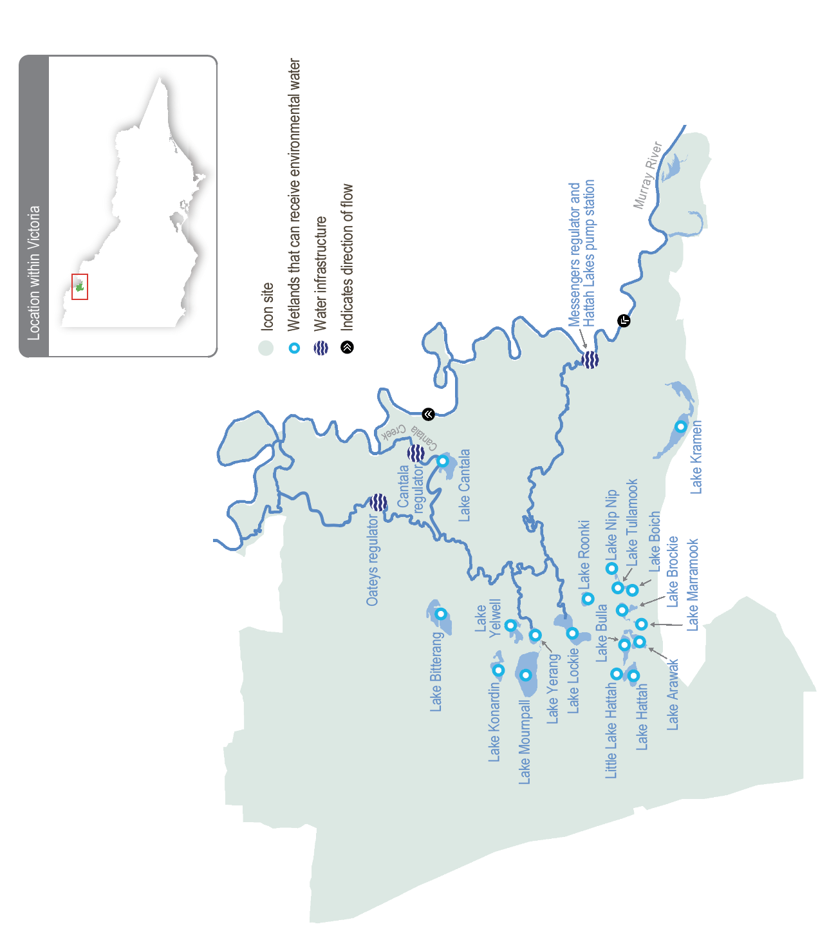

Environmental values
Hattah Lakes is home to a diverse range of flood-dependent vegetation that changes with the landscape’s topography. Vegetation types range from wetland communities in low-lying areas that require almost annual flooding to lignum and black box communities situated higher on the floodplain that only need flooding once every four to five years (on average).
A combination of natural flooding and the delivery of environmental flows since 2010 has improved tree canopy health and recruitment of black box and river red gum communities throughout the Hattah Lakes. Woodland birds, including the endangered regent parrot, have benefitted from improved tree health.
Hattah Lakes provides important waterbird breeding sites in an arid landscape. A total of 34 species of waterbirds are known to breed at the lakes when conditions are suitable. Another six species of waterbirds breed in the surrounding floodplain.
Wetland drought refuge sites are limited in the region, making the Hattah Lakes critically important for water-dependent plants, waterbirds and terrestrial animals during dry periods.
The Hattah Lakes support large-bodied native fish species (such as golden perch) and small-bodied wetland species (such as carp gudgeon). Fish move between the lakes and the Murray River when the flow is suitable. They also persist in wetlands that retain water in the Hattah Lakes during dry years before re-dispersing during floods.
Environmental objectives in the Hattah Lakes
F1 | Maintain the small- and large-bodied native fish populations at the Hattah Lakes
CN1 | Improve the function of water-dependent ecosystems by 2030 by improving productivity linkages between the river and floodplain/wetland habitats
V1 | Increase the species richness and abundance of native water-dependent floodplain and wetland aquatic vegetation by 2030
V2 | Maintain the extent and improve the condition of river red gum, black box and lignum, compared to 2006 baseline levels by 2030
B1 | Maintain the regional waterbird population by providing conditions for breeding and fledging at least three times every 10 years
B2 | Maintain the regional waterbird population by providing refuge during droughts
G1 | Maintain a variety of freshwater ecosystem types within the Hattah Lakes icon site, including semi-permanent lakes, persistent temporary wetlands, floodplain woodlands, shrublands and episodic wetlands

Traditional Owner cultural values and uses
The Hattah Lakes system is part of a highly sensitive region for Aboriginal cultural values and lies on the border of two documented language groups, the Latji Latji and the Jari Jari. Groups with an interest in the Hattah Lakes include Latji Latji, Latji Latji Mumthelang, Tati Tati Kaiejin, Tati Tati Land and Water, Wadi Wadi Land and Water, Murray Valley Aboriginal Corporation, Gilby, Dadi Dadi Weki Weki, Culpra Millee, Nyeri Nyeri and Munatunga Elders.
More than 1,000 Aboriginal archaeological sites at the Hattah Lakes are registered on the Aboriginal Cultural Heritage Register and Information System, with the freshwater lakes and wetlands providing focal points for trade and cultural exchanges among the region’s Traditional Owners. Local Aboriginal communities maintain strong connections to the land and its resources, such as native species used for food and medicine.
In October 2023, Mallee CMA and Traditional Owners held a Talk Water event at Hattah Lakes. Present were Cupra Milli, Munatunga Elders, Gilby Corpration, Latje Latje Mumthelang, Tati Tati Land & Water, Tati Tati Wadi Wadi, Wadi Wadi and Dadi Dadi Weki Weki. People discussed seasonal watering planning for Hattah Lakes and their water delivery history, including the recent floodwaters receding to the lakes and then to the Murray River. They examined maps of the recent flood extent at its peak, illustrating the inundation of the Hattah Lakes. Discussion about the seasonal watering proposal for the Hattah Lakes and north of Hattah-Kulkyne National Park included where Traditional Owners want to see water delivered, cultural plant and animal values at these sites and activities they have undertaken or want to undertake.
Discussions covered reasons why drying and drawdown might benefit the landscape. Traditional Owners asked for more background about the drawing down phase for wetlands and its part in environmental water management, planning and delivery. They also noted that water is important for all areas and wetlands and covered the ‘circle of life’: that water attracts fish, birds and other animals that come to feed off them, which provides hunting opportunities for those Aboriginal people who still hunt for food.
In March 2024, the Mallee CMA and Traditional Owner groups met to discuss 2024-25 seasonal watering proposals for Hattah Lakes with Traditional Owners agreeing on a collective list of values across all sites:
Cultural activities; native birds, reptiles, frogs, kangaroos, possums, turtles and fish; fishing; bush foods; endangered plants and animals; changing carp control to carp eradication; scar trees; clay balls; plants of cultural significance; and aquatic vegetation.
Increasing the involvement of Traditional Owners in managing environmental flows and progressing opportunities towards self-determination in the environmental watering program is a core commitment of the VEWH and its program partners. This is reinforced by legislation and policy commitments, including the Water Act 1989, the Victorian Aboriginal Affairs Framework, the 2016 Water for Victoria, the 2022 Water is Life: Traditional Owner Access to Water Roadmap, and, in some cases, agreements under the Traditional Owner Settlement Act 2010.

Social, recreational and economic values and uses
In planning the potential environmental watering actions in Table 5.2.12, the Mallee CMA considered how environmental flows could support values and uses, including:
- water-based recreation (such as fishing, kayaking and swimming)
- riverside recreation and amenity (such as birdwatching, camping, photography and walking)
- community events and tourism (educational opportunities, including bushwalking, birdwatching and bug hunting; local school education programs; Melbourne-based schools’ educational excursions; and tours involving kayaking, bike riding and camping)
- socioeconomic benefits (such as commercial beekeepers who rest bees away from horticultural orchards in native flowering trees around the lakes, multiple ecotourism operators who benefit directly when the lakes contain water, social wellbeing from connecting with nature, and social gatherings).
The Hattah Lakes are a high-profile site for the local tourism industry, providing important recreation, amenity and cultural opportunities for tourists and locals. They are recommended and promoted as a destination by the Mildura Information Centre, on the Visit Mildura website and through Parks Victoria, the land manager.
The condition of the Hattah Lakes icon site directly affects social and economic outcomes for businesses, locals and visitors alike. When environmental conditions deteriorate, as they did during the Millennium Drought, values for the community also deteriorate. Recreation and tourism-based industries suffered as visitor numbers dropped, as did amenity and other social and cultural values derived from the Hattah Lakes. The improvement in environmental conditions through the delivery of environmental water outside times of natural flooding helps improve social and economic outcomes by improving amenity, recreational opportunities and tourism jobs and income.

Scope of environmental watering
The term ‘environmental watering’ refers to the active delivery of held environmental water to support particular environmental objectives by altering the flow in a river or water level in a wetland. While other terms are sometimes used to describe the delivery of environmental water, ‘environmental watering’ is deliberately used here and in seasonal watering statements to ensure consistency in the legal instruments that authorise the use of environmental water in Victoria.
Table 5.2.12 describes the potential environmental watering actions in 2024-25, their expected watering effect (that is, the intended physical or biological effects of the watering action) and the longer-term environmental objectives they support. Each environmental objective relies on one or more potential environmental watering actions and their associated physical or biological effects.
Table 5.2.12 Hattah Lakes potential environmental watering actions, expected effects and environmental objectives
Potential environmental watering action | Expected watering effects | Environmental objectives
Southern Hattah Lakes (top up selected wetlands to 42.5 m AHD during spring) | - Stimulate the growth and improve the condition of river red gums that fringe wetlands  - Provide feeding habitat for waterbirds  - Stimulate new growth of aquatic vegetation  - Inundate dry areas of wetlands to release carbon and nutrients to increase food web productivity  - Provide spawning and recruitment habitat for small-bodied native fish and maintain sufficient water depth to provide open-water habitat for large-bodied native fish (such as golden perch)  - Inundate a variety of types of wetlands at different elevations across the Hattah Lakes to increase habitat diversity | F1  CN1  V1  V2  B1  B2  G1

Scenario planning
Table 5.2.13 outlines potential environmental watering and expected water use in various planning scenarios.
Major floods in spring 2022 inundated the entire Hattah Lakes and the surrounding floodplain. Most wetlands in the higher-elevation northern Hattah Lakes and Lake Kramen have been allowed to draw down for 12-18 months to allow native plants within lake-bed herbland communities to grow on exposed soils and provide foraging habitat for wading shorebirds.
Minor flooding in spring 2023 refilled most of the semi-permanent wetlands in the southern Hattah Lakes and eliminated the need for planned environmental watering in autumn 2024.
In 2024-25, a drawdown period for the northern Hattah Lakes and Lake Kramen will continue, but it is essential to retain some water in the semi-permanent wetlands in the south to maintain native fish populations and provide foraging habitat for waterbirds. Up to 10,000 ML of environmental water may be used in spring 2024 in the dry or average scenario to top up the semi-permanent wetlands within the southern Hattah Lakes system to 42.5 m AHD. This top-up will be timed for the end of an 8-12 month drawdown period, allowing the shallower lakes to release carbon and nutrients to stimulate food production for fish and birds.
If natural flooding occurs in an average planning scenario but is only minor, water for the environment may be pumped into the lakes to achieve the target water level of 42.5 m AHD. Final decisions about this potential watering action will be based on the timing and extent of natural flooding, particularly considering the extent of drawdown achieved before flooding.
In the wet climate scenario, large-scale natural floods are expected to inundate large parts of the Hattah Lakes and floodplain. This may happen at any time of year but is most likely during winter or spring.
No active watering is proposed in the drought planning scenario. Water from natural inundation in 2022 and 2023 is likely to persist in some of the Hattah Lakes throughout 2024-25 without additional top-ups and will provide a regional refuge habitat for waterbirds and for fish that moved into the Hattah Lakes during the floods. There is little value in trying to deliver extra water in the drought planning scenario to trigger plant and animal growth and reproduction because there may not be sufficient resources within the landscape to sustain new life.
Table 5.2.13 Hattah Lakes environmental watering planning scenarios
Planning scenario | Drought | Dry | Average | Wet
Expected river conditions | - Low flow year-round in the Murray River and no natural inflow to the Hattah Lakes; substantial wetland drying will occur | - Rare high-flow events in the Murray River and no natural inflow to the Hattah Lakes | - Short periods of high flow in the Murray River with minor spills from storages, most likely in late winter/spring, providing minor natural inflow to the Hattah Lakes | - Lengthy periods of high flow in the Murray River with major spills from storages resulting in widespread wetting of the Hattah Lakes and floodplain
Potential environmental watering – tier 1 (high priorities) | - N/A | - Southern Hattah Lakes spring top-up to 42.5 m AHD targeting semi-permanent wetlands | - Southern Hattah Lakes spring top-up to 42.5 m AHD targeting semi-permanent wetlands  - If natural inflows are minor, water for the environment will be pumped into the lakes to achieve the target water level of 42.5 m AHD as per the dry planning scenario | - All structures will be opened to allow natural flow to fill Hattah Lakes and the floodplain
Possible volume of water for the environment required to achieve objectives | - N/A | - 10,000 ML | - 0-10,000 ML | - 0 ML
Priority carryover requirements for 2025-26 | - Nil

5.2.6 Lower Murray wetlands

System overview
The lower Murray wetlands are dispersed across the Murray River floodplain between Swan Hill and the South Australian border. The system includes a myriad of interconnected creeks, wetlands and floodplains that are ecologically important and reflect the natural character and attributes of the floodplain. While there are hundreds of wetlands across the lower Murray region, only 37 have ever received water for the environment.
Regulation and diversion of the Murray River flow have substantially reduced the frequency and duration of the high river flow that would naturally water the lower Murray wetlands. This change to the water regime has been exacerbated by climate change and has reduced the variety and condition of environmental values associated with billabongs and other floodplain habitats.
Water for the environment can be delivered to some wetlands in the region by directly pumping from the Murray River and/or using irrigation supply infrastructure. Most wetlands that receive environmental flows can be managed independently of each other.
Figure 5.2.6 The lower Murray wetlands system
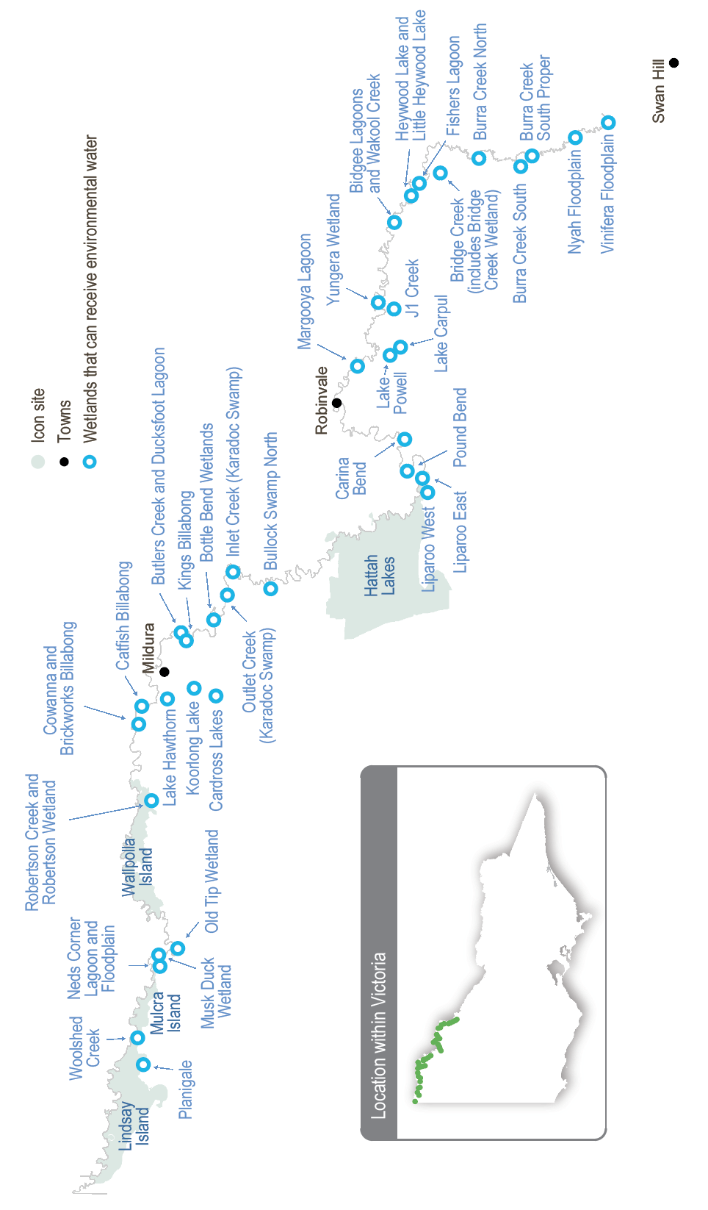

Environmental values
The lower Murray wetlands are comprised of many wetlands, creeks and billabongs. The wetlands may be permanent or temporary, and freshwater or saline, depending on their location in the landscape, interactions with groundwater and management history.
Differences in water regime and water quality across the wetlands provide a range of habitats for plants and animals. For example, permanent, saline wetlands (such as Koorlong Lake) provide vital habitat for the endangered Murray hardyhead. Ephemeral wetlands support different ecological processes in their wet and dry phases. During the wet phase, they provide short-term boom periods when river red gums and wetland plants grow, spread and provide habitat for aquatic animals (such as waterbugs, birds, frogs and, in some cases, fish). During their dry phases, sediments are exposed to the air (which is important for carbon and nutrient cycles), and terrestrial plants grow and complete their life cycles.
Environmental objectives in the lower Murray wetlands
A1 | Maintain the native frog population, including the endangered growling grass frog
B1 | Provide feeding and breeding habitat for a range of waterbird species, including threatened and migratory species and colonial nesting species (such as egrets)
CN1 | Promote carbon and nutrient cycling to enable wetland processes for food webs
F1 | Increase the Murray hardyhead populations in permanent wetlands where they are known to persist
F2 | Maintain populations of other native fish in permanent wetlands
V1 | Increase the diversity, extent and abundance of wetland plants
V2 | Improve the condition of river red gums, black box and lignum communities

Traditional Owner cultural values and uses
Watering of the Murray Wetlands supports cultural values (such as traditional food sources, medicines and important species) and provides teaching, learning and storytelling opportunities.
In October 2023, site visits were conducted with the First People of the Millewa-Mallee Aboriginal Corporation (FPMMAC) at Musk Duck Lagoon (Tiffany’s) and Wallpolla Horseshoe Lagoon. Discussions with Traditional Owners covered areas for environmental water within the FPMMAC Registered Aboriginal Party area for 2024-25. Areas visited included outlying creeks, wetlands, floodplains, lakes, lagoons, billabongs and river bends.
During site visits with Traditional Owner groups, the Mallee CMA discussed the proposed 2024-25 watering of the Murray Wetlands. Site visits were conducted with Tati Tati Land & Water, Wadi Wadi Land & Water, Dadi Dadi Weki Weki, Culpra Millie, Munatunga Elders and Wadi Wadi Nation at Lake Powell, Heywood Lake and various places within Nyah and Vinifera in November 2023. These discussions focused on where Traditional Owners want to see environmental water delivered for 2024-2025 and activities at each site. The discussions raised a lot of interest in cultural practices and interests to help prioritise areas for environmental water delivery.
Discussions covered a range of options for delivering environmental flows in 2024-2025 and the traditional ecological needs in the current climate. Feedback was positive, with groups in discussions agreeing to the needs for and reasoning behind environmental watering. Drawdown and drying were discussed in depth, and much knowledge was shared before reaching agreement.
Understanding the environmental responses to the recent flooding and identifying and protecting cultural heritage were key topics for discussion. A common foundation of all groups was the importance of water in wetlands for their culture, spirituality and connection to Country.
Other discussions with and comments by Traditional Owner groups covered wanting more native plants and animals in the areas, increasing opportunities for Indigenous landcare, providing training opportunities (such as Indigenous ranger programs), protecting and preserving Aboriginal cultural heritage on the landscape, sharing information and knowledge with the broader community and increasing use by birdwatching groups.
Site visits were also conducted at Spences Bend and Bullock Swamp with Nyeri Nyeri in November 2023 with good discussion on proposed watering in 2024-2025 and local plants and animals, and recommendations from the group on possible project ideas for the area.
In March 2024, the Mallee CMA and Traditional Owner groups met to discuss 2024-25 seasonal watering proposals for Hattah Lakes and the Murray wetlands. Traditional Owners collectively agreed to the cultural values across the sites:
Cultural activities; native birds, reptiles, frogs, kangaroos, possums, turtles and fish; fishing; bush foods; endangered plants and animals; changing carp control to carp eradication; scar trees; clay balls; plants of cultural significance; and aquatic vegetation.
For Neds Corner floodplain, Neds Corner Lagoon and the Old Tip wetland, FPMMAC will coordinate with the Mallee CMA about the delivery of environmental water to achieve cultural objectives, where possible.
Planned environmental flows may be modified to align with cultural benefits so long as environmental outcomes are not compromised.
Increasing the involvement of Traditional Owners in managing environmental flows and progressing opportunities towards self-determination in the environmental watering program is a core commitment of the VEWH and its program partners. This is reinforced by legislation and policy commitments, including the Water Act 1989, the Victorian Aboriginal Affairs Framework, the 2016 Water for Victoria, the 2022 Water is Life: Traditional Owner Access to Water Roadmap, and, in some cases, agreements under the Traditional Owner Settlement Act 2010.
Where Traditional Owners are more deeply involved in the planning and/or delivery of environmental flows for a particular site, their contribution is acknowledged in Table 5.2.14 with an icon (as explained in Figure 1.2.3). The use of this icon is not intended to indicate that these activities are meeting all the needs of Traditional Owners, but is used in the spirit of valuing that contribution.
 | Watering planned and/or delivered in partnership with Traditional Owners to support cultural values and uses

Social, recreational and economic values and uses
In planning the potential environmental watering actions in Table 5.2.14, the Mallee CMA considered how environmental flows could support values and uses, including:
- water-based recreation (such as canoeing, fishing and kayaking)
- riverside recreation and amenity (such as bike riding, birdwatching, bushwalking, camping, geocaching, photography and running)
- community events and tourism (such as day trips and sightseeing; education programs for school, TAFE and university students; and citizen science projects about birds, frogs and plants)
- socioeconomic benefits (such as economic benefits for businesses in the accommodation, beekeeping, food and beverage, ecotourism, hospitality and retail sectors; creating a focal point for socialising; and providing natural, green spaces for the local community).
Water for the environment in the lower Murray wetlands is essential to protect their unique ecosystems, plants and animals. It also provides for natural green and blue spaces, which are focal points for community and visitors alike in an otherwise dry environment. It is vital to preserve these landscapes and continue understanding how locals and visitors use them to identify their social, recreational and economic values and uses, including kayaking, walking, birdwatching and social and sporting events.
Face-to-face and online communication and community surveys indicate a lot of social and recreational use of wetlands and creeks, with a greater connection to them when they have water. Activities and values locals associate with watering include walking, water, camping, fishing, birdwatching, kayaking and bike riding. The community’s favourite places include Kings Billabong, Bottle Bend, Lake Hawthorn, Catfish Billabong, Cardross Lakes and Bullock Swamp. All these sites have some connection with environmental watering. And the list isn’t limited to the sites receiving environmental water yearly. The community strongly supports watering less-frequently-watered sites, with the benefits evident long after the watering occurs.
Local tourism also benefits from the environmental watering of the lower Murray wetlands and floodplains. Visitors to the Mildura Information Centre often ask about the best birdwatching places, which include Lake Hawthorn, Koorlong Lake, Brickworks Billabong, Cowanna Billabong and Butlers Creek. All these sites are managed with environmental water.
Increased ecotourism and visitation to the area also provide economic benefits for local businesses, primarily the accommodation and food and beverage sectors but also ecotourism providers, tour operators and local retailers, including farmers markets.
Where environmental water management and delivery are managed to align with a community benefit, so long as environmental outcomes are not compromised, this is acknowledged in Table 5.2.14 with the following icons (as explained in Figure 1.2.3).
 | Watering planned to support water sports activities (e.g. water skiing)
 | Watering planned to support waterbird-related recreational activities
Environmental water is regularly delivered to sites to meet waterbird and bird objectives, which support birdwatching, and water-based recreation.

Scope of environmental watering
The term ‘environmental watering’ refers to the active delivery of held environmental water to support particular environmental objectives by altering the flow in a river or water level in a wetland. While other terms are sometimes used to describe the delivery of environmental water, ‘environmental watering’ is deliberately used here and in seasonal watering statements to ensure consistency in the legal instruments that authorise the use of environmental water in Victoria.
Table 5.2.14 describes the potential environmental watering actions in 2024-25, their expected watering effect (that is, the intended physical or biological effects of the watering action) and the longer-term environmental objectives they support. Each environmental objective relies on one or more potential environmental watering actions and their associated physical or biological effects.
Table 5.2.14 Lower Murray wetlands system potential environmental watering actions, expected effects and environmental objectives
Potential environmental watering action |  | Expected watering effects | Environmental objectives
Bidgee Lagoons (top up in spring) |  | - Inundate adjacent river red gum and black box communities to stimulate growth and flowering to improve their condition and extent  - Provide conditions and water levels (to target 52.4 m AHD) to support the growth of aquatic and emergent vegetation and promote the diversity of emergent vegetation communities  - Provide feeding and breeding opportunities for frogs and habitat for fish species  - Mobilise leaf litter to promote carbon and nutrient cycling | A1  CN1  F2  V1  V2
Bottle Bend Wetlands (fill in spring) |  | - Provide soil moisture to maintain and improve the health of the adjacent black box (to a target water level of 36.5 m AHD)  - Provide conditions to support the growth of aquatic and emergent vegetation  - Provide feeding and breeding opportunities for frogs  - Maintain feeding and nesting opportunities for non-colonial waterbirds | A1  B1  V1  V2
Brickworks Billabong (fill in spring/summer, then as required) |  | - Recreate wetland habitat to support Murray hardyhead populations (to a target water level of 31.6 m AHD)  - Re-establish and improve the extent and coverage of ruppia to provide nursery habitat for Murray hardyhead and provide high levels of aquatic productivity  - Manage salinity within an acceptable range for Murray hardyhead and ruppia  - Provide shallow-water habitat and exposed mudflats to support foraging and resting waterbirds, including migratory waterbirds | B1  F1  V1
Bridge Creek (includes Bridge Creek Wetland) (fill in spring) |  | - Provide soil moisture to maintain and improve the condition of streamside and floodplain vegetation (to a target water level of 56.5 m AHD), specifically river red gum, black box and lignum  - Increase dissolved organic matter, particulate matter and macroinvertebrate productivity  - Provide shallow-water habitat to provide feeding habitat for wetland-dependent species, including frogs and birds  - Stimulate the growth of aquatic vegetation  - Provide conditions for semi-aquatic lake-bed herbland to establish during draw down | A1  B1  CN1  V1  V2
Brown Swamp (Pound Bend) (fill in autumn) |  | - Inundate and wet outer fringing lignum and vegetation communities (to a target water level of 47.0 m AHD) to improve their condition  - Inundate adjacent river red gum communities to stimulate their growth and flowering, to improve their condition and extent | V2
Bullock Swamp North (partial fill in spring) |  | - Provide soil moisture to maintain and improve the condition of streamside and floodplain vegetation (to a target water level of 38.5 m AHD), specifically black box and lignum  - Provide feeding opportunities for waterbirds  - Provide a lateral spread of freshwater (to a target level of 38.5 m AHD) to refresh local groundwater, which will support the condition of surrounding black box trees not directly inundated and improve the condition of the swamp | B1  V2
Burra Creek North (fill in autumn) |  | - Provide soil moisture to maintain and improve the condition of streamside and floodplain vegetation, specifically river red gum, black box and lignum  - Provide habitat through improved vegetation communities and water resources for birds and frogs  - Mobilise leaf litter to promote carbon and nutrient cycling | A1  B1  CN1  V2
Burra Creek South (fill in autumn)
Burra Creek South Proper (fill in autumn)
Koorlong Lake (top‑ups in spring, then as required) |  | - Increase and maintain the water level (to a target level between 36.7 m AHD and 38.0 m AHD) to support the growth of saline aquatic vegetation, including ruppia, to provide nursery habitat for Murray hardyhead and provide high levels of aquatic productivity  - Maintain the water level within a 1.3 m range to provide feeding resources for waterbirds and maintain the Murray hardyhead population | B1  F1  V1
Lake Carpul (fill in winter/spring 2024)¹   | Part B: July-November 2024 | - Provide a range of open-water, shallow-water and emergent vegetation habitats for water-dependent species, including frogs and birds, to support breeding and feeding opportunities  - Stimulate the growth of aquatic vegetation during inundation  - Inundate and wet outer fringing river red gum, black box, lignum and vegetation communities (to a target water level of 55.05 m AHD at Lake Powell and 52.23 m AHD at Lake Carpul) to maintain and improve their condition  - Provide conditions for semi-aquatic lake-bed herbland to establish during drawdown  - Mobilise carbon and aid nutrient cycling within the wetland to support wetland processes | A1  B1  CN1  V1  V2
Lake Powell (fill in winter/spring 2024)¹ | Part B: July-November 2024
Lake Hawthorn (top-ups in spring, then as required) |  | - Maintain the water level between 33 m AHD and 33.3 m AHD to encourage the germination and growth of saline aquatic vegetation, including ruppia, and provide mudflat and shallow-water feeding habitat for shorebirds | B1  V1
Neds Corner Floodplain² (fill in autumn)   |  | - Provide a range of open-water, shallow-water and emergent vegetation habitats for wetland-dependant species, including frogs and birds, and support breeding and feeding opportunities  - Stimulate the growth of aquatic vegetation during inundation  - Provide soil moisture to maintain and improve the condition of streamside and floodplain vegetation, specifically black box  - Provide conditions for semi-aquatic lake-bed herbland to establish during draw down | A1  B1  V1  V2
Neds Corner Lagoon² (fill in autumn)
Old Tip Wetland² (fill in autumn)
Nyah Floodplain (fill in autumn) |  | - Inundate the base and littoral zone of Parnee Malloo Creek (to a target water level of 63.2 m AHD) to support aquatic and semi-aquatic plant communities  - Improve the condition of vegetation communities to provide a range of habitats and resources for birds and frogs  - Inundate floodplain adjacent to Parnee Malloo Creek to promote the growth of herb and shrub layers  - Inundate river red gums to maintain and improve their condition  - Mobilise carbon and nutrients to promote chemical and biological processes | A1  B1  CN1  V1  V2
Outlet Creek (Karadoc Swamp) (fill in spring) |  | - Provide soil moisture to maintain and improve the condition of streamside and floodplain vegetation, specifically river red gum, black box and lignum  - Provide suitable habitat for native frog species  - Provide open-water habitat as feeding and breeding habitat for waterbirds | A1  B1  V2
Vinifera Floodplain (fill in autumn) |  | - Inundate the soils (to a target water level of 63.2 m AHD) to support aquatic and semi-aquatic plant communities  - Improve the condition of vegetation communities to provide a range of habitats and resources for birds and frogs  - Inundate the floodplain to promote the growth of herb and shrub layers  - Inundate river red gums to maintain and improve their condition  - Mobilise carbon and nutrients to promote chemical and biological processes | A1  B1  CN1  V1  V2
1 This potential watering action is Part B of a watering action commenced in 2023-24.
2 In past seasonal watering plans, this wetland has been watered as part of Neds Corner Central. It is one of three wetlands at this site: Old Tip Wetland, Neds Corner Floodplain and Neds Corner Lagoon.

Scenario planning
Table 5.2.15 outlines potential environmental watering and expected water use in various planning scenarios.
Three permanent wetlands in the lower Murray wetlands system rely on environmental watering or natural inundation every year to maintain their environmental values and are high priorities for watering in all planning scenarios in 2024-25. Brickworks Billabong and Koorlong Lake are important sites for endangered Murray hardyhead. Lake Koorlong currently supports a healthy population of Murray hardyhead and requires top-ups each year to maintain salinity levels within the target range for ruppia and successful fish breeding. Brickworks Billabong used to support Murray hardyhead, but the 2022 floods flushed the fish from the wetland and allowed pest species to become established. The billabong was drawn down in 2023-24 to eliminate pest fish species and will be filled again in 2024-25 to restore suitable habitat to allow the successful reintroduction of Murray hardyhead. Lake Hawthorn has similar characteristics to Brickworks Billabong and Koorlong Lake, but attempts to establish a Murray hardyhead population in the lake have not succeeded. The lake’s semi-saline conditions continue to support ruppia and provide foraging habitat for shorebirds. It draws down in summer and autumn and requires a spring top-up in all planning scenarios.
All other lower Murray wetlands that can receive environmental water require top-ups less than once a year, either because they are large and, when full, can retain water for several years or are ephemeral and rely on periods of inundation followed by periods of complete drying to support their environmental values. Each wetland has different watering requirements, usually determined by the vegetation communities they support. Other than in flood years, it is generally desirable for wetlands across the region to be in different stages of their wetting and drying cycles to create a mosaic of habitats for waterbirds and other native animals while also meeting the watering needs of vegetation communities at each site. Widespread floods in 2022 and subsequent inundation of low-lying areas of the floodplain in 2023-24 mean that most of the lower Murray wetlands are now in a similar phase. They either still hold a significant volume of water, are starting to draw down or have recently dried. Environmental watering in 2024-25 aims to re-establish a variety of wetland habitats across the lower Murray floodplain by refilling some sites where vegetation communities will benefit from another inundation and allowing other sites that require more frequent drying to draw down.
Natural inundation in recent years has greatly improved environmental conditions at Outlet Creek (Karadoc Swamp), Bullock Swamp North, Bottle Bend wetlands, Old Tip Wetland, Neds Corner Lagoon and Floodplain. A follow-up watering is included in the dry-to-wet planning scenarios to consolidate these gains and build resilience for potential drier periods ahead. Lake Powell and Lake Carpul will also benefit from a follow-up watering in these planning scenarios, and the planned watering in winter/spring is the second half of a watering action that commenced in autumn 2024. Bridge Creek (including Bridge Creek Wetland) is one of the few lower Murray wetlands that didn’t respond well to recent floods. The Mallee CMA suggests the wetland may need a longer period of inundation to improve the condition of the black box at the site and proposes to fill the wetland and use temporary levees to retain water for an optimal duration in 2024-25.
Nyah and Vinifera floodplains, Bidgee Lagoons, Pound Bend and the Burra Creek sites have all been inundated multiple times since 2021. Their environmental condition is currently high, and they don’t need more watering in the drought and dry planning scenarios but are prioritised in the average and wet planning scenarios to enhance their ecological condition. Brown Swamp at Pound Bend was naturally inundated in spring 2022 and has retained deep pools, which have watered the root zone and improved the condition of fringing vegetation and streamside species. Additional watering in 2024-25 is expected to improve the condition and increase the abundance and diversity of understorey vegetation adjacent to the swamp.
Vegetation communities at Bidgee Lagoons and the Burra Creek sites also improved as a result of recent floods, and additional top-ups are planned to encourage the further growth of herbland communities within the wetlands and macrophytes along associated creeklines to support waterbirds, frogs and other animals. Nyah and Vinifera floodplains are also prioritised in the average and wet planning scenarios to maintain their high natural watering frequency, preserve the rare vegetation communities of the floodplains (which are dominated by forest) and support the diverse plants and animals, including some species of conservation significance.
All other wetlands on the lower floodplain in the lower Murray wetlands system will be allowed to draw down to support dry-phase ecosystem processes, as recommended in their management plans.
A carryover target of 1,900 ML for 2025-26 has been set to ensure a sufficient water supply for annual watering at Brickworks Billabong, Koorlong Lake and Lake Hawthorn.
Table 5.2.15 Lower Murray wetlands system environmental watering planning scenarios
Planning scenario | Drought | Dry | Average | Wet
Expected conditions | - Natural flow in the Murray River is too low to connect to the wetlands  - Very low rainfall year-round and extremely hot and dry conditions in summer/autumn cause substantial wetland drying  - Wetlands rely on environmental water | - Short periods of high flow in the Murray River are possible, but overbank flow to the wetlands is unlikely  - There may be low rainfall and a very warm summer/autumn  - Wetlands rely on environmental water | - Sustained periods of high flow in the Murray River in late winter and early spring may wet some low-lying wetlands, but most will rely on environmental water  - Local rainfall may be high and provide run-off to some wetlands | - Lengthy periods of high flow and floods with major spills from storages are likely, resulting in widespread wetting of the floodplain and most wetlands  - There may be some reliance on environmental water to achieve target water levels  - Local rainfall may be high and will provide run-off to most wetlands
Potential environmental watering – tier 1 (high priorities) | - Brickworks Billabong (fill in spring/summer, then as required)  - Koorlong Lake (top-ups in spring, then as required)  - Lake Hawthorn (top-ups in spring, then as required) | - Bottle Bend Wetlands (fill in spring)  - Brickworks Billabong (fill in spring/summer, then as required)  - Bridge Creek (includes Bridge Creek Wetland) (fill in spring)  - Bullock Swamp North (partial fill in spring) | - Bidgee Lagoons (top-up in spring)  - Bottle Bend Wetlands (fill in spring)  - Brickworks Billabong (fill in spring/summer, then as required)  - Bridge Creek (includes Bridge Creek Wetland) (fill in spring) | - Bidgee Lagoons (top-up in spring)  - Bottle Bend Wetlands (fill in spring)  - Brickworks Billabong (fill in spring/summer, then as required)  - Bridge Creek (includes Bridge Creek Wetland) (fill in spring)
(continued)  Potential environmental watering – tier 1 (high priorities) |  | - Koorlong Lake (top-ups in spring, then as required)  - Lake Carpul (fill in winter/spring 2024)  - Lake Hawthorn (top-ups in spring, then as required)  - Lake Powell (fill in winter/spring 2024)  - Neds Corner Floodplain (fill in autumn)  - Neds Corner Lagoon (fill in autumn)  - Old Tip Wetland (fill in autumn)  - Outlet Creek (Karadoc Swamp) (fill in spring) | - Brown Swamp (Pound Bend) (fill in autumn)  - Bullock Swamp North (partial fill in spring)  - Burra Creek North (fill in autumn)  - Burra Creek South (fill in autumn)  - Burra Creek South Proper (fill in autumn)  - Koorlong Lake (top-ups in spring, then as required)  - Lake Carpul (fill in winter/spring 2024)  - Lake Hawthorn (top-ups in spring, then as required)  - Lake Powell (fill in winter/spring 2024)  - Neds Corner Floodplain (fill in autumn)  - Neds Corner Lagoon (fill in autumn)  - Nyah Floodplain (fill in autumn)  - Old Tip Wetland (fill in autumn)  - Outlet Creek (Karadoc Swamp) (fill in spring)  - Vinifera Floodplain (fill in autumn) | - Brown Swamp (Pound Bend) (fill in autumn)  - Bullock Swamp North (partial fill in spring)  - Burra Creek North (fill in autumn)  - Burra Creek South (fill in autumn)  - Burra Creek South Proper (fill in autumn)  - Koorlong Lake (top-ups in spring, then as required)  - Lake Carpul (fill in winter/spring 2024)  - Lake Hawthorn (top-ups in spring, then as required)  - Lake Powell (fill in winter/spring 2024)  - Neds Corner Floodplain (fill in autumn)  - Neds Corner Lagoon (fill in autumn)  - Nyah Floodplain (fill in autumn)  - Old Tip Wetland (fill in autumn)  - Outlet Creek (Karadoc Swamp) (fill in spring)  - Vinifera Floodplain (fill in autumn)
Potential environmental watering – tier 2 (additional priorities) | - N/A
Possible volume of water for the environment required to achieve objectives | - 2,050 ML (tier 1)  - N/A (tier 2) | - 8,580 ML (tier 1)  - N/A (tier 2) | - 14,275 ML (tier 1)  - N/A (tier 2) | - 8,230 ML (tier 1)  - N/A (tier 2)
Priority carryover requirements for 2025-26 | - 1,900 ML

5.2.7 Lindsay, Mulcra and Wallpolla islands

System overview
Lindsay, Mulcra and Wallpolla islands cover over 26,100 ha of Victorian floodplain in the Murray-Sunset National Park (see Figure 5.2.7). They form part of the Chowilla Floodplain and Lindsay-Wallpolla islands icon site that straddles the Victoria–South Australia-New South Wales border in the mid-Murray River system.
A network of permanent waterways, small creeks and wetlands characterises the Lindsay, Mulcra and Wallpolla islands floodplain. Lindsay River, Potterwalkagee Creek and Wallpolla Creek form the southern boundaries of the site and create large floodplain islands with the Murray River to the north.
In their natural state, these waterways and wetlands would regularly flow and fill in response to high water levels in the Murray River. Large floods still occur, but major storages in the upper reaches of the Murray River system and extraction for consumptive use have reduced the frequency of small to moderate-sized floods.
Flows in the mid-Murray River system are regulated through a series of weir pools. The weir pools are named after the locks that form part of the infrastructure at the weirs that allow vessels to navigate from one weir pool to the next. The weir pools are primarily managed as small water storages to ensure adequate water levels for off-stream diversion via pumps and regulated channels.
Water is diverted from the Lock 9 weir pool in the Murray River to Lake Victoria, where it is stored for later use to meet South Australia’s water demands. The diversion causes water to bypass Murray River locks 7 and 8 weir pools, and at times it can greatly affect the flow in those reaches.
In recent years, water levels in locks 7 and 8 weir pools have been managed to achieve environmental benefits in the Murray River channel. For example, weir pool levels have been raised during winter and spring and lowered during summer and autumn to mimic the seasonal river flow. The raising and lowering provide greater environmental benefits than a stable weir pool because it wets and dries off-channel habitats and creates more variable flow patterns in the Murray River and connected floodplain streams. Changes in water levels during appropriate seasons help establish fringing vegetation in shallow margins of the river channel and promote the cycling of nutrients and carbon as conditions fluctuate between wet and dry.
Static weir pool levels and reduced Murray River flow significantly affect the Lindsay River and Potterwalkagee Creek flows. When the natural flow increases and/or water levels in locks 7 and 8 weir pools are raised above the full supply level, the upper Lindsay River starts flowing (Lock 7) and the flow to Potterwalkagee Creek increases (Lock 8). When weir pools are lowered, flow to the upper Lindsay River and Potterwalkagee Creek ceases. Mullaroo Creek on Lindsay Island is less affected by weir pool levels, and flow is controlled independently through the Mullaroo Creek regulator, which connects the creek and the Murray River. Moderate lowering of the Lock 7 weir pool level has little effect on Mullaroo Creek, but lowering more than 0.5 m below full supply level makes it difficult to deliver the recommended minimum flow of 600 ML per day that is required to maintain fast-flowing habitat for native fish, especially Murray cod.
Fluctuation of weir pool levels is a major consideration for jurisdictions managing the flow in the Murray River and the anabranch waterways of Lindsay, Mulcra and Wallpolla islands. Environmental objectives and associated water regimes for the Murray River sometimes conflict with those for the Lindsay, Mulcra and Wallpolla anabranch systems. Responsible agencies in Victoria and NSW and the Murray-Darling Basin Authority collaboratively plan how to manage weir pools and flows to floodplain habitats effectively.
Figure 5.2.7 The Lindsay, Mulcra and Wallpolla islands
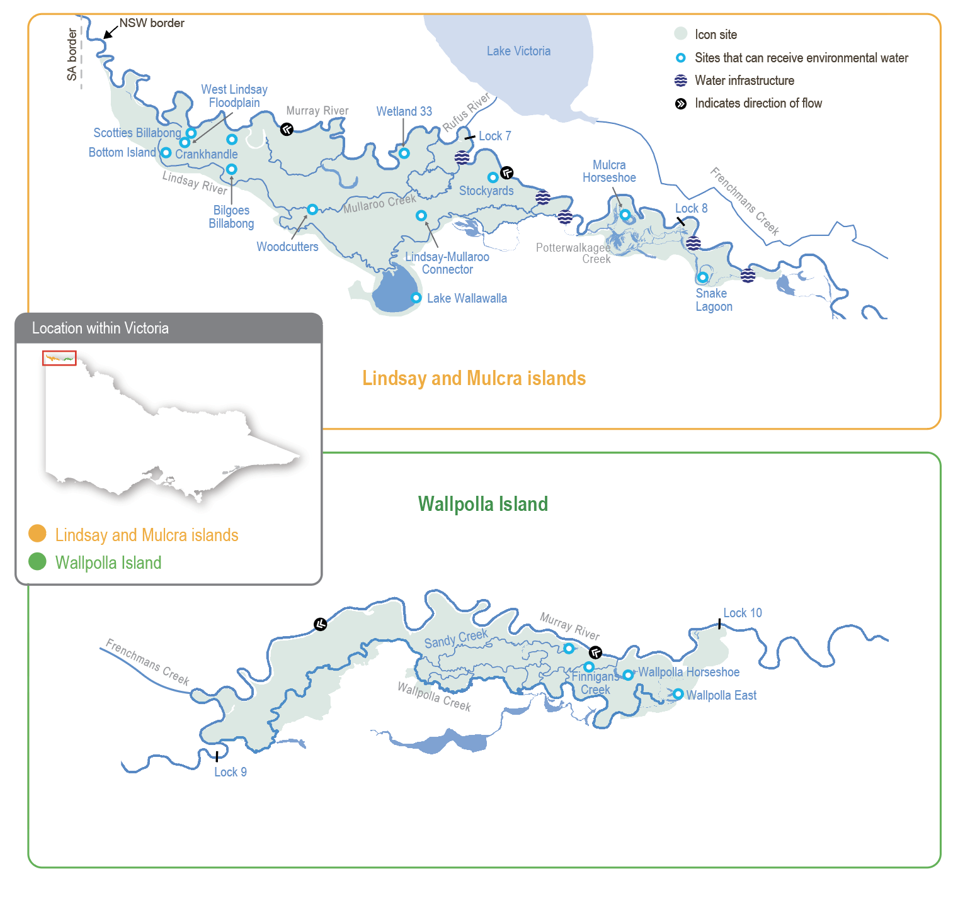

Environmental values
The Lindsay, Mulcra and Wallpolla islands represent three separate anabranch systems that contain various streams, billabongs, large wetlands and swamps. When flooded, waterways and wetlands within these systems provide habitat for native fish, frogs, turtles, waterbirds and water-dependent plants. Terrestrial animals (such as woodland birds) also benefit from improved productivity and food resources when anabranch systems are inundated. Large floodplain wetlands (such as Lake Wallawalla) can retain water for several years after receiving inflows; they provide important refuges for wetland-dependent species and support terrestrial animals (such as small mammals and reptiles).
Mullaroo Creek supports one of the most significant populations of Murray cod in the mid-Murray River system. Mullaroo Creek provides a fast-flowing habitat that Murray cod favour, contrasting with the artificially slow-flowing and still habitats in the nearby Murray River weir pools. Fish in Mullaroo Creek breed and produce juveniles that contribute to populations in adjacent parts of the Murray system (such as in the Darling River in NSW and the lower Murray River in South Australia). Waterways and wetlands throughout the icon site support several other fish species, including freshwater catfish, golden perch, silver perch, Murray-Darling rainbowfish and unspecked hardyhead.
The reduced frequency and duration of floods in the Murray River have degraded the water-dependent vegetation communities throughout the Lindsay, Mulcra and Wallpolla island system, reducing the diversity and abundance of animals that rely on healthy vegetation for habitat.
Environmental objectives in Lindsay, Mulcra and Wallpolla islands
F1 | By 2030, increase the abundance of small-bodied native fish and the spread of age classes for long-lived native fish, compared to 2006 baseline levels
A1 | Maintain the frog population
CN1 | By 2030, improve the function of water-dependent ecosystems by improving productivity linkages between river and floodplain habitats
V1 | Improve threatened flow-dependent plant populations
V2 | By 2030, maintain the extent and improve the condition of river red gum, black box and lignum compared to 2006 baseline levels
V3 | By 2030, improve the species richness and abundance of native wetland and floodplain aquatic vegetation functional groups
B1 | Maintain communities and species diversity of colonial nesting waterbirds, waterfowl, and waders that feed on fish
B2 | By 2030, increase the colonial nesting waterbird population at Lake Wallawalla and the non-colonial waterbird population at Mulcra Horseshoe and Wallpolla Horseshoe

Traditional Owner cultural values and uses
Aboriginal ancestral occupation across the Lindsay-Mulcra-Wallpolla floodplain dates back tens of thousands of years, sustained by the rich productivity of the floodplain woodland and wetland systems. Historically, the islands would have been an abundant source of food and water for these communities. The floodplain is a vital part of community health and wellbeing for Aboriginal communities.
The First People of the Millewa-Mallee Aboriginal Corporation (FPMMAC) is the Recognised Aboriginal Party (RAP) in north-west Victoria for Country that runs south of the Murray River to the Mallee Highway and west from the Calder Highway to the South Australian border, including the Murray-Sunset National Park.
There are many sites of cultural significance across the Lindsay-Mulcra-Wallpolla floodplain, including ceremonial grounds, earth oven remains, scar trees, birthing trees, shell middens, song lines, ancestral resting places and story places.
The people represented by the FPMMAC have maintained a connection with the Murray River for thousands of generations; the river and its surrounds are one of the richest sources of Aboriginal archaeological and heritage material in the nation. The floodplain provides vital resources, including food, water, shelter, medicine and tools. The Traditional Owners retain a strong connection to this Country.
The Mallee CMA has a strong working relationship with the FPMMAC, supported by regular two-way communication, planning, knowledge-sharing and collaboration. Water in the landscape is essential to the spirituality of the people FPMMAC represents, strengthening their connection to Country. The Mallee CMA and FPMMAC have frequent discussions about water, including objectives, planning and delivery of environmental water.
This year, the Mallee CMA engaged with Traditional Owners much earlier in the seasonal watering planning process than in previous years in response to feedback.
In October 2023, Mallee CMA presented to FPMMAC about environmental watering practices, how the Murray River is regulated and how environmental water benefits Mallee floodplains, including Lindsay, Mulcra and Wallpolla icon sites, due to the extensive floodplain area in the region. Mallee CMA also presented the 2022-23 flood impacts, including the environmental benefits of the unregulated watering event.
In October, a Talk Water event was held on Country at Lake Wallawalla with Traditional Owners, discussing proposed environmental watering for 2024-45. Key feedback was Traditional Owners would like to see water remain in Lake Wallawalla at all times to support the health of trees, plants, birds and animals. In addition to sites, values were discussed for the Lindsay, Mulcra and Wallpolla islands.

Values of the Lindsay, Mulcra and Wallpolla islands provided by Traditional Owners

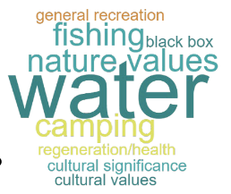
Throughout 2023-24, FPMMAC, Mallee CMA and Parks Victoria met to discuss Lake Wallawalla. FPMMAC has shared aspirations to develop Lake Wallawalla in a way that encourages people to visit the site with restrictions to protect cultural heritage values. Additionally, they aspire to build a site for cultural ceremonies and for further works to repair and protect particular cultural heritage sites.
Planned environmental flows may be modified to align with cultural benefits so long as environmental outcomes are not compromised.
Feedback about cultural input into the environmental water program and seasonal watering proposals occurs formally and informally. There are many meetings and discussions throughout the year with staff and leaders from FPMMAC, where these matters are raised and explored in detail.
FPMMAC is partnering with the Mallee CMA in all watering actions, management and monitoring on Country in 2024-25.
Increasing the involvement of Traditional Owners in managing environmental flows and progressing opportunities towards self-determination in the environmental watering program is a core commitment of the VEWH and its program partners. This is reinforced by legislation and policy commitments, including the Water Act 1989, the Victorian Aboriginal Affairs Framework, the 2016 Water for Victoria, the 2022 Water is Life: Traditional Owner Access to Water Roadmap, and, in some cases, agreements under the Traditional Owner Settlement Act 2010.
Where Traditional Owners are more deeply involved in the planning and/or delivery of environmental water for a particular site, their contribution is acknowledged in Table 5.2.16 with an icon (as explained in Figure 1.2.3). The use of this icon is not intended to indicate that these activities are meeting all the needs of Traditional Owners but is used in the spirit of valuing that contribution.
 | Watering planned and/or delivered in partnership with Traditional Owners to support cultural values and uses

Social, recreational and economic values and uses
The Lindsay-Mulcra-Wallpolla floodplain is a vast, isolated landscape. Its remote nature is a major drawcard for people hoping to ‘get away from it all’ during trips to the area. Tourism is one of the largest industries in the Mildura/Mallee area. The Murray-Sunset National Park is one of the area’s major attractions, and with the Lindsay, Mulcra and Wallpolla islands attracts visitors from around the country.
The permanent water sources of the Murray River and its anabranches are focal points for visitors. They provide many recreational opportunities, including for camping, canoeing, watching birds and wildlife, photography, fishing and four-wheel driving. When environmental water is delivered, the region’s attractiveness increases, with short-term responses to watering offering more opportunities (such as yabbying and birdwatching). Many families and groups have longstanding connections with the Lindsay-Mulcra-Wallpolla area and make regular trips to enjoy this diverse landscape.
Feedback from the community highlights the importance of these landscapes to people and the additional benefits of delivering environmental water.
The Lindsay, Mulcra and Wallpolla islands are important for apiarists who use the area for their beehives and honey collection. The bees benefit from a natural environment, which allows them to rest away from commercial crops (such as nuts and fruit) and the insecticides used in their production. Delivery of environmental water improves local vegetation’s health, resulting in flower production and subsequently more honey produced.
The direct local economic benefits of environmental watering across the Lindsay-Mulcra-Wallpolla floodplain include work for the contractors who provide the pumps needed at many sites to deliver the water. Mallee CMA contracts suitable local businesses, which employ local staff and use local goods and services.
Research helps us learn about the natural environment and the responses of plants and animals and the hydrological and geomorphological outcomes of delivering environmental water to wetlands, creeks, channels, floodplains and rivers. Research can help identify ways to improve recreational outcomes (such as improved breeding response to a recreational angling species) and cultural outcomes (such as more medicinal plants on the floodplain) by improving the timing, volume and duration of watering. Researchers may be local or use local hospitality and accommodation providers.
In planning the potential environmental watering actions in Table 5.2.16, the Mallee CMA has considered how environmental flows could support social, recreational and economic values and uses, including:
- water-based recreation (such as canoeing, kayaking, fishing and yabbying)
- riverside recreation and amenity (such as bushwalking, camping, bird and wildlife watching, four-wheel driving and photography)
- community events and tourism (such as increased and longstanding repeat visitation, ecotourism and educational programs for school, TAFE and university students)
- socioeconomic benefits (such as for commercial beekeepers who rest bees around the floodplain away from crops and pesticides ready for the next season, local businesses providing accommodation and hospitality to tourists, researchers and local water delivery contractors).

Scope of environmental watering
The term ‘environmental watering’ refers to the active delivery of held environmental water to support particular environmental objectives by altering the flow in a river or water level in a wetland. While other terms are sometimes used to describe the delivery of environmental water, ‘environmental watering’ is deliberately used here and in seasonal watering statements to ensure consistency in the legal instruments that authorise the use of environmental water in Victoria.
Table 5.2.16 describes the potential environmental watering actions in 2024-25, their expected watering effect (that is, the intended physical or biological effects of the watering action) and the longer-term environmental objectives they support. Each environmental objective relies on one or more potential environmental watering actions and their associated physical or biological effects.
Table 5.2.16 Lindsay, Mulcra and Wallpolla islands potential environmental watering actions, expected effects and environmental objectives
Potential environmental watering action | Expected watering effects | Environmental objectives
Lindsay Island – Mullaroo Creek
Year-round low flow (minimum of 600 ML/day)   | - Maintain fast-flowing habitat for large-bodied native fish (such as Murray cod, silver perch and golden perch)  - Maintain habitat for aquatic vegetation and soil moisture to maintain the condition of streamside vegetation | F1  V2  V3
Elevated spring flow (1,200 ML/day for three months during September to November) | - Increase the extent and velocity of fast-flowing habitat to cue the movement and spawning and improve recruitment opportunities for large-bodied native fish  - Increase fish passage between Mullaroo Creek and the Murray River via the Mullaroo Creek regulator fishway  - Reduce the vigour of typha by inundating reed beds during the growing season to prevent the growth of vegetation | F1  V3
Lindsay Island – Lindsay River
Spring low flow via the northern regulator (45 ML/day for three months during September to November) | - Provide temporary flowing water to connect pools and support the dispersal and recruitment of small- and large-bodied native fish and the spawning of small-bodied native fish  - Stimulate the release of carbon and nutrients from the sediment to increase the productivity of the floodplain food web  - Maintain bank soil moisture to support the growth of streamside vegetation  - Reduce the vigour of typha by inundating reed beds during the growing season to prevent the growth of vegetation | F1  CN1  V2  V3
Lindsay Island wetlands
Woodcutters (fill in spring) | - Provide shallow- and open-water habitat to create foraging and breeding opportunities for waterbirds and frogs  - Increase soil moisture to maintain and improve the condition of river red gums | B1  A1  V2
Mulcra Island – Potterwalkagee Creek
Spring low flow via the Stoney Crossing regulator (35-115 ML/day for three months during September to November) | - Provide temporary flowing water to connect pools and support the dispersal and recruitment of small- and large-bodied native fish, and the spawning of small-bodied native fish  - Stimulate the release of carbon and nutrients from the sediment to increase the productivity of the floodplain food web  - Maintain soil moisture to maintain the condition of streamside vegetation  - Reduce the vigour of typha by inundating reed beds during the growing season to prevent the growth of vegetation | F1  CN1  V2  V3
Spring low flow via the upper Potterwalkagee Creek regulator (15 ML/day for three months during September to November)
Mulcra Island wetlands
Mulcra Horseshoe (fill in spring) | - Provide shallow and open-water habitat to create foraging and breeding opportunities for waterbirds  - Provide shallow-water habitat to provide refuge (if conditions are dry in the next 2-3 years) and feeding habitat for frogs  - Stimulate the growth of emergent, aquatic and other plants growing on the water’s edge  - Provide conditions for lake-bed herbaceous plants to grow as the wetland draws down during summer and autumn, such as the threatened native couch, mallee cucumber and branching groundsel | B1  B2  A1  V1  V2  V3
Wallpolla Island
- No watering activities are planned for Wallpolla Island in 2024-25

Scenario planning
Table 5.2.17 outlines potential environmental watering and expected water use in a range of planning scenarios.
The two categories of opportunities to deliver water for the environment at Lindsay and Mulcra islands in 2024-25 are:
- deliveries of water for the environment to anabranch waterways (Mullaroo Creek, Lindsay River and Potterwalkagee Creek) in coordination with weir pool operation
- deliveries via temporary pumps to individual wetlands at Lindsay and Mulcra islands.

Anabranch watering
Permanent flowing water with a modest increase in spring is essential for Mullaroo Creek in all planning scenarios because there is good evidence this watering regime promotes fish movement and breeding, particularly for Murray cod. The flow in the Mullaroo Creek is controlled through the Mullaroo Creek regulator, and it can be managed independently of weir pool operations and moderate fluctuations in the flow in the Murray River. Delivering this water regime in all planning scenarios is practical and desirable.
Lindsay River and Potterwalkagee Creek require a low flow in eight or nine of every 10 years to maintain soil moisture for streamside vegetation and replenish and connect deep pools for the dispersal and recruitment of native fish. In most years, this is achieved by delivering a low magnitude flow in spring, but every second or third year it is delivered at a higher magnitude through winter, spring and early summer to enhance connectivity through the waterways and with the Murray River. The occasional delivery of higher-magnitude flows in Potterwalkagee Creek also enables the delivery of water to the floodplain on Mulcra Island. The flow is typically prevented from entering both anabranches from mid-to-late summer to the end of autumn. Once or twice every 10 years, the flow may not be delivered for a full year to support dry-phase environmental processes and increase the richness and abundance of the native wetland and floodplain aquatic vegetation. To achieve these outcomes, in 2024-25 the following water regimes are planned to be implemented in Lindsay River and Potterwalkagee Creek.
For the Lindsay River, the operation of the Lock 7 weir pool is expected:
- in the drought planning scenario, to ensure the weir pool does not exceed the full supply level and there is no flow in any section of the river
- in the dry and average planning scenarios, to raise the weir pool enough to deliver low flows via the northern regulator in spring, but no flow via the southern regulator, with no flow through the river in summer/winter
- in the wet planning scenario, for high flows in the Murray River to likely to deliver natural flows through all sections of the river for extended periods in winter, spring and early summer.
For Potterwalkagee Creek, the operation of the Lock 8 weir pool is expected:
- in the drought planning scenario, to hold the weir pool at full supply level or below year-round and to manage the Stoney Crossing to provide a minor flow into the creek in spring
- in the dry and average planning scenarios, to raise the weir pool enough to deliver spring low flows via the Stoney Crossing regulator and the upper Potterwalkagee regulator, with no flow through the creek from summer to winter
- in the wet planning scenario, for high flows in the Murray River to likely deliver natural flow through all sections of the creek and inundate parts of the adjacent floodplain for extended periods in winter, spring and early summer.

Deliveries via temporary pumps
Many wetlands and creeklines across the Lindsay, Mulcra and Wallpolla islands had substantial flooding or periods of sustained high flow from winter/spring 2022 to early autumn 2024. Natural flooding has improved the condition of all floodplain and wetland ecosystems, so little active watering via temporary pumping is needed in 2024-25.
Watering Woodcutters on Lindsay Island and Mulcra Horseshoe on Mulcra Island in spring are high priorities in all planning scenarios, noting that they are expected to fill from natural flooding in a wet planning scenario.
Woodcutters Creek requires a flow optimally in eight of every 10 years, but it has only filled twice in the last 10 years: in 2016 and 2022. Watering Woodcutters Creek in spring 2024 will enhance the recovery of plants growing on the water’s edge (such as river red gums) that declined in condition due to prolonged drying between 2016 and 2022.
The vegetation community at Mulcra Horseshoe requires inundation in nine out of every 10 years for optimal condition. The wetland has filled seven times in the last 10 years but only three times in the last six years. Additional watering is proposed in 2024-25 to move it closer to its optimal watering regime and improve the condition of the surrounding river red gums and understory vegetation.
All other sites in the Lindsay, Mulcra and Wallpolla islands that are usually considered for environmental watering have been watered multiple times in the last three years and will be allowed to draw down in 2024-25 to support dry-phase environmental processes (such as providing foraging habitat for wading waterbirds and allowing the growth of lake-bed herbland communities). Offsetting wetting and drying phases in different wetlands across Lindsay, Mulcra and Wallpolla islands provides a variety of habitat types and resources for waterbirds, terrestrial birds and other animals.
Table 5.2.17 Lindsay, Mulcra and Wallpolla islands environmental watering planning scenarios
Planning scenario | Drought | Dry | Average | Wet
Expected conditions | - Year-round low flow in the Murray River and no natural floodplain wetting  - Weir pools will be maintained at full supply level in spring and drawn down below full supply level during summer, autumn and winter  - Substantial wetland drying will occur | - Rare high-flow events in the Murray River and no natural floodplain wetting  - Weir pools will be raised in spring and drawn down below full supply level in summer, autumn and winter  - Substantial wetland drying will occur | - Short periods of high flow, most likely in spring/summer, will provide minor wetting of the floodplain  - Weir pool levels will be maintained at full supply level or raised in winter/spring and summer and drawn down in summer, autumn and winter | - Long periods of high flow, and major spills from storages will result in widespread wetting of the floodplain and wetting of most wetlands  - Weirs would be removed to allow the passage of a natural flow
Lindsay Island
Potential environmental watering – tier 1 (high priorities) | - Year-round low flow (Mullaroo Creek)  - Elevated spring flow (Mullaroo Creek)  - Woodcutters (fill in spring) | - Year-round low flow (Mullaroo Creek)  - Elevated spring flow (Mullaroo Creek)  - Spring low flow (Lindsay River via the northern regulator)  - Woodcutters (fill in spring) | - Year-round low flow (Mullaroo Creek)  - Elevated spring flow (Mullaroo Creek)  - Spring low flow (Lindsay River via the northern regulator)  - Woodcutters (fill in spring) | - Year-round low flow (Mullaroo Creek)  - Elevated spring flow (Mullaroo Creek)  - Spring low flow (Lindsay River via the northern regulator)  - Woodcutters (fill in spring)
Mulcra Island
Potential environmental watering – tier 1 (high priorities) | - Spring low flow (Potterwalkagee Creek via the Stony Crossing regulator)  - Mulcra Horseshoe (fill in spring) | - Spring low flow (Potterwalkagee Creek via Stony Crossing and upper Potterwalkagee regulators)  - Mulcra Horseshoe (fill in spring) | - Spring low flow (Potterwalkagee Creek via Stony Crossing and upper Potterwalkagee regulators)  - Mulcra Horseshoe (fill in spring) | - Spring low flow (Potterwalkagee Creek via Stony Crossing and upper Potterwalkagee regulators)  - Mulcra Horseshoe (fill in spring)
Possible volume of water for the environment required to achieve objectives¹ | - 1,070 ML | - 1,070 ML | - 1,070 ML | - 0-1,070 ML
1 These estimates include delivering water for the environment via temporary pumps to Woodcutters and Mulcra Horseshoe. Water for the environment used at Mullaroo Creek, Lindsay River and Potterwalkagee Creek is calculated alongside the use attributable to raising and lowering locks 7, 8 and 9 and 15 weir pools and is accounted for in Victoria or New South Wales. Water delivered by the VEWH in these arrangements is expected to be between zero and 4,000 ML.

5.3 Ovens system
Waterway manager – North East Catchment Management Authority
Storage manager – Goulburn-Murray Water
Environmental water holder – Commonwealth Environmental Water Holder

System overview
The Ovens River rises in the steep, forested mountains of the Great Dividing Range near Mount Hotham and flows about 150 km to join the Murray River in the backwaters of Lake Mulwala (Figure 5.3.1). The system has two small water storages: Lake Buffalo on the Buffalo River and Lake William Hovell on the King River. The regulated reaches of the Ovens system include the Buffalo and King rivers below these storages and the Ovens River from its confluence with the Buffalo River to the Murray River.
As its storages are small and spill regularly, the Ovens system maintains a large proportion of its natural flow regime, particularly in winter/spring. However, the storages and licensed water extractions throughout the system can restrict the flow in drier years, and parts of the system can become flow-stressed during summer and autumn.
The Ovens River flows into Lake Mulwala on the Murray River; the lake is the largest weir pool on the Murray regulated system. The Ovens River’s flow contributes to the reliability and variability of the flow in the Murray River and supports many downstream uses, including irrigation, urban supply and watering of iconic floodplain sites (such as Barmah Forest).
Water for the environment is held in Lake Buffalo and Lake William Hovell and can be released when the storages are not spilling. Five reaches in the Ovens system can benefit from releases of water for the environment. While all are important, a relatively small volume (123 ML) of water is available, and it is insufficient to meet most environmental flow objectives. In recent years, private landowners have donated some of their annual water allocations to the VEWH to use in the King River. The Taungurung Land and Waters Council has also transferred their annual allocation to the VEWH to be delivered to the King River to heal Country.
The water transfers are used selectively to deliver the greatest possible environmental benefit. Water for the environment is most commonly used in the Ovens system to deliver critical flow events in reaches immediately below the two main storages, or it is used in conjunction with operational water releases to influence the flows of the Buffalo River and the lower Ovens River. It may also be used to top up Mullinmur Wetland in Wangaratta.
Figure 5.3.1 The Ovens system
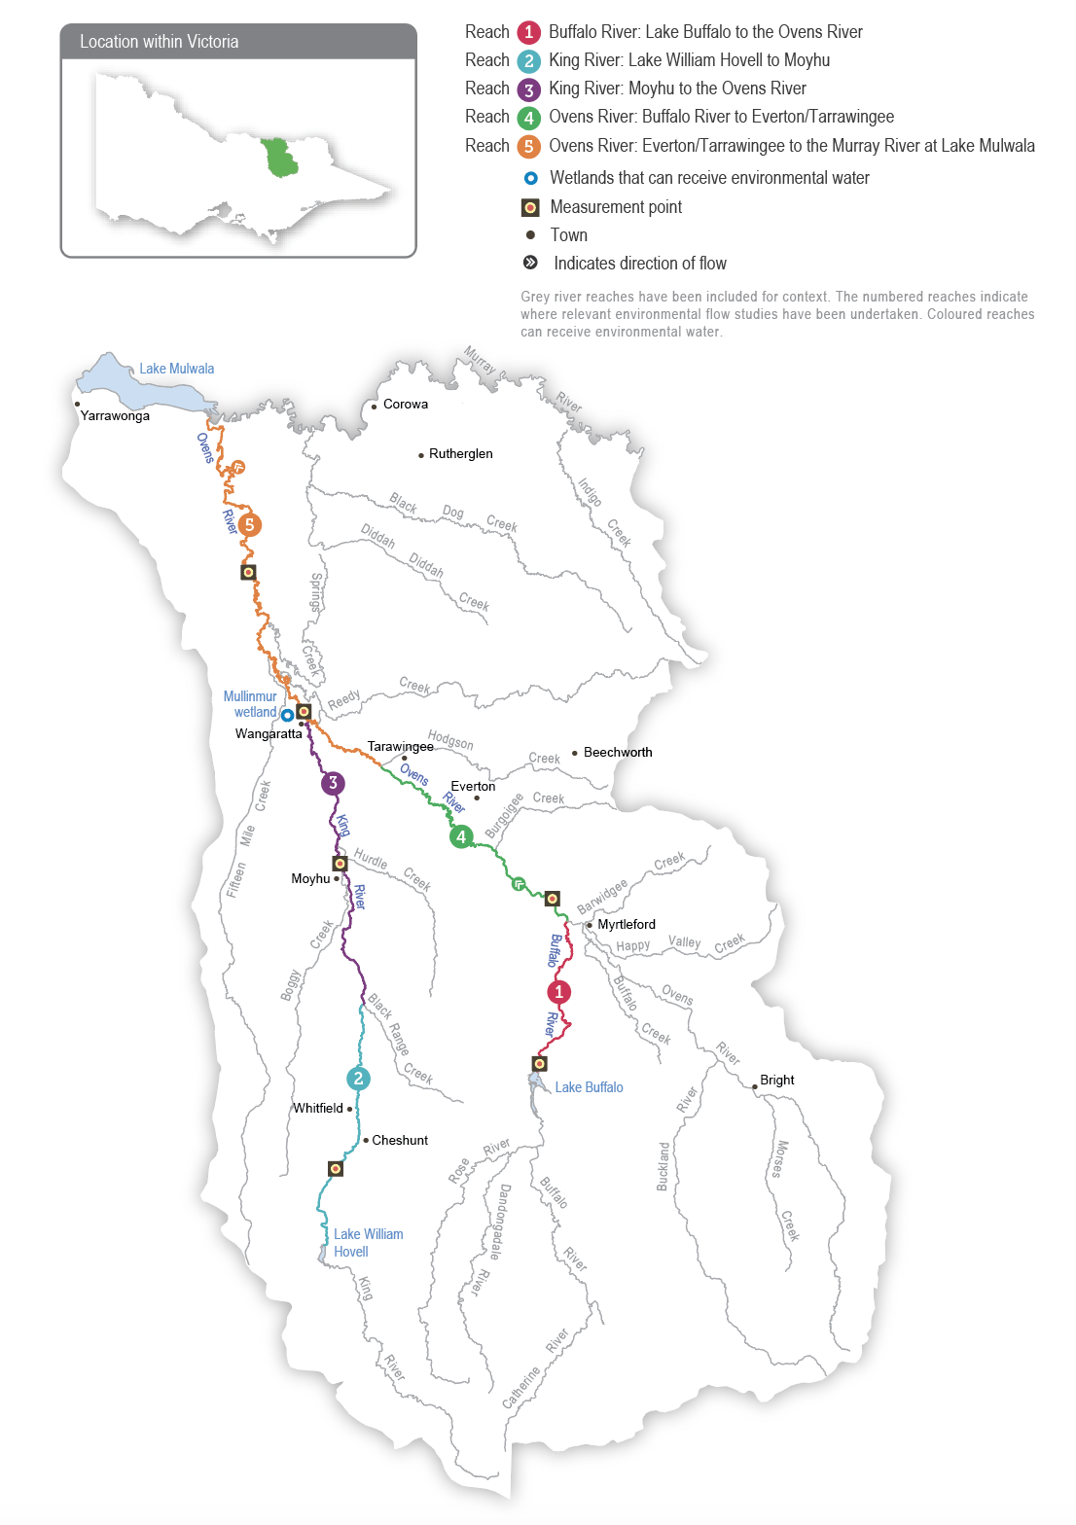

Environmental values
The diverse aquatic habitat and abundant food resources associated with the Ovens system support many native fish species, including Murray cod, trout cod, golden perch and unspecked hardyhead. The Buffalo River provides valuable habitat for large-bodied fish species during part of their breeding cycle, while trout cod have an extensive range within the system and are found as far up the King River as Whitfield. A project to recover trout cod populations in the Ovens system has been successful, and efforts to reintroduce the endangered Macquarie perch are continuing with promising results. Macquarie perch recruitment has been observed through recent surveys by the Arthur Rylah Institute (ARI) on the Ovens River, with fish captured up the Buffalo and King rivers and downstream as far as Peechelba in 2023. In January 2024, the Victorian Fisheries Authority banned the take of Macquarie perch across Victoria to protect their population.
The lower Ovens wetland complex contains over 1,800 wetlands. It is listed as nationally significant and is home to various waterbirds, including egrets, herons, cormorants and bitterns. The streamside zones of river channels throughout the Ovens system support some of Victoria’s healthiest river red gum forests and woodlands, while the wetlands support various aquatic and semi-aquatic vegetation communities.
Water for the environment was delivered to Mullinmur Wetland at Wangaratta for the first time in 2019-20. This site has been the focus of several environmental improvement projects recently, including carp removal, a revegetation program and the reintroduction of native fish.
Environmental objectives in the Ovens system
F1 | Maintain the size and distribution of native fish populations
MI1 | Maintain an adequate abundance and diversity of waterbugs to support river food webs and associated ecosystem processes
V1 | Maintain the condition and extent of wetland vegetation communities
WQ1 | Maintain water quality for all river life

Traditional Owner cultural values and uses
The Ovens system is within the recognised Registered Aboriginal Party and Recognition and Settlement Agreement boundary of the Taungurung Land and Waters Council (TLaWC) and the Yorta Yorta Nation Aboriginal Corporation (YYNAC). The Ovens system is also an area of significance to the Bangarang, Dhuduroa and Waywurru people.
The North East CMA consulted TLaWC in planning for potential 2024-25 environmental flows in the Ovens system.
The Taungurung Land and Waters Council water knowledge group Baan Ganalina (Guardians of Water) supports increasing Taungurung influence in water management, building internal capacity and advancing Taungurung water rights.
The Taungurung Country Plan’s water chapter Baan Dhumba-Dji-Ngan Mundak Gunga (We must speak to protect water) lists several objectives. These include increasing and strengthening Taungurung voices, increasing water literacy and capacity and returning water to disconnected wetlands. The future delivery of water for the environment by the Taungurung Land and Waters Council on Taungurung Country would help achieve some of these objectives.
The Yorta Yorta Nation Aboriginal Corporation Yorta Yorta Whole-Of-Country Plan 2021-2030 outlines objectives for Yorta Yorta Country, including for the Ovens River, and it identifies the lower Ovens River as a high priority for management actions. The Country Plan’s objectives aim to support more culturally informed planning for water in the lower Ovens River in the future. In discussions in 2024, Yorta Yorta have indicated that they do not wish to be involved in developing the Ovens seasonal watering proposal or the seasonal watering plan process in its current form, and continued engagement is needed to find a pathway forward for future years. The North East CMA is continuing to work with members of Yorta Yorta to meet on Country in 2024.
TLaWC and YYNAC are collaborating with the North East CMA on a 2022-24 project to update environmental flow recommendations for the Ovens system. The project aims to progress Taungurung and Yorta Yorta cultural objectives.
Planned environmental flows may be modified to align with cultural benefits so long as environmental outcomes are not compromised. The TLaWC may use its 39 ML entitlement in the King River system to support environmental flows in 2024-25 in line with Taungurung cultural obligations to heal and care for Country. The Council’s allocation has been released from Lake William Hovell five times as an environmental flow (from 2020 to 2024) in partnership with the North East CMA, Goulburn-Murray Water and the VEWH to provide additional water to the King River and help heal Country.
Increasing the involvement of Traditional Owners in managing environmental flows and progressing opportunities towards self-determination in the environmental watering program is a core commitment of the VEWH and its program partners. This is reinforced by legislation and policy commitments, including the Water Act 1989, the Victorian Aboriginal Affairs Framework, the 2016 Water for Victoria, the 2022 Water is Life: Traditional Owner Access to Water Roadmap, and, in some cases, agreements under the Traditional Owner Settlement Act 2010.
Where Traditional Owners are more deeply involved in the planning and/or delivery of environmental flows for a particular site, their contribution is acknowledged in Table 5.3.1 with an icon (as explained in Figure 1.2.3). The use of this icon is not intended to indicate that these activities are meeting all the needs of Traditional Owners but is used in the spirit of valuing that contribution.
 | Watering planned and/or delivered in partnership with Traditional Owners to support cultural values and uses

Social, recreational and economic values and uses
In planning the potential environmental watering actions in Table 5.3.1, the North East CMA considered how environmental flows could support values and uses, including:
- water-based recreation (such as kayaking, boating and fishing)
- riverside recreation and amenity (such as camping, visitation for mental/physical health and wellbeing)
- community events and tourism (such as providing a setting for community gatherings, outdoor school learning, sporting events and citizen science projects)
- socioeconomic benefits (such as businesses used by anglers and stock and domestic uses that rely on water quality, supported by deliveries of water for the environment when the natural flow is at its lowest from November to March).
Environmental flows may be delivered to Mullinmur Wetland in summer to re-establish submerged aquatic vegetation and support native fish at the site. The water is expected to sustain other benefits to the local community (such as recreation and amenity). The Mullinmur Wetland site is managed by the Catholic Education Department, supported by Wangaratta Landcare and Sustainability Incorporated. An education hub provides a space for environmental education for students from Galen Catholic College, young people attending the Borinya Wangaratta Community Partnership School and other people from the local community, including a team of Waterwatch citizen scientists. These volunteers have been involved in monitoring changes in conditions for plant and fish species to inform deliveries of water for the environment.

Scope of environmental watering
The term ‘environmental watering’ refers to the active delivery of held environmental water to support particular environmental objectives by altering the flow in a river or water level in a wetland. While other terms are sometimes used to describe the delivery of environmental water, ‘environmental watering’ is deliberately used here and in seasonal watering statements to ensure consistency in the legal instruments that authorise the use of environmental water in Victoria.
Table 5.3.1 describes the potential environmental watering actions in 2024-25, their expected watering effect (that is, the intended physical or biological effects of the watering action) and the longer-term environmental objectives they support. Each environmental objective relies on one or more potential environmental watering actions and their associated physical or biological effects.
Table 5.3.1 Ovens system potential environmental watering actions, expected effects and environmental objectives
Potential environmental watering action | Expected watering effects | Environmental objectives
Buffalo River (targeting reach 1)
Summer/autumn low-flow variability (greater than 70 ML/day for two days during February to April) | - Increase connectivity between pools for fish movement  - Maintain waterbug habitat  - Maintain adequate oxygen levels in pools | F1  MI1  WQ1
Autumn low flow fresh (430 ML/day for three days during March to April) | - Provide flow cues to stimulate the movement of native fish  - Increase connectivity between pools for fish movement  - Mix pools to improve the water quality  - Provide small variations in river levels to connect new food sources and habitat for waterbugs  - Provide an increase in the water velocity to scour biofilm from the river bed to generate new food sources for waterbugs | F1  MI1  WQ1
King River (targeting reaches 2 and 3)
Summer/autumn low-flow variability (greater than 60 ML/day for two to four days during February to April)   | - Increase connectivity between pools for fish movement  - Maintain waterbug habitat  - Maintain adequate oxygen levels in pools | F1  MI1  WQ1
Mullinmur Wetland
Mullinmur Wetland (top-up during November to April) | - Maintain the water level within the wetland to support the growth and recruitment of aquatic vegetation  - Maintain habitat and water quality for native fish | F1  V1

Scenario planning
Table 5.3.2 outlines potential environmental watering and expected water use in various planning scenarios.
The weather and inflows into storages greatly affect how water for the environment will likely be used in the Ovens system. In the drought and dry planning scenarios, the highest priority will be to use available water for the environment to introduce some variability to the summer/autumn low flow to limit the duration of extremely low-flow or cease-to-flow events that can stress native fish and waterbugs. In the average and wet planning scenarios, the objective is to provide a greater flow to support fish movement and breeding and increase the abundance and diversity of waterbugs. There is not enough water for the environment to deliver the recommended autumn fresh in full, so releases would need to coincide with and add to operational water releases. All the potential environmental watering actions for the Ovens River system are expected to be met naturally in the wet planning scenario.
Due to the small volume of water for the environment available, there is limited opportunity to vary the potential environmental watering actions each year for each planning scenario. However, water allocation donations (such as those by the Taungurung Land and Waters Council and a private donor in the King River) help to increase the effectiveness of some potential watering actions.
Mullinmur Wetland has flooded naturally in each of the last four years and last received environmental water in 2019-20. Prolonged inundation has caused the loss of submerged and emergent aquatic vegetation, and the Mullinmur Wetland Management Committee has instigated a project to replant vegetation in the wetland to improve habitat for native fish and other aquatic animals. The committee is trying to partially draw down the wetland to facilitate these plantings. The proposed action to top up Mullinmur Wetland is a low priority in 2024-25 but may be considered if it is needed to prevent the wetland from completely drying.
All available water for the environment is expected to be used in 2024-25. No carryover targets have been set for 2025-26.
Table 5.3.2 Ovens system environmental watering planning scenarios
Planning scenario | Drought | Dry | Average | Wet
Expected conditions | - Possible winter/early-spring natural fresh  - Very low flow through summer and autumn  - No bulk water release | - Possible winter/early-spring natural fresh  - Very low flow through summer and autumn  - Bulk water release is unlikely | - High winter/spring natural freshes  - Moderate flow in summer and autumn with occasional natural freshes  - Bulk water release is likely | - High natural freshes and low flow throughout most of the year  - Bulk water release is likely  - All flow objectives are achieved naturally
Expected availability of water for the environment | - 123 ML (73 ML held in Lake Buffalo and 50 ML held in Lake William Hovell)
Buffalo River (targeting reach 1)
Potential environmental watering – tier 1 (high priorities) | - Summer/autumn low-flow variability | - Summer/autumn low-flow variability | - Summer/autumn low-flow variability  - Autumn low-flow fresh | - Summer/autumn low-flow variability  - Autumn low-flow fresh
Potential environmental watering – tier 2 (additional priorities) | - N/A
King River (targeting reaches 2 and 3)
Potential environmental watering – tier 1 (high priorities) | - Summer/autumn low-flow variability | - Summer/autumn low-flow variability | - Summer/autumn low-flow variability | - Summer/autumn low-flow variability
Potential environmental watering – tier 2 (additional priorities) | - N/A
Mullinmur Wetland
Potential environmental watering – tier 1 (high priorities) | - N/A
Potential environmental watering – tier 2 (additional priorities) | - Mullinmur Wetland top-up
Possible volume of water for the environment required to achieve objectives | - 123 ML (tier 1)  - 20 ML (tier 2) |  |  | - 0-123 ML (tier 1)  - 0-20 ML (tier 2)

5.4 Goulburn system
Waterway manager – Goulburn Broken Catchment Management Authority/Melbourne Water
Storage manager – Goulburn-Murray Water
Environmental water holders – Victorian Environmental Water Holder (including the Living Murray program) and the Commonwealth Environmental Water Holder
The Goulburn system includes the Goulburn River and Goulburn wetlands

5.4.1 Goulburn River

System overview
The Goulburn is Victoria’s largest river basin, covering over 1.6 million ha or 7.1 per cent of the state (Figure 5.4.1). The Goulburn River flows for 570 km from the Great Dividing Range upstream of Woods Point to the Murray River east of Echuca. It is an ancient, iconic river rich with environmental, cultural and recreational values.
There are several environmental water holders in the Goulburn system. The Commonwealth Environmental Water Holder (CEWH) holds the largest volume, and the use of Commonwealth Water Holdings is critical to achieving outcomes in the Goulburn River, as well as priority environmental sites further downstream. Water for the environment held on behalf of the Living Murray program may assist in meeting objectives in the Goulburn system en route to icon sites in the Murray system. Water held by the VEWH in the Goulburn system is primarily used to meet environmental objectives in the Goulburn River and the Goulburn wetlands, but it can also be used to support environmental objectives at downstream sites along the Murray River and in South Australia.
The construction and operation of Lake Eildon and Goulburn Weir have significantly altered the natural flow regime of the Goulburn River. Water harvesting during wet periods and releases to meet irrigation and other consumptive demands during dry periods means the flow below these structures is typically low in winter/spring and high in summer/autumn. This is the reverse of the natural seasonal flow pattern. Land use changes and the construction of small dams and drainage schemes have further modified the Goulburn River’s flow regime. Levees and other structures prevent water from inundating the floodplain and filling many of the natural wetlands and billabongs. Several tributaries, including the Acheron, Yea and Broken rivers, join the Goulburn River downstream of Lake Eildon and can add some flow variation to the river’s regulated flows. Large floods that cause the Goulburn River’s storages to fill and spill are also important for the overall flow regime and its associated environmental values.
The priority environmental flow reaches in the Goulburn River are downstream of Goulburn Weir (reaches 4 and 5), collectively called the lower Goulburn River. The mid-Goulburn River extends from Lake Eildon to Goulburn Weir (reaches 1 to 3). From early spring to late autumn, large volumes of water are delivered from Lake Eildon to Goulburn Weir to supply the irrigation system. During that period, the flow in the mid-Goulburn River is usually well above the recommended environmental flow targets. Deliveries of water for the environment have the most benefit in the mid-Goulburn River (especially in reach 1 immediately downstream of Lake Eildon) outside the irrigation season when releases from Lake Eildon are often much lower than natural.
Environmental flow targets in the lower Goulburn River can sometimes be met by the coordinated delivery of operational water being transferred from Lake Eildon to the Murray River. These inter-valley transfers (IVTs) occur during the irrigation season between spring and autumn and may meet environmental flow objectives without the need to release water for the environment. IVTs in the Goulburn River can significantly exceed the environmental flow recommendations for summer and early autumn, damaging bank vegetation and eroding riverbanks. A new Goulburn to Murray trade rule and operating plan was introduced in 2022-23 to prevent further damage to the lower Goulburn River from a prolonged high flow over summer and autumn. Wet conditions between 2021-22 and 2023-24 have meant only small volumes of IVTs have been delivered from the Goulburn system in recent years, so the impact of the new trade rules and operating plan on environmental assets is yet to be fully assessed.
Figure 5.4.1 The Goulburn system
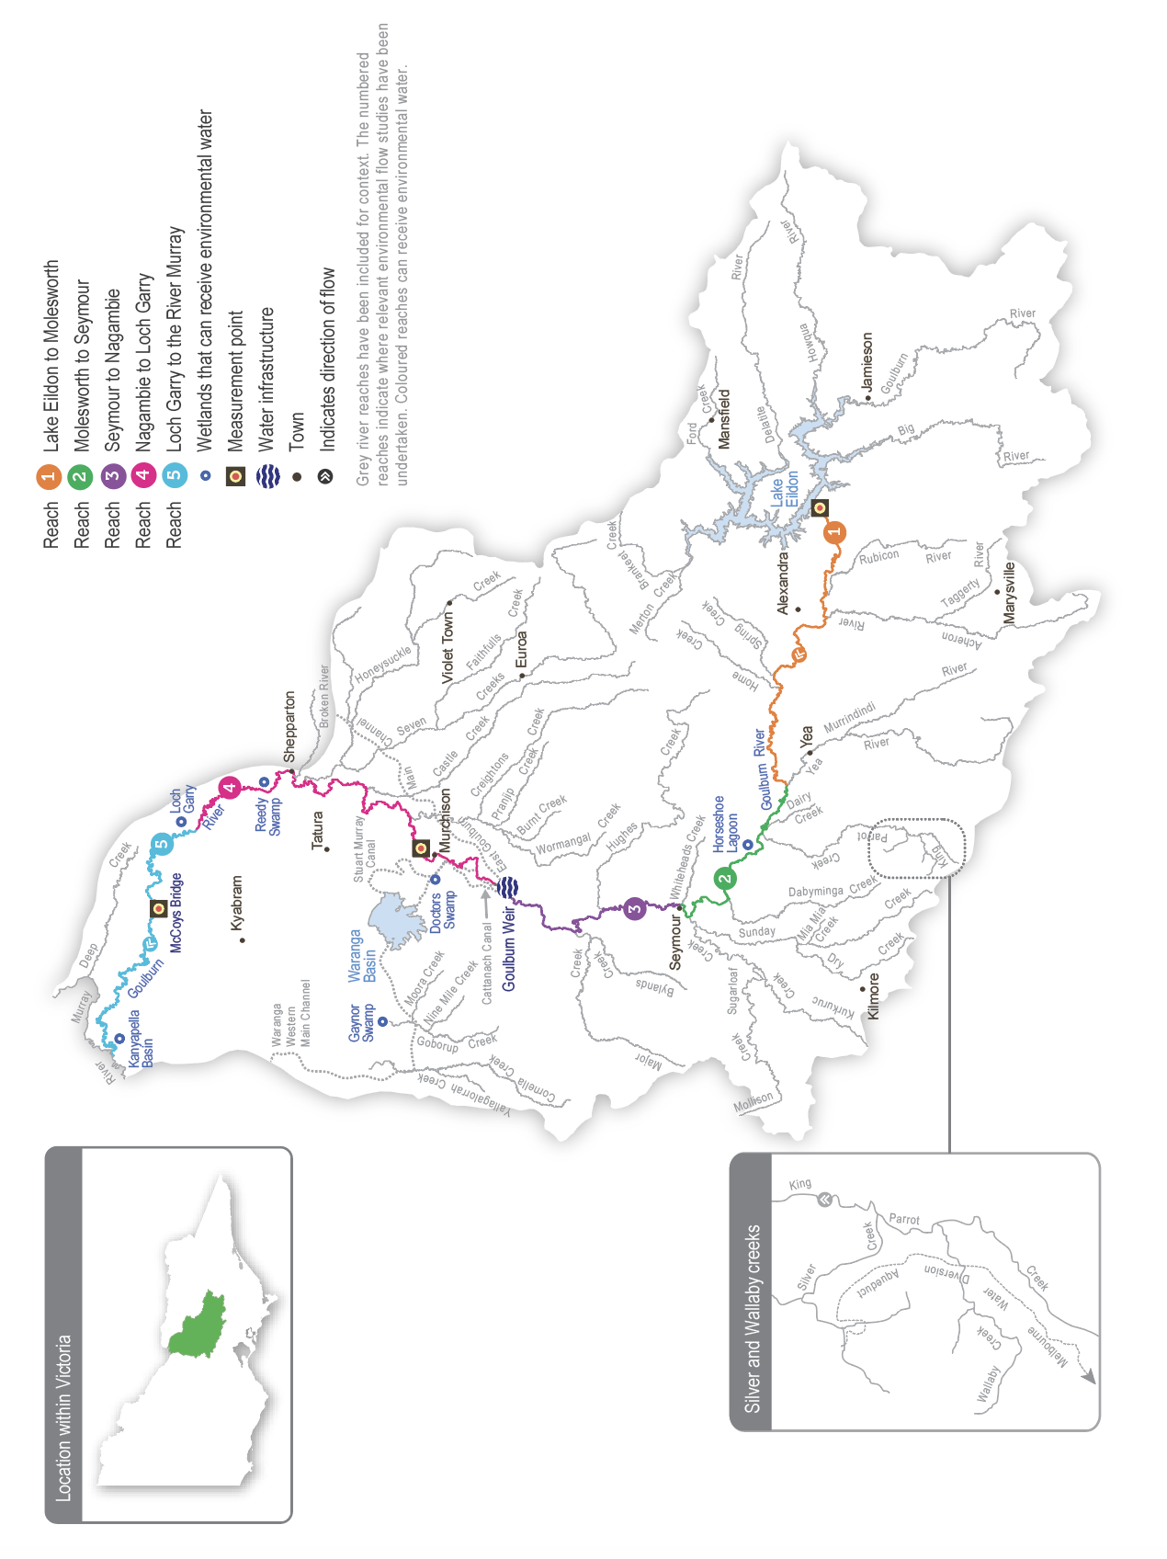

Environmental values
The Goulburn River and its tributaries support a range of native fish (including golden perch, silver perch, Murray cod, trout cod, Macquarie perch and freshwater catfish), turtles, platypus and rakali (water rats). Aquatic vegetation, scour holes and woody debris within the channel provide high-quality habitat for adult and juvenile fish. River red gums are a dominant feature of the streamside zone along the length of the Goulburn River. These trees shade the river and provide habitat for many species, including the squirrel glider. Leaves that fall from the river red gums provide carbon that supports riverine food webs, and dead trees that fall into the river provide a surface for biofilms and waterbugs and habitat for fish. Birds (such as egrets, herons and cormorants) use trees along the river to roost and feed, while frogs benefit from shallow vegetated habitats at the edge of the river channel and in adjacent wetlands.
The Goulburn River system is an important conservation area for threatened species. Several wetlands in the Goulburn catchment are formally recognised for their conservation significance. Tributaries of the mid-Goulburn River between Lake Eildon and Goulburn Weir host some of the last remaining Macquarie perch populations in the Murray-Darling Basin, while freshwater catfish occur in lagoons connected to reach 3 of the Goulburn River. Citizen science monitoring programs indicate the mid-Goulburn River supports a strong population of platypus, which are now classified as vulnerable under Victoria’s Fauna and Flora Guarantee Act 1988. Monitoring in recent years shows that environmental flows in the lower Goulburn River trigger golden perch and silver perch to spawn. However, the extent to which these spawning events contribute to populations locally and in the wider southern basin is unknown. Self-sustaining populations of Murray cod have been confirmed, and trout cod are extending their range in the lower Goulburn River.
Environmental objectives in the Goulburn River
CN1 | Provide sufficient rates of carbon and nutrient production and processing to support native fish and waterbug communities
F1 | Increase the abundance, spatial distribution and size class diversity of key native fish species
G1 | Maintain substrate surfaces to support ecological processes
G2 | Maintain the diversity of the channel form (e.g. shallow and deep water habitats)
MI1 | Maintain abundant and diverse waterbug communities to support riverine food webs
PR1 | Increase the self-sustaining platypus population
T1 | Maintain the self-sustaining turtle population
V1 | Increase the abundance of aquatic and flood-tolerant plants in the river channel and on the lower banks to provide shelter and food for animals and stabilise the riverbank
V2 | Increase the abundance of aquatic and flood-tolerant plants in low-lying and connected wetlands
WQ1 | Minimise the risk of hypoxic blackwater

Traditional Owner cultural values and uses
The Goulburn River system flows through Taungurung Country and Yorta Yorta Country.
Each year, the Goulburn Broken CMA consults with the Taungurung Land and Waters Council (TLaWC) and the Yorta Yorta Nation Aboriginal Corporation (YYNAC) about plans for environmental watering in the Goulburn River. Consultation takes the form of formal and informal discussions.
TLaWC and YYNAC are members of the Goulburn Environmental Water Advisory Group and the Goulburn and Broken Operational Advisory Group. Both groups meet frequently throughout the year and share technical, operational and other information (such as recreational and cultural values) to support environmental water management and decision-making in the Goulburn River.
In 2023, the Goulburn Broken CMA met with the Taungurung water knowledge group Baan Ganalina (Guardians of Water) to discuss environmental flow recommendations for Waring (reaches 1 to 3 of the Goulburn River).
Baan Ganalina supports flows that would help to reinstate a more natural water regime that better reflects the size, timing and variability of natural inflows to this part of the river, including off-channel areas.
“These flow recommendations will help support Waring (Goulburn River), which is such an important part of Taungurung identity. It’s good to see how the Goulburn Broken CMA has used peer-reviewed articles to show the effects on important animals like platypus and shared this knowledge. The river is a work in progress, but together with the Goulburn Broken CMA, we will continue to seek ways to heal Country despite the harm it has suffered. Baan Ganalina hopes to see the proposed higher winter flows, and looks forward to taking an ongoing role in monitoring their effects.”
– Baan Ganalina, 2023
TLaWC communicated outcomes for Waring that align with Taungurung objectives and responsibilities to heal and care for Country, include connecting wetlands that support valued species at appropriate times. This helps to protect intangible and tangible cultural heritage and values, including traditional food and medicine plants. Planned flows will also support ongoing efforts by Taungurung and program partners to care for the river and its floodplain, including investigations into rehabilitating degraded significant sites.
In 2023, the Goulburn Broken CMA met with Yorta Yorta Nation Aboriginal Corporation. YYNAC indicated there is alignment between planned watering actions for Kaiela (reaches 4 and 5 of the Goulburn River) and the cultural and ecological values of the Yorta Yorta people. The planned flows will encourage native fish to spawn, alleviate the slumping of culturally important sites (such as middens and scar trees) and will revive streamside vegetation, which is important for food, fibre and medicine.
A Yorta Yorta Nation Aboriginal Corporation representative contributed to the 2020 Kaiela Environmental Flows Study, which has influenced environmental flows in the lower Goulburn River since 2021-22.
Increasing the involvement of Traditional Owners in managing environmental flows and progressing opportunities towards self-determination in the environmental watering program is a core commitment of the VEWH and its program partners. This is reinforced by legislation and policy commitments, including the Water Act 1989, the Victorian Aboriginal Affairs Framework, the 2016 Water for Victoria, the 2022 Water is Life: Traditional Owner Access to Water Roadmap, and, in some cases, agreements under the Traditional Owner Settlement Act 2010.
Where Traditional Owners are more deeply involved in the planning and/or delivery of environmental flows for a particular site, their contribution is acknowledged in Table 5.4.1 with an icon (as explained in Figure 1.2.3). The use of this icon is not intended to indicate that these activities are meeting all the needs of Traditional Owners but is used in the spirit of valuing that contribution.
 | Watering planned and/or delivered in partnership with Traditional Owners to support cultural values and uses
In 2022, Taungurung Land and Waters Council joined the Goulburn and Broken Operational Advisory Group, which shares technical and operational information to support environmental water management and decision-making in the Goulburn River and lower Broken Creek.

Social, recreational and economic values and uses
In planning the potential watering actions in Table 5.4.1, the Goulburn Broken CMA considered how environmental flows could support values and uses such as:
- water-based recreation (such as boating, canoeing, fishing, gaming, hunting and kayaking)
- riverside recreation and amenity (for landholders and visitors)
- community events and tourism (such as paddling and boating businesses)
- socioeconomic benefits (such as improving water quality for stock and domestic uses, irrigation diverters and water supply for settlements on the Goulburn River).
If the timing or management of planned environmental flows may be modified to align with a community benefit, this is acknowledged in Table 5.4.1 with the following icon.
 | Watering planned to support angling activities
The Goulburn River provides numerous recreational and economic benefits. Environmental flows support native fish populations by providing fish passage and habitat and encouraging fish migration and spawning, which in turn benefits recreational anglers. Following community feedback, the timing of targeted environmental flow events in September (mid-Goulburn) and November/December (lower Goulburn) is planned to reduce impacts on river access around the opening of different fishing seasons, benefitting anglers and local businesses.

Scope of environmental watering
The term ‘environmental watering’ refers to the active delivery of held environmental water to support particular environmental objectives by altering the flow in a river or water level in a wetland. While other terms are sometimes used to describe the delivery of environmental water, ‘environmental watering’ is deliberately used here and in seasonal watering statements to ensure consistency in the legal instruments that authorise the use of environmental water in Victoria.
Table 5.4.1 describes the potential environmental watering actions in 2024-25, their expected watering effect (that is, the intended physical or biological effects of the watering action) and the longer-term environmental objectives they support. Each environmental objective relies on one or more potential environmental watering actions and their associated physical or biological effects.
Table 5.4.1 Goulburn River potential environmental watering actions, expected effects and environmental objectives
Potential environmental watering action | Expected watering effects | Environmental objectives
Goulburn River reach 1
Year-round low flow (400-2,000 ML/day)   | - Maintain habitat for small-bodied native fish  - Maintain adequate foraging habitat for platypus and reduce the risk of predation  - Provide habitat and food for turtles  - Wet and maintain riffles to provide habitat for biofilms and waterbugs  Additional benefits when flows delivered are above 800 ML/day:  - scour fine sediment from the gravel bed and riffle substrate  - maintain existing beds of in-channel vegetation  - provide connection to low-lying, off-stream wetland habitats, which increase food resources (waterbugs) available for fish and native animals | F1  G1  MI1  PR1  T1  V1
Winter fresh (one fresh of more than 8,000 ML/day for five to 10 days during July to August) | - Encourage female platypus to select a nesting burrow higher up the bank to reduce the risk of greater flow later in the year flooding the burrow when juveniles are present  - Scour bed sediments to maintain pools and change in-channel complexity for improved habitat  - Inundate aquatic vegetation in connected wetlands to avoid exposure to frost  - Connect larger off-stream wetlands to the river channel to provide habitat for small-bodied native fish  - Increase foraging conditions for platypus and turtles  - Increase the availability of habitat to support macroinvertebrate lifecycles | F1  G1  G2  MI1  PR1  T1  V1  V2
Winter/spring fresh(es) (one to three freshes of more than 5,000 ML/day for five to 10 days during May to November) | - Scour fine sediment from the gravel bed and riffle substrates  - Maintain existing beds of in-channel vegetation  - Maximise the time off-stream wetland habitats are available for small-bodied native fish and platypus  - Increase foraging conditions for platypus and turtles  - Increase the availability of habitat to support macroinvertebrate lifecycles | F1  G1  MI1  PR1  T1  V1  V2
Spring fresh (one fresh of more than 8,000 ML/day for five to 10 days during September to November)   | - Maintain mid-Goulburn off-stream habitat for small-bodied native fish and platypus  - Scour bed sediments to maintain pools and change in-channel complexity for improved habitat  - Maintain existing beds of aquatic vegetation both in-channel and in connected wetlands  - Connect larger off-stream wetlands to the river channel to provide habitat for small-bodied native fish  - Increase foraging conditions for platypus and turtles  - Increase the availability of habitat to support macroinvertebrate lifecycles  - Increase soil moisture in banks and connected wetlands to improve the condition of existing native vegetation | F1  G1  G2  MI1  PR1  T1  V1  V2
Goulburn River reach 4 and 5
Year-round low flow (600-1,000 ML/day) | - Provide slow, shallow habitat required for the recruitment of larvae/juvenile fish and habitat for adult small‑bodied fish  - Provide deep water habitat for large-bodied fish  - Submerge snags and littoral vegetation to provide habitat for fish and waterbugs and a substrate for biofilms to grow  - Provide habitat and food for turtles  - Maintain habitat for aquatic vegetation and water the root zone of low-bank vegetation  - Vary flow within a specified range to encourage plankton production for food, disrupt biofilms and maintain water quality  - Provide a low, variable flow to enable vegetation to establish to protect against notching and bank erosion | CN1  F1  MI1  PR1  T1  V1  WQ1
Winter/autumn fresh (one fresh of up to 10,000 ML/day with more than four days above 7,300 ML/day during July to August and May to June) | - Wash organic matter and carbon (e.g. leaf litter) into the channel  - Provide connectivity to off-channel habitats and through the river for fish dispersal and greater food resources  - Scour bed sediments to maintain pools and change in-channel complexity for improved habitat  - Provide cues for platypus to nest higher up the bank  - Provide sediment and plant propagules from tributary inflows after large rain events to encourage the establishment of new plants  - Drown terrestrial vegetation on low banks and trigger the recruitment of native, flood-tolerant streamside vegetation  - Improve waterbug habitat and food availability by scouring fine sediments | CN1  F1  G1  G2  MI1  PR1
Early-spring fresh (one fresh of up to 10,000 ML/day with more than seven days above 7,300 ML/day during September to October) | - Wash organic matter and carbon (e.g. leaf litter) into the channel  - Provide connectivity to off-channel habitats and through the river for fish dispersal and greater food resources  - Scour bed sediments to maintain pools and change in-channel complexity for improved habitat  - Increase soil moisture in banks to improve the condition of existing native vegetation  - Provide sediment and plant propagules from tributary inflows after large rain events to encourage the establishment of new plants  - Drown terrestrial vegetation on low banks and trigger the recruitment of native flood-tolerant streamside vegetation  - Improve waterbug habitat and food availability by scouring fine sediments and biofilms from hard substrates | CN1  F1  G1  G2  MI1  V1  V2
Late-spring fresh (one fresh of more than 6,600 ML/day for two days during October to December)   | - Stimulate spawning of golden and silver perch  - Scour bed sediments to maintain pools and change in-channel complexity for improved habitat  - Improve waterbug habitat and food availability by scouring fine sediments and biofilms from hard substrates | F1  G1  G2  MI1
Autumn fresh (one fresh of more than 5,700 ML/day for two to five days during March to May) | - Cue fish to move into and through the system to increase their abundance and dispersal  - Scour bed sediments to maintain pools and change in-channel complexity for improved habitat  - Increase soil moisture in banks to maintain existing vegetation  - Scour old biofilm from hard substrates to allow new biofilm growth to improve food and habitat for macroinvertebrates | F1  G1  G2  MI1
Environmental risk mitigation flow; slow recession of unregulated flow or releases from Goulburn Weir (6,000 ML/day) | - Minimise the risk of bank erosion associated with a rapid reduction in the water level  - Transport and deposit seed, plant propagules and sediment on the riverbank  - Minimise the risk of hypoxic blackwater after natural events | G1  V1  WQ1

Scenario planning
Table 5.4.2 outlines potential environmental watering and expected water use in various planning scenarios.
The environmental flows study for the Goulburn River recommends a range of watering actions needed most years to achieve the target environmental outcomes. High water availability in the Goulburn system at the end of 2023-24 and a strong resource outlook for 2024-25 mean all recommended watering actions can potentially be met, even in a return to dry conditions. Therefore, the proposed actions are the same for all planning scenarios in 2024-25.
The highest-priority environmental watering actions in the lower Goulburn River in 2024-25 aim to increase the extent and improve the composition and condition of riparian vegetation within the channel. Unnaturally high IVT flows have severely damaged native vegetation on the banks of the lower Goulburn River during the irrigation seasons from 2017 to 2021. The lower parts of the bank have very limited vegetation, and a few species that can tolerate prolonged inundation dominate the middle and upper parts of the bank. The loss of vegetation on the lower banks has reduced the quantity and quality of littoral habitat for fish and waterbugs and increased the risk of bank slumping, increasing sediment deposition within the channel. Large spring and summer floods in 2022-23 and 2023-24 restricted the recovery of bank vegetation but also deposited sediments and seeds that helped new plant growth in autumn 2024. Ongoing flow management is required to consolidate this new growth and help the vegetation fully recover.
The most important flows for bank vegetation in the Goulburn River are year-round low flows and freshes during winter and spring. The target range for low flows aims to inundate enough of the channel to support in-stream vegetation and expose the lower parts of the bank for sustained periods during the warmer growing season to avoid drowning riparian vegetation. Winter and spring freshes are needed to periodically wet higher parts of the bank to enhance the growth and recruitment of native plants growing on the water’s edge and deter the growth of terrestrial species. Where possible, these freshes will be delivered by passing tributary inflows from the mid-Goulburn River to the lower Goulburn reaches so that seeds, sediments and nutrients that are carried from natural tributary flows are transported and deposited along the banks of rivers throughout the whole system.
Year-round low flows and freshes may be fully or partially achieved with natural flows under wetter climate scenarios, and operational releases (such as IVTs) may help meet environmental flow targets in the drier climate scenarios. Goulburn-Murray Water generally diverts a proportion of the natural high flow from Goulburn Weir into the Waranga Basin. These operational transfers can cause the flow rate in the lower Goulburn River to drop rapidly after a natural high-flow event, and water for the environment may be used as required to slow the recession of natural spills at Goulburn Weir to reduce the risk of bank slumping.
The next-highest priority for environmental watering in 2024-25 will be to support native fish objectives. Recent monitoring has recorded significant declines in small-bodied native fish populations in the Goulburn River and other connected systems since the 2022 and 2023 floods. These declines are likely due to a range of factors, including hypoxic blackwater, temporary loss of slow-flowing littoral habitat within the channel and an increase in the proliferation of carp in the Murray River and its tributaries. Recent fish monitoring also suggests there has been little recruitment of larger native species (such as golden and silver perch) in recent years. While these species do not need to spawn every year, actions to increase their populations will be taken where possible. Late-spring freshes are known to trigger golden and silver perch spawning in the lower Goulburn River, and water for the environment may be used to deliver freshes in spring 2024 as long as their timing does not compromise outcomes for re-establishing bank vegetation.
The final focus for environmental watering in the Goulburn River in 2024-25 will be to maintain minimum flows in reach 1 (immediately downstream of Lake Eildon) during winter when there are no irrigation releases and deliver multiple freshes in winter and spring to reinstate some natural flow variation and connect floodplain wetlands between reach 1 and reach 3. Collectively, these flows will maintain in-channel habitat through the mid-Goulburn system and provide opportunities for fish and platypus to access off-channel habitats for feeding and breeding. Citizen science monitoring of platypus suggests that multiple years of high overbank flooding may have damaged their breeding cycles. Therefore, delivering a winter fresh in reach 1 to optimise platypus breeding success is a high priority in 2024-25.
Carrying over water to meet minimum low-flow objectives from July 2025 to September 2026 is an important consideration in the drought and dry climate scenarios, but it is less important in the average and wet planning scenarios due to likely high early-season allocations.
Table 5.4.2 Goulburn River environmental watering planning scenarios
Planning scenario | Drought | Dry | Below average | Average | Wet
Expected conditions | - Very few or no large natural-flow events  - Blackwater could be an issue if there is a large rain event in the warmer months | - One to two short-duration, large natural flow events are likely to provide small winter/spring freshes  - Blackwater could be an issue if there is a large rain event in the warmer months | - One to three average duration, large natural flow events are likely to provide winter/spring freshes  - Blackwater could be an issue if there is a large rain event in the warmer months | - Large natural-flow events will provide low flow for most of the year and will likely provide winter/spring freshes  - Blackwater could be an issue if there is a large rain event in the warmer months | - Large natural-flow events will provide low flow and multiple freshes and/or overbank flow events in winter/spring  - Blackwater could be an issue if there is a large rain event in the warmer months
Expected availability of water for the environment | - 604 GL | - 754 GL | - 754 GL | - 754 GL | - 754 GL
Goulburn River (targeting reach 1)
Potential environmental watering – tier 1 (high priorities) | Tier 1a (can be achieved with predicted supply)
- Year-round low flow
- Winter fresh
- Winter/spring freshes
- Spring fresh
Goulburn River (targeting reach 4 and 5)
Potential environmental watering – tier 1 (high priorities) | Tier 1a (can be achieved with predicted supply)
- Year-round low flow
- Winter/autumn fresh
- Early-spring fresh
- Autumn fresh
- Ecological risk mitigation flow
- Late-spring fresh
Possible volume of water for the environment required to achieve objectives | - 576 GL (tier 1a) | - 562 GL (tier 1a) | - 520 GL (tier 1a) | - 520 GL (tier 1a) | - 555 GL (tier 1a)
Priority carryover requirements for 2025-26 | - 50,000 ML |  | - N/A

5.4.2 Goulburn wetlands

System overview
Within the Goulburn Broken catchment, there are about 2,000 natural wetlands identified, but only six — Doctors Swamp, Gaynor Swamp, Horseshoe Lagoon, Kanyapella Basin, Loch Garry and Reedy Swamp — have received water for the environment through the VEWH’s or CEWH’s entitlements. Several other small wetlands in the Goulburn catchment have been watered under a separate arrangement through the Murray-Darling Wetlands Working Group.
Doctors Swamp, Gaynor Swamp, Kanyapella Basin, Loch Garry and Reedy Swamp can receive water for the environment through irrigation supply infrastructure. The volume of water that can be delivered to each wetland depends on the physical capacity of the infrastructure and the seasonal allocation. Water for the environment can be delivered from the Goulburn River to Horseshoe Lagoon via a temporary pump.

Environmental values
Many natural wetlands across the Goulburn catchment, including Doctors Swamp, Gaynor Swamp, Kanyapella Basin, Loch Garry and Reedy Swamp, are formally recognised for their conservation significance. The Goulburn wetlands support various plant communities ranging from river red gum swamps to cane grass wetlands.
Doctors Swamp is one of Victoria’s most intact red gum swamps, supporting over 80 wetland plant species.
Gaynor Swamp is a cane grass wetland situated on paleosaline soils: soils formed from historic oceans. When wet, the wetland supports thousands of waterbirds, including brolga and intermediate egrets. Gaynor Swamp is more saline than other wetlands in the region when water levels are low, and it attracts a different group of feeding waterbirds as it draws down. The red-necked avocet is one of the most significant species that feed on exposed mudflats at Gaynor Swamp.
Horseshoe Lagoon is a paleochannel of the Goulburn River with tall marsh, floodway pond herbland and floodplain streamside woodland vegetation communities. The lagoon supports numerous waterbird species and is home to three turtle species, including the broad-shelled turtle.
Kanyapella Basin is a shallow freshwater marsh that provides habitat for numerous plant and animal species, including the threatened intermediate egret. Historically, it has been a popular breeding site for ibis, herons and cormorants.
Loch Garry is a paleochannel of the Goulburn River that provides deep open-water habitat. Shallow, vegetated wetland depressions, red gum forest and sand ridges surround the channel. It is an important site for waterbird feeding and roosting, and it is a drought refuge for eastern great egrets, musk ducks, nankeen night herons and royal spoonbills.
Reedy Swamp contains a mosaic of vegetation types, including tall marsh, floodway pond herbland and rushy riverine swamp. It is a vital drought refuge, nesting site for colonial waterbirds and stopover feeding site for migratory birds (such as sharp-tailed sandpiper and marsh sandpiper).
Environmental objectives in the Goulburn wetlands
A1 | Maintain the frog population
B1 | Provide breeding habitat for waterbirds
B2 | Provide feeding and roosting habitat for waterbirds
CN1 | Restore carbon and nutrient cycling within the wetlands to increase ecosystem productivity
T1 | Maintain the freshwater turtle population
V1 | Increase the diversity and cover of native wetland plant species consistent with ecological vegetation class benchmarks
V2 | Reduce the cover and diversity of exotic plants

Traditional Owner cultural values and uses
The Goulburn wetlands span the lands of two Traditional Owner groups, represented by the Taungurung Land and Waters Council (TLaWC) and the Yorta Yorta Nation Aboriginal Corporation (YYNAC). Gaynor Swamp and Horseshoe Lagoon are on Taungurung Country. TLaWC has been involved in environmental water planning for both wetlands for several years and in delivering water for the environment at Horseshoe Lagoon since 2021. TLaWC has been working with Parks Victoria to reintroduce aquatic plant species that are either missing or in low numbers at Horseshoe Lagoon to boost their diversity and abundance.
Doctors Swamp, Kanyapella Basin, Loch Garry and Reedy Swamp are on Yorta Yorta Country. The YYNAC has been involved in planning for environmental flows at these wetlands for several years, including participating in developing environmental water management plans.
In late 2023, the Goulburn Broken CMA discussed proposed 2024-25 priorities for water for the environment in the Goulburn wetlands through the Goulburn Broken Wetlands Technical Reference Group. As this could not be done online or in person, the proposals were emailed for review and feedback. Priorities were also discussed with the Goulburn Broken Environmental Water and Wetlands Advisory Group which met online on 29 February 2024.
The TLaWC has identified that water for the environment supports cultural values by protecting intangible cultural heritage and valued species, traditional food and medicine plants. Participation in environmental water planning by TLaWC and the Taungurung water knowledge group Baan Ganalina (Guardians of Water) makes an essential contribution in enabling Taungurung Traditional Owners to fulfil their obligations to care for Country. This includes working to restore a more natural watering regime to degraded significant sites and rehabilitating habitat for native species. This work contributes to reconnecting the Taungurung community to Country by supporting and securing access for Taungurung contemporary cultural practices and uses, teaching places, camping sites and other places of cultural importance.
The Taungurung people have a special interest in rehabilitating floodplain wetlands associated with Waring (Goulburn River reaches 1 to 3), which are now largely disconnected from the main river channel due to the impacts of river flow regulation. The Council monitors biocultural values and habitat conditions at six disconnected wetlands as part of the ongoing Reading Country program. The monitoring findings will inform future seasonal watering proposals and planning for water for the environment. The Council is working with partners to improve habitat conditions for native species in the area, and healthy Country assessments will provide important information about cultural objectives and indicators.
Horseshoe Lagoon has high cultural significance for the Taungurung people, particularly Taungurung women, as it is central to their creation story. Environmental water provides the opportunity for Traditional Owner women to visit the site for their cultural beliefs, traditional foods and medicines.
In 2017, TLaWC undertook an Aboriginal Waterways Assessment at Horseshoe Lagoon. In 2019, the Council helped develop the environmental water management plan before the first delivery of water for the environment to Horseshoe Lagoon in winter 2019. In 2021 and 2022, council staff and Baan Ganalina coordinated the delivery of environmental water to Horseshoe Lagoon by managing the pumping and delivery. This is planned again for autumn 2025, provided the drying period is met.
For Yorta Yorta people, water for the environment supports many cultural values. At Doctors Swamp, it supports nardoo (a food source), native grasses, old man weed (which has medicinal uses), sedges and rushes (for basket weaving), as well as a wide range of bird and animal species. At Loch Garry, water for the environment supports culturally important food, fibre and medicinal plants. A flow delivered to Loch Garry in April 2020 initiated a resurgence of these plants and giant rush, which provided nesting opportunities for important bird species. Loch Garry is rich in cultural values: stone scatters, scar trees and significant sand hills in the higher elevations.
Kanyapella Basin is important for the Yorta Yorta People’s cultural and spiritual connections. It supports the health of cultural values in the landscape (such as the Creation Story and traditional food and medicine plants). Before the delivery of environmental flows in winter 2020, Yorta Yorta People conducted a cultural burn at the site, helping to enable direct delivery of the water and help the growth of old man weed.
Planned environmental flows may be modified to align with cultural benefits so long as environmental outcomes are not compromised.
Increasing the involvement of Traditional Owners in managing environmental flows and progressing opportunities towards self-determination in the environmental watering program is a core commitment of the VEWH and its program partners. This is reinforced by legislation and policy commitments, including the Water Act 1989, the Victorian Aboriginal Affairs Framework, the 2016 Water for Victoria, the 2022 Water is Life: Traditional Owner Access to Water Roadmap, and, in some cases, agreements under the Traditional Owner Settlement Act 2010.
Where Traditional Owners are more deeply involved in the planning and/or delivery of environmental flows for a particular site, their contribution is acknowledged in Table 5.4.3 with an icon (as explained in Figure 1.2.3). The use of this icon is not intended to indicate that these activities are meeting all the needs of Traditional Owners but is used in the spirit of valuing that contribution.
 | Watering planned and/or delivered in partnership with Traditional Owners to support cultural values and uses

Social, recreational and economic values and uses
In planning the potential environmental watering actions in Table 5.5.4, the Goulburn Broken CMA considered how environmental flows could support values and uses, including:
- water-based recreation (such as canoeing)
- riverside recreation and amenity (such as birdwatching, camping, cycling, hiking, photography and walking)
- community events and tourism (such as birdwatching events, the Nature Scripts Initiative and outdoor classroom learning).
Environmental watering of wetlands increases the number of visitors and opportunities for them, including for birdwatching, photography, walking, camping, and hunting (state game reserves have been reclassified as wildlife reserves).
Wetlands provide resources for Traditional Owners for cultural values and uses, including hunting, food, medicinal and traditional activities.
A summary of potential shared benefits of the 2024-2025 proposed environmental water deliveries in the Goulburn catchment are listed below.
Shared benefits of watering wetlands in the Goulburn Catchment in 2024-25
Wetland | Beneficiary | Connection to wetland | Value | How have these benefits been considered?
Horseshoe Lagoon | Taungurung women  Bird watchers  Photographers  Walkers  Campers  Local landholders | Connection to Country for Taungurung women | Environmental water provides a connection to Country for Traditional Owners, especially women from Taungurung Land and Waters Council. | Autumn watering of the site promotes growth of wetland plants that are beneficial for roosting and foraging for waterbirds. The water provides the opportunity for Traditional Owner women to visit the site for their cultural beliefs, traditional foods, and medicines.

Scope of environmental watering
The term ‘environmental watering’ refers to the active delivery of held environmental water to support particular environmental objectives by altering the flow in a river or water level in a wetland. While other terms are sometimes used to describe the delivery of environmental water, ‘environmental watering’ is deliberately used here and in seasonal watering statements to ensure consistency in the legal instruments that authorise the use of environmental water in Victoria.
Table 5.4.3 describes the potential environmental watering actions in 2024-25, their expected watering effect (that is, the intended physical or biological effects of the watering action) and the longer-term environmental objectives they support. Each environmental objective relies on one or more potential environmental watering actions and their associated physical or biological effects.
Table 5.4.3 Goulburn wetlands system potential environmental watering actions, expected effects and environmental objectives
Potential environmental watering action | Expected watering effects | Environmental objectives
Horseshoe Lagoon (fill in autumn 2025 if it is dry for six months) | - Inundate the deeper section and wetland margin to maintain naturally occurring wetland vegetation communities and help recently planted aquatic vegetation continue to establish  - Suppress the growth of weeds  - Provide food and breeding habitat for turtle populations  - Provide food and roosting habitat for birds | T1  V1  V2  B2

Scenario planning
Table 5.4.4 outlines potential environmental watering and expected water use in various planning scenarios.
The Goulburn wetlands have filled multiple times in recent years due to natural floods. The latest floods were in October 2023 and January 2024, and all six Goulburn wetlands were relatively full at the end of autumn 2024. Reedy Swamp and Loch Garry have held water continuously since 2021, and the priority at all Goulburn wetlands in 2024-25 will be to allow them to draw down naturally to support dry-phase ecosystem processes, including nutrient cycling. Drying the wetlands will also help control pest species, including European carp at Horseshoe Lagoon and Reedy Swamp and cumbungi at Doctors Swamp and Gaynor Swamp. It is recommended that Gaynor Swamp remain dry for four years to combat cumbungi expansion.
The only active environmental watering action planned for the Goulburn wetlands in 2024-25 is to fill Horseshoe Lagoon in autumn 2025 if it has been dry for at least six months. The environmental water management plan for Horseshoe Lagoon recommends annual filling, whereas other wetlands require less frequent wetting. Active watering at Horseshoe Lagoon is more likely in the drought-to-average climate scenarios because it will likely fill naturally in the wet planning scenario.
No end-of-year carryover target has been set for the Goulburn wetlands because seasonal allocations are expected to meet environmental watering requirements in 2025-26.
Table 5.4.4 Goulburn wetlands system environmental watering planning scenarios
Planning scenario | Drought | Dry | Average | Wet
Expected conditions | - Catchment run-off and natural flow into the wetlands are highly unlikely | - Catchment run-off and natural flow into the wetlands are highly unlikely | - Some catchment run-off and natural flow into some of the wetlands are likely, particularly in winter/spring | - Catchment run-off and natural flow into the wetlands are likely to fill or partially fill the wetlands, particularly in winter/spring
Potential environmental watering – tier 1 (high priorities) | - Horseshoe Lagoon |  |  | - N/A
Potential environmental watering – tier 2 (additional priorities) | - N/A
Possible volume of water for the environment required to achieve objectives | - 120 ML | - 120 ML | - 80 ML | - N/A
Priority carryover requirements for 2025-26 | - N/A

5.5 Broken system
Waterway manager – Goulburn Broken Catchment Management Authority
Storage manager – Goulburn-Murray Water
Environmental water holders – Victorian Environmental Water Holder and Commonwealth Environmental Water Holder
The Broken system includes the Broken River, upper Broken Creek, lower Broken Creek and the Broken wetlands.

5.5.1 Broken River and upper Broken Creek

System overview
The Broken River is a tributary of the Goulburn River, rising in the Wellington-Tolmie highlands and flowing northwest to Benalla and then west for a total distance of 190 km before it joins the Goulburn River near Shepparton (Figure 5.5.1). Lake Nillahcootie is the main storage on the Broken River. It is about 36 km upstream of Benalla and harvests water from the river to support stock and domestic supply and irrigated agriculture. The main tributaries of the Broken River are Hollands Creek, Ryans Creek and Lima East Creek.
Lake Nillahcootie has a storage capacity of about half the mean annual flow of its upstream catchment, so it fills in most years. The operation of Lake Nillahcootie has modified the river’s natural flow pattern: winter/spring flow downstream of the reservoir is less than natural because a large proportion of inflow is harvested, while the summer/autumn flow is greater than natural because water is released to meet downstream irrigation demands. These impacts are most pronounced in the reach between Lake Nillahcootie and Hollands Creek. Below Hollands Creek, the river retains a more natural flow pattern due to flows from unregulated tributaries, although the total annual flow is considerably less than natural. The catchment has been extensively cleared for agriculture, including dryland farming (such as livestock grazing and cereal cropping) and irrigated agriculture (such as dairy, fruit and livestock).
Water is released from Lake Nillahcootie to meet downstream demand and minimum-flow requirements specified under the bulk entitlement for the Broken River system. Releases from storage may be less than 30 ML per day as tributary inflows immediately below the storage (such as from Back Creek) can supply much of the minimum-flow requirements specified in the bulk entitlement.
Upper Broken Creek is defined as the 89-km stretch of creek from the Broken River (at Caseys Weir) to the confluence with Boosey Creek near Katamatite. Upper Broken Creek flows across a flat riverine plain and has naturally low run-off from its local catchment. It receives flood flows from the Broken River, although river regulation, earthworks and road construction have reduced the frequency of these floods.
Upper Broken Creek has been regulated for more than a century. Before 2007, water was diverted into upper Broken Creek at Caseys Weir to meet local demand, but recent water savings projects have reduced the demand on the creek. There is now a low flow between Caseys Weir and Waggarandall Weir throughout the year. The flow below Waggarandall Weir is more variable and experiences regular cease-to-flow periods. These changes have reduced the amount of permanent aquatic habitat.
Delivery of water for the environment to the Broken River is primarily constrained by the small volume of Water Holdings in the Broken system. Environmental water holders can trade water into the Broken system from other trading zones subject to relevant limits and conditions to meet environmental needs.
The bulk entitlement for the Broken system held by Goulburn-Murray Water stipulates that a minimum environmental flow — also known as passing flow — is to be maintained in the Broken River when there are natural flows into the system. The bulk entitlement also allows Goulburn-Murray Water and the Goulburn Broken CMA to agree to reduce the minimum passing flow and accumulate unused volumes for later releases that will provide a greater environmental benefit. Accumulated passing flow is the first volume lost when the storage spills. Environmental flows in upper Broken Creek are restricted by the volume of available supply, channel capacity and the need to avoid flooding low-lying, adjacent land.
Figure 5.5.1 The Broken system
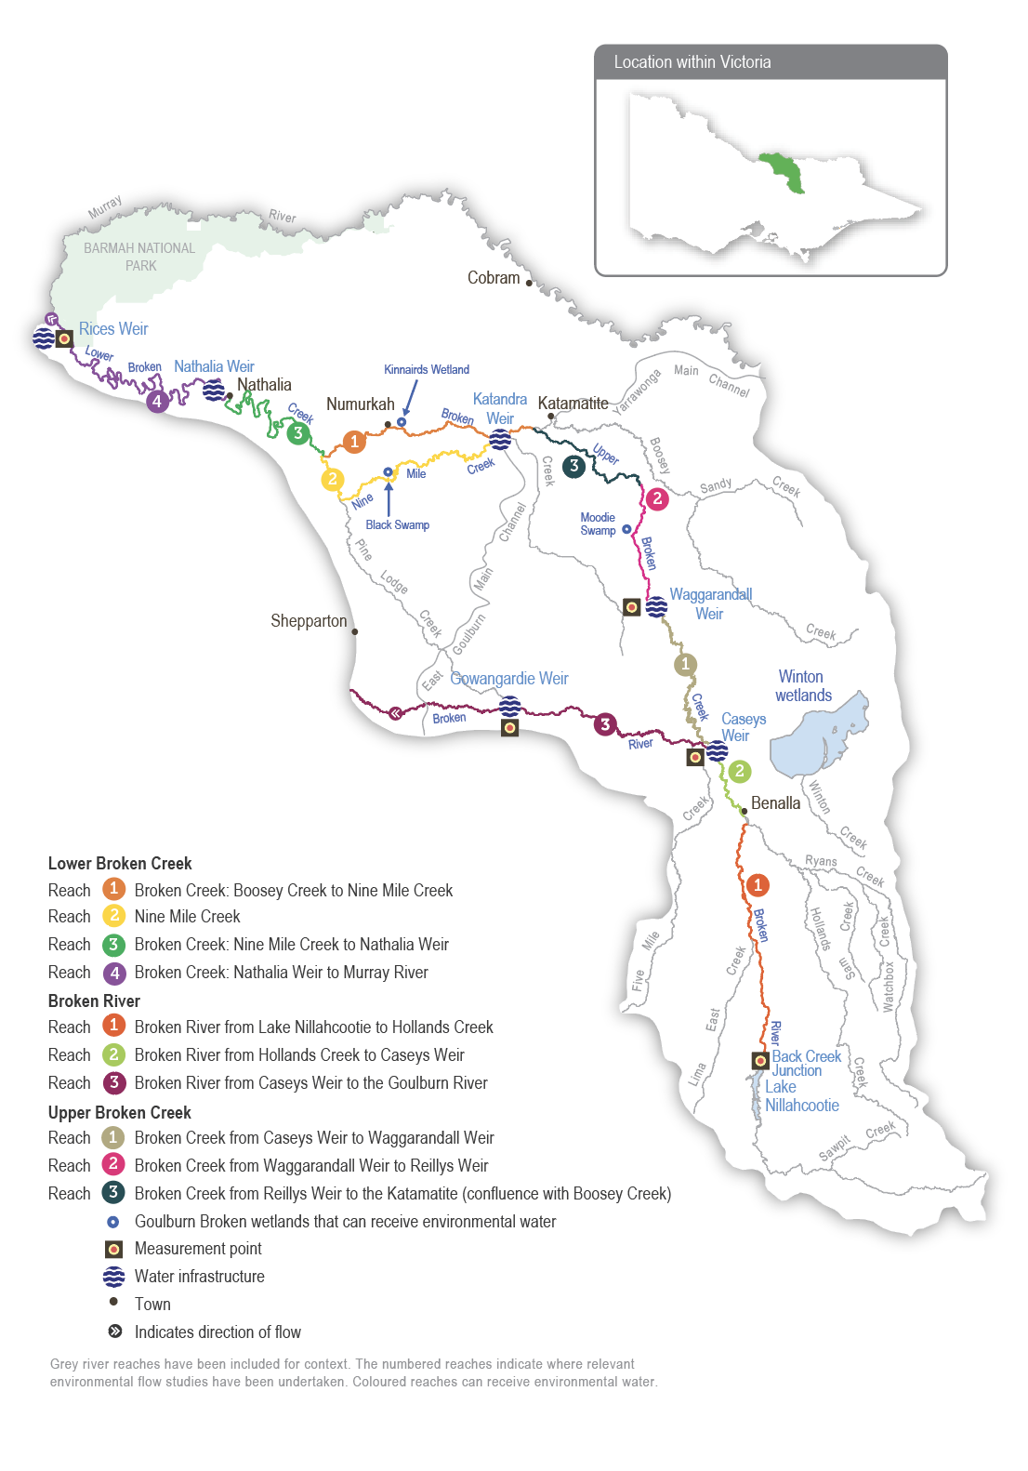

Environmental values
The Broken River retains one of the best examples of healthy in-stream vegetation in a lowland river in the region. A range of native submerged and emergent plant species, including eelgrass, common reed and water ribbons, populate the bed and margins of the river. These plants provide habitat for various animals, including small- and large-bodied native fish. Murray cod, Macquarie perch, golden perch, silver perch, river blackfish, mountain galaxias, southern pygmy perch and Murray-Darling rainbowfish all occur in the Broken River. The river also supports a platypus population.
Upper Broken Creek is dominated by unique box streamside vegetation and remnant plains grassy woodland. The creek and its streamside zone support numerous threatened species, including brolga, Australasian bittern, buloke and ridged water-milfoil. Much of the high-quality native vegetation in the region is set aside as a natural features reserve managed by Parks Victoria. Upper Broken Creek supports a variety of native fish species, including carp gudgeon, Murray cod, river blackfish and Murray-Darling rainbowfish, as well as platypus and common long-necked turtle.
The Broken River and upper Broken Creek are listed in the Directory of Important Wetlands in Australia.
Environmental objectives in the Broken River and upper Broken Creek
F1 | Maintain the native fish population
G1 | Turn over bed sediments and scour around large wood to maintain in-channel habitat diversity
MI1 | Maintain the diversity and abundance of waterbugs
PR1 | Maintain the platypus population
V1 | Maintain in-stream vegetation
WQ1 | Maintain water quality

Traditional Owner cultural values and uses
The Broken River system flows through the Country of the Taungurung and the Yorta Yorta peoples. The Broken Creek is on Yorta Yorta Country. Water for the environment in the Broken system supports the health of cultural values and landscapes, including intangible cultural heritage, valued species and traditional food and medicine plants.
The Taungurung Land and Waters Council (TLaWC) and the Yorta Yorta Nation Aboriginal Corporation (YYNAC) are Broken Environmental Water Advisory Group members. Each year, the Goulburn Broken CMA discuss plans for environmental watering in the Broken River and upper Broken Creek with TlaWC and YYNAC. Both groups support the proposed watering actions.
TLaWC plans to assess cultural values and objectives for the Broken River through healthy Country assessments like Aboriginal Waterway Assessments. These will help the Council develop more specific cultural objectives for the Broken River system and culturally informed recommendations for water for the environment.
In 2021, YYNAC provided the following statement about the cultural values of the Broken River system, including Broken Creek.
“The Broken River (and Broken Creek) holds many cultural values. Common reed contained within the slack water provides important material for tools while also providing refuge for culturally important fish species (large- and small-bodied). The river also has significant stands of old-growth river red gum containing important habitat and exhibiting scars made from carving out canoes and coolamons.”
Increasing the involvement of Traditional Owners in managing environmental flows and progressing opportunities towards self-determination in the environmental watering program is a core commitment of the VEWH and its program partners. This is reinforced by legislation and policy commitments, including the Water Act 1989, the Victorian Aboriginal Affairs Framework, the 2016 Water for Victoria, the 2022 Water is Life: Traditional Owner Access to Water Roadmap, and, in some cases, agreements under the Traditional Owner Settlement Act 2010.

Social, recreational and economic values and uses
In planning the potential environmental watering actions, the Goulburn Broken CMA considered how environmental flows could support values and uses, including:
- water-based recreation (such as canoeing, fishing, kayaking and swimming)
- riverside recreation (such as birdwatching, bushwalking, camping, duck hunting and picnicking)
- green and blue spaces, important for community mental and physical health and wellbeing in an otherwise dry environment
- community events and tourism (such as markets around Benalla Lake)
- socioeconomic benefits (such as maintaining the volume of water in the lower sections to optimise the efficiency of deliveries of consumptive water, maintaining the quality of water for irrigation, stock and domestic use and supporting terrestrial birds that help control agricultural pests).

Scope of environmental watering
The term ‘environmental watering’ refers to the active delivery of held environmental water to support particular environmental objectives by altering the flow in a river or water level in a wetland. While other terms are sometimes used to describe the delivery of environmental water, ‘environmental watering’ is deliberately used here and in seasonal watering statements to ensure consistency in the legal instruments that authorise the use of environmental water in Victoria.
Table 5.5.1 describes the potential environmental watering actions in 2024-25, their expected watering effect (that is, the intended physical or biological effects of the watering action) and the longer-term environmental objectives they support. Each environmental objective relies on one or more potential environmental watering actions and their associated physical or biological effects.
Table 5.5.1 Broken River and upper Broken Creek potential environmental watering actions, expected effects and environmental objectives
Potential environmental watering action | Expected watering effects | Environmental objectives
Upper Broken Creek¹ – reach 1 (compliance points: Waggarandall Weir and Caseys Weir)
Year-round low flow (5-10 ML/day) | - Maintain aquatic habitat and connections between weir pools for native fish and platypus  - Inundate benthic surfaces and large wood located at the bottom of the channel, which are waterbug habitat  - Maintain water quality (specifically dissolved oxygen levels) for native fish, platypus and waterbugs | F1  PR1  MI1  WQ1
Year-round fresh (trigger-based, of 20-50 ML/day for 10 days)²  Triggers:  - low dissolved oxygen  - low or cease-to-flow river conditions  - high water temperatures | - Increase the flow and flush pools to improve water quality and dissolved oxygen levels | WQ1
Winter/spring fresh (50 ML/day for 10 days from July to November)² | - Increase food resources for native fish, platypus and waterbugs  - Increase the flow and flush pools to improve water quality and dissolved oxygen levels  - Increase longitudinal connection that provides opportunities for the downstream dispersal of juvenile platypus in early winter  - Provide migration cues and longitudinal passage for native fish | F1  PR1  MI1  WQ1
Broken River³ – reaches 1, 2 and 3 (compliance points: Back Creek Junction, Caseys Weir, Gowangardie Weir)
Year-round low flow (15-100 ML/day) | At 15 ML/day:  - Provide minimum longitudinal connection along the length of the river and habitat for native fish, aquatic plants, platypus and waterbugs  - Maintain water quality and oxygen levels for native fish, platypus and waterbugs  - Maintain riffles, pools and slackwater habitats for native fish, aquatic plants, platypus and waterbugs  At 30-100 ML/day:  - Increase habitat for in-stream and fringing vegetation and prevent terrestrial vegetation from colonising the stream bed  - Enhance riffles, pools and slackwater to increase the diversity of habitat for native fish, aquatic plants, platypus and waterbugs  - Improve water quality and oxygen levels | V1  F1  PR1  MI1  WQ1
Summer/autumn fresh (one fresh of 400-500 ML/day for two to five days during December to May) | - Scour sediments around large wood, turn over bed sediments, replenish biofilms and maintain macrophyte habitat  - Provide flow cues to stimulate native fish to breed and migrate  - Increase food resources for native fish, platypus and waterbugs | F1  G1  PR1  MI1
1 Potential watering actions in upper Broken Creek will be delivered at a lower magnitude if insufficient water is available to achieve the target magnitude, i.e. 1-9 ML per day.
2 The compliance point is Caseys Weir, as potential watering action targets a maximum volume that can be diverted from Caseys Weir to Broken Creek (50 ML per day) rather than a volume at Waggarandall Weir.
3 30-100 ML per day is the recommended flow required to achieve optimal habitat and water quality in the Broken River. When water availability is low, a flow may need to be delivered at 15 ML per day to provide the minimum habitat and water quality requirements to sustain populations of fish, platypus and vegetation while conserving enough water to deliver throughout the year.

Scenario planning
Table 5.5.2 outlines potential environmental watering and expected water use in various planning scenarios.
The small environmental water entitlement restricts the scope of watering actions that can be delivered in the Broken River system. The proposed actions for 2024-25 are similar to those that have been delivered in previous years.
There are two sets of watering actions: one for upper Broken Creek and another for the Broken River. Delivering a flow to upper Broken Creek is a higher priority because upper Broken Creek has no inflows from tributaries and relies more on operational water deliveries and water for the environment. The potential watering actions for upper Broken Creek require less water than those for the Broken River. Any environmental flows delivered to upper Broken Creek will pass through reaches 1 and 2 of the Broken River, where they will provide some environmental benefit.
All potential watering actions in the Broken River and upper Broken Creek are required across all planning scenarios, but there is unlikely to be enough supply to meet all demands. The expected supply is only sufficient to partially deliver summer low flows through upper Broken Creek in the drought and dry planning scenarios and fully deliver the summer low flow in upper Broken Creek in the average and wet planning scenarios. Year-round low-flow requirements for the Broken River are typically met by passing and operational flows in the average and wet planning scenarios. Delivery of the remaining potential watering actions relies on natural events and the VEWH and CEWH trading water into the system where possible. The VEWH and CEWH have traded water into the Broken system to deliver critical watering actions in 2022-23 and 2023-24, and it is expected that trade will allow some tier 1b watering actions to be delivered in average and wet planning scenarios in 2024-25.
The main environmental watering objective in upper Broken Creek is to maintain a low flow throughout the year to maintain connectivity, water quality and habitat for native fish, platypus and waterbugs. Maintaining an adequate flow is particularly important during spring and summer when native fish, platypus and waterbugs are most active and plants grow the most. Longitudinal flow connectivity may be lost in drier conditions, but baseline ecological values may be protected in weir pools. The year-round, trigger-based fresh will help prevent low dissolved oxygen events, which can result in fish deaths. The Goulburn Broken CMA will monitor water quality conditions in upper Broken Creek and seasonal forecasts and may limit water use for lows flows during low-risk periods to conserve water for additional trigger-based freshes if necessary. Upper Broken Creek no longer receives the natural high flows that provide longitudinal connectivity for fish and platypus migration, and water traded into the system may be used to deliver winter/spring freshes to restore these ecological functions in average or wet planning scenarios.
A year-round low flow (in all planning scenarios) and a summer/autumn fresh (in the average and wet planning scenarios) are needed to support the Broken River’s environmental objectives. However, there is little capacity to influence these with environmental water, especially in the drought and dry planning scenarios. Any environmental water allocations in the drought or dry planning scenarios will be prioritised to deliver a flow to upper Broken Creek, and water will need to be traded into the system if a decision is made to supplement low operational deliveries and natural tributary inflows in the Broken River in these planning scenarios. In the average and wet planning scenarios, increased operational deliveries and tributary inflows will help meet the recommended year-round low flow in the Broken River, but the recommended minimum low flows may not be met in the dry or drought planning scenarios.
Carryover requirements have not been identified for the upper Broken Creek and Broken River. The preferred course is to use available water in 2024-25 and seek extra supply through trade in 2025-26, if needed, to meet essential environmental demands.
Table 5.5.2 Broken River and upper Broken Creek environmental watering planning scenarios
Planning scenario | Drought | Dry | Average | Wet
Expected conditions | - Limited or no unregulated flow in Broken River or upper Broken Creek  - Low releases of operational water in Broken River  - Likely low and cease-to-flow events throughout the year in all reaches | - Low, unregulated flow in Broken River  - Low or no unregulated flow in upper Broken Creek  - Low releases of operational water in Broken River and upper Broken Creek  - Possible low and cease-to-flow events throughout the year in all reaches | - High winter/spring flow in Broken River  - Increased releases of operational water in Broken River  - Periods of unregulated flow in upper Broken Creek | - High winter/spring flow in Broken River  - Increased releases of operational water in Broken River  - Periods of unregulated flow in upper Broken Creek with some winter/spring freshes
Expected availability of water for the environment | - 187 ML | - 306 ML | - 647 ML | - 647 ML
Upper Broken Creek – reach 1
Potential environmental watering – tier 1 (high priorities) | Tier 1a (can be achieved with predicted supply)
 | - Year-round low flows (partially delivered)
 | Tier 1b (supply deficit)
 | - Year-round low flow (remaining volume)  - Year-round fresh (as required) |  | - Year-round low flow (remaining volume)  - Year-round fresh (as required)  - Winter/spring fresh
Potential environmental watering – tier 2 (additional priorities) | - N/A
Broken River – all reaches
Potential environmental watering – tier 1 (high priorities) | Tier 1a (can be achieved with predicted supply)
 | - N/A |  | - Year-round low flow
 | Tier 1b (supply deficit)
 | - Year-round low flow |  | - Summer/autumn fresh
Potential environmental watering – tier 2 (additional priorities) | N/A
Possible volume of water for the environment required to achieve objectives | - 187 ML (tier 1a)  - 3,888-5,988 ML (tier 1b) | - 306 ML (tier 1a)  - 3,769-5,869 ML (tier 1b) | - 647 ML (tier 1a)  - 3,900-7,254 ML (tier 1b) | - 647 ML (tier 1a)  - 3,900-7,254 ML (tier 1b)
Priority carryover requirements for 2025-26 | - N/A

5.5.2 Lower Broken Creek

System overview
The lower Broken Creek system is within Yorta Yorta Country, and their cultural connection is evident throughout the landscape. The lower Broken Creek system includes the section of Broken Creek that flows from the confluence of Boosey Creek near Katamatite to the Murray River and Nine Mile Creek, which is an anabranch of lower Broken Creek that flows from the East Goulburn Main Channel to below Numurkah.
Lower Broken and Nine Mile creeks have been regulated for over a century. Before regulation, the creeks would have had most of their flow in winter/spring, then contracted to isolated pools or dried out during summer/autumn. The adjacent floodplain would have also flooded regularly. The creeks now have numerous weirs that maintain a relatively constant water level from mid-August until mid-May to support irrigated agriculture and little flow during the non-irrigation season. These modifications have changed how native species use the creek and favour invasive species (such as arrowhead). Previously, native fish would have moved into the creek when it flowed and returned to the Murray River as it dried. Both creeks now provide year-round habitat for native fish, and fish passage structures allow fish to move between weir pools. Water for the environment supports these permanent fish habitats by providing flows to trigger fish movement and support fish passage, encourage the growth of native plants, promote in-stream productivity, control water quality and flush the water fern azolla as necessary.
The irrigation channel network delivers regulated water from the Goulburn and Murray systems to lower Broken Creek. Lower Broken Creek is operated separately from upper Broken Creek and Broken River, and both are supplied from Lake Nillahcootie on the upper Broken River.
Environmental water can be provided to lower Broken Creek from the Goulburn system through the East Goulburn Main Channel and the Murray system through the Yarrawonga Main Channel. Water is released into lower Broken Creek from several irrigation regulators along its length. The main priority for environmental flows in the lower Broken Creek system is a minimum flow throughout the year to maintain suitable habitat for native fish. Particular attention is paid to reaches 1 and 2 during the non-irrigation season when the flow can stop. The next priority is to deliver freshes in winter/spring to trigger fish movement and spawning, maintain water quality and manage azolla accumulations in reaches 3 and 4. Rices Weir is the measurement point for environmental flows in lower Broken Creek.
Operational water releases — inter-valley transfers (IVTs) from the Goulburn to the Murray or Barmah Choke bypass flows delivered to meet downstream demands — partly or wholly meet some environmental flow targets for lower Broken Creek. These operational deliveries mainly occur during peak irrigation demand between spring and autumn. Water for the environment may be used to supplement these operational releases and deliver recommended flow components not met by operational releases.

Environmental values
Lower Broken Creek and Nine Mile Creek support a diverse and abundant native fish community, including the threatened Murray cod, golden perch, silver perch, unspecked hardyhead and Murray-Darling rainbowfish.
Sections of lower Broken and Nine Mile creeks have been reserved as state parks and natural feature reserves. The associated floodplain and wetland habitats support box-dominated grassy woodland communities and numerous species of state and national conservation significance, including river swamp wallaby grass and the Australasian bittern.
Environmental objectives in the Lower Broken Creek
F1 | Protect and increase the native fish population, including threatened Murray cod, golden perch, silver perch and small-bodied species
MI1 | Increase the diversity and abundance of the waterbug population
PR1 | Protect the platypus and rakali (water rat) populations, particularly outside the irrigation season
T1 | Protect the turtle population, particularly outside the irrigation season
V1 | Avoid the excessive build-up of azolla
V2 | Increase the cover and condition of native in-stream and littoral vegetation communities
WQ1 | Maintain oxygen levels suitable for aquatic animals

Traditional Owner values and uses
The lower Broken Creek system is within Yorta Yorta Country, and their cultural connection is evident throughout the landscape.
Each year, the Goulburn Broken CMA meets with the Yorta Yorta Nation Aboriginal Corporation (YYNAC) representatives to discuss water for the environment in lower Broken Creek. In March 2024, a meeting was held to discuss 2024-25 environmental watering priorities.
YYNAC supports the planned environmental flows for 2024-25 in the lower Broken Creek. Flows will support in-stream vegetation and native fish, along with other aquatic plants and animals. The Goulburn Broken CMA will continue to work with the Yorta Yorta people to identify how the management of water for the environment can better support cultural values.
In 2021, the Yorta Yorta Nation Aboriginal Corporation provided the following statement about the cultural values of the Broken River system, including lower Broken Creek.
“The Broken River (and Broken Creek) holds many cultural values. Common reed contained within the slack water provides important material for tools while also providing refuge for culturally important fish species (large and small-bodied). The creek also has significant stands of old-growth river red gum containing important habitat and exhibiting scars made from carving out canoes and coolamons.”
YYNAC has raised concerns about the regulation of flows in all their waterways, which affects their Country and cultural knowledge.
YYNAC continues to pursue the Yorta Yorta people’s inherent rights to water for Country. Rights to water will improve their spiritual, cultural, environmental, social and economic needs, in line with the Yorta Yorta Whole-Of-Country Plan 2021-2030.
Increasing the involvement of Traditional Owners in managing environmental flows and progressing opportunities towards self-determination in the environmental watering program is a core commitment of the VEWH and its program partners. This is reinforced by legislation and policy commitments, including the Water Act 1989, the Victorian Aboriginal Affairs Framework, the 2016 Water for Victoria, the 2022 Water is Life: Traditional Owner Access to Water Roadmap, and, in some cases, agreements under the Traditional Owner Settlement Act 2010.

Social, recreational and economic values and uses
In planning the potential watering actions in Table 5.5.3, the Goulburn Broken CMA considered how environmental flows could support values and uses, including:
- water-based recreation (such as canoeing, fishing, game hunting and kayaking)
- riverside recreation and amenity (such as aesthetic and amenity values that are particularly important for the community’s mental health and wellbeing during dry periods and for passive recreation)
- community events and tourism
- socioeconomic benefits (such as consumptive water users, Goulburn-Murray Water irrigators and diverters and Goulburn Valley Water customers).
The creeks making up the lower Broken Creek system have a narrow streamside zone with residential and farming properties adjoining or overlooking them. The creek system runs through the Katamatite, Wunghnu, Numurkah and Nathalia townships. Consequently, these communities have a direct connection with their creek, which provides high aesthetic and amenity values that are particularly important to the community. The creeks are also important recreational areas, including for fishing, canoeing, kayaking and passive recreation.
“The Broken and Nine Mile creeks are important in regards to being one of the most accessible waterways in Victoria for fishing, family picnics and camping”
– Nathalia community member, 22 February 2023
The expected benefits from the delivery of water for the environment in lower Broken Creek and Nine Mile Creek in 2024-25 include benefits from winter flows which support amenity and maintain adequate depth for canoeing and fishing.
The lower Broken Creek system is the source of consumptive water for irrigation, stock and domestic uses for more than 70 diverters and urban water for Nathalia. The creek can be prone to poor water quality due to high turbidity, elevated colour and/or low dissolved oxygen events. Delivery of baseflows and freshes during the warmer months can help improve water quality for consumptive users.

Scope of environmental watering
The term ‘environmental watering’ refers to the active delivery of held environmental water to support particular environmental objectives by altering the flow in a river or water level in a wetland. While other terms are sometimes used to describe the delivery of environmental water, ‘environmental watering’ is deliberately used here and in seasonal watering statements to ensure consistency in the legal instruments that authorise the use of environmental water in Victoria.
Table 5.5.3 describes the potential environmental watering actions in 2024-25, their expected watering effect (that is, the intended physical or biological effects of the watering action) and the longer-term environmental objectives they support. Each environmental objective relies on one or more potential environmental watering actions and their associated physical or biological effects.
Table 5.5.3 Lower Broken Creek potential environmental watering actions, expected effects and environmental objectives
Potential environmental watering action | Expected watering effects | Environmental objectives
Winter low flow (20‑40 ML/day during May to August) | - Provide native fish with passage through fish ladders  - Provide suitable foraging habitat for platypus and rakali (water rats) and support the conditioning of females in preparation for the breeding season  - Provide habitat for turtles, including protection from exposure during their winter dormancy  - Provide flowing-water habitat and avoid winter drying of weir pools for fish, vegetation, waterbugs, platypus and turtles  - Maintain water over submerged aquatic plants so they are protected from drying and frost  - Reduce the stagnation of weir pools | F1  PR1  T1  V2  MI1  WQ1
Spring/summer/autumn low flow (70-250 ML/day in reaches 1 and 2 and 200-450 ML/day in reaches 3 and 4 during August to May) | - Provide habitat for native fish, platypus, rakali (water rats), turtles and waterbugs  - Support the movement and recruitment of fish  - Maintain oxygen levels in summer  - Additional benefits when delivered from December to February (at 250-450 ML/day):  - Mobilise azolla and increase oxygen levels during high-risk periods | F1  PR1  T1  V1  MI1  WQ1
Winter/spring fresh(es) (one to three freshes of 300-450 ML/day for one to two weeks during July to November) | - Flush and mobilise azolla if it has accumulated to maintain water quality  - Trigger the movement and spawning of fish  - Encourage the germination and growth of littoral and in‑stream vegetation  - Reduce the stagnation of weir pools to maintain water quality | F1  V1/2  WQ1

Scenario planning
Table 5.5.4 outlines potential environmental watering and expected water use in various planning scenarios.
The high degree of regulation in the lower Broken Creek system means flow patterns in the lower Broken and Nine Mile creeks are the same in all planning scenarios. Water for the environment will primarily be used in the lower Broken Creek system to guard against a reduced flow during the non-irrigation season.
Potential watering actions in all planning scenarios include maintaining a flow above 40 ML per day outside the irrigation season, ameliorating sudden fluctuations in irrigation demand during the irrigation season and delivering spring freshes to trigger fish movement or flush excessive accumulations of azolla. Delivering spring freshes in 2024-25 in all planning scenarios will be of particular importance to trigger the movement and spawning of native fish in the system and help the fish community recover from extensive flooding and associated hypoxic blackwater events that caused widespread fish deaths in the lower Broken Creek and many parts of the southern connected basin. Low flows and freshes throughout the year will also support native fish, which are being restocked as part of a recovery project.
The Goulburn Broken CMA will monitor water quality throughout the year, and it may ask to increase the flow to the upper end of the recommended range in Table 5.5.3 if dissolved oxygen levels drop below 4.0 mg/L. The total volume of water for the environment that will be needed to achieve planned watering actions in 2024-25 will vary depending on operational deliveries (including IVTs) and the size and duration of any unregulated flow events. A carryover target of 5,000 ML applies in all climate scenarios to ensure a minimum low flow and a small fresh can be delivered early in 2025-26.
Table 5.5.4 Lower Broken Creek environmental watering planning scenarios
Planning scenario | Drought | Dry | Average | Wet
Expected conditions | - No unregulated flow | - Some unregulated flow in winter  - No unregulated flow throughout the irrigation season (mid-August to May)  - No diversion of unregulated Murray River flow is available | - Unregulated flow in winter/spring  - Unregulated flow is unlikely from October to May  - Diversion of unregulated Murray River flow is available from mid-August to October | - Unregulated flow is likely in winter/spring  - Unregulated flow is possible from November to May  - Diversion of unregulated Murray River flow available from mid-August to November
Lower Broken Creek (targeting reach 4)
Potential environmental watering – tier 1 (high priorities)¹ | - Winter low flow  - Spring/summer/autumn low flow  - Winter/spring freshes
Possible volume of water for the environment required to achieve objectives | - 80,000 ML
Priority carryover requirements for 2025-26 | - 5,000 ML
1 Tier 1 potential environmental watering for lower Broken Creek is not classified as tier 1a or 1b because the water available for use is shared across various systems, and it is not possible to reliably determine the supply specifically available for lower Broken Creek.

5.5.3 Broken wetlands

System overview
Of some 3,600 natural wetlands in the Goulburn Broken region, only three in the Broken catchment have infrastructure that allows them to receive environmental water: Black Swamp, Kinnairds Wetland and Moodie Swamp.
All three wetlands are on the Country of the Yorta Yorta People. Their knowledge and practice are evident throughout the landscape; for example, Black and Moodie Swamps have evidence of old cooking mounds around their perimeter. Kinnairds Wetland and Black Swamp are red gum swamps near Numurkah. Moodie Swamp is a cane grass wetland adjacent to upper Broken Creek at Waggarandall that provides excellent breeding habitat for brolga.
The water regimes of these wetlands are influenced by their position in the landscape. The development and operation of the Shepparton and Murray Valley irrigation districts have changed the natural flow paths and the timing, frequency, volume and duration of natural flooding to these and other wetlands in the region. The existing irrigation system infrastructure enables water for the environment to be delivered to the three wetlands, but under existing agreements, irrigation deliveries have priority within the channel system. This limits the volume of water that can be delivered to the wetlands. The VEWH, waterway managers and storage managers adjust the timing and rate of environmental deliveries where possible to optimise environmental outcomes within the current system constraints.

Environmental values
Moodie Swamp, Kinnairds Wetland and Black Swamp support diverse vegetation communities ranging from river red gum to cane grass. The wetlands contain state and nationally threatened vegetation communities and species, including ridgid water-milfoil and river swamp wallaby grass. The wetlands also provide food resources and breeding habitat for bird species of high conservation significance, including eastern great egret, Latham’s snipe, white-bellied sea eagle, Australasian bittern, brolga, royal spoonbill, yellow-billed spoonbill, Australasian shoveler and glossy ibis. Many of these species are listed in international agreements and conventions. Moodie Swamp also supports Sloane’s froglet, listed in the Commonwealth Environment Protection and Biodiversity Conservation Act 1999.
Environmental objectives in the Broken wetlands
A1 | Provide breeding habitat for frogs
CN1 | Restore carbon and nutrient cycling within the wetlands to increase ecosystem productivity
V1 | Improve the cover, diversity, recruitment/regeneration and growth of native wetland plant species, consistent with ecological vegetation class benchmarks
V2 | Reduce the cover and diversity of exotic plant species
V3 | Maintain populations of ridged water-milfoil
V4 | Maintain populations of river swamp wallaby grass
B1 | Provide breeding habitat for waterbirds
B2 | Provide feeding and roosting habitat for waterbirds

Traditional Owner cultural values and uses
Moodie Swamp, Kinnairds Wetland and Black Swamp support various native plants and animals that provide many cultural values and uses for the Yorta Yorta People. Black Swamp and Kinnairds Wetland support multiple varieties of nardoo (a food source), native grasses (such as old man weed, which has medicinal uses) and sedges and rushes (used for basket weaving). Basket weaving sedges also grow at Moodie Swamp.
Increasing the involvement of Traditional Owners in managing environmental flows and progressing opportunities towards self-determination in the environmental watering program is a core commitment of the VEWH and its program partners. This is reinforced by legislation and policy commitments, including the Water Act 1989, the Victorian Aboriginal Affairs Framework, the 2016 Water for Victoria, the 2022 Water is Life: Traditional Owner Access to Water Roadmap, and, in some cases, agreements under the Traditional Owner Settlement Act 2010.

Social, recreational and economic values and uses
When planning potential environmental watering actions, the Goulburn Broken CMA considers how environmental flows could support values and uses, including:
- water-based recreation (such as canoeing)
- riverside recreation and amenity (such as birdwatching, camping, picnicking, photography, walking and hunting)
- community events and tourism (such as community gatherings at Kinnairds Wetland and the Walk and Squawk event)
- socioeconomic benefits (such as tourism, which greatly contributes to the local economy).

Scope of environmental watering
The term ‘environmental watering’ refers to the active delivery of held environmental water to support particular environmental objectives by altering the flow in a river or water level in a wetland. While other terms are sometimes used to describe the delivery of environmental water, ‘environmental watering’ is deliberately used here and in seasonal watering statements to ensure consistency in the legal instruments that authorise the use of environmental water in Victoria.
Table 5.5.5 describes the potential environmental watering actions in 2024-25, their expected watering effect (that is, the intended physical or biological effects of the watering action) and the longer-term environmental objectives they support. Each environmental objective relies on one or more potential environmental watering actions and their associated physical or biological effects. No active deliveries of water for the environment are planned for the Broken wetlands in 2024-25 because they need to draw down to support dry-phase ecological processes required to achieve long-term environmental objectives at each site.
Table 5.5.5 Broken wetlands system potential environmental watering actions, expected effects and environmental objectives
Potential environmental watering action | Expected watering effects | Environmental objectives
- No deliveries of water for the environment are planned in 2024-25

Scenario planning
Table 5.5.6 outlines potential environmental watering and expected water use in various planning scenarios.
Black Swamp, Kinnairds Wetland and Moodie Swamp rely on a mix of wetting and drying cycles to support their environmental values. The Broken River catchment has flooded three times since spring 2020, and as a result, Black Swamp, Kinnairds Wetland and Moodie Swamp have all exceeded their optimal wet-phase duration. Moodie Swamp has held water continuously since August 2021, and as a result, some of the cane grass and aquatic herbs are being replaced by a thick carpet of upright water-milfoil. This change in vegetation community composition is a natural response to the prolonged inundation. No environmental watering is planned at any of the Broken wetlands during 2024-25 to allow them to draw down and support dry-phase ecological processes. The planned drying aims to restore the intended mix of vegetation communities at Moodie Swamp and prevent changes in the Black Swamp and Kinnairds Wetland vegetation communities. The wetlands are expected to provide foraging habitat for various waterbirds as they draw down, and the drying sediments will facilitate carbon and nutrient cycling processes.
The wetlands are expected to draw down effectively in the drought-to-average planning scenarios, but natural floods in the wet planning scenario may top them up again. If the wetlands draw down during 2024-25, it is recommended that Kinnairds Wetland and Black Swamp remain dry until spring 2025 and Moodie Swamp remains dry for six to nine months before it is refilled.
Table 5.5.6 Broken wetlands system environmental watering planning scenarios
Planning scenario | Drought | Dry | Average | Wet
Expected conditions | - Catchment run-off and natural flow into the wetlands are highly unlikely | - Catchment run-off and natural flow into the wetlands are unlikely | - Some catchment run-off and natural flow into some of the wetlands are likely, particularly in winter/spring | - Catchment run-off and natural flow into the wetlands may significantly contribute to water levels in the wetlands, particularly in winter/spring
Potential environmental watering – tier 1 (high priorities) | - N/A: No deliveries of water for the environment are planned in 2024-25
Potential environmental watering – tier 2 (additional priorities) | - N/A
Possible volume of water for the environment required to achieve objectives | - N/A
Priority carryover requirements for 2025‑26 | - N/A

5.6 Campaspe system
Waterway manager – North Central Catchment Management Authority
Storage manager – Goulburn-Murray Water
Environmental water holders – Victorian Environmental Water Holder (including the Living Murray program) and the Commonwealth Environmental Water Holder
The Campaspe system includes the Campaspe and Coliban rivers.

5.6.1 Campaspe River

System overview
Natural inflows in the upper Campaspe River catchment are harvested into Lake Eppalock, located near the townships of Axedale and Heathcote. The main tributaries of the Campaspe River are the Coliban River, McIvor and Wild Duck creeks above Lake Eppalock and Mount Pleasant, Forest and Axe creeks below Lake Eppalock (Figure 5.6.1).
Below Lake Eppalock, the major in-stream structure is the Campaspe Weir, built to divert water to the Campaspe Irrigation District. It is no longer used for water diversion but is a barrier to fish migration. Gates on the weir provide some degree of control over the flow, but large flows spill over the weir. The Campaspe Siphon, just below Rochester, is part of the Waranga Western Channel, which carries water from the Goulburn system to western Victoria. Water can be released from the Waranga Western Channel into the lower reaches of the Campaspe River, or water can be pumped from the river into the Waranga Western Channel. The siphon is another barrier to fish migration when there is low-to-moderate flow.
The flow below Lake Eppalock is influenced mainly by releases from storage and the operation of the Campaspe Weir and the Campaspe Siphon. The Campaspe’s major tributary (the Coliban River) flows through the three Coliban Water storages (the Upper Coliban, Lauriston and Malmsbury reservoirs) before reaching Lake Eppalock. Water for the environment is held and released from Lake Eppalock, with some limited ability to regulate the flow further downstream at the Campaspe Weir.
Water for the environment is released from Lake Eppalock to support aquatic plants and animals in and along the Campaspe River. It can be supplemented by water for the environment delivered via the Waranga Western Channel at the Campaspe Siphon, which provides flexibility to meet environmental demands in reach 4. Water for the environment is primarily used in the Campaspe River to improve the magnitude and variability of flow during winter and spring, but it is also used to deliver a critical flow in summer and autumn that is not met or exceeded by operational deliveries. Primary flow measurement points are at Barnadown (reach 2) and below the Campaspe Siphon (reach 4).
Goulburn-Murray Water transfers operational water from Lake Eppalock or through the Waranga Western Channel to Murray River customers and downstream storages (such as Lake Victoria). These inter-valley transfers (IVTs) usually occur in summer and autumn and, depending on the rate of delivery, can either support or compromise environmental flow objectives. High IVT flows delivered when the Campaspe River would naturally have a low flow may reduce suitable habitat for juvenile fish, which rely on protected, shallow areas of water near the edge of the river channel. Sustained high IVT flows in summer can also drown recruiting streamside vegetation. Storage managers and the North Central CMA have been working cooperatively to enhance the positive effects and limit the harmful effects of IVTs on native plants and animals in the Campaspe River. For example, IVTs are sometimes delivered in a pattern that meets summer low-flow and fresh requirements, reducing demand on the environmental entitlement. IVTs have also been released in a pattern to support native fish migration from the Murray River into reach 4 of the Campaspe River without affecting delivery to downstream users.
Figure 5.6.1 The Campaspe system
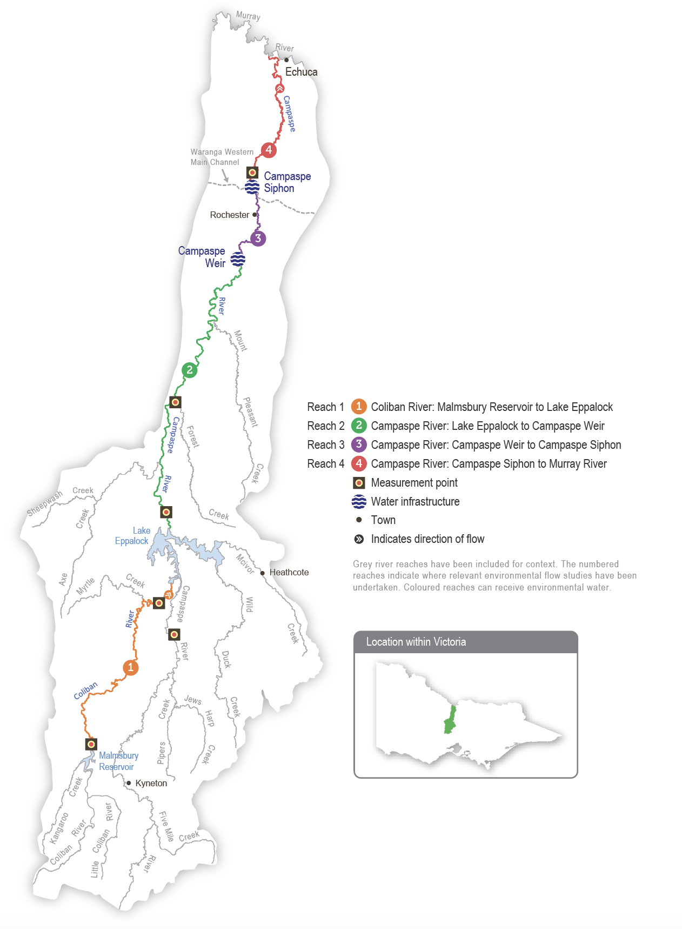

Environmental values
The Campaspe River below Lake Eppalock provides essential habitat for native fish species, including Murray cod, silver perch, golden perch, Murray-Darling rainbowfish and flat-headed gudgeon. Murray-Darling rainbowfish were presumed lost from the system during the Millennium Drought, but since 2011 they have been recorded at many sites on the Campaspe River. Environmental flows help native fish migrate and disperse throughout the Campaspe system.
Platypus, rakali (water rats), turtles and frogs are also present along the length of the Campaspe River. The narrow streamside vegetation zone is dominated by large, mature river red gum trees supporting wildlife (such as the swift parrot and squirrel glider).
Environmental objectives in the Campaspe system
F1 | Protect and increase the native fish population
F2 | Facilitate recolonisation by native fish species (including trout, cod and blackfish) that have been presumed lost
MI1 | Increase the diversity and biomass of waterbugs
PR1 | Protect the platypus population
V1 | Maintain adult river red gums and increase the recruitment of immature trees
V2 | Maintain the extent and increase the diversity of streamside vegetation
V3 | Increase the extent of in-stream aquatic plants
WQ1 | Maintain water quality in deep pools and prevent stratification in summer
WQ2 | Reduce the risk of low-oxygen blackwater events in summer

Traditional Owner cultural values and uses
Djaara, Taungurung and Yorta Yorta Nations are the First Peoples of the Campaspe River, and we acknowledge their rights to practice their culture and identity as Traditional Owners, to maintain their relationship with the river and natural resources on or depending on their land and to protect places and areas of importance on their land. The Traditional Owners have rights as the primary guardians, keepers and knowledge holders of Aboriginal cultural heritage and knowledge.
In planning for environmental flows in the Campaspe River in 2024-25, the North Central CMA met with the Dja Dja Wurrung Clans Aboriginal Corporation (DJAARA) and the Taungurung Land and Waters Council (TLaWC) to discuss how cultural objectives can be supported by water for the environment and the importance of Traditional Owner involvement in the management of water on Country.
To enhance Traditional Owner engagement, DJAARA hosted a North Central CMA environmental water officer to work from the DJAARA office one day a week while developing the seasonal watering proposal. The purpose was to work with DJAARA to gain input into the Campaspe River’s and other systems’ seasonal watering proposals for 2024-25 and allow for exchanging information between both organisations.
TLaWC discussed the proposed watering actions with the Taungurung water knowledge group Baan Ganalina (Guardians of Water) in early 2023. This was informed by earlier discussions between the North Central CMA and Baan Ganalina in 2023 and ongoing biocultural monitoring and assessments at seven sites on the Campaspe River by TLaWC as part of its Reading Water Country program during the previous year.
The Djaara and Taungurung Nations’ values and uses of the Campaspe River and how these have been considered in developing the 2024-25 Campaspe seasonal watering proposal are summarised below.

Djaara
Dhelkunya Dja: Dja Dja Wurrung Country Plan 2014-2034 describes the Djaara peoples’ aspirations for the management of rivers and waterways and articulates the Djaara’s support for reinstating environmental flows as an overall objective for the management of water on Country.
“Traditional Aboriginal culture revolved around relationships to the land and water — relationships that hold deep physical, social, environmental, spiritual and cultural significance. Today, the land and its waterways remain central to our cultural identity and aspirations for community and economic development. Our rivers are the veins of Country, and provide food and medicine, and places to camp, hunt, fish, swim and hold ceremonies. They are places that are central to our creation stories, and many of our cultural heritage sites are associated with waterways — burial sites, birthing sites and middens. Our waterways are places that we connect with our ancestors and pass traditional knowledge on to our children and grandchildren.”
– Dhelkunya Dja: Dja Dja Wurrung Country Plan 2014-2034
Collaboration between the North Central CMA, DJAARA and the Djaara people is guided by the 2016 Dja Dja Wurrung Clans Aboriginal Corporation and North Central Catchment Management Authority Engagement Framework, the Kapa Gatjin (We speak water) North Central CMA Seasonal Watering Proposal Engagement Framework and input from Kapa Gatjin (Dja Dja Wurrung water knowledge group).
Cultural objectives for the Campaspe River developed in 2019-20 emphasise the importance of native fish, turtles, medicine plants and pest control. DJAARA expects to be respected and involved in environmental water management. Cultural and environmental objectives may align, but they are independent and must be defined, monitored and reported independently. The North Central CMA will work with Kapa Gatjin, and funding sources will need to be found, to enable Kapa Gatjin members to undertake monitoring to track progress in achieving their cultural values.
Table 5.6.1 Kapa Gatjin objectives and values, Campaspe River
Cultural objective | Cultural values and hydrological objectives | Concerns | Indicator | Measure | Watering/management action | Potential watering action (where applicable)
Cultural heritage (intangible) | - Increase knowledge of site-specific water management advice | - Gaps between traditional knowledge and land/water management | - Stronger relationships and communication between Traditional Owners, landowners and North Central CMA |  | - On-site cultural tours
Cultural heritage (tangible) | - Protection of culturally significant artefacts (e.g. scar trees) | - Many sites are unrecorded |  |  |  | - Ramp up and down rates to minimise the risk of erosion and bank slumping
Plants | - Promote the growth of traditional food, fibre and medicine plants (e.g. water ribbons, water pepper, old man weed, native thistles) | - Lack of native biodiversity and culturally significant vegetation | - Improved water quality  - More abundant native species  - Improved bank stability | - Plant surveys  - Photo points | - Make water available during seed dispersal seasons | - Summer freshes and a winter high flow to wet margins of the riverbank to promote in-stream and fringing vegetation
 | - Improve water quality and bank stability | - Bank erosion  - Habitat destruction  - Loss of cultural artefacts | - Decrease in bank erosion rate  - More plants growing on the water’s edge | - Water quality testing | - Implement flood management | - Flow variability
Wildlife | - Improve vegetation and pest management to prevent the encroachment of terrestrial weeds | - Lack of native biodiversity | - Absence of weeds  - Increased abundance of (locally) native plants | - Plant surveys  - Photo points | - Physical and/or chemical removal of weeds, streamside burning  - Environmental flow that helps re-establish native grasses (exclusion plots) | - Winter high flow to prevent terrestrial vegetation establishing on the lower bank
 | - Improve native fish populations | - Water high and low flows deliveries may not be timed with other natural breeding cues | - Recruitment of native plants and animals | - Plant and animal surveys  - Photo points  - Fish tagging | - Ensuring the delivery of flows is timed with other natural breeding cues | - All flow variability

Author - Voytek Lapinski, Taungurung Land and Waters Council (TLaWC)
On 4-5 September 2019, the North Central CMA met with the Taungurung water knowledge group, Baan Ganalina for a two-day field tour of the Campaspe River and a workshop to identify biocultural values and express Taungurung objectives for healing and caring for the Campaspe River in line with cultural obligations and priorities.
In line with values and objectives identified by knowledge holders during this process and building on the ecological and cultural assessment undertaken on the Campaspe in 2019 in collaboration with Dja Dja Wurrung, commencing in 2022, Biik crew members have monitored seven sites on the river monthly to maintain connection to Country and help collect biocultural knowledge. This knowledge has been synthesised through ongoing discussions with Baan Ganalina to develop the cultural objectives in this section.
Baan Ganalina has highlighted the importance of native animals, including fish, frogs, platypus, waterbirds, mussels and crustaceans, and identified the importance of overstorey, mid-layer and aquatic vegetation in creating healthy habitat. The group has emphasised the principle of ‘right way water’ (right time, right place, right amount) to ensure the river’s flow is at varying and seasonally appropriate levels and the importance of reconnecting backwaters, maintaining water quality and preventing flows that might erode or damage cultural sites. The group also emphasised the need for their ongoing involvement in water management decisions so cultural values and objectives are incorporated appropriately.
TLaWC has identified that this method of ongoing engagement is needed so objectives identified in the initial cultural waterway assessment process can be built upon in subsequent years through an iterative refinement process in response to cultural direction and priorities. This requires regular assessments of the river as well as necessary funding.
The following is not a complete picture of Taungurung knowledge, values and objectives regarding the Campaspe River. Funding is required to enable Baan Ganalina and Biik crew members to monitor the ongoing health of Country. The North Central CMA continues to work with TLaWC and Baan Ganalina to support the assessment and monitoring of biocultural values on the Campaspe River.

Baan Ganalina cultural objectives for the Campaspe River, 2023
The health of Country is central to all Taungurung objectives for the Campaspe River. Taungurung have an obligation to care for the river and know that the health of the Taungurung community and its Country are connected and interdependent. Objectives for environmental flow management, streamside works and other management activities on the river should not be considered in isolation. They must always recognise this interconnectedness and the central role of Traditional Owners in speaking for Country.
Baan Ganalina has prioritised the following aspects of the broader health of Country as objectives for 2024-25.
- Taungurung are better able to meet their cultural obligation to care for the river and actively manage land and water through increased activation of rights and building capacity.
- Taungurung’s obligation to care for the Campaspe includes obligations to other Nations who share the river. The Campaspe is a meeting place with Djaara and connects the two Nations. Reading and healing Country activities need to recognise and support this important relationship.
- Healthy water and healthy flows. Water on Country is ‘right way water’: at the right times, at the right places and in the right amounts. This includes:
- maintaining and improving water quality
- the river flowing at varying seasonally appropriate levels: environmental water releases should mimic natural flow regimes and respond to/top up natural flow events
- the flow regime supporting fish habits, maintaining water quality and supporting the abundance and diversity of native species and wildlife, as set out below.
- Native species diversity and abundance:
- overstorey trees: support the health of existing red gums and encourage recruitment
- establish a healthy mid-storey and understorey where they are absent
- maintain and improve aquatic vegetation; water ribbons and juncus (rushes) are key food and fibre plants, respectively, and good indicators of the health of Country
- Wildlife diversity and abundance:
- promote healthy breeding frog populations and provide cues for frog breeding
- maintain or improve mussel and crustacean populations
- maintain or improve platypus populations and provide cues for platypus breeding
- maintain or improve waterbird populations
- improve native fish populations, provide cues for fish breeding and ensure fish can move.
- The backwaters are an essential part of the Campaspe, and maintaining their health and connection to the river is vital for its health.
- Supporting food sources is essential. There are many food plants on the Campaspe (such as water ribbons), which should be supported.
- Improve community ties to the river through ongoing reading Country activities, support camping by the river and access to and availability of food species.
- Officially record culturally significant sites and artefacts. Maintain and protect cultural sites.

Kapa Gatjin and Baan Ganalina advisory groups’ joint 2019 Campaspe River Aboriginal Waterway Assessment
The Kapa Gatjin advisory group and the Taungurung Baan Ganalina advisory group completed a joint Aboriginal Water Assessment along the Campaspe River in November 2019.
Table 5.6.2 summarises the cultural aspirations and values and uses the assessment identified. Djaara emphasises that it is impossible to include all their cultural water aspirations, uses, values and places of cultural importance in one document. Djaara’s values are diverse and complex and can widely differ between family and clan groups. Djaara’s interests and beliefs are multifaceted and cannot be defined through a single standpoint or response.
Table 5.6.2 Traditional Owner values and uses, Campaspe River
Traditional Owner group | Values, uses, objectives & opportunities | How will this opportunity be considered in environmental watering in 2024-25?
Kapa Gatjin and Baan Ganalina | - Protect culturally significant sites (such as scar trees). | - Water for the environment deliveries will include ramp-up and ramp-down rates at the lower end of the environmental flow recommendations to minimise erosion risk and bank slumping.  - More work is required to locate and document cultural assets that may be affected by river flows.
Baan Ganalina | - The flow regime reflects the principle of ‘right way water’. Environmental water releases should mimic natural flow regimes and respond to/top up natural flow events. Backwaters are connected to maintain the health of the river. | - Environmental water deliveries, where feasible, should be delivered consistent with antecedent conditions and seasonality, respectful of natural cycles and the needs of Country. Winter and spring high and low flows should reflect the climatic conditions at the time of delivery: lower in dry years and greater in average to above-average rainfall years. Summer freshes and winter high-flow events should be delivered to coincide with forecast rainfall events if possible.
Kapa Gatjin | - Promote the growth of traditional food, fibre and medicine plants (such as water ribbons, water pepper and juncus). | - Environmental water deliveries will include summer/autumn freshes and winter/spring high flows to wet riverbank margins to promote in-stream and fringing vegetation.
Baan Ganalina | - Maintain or improve the diversity, abundance and health of native vegetation assessed using indicator species (such as water ribbon for food and juncus for fibre) to assess the overall health of Country. | - Environmental water deliveries will include summer/autumn freshes and winter/spring high flows to wet riverbank margins to promote bank, in-stream and fringing vegetation.
Kapa Gatjin | - Improve vegetation and prevent the encroachment of terrestrial weeds. | - Ensure winter/spring high flows to prevent terrestrial vegetation establishing on the lower bank.
Kapa Gatjin and Baan Ganalina | - Healthy water, improved water quality. | - Delivery of the recommended flow regime will lead to improved water quality.  - Delivery of a winter/spring high flow will reduce the risk of a blackwater event in summer.
Kapa Gatjin and Baan Ganalina | - Improve native fish populations. | - Some environmental water deliveries will protect and improve native fish populations (such as summer/autumn freshes for large-bodied fish movement and steady spring flows to prevent Murray cod abandoning their nests).
Baan Ganalina and Yorta Yorta | - Maintain and improve platypus populations. | - Connect the low flow for movement, summer/autumn fresh in April reduces predation during juvenile dispersal.  - A winter/spring low flow allows male platypus to move long distances during the breeding season, and the timing of a spring high flow prevents burrows from being inundated during the breeding season.

Yorta Yorta First Nations People
Yorta Yorta have raised concerns in the past about the impacts of gold mining and groundwater extraction on river flows in the Campaspe Valley. Yorta Yorta support flows that will mitigate the impacts of consumptive water delivery in summer and provide conditions to improve habitat for platypus breeding.
The Yorta Yorta Nation Aboriginal Corporation continues to pursue the Yorta Yorta People’s inherent rights to water for Country. Rights to water will address their spiritual, cultural, environmental, social and economic needs, in line with the Yorta Yorta Whole-Of-Country Plan 2021-2030. Yorta Yorta values encompass an inherent and living connection to land (woka), water (wala) and caring for Country. Examples of Yorta Yorta cultural values and uses that are supported through deliveries of water for the environment include:
- maintaining refuges that protect turtles, an important totemic species for the Yorta Yorta People
- watering to support vegetation, which includes food, fibre and medicinal plants
- improving the health of river red gums, which has benefits for important Yorta Yorta sites and significant markings (such as a scar tree) and furthers connections to Country
- restoring the environment to achieve healthy Country.
Increasing the involvement of Traditional Owners in managing environmental flows and progressing opportunities towards self-determination in the environmental watering program is a core commitment of the VEWH and its program partners. This is reinforced by legislation and policy commitments, including the Water Act 1989, the Victorian Aboriginal Affairs Framework, the 2016 Water for Victoria, the 2022 Water is Life: Traditional Owner Access to Water Roadmap, and, in some cases, agreements under the Traditional Owner Settlement Act 2010.

Social, recreational and economic values and uses
Consistent with Water for Victoria and the Victorian Water Act 1989, CMAs consider shared benefits in environmental water planning and delivery. Shared benefits may be intrinsic or secondary opportunistic benefits, including economic, social, indigenous cultural, recreational and environmental benefits from storing, delivering or using water.
The Campaspe River provides diverse social, recreational and economic values, which Table 5.6.3 shows. Recreation and tourism activities include camping, fishing, water sports, birdwatching and duck hunting. These activities directly benefit the local economy and economies in the wider region. One shared benefit identified by the 2016-2024 Victoria Environmental Flow Monitoring and Assessment program is the increased breeding and abundance of native fish in the Campaspe River. This ecological benefit also achieves social, recreational, economic and cultural objectives.
Although they are not measured, the river likely provides indirect economic benefits through ecosystem services (such as groundwater recharge and carbon storage). The delivery of environmental water aims to support shared economic, social and cultural benefits as long as they do not compromise the environmental objectives of watering or impose extra demands on the Environmental Water Reserve: that is, require additional environmental water.
In planning the potential environmental watering actions in Table 5.6.4, the North Central CMA considered how environmental flows could support values and uses, including:
- water-based recreation (such as canoeing, kayaking, fishing and water sports)
- riverside recreation and amenity (such as birdwatching, bushwalking, camping, cycling, duck hunting and picnicking)
- community events and tourism (such as visitors travelling to canoe and kayak on the river)
- socioeconomic benefits (such as diversions for irrigation, domestic and stock uses; local and regional economic benefits from increased visitation; ecosystem services such as carbon storage, groundwater recharge and water quality regulation; lower salinity management costs, lower blackwater and blue-green algae risks for landholders, and contributions to community enjoyment, health and recuperation).
Planned environmental flows may be modified to align with a community benefit so long as environmental outcomes are not compromised. There are many places along the Campaspe River where visitors like to camp. Aysons Reserve is a popular camping site near Elmore, and it draws hundreds of campers during school holidays. Where possible, freshes are delivered outside peak visitation periods (such as the March and April long weekends) to ensure the flow is not too high for campers and water-related activities.
 | Watering planned to support peaks in visitation (e.g. camping or other public activities on long weekends or school holidays)
Table 5.6.3 Social, recreational and economic shared benefits, Campaspe River
Waterway | Beneficiary | Connection to river | Values, uses, objectives & opportunities | How have these benefits been considered?
Campaspe River | - VRFish  - Recreational fishers | - Anglers have a close connection, and interest in maintaining the river’s health | - Flows associated with the movement or dispersal of fish benefit recreational fishers by encouraging fish to move through the system to promote a healthy fish population providing anglers with recreational opportunities | - Summer/autumn low flows and freshes  - Winter/spring low and high flows
 | - Domestic, stock and agricultural diverters  - Recreational users  - Traditional Owners | - Diverters along the river rely on environmental water to ensure they have useable water for domestic and agricultural business uses and that the river can support recreational activities | - Many potential watering actions target water quality. Low flows and freshes improve water quality for diverters to benefit their households | - Summer/autumn low flows and freshes in reach 4 help provide water with lower salinity for diverters  - Winter/spring high flows reduce the risk of toxic blackwater in summer, which unregulated and operational flows can trigger
Campaspe River reaches 3 and 4 | - Powered and unpowered boat users | - Rochester Weir (reach 3) and the Campaspe Weir Pool (reach 2) are popular locations for water-based recreational uses, including fishing and boating. Environmental water helps maintain water quality and water levels within the weirs and promotes a healthy riverine environment | - Environmental water increases the river’s flow and improves water quality for canoeing, a popular activity along the river | - Summer/autumn low flows and freshes, which help provide lower-salinity water for diverters.  - Winter/spring low and high flows
Campaspe River reach 2 | - Unpowered boat users | - Canoeists want the river’s health, flow and aesthetic values maintained | - Canoeing and kayaking are popular along the river, particularly at Rocky Crossing. Kayakers are notified of high river flows and schedule kayaking trips on the high flows | - Winter/spring low flows and freshes
Campaspe River reaches 2-4 | - Campers | - Campers want the river’s health, flow and aesthetic values maintained | - Aysons’s Reserve camping site near Elmore draws hundreds of campers during the summer school holiday period. Other sites include Doaks Reserve, Runnymede Nature Reserve, Bryant’s Lane, and Spencer Road Reserve. Campers enjoy healthy, flowing waterways with good water quality from environmental water | - All potential watering actions
Campaspe River reaches 2-4 | - Passive recreation | - Bushwalkers and cyclists want the river’s health, flow and aesthetic values maintained | - Many local councils provide picnic facilities and walking and cycling tracks that provide opportunities for passive recreation. The river is a vital feature of these opportunities and contributes to the wellbeing of the community, visitors and local economy | - All potential watering actions

Scope of environmental watering
The term ‘environmental watering’ refers to the active delivery of held environmental water to support particular environmental objectives by altering the flow in a river or water level in a wetland. While other terms are sometimes used to describe the delivery of environmental water, ‘environmental watering’ is deliberately used here and in seasonal watering statements to ensure consistency in the legal instruments that authorise the use of environmental water in Victoria.
Table 5.6.4 describes the potential environmental watering actions in 2024-25, their expected watering effect (that is, the intended physical or biological effects of the watering action) and the longer-term environmental objectives they support. Each environmental objective relies on one or more potential environmental watering actions and their associated physical or biological effects.
Table 5.6.4 Campaspe system potential environmental watering actions, expected effects and environmental objectives
Potential environmental watering action | Expected watering effects | Environmental objectives
Campaspe River (targeting reach 4)
Winter/spring low flow (40-200 ML/day during June to November) | - Maintain longitudinal connectivity to allow native fish to disperse within reaches  - Provide foraging opportunities across a wide range of habitats for female platypus to develop fat reserves before breeding  - Maintain water quality by preventing pools from stratifying  - Discourage terrestrial plants from colonising the lower sections of the riverbank and low benches in the channel  - Maintain soil moisture in the riverbank to water established river red gums and woody shrubs  - Help establish littoral vegetation¹  - Provide a variety and large abundance of habitats for high macroinvertebrate productivity supporting food webs  - A greater-volume flow will facilitate:  - long-distance movement by male platypus, especially in the August to October breeding season  - greater movement of large-bodied native fish | F1  MI1  PR1  V2  WQ1
Winter/spring fresh(es) (one to two freshes 1,000-1,600 ML/day for two to five days during July to November) | - Enable plants growing on the water’s edge to become established low on the bank and limit colonisation by terrestrial plant species  - Provide sufficient velocity to scour accumulated sediment from pools and scour biofilms  - Promote the local movement of adult fish to access alternative habitats and trigger mitigation from the Murray River  - Flush accumulated leaf litter from the banks and low benches to reduce the risk of blackwater events during high river flow in summer  - Maintain soil moisture for established river red gum and woody shrubs (such as bottlebrush and tea tree)  - Maintain connectivity to allow native fish to move and access new habitat  - Encourage female platypus to select nesting burrows higher up the bank to reduce the risk of a high flow later in the year flooding burrows when juveniles are present | F1  F2  MI1  PR1  V1  V2  WQ2
Summer/autumn low flow (40-60 ML/day² at the Campaspe Siphon during December to May) | - Maintain slackwater habitats for zooplankton and nursery habitats for native fish  - Maintain the water depth and prevent stratification in deep pools in summer to maintain habitat for native fish and platypus  - Help establish in-stream and littoral vegetation  - Inundate a variety of habitats to facilitate the growth of biofilms and support waterbug productivity  - Allow platypus to move between pools safely while foraging, and ensure there is adequate food for lactating females  - Reducing flow to 20 ML/day in reaches 2 and 3 in autumn will expose mudflats and encourage the recruitment of some fringing vegetation | F1  MI1  PR1  V1  V2  WQ1
Summer/autumn freshes (three freshes of 100-200 ML/day for two to four days during December to May) | - Promote the germination, growth and survival of fringing emergent macrophytes, including phragmites, reeds and sedges, by inundating the lower banks and low benches to wet the soil  - Promote the local movement of adult fish to access alternative habitats and trigger migration from the Murray River  - Increase longitudinal connectivity to allow native fish to access new habitats  - Wet submerged wood and flush fine silt and old biofilms to promote new biofilm growth and increase waterbug productivity for native fish and platypus  - Facilitate the downstream dispersal of juvenile platypus in April/May to colonise other habitat areas | F1  MI1  PR1  V2  WQ1
Year-round fresh (trigger-based, 50-300 ML/day as required)  Triggers:  - oxygen level below 5 mg/L  - low or cease-to-flow river conditions  - high water temperatures | - Destratify pools and improve water quality (increase oxygen levels) along the river in reach 4, ensuring there is adequate oxygen to support aquatic animals (such as native fish and platypus) | WQ1
1 A greater-magnitude flow rate will wet a larger perimeter of the riverbank, supporting increased littoral vegetation.
2 The reach 4 flow will target 40-60 ML per day. However, reducing the flow to 20-30 ML per day at reaches 2 and 3 may be considered in autumn to expose the river’s mudflats and promote native vegetation recruitment. To achieve these two flow rate targets, water for the environment from the Goulburn River flow will need to be delivered to reach 4 at the Campaspe Siphon.

Scenario planning
Table 5.6.5 outlines potential environmental watering and expected water use environmental watering planning scenarios.
Flood events in 2022 and 2024 affected the condition of the Campaspe River. The upper banks and tops of banks benefited from the higher flows by removing terrestrial and agricultural vegetation. However, the frequent flows and prolonged inundation reduced the diversity and abundance of many streamside and littoral vegetation species on the lower section of the bank and reduced in-stream vegetation biomass. Although the floods were a natural disturbance event for the river, the benefits of previous years of environmental watering should have built system resilience to help the river rebound quickly.
The environmental water supply outlook for 2024-25 is expected to be high in all planning scenarios, so all planned environmental watering actions are likely to be delivered at magnitudes to improve the composition and condition of native plants growing on the water’s edge and help the river recover from the 2022 and 2024 flood damage.
Planned watering actions for the Campaspe River aim to meet low-flow targets throughout the year and to deliver a mix of small and medium-sized freshes in all planning scenarios. In the drought and dry planning scenarios, freshes and the winter/spring low flow will likely be delivered at the lower end of the target magnitude and duration ranges, in line with climate conditions. Some watering actions will likely be achieved naturally in the average and wet planning scenarios. This means that water for the environment can be used to deliver freshes and a winter/spring low flow at the higher end of their recommended magnitude to help increase populations of platypus, native fish and native plants and improve the condition of individuals. The North Central CMA will monitor water levels and quality throughout the year and deliver trigger-based freshes in any planning scenario, if needed to improve poor water quality.
In all planning scenarios, the flow may be lowered to about 20 ML per day in reaches 2 and 3 in autumn to encourage the recruitment of fringing plants on exposed mudflats. This would be a joint initiative between the North Central CMA and Arthur Rylah Institute vegetation ecologists, and it will be supported by dedicated monitoring if it proceeds. Lowering the flow in reach 4 may pose a risk to water quality, so the watering trial will only proceed if sufficient water can be delivered from the Western Waranga Channel to supplement the flow downstream of the Campaspe Siphon.
The carryover target of 6,000 ML in the drought and dry planning scenarios is based on the volume required to deliver a priority summer/autumn low flow during 2025-26 if there is a return to dry or drought conditions. No carryover targets are set for the average/wet planning scenario, as early-season allocations in 2025-26 will likely be sufficient to meet summer/autumn low-flow environmental flow demands.
Table 5.6.5 Campaspe system environmental watering planning scenarios
Planning scenario | Drought | Dry | Average to wet
Expected conditions | - Little to no natural flow from tributaries and local run-off  - Low passing flow  - Operational water deliveries | - Some natural flow from tributaries and local run-off  - Increased passing flow  - Operational water deliveries | - Moderate-to-high natural flow from tributaries and local run-off  - Increased passing flow  - An expected spill of Eppalock Reservoir
Expected availability of water for the environment | - 34,500 ML | - 34,500 ML | - 27,500 ML
Campaspe River (targeting reach 4)
Potential environmental watering – tier 1 (high priorities) | Tier 1a (can be achieved with predicted supply)
 | - Winter/spring low flow (lower magnitude)  - Winter/spring fresh (one of lower magnitude and duration)  - Summer/autumn low flow¹  - Summer/autumn freshes (three of lower magnitude and duration)  - Year-round fresh (if required) | - Winter/spring low flow (lower magnitude)  - Winter/spring fresh (one of lower magnitude and duration)  - Summer/autumn low flow¹  - Summer/autumn freshes (three of lower magnitude and duration)  - Year-round fresh (if required) | - Winter/spring low flow  - Winter/spring fresh(es) (one to two freshes²)  - Summer/autumn low flow¹  - Summer/autumn freshes (three freshes)  - Year-round fresh (if required)
 | Tier 1b (supply deficit)
 | - N/A | - N/A | - N/A
Potential environmental watering – tier 2 (additional priorities) | - N/A
Possible volume of water for the environment required to achieve objectives | - 28,100 ML (tier 1a)  - 1,200 ML³ (tier 1a Goulburn) | - 27,600 ML (tier 1a)  - 1,200 ML³ (tier 1a Goulburn) | - 27,000 ML (tier 1a)  - 1,200 ML³ (tier 1a Goulburn)
Priority carryover requirements for 2025-26 | - 6,000 ML | - 6,000 ML | - N/A
1 This potential watering action may have a period of a lower flow rate in reaches 2 and 3 (20 ML per day) while maintaining the 40-60 ML per day flow in reach 4. To achieve this outcome, water for the environment from the Goulburn will need to be delivered to reach 4 at the Campaspe Siphon.
2 A second winter/spring fresh may be delivered in the average and wet planning scenarios to further improve streamside vegetation by wetting riverbanks, support fish movement and clear accumulated leaf litter to reduce the risk of blackwater events during the summer high flow.
3 The possible volume of water required from the Goulburn could increase to 2,400 ML if it is more effective to source water from Waranga Western Channel to deliver a year-round fresh to reach 4 at the Campaspe Siphon.

5.6.2 Coliban River

System overview
The Coliban River is the major tributary of the Campaspe River and flows into Lake Eppalock. It is highly regulated, with three storages harvesting water primarily for urban use.
The operation of the Malmsbury, Lauriston and Upper Coliban reservoirs regulates the flow in the Coliban River below Malmsbury Reservoir. An important distinction between the Coliban River and other regulated Victorian systems is the lack of irrigation demand that may be met by managed releases downstream of system storages. The flow in the river is influenced by the passing flow entitlement, which depends on catchment inflows and major flood events in the catchment.
The VEWH does not have any environmental entitlements in the Coliban system, but the passing flow can be managed — for example, it can be accumulated and released when most needed — to help mitigate some risks associated with a critically low summer/autumn flow, including low oxygen levels in the river between Malmsbury Reservoir and Lake Eppalock. The Commonwealth Environmental Water Holder has a small entitlement in the Coliban system, but using that water attracts high delivery costs.

Environmental values
The Coliban River provides habitat for platypus, rakali (water rats) and small-bodied native fish (such as flat-headed gudgeon and mountain galaxias). The Coliban River also contains a diverse range of waterbugs supported by stands of emergent and submergent aquatic vegetation. It is bordered by remnant patches of streambank shrubland vegetation and woodland containing river red gum, Callistemon, woolly tea tree and inland wirilda, which provide habitat for terrestrial animals.
Environmental objectives in the Coliban River
F1 | Maintain the abundance and diversity of small-bodied native fish
MI1 | Maintain an adequate diversity and biomass of waterbugs to break down dead organic matter and supply the river’s food chain
PR1 | Maintain the platypus population
V1 | Maintain the cover and diversity of aquatic plants
V2 | Maintain the cover and diversity of fringing vegetation while limiting encroachment into the middle of the channel
V3 | Maintain streamside woody vegetation and facilitate recruitment
WQ1 | Maintain water quality to support aquatic life and ecological processes

Traditional Owner cultural values and uses
The Coliban River system is on the Country of the Djaara People, represented by the Dja Dja Wurrung Clans Aboriginal Corporation (DJAARA).
In November 2023, DJAARA launched its water strategy, Dhelkunyangu Gatjin: Working together to heal water, setting a baring (pathway) for Djaara to partner with authorities and the community to manage water for a healthy and sustainable future. The Djaara Nation Statement in Water is Life: Traditional Owner Access to Water Roadmap 2022 and the Dhelkunya Dja (Healing Country) Country Plan 2014-2034 also describe Djaara aspirations for the management of water on their Country.
DJAARA’s Kapa Gatjin (Dja Dja Wurrung water knowledge group) and the North Central CMA have been working together to identify sites where water for the environment can support Djaara aspirations for the Coliban River. Opportunities are also identified for greater Djaara involvement in managing and administering environmental water, with the aim of Djaara ownership and management of environmental water, as stated in the Gatjin strategy.
In recent years, DJAARA has completed several Aboriginal Waterways Assessments in the upper and lower catchments of the Coliban River.
Increasing the involvement of Traditional Owners in managing environmental flows and progressing opportunities towards self-determination in the environmental watering program is a core commitment of the VEWH and its program partners. This is reinforced by legislation and policy commitments, including the Water Act 1989, the Victorian Aboriginal Affairs Framework, the 2016 Water for Victoria, the 2022 Water is Life: Traditional Owner Access to Water Roadmap, and, in some cases, agreements under the Traditional Owner Settlement Act 2010.
Social, recreational and economic values and uses
In planning the potential environmental watering actions in Table 5.6.7, the North Central CMA considered how environmental flows could support values and uses, including:
- water-based recreation (such as swimming, canoeing, and fishing)
- riverside recreation and amenity (such as socialising, relaxing, birdwatching, bushwalking, camping, and cycling)
- socioeconomic benefits, including tourism to Malmsbury, diversions for domestic and stock uses, benefits to the local and regional economies from recreational activities, ecosystem services (such as carbon storage, groundwater recharge and water quality regulation), lower salinity costs and blackwater and blue-green algae risks for landholders and contributions to community enjoyment, health, and recuperation.
The Coliban River provides diverse social, recreational and economic values to the local region, which Table 5.6.6 summarises.
Table 5.6.6 Social, recreational and economic shared benefits, Coliban River
Beneficiary | Connection to river | Values, uses, objectives & opportunities | How have these benefits been considered?
VRFish  Recreational fishers | - Anglers have a close connection to the river, and interest in maintaining its health | - Flows associated with the movement or dispersal of fish benefit recreational fishers by encouraging fish to move through the system to promote a healthy fish population | - Summer low flows and freshes  - Winter low flows and high flows
Stock and domestic diverters | - Stock and domestic diverters rely on unregulated and passing flows for household uses as there is no stock and domestic entitlement | - Many potential watering actions target water quality. Low flows and freshes improve water quality for diverters and provide water when the river has no natural flow | - Summer low flows and freshes  - Winter low flows and high flows
Unpowered boat users | - Canoeists want the river’s health, flow and aesthetic values maintained | - Water for the environment provides river flows and improves water quality for canoeing, a popular activity along the river | - Summer low flows and freshes  - Winter low flows and high flows
Campers | - Campers want the river’s health, flow and aesthetic values maintained | - Visitors can camp in many places along the Coliban and enjoy a healthy river environment | - All potential watering actions
Bushwalkers and cyclists | - Bushwalkers and cyclists want the river’s health and aesthetic values maintained | - There are walking and cycling tracks on Malmsbury Common, a popular site for passive recreation  - The river contributes much to the wellbeing of the community and visitors and the local economy | - All potential watering actions
Planned environmental flows may be modified to align with a community benefit so long as environmental outcomes are not compromised. Where possible, low flows and freshes are delivered in summer to support angling and paddling. This is acknowledged in Table 5.6.7 with the following icon (as explained in Figure 1.2.3).
 | Watering planned to support angling activities
 | Watering planned to support water sports activities (e.g. canoeing)

Scope of environmental watering
The term ‘environmental watering’ refers to the active delivery of held environmental water to support particular environmental objectives by altering the flow in a river or water level in a wetland. While other terms are sometimes used to describe the delivery of environmental water, ‘environmental watering’ is deliberately used here and in seasonal watering statements to ensure consistency in the legal instruments that authorise the use of environmental water in Victoria.
Table 5.6.7 describes the potential environmental watering actions in 2024-25, their expected watering effect (that is, the intended physical or biological effects of the watering action) and the longer-term environmental objectives they support. Each environmental objective relies on one or more potential environmental watering actions and their associated physical or biological effects.
Table 5.6.7 Coliban River potential environmental watering actions, expected effects and environmental objectives
Potential environmental watering action | Expected watering effects | Environmental objectives
Coliban River (targeting reach 1)
Winter/spring low flow (2-10 ML/day during June to November) | - Increase wet areas for native aquatic and streamside plants while limiting terrestrial species encroaching on the river channel  - Increase flow to mix water in pools to prevent stagnation and a decline in water quality  - Increase the channel area for habitat for waterbugs  At 7-10 ML/day:  - Maintain a connected river that allows small-bodied native fish and platypus to disperse throughout the reach | F1  MI1  PR1  V1  V2  V3  WQ1
Winter/spring fresh (one fresh of 25-160 ML/day for three to five days during July to September) | - Increase the water depth through riffle-run habitats to 8-20 cm for a 25-50 ML/day event to increase the wetted river perimeter to increase habitat for waterbugs  - Increase the water depth through riffle-run habitats to 45-60 cm for a 160 ML/day event to:  - disperse native fish throughout the river and colonise sites  - encourage female platypus to select a nesting burrow higher up the bank to reduce the risk of a greater flow later in the year flooding the burrow when juveniles are present  - increase the wetted river perimeter for fringing and edge vegetation  - flush organic matter to reduce the risk of declining water quality in summer | F1  MI1  PR1  V2  V3
Summer/autumn low flow (2-10 ML/day during December to May) | - Wet the channel to maintain in-stream aquatic and fringing vegetation  - Maintain aquatic habitat that supports waterbugs, native fish and platypus  - Maintain water quality, including oxygen levels  At 7-10 ML/day:  - Maintain up to 6 cm water depth between pools for native fish movement and maintain river pool depth | F1  MI1  PR1  V1  V2  V3  WQ1
Summer/autumn fresh(es) (one to two freshes of 25-160 ML/day for three to five days during December to May) | - Increase the water depth through riffle-run habitats to 8-20 cm for a 25-50 ML/day event to maintain water quality and habitat for waterbugs  - Increase the water depth through riffle-run habitats to 45-60 cm for a 160 ML/day event to:  - facilitate the movement of fish and platypus  - clean sediment and biofilms from river substrates  - wet the benches and low banks to promote the growth and recruitment of fringing vegetation | F1  MI1  PR1  V2  V3  WQ1
Pulsed summer/autumn low flow (5-15 ML/day for up to 14 days during December to May, trigger-based)  Triggers:  - oxygen level below 5 mg/L  - low or cease-to-flow river conditions  - high water temperatures | - Improve water quality, including oxygen levels  - Maintain refuge habitat for aquatic animals, including fish and platypus | F1  PR1  WQ1

Scenario planning
Table 5.6.8 outlines potential environmental watering and expected water use in various planning scenarios.
The potential environmental flows required for the Coliban River include a low flow and freshes in all planning scenarios, but the magnitude of particular flows and the number and duration of freshes that can be delivered varies between planning scenarios due to available supply and the expected contribution of the natural flow in the system. If supply is limited, a low flow will be delivered at the lower end of the recommended magnitude to maintain some connecting flow for a more extended period. Freshes will be delivered where possible to facilitate the dispersal of platypus and fish and clean biofilms from in-stream surfaces.
In all planning scenarios, the highest-potential watering action in the Coliban River is the summer/autumn low flow to maintain sufficient habitat for native fish, platypus and waterbugs. Natural baseflow and tributary inputs help to maintain some flow through the Coliban River during winter and spring each year, but long sections of the river contract to a series of pools or completely dry during late summer and autumn, especially in dry and drought years. Deliveries of water for the environment in summer and autumn help to maintain water quality, especially when oxygen levels are low. They also maintain the depth of pools in the upper reaches to help sustain populations of native fish and platypus.
In July 2023, Malmsbury Reservoir started spilling, resulting in the loss of water held in the Passing Flows Account, including water carried over from 2022-23. When the reservoir ceased spilling in October 2023, the passing flows recommenced at a rate of 4 ML per day to maintain a continuous low flow and allow the remaining water to accrue and be used to deliver a summer/autumn fresh in April 2024. Providing Malmsbury Reservoir does not spill again over winter/spring 2024, any remaining water carried over from 2023-24 will be used to help maintain a continuous low flow in all planning scenarios in 2024-25. If a continuous flow cannot be maintained, shorter, pulsed flows may be delivered to maintain pool habitats for native fish and platypus. These trigger-based pulses will most likely be needed in the dry planning scenario, but may also be needed in the wetter planning scenarios if there is insufficient supply to deliver a continuous low flow in late summer or early autumn. Where possible, summer and autumn freshes will be delivered to facilitate the movement of fish and platypus and support fringing vegetation. These freshes will aim to be delivered in March or April to support the dispersal of juvenile platypus.
An aspirational carryover target of 720 ML has been set for all planning scenarios to supply high-priority summer and autumn low flows in 2025-26. This target is unlikely to be achieved in most years due to the limited availability of water for the environment in the Coliban system and yearly variations in climatic conditions. The carryover target will be revised throughout the year based on climatic forecasts, the risk of spills and the extent to which priority actions for 2024-25 have been met. For example, if forecasts indicate a high likelihood of dry conditions in 2025-26, setting aside supply for carryover might become a higher priority than delivering a second summer/autumn fresh in 2024-25. Alternatively, if Malmsbury Reservoir is predicted to spill, delivering at least one summer/autumn fresh in 2024-25 will be a higher priority than achieving the full 720 ML carryover target.
Table 5.6.8 Coliban River environmental watering planning scenarios
Planning scenario | Drought | Dry | Average to wet
Expected conditions | - Little to no natural flow | - Some natural flow | - Extended periods of natural flow, including some high-flow events and reservoir spills
Expected availability of water for the environment¹ | - 1,550 ML | - 1,680 ML | - 2,480 ML
Coliban River (targeting reach 1)
Potential environmental watering – tier 1 (high priorities) | Tier 1a (can be achieved with predicted supply)
 | - Winter/spring low flow (lower magnitude)  - Summer/autumn low flow (lower magnitude)  - Summer/autumn fresh (one fresh of lower magnitude)  - Pulsed summer/autumn low flow (trigger-based) | - Winter/spring low flow (lower magnitude)  - Summer/autumn low flow  - Summer/autumn fresh (one fresh of lower magnitude) | - Winter/spring low flow  - Summer/autumn low flow  - Summer/autumn fresh(es) (one to two freshes of lower magnitude)
 | Tier 1b (supply deficit)
 | - Summer/autumn low flow (greater magnitude)  - Summer/autumn fresh (tier 1a partially delivered at increased magnitude) | - Winter/spring fresh (one fresh)  - Summer/autumn freshes (tier 1a partially delivered at increased magnitude) | - Winter/spring fresh (one fresh)  - Summer/autumn freshes (tier 1a freshes at full magnitude)
Potential environmental watering – tier 2 (additional priorities) | - N/A
Possible volume of water for the environment required to achieve objectives | - 1,550 ML (tier 1a)  - 1,640 ML (tier 1b) | - 1,680 ML (tier 1a)  - 1,650 ML (tier 1b) | - 2,020 ML (tier 1a)  - 850 ML (tier 1b)
Priority carryover requirements for 2025-26 | - 0-720 ML
1 The expected availability of water for the environment is the total volume of expected available passing flows – both what is passed and what is banked.

5.7 Loddon system
Waterway manager – North Central Catchment Management Authority
Storage manager – Goulburn-Murray Water
Environmental water holders – Victorian Environmental Water Holder and the Commonwealth Environmental Water Holder
The Loddon system includes the Loddon River system (including Serpentine and Pyramid Creeks), the Boort wetlands and Birchs Creek subsystems

5.7.1 Loddon River system (including Serpentine and Pyramid Creeks)

System overview
The Loddon River flows from the Great Dividing Range in the south to the Murray River in the north (Figure 5.7.1). The middle section of the Loddon River is characterised by many distributary streams and anabranches that carry water away from the river onto the floodplain. Pyramid Creek joins the lower Loddon River at Kerang, at which point the Loddon becomes part of the Murray River floodplain.
The two main storages on the Loddon River are Cairn Curran Reservoir and Tullaroop Reservoir. Laanecoorie Reservoir is a smaller storage used to regulate water released from the larger upstream storages. The operation of the Bridgewater, Serpentine, Loddon and Kerang weirs regulates the Loddon River’s flow downstream of Laanecoorie Reservoir.
Water for the environment can be delivered to the Loddon River from Cairn Curran or Tullaroop reservoirs or from the Goulburn system via the Waranga Western Channel, which intersects with the Loddon River at Loddon Weir. Water is provided to Pyramid Creek through releases from Kow (Ghow) Swamp, which receives water diverted from the Murray River at Torrumbarry Weir. Water is diverted from the Loddon River to the Loddon Valley Irrigation Area to supply agriculture and to Serpentine Creek to support environmental values and supply agriculture.
The highly regulated nature of the Loddon system provides challenges and opportunities for the effective management of water for the environment. The ability to manipulate the timing of releases at multiple locations can help achieve environmental outcomes at discrete locations. However, coordinating environmental and consumptive flows is difficult through the irrigation season, especially when irrigation demand is high or the flow in the river is highly variable. These issues can constrain the timing and delivery of water for the environment or lead to a flow that exceeds the recommended flow rates above Loddon Weir. The structures for managing irrigation water also form barriers in the waterway that restrict native fish movement throughout the river and make it difficult to meet environmental objectives.
Figure 5.7.1 The Loddon system
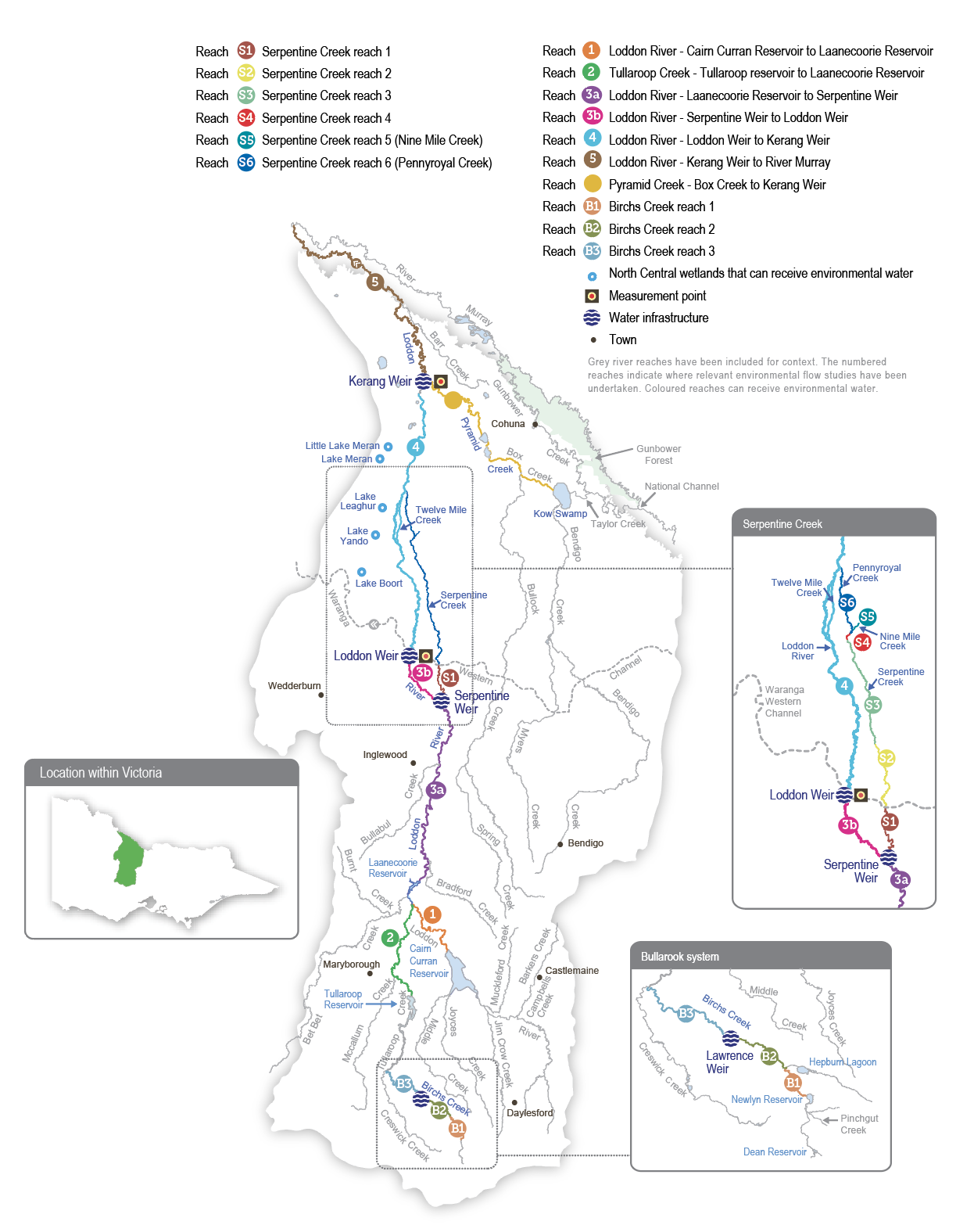

Environmental values
The Loddon River system supports platypus, rakali (water rats) and several native fish species (such as Murray cod, golden perch, silver perch, river blackfish and Murray-Darling rainbowfish). Streamside vegetation varies in condition depending on the recent water regime, the extent of clearing and historic and current land management practices. The remaining relatively intact areas support various woodland birds and other native animals. Important plant species across the system include cane grass, tangled lignum, black box and river red gum.
Although fish populations in the Loddon system are affected by the many barriers caused by weirs and reservoirs, many species are still found through the catchment. Native fish are most abundant and diverse in the upper catchment. River blackfish are found in Serpentine Creek, and Murray-Darling rainbowfish are found in the middle and lower sections of the Loddon River.
The highest-priority reach for water for the environment is from Loddon Weir to Kerang Weir. The reach does not carry irrigation water and relies heavily on environmental flows to maintain its environmental condition. Environmental flows to this reach aim to maintain water quality, increase the abundance and diversity of native fish and improve the condition of in-stream and streamside vegetation. Environmental flows are delivered to the upper Loddon River and Serpentine Creek to maintain or increase river blackfish and platypus populations.
Pyramid Creek and the lower Loddon River support large-bodied fish (such as golden perch, Murray cod and silver perch) and are important corridors for fish migration between the Loddon, Murray and Gunbower Creek systems. Engineering works to provide fish passage at the Chute and Kerang Weir on the Loddon River, Box Creek regulator on Pyramid Creek, Taylors Creek Weir on Taylors Creek, and Fish Point Weir and Little Murray Weir on the Little Murray River in recent years have been important in reopening these migration routes. The Arthur Rylah Institute has monitored fish movement and populations in Pyramid Creek and the lower Loddon River since 2017. The monitoring indicates that the combined flows in the lower Loddon River and Pyramid Creek stimulate native fish movement through the fishways.
Environmental objectives in the Loddon River system
CN1 | Maintain productive and dynamic food webs
CN2 | Maintain the diversity and abundance of biofilms
F1 | Increase the small- and large-bodied native fish populations
F2 | Provide habitat for fish to feed and breed and opportunities for movement between habitats
G1 | Enhance the channel form and features, including deep pools and benches
G2 | Maintain the condition of suitable substrate to maintain ecosystem processes
G3 | Engage flood runners, distributary channels, anabranches and backwaters
MI1 | Maintain the diversity and increase the abundance of waterbugs and waterbug functional feeding groups
PR1 | Increase the population and recruitment of platypus
PR2 | Maintain a stable rakali (water rat) population in the long term
V1 | Maintain the condition of streamside and floodplain vegetation
V2 | Maintain and increase the extent of in-stream vegetation
WQ1 | Maintain water quality to support aquatic animals and minimise the occurrence of blackwater events

Traditional Owner cultural values and uses
The Dja Dja Wurrung People (Djaara), represented by the Dja Dja Wurrung Clans Aboriginal Corporation (trading as DJAARA), and Djaara (Dja Dja Wurrung People) are recognised as the Traditional Owners in the upper part of the Loddon catchment. The Barapa Barapa and Wamba Wemba people are recognised as Traditional Owners in the lower part of the catchment.
In the upper part of the catchment, the DJAARA Kapa Gatjin (Dja Dja Wurrung water knowledge group) and the North Central CMA work together to identify opportunities and sites where environmental water can support Djaara objectives for the Loddon River. A key aspiration is for Djaara to be more involved in managing and administering environmental water, with the aim of owning and managing it in future.
In the lower part of the catchment, the Barapa Barapa and Wamba Wemba Traditional Owners communicated their cultural objectives for the Loddon River and other waterways in the Barapa Barapa Healthy Country Plan 2018-2021. Objectives that relate to the Loddon River system include:
- that all wetlands surrounding the Murray River, Gunbower Forest, Loddon River and associated lakes will have good plant life and healthy native fish (cod and yellow belly), mussels and turtle populations by 2033
- by 2033, the Murray, Gunbower and Loddon rivers and associated lakes will have enough water, their water quality is improving and the water will be clear for most of the year in good years
- Barapa people are actively involved in water management
- there are fewer fish and plant deaths from toxic blackwater events.
In planning for environmental flows in the Loddon River system, Djaara, Barapa Barapa, Wamba Wemba and the North Central CMA have considered how environmental flows in the Loddon system can be managed to support their respective cultural values, priorities and uses, which the following table summarises.
Table 5.7.1 Traditional Owner values and uses, Loddon River system
Waterway and/or reach | Traditional Owner Group | Values, uses, objectives & opportunities | How will this opportunity be considered in environmental watering in 2024-25?
Loddon River Cairn Curran to Durham Ox, Tullaroop Creek, Serpentine Creek reach 1 | - DJAARA Kapa Gatjin (Dja Dja Wurrung water knowledge group) | - Environmental water management helps preserve historical and contemporary values held highly by the Dja Dja Wurrung, including promoting a sense of place and spiritual connection.  - The Loddon River is included in the Dja Dja Wurrung Country plan.  - The Dja Dja Wurrung Traditional Owners are interested in seeing species that were more abundant within peoples’ living memory return to the river, including platypus, turtles and yabbies.  - Restoring a natural flow regime and improving water quality are overall cultural aspirations of the Dja Dja Wurrung for waterways management. | - Flows that are designed to support species of cultural value.  - Kapa Gatjin and the North Central CMA have been working to identify opportunities and sites where environmental water can support the Dja Dja Wurrung’s aspirations for the Loddon River. Further work is required.  - Environmental water management helps preserve values held highly by Traditional Owners, including native fish, turtles and potentially crayfish (yabbies).
Loddon River Durham Ox to the Little Murray River, Serpentine Creek, Pyramid Creek | - Barapa Barapa & Wamba Wemba (Water for Country Steering Committee) | - Healthy plant and fish life (Murray cod, golden perch) and other aquatic life (turtles and mussels).  - Active involvement in water management on Country.  - There are sites and artifacts of cultural significance (such as scar trees, campsites, meeting places and burial places) throughout the Loddon and Pyramid system and its floodplain, as well as food and fibre sources. | - Flows designed to support food and fibre species of cultural value and facilitate cultural activities.  - Environmental water management helps preserve values held highly by Traditional Owner Groups, including native fish, turtles and potentially crayfish (yabbies).
Increasing the involvement of Traditional Owners in managing environmental flows and progressing opportunities towards self-determination in the environmental watering program is a core commitment of the VEWH and its program partners. This is reinforced by legislation and policy commitments, including the Water Act 1989, the Victorian Aboriginal Affairs Framework, the 2016 Water for Victoria, the 2022 Water is Life: Traditional Owner Access to Water Roadmap, and, in some cases, agreements under the Traditional Owner Settlement Act 2010.

Social, recreational and economic values and uses
Consistent with the 2016 Water for Victoria water plan and the Victorian Water Act 1989, waterway managers must consider shared benefits in environmental water and its planning. Shared benefits may be intrinsic or secondary opportunistic benefits, including economic, social, indigenous cultural, recreational and environmental benefits that arise from storing, delivering and using water.
The Loddon River system and Boort wetlands provide a diverse range of social, recreational and economic values. Recreation and tourism activities include camping, fishing, powered and non-powered boating, water sports, bird watching and hunting.
In planning the potential environmental watering actions in Table 5.7.2, the North Central CMA considered how environmental flows could support values and uses, including:
- water-based recreation (such as fishing, powered and non-powered boating, water skiing and water sports)
- riverside recreation and amenity (such as birdwatching, bushwalking, camping and cycling)
- community events and tourism (such as water skiing competitions at Bridgewater and associated visitation)
- socioeconomic benefits (such as diverters for domestic and stock uses, local and regional economic benefits from increased visitation and ecosystem services, including carbon storage, groundwater recharge and nutrient recycling).
Planned environmental flows may be modified to align with a community benefit so long as environmental outcomes are not compromised. The Bridgewater Weir pool is a nationally recognised waterskiing location, with national competitions held annually. The North Central CMA will work with Goulburn-Murray Water to manage the delivery of low flow rates and the timing of freshes over summer/autumn to support optimum conditions for these annual water skiing competitions, where possible. This is acknowledged in Table 5.7.2 with the following icon (as explained in Figure 1.2.3).
 | Watering planned to support water sports activities (e.g. canoeing, kayaking, rowing, swimming, water skiing)

Scope of environmental watering
The term ‘environmental watering’ refers to the active delivery of held environmental water to support particular environmental objectives by altering the flow in a river or water level in a wetland. While other terms are sometimes used to describe the delivery of environmental water, ‘environmental watering’ is deliberately used here and in seasonal watering statements to ensure consistency in the legal instruments that authorise the use of environmental water in Victoria.
Table 5.7.2 describes the potential environmental watering actions in 2024-25, their expected watering effect (that is, the intended physical or biological effects of the watering action) and the longer-term environmental objectives they support. Each environmental objective relies on one or more potential environmental watering actions and their associated physical or biological effects.
Table 5.7.2 Loddon River system potential environmental watering actions, expected effects and environmental objectives
Potential environmental watering action | Expected watering effects | Environmental objectives
Loddon River (targeting reach 4)
Winter/spring low flow (50-100 ML/day during June to November)¹ | At 50 ML/day:  - A low flow will provide a minimum level of continuous flow through the reach and maintain water quality and adequate depth in pools to provide habitat for aquatic plants, waterbugs, fish and rakali (water rats)  At 100 ML/day:  - Increase the water depth for fish, platypus and rakali (water rat) dispersal (especially for male juvenile platypus) to colonise new breeding territory in winter and provide foraging habitat  - Prevent silt and fine sediment from settling on submerged wood and other hard surfaces  - Inundate a variety of habitats to increase the growth of biofilms and support waterbug productivity  - Inundate native fringing bank vegetation to support seed germination and growth and prevent the encroachment of exotic terrestrial plants in the river channel | CN1  F1  G2  MI1  PR1  V1  V2
Winter/spring low flow trial(s) (one to three trials of 100-200 ML/day for 10 to 30 days during June to November if triggered by an unregulated flow event) | - Prolong the period that fish can move longitudinally through and between reaches to access new habitat | F2
Winter/spring high flow (one high flow of 400-450 ML/day for 10 days² during August to November) | - Provide sufficient velocity to scour accumulated sediment from pools and scour biofilms, promoting the growth of new biofilms and increasing waterbug productivity  - Flush accumulated organic matter from the bank and benches to increase productivity and reduce the risk of a blackwater event in summer  - Wet the banks to promote the recruitment and growth of streamside and emergent vegetation  - Stimulate native fish movement and breeding | CN1  CN1  F1  F2  G1  G3  MI1  V1  V2  WQ1
Summer/autumn low flow (50 ML/day during December to May) | - Maintain an adequate depth in pools for aquatic plants and to provide habitat for waterbugs, fish and rakali (water rats)  - Provide a continuous flow through all reaches  - Maintain water quality throughout most of the reach, except the Loddon River west branch, during warm weather  - Wet the banks and shallow riffles to support the growth of in-stream and fringing non-woody vegetation | F1  MI1  PR2  V1  V2  WQ1
Summer/autumn low-flow trial (50-100 ML/day for six weeks during December to May) | - Maintain water quality and mitigate against a hypoxic blackwater event in the Loddon River west branch  - Prevent the emigration of native fish species due to poor water quality | F2  WQ1
Summer/autumn freshes (three freshes of 100 ML/day for three days during December to May) | - Increase the water level to promote seed germination and the growth of fringing emergent macrophytes  - Increase connectivity between deep pools to promote the local movement of fish and prompt the dispersal of juvenile platypus in autumn  - Generate sufficient force to flush fine sediment and old biofilms from submerged wood and other hard surfaces, promoting the growth of new biofilms and increasing waterbug productivity  - Freshen water quality and reoxygenate pools | CN1  CN2  F2  MI1  PR1  V1  WQ1
Autumn high flow (one high flow of 400 ML/day for six days³ during March to April) | - Trigger and facilitate the upstream movement of golden perch, silver perch and Murray cod older than one year  - Facilitate the dispersal of juvenile platypus  - Generate sufficient force to flush fine sediment and old biofilms from submerged wood and other hard surfaces, promoting the growth of new biofilms and increasing waterbug productivity | CN1  CN2  F2  G2  MI1  PR1
Year-round fresh (trigger-based, 100-200 ML/day for three to five days as required)  Triggers:  - dissolved oxygen level below 5 mg/L  - low or cease-to-flow river conditions  - high water temperatures | - Destratify pools and improve water quality (increase oxygen levels) along the river in reach 4, ensuring there is adequate oxygen to support aquatic animals (such as native fish and platypus) | WQ1
Pyramid Creek and Loddon River (targeting reach 5)
Year-round low flow (90-300 ML/day at Box Creek regulator) | At 90 ML/day:  - The low flow will maintain connectivity between pools, maintain water quality at a level that can support fish and macroinvertebrates and provide habitat for aquatic animals  At 200 ML/day:  - Increase longitudinal connectivity to allow native fish and platypus to access new habitats  - Improve water quality by reducing salinity levels  - Increase the wetted area to maintain and promote the growth of fringing emergent (non-woody) vegetation along the lower banks of the channel  At 300 ML/day:  - Facilitate greater movement for large-bodied native fish  - Increase hydrodynamic diversity and improve the quality of flowing habitats | F1  MI1  PR1  V1  WQ1
Winter/spring high flow (one high flow of 650 ML/day at Kerang Weir for 10 days⁴ during August to November)⁵ | - Trigger the migration, spawning and recruitment of native fish species, including Murray cod  - Maintain connectivity between habitats and improve water quality  - Provide sufficient energy to flush accumulated sediment from pools and substrates | F1  F2  G1  WQ1
Autumn high flow (one high flow of 650 ML/day at Kerang Weir for 10 days⁶ during March to April)⁷ | - Trigger and facilitate the upstream movement of golden perch, silver perch and Murray cod older than one year  - Maintain connectivity between habitats and improve water quality  - Facilitate platypus dispersal  - Provide sufficient energy to flush accumulated sediment from pools and substrates | F1  F2  G1  PR1  WQ1
Serpentine Creek (targeting reach 1)⁸
Winter/spring low flow (10-30 ML/day during June to November) | At 10 ML/day:  - Maintain connectivity between pools to allow the dispersal of small- to medium-bodied native fish  - Provide a sufficient flow to maintain water quality by oxygenating pools  - Maintain foraging habitat for platypus  - Maintain the wetted area to support in-stream aquatic vegetation (such as water ribbons, eel weed and milfoil)  At 20-30 ML/day:  - Maintain habitat for larger native fish and facilitate movement for aquatic animals  - Wet exposed roots, woody debris, emergent vegetation and leaf packs to provide habitat for aquatic animals  - Inundate low benches, banks and some secondary channels to help increase macroinvertebrate productivity and native fish breeding, including river blackfish breeding  - Provide flow variability to maintain the diversity of the fringing vegetation | F1  G2  MI1  PR1  V2  WQ1
Winter/spring fresh (one fresh of 40-120 ML/day for two days during August to November) | - Provide connectivity for fish and waterbugs to access different habitat areas  - Transport organic matter that has accumulated in the channel to facilitate its breakdown and incorporation into the food web, with a low risk of hypoxic blackwater  - Wet the banks to promote the recruitment and growth of streamside and emergent vegetation  At 120 ML/day:  - Maintain the channel form and scour pools  - Encourage female platypus to select nesting burrows higher up the bank to reduce the risk of a greater flow later in the year flooding burrows with juveniles in them  - Flush accumulated leaf litter from the banks and low benches to reduce the risk of blackwater events during summer | CN1  CN2  F1  G2  MI1  PR1  V2  WQ1
Summer/autumn low flow (10-20 ML/day during December to May) | At 10 ML/day:  - Provide connectivity between pools to allow the dispersal of small- to medium-bodied native fish  - Provide a sufficient flow to maintain water quality by oxygenating pools  - Maintain foraging habitat for platypus  - Maintain the wetted area to support in-stream aquatic vegetation (such as water ribbons, eel weed and milfoil)  At 20 ML/day:  - Maintain habitat for larger native fish and facilitate movement of aquatic animals  - Wet exposed roots, leaf packs and woody debris to provide habitat for aquatic animals | F1  MI1  PR1  V2  WQ1
Summer/autumn freshes (three freshes of 40 ML/day for two days during December to May) | - Maintain the channel form by inundating benches  - Generate sufficient force to flush fine sediment and old biofilms from submerged wood and other hard surfaces, promoting the growth of new biofilms, increasing waterbug productivity and replenishing the food supply for aquatic animals  - Increase connectivity between pools to promote the local movement of fish and prompt the dispersal of juvenile platypus in autumn  - Provide flow variability to maintain the diversity of fringing vegetation (such as emergent macrophytes)  - Freshen the water to improve its quality by diluting salt, reoxygenating the water and flushing poor-quality water in pools, transporting accumulated nutrients and carbon downstream | CN1  CN2  F1  G1  MI1  PR1  V2  WQ1
1 A winter/spring low flow of 50 ML per day is below the passing flow magnitude and will result in the VEWH banking passing flow savings for use in other potential watering actions.
2 The high flow of this event is planned to be delivered for 10 days, but there is an extended 10-to-14-day ramp-down period.
3 The high flow of this event is planned to be delivered for six days, but there is an extended 10-day ramp-down period.
4 The high flow of this event is planned to be delivered for 10 days, but there is an extended, 14-day ramp-down period.
5 Winter/spring and autumn freshes are planned to occur at the same time in the Loddon River and Pyramid Creek, with the peaks timed to meet at Kerang Weir. 650 ML per day is the total combined target at Kerang Weir.
6 The high flow of this event is planned to be delivered for six days, but there is an extended, 10-day ramp-down period.
7 Winter/spring and autumn freshes are planned to occur at the same time in the Loddon River and Pyramid Creek, with the peaks timed to meet at Kerang Weir. 650 ML per day is the total combined target at Kerang Weir.
8 The flow delivered from Serpentine Weir may be restricted to manage end-of-system outfalls to avoid third-party impacts until an alternate solution is found.

Scenario planning
Table 5.7.3 outlines potential environmental watering and expected water use in various planning scenarios.

Loddon River
In the Loddon River, the delivery of a continuous, year-round low flow, three summer/autumn freshes and a winter/spring high flow are high priorities in all planning scenarios to maintain habitat for native fish, platypus and native vegetation and prevent poor water quality.
A flow of 50 ML per day is preferred during summer and autumn to minimise the risk of poor water quality during warm weather. Low-oxygen incidents in recent years have highlighted the need for a fresh that can be delivered at any time to respond to poor water quality. This watering action may be delivered up to a magnitude of 200 ML per day, based on the flow rate needed to improve water quality in 2017 and 2022, and it is a high priority in all planning scenarios. Coordinated winter/spring high flows in the Loddon River and Pyramid Creek are a high priority in all planning scenarios (and achieved with natural flow in wet conditions) to trigger the upstream movement of native fish from the Murray system for feeding and breeding and to remove accumulated organic matter on the banks and benches.
In drought-to-wet planning scenarios, the winter/spring low flow will be delivered between 50-77 ML per day in July and November to create a transition flow between the warmer and cooler seasons, although it will likely be delivered towards the upper range for longer if water availability allows. Delivering the winter/spring low flow at the greater magnitude aims to improve the condition of vegetation higher up the bank, improve water quality and increase the abundance of native fish and platypus.
Fish ecologists have recommended trialling different flow rates to improve fish outcomes in the Loddon River if sufficient water is available. The first trial involves increasing the winter/spring flow to 200 ML per day after an unregulated event to improve fish passage past low-level barriers. The second trial aims to increase the summer/autumn low flow to 100 ML per day during the warmest months — likely in January and February or if hot conditions are forecast at other times — to reduce the risk of fish emigration. It will also test whether adaptive flow management can mitigate water quality issues in the mid-Loddon River. The first trial is proposed in the average-to-wet planning scenarios in response to unregulated flows or spills at Loddon Weir. The second trial may be delivered in dry-to-wet planning scenarios. Each trial will only be implemented if appropriate monitoring is in place to assess their effect and to inform adaptive management.
An autumn high flow will likely be delivered in average and wet planning scenarios to cue the movement and dispersal of juvenile golden perch and silver perch from the Murray River into the Loddon River, Pyramid Creek and Gunbower Creek. This event is intended to be coordinated with a similar flow in Pyramid Creek. It will be a high priority if it is likely that there are large numbers of young native fish in the mid-Murray system, and it is not expected to be delivered in drought conditions.

Pyramid Creek
Pyramid Creek is regionally significant for native fish. Fish populations within Pyramid Creek have increased since the Millennium Drought, and removing fish barriers means it is now a vital dispersal corridor for fish moving between the Murray River, Kow (Ghow) Swamp and Gunbower Creek. Maintaining an adequate low flow to allow fish to remain in Pyramid Creek all year (including during the non-irrigation season) and delivering high flows to cue and facilitate fish movement at key times of the year are high priorities in all planning scenarios.
Modelling conducted as part of the FLOWS study indicates that maintaining a low flow of at least 200 ML per day throughout the year in Pyramid Creek is optimal for resident fish populations, but a flow of about 90 ML per day should provide minimum habitat requirements. Operational flow during the irrigation season usually provides a flow of about 300 ML per day, and water for the environment will likely be used to maintain a flow of 200 ML per day for as long as possible during the irrigation shutdown period.
The winter/spring high flow in Pyramid Creek has a target flow rate of 650 ML per day at Kerang Weir to cue and facilitate fish movement between the Murray River and the Loddon system during their breeding season. It is a high priority in all planning scenarios and requires coordinated releases in Pyramid Creek and reach 4 of the Loddon River. A similar-sized event in autumn is recommended for the dry-to-wet planning scenarios when large numbers of juvenile fish are likely to migrate from the Murray River into the Loddon system. The autumn high flow may also facilitate the dispersal of juvenile platypus in years following successful spring breeding.

Serpentine Creek
In Serpentine Creek, the main priority will be to maintain a low flow throughout the year to provide habitat for native fish, waterbugs, rakali (water rats) and platypus and to deliver freshes to improve water quality, allow fish and platypus movement and improve the condition of streamside vegetation. These flows are needed in all planning scenarios but will likely be delivered at the lower end of the recommended range to avoid inundating private property at the end of the system. Lower-magnitude flows are expected to maintain connectivity between habitats but will not provide as much habitat complexity for aquatic plants and animals as environmental flows delivered at the upper end of the recommended range.
Carryover of 3,000 ML is prioritised into 2025-26 in the drought planning scenario. If conditions are drier, this water will ensure delivery of the priority winter/spring high flow in the Loddon River. No carryover targets are set in the dry-to-wet planning scenarios, as early-seasonal allocations in 2025-26 are likely to be sufficient to meet winter/spring high-flow environmental flow demands.
Table 5.7.3 Loddon River system environmental watering planning scenarios
Planning scenario | Drought | Dry | Average | Wet
Expected conditions | - Negligible contributions from unregulated reaches and tributaries of the Loddon River  - Consumptive water deliveries in the irrigation season (but not in reach 4)  - Combined volume in storages above 60 GL | - Small inflows from unregulated reaches and tributaries of the Loddon River contributing to low flow  - Consumptive water deliveries in the irrigation season (but not in reach 4) | - The natural flow will provide a low flow and multiple freshes, most likely in winter/spring  - Consumptive water deliveries in the irrigation season (but not in reach 4)  - Spills from Loddon system storages are possible | - Spills from Loddon system storages will provide an extended-duration high flow  - Overbank flow is most likely in winter/spring
Expected availability of water for the environment | - 21,931 ML | - 24,135 ML | - 24,135 ML | - 20,576 ML
Loddon River (targeting reach 4)
Potential environmental watering – tier 1 (high priorities) | Tier 1a (can be achieved with predicted supply)
 | - Winter/spring low flow (delivered at 50-77 ML/day)  - Winter/spring high flow (one high flow)  - Summer/autumn low flow (delivered at 50 ML/day)  - Summer/autumn freshes (three freshes)  - Year-round fresh if triggered | - Winter/spring low flow (delivered at 77-100 ML/day1)  - Winter/spring high flow (one high flow)  - Summer/autumn low flow (delivered at 50 ML/day)  - Summer/autumn low flow trial  - Summer/autumn freshes (three freshes)  - Year-round fresh if triggered | - Winter/spring low flow (delivered at 77-100 ML/day1)  - Winter/spring high flow (one high flow)  - Summer/autumn low flow (delivered at 50 ML/day)  - Summer/autumn low flow trial  - Summer/autumn freshes (three freshes)  - Autumn high flow (one high flow)  - Year-round fresh if triggered | - Winter/spring low flow (delivered at 77-100 ML/day)  - Winter/spring low flow trial, if triggered  - Winter/spring high flow (one high flow)  - Summer/autumn low flow (delivered at 50 ML/day)  - Summer/autumn low flow trial  - Summer/autumn freshes (three freshes)  - Autumn high flow (one high flow)  - Year-round fresh if triggered
 | Tier 1b (supply deficit)
 | - Summer/autumn low flow trial | - Autumn high flow (one high flow) | - Winter/spring low flow trial, if triggered | - N/A
Potential environmental watering – tier 2 (additional priorities) | - Winter/spring low flow trial, if triggered  - Autumn high flow (one high flow) | - Winter/spring low flow trial, if triggered | - N/A
Possible volume of water for the environment required to achieve objectives | - 20,500 ML (tier 1a)  - 4,900 ML (tier 1b)  - 6,500 ML (tier 2) | - 22,400 ML (tier 1a)  - 4,500 ML (tier 1b)  - 2,000 ML (tier 2) | - 22,400 ML (tier 1a)  - 2,000 ML (tier 1b) | - 14,700 ML (tier 1a)
Pyramid Creek and Loddon River (targeting reach 5)
Potential environmental watering – tier 1 (high priorities) | - Year-round low flow  - Winter/spring high flow (one high flow) | - Year-round low flow  - Winter/spring high flow (one high flow)  - Autumn high flow (one high flow)
Potential environmental watering – tier 2 (additional priorities) | - Autumn high flow (one high flow) | - N/A
Possible volume of water for the environment required to achieve objectives² | - 4,000 ML (tier 1)  - 2,000 ML (tier 2) | - 6,000 ML (tier 1)
Serpentine Creek (targeting reach 1)
Potential environmental watering – tier 1 (high priorities) | Tier 1a (can be achieved with predicted supply)
 | - Winter/spring low flow (delivered at 10 ML/day)  - Winter/spring fresh (one fresh delivered at 40 ML/day)  - Summer/autumn low flow (delivered at 10 ML/day)  - Summer/autumn freshes (three freshes) | - Winter/spring low flow (delivered at 10 ML/day)  - Winter/spring fresh (one fresh)  - Summer/autumn low flow (delivered at 10 ML/day)  - Summer/autumn freshes (three freshes) | - Winter/spring low flow (delivered at 10 ML/day)  - Winter/spring fresh (one fresh)  - Summer/autumn low flow  - Summer/autumn freshes (three freshes) | - Winter/spring low flow (delivered at 10 ML/day)  - Winter/spring fresh (one fresh)  - Summer/autumn low flow  - Summer/autumn freshes (three freshes)
 | Tier 1b (supply deficit)
 | - Winter/spring low flow (delivered at 10-20 ML/day)  - Winter/spring fresh (tier 1a fresh delivered at 120 ML/day)  - Summer/autumn low flow (delivered at 10-20 ML/day) | - Winter/spring low flow (delivered at 10-20 ML/day)  - Summer/autumn low flow (delivered at 10-20 ML/day) | - Winter/spring low flow (delivered at 10-30 ML/day)  - Summer/autumn low flow (delivered at 10-20 ML/day) | - Winter/spring low flow (delivered at 10-30 ML/day)  - Summer/autumn low flow (delivered at 10-20 ML/day)
Potential environmental watering – tier 2 (additional priorities) | - N/A
Possible volume of water for the environment required to achieve objectives | - 1,300 ML (tier 1a)  - 3,730 ML (tier 1b) | - 1,430 ML (tier 1a)  - 2,500 ML (tier 1b) | - 1,300 ML (tier 1a)  - 3,500 ML (tier 1b) | - 1,160 ML (tier 1a)  - 3,500 ML (tier 1b)
Priority carryover requirements for 2025-26 | - 3,000 ML | - N/A
1 A winter/spring low flow of less than 77 ML per day can be delivered in dry conditions to reflect natural inflows.
2 Pyramid Creek is supplied by Murray River storages, not Loddon River storages.

5.7.2 Boort wetlands

System overview
The Boort wetlands are on the floodplain west of the Loddon River, below Loddon Weir. They consist of temporary and permanent freshwater lakes and swamps: Lake Boort, Lake Leaghur, Lake Yando, Little Lake Meran and Lake Meran. Together, the Boort wetlands cover over 800 ha. Numerous other wetlands in the district are not currently managed with water for the environment.
The natural watering regimes of wetlands throughout the broader Loddon system have been substantially modified by the construction of levees and channels across the floodplain and by constructing and operating reservoirs and weirs along the Loddon River. Water is delivered to the Boort wetlands through Loddon Valley Irrigation Area infrastructure.
The availability of water for the environment for the Boort wetlands is closely linked to water available for the Loddon River system. Channel capacity constraints sometimes limit the ability to deliver water for the environment to the wetlands. The VEWH and the North Central CMA work with the storage manager (Goulburn-Murray Water) to best meet environmental objectives within capacity constraints.

Environmental values
The Boort wetlands provide habitat for a range of plant and animal species. At Lake Yando, 12 rare plant species have been recorded, including the jerry-jerry and water nymph. Bird species recorded at Lake Boort, Lake Leaghur and Lake Meran include the white-bellied sea eagle, Latham’s snipe and eastern great egret. Little Lake Meran is a swampy woodland with black box trees on the higher wet margins and river red gums fringing the waterline.
Environmental objectives in the Boort wetlands
A1 | Increase the size and diversity of the native frog population, including by enhancing breeding opportunities
B1 | Support a high diversity of wetland birds by enhancing feeding and breeding conditions
F1 | Increase the large and small-bodied fish populations
T1 | Maintain the freshwater turtle population, in particular Murray River turtles
V1 | Rehabilitate and increase the extent of emergent and aquatic vegetation (aquatic herblands, tall marsh), intermittent swampy woodland and riverine chenopod woodland
V2 | Maintain the health and restore the distribution of river red gums and associated understorey species
V3 | Maintain the extent and restore the health of black box vegetation on the fringes of the wetlands
V4 | Maintain the extent of the culturally significant spiny flatsedge, which can be used for basket weaving

Traditional Owner cultural values and uses
In planning for environmental flows in the Boort wetlands, the North Central CMA works with Barapa Barapa and Wamba Wemba Traditional Owners and the Dja Dja Wurrung Clans Aboriginal Corporation (DJAARA). Lake Boort is within the Dja Dja Wurrung Registered Aboriginal Party boundary. Boort wetlands to the north of Lake Boort are on Barapa Barapa Country. Table 5.7.4 summarises Traditional Owner values and uses in the Boort wetlands.
Table 5.7.4 Traditional Owner values and uses, Boort wetlands
Traditional Owner Group | Values, uses, objectives & opportunities | How will this opportunity be considered in environmental watering in 2024-25?
Barapa Barapa and Wamba Wemba Traditional Owners | - Cultural plants and cultural practices | - Environmental water and natural flooding support the growth of culturally important plants that Barapa Barapa and Wamba Wemba Traditional Owners value and allow the continuation of cultural practices, including harvesting food, medicine and weaving plants (e.g. harvesting nardoo at Lake Yando).  - Barapa Barapa and Wamba Wemba Traditional Owners recognise the value of resources that occur on the drawdown after inundation of wetlands, providing food for animals and cultural plants (such as old man weed). This aspiration can be supported by allowing wetlands to draw down naturally after receiving water to expose mudflats. This is a consideration at Little Lake Meran, Lake Yando and Lake Leaghur.  - Having diverse habitat and vegetation responses is a priority for Barapa Barapa and Wamba Wemba Traditional Owners. They highlighted the importance of having a range of water depths across wetlands, which creates a more diverse vegetation response and results in a range of resources becoming available over a longer timeframe.  - Barapa Barapa Traditional Owners have undertaken revegetation activities as part of the Decision Support Tool Wetland Revegetation Project at Lake Leaghur. There are other opportunities to get Traditional Owners involved with monitoring and revegetation at some wetlands.  - Environmental water deliveries can be managed in the future so that the revegetated areas at Lake Leaghur are provided with an appropriate water regime (i.e. plants receive water but are not drowned) to ensure their ongoing survival and provide opportunities for natural recruitment.
 | - Cultural animals and cultural practices | - Environmental water can help preserve and improve cultural animals (i.e. totem species). Also, the delivery of environmental water will aim to ensure that culturally important animals (food sources, such as black swans) have sufficient feeding and breeding habitat to build their populations.
(continued)  Barapa Barapa and Wamba Wemba Traditional Owners | - Healthy Country | - Providing drought refuges for frogs, turtles and birds and maintaining areas with healthy habitat is a high priority for Barapa Barapa and Wamba Wemba Traditional Owners. Current conditions provide for this, but once wetlands dry out, they consider it important to ensure that water is delivered to healthy areas that elicit a good vegetation response and can support wetland animals.  - Future water for the environment actions will ensure water is present in high-priority wetlands regardless of whether natural flooding occurs., This will provide refuge habitat for waterbirds, woodland birds, turtles and frogs and ensure high-quality feeding and breeding habitat is available.
 | - Cultural heritage | - Cultural heritage artefacts are at the wetlands as they have been important gathering sites for Traditional Owners. The loss of fringing trees and changes to the natural watering regime have exposed sediments around these wetlands for prolonged periods, resulting in some cultural artefacts being uncovered.  - Delivering environmental water can support fringing red gum trees and tall marsh growth, reduce erosion at these wetlands, and help keep cultural heritage artefacts covered.
Lake Boort
Kapa Gatjin (Dja Dja Wurrung water knowledge group) | - Environmental water management helps preserve historical and contemporary values held highly by the Dja Dja Wurrung. This includes promoting a sense of place and spiritual connection. Lake Boort is a priority in the Dja Dja Wurrung Country Plan. | - The drawdown after the 2024 flood will be monitored and DJAARA and the Yung Balug family group will be given the opportunity to assess current communities of culturally significant plants.
Increasing the involvement of Traditional Owners in managing environmental flows and progressing opportunities towards self-determination in the environmental watering program is a core commitment of the VEWH and its program partners. This is reinforced by legislation and policy commitments, including the Water Act 1989, the Victorian Aboriginal Affairs Framework, the 2016 Water for Victoria, the 2022 Water is Life: Traditional Owner Access to Water Roadmap, and, in some cases, agreements under the Traditional Owner Settlement Act 2010.

Social, recreational and economic values and uses
No environmental water deliveries are planned for the Boort Wetlands in 2024-25. However, as the wetlands draw down, the North Central CMA has considered how the wetlands could support social, recreational and economic values and uses, including:
- water-based recreation (such as fishing and water sports)
- waterway recreation and amenity (such as birdwatching, camping and duck hunting)
- community events and tourism (such as attracting locals and visitors for birdwatching and hunting)
- socioeconomic benefits (such as aesthetic benefits for landholders, groundwater recharge and appropriate water levels and quality for flood mitigation, nutrient treatment and carbon storage).

Scope of environmental watering
The term ‘environmental watering’ refers to the active delivery of held environmental water to support particular environmental objectives by altering the flow in a river or water level in a wetland. While other terms are sometimes used to describe the delivery of environmental water, ‘environmental watering’ is deliberately used here and in seasonal watering statements to ensure consistency in the legal instruments that authorise the use of environmental water in Victoria.
Table 5.7.5 describes the potential environmental watering actions in 2024-25, their expected watering effect (that is, the intended physical or biological effects of the watering action) and the longer-term environmental objectives they support. Each environmental objective relies on one or more potential environmental watering actions and their associated physical or biological effects.
Table 5.7.5 Boort wetlands potential environmental watering actions, expected effects and environmental objectives
Potential environmental watering action | Expected watering effects | Environmental objectives
- No deliveries of water for the environment are planned in 2024-25

Scenario planning
Table 5.7.6 outlines potential environmental watering and expected water use in various planning scenarios.
Wet conditions in spring 2022 caused widespread flooding across the Loddon system that filled all the Boort wetlands except Little Lake Meran, which was filled with environmental water. Regular rainfall in 2023 and flooding in January 2024 topped up all wetlands in this system. All of the Boort wetlands have recommended wetting and drying regimes and, given the wetlands have had high water levels for at least 18 months they will be allowed to draw down during 2024-25, unless they are naturally flooded, to support dry-phase ecological processes.
No carryover targets into 2025-26 have been set for the Boort wetlands. Many wetlands will still be in their drawdown or drying phases, and seasonal allocations will likely be sufficient to meet expected environmental demands next year.
Table 5.7.6 Boort wetlands environmental watering planning scenarios
Planning scenario | Drought | Dry | Average | Wet
Expected conditions | - No natural inflow to wetlands  - Storages above 60 GL | - Minimal natural inflow to wetlands from local catchment run-off is possible | - Moderate inflow from local catchment run-off, but little if any inflow from nearby creeks or flood runners | - Extended durations of high flow and overbank flow from creeks and flood runners, which fill most wetlands
Expected availability of water for the environment¹ | - 21,931 ML | - 24,135 ML | - 24,135 ML | - 20,576 ML
Potential environmental watering – tier 1 (high priorities) | Tier 1a (can be achieved with predicted supply)
 | - N/A: no deliveries of water for the environment are planned in 2024-25
 | Tier 1b (supply deficit)
 | - N/A
Potential environmental watering – tier 2 (additional priorities) | - N/A
Possible volume of water for the environment required to achieve objectives | - N/A
Priority carryover requirements for 2025-26 | - N/A
1 Loddon system entitlements are shared between the Loddon River system and the Boort wetlands.

5.7.3 Birchs Creek

System overview
Birchs Creek is a tributary of the Loddon River located in the southernmost part of the catchment. The creek rises in the ranges northeast of Ballarat and flows northwest through Newlyn and Smeaton before joining Tullaroop Creek near Clunes. The lower parts of the catchment are extensively cleared, where the creek meanders through an incised basaltic valley. The creek contains a regionally significant platypus community and a vulnerable river blackfish population.
Birchs Creek is part of the broader Bullarook system, which contains two small storages — Newlyn Reservoir and Hepburn Lagoon — that provide water for irrigation and urban supply. The storages fill and spill during winter or spring in years with average or above-average rainfall. The VEWH holds water for the environment in Newlyn Reservoir but none in Hepburn Lagoon.
Birchs Creek receives tributary inflows from Rocky Lead, Langdons, Lawrence and Tourello creeks. Groundwater provides reliable baseflows to the downstream reaches of Birchs Creek in most years.
The VEWH is allocated 100 ML in Newlyn Reservoir on 1 December each year, provided that seasonal determinations in the Bullarook system are at least 20 percent. Any unused allocation from 1 December can be carried over until 30 November of the following water year, but if Newlyn Reservoir spills from 1 July to 30 November, the volume held in carryover is lost. Any water remaining on 30 November is forfeited. When seasonal determinations are below 20 percent, the VEWH does not receive an allocation, and the system’s resources are used to protect essential human needs.

Environmental values
Birchs Creek supports threatened aquatic plants, and its deep pools provide habitat for aquatic animals during dry periods. The creek contains native fish, including regionally significant populations of river blackfish and mountain galaxias, as well as flat-headed gudgeon and Australian smelt. Recent monitoring indicates that platypus are present throughout the entire creek.
Environmental objectives in Birchs Creek
F1 | Maintain the abundance and diversity of small- and medium-bodied native fish, including river blackfish, mountain galaxias, flat-headed gudgeon and Australian smelt
MI1 | Maintain the waterbug population and the diversity of functional groups to drive productive and dynamic food webs
PR1 | Maintain the platypus population
V1 | Maintain the diversity and abundance of in-stream aquatic plants
V2 | Maintain a diverse variety of native fringing plants and communities of plants growing on the water’s edge
WQ1 | Maintain water quality to support aquatic life and environmental processes

Traditional Owner cultural values and uses
Birchs Creek is on the Country of the Djaara people, represented by the Dja Dja Wurrung Clans Aboriginal Corporation (DJAARA). In November 2023, DJAARA launched its water strategy, Dhelkunyangu Gatjin: working together to heal water, setting a baring (pathway) for Djaara to work in partnership with authorities and the community to manage water for a healthy, sustainable future.
The Djaara Nation Statement in Water is Life: Traditional Owner Access to Water Roadmap 2022 and the Dhelkunya Dja (Healing Country) Country Plan 2014-2034 also describe Djaara objectives for managing water on their Country. In planning for environmental flows in Birchs Creek, DJAARA and the North Central CMA have identified the creek as a potential site for future projects. The Dhelkunya Dja: Dja Dja Wurrung Country Plan 2014-2034 can provide the foundation to identify and integrate cultural values, which Table 5.7.7 shows, into Bullarook System environmental water planning.
Table 5.7.7 Traditional Owner values and uses, Birchs Creek (all reaches)¹
Values, uses, objectives & opportunities | How will this opportunity be considered in environmental watering in 2024-25?
- Environmental water management helps preserve historical and contemporary values held highly by the Dja Dja Wurrung. This includes promoting a sense of place and spiritual connection. | - Kapa Gatjin and the North Central CMA have been working to identify opportunities and sites where environmental water can support the Dja Dja Wurrung’s aspirations for the Creek. Further work is required.
- The Dja Dja Wurrung Traditional Owners are interested in seeing species that were more abundant within peoples’ living memory return to the river, including platypus, turtles and yabbies.  - Restoring a natural flow regime and improving water quality are cultural aspirations of the Dja Dja Wurrung for waterways management. | - Environmental water helps preserve values held highly by Traditional Owner groups, including native fish, turtles and potentially crayfish (yabbies).
1 The Traditional Owner group is Kapa Gatjin (Dja Dja Wurrung water knowledge group).
Increasing the involvement of Traditional Owners in managing environmental flows and progressing opportunities towards self-determination in the environmental watering program is a core commitment of the VEWH and its program partners. This is reinforced by legislation and policy commitments, including the Water Act 1989, the Victorian Aboriginal Affairs Framework, the 2016 Water for Victoria, the 2022 Water is Life: Traditional Owner Access to Water Roadmap, and, in some cases, agreements under the Traditional Owner Settlement Act 2010.

Social, recreational and economic values and uses
Consistent with the Water for Victoria and the Water Act 1989, CMAs must consider shared benefits in environmental water and planning. Shared benefits may be intrinsic or secondary opportunistic benefits, including economic, social, Aboriginal cultural, recreational and environmental benefits arising from storing, delivering and using water.
In planning the potential environmental watering actions in Table 5.7.8, the North Central CMA considered how environmental flows could support values and uses, including:
- water-based recreation (e.g. fishing)
- riverside recreation and amenity (e.g. cycling and walking, particularly in Newlyn, Smeaton and Clunes, and improved amenity at key community spaces like Andersons Mill)
- improved water quality (e.g. domestic and stock use)
- socioeconomic benefits (e.g. increased tourism and visitation to key community spaces).

Scope of environmental watering
The term ‘environmental watering’ refers to the active delivery of held environmental water to support particular environmental objectives by altering the flow in a river or water level in a wetland. While other terms are sometimes used to describe the delivery of environmental water, ‘environmental watering’ is deliberately used here and in seasonal watering statements to ensure consistency in the legal instruments that authorise the use of environmental water in Victoria.
Table 5.7.8 describes the potential environmental watering actions in 2024-25, their expected watering effect (that is, the intended physical or biological effects of the watering action) and the longer-term environmental objectives they support. Each environmental objective relies on one or more potential environmental watering actions and their associated physical or biological effects.
Table 5.7.8 Birchs Creek potential environmental watering actions, expected effects and environmental objectives
Potential environmental watering action | Expected watering effects | Environmental objectives
Birchs Creek (targeting reach 2)¹
Winter/spring fresh (one fresh of 27 ML/day for three days during June to November) | - Maintain and support the growth and germination of streamside vegetation by increasing soil moisture and depositing sediment on the bank and benches  - Scour old biofilms and organic matter that has accumulated in the channel and cycle nutrients throughout the creek  - Improve water quality by freshening refuge pools and provide connectivity between pools for fish and platypus movement | F1  MI1  PR1  V2  WQ1
Summer/autumn freshes (three freshes of 10-15 ML/day for three days during December to May) | - Increase the water depth to maintain and support seed germination and the growth of in-stream aquatic vegetation  - Top up pools to refresh water quality (particularly oxygen levels) and enhance connectivity between pools for fish and platypus movement | F1  PR1  V1  WQ1
1 Environmental flows target outcomes in reach 3, but compliance can only be assessed in reach 2.

Scenario planning
Table 5.7.9 outlines potential environmental watering and expected water use in various planning scenarios.
Water for the environment in Birchs Creek is primarily used to deliver winter/spring freshes and summer/autumn freshes, where these are not met by the natural flow or consumptive water deliveries. The volume of available water for the environment is insufficient to deliver any other environmental flows recommended for the system.
Regular winter/spring freshes are important to cycle nutrients throughout the system and wet higher channel features to increase connectivity between habitat types for aquatic animals. Summer/autumn freshes are needed to maintain water quality in the warmer months and ensure pools do not dry out. While both watering actions are important, summer/autumn freshes may be prioritised in dry-to-average planning scenarios, if required and where allocation allows to avoid critical loss of environmental values when the system is likely under the greatest stress. Summer/autumn freshes should be delivered at the upper magnitude where possible, either by augmenting natural or consumptive flows or using water for the environment to deliver greater-magnitude freshes after one fresh has been met naturally. In the drought planning scenario, the environment is unlikely to receive its allocation in December, so carryover from 2023-24 should be used to deliver a winter/spring fresh before the water is forfeited on 30 November. Winter/spring freshes will likely be delivered naturally by reservoir spills in average and wet planning scenarios.
Table 5.7.9 Birchs Creek environmental watering planning scenarios
Planning scenario | Drought | Dry | Average | Wet
Expected conditions | - The reservoir is unlikely to spill  - Extremely low flow in winter/spring  - Limited irrigation releases due to low allocations | - Reservoir spill is possible  - Low flow in winter/spring if no spills occur  - Moderate irrigation releases | - Reservoir spills are certain in winter/spring  - Some natural flow through summer/autumn  - Groundwater contributes to baseflow throughout the year | - Reservoir spills are certain in winter/spring  - Natural flow through summer/autumn  - Groundwater contributes to baseflow throughout the year
Expected availability of water for the environment | - 100 ML (2023 carryover) | - 100-200 ML (2023 carryover and likely 2024 allocation) | - 100 ML (2024 allocation)¹
Birchs Creek (targeting reach 2)
Potential environmental watering – tier 1 (high priorities) | Tier 1a (can be achieved with predicted supply)
 | - Winter/spring fresh (one fresh for three days) | - Winter/spring fresh (one fresh for three days)  - Summer/autumn freshes (three freshes)
 | Tier 1b (supply deficit)
 | - Summer/autumn freshes (three freshes) | - N/A
Potential environmental watering – tier 2 (additional priorities) | - N/A
Possible volume of water for the environment required to achieve objectives | - 100 ML (tier 1a)  - 135 ML (tier 1b) | - 200 ML (tier 1a) | - 100 ML (tier 1a) | - 0 ML (tier 1a)
Priority carryover requirements for 2025-26 | - If the 100 ML allocation is received on 1 December 2024 and water for the environment is not required to achieve summer/autumn freshes, it will be carried over into 2025-26 for use by 30 November 2025.
1 In the average and wet planning scenarios, it is likely that Newlyn Reservoir will spill before 30 November 2023, losing the 100 ML carryover from December 2023

Section 6: Further information

6.1 Acronyms and abbreviations
AHD – Australian Height Datum (also see Glossary entry)
BGLC – Barengi Gadjin Land Council Aboriginal Corporation
CEWH – Commonwealth Environmental Water Holder
CEWO – Commonwealth Environmental Water Office
CMA – Catchment management authority
DDAC – Duduroa Dhargal Aboriginal Corporation
DEECA – Department of Energy, Environment and Climate Action
DJAARA – Dja Dja Wurrung Clans Aboriginal Corporation
EMAC – Eastern Maar Aboriginal Corporation
FPMM – First People of the Millewa-Mallee Aboriginal Corporation
FPMMAC – First People of the Millewa-Mallee Aboriginal Corporation
GL – Gigalitre (also see Glossary entry)
GLaWAC – Gunaikurnai Land and Waters Aboriginal Corporation
GMTOAC – Gunditj Mirring Traditional Owners Aboriginal Corporation
GWMWater – Grampians Wimmera Mallee Water
IVT – Inter-valley transfer
ML – Megalitre (also see Glossary entry)
RAP – Registered Aboriginal Party
RMIF – River Murray Increased Flows
RMUF – River Murray Unregulated Flows
TLaWC – Taungurung Land and Waters Council
VEWH – Victorian Environmental Water Holder
WMPP – Wimmera-Mallee Pipeline Project
WTOAC – Wadawurrung Traditional Owners Aboriginal Corporation
YYNAC – Yorta Yorta Nation Aboriginal Corporation

6.2 Glossary
Acid sulfate soils – Naturally occurring soils containing high quantities of iron sulfate. These soils are stable when inundated but can generate sulphuric acid and severe environmental impacts when exposed to air.
Adaptive management – An iterative decision-making process based on continuous learning that aims to improve outcomes over time. Also known as ‘learning by doing’.
Allocation (of water) – The specific volume of water made available against a water entitlement in a given water year. Allocation water is water that is actually available to use or trade in any given year, including new allocations and carryover.
Australian Height Datum (AHD) – Height above sea level.
Azolla – A native aquatic fern that grows in waterways in dense patches. Its presence usually indicates high levels of nutrients.
Bank erosion – The wearing away of the banks of a stream or river, as distinct from erosion of the bed.
Bank slumping – When a coherent mass of loosely consolidated materials or rock layers that form part of the river bank moves a short distance down a slope. Bank slumping is usually associated with bank erosion.
Bankfull flow – A flow of sufficient size to reach the top of the riverbank, with little flow spilling onto the floodplain.
Biodiversity – The variety of plant and animal species in a particular habitat or environment.
Biofilm – A slimy film of bacteria, other microbes and organic materials that covers underwater surfaces including rocks and snags.
Blackwater – A natural occurrence caused by the breakdown of organic matter in a waterway leading to discolouration. Sometimes the breakdown of organic matter can deplete oxygen in the waterway. When the depletion is severe, fish and other animals that breathe underwater can die, and this is referred to as hypoxic blackwater.
Brackish (water) – Water that is moderately salty but not as salty as seawater. It may result from the mixing of seawater with freshwater, as in estuaries.
Carryover – Allows entitlement holders to retain ownership of unused water allocated or purchased from the current season into the following season, according to specified rules.
Catchment management authority (CMA) – A Victorian statutory authority responsible for the integrated planning and coordination of land, water and biodiversity management in a designated catchment and land protection region. Victoria’s CMAs are listed in section 6.3 under Contact details.
Cease-to-flow – The period in which there is no discernible flow in a river and partial or total drying of the river channel.
Commonwealth Environmental Water Office – The office that manages water entitlements recovered by the Commonwealth Government through a combination of investments in water-saving infrastructure, water purchases and other water-recovery programs. The entitlements are held by the Commonwealth Environmental Water Holder.
Community – In the context of this plan, engagement with community refers to a group of people who live in the same geographical area or have a shared background, interest, affiliation or membership.
Confluence – The point where a tributary joins a larger river (called the main stem) or where two streams meet to become the source of a river of a new name.
Consumptive water – Water owned by water corporations or private entitlement holders held in storages and actively released to meet domestic, stock, town and irrigation needs.
Country – Aboriginal culture revolves around relationships to the land and water. For Traditional Owners, Country is a part of who they are, just as they are a part of it. Country must be respected. Traditional Owners of Country are authorised to speak for Country and its heritage.
Diadromous fish – Fish that migrate between freshwater and saltwater to complete specific parts of their life cycle.
Deficit in supply – The situation when the available volume of water for the environment is insufficient to meet identified requirements to deliver water for the environment.
Drawdown – Water released or allowed to evaporate from a dam, reservoir or wetland to lower the water level. Drawdowns in storages are usually done for operational or maintenance purposes and may be done in wetlands to support specific ecological outcomes.
Ecological vegetation class – A standard unit for classifying vegetation types in Victoria based on floristic, structural and environmental features.
En route (water) – Water that has been released from a storage and is moving downstream to meet an urban, irrigation or operational need.
Environmental flows study – A scientific study of the flow requirements of a particular river and/or wetland system that is used to inform decisions about the management and allocation of water resources.
Environmental objective – A measurable environmental outcome sought from deliberate management actions (such as the delivery of water for the environment) in a particular system. An environmental objective may take years or even decades to achieve.
Environmental water – Water available under environmental entitlements that is actively managed to maintain the health of rivers and wetlands.
Environmental watering – The active delivery of environmental water to support particular environmental objectives by altering the flow in a river or the water level in a wetland.
Environmental water entitlement – A legal right to take and use water to maintain an Environmental Water Reserve or improve the environmental values and health of a water ecosystem. It covers an environmental entitlement, environmental bulk entitlement, water share, section 51 or take and use licence or supply agreement.
Environmental water management plan – A plan developed by a waterway manager setting long-term environmental objectives and the necessary water regime to support those objectives.
Estuary – A partially enclosed body of water along the coast where freshwater from rivers and streams meets and mixes with saltwater from the sea.
Expected watering effect – A physical, chemical, biological or behavioural effect expected from a potential watering action. Each potential action will have one or more expected watering effects.
Fishway – A series of pools built like steps to enable fish to travel past an artificial obstruction like a dam or weir.
Fledging – The stage at which a young bird grows feathers, becomes independent and can fly and leave its nest.
Flow component – A component of a river system’s flow regime that can be described by its size, timing, frequency and length, for example, cease-to-flow and overbank flow.
Fresh – A small increase in the size of a flow over a short length of time within a river. A fresh can occur in any season and usually lasts from several days to a few weeks.
Geomorphology – The scientific study of landforms and the processes that shape them.
Gigalitre (GL) – One billion litres of water or a thousand megalitres.
Groundwater – Water held underground in the soil or in pores and crevices in rock.
Headwater – A tributary stream of a river close to or forming part of its source.
Headworks system – A collection of water storage infrastructure (such as reservoirs, diversion weirs and channels) that supports the harvest and distribution of water within one or more catchment regions.
Held environmental water – A component of the environmental water reserve that is ’held’ in storage to allow water holders to plan for its use and delivery, as opposed to a component of the environmental water reserve that is not held in storage (such as passing flows and unregulated flows).
Heritage river – A river listed under the Heritage Rivers Act 1992 and part of a river and river catchment area in Victoria that has significant nature conservation, recreation, scenic or cultural heritage attributes.
High-reliability entitlement – A legally recognised, secure entitlement to a defined share of water. Water shares are classed by their reliability, which is defined by how often full seasonal allocations are expected to be available. Allocations are made to high-reliability water shares before low-reliability shares.
Hydrology – The study of the properties of water and its movement in relation to land.
Inter-valley transfer – The transfer of water between river systems to meet demands as a result of water trade between river systems.
Irrigation release – The release of water for irrigation purposes.
Juvenile – A stage of life at which an animal or plant is not yet fully mature.
Land manager – An agency or authority responsible for conserving natural and cultural heritage on public land including parks and reserves (such as Parks Victoria and DEECA).
Low flow – A relatively stable, sustained flow in a river, generally being its minimum natural level for that season.
Low-reliability entitlement – A legally recognised, secure entitlement to a defined share of water. Allocations are made to high-reliability water shares before low-reliability shares.
Macroinvertebrate (also called a waterbug) – An aquatic animal without a backbone that can be seen with the naked eye. Worms, snails, mites, bugs, beetles, dragonfly larvae, shrimps and freshwater crayfish are all macroinvertebrates.
Macrophyte – An aquatic plant that is either emergent or growing out of the water (such as phragmites), submergent or growing under the water (such as ribbon weed) or floating (such as floating pondweed).
Managed release – A deliberate release of stored water for the environment to deliver a potential watering action and associated environmental outcomes.
Megalitre (ML) – One million litres of water.
Midden – A site of cultural significance where Aboriginal people left the remains of their meals and other domestic waste.
Millennium Drought – The Millennium Drought of 1997 to 2009 was the most severe drought experienced in Victoria since European settlement. The drought broke in 2010, the fifth-wettest year on record, and resulted in severe flooding in the summer of 2010-11.
Operational release – A release of water from a storage to support the operation of the water distribution system or make water available to consumptive water users.
Overbank flow – A flow event that exceeds the capacity of the river channel and inundates neighbouring floodplains.
Passing flow – A release of water from a storage to operate a river and distribution system, often to help deliver water for environmental or consumptive uses, and to maintain environmental values and provide other community benefits. The volume of a passing flow is generally determined by inflows to the storage.
Potential watering action – An environmental flow component that has been identified for a particular system in a particular year.
Program partner – An organisation responsible for delivering part of the environmental watering program. The VEWH’s program partners include Victoria’s waterway managers (catchment management authorities and Melbourne Water), DEECA, other environmental water holders, storage managers and land managers. Traditional Owners are also increasingly partnering in the environmental watering program.
Pulse – Water released to increase the size of a flow for a short length of time, usually to cue an ecological response like triggering the movement of fish.
Ramsar-listed (site) – A site (such as a wetland) that is listed as internationally significant under the Convention on Wetlands of International Importance signed in Ramsar, Iran, in 1971.
Reach – A section of a river, generally defined in an environmental flows study.
Recreational values – The objectives and benefits that recreational users and community members associate with the use of waterways for recreational activities. They include wellbeing and enjoyment derived from social interaction, physical activity and relaxation associated with activities like sporting events, fishing, waterskiing, rowing, paddling, camping, walking and gathering with friends and family.
Recruitment – The process where individuals are added to a population, such as when plants and animals mature from their early life stages to breeding ages.
Regional catchment strategy – A long-term environmental strategy for a catchment management region developed to guide the collective efforts of government, organisations and communities to protect and improve the health of the land, water and biodiversity resources. Catchment management authorities lead the development of these strategies, but the planning belongs to the community.
Regional waterway strategy – An eight-year strategy prepared by a waterway manager for the rivers, wetlands and estuaries in its catchment. It is the single regional planning document for waterways in the area.
Remnant vegetation – Patches of native trees, shrubs and grasses remaining after disturbance (such as by land clearing).
Return flow – The part of a delivery of water for the environment that flows back into the river channel or out the end of a river system and is available for use further downstream. Return flows may be captured and stored for later reuse, but they are more commonly used as the water moves downstream.
Riffle – A shallow section of stream where water flows at a higher velocity, turbulence increases and the surface is disturbed.
Riparian vegetation – Plants that grow along the banks of waterways, in the zone between the waterway and the land next to it.
Seasonal watering plan – The VEWH’s annual operational document describing potential actions to deliver water for the environment across Victoria in the coming water year.
Seasonal watering proposal – An annual proposal outlining the regional priorities for using water for the environment in each water year that waterway managers submit to the VEWH to consider for its seasonal watering plan.
Seasonal watering statement – An authorised statement issued from the VEWH to allow a CMA or Melbourne Water to apply water from specific environmental entitlements to deliver the watering actions specified in the seasonal watering plan.
Self-determination – The United Nations Declaration on the Rights of Indigenous Peoples describes self-determination as the ability for Indigenous people to freely determine their political status and pursue their economic, social and cultural equity based on their own values and way of life. This means that Traditional Owners have the right to make choices that best reflect them on their journey to self-determination and self-governance.
Shared benefits – Benefits achieved when water is managed primarily to meet the needs of the entitlement holder, but secondary environmental, Traditional Owner, recreation or social benefits are also provided without requiring additional water.
Shared risk – A risk associated with the environmental watering program that is shared by two or more agencies and that requires coordinated management by more than one agency.
Slackwater habitat – An area of a river or stream with little or no current. The area may be immediately downstream of an obstruction like a rock or at the margins of the channel, and it is often an important place for waterbugs, fish larvae and small-bodied fish.
Spawning – The process of fish releasing eggs and sperm to reproduce.
Stakeholder – An organisation, group or individual with an interest in the environmental watering program. Program partners engage with stakeholders when they are planning or delivering water for the environment or reporting on the outcomes of the watering.
Storage manager – An authority appointed by the Minister for Water to operate major water storages in a river basin to deliver water to entitlement holders.
Terrestrial vegetation – Land-based plants.
The Living Murray program – The intergovernmental program that holds an average of 500,000 ML of water for the environment each year to use at six iconic sites along the Murray River.
Tier 1 – Potential actions to deliver water for the environment that are required this year to achieve intended environmental objectives, given current environmental conditions and the planned strategies to deliver water for the environment under each climate scenario.
Tier 1a – The subset of tier 1 watering actions that the waterway manager proposes to deliver with the predicted supply under each climate scenario.
Tier 1b – The subset of tier 1 watering actions that the waterway manager does not expect to be able to deliver if the available supply is exhausted on tier 1a actions.
Tier 2 – Potential watering actions that are generally not required every year to achieve the intended environmental objectives but are needed over the long term. When a seasonal watering plan is being developed, these actions are not considered necessary to deliver in the current year under specific climate scenarios. They are, however, likely to be necessary in coming years, and they may be delivered in the current year to take advantage of operational circumstances or if environmental conditions change.
Trade – see Water trading
Traditional Owners – People who, through membership of a descent group or clan, are responsible for caring for particular Country. A Traditional Owner is authorised to speak for Country and its heritage.
Tributary – A smaller river or creek that flows into a larger river.
Unregulated (entitlement) – An entitlement to water declared during periods of unregulated flow in a river system, usually when high rainfall causes river flow to exceed consumptive and system storage demands.
Unregulated flow – A natural streamflow that cannot be captured in a major reservoir or storage.
Victorian Environmental Water Holder (VEWH) – The independent statutory body responsible for holding and managing Victorian water for the environment entitlements and allocations.
Victorian environmental watering program – The overarching program for planning and delivering water for the environment and involving all program partners.
Water Act 1989 – The legislation that governs water entitlements and establishes how Victoria’s water resources are managed.
Water entitlement – The right to a volume of water that can usually be stored in a reservoir and taken and used under specific conditions and the right to receive water allocations, depending on resource availability.
Water allocation – See Allocation (of water).
Waterbug – See Macroinvertebrate.
Water for the environment – Water available for environmental purposes, including entitlements held by the VEWH, passing flows and unregulated flows.
Water trading – The process of buying, selling or exchanging rights to water. A water trade can be a permanent transfer of ownership of a water entitlement or the trade of an annual water allocation. The Minister for Water sets rules for water trading in Victoria. The term ‘trade’ used in the seasonal watering plan refers to the purchase, sale or transfer of annual water allocation.
Water year – The twelve-month period from 1 July to 30 June used for allocating, managing and reporting the use of water entitlements.
Waterway manager – The agency or authority (regional CMAs or Melbourne Water) responsible for the environmental management of a catchment or waterway.
Waterway – A river, wetland, creek, floodplain, estuary or other body of water.

6.3 Contact details
For further information about the Seasonal Watering Plan 2024-25, please contact the VEWH.

Victorian Environmental Water Holder
Ground floor, 8 Nicholson Street, East Melbourne, Victoria 3002
PO Box 500, East Melbourne, Victoria 3002
(03) 9637 8951
general.enquiries@vewh.vic.gov.au
www.vewh.vic.gov.au
For specific information about each system and details about specific seasonal watering proposals, please contact the relevant waterway manager.

Corangamite CMA
64 Dennis Street, Colac, Victoria 3250
PO Box 159, Colac, Victoria 3250
1800 002 262
info@ccma.vic.gov.au
www.ccma.vic.gov.au
East Gippsland CMA
574 Main Street, Bairnsdale, Victoria 3875
PO Box 1012, Bairnsdale, Victoria 3875
(03) 5152 0600
reception@egcma.com.au
www.egcma.com.au

Glenelg Hopkins CMA
79 French Street, Hamilton, Victoria 3300
PO Box 502, Hamilton, Victoria 3300
(03) 5571 2526
http://www.ghcma.vic.gov.au
www.ghcma.vic.gov.au
Goulburn Broken CMA
168 Welsford Street, Shepparton, Victoria 3630
PO Box 1752, Shepparton, Victoria 3630
(03) 5822 7700
reception@gbcma.vic.gov.au
www.gbcma.vic.gov.au

Mallee CMA
Agriculture Victoria Centre, Corner Koorlong Avenue and Eleventh Street, Irymple, Victoria 3498
PO Box 5017, Mildura, Victoria 3502
(03) 5051 4377
reception@malleecma.com.au
www.malleecma.com.au

Melbourne Water
990 La Trobe Street, Docklands, Victoria 3008
PO Box 4342, Melbourne, Victoria 3001
131 722
enquiry@melbournewater.com.au
www.melbournewater.com.au

North Central CMA
628–634 Midland Highway, Huntly, Victoria 3551
PO Box 18, Huntly, Victoria 3551
(03) 5448 7124
info@nccma.vic.gov.au
www.nccma.vic.gov.au

North East CMA
Level 1, 104 Hovell Street, Wodonga, Victoria 3690
PO Box 616, Wodonga Victoria 3689
1300 216 513 or (02) 6043 7600
necma@necma.vic.gov.au
www.necma.vic.gov.au

West Gippsland CMA
16 Hotham Street, Traralgon, Victoria 3844
PO Box 1374, Traralgon, Victoria 3844
1300 094 262
www.wgcma.vic.gov.au (which includes a contact form)

Wimmera CMA
24 Darlot Street, Horsham, Victoria 3400
PO Box 479, Horsham, Victoria 3402
(03) 5382 1544
wcma@wcma.vic.gov.au
www.wcma.vic.gov.au
For specific information about the other environmental water holders in Victoria, please contact one of the following organisations.

Murray-Darling Basin Authority
33 Allara Street, Canberra City, ACT 2601
GPO Box 1801, Canberra City, ACT 2601
(02) 6279 0100 or 1800 630 114
www.mdba.gov.au

Commonwealth Environmental Water Holder
John Gorton Building, King Edward Terrace, Parkes, ACT 2600
GPO Box 858, Canberra, ACT 2061
(02) 5156 4570
ewater@dcceew.gov.au
www.dcceew.gov.au/wter/cewo
© Victorian Environmental Water Holder 2024
This work is licensed under a Creative Commons Attribution 4.0 Australia licence. You are free to reuse the work under that licence, on the condition that you credit the Victorian Environmental Water Holder (VEWH) as the author. The licence does not apply to any images, photographs or branding, including the Victorian Government logo and the VEWH logo. To view a copy of this licence, visit http://creativecommons.org/licenses/by/4.0/.
ISSN: 2203-6520 (Online)

Disclaimer
This publication may be of assistance to you, but the VEWH and its employees do not guarantee that the publication is without flaw of any kind or is wholly appropriate for your particular purposes and therefore disclaims all liability for any error, loss or other consequence that may arise from you relying on any information in this publication.

In the context of the Victorian Government commitment to self-determination for First Nations, partners in the environmental watering program are committed to strengthening the role of Traditional Owners as program partners into the future and supporting self-determination within and beyond the program.
Bunurong name for the Werribee River

