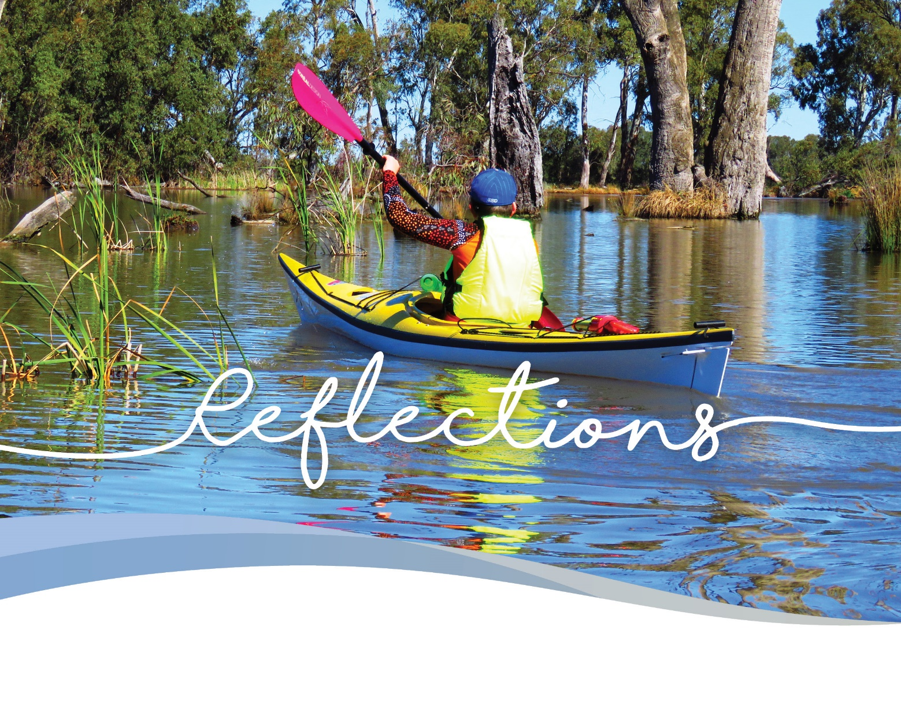

Water for the Environment in
Victoria 2018-19
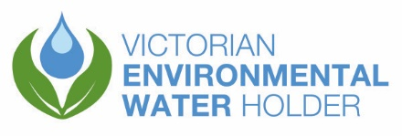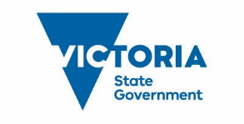

Acknowledgement of Traditional Owners
The Victorian Environmental Water Holder proudly acknowledges Victoria’s Aboriginal communities and their rich culture and pays respect to their Elders past and present.
We acknowledge Aboriginal people as Australia’s first peoples and as Traditional Owners and custodians of the land and water on which we rely. We recognise the intrinsic connection of Traditional Owners to Country, and we value their ongoing contribution to managing Victoria’s landscapes. We value the contribution of Aboriginal people and communities to Victorian life and how this enriches us.
The Victorian Environmental Water Holder recognises the intersection between environmental flow objectives and outcomes for Traditional Owners and Aboriginal Victorians. We acknowledge the ongoing contribution that Aboriginal people are making to the science, planning, managing and monitoring of environmental flows and the benefits that have resulted from these partnerships.
Stories in this edition of Reflections highlight several examples of the benefits and partnerships arising from this contribution. These, however, are only a small sample of the partnerships that are taking place.
In many regions of Victoria, Traditional Owner Nations have strong relationships with environmental watering program partners, and they are working to better realise Aboriginal Victorians’ aspirations and incorporate Traditional Owners’ objectives into environmental flow management. There are still further opportunities for the Victorian Environmental Water Holder and its partners to develop enduring partnerships with Traditional Owners who wish to participate in the management of water for the environment, and we will continue to look for these opportunities.
The Victorian Environmental Water Holder embraces the spirit of reconciliation, working towards equity and an equal voice for Traditional Owners.

Acknowledgement of program partners
The Victorian Environmental Water Holder acknowledges the significant contribution of program partners, particularly the Commonwealth Environmental Water Holder, the Murray-Darling Basin Authority and Victoria’s waterway, storage and land managers, all of which work tirelessly to improve the health of the state’s rivers, wetlands and floodplains.
Victoria’s water for the environment program is overseen and funded by the Department of Environment, Land, Water and Planning (DELWP) on behalf of the Minister for Water. It is part of the Victorian Government’s broader $222 million investment in healthy waterways and catchments.
Collaboration is a core value of the Victorian Environmental Water Holder. We have a pivotal partnership with Victoria’s waterway managers, Catchment Management Authorities (CMAs) and Melbourne Water.
The Living Murray is a joint program funded by New South Wales, South Australia, Victoria and the Commonwealth governments. Barmah Forest, Gunbower Forest, Hattah Lakes and Lindsay, Mulcra Wallpolla islands are Victoria’s four Living Murray icon sites.
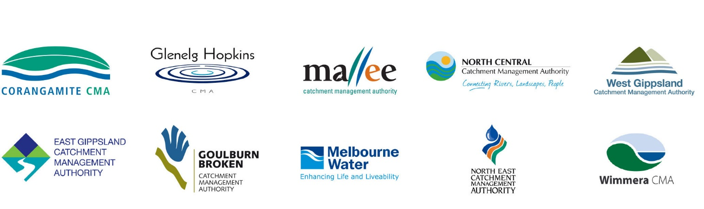

Contents
Foreword 5
Highlights of environmental watering in 2018-19 7
Victoria’s environmental watering program 10
Tools of the trade – how water trade supports environmental outcomes 19
How monitoring programs are maximising benefits for the environment
and communities 23
Gippsland region 27
Latrobe system 28
Community Highlights Lower Latrobe wetlands 30
Thomson system 32
Macalister system 33
Snowy system 34
Central region 36
Yarra system 37
Tarago system 39
Maribyrnong system 41
Werribee system 42
Moorabool system 43
Community Highlights Moorabull yulluk 44
Upper Barwon River 46
Lower Barwon wetlands 47
Western region 48
What does climate change mean for our rivers in the west? 49
Investment in metering in the western region 51
Glenelg system 53
Community Highlights Glenelg River 54
Wimmera system 56
Community Highlights Ranch Billabong 57
Community Highlights Wimmera-Mallee wetlands 59

Northern region 60
Barmah Forest 61
Gunbower Forest and Creek 62
Highlights of environmental watering across the Central Murray and Boort wetlands 65
Community Highlights Central Murray wetlands 67
Hattah Lakes 69
Lower Murray wetlands 71
Lindsay, Mulcra and Wallpolla islands 72
Community Highlights Ovens system 73
Goulburn system 75
Broken system 77
Goulburn Broken wetlands 78
Community Highlights Fishers and scientists working together to help native fish 80
Campaspe River 82
Community Highlights Coliban River 83
Loddon system 84
Community Highlights Lake Boort 86
It’s not just about adding water 87
Cohuna fish screens a win-win for community and native fish 90
Fish on the move at Koondrook Weir 92
Glossary 94
Summary of water for the environment delivery 2018-19 96

Foreword
I am proud to acknowledge the progress that Victorian water managers are making in understanding and responding to the watering needs of the environment, valuing local knowledge and increasingly, working with Traditional Owners to deliver cultural outcomes in tandem with environmental objectives.
Reflections 2018-19 relates many examples of increasing expertise in managing water under dry conditions and in the face of water security challenges such as population growth, drought and climate change. I commend that return flows are used to benefit multiple sites along the river systems of Victoria so that environmental water use is highly efficient.
Through careful water management the VEWH, their program partners, communities and stakeholders are ensuring a raft of environmental and shared benefits including: habitat protection for native fish, birds and animals in rivers and wetlands, productivity boosts to the freshwater food chain, support for native fish spawning and waterbird nesting, improved water quality, healthy conditions for fringing wetland vegetation and floodplain trees, enhanced recreational and tourism facilities and cultural values.
During autumn 2019, the benefits of efficient water management were realised in the trade of 10 GL of water allocated to the environment on the open water market in northern Victoria. This water entering the market provided additional flexibility for water users and the proceeds from the sale are being invested in projects to boost native fish populations in northern Victoria.
In June 2019, I welcomed a new Commission to the helm of the Victorian environmental watering program. Victoria’s water sector continues to reflect the diversity of the community, with the latest appointment of Victorian Environmental Water Holder (VEWH) Commissioners.
The stories in Reflections 2018-19 shine a light on the dedication and hard work of the Commissioners and staff at the VEWH, their program partners, and the communities that value and rely on waterways across Victoria. The Labor Government has invested $584 million to deliver water initiatives as a part of the state’s water plan, Water for Victoria, including a record $222 million investment for waterway and catchment health. The water management consultation, planning, implementation and monitoring supported by this investment ensures that Victorians enjoy the benefits of water for the environment.
Hon Lisa Neville
MP Minister for Water
Much of Victoria is experiencing drier than average conditions and some regions are struggling with restricted water availability. As a result, many rivers, wetlands and farming communities are under stress.
Under these conditions, like all other conditions, it is important that we are transparent in how we use water for the environment and demonstrate the benefit that it provides. Our 2018-19 Reflections articulates how we use water for the environment, what we have achieved, what we have learnt and outlines challenges in delivering water for the environment throughout the year.
We make rigorous decisions about how we can use our valuable water to optimise environmental outcomes and avoid critical loss of vulnerable and threatened species.
Environmental watering relies on the best available science and input from the communities that live, work and play near our precious waterways. At the Victorian Environmental Water Holder (VEWH), we work eagerly with our program partners to protect our river systems for the benefit of the community.
In 2018-19, the VEWH invested in two projects to improve the effectiveness of environmental watering by installation of structures in northern Victoria to enhance and protect fish movement associated with environmental watering events. This investment will also increase recreational fishing opportunities and boost tourism in
the area.
Traditional Owner involvement in the planning, management and delivery of environmental water has been a key focus of engagement in 2018-19. Watering events at Ranch Billabong and the Moorabool River were celebrated by Traditional Owners and resulted in outstanding cultural and environmental benefits.
Local community members have also contributed critical knowledge, experience and historical understanding. This local knowledge is invaluable to our seasonal watering planning and has provided opportunities for great partnerships and outcomes. For example, the local community at Lake Cullen provided insight into the historical role of Lake Cullen as a drought refuge, this critical information instigated an investigation project that led to a new watering regime for the lake, and the community saw the benefits of environmental watering flow with tens of thousands of waterbirds staying on to breed and feed.
It gives me great pleasure to present my first Reflections as Chairperson of the VEWH. I would like to acknowledge our many program partners, including waterway, storage and land managers, Traditional Owners and local communities for their tireless work in supporting Victoria’s valuable rivers, wetlands and floodplains and the plants and animals that rely on them.
Chris Chesterfield
Chairperson

Highlights of environmental watering in 2018-19
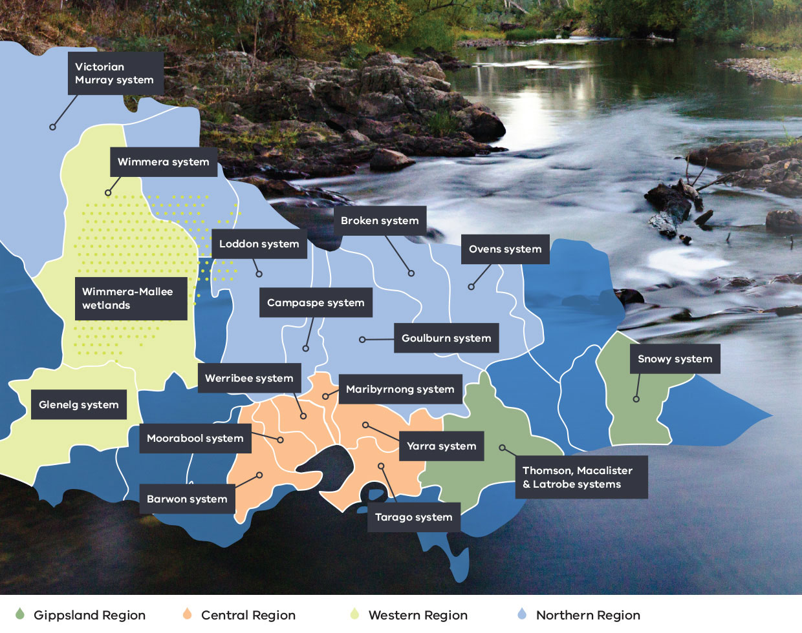

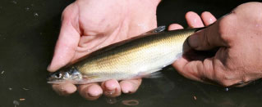

Glenelg River
A combination of water for the environment and integrated catchment management actions saw the first Australian grayling caught in the Glenelg River for 122 years. The nationally threatened species was discovered downstream of Casterton by scientists from Arthur Rylah Institute.
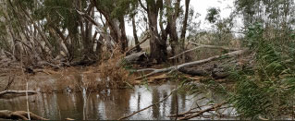

Ranch Billabong
Watering began at Ranch Billabong, identified as a priority cultural site and home to many generations of Wotjobaluk people. Monitoring before and after watering showed salinity levels in the billabong halved with frogs and waterbirds returning to the area.
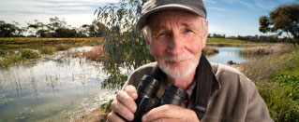

Wimmera-Mallee wetlands
Community members have been out on site at the Wimmera Mallee Pipeline Wetlands helping to monitor water for the environment deliveries! Mallee CMA delivered a citizen science workshop teaching people how to monitor birds at wetlands.
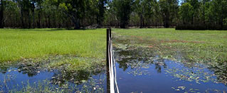

Barmah Forest
Threatened Moira grass populations flourished due to a combination of environmental watering and fenced areas which exclude grazing from feral horses and other pest animals. Moira grass is a critical wetland species providing unique environmental values within the forest.

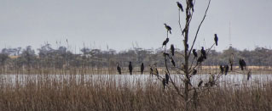

Lake Cullen
Community insights helped review the watering regime for Lake Cullen, then environmental flow deliveries made it a highly sought refuge in a dry landscape - around 30,000 waterbirds visited the site in 2018. Monitoring recorded at least 60 different species!
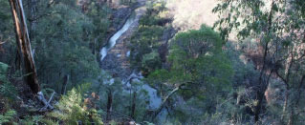

Thomson River
Construction of the Thomson River Fishway reopened the original river bed, providing connectivity and supporting passage for native fish to access more of the Thomson River for migration and spawning.
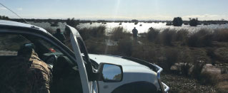

Lower Latrobe wetlands
A fantastic partnership was established between West Gippsland CMA and Sale Field & Game to undertake water quality monitoring in the Lower Latrobe wetlands. An additional five sites were monitored as a result of the partnership.
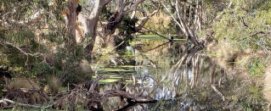

Moorabool River
The VEWH secured and released an extra 500 megalitres of water for the environment for the Moorabool River. Collaboration with program partners ensured this important delivery to improve environmental outcomes and protect Wadawurrung cultural values.
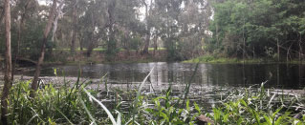

Yarra billabongs
Melbourne Water, Wurundjeri Woi-wurrung Corporation, Parks Victoria, local government and community members are developing a long-term strategy to guide management of wetlands’ environmental, cultural and social values.

Victoria’s environmental watering program
Environmental watering in Victoria is the collaborative management of water available for environmental purposes. It is used to improve the health of Victoria’s rivers and wetlands and the native plants and animals that depend on them.

The need for water for the environment
As Victoria’s population has grown, many of its rivers and wetlands have been highly modified compared to how they were managed by Traditional Owners for tens of thousands of years. Water now flows very differently through the landscape – it is captured in dams and weirs, diverted by pipelines, pumps, drains, levees and constructed channels to support towns, cities, industry and farming.
Some of our rivers give up more than a third, and sometimes half, of their water for farms, homes and businesses. Instead of flowing naturally, with high flows in winter and low flows in the hotter summer months, many rivers now run higher when water needs to be delivered for farming and urban use.
As a result, these waterways cannot function as they would naturally, so it is necessary to actively manage how water flows through them. These managed flows that are used to achieve specific environmental outcomes are called ‘water for the environment’ or ‘environmental flows’.
Water for the environment is set aside in storages and released into rivers, wetlands and floodplains to support them, the plants that grow in them and the native animals that live, feed and breed in them.
Healthy waterways support healthy communities. Healthy rivers and wetlands make cities and towns more liveable and support the physical and mental wellbeing of communities. Rivers and wetlands provide places for people to play, relax and connect with nature, and they sustain healthy Country for Aboriginal communities.
In 2018-19, the Victorian Environmental Water Holder (VEWH) coordinated the delivery of water for the environment to 90 river reaches (across 38 rivers) and 78 wetlands, totalling 168 sites across Victoria.
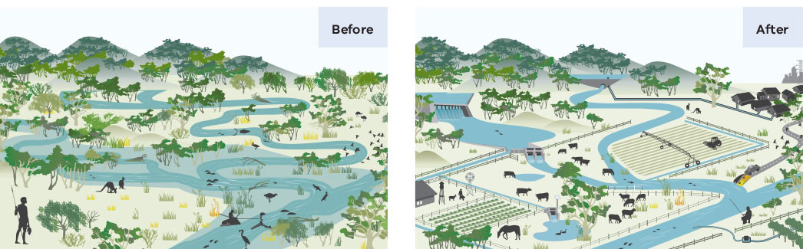

How does water for the environment work?
Water for the environment is released into rivers to mimic some of the flows that would have occurred naturally before the construction of dams, weirs and channels. This is vital to maintain the physical, chemical and biological health of rivers.
Managers of water for the environment generally focus on returning some of the small and medium sized river flows that are essential in the life cycles of native plants and animals. These flows can move sediment and nutrients through river systems, connect habitats and improve water quality.
The success of environmental watering relies on the timing, magnitude and frequency of flow – just as agriculture requires water to be applied at the right time and in the right amount. For benefits to occur, water must be released at a particular time, in a certain amount, for an adequate number of days.
The timing, duration and volume of water delivery is designed to support the plants and animals that rely on these flows. For example, fish such as Australian grayling rely on an increased river flow in autumn as it signals them to migrate downstream to release their eggs. Waterbirds require wetlands to retain water for long enough to allow their chicks to grow, and floodplain forests require inundation every few years to ensure the survival of tree species such as river red gums and black box.
Many wetlands in Victoria are now either disconnected from the rivers that used to naturally fill them or are permanently connected to rivers or channels. This means that some wetlands do not get enough water, and others get too much.
In wetlands, the aim is to mimic the natural cycles of wetting and drying on which many plants and animals depend for their diversity and long-term resilience.
For example, where wetlands and floodplains have been cut off from natural river flows, water for the environment can be used to reconnect these areas, sometimes via irrigation infrastructure (such as pumps, channels and regulators).
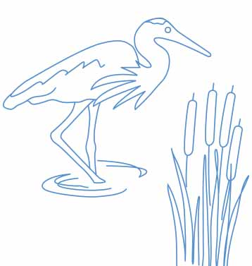

Seasonal watering plan
Every year a seasonal watering plan is developed that guides environmental watering decisions in Victoria. This provides stakeholders with a sense of what to expect during the watering year.
Environmental watering objectives and water availability may differ depending on seasonal conditions. Planning considers the range of potential seasonal conditions or water availability scenarios ranging from drought to very wet.
For a comprehensive overview of the environmental watering program and the annual Seasonal Watering Plan see the VEWH website www.vewh.vic.gov.au.
Examples of environmental watering objectives under different planning scenarios
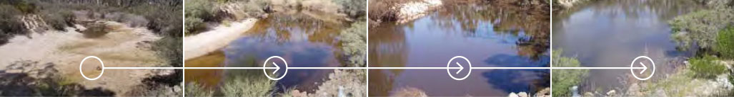
Drought | Dry | Average | Wet to very wet
Main objective: PROTECT  - Avoid critical loss  - Maintain key refuges  - Avoid catastrophic events | Main objective: MAINTAIN  - Maintain river functioning with reduced reproductive capacity  - Maintain key functions of high priority wetlands  - Manage within dry-spell tolerances | Main objective: RECOVER  - Improve ecological health and resilience  - Improve recruitment opportunities for key animal and plant species | Main objective: ENHANCE  - Restore key floodplain and wetland linkages  - Enhance recruitment opportunities for key animal and plant species

Who is involved in the Victorian environmental watering program?
The Victorian environmental watering program involves a collaboration and strong working relationships between a range of groups and organisations that are the foundation of the program.
This includes local communities, waterway managers (Victoria’s catchment management authorities (CMAs) and Melbourne Water), storage managers (largely water corporations), environmental water holders (the VEWH, Commonwealth Environmental Water Holder (CEWH) and Murray-Darling Basin Authority) and land managers such as Traditional Owner land management boards, Parks Victoria, and the Department of Environment, Land, Water and Planning (DELWP).
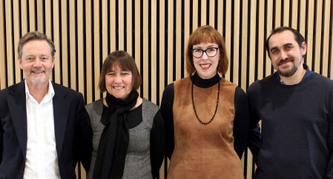
Above: VEWH Commissioners: Chris Chesterfield, Peta Maddy, Jennifer Fraser and Rueben Berg, by Zarleen Blakeley, VEWH

The Victorian Environmental Water Holder
The Victorian Environmental Water Holder (VEWH) is an independent body, established by the Victorian Government in 2011.
Set up under the Water Act 1989, the VEWH manages environmental water entitlements — the legal right to access a share of water available at specified locations to improve the environmental values and health of Victoria’s rivers, wetlands and floodplains, and the plants and animals that rely on them.
The VEWH’s operations fit within Victorian Government policies for integrated catchment and waterway management. Key policy and strategies influencing the VEWH’s operations include Water for Victoria, Victorian Waterway Management Strategy, Our Catchments, Our Communities, Protecting Victoria’s Environment – Biodiversity 2037 and Basin Plan 2012.
The VEWH works with local waterway managers to ensure water for the environment achieves the best environmental outcomes.
The role of the VEWH is to:
- make decisions about the most effective use of the environmental water entitlements, including for use, carryover or trade
- commit water and authorise waterway managers to implement watering decisions
- work with storage managers and other water holders to coordinate and optimise environmental outcomes from the delivery of all water
- commission projects to demonstrate the ecological outcomes of environmental flows at key sites and to help improve the management of water for the environment
- publicly communicate environmental watering decisions and outcomes.
The VEWH consists of four part-time commissioners and a small team. The commissioners are Chris Chesterfield (Chairperson), Peta Maddy (Deputy Chairperson), Jennifer Fraser (Commissioner) and Rueben Berg (Commissioner).

Traditional Owners
Traditional Owners and their Nations in Victoria have an enduring connection to Victoria’s waterways spanning tens of thousands of years. The VEWH and its environmental watering program partners recognise the intersection between environmental flow objectives and Aboriginal environmental outcomes and acknowledge the benefit of genuine, enduring partnerships with Aboriginal people in planning and managing water for the environment.
Traditional Owner groups are assisting with the science, planning, management and monitoring of environmental flows. For example, Barengi Gadjin Land Council Aboriginal Corporation planned for and monitored environmental flows at Ranch Billabong in the Wimmera and Dja Dja Wurrung are monitoring at Lake Boort, including recoding plant surveys and animal sightings.
The VEWH and program partners recognise and support the need to develop enduring partnerships with Traditional Owner Nations who want to participate in the management of water for the environment. The VEWH is investing in projects to identify opportunities and to better realise Aboriginal Victorians’ aspirations to incorporate Traditional Owners’ objectives into the management of environmental flows.

Scientists and local communities
To effectively manage water for the environment, it is essential to draw on the collective understanding of scientists, Traditional Owners and local communities.
Scientists provide advice about how water for the environment will best support native plants and animals. Their ongoing work to monitor, evaluate and report on the outcomes of environmental watering ensure ongoing improvements to the program.
Citizen scientists are increasingly monitoring the outcomes of environmental watering. Recreational fishers and volunteers from Birdlife Australia and Waterwatch have been collecting vital information to inform management decisions.
Local communities are often actively involved with local rivers and wetlands and bring important environmental, cultural, social and economic perspectives to the program.

Effective and efficient management
As much as possible, the VEWH seeks to meet environmental water demands (and avoid water supply shortfalls) by implementing seasonally adaptive planning and efficient use of water for the environment. This includes reuse of return flows and use of other water management tools such as carryover and trade. Other options, including working with storage managers to alter the timing and route for delivery of consumptive water, can also help to achieve environmental objectives efficiently without negatively impacting other water users.

Carryover and trade
Carryover means that water allocated in one year can be kept in storages for use in the following year, subject to certain conditions. Water trading is buying, selling or exchanging water. These mechanisms enable water for the environment to be used when and where it is most needed.
Carryover rules allow for the flexible management of water between seasons. Irrigators and environmental water holders rely on carryover to manage differences between water supply and demand in wet years versus dry years.
Since its commencement in 2011, the VEWH has bought and sold water allocation in water systems around Victoria, including the Murray, Goulburn, Loddon, Werribee, Moorabool, Wimmera-Glenelg and Maribyrnong systems.
In northern Victoria, since 2012, the VEWH has sold over 82,000 megalitres in the Murray and Goulburn systems (including 10,000 megalitres in March-April 2019) and has bought 300 megalitres in the Loddon system. (see ‘Tools of the trade’ page 17).
The VEWH’s annual Water Allocation Trading Strategy covers the trading activity that the VEWH may undertake in each region depending on priority environmental demands, weather conditions and other factors: www.vewh.vic.gov.au/watering-program/trading

Benefits to the community
There is no doubt that the beauty of Victoria’s waterways brings a sense of joy to communities. Water for the environment is for everyone, providing social, economic and recreational benefits and Aboriginal cultural benefits.
By improving the health of waterways, water for the environment supports vibrant and healthy communities sustaining towns, farms and businesses. In a recent survey, 90 percent of Victorians said they visited waterways to relax, rest and enjoy the scenery.
Healthy rivers and wetlands make cities and towns more liveable and support the physical and mental wellbeing of communities and sustain healthy Country for Aboriginal communities.
The benefits of healthy waterways include fishing, birdwatching, kayaking, bushwalking, cycling, camping, yabbying, swimming and picnicking. These activities are all enjoyed on or around Victoria’s rivers, wetlands and floodplains.
Healthy rivers help sustain recreational fishing in Victoria. Of the top 50 Victorian recreational fishing river reaches, 28 can receive water for the environment. River tour operators and canoe clubs have also been enjoying healthier rivers, getting out on environmental flows.

Community benefits snapshot

Birdwatching
Environmental flows provided great opportunities for birdwatchers across Victoria, as many waterbirds took refuge from the drought-stricken areas of New South Wales and Queensland. North Central CMA’s annual ‘Breakfast with the Birds’ event at Lake Murphy, funded by the National Landcare Program, was attended by over 70 people keen to see the many bird species that flocked to the site following environmental flow deliveries.

Canoeing
Canoe clubs, outdoor education companies, and recreational canoeists and kayakers benefit from the ideal whitewater rafting conditions created by environmental flow releases in the upper Thomson. The releases in spring 2018 were timed over the Melbourne Cup weekend to maximise the opportunity for kayakers and canoeists to take advantage of the flows.

Contemporary cultural outcomes
Environmental flows were released in the Glenelg system to support contemporary cultural outcomes on the Glenelg river at the Johnny Mullagh cricket match between the Gunditj Mirring and Barengi Gadjin Traditional owners. This helped to improve water quality in swimming holes and amenity for Traditional Owners and visitors attending the cricket event, an important cultural event held on the river.

Citizen scientists
Passionate and interested community members across Victoria assisted in monitoring outcomes of environmental flows for birds, bugs, fish and frogs as part of the VEFMAP, WetMAP and Waterwatch programs.

Lifeblood of the community
In the relatively dry western region of Victoria, the Wimmera River is a focal point for community activities and events. Environmental flows supported many community activities and events on the river in 2018-19, including water skiing at the Horsham and Dimboola weir pools, including the Kanamaroo Festival (Horsham) and Peter Taylor Barefoot Water-ski Memorial Tournament (Dimboola); rowing at Horsham and Dimboola, including the Dimboola Rowing Regatta; the Wimmera River Duck Race to raise money for Wimmera Health Care Group; the Horsham Triathlon; and the Horsham, Dimboola and Jeparit fishing competitions.

Everything and anything!
An online survey in the Mallee region asked community members what activities they undertook at wetlands and floodplains and revealed a diverse range of activities. Activities included fishing, walking, plant identification, geocaching, running, intensive exercise programs or ‘boot camps’, meditating, snorkelling, camping, picnicking, photography, mountain bike riding, yoga, canoeing and swimming. Reasons for doing so also varied, with participants stating they visited wetlands to relax or get some ‘downtime’, exercise, spend time with family and/or friends and getting away from modern life.
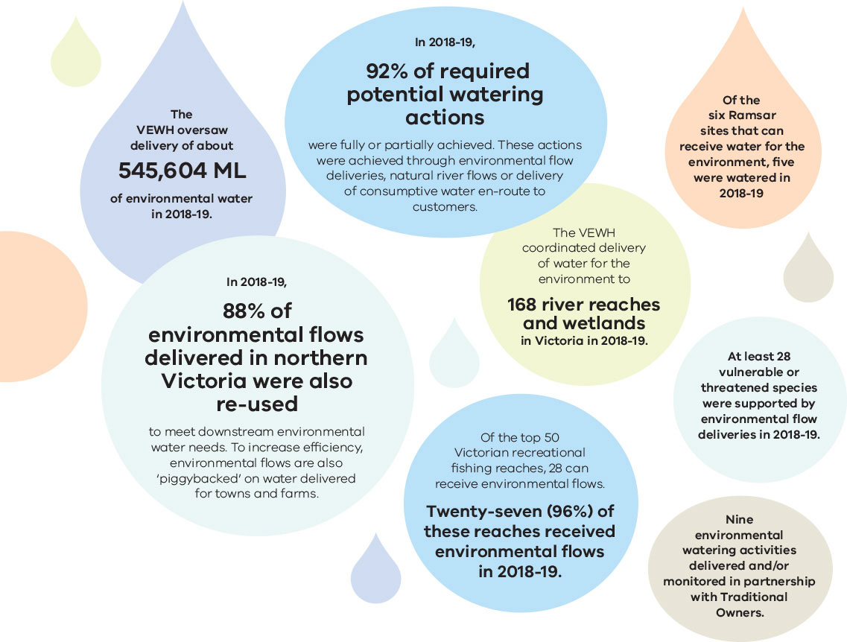

Some key statistics for 2018-19 are:
- The VEWH oversaw delivery of about 545,604 ML of environmental water in 2018-19.
- In 2018-19, 88% of environmental flows delivered in northern Victoria were also re-used to meet downstream environmental water needs. To increase efficiency, environmental flows are also ‘piggybacked’ on water delivered for towns and farms.
- In 2018-19, 92% of required potential watering actions were fully or partially achieved. These actions were achieved through environmental flow deliveries, natural river flows or delivery of consumptive water en-route to customers.
- The VEWH coordinated delivery of water for the environment to 168 river reaches and wetlands in Victoria in 2018-19.
- Of the top 50 Victorian recreational fishing reaches, 28 can receive environmental flows. Twenty-seven (96%) of these reaches received environmental flows in 2018-19.
- Of the six Ramsar sites that can receive water for the environment, five were watered in
2018-19.
- At least 28 vulnerable or threatened species were supported by environmental flow deliveries in 2018-19.
- Nine environmental watering activities delivered and/or monitored in partnership with Traditional Owners.

Tools of the trade – how water trade supports environmental outcomes
With below average rainfall across most of Victoria in 2018-19, environmental water managers were required to access many of their tools in the toolkit to help manage the impact of the dry conditions on our waterways – including water trading.
Water trading helps water users manage the ups and downs of water availability across different seasons, industries and water supply systems. Subject to affordability and physical limitations on water availability and delivery, water markets facilitate the movement of water between users to where it is needed. It provides an option that enables people to buy and sell water where it suits their business needs.
In dry conditions the VEWH’s main priority is to make sure water for the environment works to provide refuges for plants and animals, avoid critical loss of species and improve resilience in rivers and wetlands. Being able to buy or sell small volumes of water allocation can help with this.
The VEWH can buy water to help meet a shortfall in available water for the environment or sell water if it is not needed in a particular year or invest sale revenue in projects with enduring environmental benefits, such as habitat restoration, critical research or fishway construction.
Several stories in this year’s Reflections highlight the VEWH’s use of water markets and trade.

What are water markets and water trading?
Water trading is buying, selling or exchanging water allocation and/or entitlements to water.
Trade of allocation can be facilitated via established water markets, or by agreement between entitlement holders. Water markets in the irrigation supply systems in the northern region and the Murray-Darling Basin are well established and are commonly used by entitlement holders to manage water for irrigation, towns and the environment.
In other regions in Victoria, while trade is possible, there are not always well established processes. The Victorian water grid, which connects water sources within and across different regions, can provide opportunities that enable transfer or exchange of water allocation between systems.

How does the VEWH use water trade?
Decisions to trade water for the environment are made by the VEWH Commission as part of the VEWH’s standard water entitlement management. The VEWH regularly assesses its environmental demand and supply position throughout the year, considering factors such as environmental condition and demand, current and forecast climate conditions and water availability, carryover capacity and market conditions.
Subject to trading rules set by governments, the VEWH can undertake trades with a commercial value (buy or sell) and administrative transfers of water between VEWH entitlements held in different, but connected, water systems.
Administrative water transfers have no financial consideration (other than trade fees) and are used to optimise water for the environment use across Victorian systems. It provides opportunities to manage the VEWH water portfolio throughout the season and can assist in achieving the highest-priority watering actions across multiple catchments.
The VEWH can buy or sell water allocation where it is in line with the VEWH’s statutory objectives: that is, if it benefits the environment. The VEWH purchases water to meet shortfalls in water available to meet environmental demand and to mitigate risks, such as preventing the loss of threatened species. The VEWH can sell water to buy water in a different system or a future year, or to invest in knowledge, capability, adaptive/risk management, or complementary works and measures, where these projects optimise environmental watering outcomes for enduring benefit. The VEWH consults with DELWP where these projects have government policy or program implications.
Examples of investment of trade revenue include:
- Monitoring projects, such as the Lower Goulburn River Flows study to undertake bank vegetation and condition assessments before and after the delivery of inter-valley transfers (IVTs) in the lower Goulburn River in 2018-19 (see ‘Bigger is not always better – the story of Goulburn system inter-valley transfers and the environment’ page 73).
- Technical investigations, such as a model for lower Goulburn environmental flow delivery
- Works projects, such as a fishway on the Glenelg River.
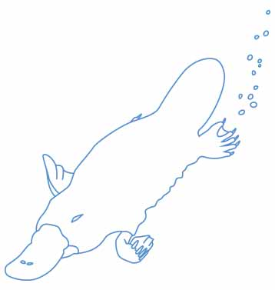

How did the VEWH use water trade in 2018-19?
Below average rainfall across large parts of Victoria and the Murray-Darling Basin created significant challenges for many water users in 2018-19, including environmental water holders.
Low on-farm rainfall across entire regions meant there was increased demands on water for irrigation, while persistent dry conditions since late 2016 meant that water availability was relatively low, particularly in New South Wales, as many storages were at their lowest levels since the Millennium drought. With only relatively small volumes of water available on the market, the price of available water rose to levels that only a few industries could reasonably afford. From an already high $250 per megalitre in July 2018, prices rose to $550 per megalitre in May 2019, creating big challenges for many prospective buyers.
In many systems, the VEWH had enough water available to meet the environmental flow requirements in such a dry year. Environmental flows were provided to selected waterways to provide drought refuge, maintain water quality and prevent potential fish deaths or other impacts on aquatic plants and wildlife (for example see ‘Challenging conditions lead to thoughtful planning in the Macalister system’ on page 31).
However, in other systems, there was not enough water available to mitigate some of the risks that arose from the lack of flow and/or rainfall. The VEWH was able to utilise water trade to help mitigate the dry conditions. The VEWH was also able to sell a small portion of water with low risk to the environment to invest in a project with long term benefits for recovery of native fish populations.
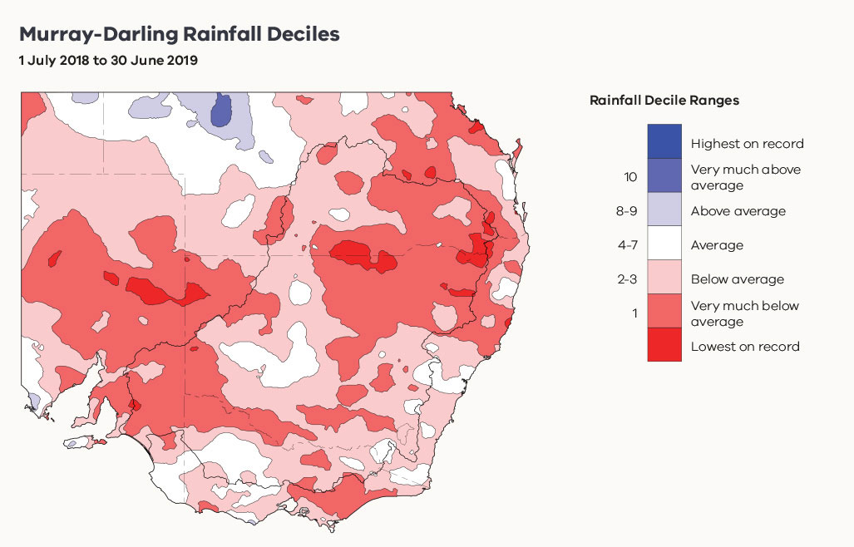
Source: Commonwealth of Australia 2019, Australian Bureau of Meteorology

Buying or acquiring water
In systems like the Moorabool and Maribyrnong Rivers in southern Victoria, the VEWH was able to acquire additional water for the environment through transfer or purchase from other entitlement holders to help mitigate the risk of fish deaths and low flows. For example, the VEWH:
- entered into a once-off exchange of 500 megalitres with Central Highlands Water to boost water availability in the Moorabool system (see ‘A small splash can have a big result’ page 41)
- bought 1,000 megalitres in the Moorabool system from Barwon Water (see ‘Making the most of a new entitlement’ page 44)
- bought 300 megalitres from licence holders in the Maribyrnong River (see ‘How do we get water for the environment in the Maribyrnong system?’ page 39).
These were great examples of where the VEWH was able to work with other entitlement holders to temporarily boost supply of water for the environment to help manage the risks of dry conditions to native fish and other aquatic animals and plants.
The VEWH also transferred water between its own entitlements to meet environmental watering demands. For example, 4,000 megalitres was transferred from VEWH entitlements in the Goulburn system to the Loddon system to help provide flows under dry conditions in the Loddon River (see ‘Continual learning along the Loddon system ensures maximum water use efficiency’ page 82).

Selling water
In February 2019, the VEWH took a decision to sell a small portion of its available water in the Murray system. The 10 gigalitres of water allocation was originally planned to support potential bird breeding in Barmah Forest but was not needed as monitoring showed only a small number of waterbirds had bred.
Assessments showed that there was enough water available to supply all foreseeable demands in the Murray system for the remainder of 2018-19, and low risk that selling the 10 gigalitres will affect the VEWH’s ability to provide necessary flows in the following year. The timing of the sale also helped support irrigators looking to purchase water to meet autumn irrigation demands and carryover into next year.
Revenue from the sale was committed to fund construction of a fishway at Koondrook Weir. The Koondrook fishway is an example of how the VEWH can sell unused water for the environment and use the revenue generated for important complementary works (see ‘Fish on the move at Koondrook Weir’ page 90).

How monitoring programs are maximising benefits for the environment and communities
It is critical that the impact of water for the environment is measured, monitored and assessed – so that we can report back to the community on what is being achieved, and so we can continue to adapt and improve our management over time to optimise outcomes. In Victoria, this occurs through large-scale, multi-site, long-term monitoring programs as well as short, immediate investigations that examine responses to environmental flows at a single wetland or river reach.
The monitoring of environmental watering in Victoria incorporates State, Commonwealth, Murray-Darling Basin and regional programs implemented by environmental scientists; some of these programs also involve community groups, citizen scientists and Traditional Owners in the collection of data and sharing of information.
The knowledge gained through this monitoring informs waterway managers about the ecological outcomes from environmental flows and helps them make more informed and responsive decisions about future watering actions, and report back on the outcomes of those actions. The monitoring and assessment programs undertaken across Victoria contribute to an environmental watering program that pursues maximum benefit for the environment and communities.
Two key monitoring programs inform the Victorian environmental watering program:
- The Victorian Environmental Flows Monitoring and Assessment Program (VEFMAP); monitoring started in 2007 and has been evolving and improving over the last 12 years. The program now focuses on answering key questions that examine effects of environmental flows on native fish and aquatic and riverbank vegetation in Victorian rivers. VEFMAP monitoring is currently conducted at 144 sites across 25 rivers.
- The Wetland Monitoring and Assessment Program (WetMAP); this program is collecting data required to identify ecological responses to water management and to understand the water regimes needed to maintain and improve wetland habitats, communities and biodiversity. There are four themes being monitored: vegetation, fish, frogs and birds. WetMAP monitoring is currently conducted at 55 Victorian wetlands.
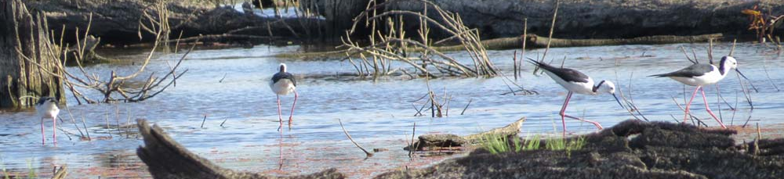
Above: Black-winged stilts at McDonalds Swamp, by ARI

Both programs are funded by the Victorian Government’s Department of Environment, Land, Water and Planning (DELWP). Scientists from the Arthur Rylah Institute for Environmental Research (ARI) design, plan and carry out the monitoring, in collaboration with university researchers, students and experienced contractors. These programs also incorporate citizen scientist involvement, which includes partnerships with anglers, BirdLife Australia and Frogs Victoria. The location of the VEFMAP and WetMAP monitoring sites is shown in Figure 1.
VEFMAP and WetMAP both focus on strong collaboration and communication between the monitoring teams, project managers and catchment management authorities. This involves regular liaison to:
- discuss with and advise managers of intended field monitoring schedules
- provide timely feedback soon after surveys regarding results and highlights
- provide advice on watering plans.
Such advice can help managers in several ways, including providing evidence to support their existing watering plans, as well as indicating where slight changes in components of watering regimes are advised.
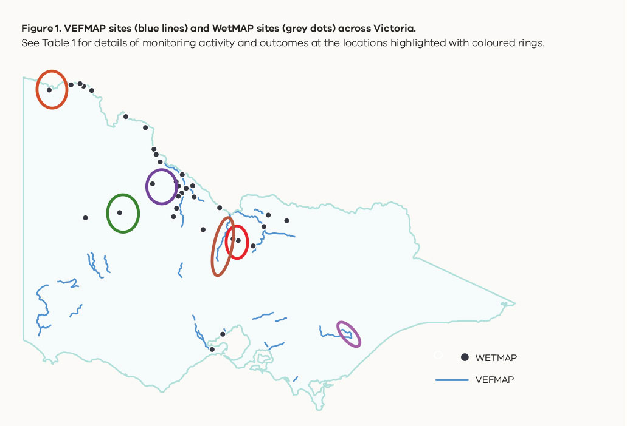

Table 1. Informing management of environmental flows through monitoring
under the WetMAP and VEFMAP programs
Neds Corner Central Wetland: timing of watering (WetMAP)
Neds Corner Central Wetland is one of many wetlands located on the Neds Corner Station Trust for Nature property adjacent to the Murray River. The first vegetation survey in 2017 revealed many Victorian rare or threatened plants. This finding informed the Mallee CMA’s decision to postpone a watering event scheduled for winter/spring 2018. Scientific advice from the WetMAP team indicated that these plants were yet to set seed and a watering event at the proposed time would have risked depleting the seedbank. Watering is now scheduled for spring/summer 2019.
Round Lake: frequency, timing and volume of watering (WetMAP)
Round Lake receives environmental water annually to maintain a population of the critically endangered Murray hardyhead, a highly salt-tolerant fish species. There are only three known populations remaining in Victoria. Recent research by ARI determined the salinity tolerance of eggs, larvae and juvenile Murray hardyhead. Based on the research findings, advice was provided to alter the way the site was being watered (i.e. frequency, timing and volume of water delivered). Recent monitoring has shown that the population has increased to the highest number in over 10 years.
Carapugna Wetland: confirmation of vegetation values and timing of watering (WetMAP)
Carapugna Wetland supports a rare example in the western region of a relatively intact black box wetland – with scattered black box trees and a diverse aquatic plant assemblage that emerges during inundation. Since WetMAP monitoring commenced, parts of the wetland have been watered annually in late winter through to late spring. Three WetMAP surveys prior to and following watering have observed many plant species of significance following watering events. Liaison between the WetMAP team and the Wimmera CMA has led to a shift in the timing of watering, which will now occur in autumn to help maintain populations of the rare ridged water milfoil.
Campaspe River: fish response to water for the environment (VEFMAP)
Monitoring of native fish and vegetation continued in the Campaspe River in 2018-19. Murray cod larvae were detected for the second year in a row along with eggs and larvae of Australian smelt, flat-headed gudgeon, carp gudgeon, redfin and carp. Population surveys conducted in autumn 2019 revealed an increase in the number of Murray River rainbowfish and young-of-year Murray cod, in comparison to 2018 surveys. These results are likely to reflect a summer reduction in inter-valley transfers of water (high flows of water from the Campaspe system to meet consumptive water demands in the Murray system), which adversely affect the survival and recruitment of young native fish.
Gaynor Swamp: frequency and duration of inundation (WetMAP)
Gaynor Swamp is part of a complex of Goulburn River floodplain wetlands of ecological significance. WetMAP monitoring commenced at Gaynor Swamp just prior to the first environmental watering event in autumn 2018 and surveys of frogs, waterbirds and vegetation have continued. The duration of inundation for this watering event was extended by an additional water allocation in early summer 2019 to increase the potential of waterbird breeding. WetMAP observations identified there was no waterbird breeding and an unwanted increase in extent of the invasive native plant typha. Due to these observations, combined with bird and frog data, Gaynor Swamp will be kept dry in 2019-20 to prevent the continued spread of the plant.
Macalister River: native vegetation response to water for the environment (VEFMAP)
The upper Macalister River ceased to flow for the first time in decades in 2018-19, due to drought. This is a likely indication of a future with lower flows and a need for well-informed management to support the environmental values within the system – particularly perennial vegetation species that may be experiencing dramatic changes in water availability. West Gippsland CMA environmental water managers were able to draw on VEFMAP/ARI staff expertise and vegetation and fish survey experience to adapt their flow management in response to the unusual flow conditions. This experience has now been incorporated into water management planning for future drought or dry conditions.
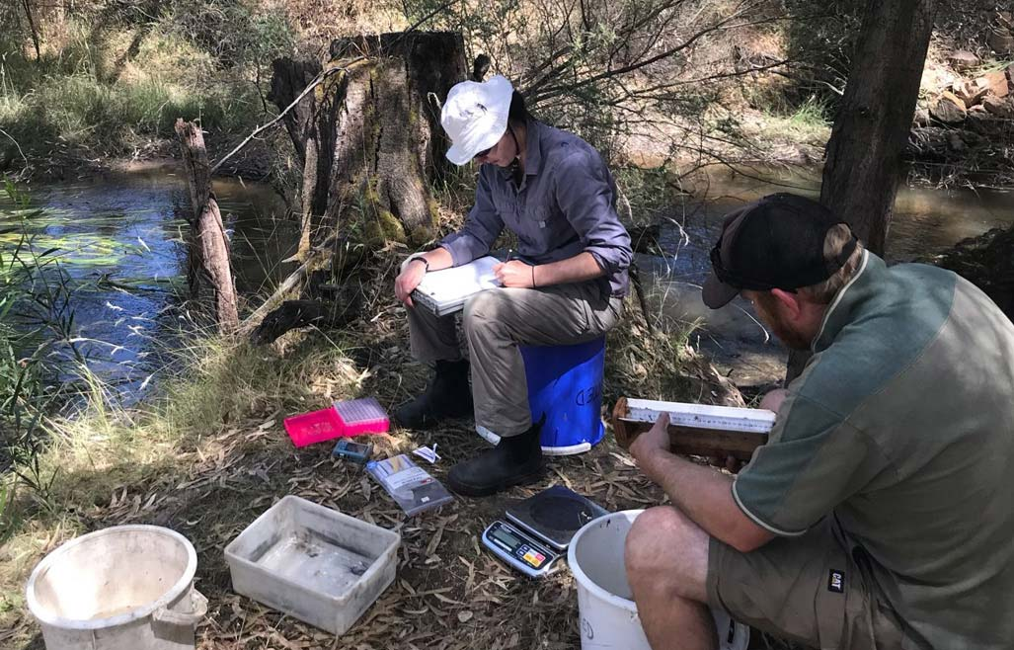
Above: Data recording at MacKenzie River and Mount William Creek, by A

Gippsland region
Great news for the migration of native fish with the opening of the new Thomson River Fishway at Horseshoe Bend. Across much of Gippsland very dry conditions continued, with water managers focussing on where and how to use available water to optimise environmental outcomes and maintain river health.
Water for the environment delivered to the Gippsland region in 2018-19 (megalitres)
Latrobe system 5,502 ML
Thomson system 12,699 ML
Macalister system 15,124 ML
Snowy system 129,400 ML
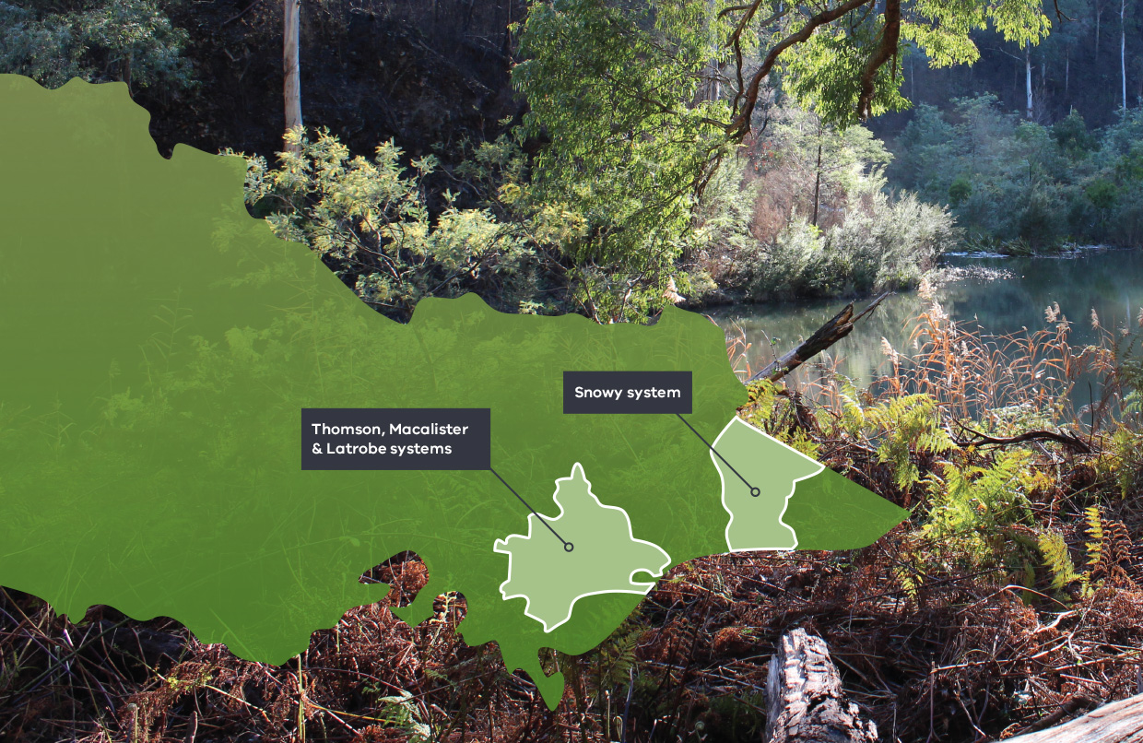

Latrobe system
Effective and efficient water use
Continually learning about the water needs of the environment and improving what we do with water for the environment are key to ensuring effective and efficient water use and maximising environmental benefits.
Recently the environmental flow recommendations for the Latrobe River, Latrobe River estuary and lower Latrobe wetlands were reviewed and updated in consultation with local community to ensure environmental flows management is using the best available knowledge and science.
Environmental Water Officer at the West Gippsland CMA, Adrian Clements, says the recent review adds to the level of knowledge involved in managing the system.
“The new recommendations take a more integrated approach to managing flows in the wider Latrobe catchment,” Adrian said.
“In 2018-19 over 5,500 megalitres of water for the environment were used in this system to protect a broad range of environmental objectives. The environmental watering program continues to improve with new knowledge and adaptive management.”
The Latrobe system includes the Latrobe River and its tributaries and the lower Latrobe wetlands. Plant and animal species of high conservation significance are found here, including several vegetation types and waterbird, fish and frog species, including the Australian grayling, dwarf galaxias and Macquarie perch. The Latrobe River also provides an essential source of freshwater to the internationally recognised, Ramsar listed Gippsland Lakes site, which includes the lower Latrobe wetlands.
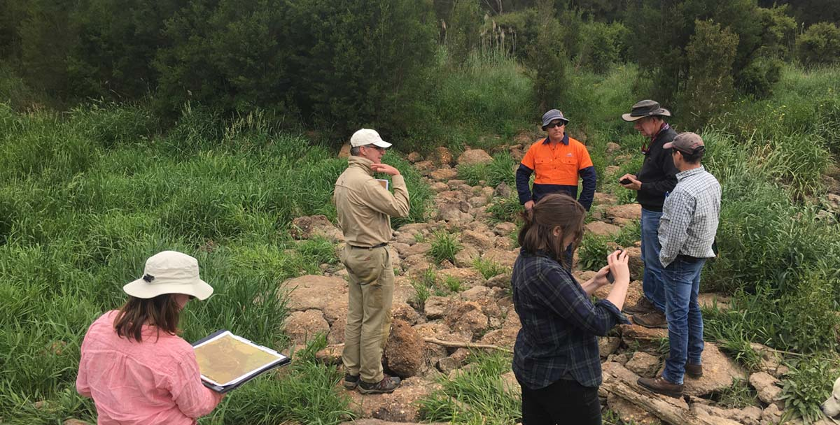
Above: Environmental Flows Technical Panel assessing a lower reach on the Latrobe River, by West Gippsland CMA

“A sound understanding of how much water is required, and under what conditions the water is needed, is essential to ensuring that environmental values are maintained or improved here. Working with a Project Advisory Group on the review ensured we could include the local community, access the necessary expertise and consult with the right stakeholders,” said Adrian.
The result of their efforts is a set of environmental flow recommendations for the West Gippsland CMA and the VEWH to use for planning environmental watering activities. The new information builds on existing knowledge and means managers are now better equipped to consider the wetlands and estuary at the end of the system when planning to release environmental flows in the Latrobe and Thomson Rivers.
Waterway manager: West Gippsland CMA
Storage manager: Southern Rural Water (Latrobe River)
Land manager: Parks Victoria and Field & Game (lower Latrobe wetlands)
Site | Volume delivered 2018-19 (megalitres)
Latrobe River | 5,502
Heart Morass | Water was diverted into Heart Morass from the Latrobe River
Sale Common | Water was diverted into Sale Common from the Latrobe River
Dowd Morass | Water was diverted into Dowd Morass from the Latrobe River

Community Highlights
  - Lower Latrobe wetlands
“A tremendous working relationship”
West Gippsland CMA manages water for the environment for the lower Latrobe wetlands, Sale Common, Heart Morass and Dowd Morass. The three wetlands are an important component of the internationally recognised Gippsland Lakes Ramsar site and provide habitat for a variety of waterbirds of state, national and international conservation significance.
They are also sites close to the heart of Sale Field & Game members, who have done extensive conservation work on the 3,000 acres of Heart Morass they manage on behalf of their members and the duck hunting community.
To assist in the decision-making process for environmental water delivery, in August 2018, Sale Field & Game were engaged to undertake monthly water quality monitoring at several sites at Heart Morass.
Sale Field & Game representative Gary Howard said, “The water quality monitoring undertaken by Sale Field & Game further entrenches our fantastic partnership with the CMA for the betterment of the wetlands.”
“Sale Field & Game have had a tremendous working relationship with West Gippsland CMA since the restoration project at Heart Morass began and we are keen to see this continue,” he said.
Results from this monitoring informs the timing of environmental water delivery.
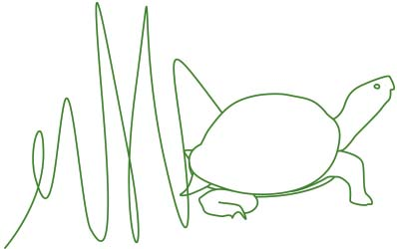

Adrian Clements, Environmental Water Officer at West Gippsland CMA, says “Initially, six sites were selected for monitoring, however at the request of the Field & Game volunteers, an additional five sites have been included in the monitoring regime. This is a significant improvement as it provides a higher resolution of water quality information from across the morass.”
“Water delivery timing and volume is the key to mitigating salinization, caused by intrusion of salt water from Lake Wellington and acidification, caused by acid sulphate soils in the morass,” says Adrian.
Heart Morass was partially filled with water for the environment between August and October 2018, and further top-ups were provided in December 2018 and March 2019 to manage acid sulphate soils. Monitoring showed that the environmental flows reduced salinity in the wetland while also inundating semi-aquatic grasses, which provided food for waterbirds.
“Through the CMA’s Water Management Program, we’ve improved it. It’s noticeable in the vegetation. There were areas there that were bare, red dirt bare.” Gary says the red colour comes from the influx of salts to the soil. “We now have areas that are improving very slowly and other areas where plants are again starting to grow quite successfully.”
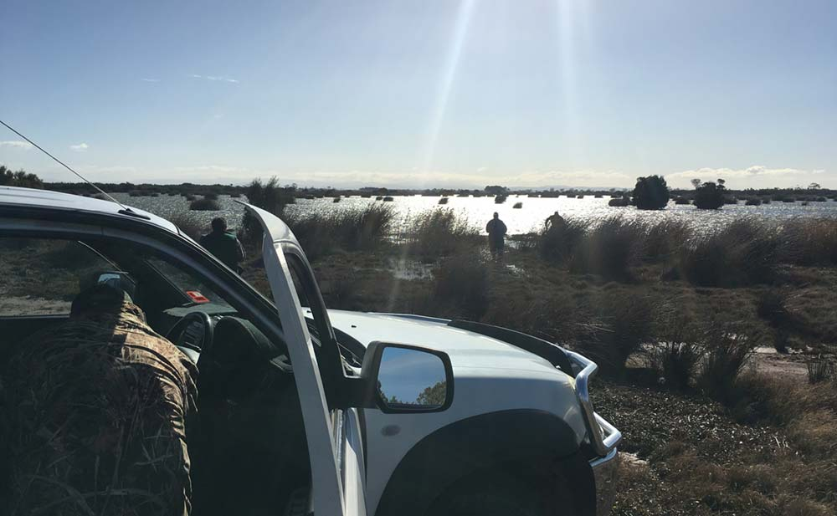
Above: Sale Field and Game measuring water quality at Heart Morass, by West Gippsland CMA

Thomson system
Helping fish move freely
Construction of the Thomson River Fishway, completed in mid-2019, at Horseshoe Bend near Walhalla in Gippsland has ensured a balance between the preservation of a heritage gold mining site and restoration of river flows and fish passage to support the region’s natural heritage.
The fishway will significantly boost the outcomes achievable from environmental flows by allowing the threatened Australian grayling and other native fish species to move further along the length of the of the Thomson River.
With a low impact design incorporating natural rock eddies and pools, the new fishway has reopened the original river bed, connecting the river above and below an historical goldmining river diversion tunnel. Water entering Horseshoe Bend on the Thomson River will be shared between the tunnel and the original riverbed (60% for the tunnel and 40% for the fishway), maintaining the heritage values of the tunnel, while simultaneously restoring river passage from the Gippsland Lakes to the Victorian Alps for the benefit of native fish.
Most migratory fish living in the Thomson River below Horseshoe Bend have been unable to move upstream due to the barrier presented by the tunnel. Fish migration is important in the lifecycle of many native fish, including the threatened Australian grayling. The fishway means fish in the Thomson River and estuary will have access to an extra 22 km of the Thomson River and 64 km of the Aberfeldy River.
The historic Horseshoe Bend Tunnel, which was built to divert the river for gold mining over 100 years ago, has been preserved. This feature is a favourite with sight seers in the picturesque Baw Baw region.
Jemima Milkins Environmental Water Resource Officer at the West Gippsland CMA is enthusiastic about the benefits of the fishway to the Thomson River.
“The combination of the fishway construction and provision of environmental flows will benefit the whole system. Connectivity has been restored and fish passage enabled.”
“This year we could not provide the autumn fresh that was initially planned for this system, due to the construction works. I am really looking forward to seeing that increased autumn flow in 2020. These flows cue the downstream migration of Australian grayling, for spawning in the estuary.”
“The fishway provides access to the upper Thomson and Aberfeldy rivers, which increases the amount of fish habitat. The more habitat available the more fish in the system, which increases the success of future fish spawning events,” Jemima said.
Waterway manager: West Gippsland CMA
Storage manager: Melbourne Water, Southern Rural Water
Site | Volume delivered 2018-19 (megalitres)
Thomson River | 12,699

Macalister system
Challenging conditions lead to thoughtful planning
Very dry conditions prevailed across much of Gippsland, including the Macalister River catchment during the 2018-19 watering year. The region experienced below average to well below average rainfall and above average temperatures for most of the year. Lake Glenmaggie, on the Macalister River, did not spill in 2018-19, which is rare for this system.
Low inflows to Lake Glenmaggie resulted in a stressed catchment and algal blooms in all sections of the lower Macalister River and irrigation channels. This lower stretch of the river is home to seven species of native migratory fish relying on access to both the freshwater reaches of the river and the Latrobe River estuary and ocean to complete their lifecycles. With such dry conditions there was a risk that flow below Maffra weir would cease completely and threaten this important fish community.
Martin Fuller, Chief Executive Officer at the West Gippsland CMA, said that conditions were challenging, and water managers needed to think laterally.
“A variation to our original water planning was required in this scenario. Using water for the environment we sustained low flows at Maffra weir to ensure that the Macalister River continued to flow; and aquatic life was maintained during the algal bloom.”
“This is a way to protect our aquatic plants and animals and allow instream vegetation to remain wetted, allow water bugs and fish to move around their habitats and maintain the water quality and critical ecological processes,” Martin explained.
“A protective flow like this also means that if the situation improves and we receive significant rain, we can alter the plan. Or if water quality diminishes, we can respond to that too. Through our monitoring we saw an improvement in dissolved oxygen levels, lowered water temperature and generally the flow sustained the health of this stretch of the river. It was a marked improvement from what was happening before the flow commenced.”
“Every season brings opportunities to learn, we are always improving our understanding of best use of water for the environment,” said Martin.
“Working with the community and our partners was particularly important in informing the appropriate responses for the conditions. Our staff worked through the implications of the changed conditions with our community-based Macalister Environmental Water Advisory Group, who endorsed the revised approach.”
Variations to water planning can be accessed through the VEWH website.
Waterway manager: West Gippsland CMA
Storage manager: Southern Rural Water
Site | Volume delivered 2018-19 (megalitres)
Macalister River | 15,124

Snowy system
Community consultation is critical
A new community based committee will guide decision making on environmental flows for the iconic Snowy River. Formed in 2018 by the NSW Government, the Snowy Advisory Committee has been tasked with providing vital community and expert input to the timing and pattern of the release of environmental flows to the Snowy River and Snowy montane rivers, to ensure their ongoing health. The committee’s advice captures ecological, technical, social and cultural considerations.
Graeme Dear, Chief Executive Officer at East Gippsland CMA is a member of the committee that also includes local community members, Aboriginal representation, environmental experts and NSW and Victorian government delegates.
“This committee is working together well and provides advice on flows based on input from a broad cross section of government and community interests in New South Wales and Victoria,” Graeme said.
Investment in environmental water recovery by the Victorian, New South Wales and Commonwealth governments has enabled up to 21% of the natural flow to be returned to the Snowy River – up from just 3% in 2002.
The East Gippsland CMA monitors the outcomes of environmental flows in the Snowy system, and utilises the information gained to provide ongoing advice through the advisory committee.
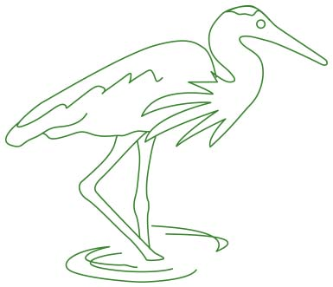

Bec Hemming, Program Manager at the CMA said, “Over the past seven years monitoring has confirmed that managed environmental flows help improve physical and ecological processes, increase ecosystem productivity and improve aquatic habitat in the Snowy River catchment. These healthy conditions are great for the plants and animals using the waterways, and for the kayakers, anglers and local communities who love it too!”
Waterway manager: NSW Department of Primary Industries, East Gippsland CMA
Storage manager: Snowy Hydro Limited
Site | Volume delivered 2018-19 (megalitres)
Snowy Rive | 129,400

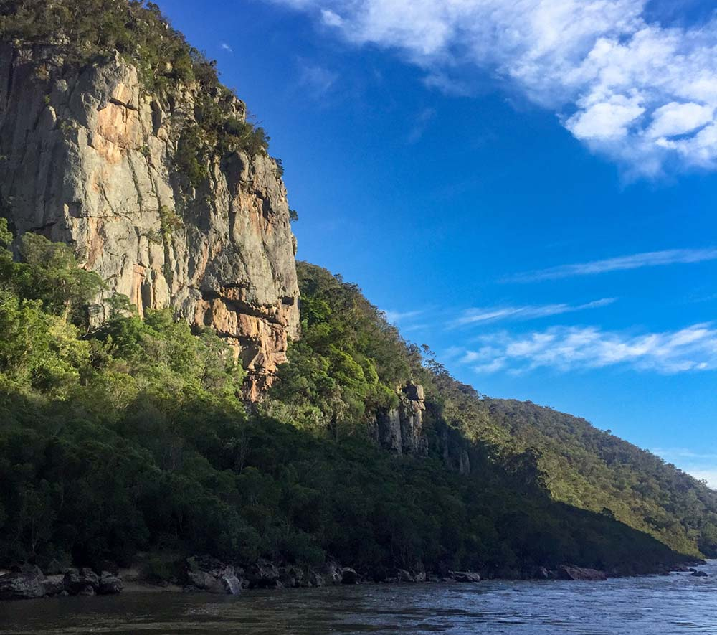
Above: Snowy River, by East Gippsland CMA

Central region
In the central region, securing extra water for the environment helped manage dry conditions along the Moorabool River, supporting biodiversity and protecting Wadawurrung cultural values. In the Tarago system, innovative long-term fish monitoring is providing crucial information to determine environmental flow deliveries.
Water for the environment delivered to the Central region in 2018-19 (megalitres)
Yarra system 16,518 ML
Tarago system 1,210 ML
Maribyrnong system 180 ML
Werribee system 793 ML
Moorabool system 2,000 ML
Barwon system 1,020 ML
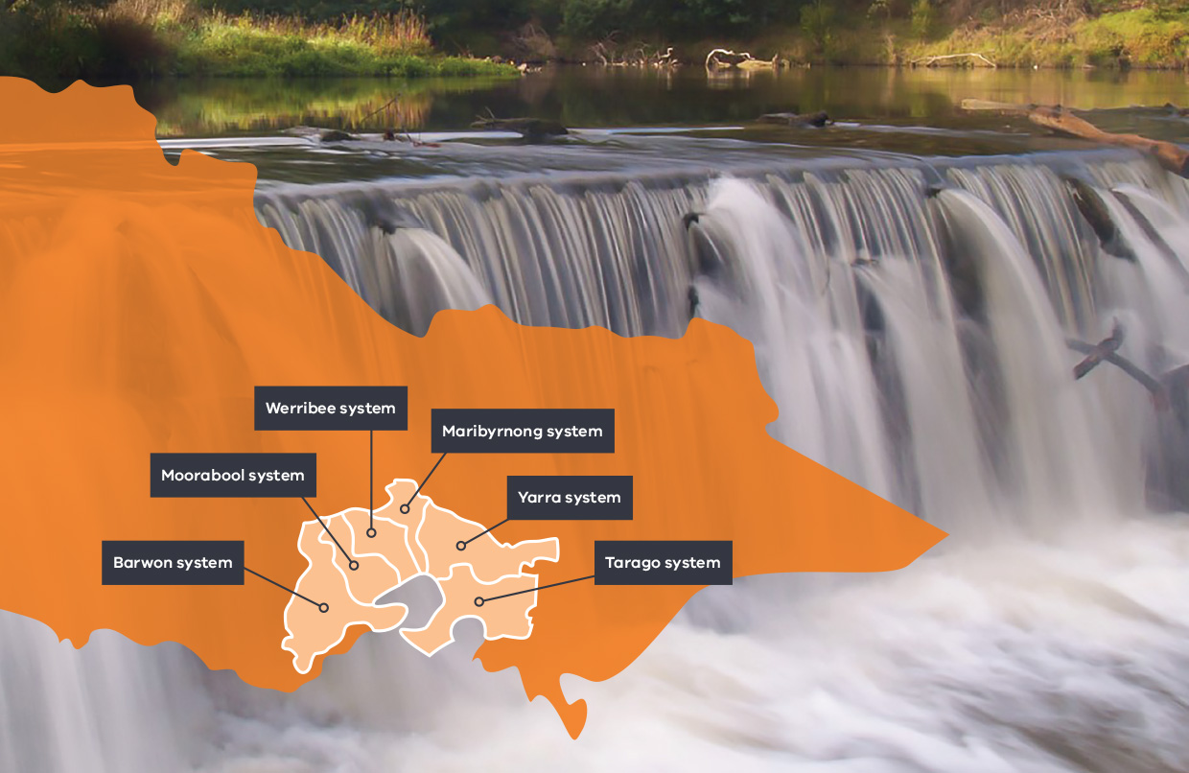

Yarra system
The bigger picture: bringing water back to the Yarra billabongs
Our billabongs need our help! There are hundreds of billabongs scattered across the Yarra floodplain that support vital ecological, cultural and liveability values, yet they face many challenges. While high flows from the Yarra River periodically fill the billabongs, changes to the river and landscape over many years have reduced how frequently this occurs. This means the billabongs do not get the water they need to be healthy.
Melbourne Water, Wurundjeri Woi-wurrung Corporation, Parks Victoria, local government and community members are developing a long-term strategy to guide management of wetlands’ environmental, cultural and social values.
As part of this initiative, Melbourne Water has trialled delivery of environmental flows to five of these wetlands over the past six years to help begin rehabilitation across the floodplain.
“Many of the Yarra Billabongs no longer fill naturally with the same frequency due to changes in the catchment,” Melbourne Water’s Environmental Water Resources Delivery Lead Sarah Gaskill said.
“Monitoring the billabong watering will help us better understand what they need to be healthy, so we can help to determine long term solutions that are self-sustaining. We are adopting a wide landscape-scale approach under our Healthy Waterways Strategy,” she said.
In 2018-19, for the first time, water for the environment was pumped into Burke Road and Willsmere billabongs to support the vegetation communities, frogs, birds and eels. Environmental flows were also delivered to Yering Backswamp to support the vegetation communities.
“It’s still early days, but in our initial observations we’ve seen successful recruitment for a range of wetland vegetation communities such as triglochin (water ribbons), which is fantastic habitat for tadpoles and could mean frogs in the future!” said Sarah.
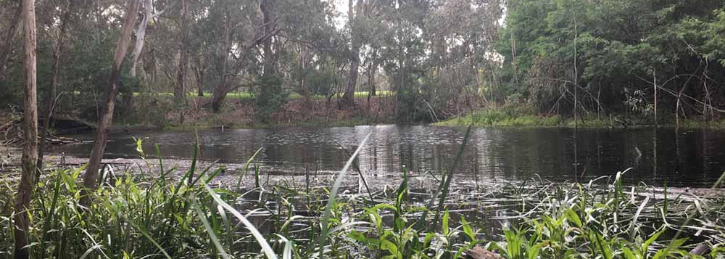
Above: Willsmere Billabong after water for the environment delivery, by Melbourne Water

Wurundjeri’s Narrap team are monitoring water quality and frogs at several billabongs on the lower Yarra River floodplain, helping to inform ongoing management strategies.
Wurundjeri’s water policy for the Yarra “Nahnbu narrun ba ngargunun twarn Birrarung” highlights the cultural links of the billabongs and strives to have them recognised and managed together as a site of environmental and cultural significance.
The wetlands are also a key feature of Melbourne’s Healthy Waterways Strategy, and Melbourne Water is working in partnership with Traditional Owners, community members and public entities on the development of the Yarra Strategic Plan. The strategic plan has a key focus on improving the overall health of the river, enhancing cultural and heritage values and increasing community use by improving access and amenity of the river and parklands.
Waterway manager: Melbourne Water
Storage manager: Melbourne Water
Site | Volume delivered 2018-19 (megalitres)
Yarra River | 16,459
Yering Backswamp | 46
Burke Road Billabong | 7
Willsmere Billabong | 6
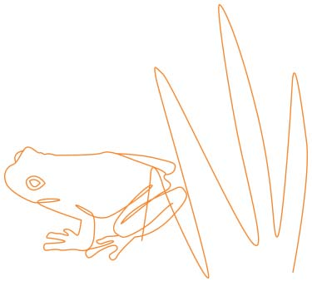

Tarago system
What do fish really get up to in the Tarago River?
Understanding the flow requirements of the Australian grayling helps water managers in delivering water for the environment to support their life cycles.
Protecting the threatened Australian grayling is a key focus of environmental flow management in the Tarago River. Environmental flows are delivered at specific times of the year to trigger Australian grayling to move and spawn.
Over the last 10 years, innovation has increased our understanding of these migratory fish, and now we are looking forward to expanding our knowledge through new technology to be installed in the Bunyip-Tarago rivers.
Arthur Rylah Institute’s Dr Wayne Koster said researchers are continually developing techniques to build knowledge on the life histories and water requirements of the Australian grayling.
“Monitoring using drift nets in the Bunyip River from 2009-2017 identified the timing and location of Australian grayling spawning, and the importance of increased flows and the timing of flow releases.
“Acoustic tracking of tagged Australian grayling in 2009, 2010 and 2015 revealed fish migrate long-distances downstream to spawn in the lower freshwater river reaches during flow increases – this has helped determine the duration of flow releases,” Wayne said.
Collaboration between researchers and water managers is vital to ensuring the most efficient and effective use of water for the environment. This long-term fish monitoring program has informed how flow requirements could be updated, especially for the downstream migration in autumn. Monitoring indicates that successful spawning can be achieved with less environmental water delivered over a shorter period.
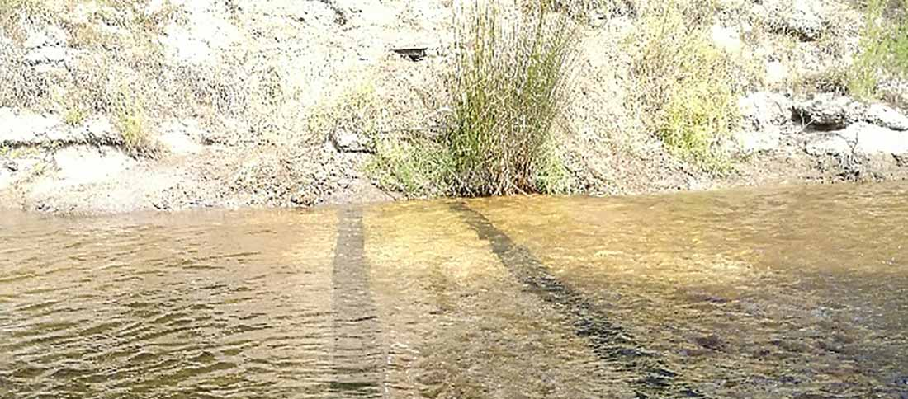
Above: PIT tag reader system in the Bunyip River, by Wayne Koster, ARI

To further understand the flow requirements of a suite of migratory species (Australian grayling, short-finned eels, tupong, lamprey), the Arthur Rylah Institute and Melbourne Water are installing three Passive Integrated Transponder (PIT) tag reader systems in the Bunyip-Tarago rivers. This monitoring system involves small tags inserted into selected fish and receiver stations mounted in the river system, which pick up signals emitted by the fish tags and provide data on fish movement.
Melbourne Water’s Environmental Water Resources Delivery Lead Sarah Gaskill said that the PIT tag readers can be remotely accessed from the comfort of an office.
“We are investing in active monitoring in the system. This will feed into our continuous improvement and adaptive management of our water delivery program. Maybe in the future we could even track the grayling visually,” she said.
Waterway manager: Melbourne Water
Storage manager: Melbourne Water
Site | Volume delivered 2018-19 (megalitres)
Tarago River | 1,210
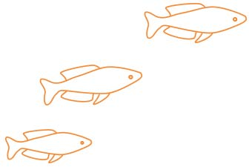

Maribyrnong system
How do we get water for the environment in the Maribyrnong system?
As with much of the state, conditions in the Maribyrnong catchment have been drier than average since 2016-17. The VEWH does not hold an environmental entitlement in the Maribyrnong system, but relies on opportunistic, temporary trade to meet demands. Each year since 2014, Melbourne Water and the VEWH have worked with local diversion licence holders to purchase unused water to support environmental outcomes.
When providing environmental flows in the Maribyrnong system, the upper reaches are targeted, Jacksons Creek below Rosslynne Reservoir, and the top section of the Maribyrnong River.
With the agreement of all parties involved, in 2018–19, water for the environment was used in autumn to prevent adverse water quality conditions and flush fine sediments from hard surfaces.
These functions are important during very low flow periods to maintain suitable habitat and food resources for small-bodied native fish, waterbugs and platypus.
The autumn watering also provided opportunities for fish to disperse through the waterway and helped support in-stream and riverbank vegetation.
Waterway manager: Melbourne Water
Storage manager:Southern Rural Water
Site | Volume delivered 2018-19 (megalitres)
Upper Jacksons Creek | 180
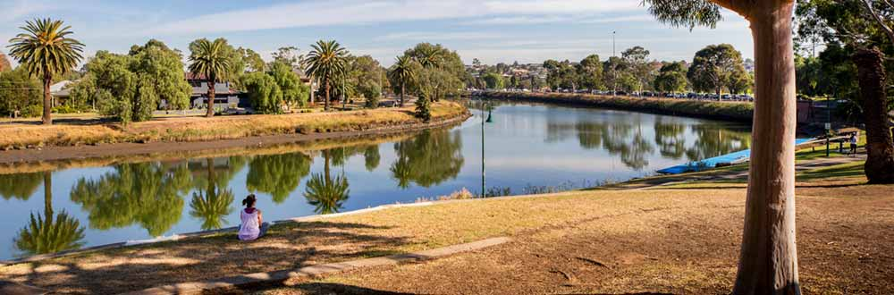
Above: Spending time by the Maribyrnong River, by Melbourne Water

Werribee system
Make way for our waterbugs
Citizen scientists are collecting crucial data on waterbugs in the Werribee River. The landmark project addresses pollution in the river and will help to inform waterway managers in using environmental flows and other tools to improve the health of the river.
Dr Teresa MacIntosh from the Werribee River Association said that waterbugs are essential to the survival of iconic species like platypus.
“A female platypus can eat up to 80 percent of her body weight in
macro-invertebrates per day, when producing milk to feed her young – called puggles! Waterbugs also provide protein in the diets of many fish, bird and other animal species. Many also have a role in cleaning up, by consuming dead and decaying organic matter that circulates in the water.”
In 2018-19, Melbourne Water released environmental flows in the Werribee River to enhance habitat for waterbugs. The water flushes silt from rocky sections of the river, allowing the bugs to access nooks and crannies where they can feed, breed and hide from predators.
“Fifty volunteers are working with a team of researchers to collect water samples and identify waterbugs from 13 sites along the Werribee River, as part of a project to uncover how pollution in the river is impacting on the ecosystem,” said Teresa.
“We have already used this data to educate local businesses about how they can improve their practices to reduce pollution in the river, and we’re excited about what we can achieve in the next year.”
Yvonne Cabuang, Project Lead - Waterwatch and Education, Customer and Strategy at Melbourne Water, says that the data also contributes to their understanding of waterway management.
“The information collected by the Werribee River Association volunteers joins data collected by Waterwatch volunteers around Victoria in the Waterwatch data portal, where it is an important resource for waterway managers planning environmental flows.”
Waterway manager: Melbourne Water
Storage manager: Southern Rural Water
Site | Volume delivered 2018-19 (megalitres)
Pyrites Creek | 290
Werribee River | 503

Moorabool system
A small splash can have a big result
To help combat dry conditions and improve river health and habitat for native fish, the VEWH secured and released an additional 500 megalitres of water for the environment for the Moorabool River.
The Moorabool is one of the most stressed rivers in Victoria. River regulation through the creation of large water storages and diversion weirs up-stream severely reduces water flows downstream. Ongoing dry conditions and low rainfall are also placing pressure on the Moorabool by compromising connectivity between pools and reducing water quality.
VEWH Co-CEO Beth Ashworth said collaboration between program partners was essential in ensuring the 500 megalitres of water for the environment could be delivered.
“We worked together with Central Highlands Water to secure the water, Barwon Water to maximise benefits through timing the release with the release of water for consumption, and the Department of Environment, Land, Water and Planning to make this happen,” said Beth.
The release was welcomed by Corangamite CMA and the Wathaurung Aboriginal Corporation who worked with the VEWH to time the delivery to coincide with a cultural event.
“The exchange is evidence of the strong regional partnership approach that exists between waterway managers and entitlement holders, and how working together can achieve positive environmental, social and cultural benefits,” said Beth.
Corangamite CMA Senior Project Officer Sharon Blum-Caon said the 500 megalitres provided some much-needed relief during dry times.
“The Moorabool river is very dependent on seasonal rainfall and given the dry conditions we were experiencing in autumn the extra 500 megalitres delivered in May made a huge difference. The water was able to help maintain habitat connection for native fish species and improve water quality for waterbugs and plants while also supporting cultural and recreational activities such as fishing, boating and birdwatching,” said Sharon.
As the 2018-19 watering year came to an end, the VEWH and Corangamite CMA worked with Barwon Water to secure another 1,000 megalitres of water for the environment for use in the Moorabool River. Waterway managers will work together to tailor the delivery of this water to enhance ecological outcomes for the Moorabool River in 2019-20.
Waterway manager: Corangamite CMA
Storage manager: Central Highlands Water
Site | Volume delivered 2018-19 (megalitres)
Moorabool River | 2,000

Community Highlights
  - Moorabull yulluk
The Moorabool River is known to the Wadawurrung people as ‘Moorabull yulluk.’ All Wadawurrung main rivers have traditional language names.
Celebrating culture and water, Wadawurrung Traditional Owners, community members, Corangamite CMA and water industry partners from agencies such as the Department of Environment, Land, Water and Planning, Central Highlands Water, Barwon Water and the VEWH met at Dog Rocks on the Moorabull yulluk to welcome the release of 500 megalitres of water for the environment.
Wadawurrung woman Melinda Kennedy said that Wadawurrung people have a strong connection to the Moorabull yulluk and traditionally caught eels as a food source.
“One of the species this water will benefit is the short-finned eel and we will celebrate this by showcasing a hand-woven ‘Buniya Binak’ (eel trap) that has been created by Wadawurrung’s Tammy Gilson.”
“Securing the water is vital for maintaining flows, filling refuge pools and linking habitats to support species survival. It also ensures locations along the Moorabool that are culturally significant for meeting, ceremony and trade are preserved,” Melinda said.
Wadawurrung held a special Welcome and Water Ceremony – ‘Yaluk Wiyn Burt.’ As part of the Ceremony, Wadawurrung presented a beautifully designed possum skin, coolamon and baby Buniya Binak to Corangamite CMA Aboriginal Water Officer Kristen Lees. And, the Buniya Binak was placed between rocks in the river under a cultural fishing permit in the hopes of catching an eel!
Above: Wadawurrung women Melinda Kennedy (left) and Tammy Gilson (right), by Kristen Lees, Corangamite CMA
“The Buniya Binak was woven from reeds collected along the river. Traditionally it was the Wadawurrung women who wove the traps and caught the eels. This is a great celebration of Wadawurrung women,” Melinda said.
“The design on the possum skin celebrates the projects and symbolises the mountains and confluences of the Moorabull and Barwon – and all the meeting places along the river banks.”
Wadawurrung and Corangamite CMA have developed a strong partnership. Through working together, they have been able to ensure that Wadawurrung Traditional Owners have a central voice in waterway management on their Country.
Recognising culturally significant places and species, and celebrating traditional practices, like the Buniya Binak, helps share knowledge, restore connections and highlight Wadawurrung culture along the river.

Upper Barwon River
Making the most of a new entitlement
A new environmental entitlement was established in April 2018, enabling water for the environment to be used in the upper Barwon River for the first time. The entitlement provides 1,000 megalitres per year on average from the West Barwon Reservoir.
The upper Barwon River is home to native fish species including the Australian grayling, river blackfish, short-finned eel, southern pygmy perch, Australian smelt and various galaxia species. The system retains some water plants, undercut banks, overhanging vegetation and riffle-pool sequences: these provide important habitat for fish and other aquatic animals.
To support the new entitlement, the Corangamite CMA updated the environmental flow recommendations for the upper Barwon River in 2019 to ensure management decisions are underpinned by the best-available science.
Traditional knowledge informed the new flow recommendation and input was provided by a representative of the Wadawurrung Traditional Owner group, to specifically consider the cultural values of the waterways in their region. For example, Wadawurrung knowledge was able to help identify culturally significant places and species, such as eels and blackfish that could be supported through targeted planning of environmental flows.
Corangamite CMA Senior Project Officer Sharon Blum-Caon said they were able to closely monitor the first environmental flow delivered in summer 2018-19.
“Experience gained from the release will be used to determine the magnitude and timing of future deliveries, as well as inform future works to clear flow restrictions, and restore functional channels and bank vegetation.”
Waterway manager: Corangamite CMA
Storage manager: Barwon Water
Site | Volume delivered 2018-19 (megalitres)
Upper Barwon River | 1,020

Lower Barwon wetlands
Getting smart with acid sulphate soils
Corangamite CMA is being careful to monitor the risk associated with acid sulphate soils and maintain an ecologically diverse wetland community while conducting a four-year wetting and drying regime at Reedy Lake.
Reedy Lake forms part of the internationally recognised Port Phillip Bay and Bellarine Peninsula Ramsar site. The wetland is a popular feeding and breeding site for thousands of bird species including the orange-bellied parrot, Australasian bittern and brolga.
“The habitat diversity within Reedy Lake and the diversity and abundance of waterbirds that can use the lake is threatened by a lack of different types of vegetation brought about by year-round flooding in recent times,” said Corangamite CMA Senior Project Officer Sharon Blum-Caon.
“Maintaining ecological diversity at the wetland requires a balance between the vegetation communities. The watering regime allows different species to grow and establish when water levels lower. This provides more habitat types for a wider range of species.”
In 2018-19 the wetting and drying regime allowed for a partial drying during summer before the lake was topped up in winter. At coastal sites, like Reedy Lake, acid sulphate soils, when activated, can damage the surrounding environment and pose a risk to the plant and animal communities in the area. The CMA controls environmental flow deliveries and undertakes testing at the lake to monitor this risk.
Keeping some water in Reedy Lake all year round means that the majority of the lake bed soil remains wet and is not fully exposed to the air. When soil like this is exposed to the air, acid can be released and may damage the surrounding environment. The site would have naturally flooded and dried prior to European settlement, making the risk of acid sulphate soil activation low, but water and sediment samples are being taken and analysed to be sure.
Sharon said to help lessen the risk, the CMA avoids letting the lake dry out completely, which would leave a much larger area of soil exposed.
“Early results from monitoring in the third year of the regime, 2018-19, have indicated that low partial drying is not resulting in lake acidity or elevated levels of metals or metalloids,” said Sharon.
Waterway manager: Corangamite CMA
Storage manager: Barwon Water
Site | Volume delivered 2018-19 (megalitres)
Reedy Lake | Water was diverted into Reedy Lake from the Barwon River
Hospital Swamps | Water was diverted into Hospital Swamps from the Barwon River

Western region
A year of firsts for the western region, with the first Australian grayling caught in the Glenelg River for 122 years - a sign that native fish, including threatened species, are recovering with support from efficient environmental flow management. And at Ranch Billabong on the Wimmera River, culture, environment and community came together to mark the first delivery of water for the environment at this significant site.
Water for the environment delivered to the Western region in 2018-19 (megalitres)
Glenelg system 17,180 ML
Wimmera system 15,651 ML
Wimmera-Mallee wetlands 150 ML
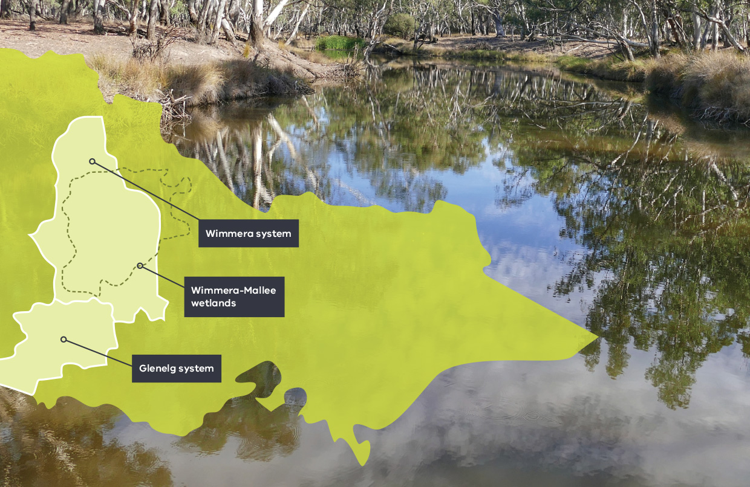

What does climate change mean for our rivers in the west?
Victoria’s climate has seen a drying and warming trend over the last two decades, and it is predicted this trend will continue. Climate modelling indicates there will be more extreme events including droughts, floods and heatwaves, and it is expected there will be more bushfires. Seasonal shifts in rainfall are expected to continue, with proportionally less rain in the cooler months. Average stream flow is predicted to decline across all parts of Victoria, with some of the greatest declines expected in the south-west and parts of the central and northern regions.
The map shows the predicted changes in run-off across Victoria. You may notice that by 2065 areas in the west could become subject to 50 percent less run off. This could lead to less water flowing into our river systems.
These predicted changes have significant implications for waterway health, through reduced availability of water for the environment and increased water quality risk. There will also be impacts on the plants and animals that live in and around the waterways and rely on well-established flow patterns for successful breeding and movement through the landscape.
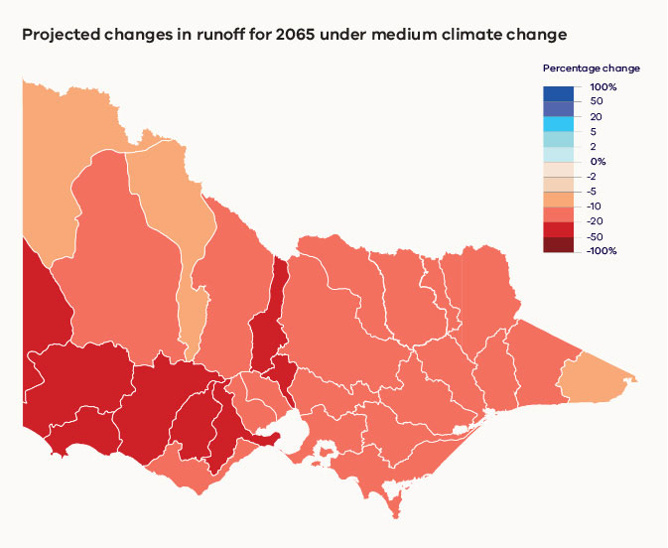
Source: Water for Victoria, 2016
The VEWH and its program partners are taking steps to address the challenges associated with climate change. In Victoria’s western region the VEWH is working with Glenelg Hopkins CMA and Wimmera CMA to identify the most effective and efficient use of water for the environment during critically dry periods.
The Wimmera CMA is identifying high priority refuges for small-bodied native fish, platypus and waterbug populations in MacKenzie River, Burnt Creek and the Wimmera River, and is investigating how water for the environment can be best used to protect these refuges. This is all done while also aiming to maximise economic, social and cultural outcomes.
Glenelg Hopkins CMA is undertaking a similar investigation to identify the key drought refuge areas for protection in the mid and upper reaches of the Glenelg River.
The Glenelg River Drought Refuge project will identify the status of existing refuges and develop population carrying capacity models to inform watering actions required to protect these habitats for native plants, fish and other animals during drought and dry conditions.
Both the Wimmera CMA and the Glenelg Hopkins CMA have worked hard to provide environmental flows and enhance river health through integrated catchment management strategies to support native animal and plant species. The Wimmera and Glenelg systems support a variety of native fish populations including southern pygmy perch, Australian grayling, Glenelg spiny crayfish, western swamp crayfish and platypus populations. Identifying key refuge sites and prioritising water for the environment during persisting dry conditions will be crucial in avoiding critical losses.
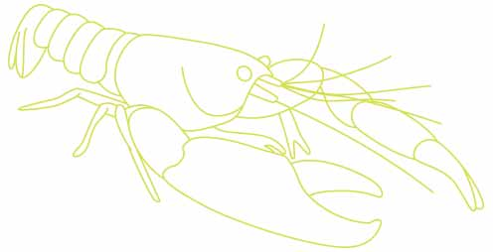

Investment in metering in the western region
Whether using water for the environment or for other needs, every drop counts
Just as is the case for urban water users and irrigation farming enterprises, delivery of water for the environment needs to be accurately measured and accounted for. That’s why the VEWH has worked with GWMWater to upgrade water metering at 13 sites in the western region – ensuring more accurate and efficient releases of water for the environment and saving the storage manager time and effort.
In 2015, the VEWH undertook a project to scope metering improvements for water for the environment across Victoria. In consultation with waterway managers and storage managers, the VEWH identified the highest priority metering improvements and developed detailed specifications and cost estimates for upgrades.
Prioritisation involved assessment of the extent to which each site would improve the quality of information relative to the environmental objectives of a watering program. The metering will improve the efficiency of the delivery of the environmental watering program from both a cost and water use perspective.
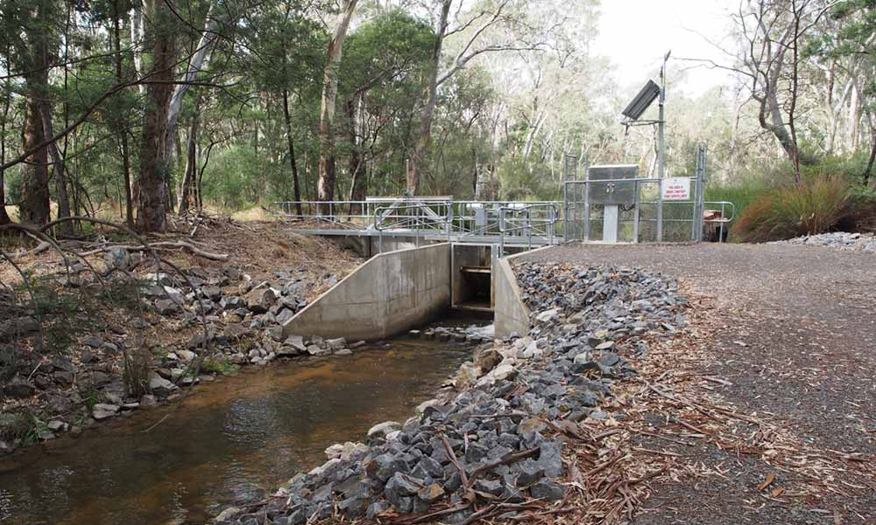
Above: Infrastructure at Distribution Heads on Burnt Creek, by Chloe Wiesenfeld
Beth Ashworth, Co-Chief Executive Officer at the VEWH, says “We were keen to invest in metering of water for the environment because we knew that a lot of the infrastructure we use across the state was not originally designed to deliver or measure environmental flows. Installing new meters means the storage managers can measure very accurately how much water is released from a storage and flows down a river or into a wetland to support environmental objectives like improving water quality and fish habitat.”
Thirteen high priority meters requiring an upgrade were in the western region. This included three sites on the Glenelg River and 10 in the Wimmera River system. Over three years, from
2016-2019, the VEWH has invested almost $1.4 million toward improvements to Glenelg and Wimmera system meters, which are part of the Wimmera-Glenelg Headworks system.
GWMWater is the Storage and Resource Manager for the system and is managing the delivery of the meter upgrades.
Mark Williams, Managing Director at GWMWater says that the meter upgrades funded by the VEWH have flow-on benefits for storage managers. New and improved meters complement the major system upgrades achieved between 2004 and 2010 when the Wimmera-Mallee Pipeline was built.
“At the time, the Wimmera-Mallee Pipeline was one of the largest water infrastructure projects in Australia and a key feature is the accurate and efficient delivery of water from the pipeline to our customers across the Wimmera and Mallee,” Mark said.
“These recent metering upgrades to many of our bulk meters, such as those at the Rocklands Reservoir, Taylors Lake and Lake Wartook outlets, will complete the picture. It will help us to accurately deliver a more targeted and precise watering program to the Glenelg and Wimmera rivers on behalf of the VEWH and the Catchment Management Authorities.”
“This helps us meet operational needs as well, because new metering features that provide automation and remote access to data will save us time in meeting our commitments.”

Glenelg system
Australian grayling are on the move
Australian grayling has been caught in the Glenelg River for the first time in 122 years! The exciting discovery is likely due to a combination of environmental flow deliveries and integrated catchment management strategies.
The nationally threatened species was discovered downstream of Casterton by scientists from Arthur Rylah Institute for Environmental Research (ARI) during surveys for the Native Fish Report Card program. In south-eastern Australia, populations have vastly declined due to altered river flows and the creation of man-made barriers obstructing fish movement.
Australian grayling requires certain river flows at different times every year to cue the fish to complete its lifecycle, including moving between freshwater and the ocean. Some flows trigger movement for adults and juvenile fish to recruit and breed, and other flows are needed to push larvae back into the ocean. In the Glenelg River, estuary perch and black bream rely on flow cues for spawning and recruitment too.
Glenelg Hopkins CMA Waterway Health Planner Stephen Ryan said, “Recent exciting results added to the story of positive outcomes for native fish species in the Glenelg system.”
“We have recorded a tenfold increase in numbers of the critically endangered variegated pygmy perch and more than doubling of river blackfish numbers. Rediscovering the Australian grayling here is the last piece of an ecological puzzle showing encouraging signs that native fish, including threatened species, are recovering with support from efficient environmental flow management.”
Ongoing integrated catchment management initiatives by Glenelg Hopkins CMA through the Glenelg River Restoration Project continue to improve the health of the river system.
“Widespread work through the project to install fish habitat, control erosion, improve fish passage and water quality has also supported this recovery. It’s good news for other species found here like spiny crayfish and platypus as well,” Stephen said.
Waterway manager: Glenelg Hopkins CMA
Storage manager: GWMWater
Site | Volume delivered 2018-19 (megalitres)
Glenelg River | 17,180

Community Highlights
  - Glenelg River
Strong alliances = strong river systems
Building strategic partnerships with anglers and fishing groups has been instrumental in boosting awareness of environmental flows in the Glenelg River and environmental conditions in other waterways.
In recent years, Glenelg Hopkins CMA water resource officers have forged strong networks with influential anglers and angler groups. Anglers and water managers collaborate during fishing competitions and fish surveys, electrofishing and fyke-netting demonstrations, and fish habitat restoration projects.
In 2019 Glenelg Hopkins CMA, for the first time, supported the Vic Bream Classic catch and release series through sponsorship of tournaments on the Glenelg and Hopkins rivers.
Glenelg Hopkins CMA CEO Adam Bester said that supporting this type of event improves access to, and relationships with, leading anglers from Victoria and beyond to boost awareness about environmental management of rivers and the status of native fish species.
“We see our work with recreational anglers as a real win-win situation for both parties.”
“By establishing strong alliances, not only can we encourage advocacy from this critical stakeholder group, but also undertake a joint approach to building stronger and more resilient river systems.”
“Anglers understand that our work to restore flows and improve fish habitat brings greater fishing opportunities. And we know that we can learn a lot from anglers who observe changes in river conditions and fish movement firsthand.”
“Tapping into this knowledge will help to inform and prioritise management actions to support self-sustaining fish populations,” he said.
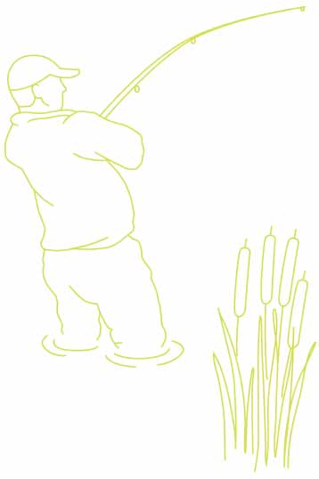
Western Victorian angler Shane Lowery commented during the event in February, “Since we’ve had environmental flows coming down the river, we’ve had incredible movements of fish that hadn’t happened for years. We’re seeing fish push hundreds of kilometres up the river in a river that used to be, in the higher reaches, very disconnected and a series of small pools. Now that we’re getting environmental water, we’re seeing improvements in the fishing all the time. I’ve spoken to people that tell me this is the most consistent they’ve seen the river fish in 30, 40 years.”
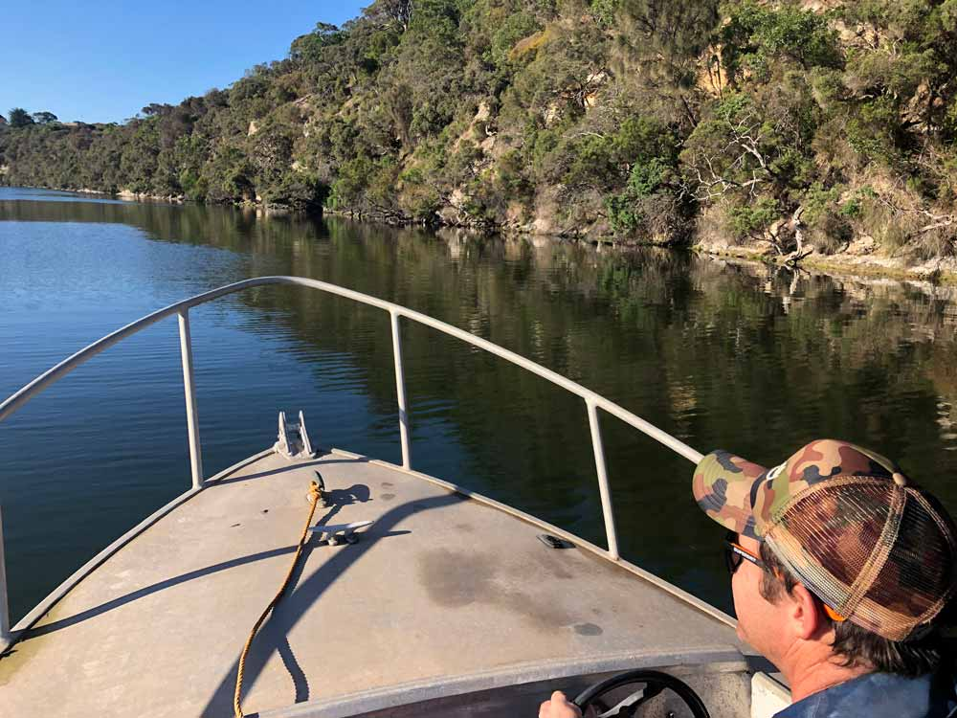
Above: Enjoying the Vic Bream Classic, by Glenelg Hopkins CMA

Wimmera system
Across the Wimmera

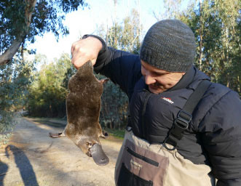
Above: Ben Holmes from Wimmera CMA holds a platypus, by Wimmera CMA
A new female platypus was found during the Wimmera’s annual platypus surveys in the MacKenzie River! The community have named the platypus ‘Hope.’ Using environmental DNA to help track platypus movement in the river researches are eager to see if their habitat range has extended.
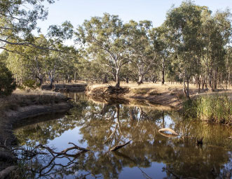
Above: Mount William Creek, by John Tiddy
Environmental flows helped keep fish alive in the upper Mount William Creek! Water for the environment was released to a drying section of the river that provides valuable breeding and refuge habitat for native fish including southern pygmy perch, Australian smelt, common galaxias and flatheaded gudgeon.
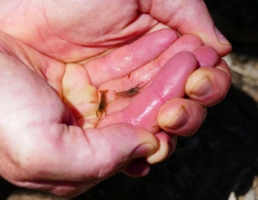
Above: Western swamp crayfish, by Greg Fletcher, Wimmera CMA
Despite dry conditions, regular water for the environment releases have been vital for protecting a population of threatened western swamp crayfish in northern Grampians rivers. This small crayfish cannot dig burrows and its habitat would be restricted without water for the environment to keep areas wet.
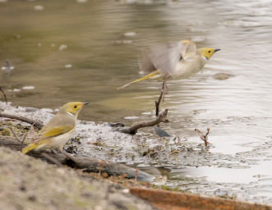
Above: White plumed honeyeater at Carapungna wetland, by Jenny Stephens
Exciting finds in 2018-19 at Carapugna, one of the Wimmera CMA Wimmera Mallee Pipeline Wetlands, included the rare hard-head saltbush and endangered tall sneezeweed. Ten wetland bird species were recorded too, including Latham’s snipe.

Community Highlights
  - Ranch Billabong
Wotjobaluk Traditional Owners and Barengi Gadjin Land Council identified cultural connections that support water for the environment objectives. With this information and through collaboration with the Wimmera CMA and the VEWH, environmental flows for the Ranch Billabong became a reality.
Culture, environment and community came together to mark a significant occasion for the Barengi Gadjin Land Council (BGLC) and Wotjobaluk Traditional Owners at Ranch Billabong near Dimboola as a watering program began in December.
The first watering was celebrated on the anniversary of the 2005 Native Title determination and was followed by a workshop to map out aspirations for the site going forward.
The Ranch Billabong area has been home to many generations of Wotjobaluk people, long before European settlement and increasingly after Ebenezer Mission at Antwerp closed. The cultural connection to the site remains and plans for its management are included in Growing What is Good Country Plan, Voices of the Wotjobaluk Nations.
Using the Aboriginal Waterways Assessment tool to document cultural values and objectives along the Wimmera River, Traditional Owners and Aboriginal groups highlighted Ranch Billabong as a priority cultural site for rehabilitation.
BGLC Water Officer and Traditional Owner Stuart Harradine said that BGLC are working to restore plants and animals and control weed species, recreating a space for gatherings and events.
“We are hoping to see ‘old man weed’ or ‘sneezeweed’ thriving again; this plant, known as ‘Gukwonderuk’ in our language, is important for traditional medicine and grows when water levels recede.
“Restoring the area is important for the Wotjobaluk people and we are aiming to improve access and knowledge sharing at the site with tracks and interpretative signage,” he said.
Creating a strong partnership, BGLC, Traditional Owners, Wimmera CMA and the VEWH worked together to ensure the delivery of water for the environment was a success both culturally and ecologically.
The trial watering of seven megalitres in December 2018 significantly improved water quality, supporting the surrounding river red gums and aquatic animals. Monitoring before and after water for the environment was delivered showed that salinity levels in the billabong halved, with frogs and waterbirds quickly returning to the area taking advantage of the inviting habitat.

A top-up of six megalitres was delivered in March 2019, boosting the wetlands plants and animals in autumn and again lowering salinity levels to improve the health of the billabong into the future.
“A peaceful place of gathering, sharing and nurturing - that’s how I remember it. The Ranch Billabong is one of few remaining places that connect with how our mob lived before and after settlement. We were told stories of the area and how families lived and survived. As kids you don’t really notice much around you, you’re more or less enjoying the moment - but as you get older you realise what the old people meant by their stories. I’ll always treasure the times our families spent at the Ranch Billabong. I would love for future generations to experience that culture and history. The place is in poor shape and needs to be restored, including a general clean up, revegetation of native plants and re-directing water back into the Billabong.”
- Dylan Clarke, Chair, Barengi Gadjin Land Council
Waterway manager: Wimmera CMA
Storage manager: GWMWater
Site | Volume delivered 2018-19 (megalitres)
Site | VEWH | CEWH | Total
Wimmera River | 5,517 | 5,085 | 10,602
MacKenzie River and Burnt Creek | 3,388 | 0 | 3,388
Lower Mount William Creek | 753 | 753 | 1,506
Upper Mount William Creek | 154 | 0 | 154
Ranch Billabong | 13 | 0 | 13
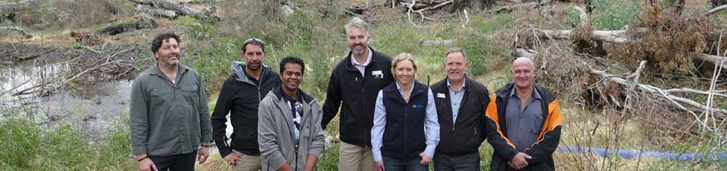
Above: At Ranch Billabong for the first watering, by Greg Fletcher, Wimmera CMA

Community Highlights
  - Wimmera-Mallee wetlands
Community members out on site at the Wimmera Mallee Pipeline Wetlands!
Mallee CMA hosted a field excursion to wetlands receiving water for the environment in spring 2018. The group of about 25 included landholders, local council employees, Landcare club members and local community. The excursion was an opportunity for people to see the benefits water for the environment is having at the Morton Plain and Roselyn wetlands. Dorothy Reid, landholder at Roselyn wetland, presented to the group on animals she had observed using the wetland.
“Not only birds, but also turtles, kangaroos, lace monitors, bearded dragons and snakes use the wetland,” Dorothy said.
Mallee CMA also delivered a citizen science workshop in Birchip, teaching people how to monitor birds at wetlands receiving environmental flows. Ten community members attended the workshop, learning about the methodology for collecting data and how to use their binoculars and spotting scopes. One volunteer was Gary Cheers, a retired ecologist who loves bird watching and photography. Gary joined the workshop as he felt “this will be a project which will give interesting results.”
Gary said he expected his monitoring to show a variety of birds that rely on wetlands in the Mallee and Wimmera catchments, and was very appreciative of the watering program in the region as “without the water, they won’t be there.” Gary praised the Mallee CMA for the workshop, which he said helped to “engage people who already had an interest in the environment and put their experience in birdwatching to use”.
Waterway manager: Wimmera, North Central and Mallee CMAs
Storage manager: GWMWater
Site | Volume delivered 2018-19 (megalitres)
Site | VEWH | Other | Total
Wimmera-Mallee wetlands (various sites) | 148 | 3 | 151

Northern region
It has been a great year for waterbirds in the north! Around 30,000 birds have been recorded at Lake Cullen since water for the environment deliveries began in 2018 with benefits flowing on to tourism and recreation in the area. And, more than 20 brolgas - currently listed as vulnerable in Australia - have been sighted at Gaynor Swamp!
Water for the environment delivered to the Northern region in 2018-19 (megalitres)
Victorian Murray system 155,672 ML
Loddon system 17,150 ML
Campaspe system 23,356 ML
Goulburn system 226,681 ML
Broken system 34,562 ML
Ovens system 162 ML
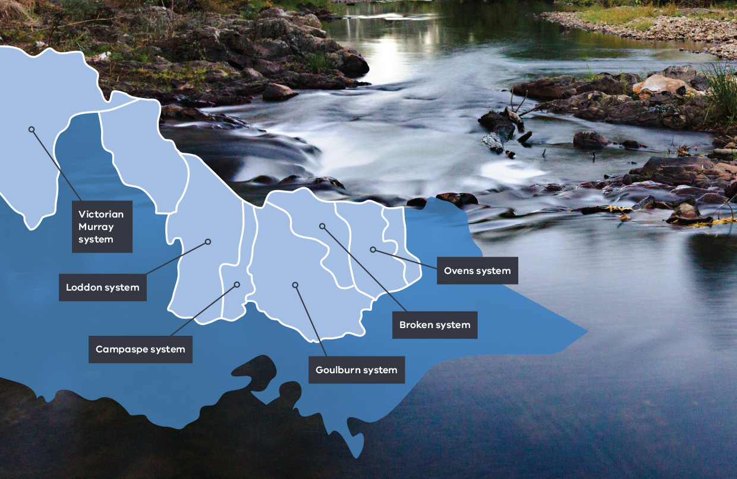

Barmah Forest
Moira grass makes a massive comeback
In a stunning lime green display, Moira grass in Barmah Forest is flourishing due to a combination of water for the environment and fenced areas which exclude grazing from feral horses and other pest animals.
Under the right conditions, Moira grass grows in large floating mats, with roots and stems hanging down in a tangle beneath the surface. The outstanding results of careful management of some Barmah Forest floodplain areas can be seen from the air!
After observing great results with Moira grass growth in 2017, following environmental flows and fencing, water for the environment was delivered to Barmah Forest in November and December 2018, which provided ideal conditions for wetland plants to thrive and set seed.
The floodplain includes Moira grass and the threatened river swamp wallaby grass, among other low-lying vegetation. They add to the mosaic of plant communities in the internationally significant, Ramsar-listed wetland complex of the Barmah Forest. Environmental flows support the growth, flowering and seed set of Moira grass, which has specific water needs to complete its lifecycle. Moira grass is a critical wetland species providing unique environmental values within the forest.
“Over the last two years, watching the rehabilitation of the Moira grass plains inside the enclosure clearly indicates the damaging effect of feral animals,” said Goulburn Broken CMA Environmental Water Reserve Manager Keith Ward.
“Growth rates inside the enclosures have been exceptionally good with excellent flowering and stem length recorded. Moira grass has even been recorded in areas where it had previously disappeared, proving the effectiveness of long-term management in the forest.”
“Significant improvements in Moira grass communities in the Barmah Forest is an exciting achievement. With continued support from the VEWH and land managers in coordinating water for the environment deliveries and reducing the impact of feral animals, we can continue to protect and enhance ecological values in the forest,” Keith said.
Waterway manager: Goulburn Broken CMA
Storage manager: Goulburn-Murray Water, Murray-Darling Basin Authority (River Murray Operations)
Site | Volume delivered 2018-19 (megalitres)
Site | VEWH | MDBA | CEWH | Total
Barmah Forest | 12,476 | 16,128 | 46,032 | 74,636

Gunbower Forest and Creek
“A healthy environment underpins healthy communities”
A healthy Gunbower Forest has big benefits for the local community and economy. For the forest to be healthy, it requires water for the environment.
Before regulation of the River Murray, Gunbower Forest would have flooded roughly seven out of every 10 years, with large widespread flooding lasting for up to six months in four of those seven years.
In the past 22 years, between natural floods and allocated water for the environment, key sections of the forest floodplain have been inundated only eight times – stretching the tolerances of wetland and floodplain plants to breaking point. While environmental flows in recent years have helped bring back some of these areas from the brink, there is still a long way to go.
In 2018, critical watering was required to ensure resilience of this internationally recognised site. Gunbower Forest had been in a drying phase for two very hot and dry summers and a very dry winter in 2017, and the floodplain was beginning to show signs of stress. The sedges, reeds and rushes that flourished after the 2016 flood had died back and river red gum trees were beginning to struggle.
“Water for the environment is the life support of Gunbower Forest. It provides Mother Nature with a much-needed helping hand and helps build resilience if dry conditions continue,” said North Central CMA’s Program Delivery Executive Manager Rachel Murphy.
“It can be hard to imagine given how heavily our river systems are managed today, but even in a dry year such as 2018, the forest would still have received water in spring if Murray River flows weren’t regulated by dams and weirs.” (Figure 1)
“The watering this year was critical to ensure we would not go backwards after the gains we’ve made through the watering program in recent years.” Rachel said.
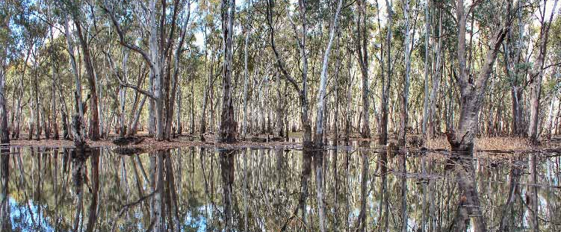
Above: Gunbower Forest, By Kathryn Walker, VEWH

“Thanks to the watering, understorey vegetation in the red gum forests and box woodlands is in the healthiest condition it has been since we began monitoring it in 2005, though it still has some way to go towards making a full recovery.”
“The Forest is also an incredibly important refuge site for waterbirds, particularly when such large areas of New South Wales and Queensland are so dry.”
The flows ensured many species of waterbirds were able to breed and successfully fledge their young, including ducks, Australasian grebes and black swans. Monitoring surveys in December 2018 at Long Lagoon found over 50 nests (about 150 juveniles present) including Australasian darter, Australian ibis, little pied cormorants, little black cormorants and great cormorant species. Most chicks fledged successfully by January 2019.
The watering at Gunbower Forest was carefully planned to occur outside major irrigation demand periods, ensuring there would be no impacts on farm water delivery. It was also undertaken as efficiently as possible, with the same water being used as many times as possible at multiple sites upstream and downstream.
“A lot of people don’t realise that the water that went into Gunbower was actually water that was used for healthy river flows down the Campaspe and Goulburn Rivers.” Rachel explained.
“Over 70 percent of the water delivered to the forest in 2018-19 came from environmental flows in the rivers upstream. The water then passes through Gunbower Forest filling up its wetlands, and just under half of it flows out of the forest and ends up back in the Murray River. The water was used again multiple times by the environment as it travelled downstream, in the river channel itself and at other floodplain sites.
“That is an amazingly efficient use of water in anyone’s language. And it is also great for our native fish, who thrive on the food that comes off the floodplain and back into the creeks and river.”
Rachel said Gunbower Forest is a tourist hotspot, providing economic benefits for the region’s towns and businesses.
“A healthy environment underpins healthy communities,” she said.
“More than 95 percent of locals recently surveyed told us they value Gunbower Forest for its recreation and as an attractive place to visit.
“We are working hard to keep it that way and preserve it for the future economic benefit of our children and grandchildren.
“Tourism in the region is worth $503 million, up $100 million since the drought, and Gunbower Forest is a key part of that.”
The Gunbower Forest Flooding for Life project is delivered by the North Central CMA in partnership with Goulburn–Murray Water, Murray-Darling Basin Authority, the Commonwealth Environmental Water Office, the Victorian Environmental Water Holder, DELWP and Parks Victoria.
It is part of The Living Murray program, a joint initiative of the New South Wales, Victorian, South Australian, Australian Capital Territory and the Commonwealth governments, coordinated by the MDBA.
The graph below shows that Gunbower Forest would have received two periods of natural inflows in April and September 2018 via the natural creek systems feeding the Forest floodplain.
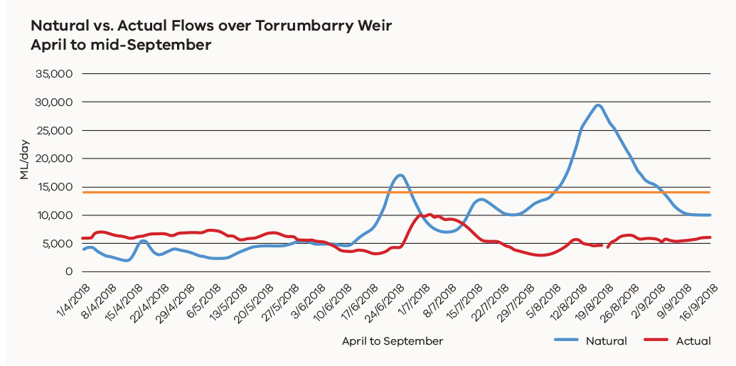
Figure 1 Actual flow vs modelled ‘natural’ flow into Gunbower Island Forest from April to September 2018. The flat orange line demonstrates when flows in the River Murray are high enough to flow into Gunbower Forest (i.e. when flows in the river reach 15,000 ML/day). This indicates that under natural conditions (blue line), there would have been two periods of inflows for Gunbower Forest in 2018. The red line shows the actual regulated flows delivered at Torrumbarry Weir on the Murray. (Source: MDBA river data, 2018)

Highlights of environmental watering across the Central Murray and Boort wetlands

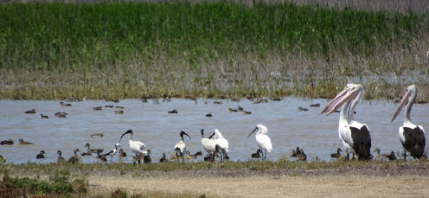

Lake Cullen
Community knowledge helped deliver 7,790 megalitres of water for the environment to Lake Cullen making it become an efficient drought refuge for waterbirds over summer 2018-19! About 30,000 waterbirds were recorded across 60 different species! Birdlife Australia, supported by the VEWH, has been monitoring waterbirds at the lake.
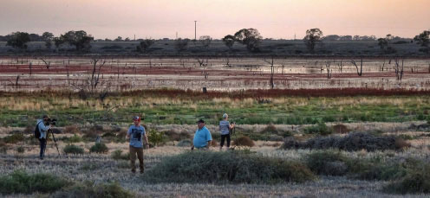

Lake Murphy
North Central CMA’s annual ‘Breakfast with the Birds’ event, funded by the National Landcare Program, was held at Lake Murphy this year. In February 2019, over 70 people met at the lake to see some of the bird species that have been flocking to the site after water for the environment deliveries.
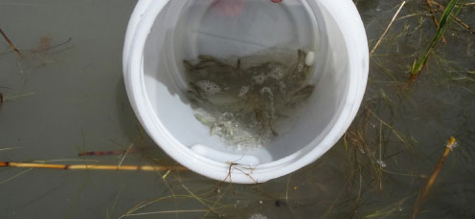

Round Lake and Lake Elizabeth
Water for the environment was delivered to Round Lake and Lake Elizabeth to maintain conditions for the critically endangered Murray hardyhead. Both lakes received two instalments of environmental flows, ensuring that they remain permanently inundated. Round Lake and Lake Elizabeth are both part of a program to re-establish Murray hardyhead populations.
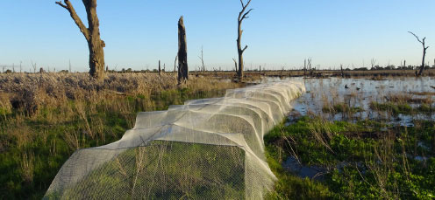

McDonalds Swamp
North Central CMA is continuing to work with Barapa Barapa Traditional Owners at McDonalds Swamp through the Testing Wetland Decision Support Tool (DST) project. The project aims to revegetate aquatic species at the swamp. In spring 2018, the area was inundated with water for the environment and the revegetation sites showed significant improvement in aquatic plant species.
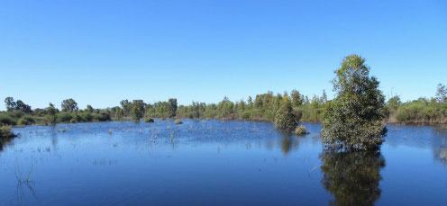

Wirra-Lo Wetland Complex
Over spring and summer, water for the environment was delivered to Lignum Swamp North, part of the Wirra-Lo Wetland Complex. Deliveries provide suitable breeding conditions for the nationally endangered growling grass frog. Wetland plant species also flourished with tall spike-sedge naturally spreading through the area.
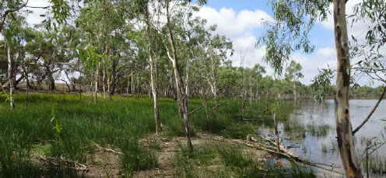

Little Lake Meran
North Central CMA filled Little Lake Meran for the first time! In spring 2018, the wetland received 510 megalitres of water for the environment and plant and animal numbers quickly thrived. Naturally recruited river red gums have shown significant growth and grasses flourished across the mudflats.

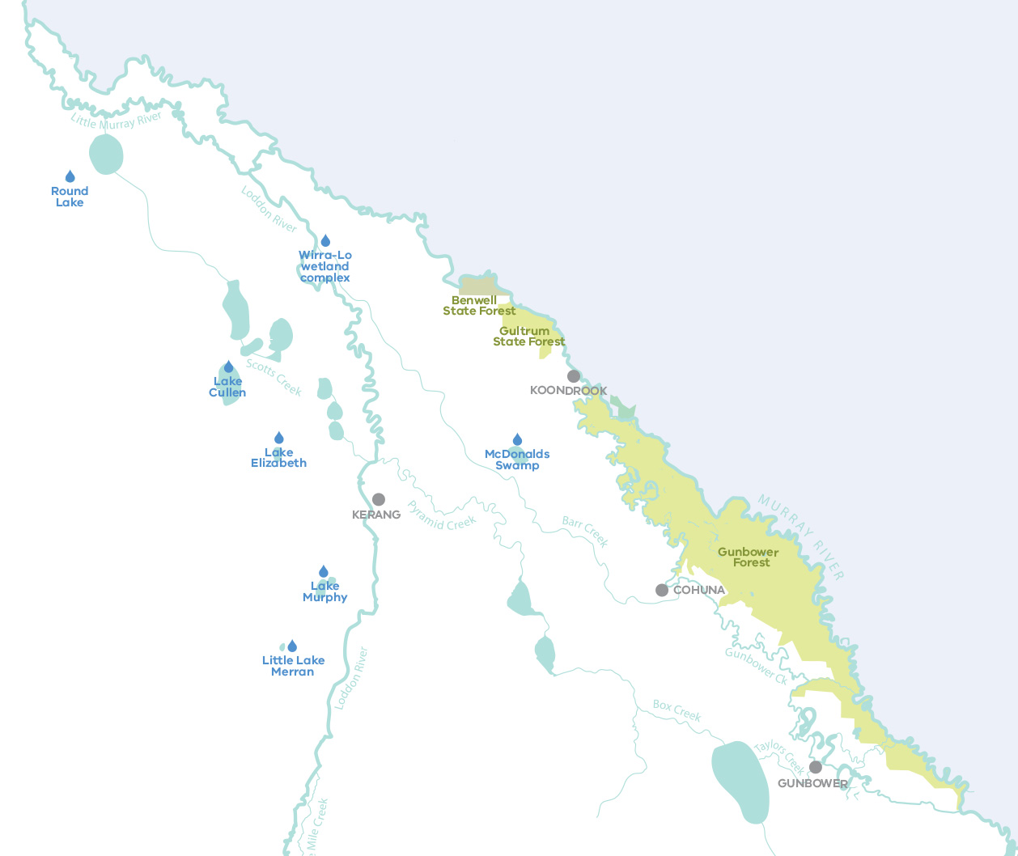

Community Highlights
  - Central Murray wetlands
We want to know what you know! How the Lake Cullen community helped inform water management decisions.
Community members are a wealth of local knowledge. Sharing this knowledge can be instrumental in adapting water management decisions. North Central CMA and the VEWH have listened to feedback from community members in the Kerang Wetlands region, resulting in excellent outcomes for Lake Cullen.
Forming part of the central Murray wetlands, Lake Cullen is an important part of the internationally recognised and protected Kerang Wetlands, supporting thousands of waterbirds of many different species. The lake is a popular spot for birdwatching and hosts some of Australia’s endangered species including the Australasian bittern and freckled duck.
In planning for and delivering water for the environment, North Central CMA has been guided by the Lake Cullen Environmental Water Management Plan (EWMP). The watering regime developed in the EWMP in part relied on a technical groundwater report prepared during the Millennium Drought. The report suggested that when Lake Cullen fills, saline groundwater could be pushed into the neighbouring Avoca Marshes, with potentially negative consequences for the marshes and surrounding environment.
Based on this hypothesis, the watering regime for Lake Cullen recommended that the marshes need to be full when filling Lake Cullen to reduce the risk of saline groundwater intrusion.
North Central CMA Water for the Environment Program Manager Louissa Rogers said that local community members and landholders shared a different theory based on their knowledge and observation of the landscape over time. This led North Central CMA to undertake further scientific investigation, which confirmed the local knowledge.
“What we found was very little interaction at all between the two water bodies, which was great news. It presented the local community with a rare opportunity - locals wanted to see the benefits of the bird breeding, including the tourism benefits, flow on for another year, and asked if water for the environment could be added again,” Louissa said.
“We all understand the current dry conditions are tough, and the local community is working side by side with the CMA and the VEWH to deliver water for the environment to make the region a better place to live and visit.”
North Central CMA worked with the Loddon Murray Wetlands Environmental Water Advisory Group and the wider community to deliver water for the environment to wetlands in the region this year.
“The Loddon Murray Wetlands are important for the region’s economy, especially for tourism. The wetlands are key attractions for recreation, education, cultural connections and social wellbeing,” Louissa said.
“About 30,000 birds across 60 different species were recorded on Lake Cullen in 2018, and the community advisory group was keen to give them a chance to survive the very dry conditions this year by providing high quality refuge habitat. With most of the nearby wetlands drying up, Lake Cullen is now taking on extra importance. It is better for all these birds to stay there and breed than to have to find another home.”
Waterway manager: North Central CMA
Storage manager: Goulburn-Murray Water
Site | Volume delivered 2018-19 (megalitres)
Johnson Swamp | 1,500
Lake Elizabeth | 1,080
Lake Murphy | 2,550
McDonalds Swamp | 230
Round Lake | 461
Lake Cullen | 7,790
Wirra-Lo wetland complex | 92
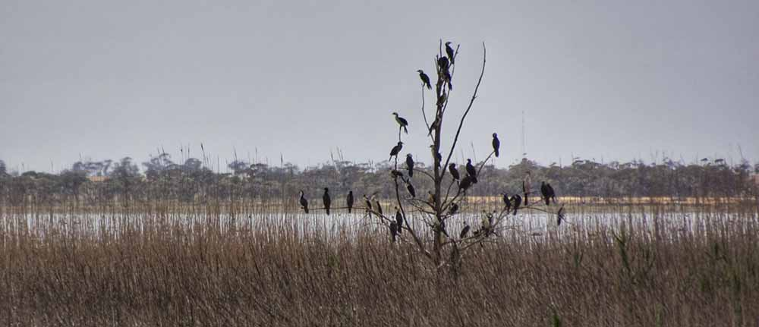
Above: Cormorants at Lake Cullen, by North Central CMA

Hattah Lakes
How drying at Hattah Lakes helps keep the habitat healthy
Home to many threatened species and highly valued by the local community, the Hattah Lakes system contains more than 20 semi-permanent freshwater lakes.
Both wet and dry periods are vitally important for these wetlands as these phases help improve the ecological health of the site.
To consolidate the outcomes of five years of watering, no water for the environment was delivered to the lakes in 2018-19. The planned dry year was important for enhancing the diversity in plant and animal communities and helping ensure that the lakes remain a local hot spot!
Five years of watering has helped restore declining black box trees and support over 140 native plants, on the Hattah floodplain, as well as an abundance of wildlife. Since the installation of pumping infrastructure at Hattah Lakes, environmental flow deliveries have been able to efficiently target the most elevated parts of the floodplain. This has provided much-needed relief to stressed black box trees and other vegetation, some of which, before the pump installation in 2014-15, had not received a drink since the 1990s.
The lakes underwent a planned drying phase 2018-19 to enable understorey plants to germinate, grow and set seed.
The ecological benefits of the wetting and drying phases are revealing themselves, with monitoring indicating floodplain vegetation has responded well.
Andrew Greenfield, senior ecologist with the Mallee CMA explains, “We’ve seen a vast improvement in the blackbox trees over the past decade, with monitoring following the recent watering events showing that over 60 percent of blackbox trees are healthy, compared to just 19 percent in 2009.”
“In 2018-19 we implemented widespread drying to enable seeds to germinate and plants to grow and become established. As the lakes slowly dry, the exposed mudflats and shallow-water habitats continue to provide amazing feeding habitat for waterbirds,” said Andrew.
Drying the lakes also increases the environmental benefits that can be achieved from future environmental watering.
“By June 2019, 15 of the lakes were dry,” Andrew said. “When the next flood occurs, or when we next pump water for the environment to Hattah Lakes, we should see a boom in productivity because all the nutrients and carbon that have accumulated on the dry lake bed will be released rapidly, building the food chain from the bottom up.”
Waterway manager: Mallee CMA
Storage manager: Goulburn-Murray Water, Murray Darling Basin Authority (River Murray Operations)
Site | Volume delivered 2018-19 (megalitres)
Site | MDBA
Hattah Lakes | 281
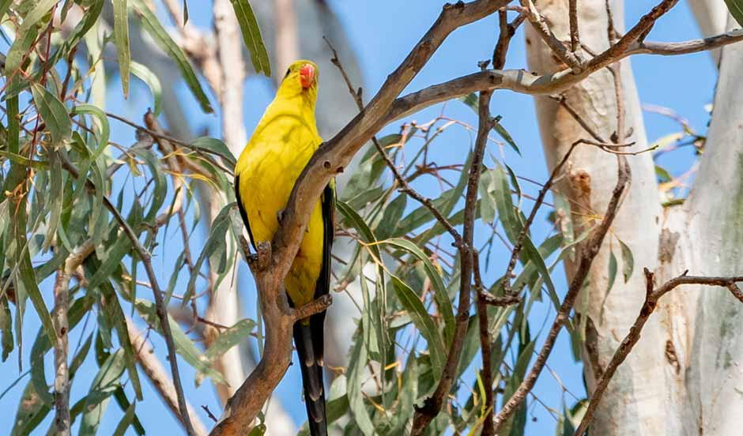
Above: Regent parrot at Hattah Lakes, by Mallee CMA

Lower Murray wetlands
Microbats, frogs, sugar gliders – helping out the little guys
At the eastern edge of the Lower Murray wetlands lies Vinifera floodplain, located between Nyah and Swan Hill.
Originally slated for watering during spring 2018, the watering was delayed until autumn 2019 to allow for complete drying of the wetland over summer.
“The drying phase is really important,” explains Andrew Greenfield, senior ecologist with Mallee CMA.
“Allowing time for the floodplain to completely dry kills any carp that have populated the wetland when water was pumped in from the River Murray. Drying also allows clays in the bed of the wetland to crack, which provides habitat for insects and reptiles and allows carbon and other soil nutrients to accumulate. This input of carbon and nutrients during a dry phase leads to increased productivity when a wetland is next watered.”
Vinifera Floodplain is known as a breeding area for colonial nesting waterbirds (cormorants and Australasian darters) and may also support breeding by royal spoonbill and Nankeen night heron. Providing environmental water to Vinifera floodplain when it needs it (and when water is available) is one method of creating ideal habitat for these waterbirds. Microbats, frogs, sugar gliders and wallabies are also known to live on or visit Vinifera.
Vinifera Floodplain is one of the wetlands in the Lower Murray section of Victoria, which includes wetlands across the floodplain of the River Murray between Swan Hill and the South Australian border. The system includes a myriad of interconnected creeks, wetlands and floodplains. Over the last fifteen years, 54 waterbodies in this area have received water for the environment resulting in increased biodiversity and health, providing important places for the local community to relax and enjoy.
Waterway manager: Mallee CMA
Storage manager: Goulburn-Murray Water
Site | Volume delivered 2018-19 (megalitres)
Brickworks Billabong | 251
Burra Creek North | 250
Burra Creek South | 747
Lake Hawthorn | 1,498
Lake Koorlong | 57
Nyah Floodplain | 1,000
Vinifera Floodplain | 665
Yungera Wetland | 184

Lindsay, Mulcra and Wallpolla islands
Horseshoe Lagoon - a perfect nursery habitat for native fish
Near the border between Victoria and South Australia lies the Lindsay, Mulcra and Wallpolla islands – a remote but significant part of the Victorian River Murray floodplain in the Murray-Sunset National Park which is traversed by a network of permanent waterways, small creeks and wetlands.
The islands and their waterways are special places and, in 2018-19, Horseshoe Lagoon on Wallpolla Island, became home to more than 120,000 golden and silver perch that were released into the wetland, just days after hatching.
The lagoon was dried in 2016-17 which eliminated carp. Water for the environment, delivered to Horseshoe Lagoon in 2017-18 and 2018-19, improved the productivity of the wetland making it an ideal nursery habitat for stocked native fish to grow and develop.
The fish release was an initiative of the Mallee CMA along with Victorian Fisheries, Traditional Owners and other partners.
“Off-stream habitats like this provide the perfect recipe for heightened survival rates for native fish,” explains Mallee CMA senior ecologist Andrew Greenfield.
“A small top-up of environmental water in spring 2019 will help ensure Horseshoe Lagoon continues to be a perfect nursery for native fish.”
With fish populations in the Murray-Darling Basin at an estimated 10 per cent of their pre-European occupation levels, environmental flows and stocking of hatchery-bred native fish are both important management tools that can help ensure recovery of our native species. Ensuring the survival of stocked fish, and ultimately their establishment in self-sustaining populations is critical.
“The stocked fish face the same threats as our natural populations – predation by carp and other large fish, habitat loss, barriers to migration, water quality and many others. Opportunities like this, where we’ve been able manage our environmental flows to enable removal of carp, support the growth and development of the stocked fish, and plan for their dispersal into the population show how these two tools can work together,” Andrew said.
Waterway manager: Mallee CMA
Storage manager: Goulburn-Murray Water, Murray-Darling Basin Authority (River Murray Operations)
Site | Volume delivered 2018-19 (megalitres)
Wallpolla Island - Horseshoe Lagoon | 737

Community Highlights
  - Ovens system
“The rivers are the veins of the Country”
Taungurung Traditional Owners and the North East CMA have worked with the VEWH and Goulburn Murray Water to release water for the environment. In June 2019, 39 megalitres of water owned by Taungurung Land and Waters Council was delivered as an environmental flow to the King River.
This water release contributed to healing Country by providing a boost to the health and productivity of the waterway. This flow provided a small variation in the water level of the King River downstream of Lake William Hovell, which inundated new habitat for waterbugs and fish, allowing them to move more freely and find new sources of food.
The release coincided with the Taungurung Water Group visiting the King Valley to scope out sites for a future Aboriginal Waterway Assessment of the King River.
Shane Monk, Taungurung man, said “The rivers are the veins of the Country, if you take too much water from them Country would get sick. Taungurung has a responsibility and we are only doing the right thing for Country by bringing water back to the river. We are working with the North East CMA, VEWH and GMW to achieve this. We feel confident we can do more if we continue working together.”
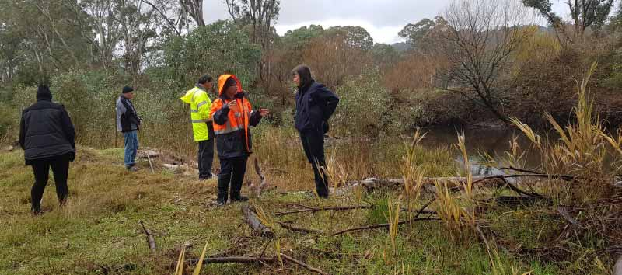
Above: Taungurung and North East CMA at King River, by North East CMA
Catherine McInerney, Environmental Water Officer at the North East CMA, explains “The King River catchment has recently been incorporated into the Taungurung Clans Aboriginal Party area. It has been great to start our working relationship with them by providing some positive environmental and cultural outcomes on the ground, or waterway as the case may be!”
“This project shows a great collaboration between Traditional Owners and water agencies, with a positive impact on the environment,” said Catherine.
Waterway manager: North East CMA
Storage manager: Goulburn-Murray Water
Site | Volume delivered 2018-19 (megalitres)
Site | Taungurung | CEWH | Total
Ovens River | - | 73 | 73
King River | 39 | 50 | 89

Goulburn system
Bigger is not always better: the story of Goulburn system inter-valley transfers and the environment
A winter fresh and spring fresh were delivered in spring 2018 to try to stabilise the lower banks of the lower Goulburn River by helping to deposit sediment and seed and improve bank and in-stream vegetation. Bank stability is of major concern to the Goulburn Broken CMA and the wider community as a result of high unseasonal summer and autumn flows. More water is not necessarily good for the environment - the timing of high and low flows during the year is important to environmental outcomes. The Goulburn River’s environment is healthiest if it is low-flowing in summer and autumn, as naturally occurs in these low-rainfall seasons.
In recent years, however, the lower Goulburn River is increasingly relied on as a passage to supply inter-valley transfers (IVTs) from the Goulburn system to the Murray system. The amount of water delivered as IVTs has substantially increased, causing significant damage to lower Goulburn River banks and native vegetation.
Goulburn Broken CMA and the VEWH are using drone technology and on-ground field visits to investigate the environmental impacts of the high IVTs in summer and autumn.
Early data shows the IVTs delivered last summer-autumn resulted in:
- increased bank erosion, with some lower banks receding by up to 20 cm and others affected by mass failure (slumping)
- loss of lower bank vegetation and reduced survival.
This reduces the habitat available for native plants and animals supported by the Goulburn River including several threatened fish species such as Murray cod.
“We know that the Goulburn River is the lifeblood of this region, providing numerous economic, recreational and environmental benefits and we are continuing to meet with key agencies to look at ways we can minimise the environmental effects of high unseasonal flows due to IVTs,” said Goulburn Broken CMA CEO Chris Norman.
It is a continuing balancing act to manage the rivers in a way that supports the environment, farmers and communities the whole way along.

What are inter-valley transfers?
In the big river systems that connect to the River Murray, part of the water stored in systems like the Goulburn and Campaspe contributes to supplying water users downstream in the Murray. Storage managers account for how much water is available to support the Murray, balanced with the water needed to supply water entitlements in the Goulburn and Campaspe.
Water allocation trade affects the balance of these accounts. For example, when water is traded from the Goulburn to a water user in the Murray, the account increases to record the change in location of the demand.
When water from these upstream systems is delivered to meet the needs of the downstream system, this is known as an ‘inter-valley transfer’. When the demand for water is high, like it is during irrigation season, large volumes can be released over a short period of time.
Waterway manager: Goulburn Broken CMA
Storage manager: Goulburn-Murray Water
Site | Volume delivered 2018-19 (megalitres)
Site | VEWH | MDBA | CEWH | Total
Goulburn River – Reach 1 | 9,665 | - | - | 9,665
Goulburn River – Reach 4 & 5 | 15,000 | 26,468 | 174,447 | 215,915
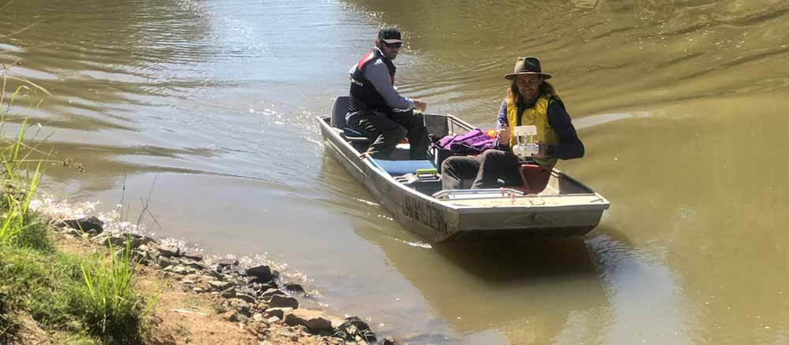
Above: Drone technology monitoring high IVT on the lower Goulburn River, by Goulburn Broken CMA

Broken system
Just enough to keep things flowing
In the Broken River, platypus and native fish populations would struggle to survive without water for the environment. When demand for irrigation water ceases, water levels in the system can became dangerously low.
“Environmental flows help keep the Broken system healthy,” said Goulburn Broken CMA Environmental Water Manager Simon Casanelia.
“A continuous low flow using water for the environment provides connectivity for fish between deeper pools, which could disconnect into isolated pools after the irrigation season.”
“Ideally, to maintain water quality and bank vegetation, provide shelter and food for fish and wildlife such as platypus and support water bugs, we need at least 15 megalitres per day to flow along the Broken River.”
The Lake Nillahcootie dam on the Broken River captures water mainly to supply irrigation demands along the river and the upper Broken Creek. During the winter months, demand for this water downstream ceases and flow in the river drops, especially during dry winters like in 2018 and 2019.
Goulburn Broken CMA works closely with Goulburn-Murray Water, the VEWH and the Commonwealth Environmental Water Holder to ensure the river continues to run in winter with water for the environment.
“Due to limited tributary inflows and low operational releases from Lake Nillahcootie this autumn and winter, this minimum flow target would not be met in the section of the river between Nillahcootie and Hollands Creek. Fortunately, in winter 2018 we were able to use 250 megalitres of water for the environment to maintain a low flow,” said Simon.
Goulburn Broken CMA CEO Chris Norman said water for the environment would become even more critical to the Broken River if dry times continue.
“Anyone living by the Broken River knows how low the river level can be. Delivering this small amount of water over winter is critical for maintaining the health of the entire river and the fish, wildlife and people who rely on it.”
Waterway manager: Goulburn Broken CMA
Storage manager: Goulburn- Murray Water
Site | Volume delivered 2018-19 (megalitres)
Site | VEWH | CEWH | Total
Broken River | 250 | - | 250
Lower Broken Creek | - | 33,847 | 33,847

Goulburn Broken wetlands
Oh My Brolga! Bird numbers soar at Gaynor Swamp
Brolga numbers continue to rise at Gaynor Swamp! More than 20 brolgas - currently listed as vulnerable in Australia - have been sighted since water for environment deliveries began in 2018.
The brolgas were seen displaying breeding behaviour at the wetland. Courtship and breeding between brolga pairs is quite a scene – they toss grass in the air and catch it, dance, leap, flap their wings and trumpet!
Colbinabbin local John Avard said the environmental flows support ecological and community values.
“This will be great for the waterbirds, particularly the brolga, and those of us who live in the area and value the wetland and the wildlife it attracts, are pleased that water for the environment is being used to improve and protect this special spot,” John said.
Maximising on this positive ecological response Goulburn Broken CMA made additional water deliveries in spring and summer 2018.
“The community has been calling for environmental flows to be delivered to Gaynor Swamp for some time now and were very supportive when, back in autumn, water for the environment was delivered to the wetland for the very first time,” said Goulburn Broken CMA CEO Chris Norman.
“Given the terrific response from wildlife and to maintain the water level for a few more months, another 101 megalitres of water for the environment was delivered to the site.”
Providing feeding and breeding habitat for a range of waterbirds including brolgas is a key environmental objective when delivering water for the environment to Goulburn Broken wetlands.
“We’ve seen freckled ducks, which is very, very exciting as they are endangered in Victoria, and black-tailed native hens, brolga and massive numbers of yellow spoonbills, which is unusual as they tend to gather in small groups,” said Chris.
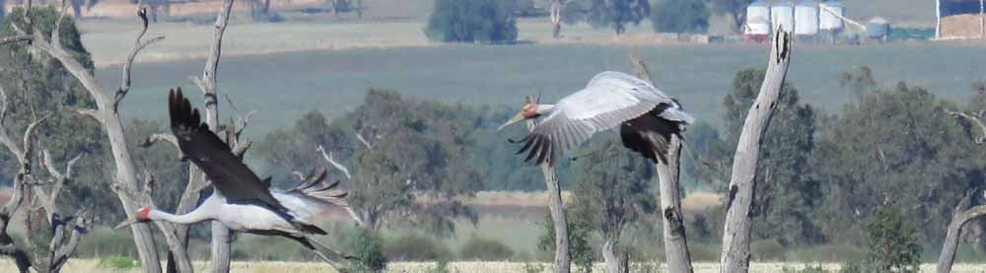
Below: Brolgas at Gaynor Swamp, by Pat Feehan

Goulburn Broken wetlands
A speedy response at Reedy Swamp
Water for the environment provides relief for plants and animals at Reedy Swamp as it quickly becomes an aquatic refuge during dry times. The swamp, located just off the Goulburn River north of Shepparton, is listed under the Directory of Important Wetlands in Australia.
Goulburn Broken CMA has undertaken extensive wetland monitoring at Reedy Swamp. Since monitoring began in 2008, 104 water-dependent animal species have been recorded and 85 plant species.
When delivering environmental flows to wetlands, the VEWH and waterway managers try to manage and time deliveries to reflect natural watering regimes. This is often tricky because changes have been made to the waterways and the land, compromising natural inflows.
Ensuring wetlands undergo drying is an important part of their management. It provides time for plants to germinate and soils to settle. When it comes time to add water for the environment, it can have a much greater impact if deliveries are made after the swamp has been given time to dry.
Over the last three years, Reedy Swamp has undergone a drying period. Water was able to recede completely, and the wetland was dry for 12 months before being re-filled.
Goulburn Broken CMA CEO Chris Norman said that wetlands in the area such as Reedy Swamp and Gaynor Swamp provide a much-needed refuge during dry times.
“Reedy Swamp is classed as a drought refuge because it has so many types of natural features – mud flats, deeper open water and giant rushes – that provide valuable habitat for a huge range of waterbirds, as well as frogs, during dry times. During the hot dry spring and summer experienced in this region, these wetlands provided much-needed habitat for wildlife at a critical time in the breeding and migration cycle,” said Chris.
Monitoring of environmental flows at Reedy Swamp and Gaynor Swamp will continue with acoustic recorders and time-lapse cameras.
Waterway manager: Goulburn Broken CMA
Storage manager: Goulburn-Murray Water
Site | Volume delivered 2018-19 (megalitres)
Reedy Swamp | 500
Gaynor Swamp | 601
Kinnairds Wetland | 384
Black Swamp | 80

Community Highlights
  - Fishers and scientists working together to help native fish
Recreational fishers in northern Victoria joined forces with scientists to find out how water for the environment helps the migration, spawning and survival of native fish.
Every year thousands of Victorians head to local waterways to catch fish. For those who keep Murray cod and golden perch for the dinner table, they were asked to help the scientists at the Arthur Rylah Institute (ARI) discover how fish populations have benefitted from environmental flows. All they needed to do was hold on to a part of each fish that they would normally throw away – its ‘ear bones’.
These ear bones, found at the back of the fish head, are actually calcium carbonate structures called ‘otoliths’, and play a role in balance and hearing. They are made up of layers like miniature tree rings, and when examined under the microscope, they can reveal an amazing amount about the origin, age, growth and movement history of a fish, and even whether it is a stocked fish or a natural recruit.
“We’ve been partnering with fishing clubs, North Central CMA and Goulburn Broken CMA since early 2018 to collect this useful data,” ARI’s Pam Clunie explained.
“The angler scientists are really interested in the work that’s happening to support and monitor our native fish, and they understand the important contribution they’re making to our scientific knowledge.”
In November 2018, angler scientists and staff from the ARI, North Central CMA and the Victorian Fisheries Authority got together on the Campaspe River near Elmore to have a go at extracting fish otoliths (ear bones), hear about environmental flows and fish monitoring, and enjoy a barbeque.
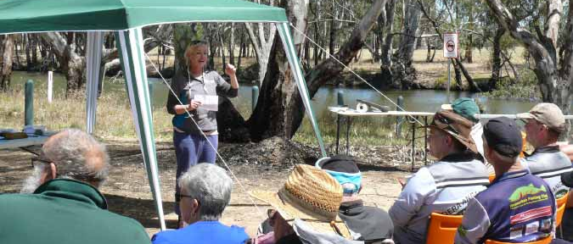
Above: Pam Clunie, ARI, talking at Angler Scientist field day at Aysons Reserve, by ARI

Plenty of keen angler scientists came along - some with frozen fish heads and some with ear bones already extracted! Anglers practiced extracting the ear bones, under the guidance of ARI experts.
Fishing club members, along with individual recreational fishers from across northern Victoria, collected ear bones from fish caught in waterways including the mid-Murray, Goulburn, Broken, Loddon and Campaspe rivers, and Pyramid and Gunbower creeks.
“We’ve collected 84 golden perch ear bones and 25 Murray cod ear bones during the project, which is a great result. Once we’ve finished the analysis, every angler will receive a ‘fish profile’, telling them all about each of the fish they collected!” said Pam.
“There are so many benefits to citizen science projects such as this. Angler scientists help us gather a larger sample size to analyse, which will provide us with a better understanding of how fish respond to environmental flows. Scientists and anglers also build relationships and better understand each other’s perspectives and interests,” said Pam.
This work is part of the Victorian Environmental Flows Monitoring and Assessment Program (VEFMAP), which is monitoring how fish and vegetation along rivers respond to the delivery of water for the environment. This information in turn helps waterway managers to make informed decisions about where, when and how to deliver environmental flows.
To find out more, contact Pam.Clunie@delwp.vic.gov.au or go to https://www.ari.vic.gov.au/research/people-and-nature/fishers-fishing-for-fish-ear-bones.
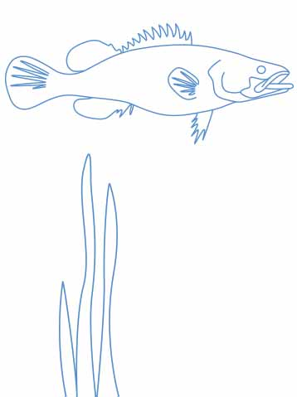

Campaspe River
Snow falling along the Campaspe River in October…?
Surely not!
When water for the environment was used to create a spring fresh in the Campaspe River, a site near Barnadown was briefly transformed to look like an alpine winter wonderland.
Already special due to the rocky riffle habitat which is unusual in lowland rivers, the site was quite a spectacle when covered in a crunchy white layer resembling fresh snow – on the Campaspe River floodplain – in October!
The actual explanation for this pretty scene is growth and bleaching of diatoms; diatoms are microscopic algal organisms with a ‘boom and bust’ lifecycle. They can proliferate in water and settle on rocks during higher flows and then, when water levels drop, exposure to air and sun dries and bleaches them.
Diatoms are an indicator of good water quality and a source of food in the freshwater food web. A diatom boom adds to the productivity of the whole system, providing food for bugs, yabbies, frogs, turtles and fish. As the bleached crust of diatoms breaks down it returns carbon to the system, fuelling growth and supporting a healthy ecosystem.
The Campaspe River downstream of Lake Eppalock provides habitat for several native fish species including Murray cod, silver perch, golden perch, Murray-Darling rainbowfish and flat-headed gudgeon. Platypus, rakali (water rats), turtles and frogs are also present along the length of the Campaspe River. All these animals need a productive food chain in the river.
Water for the environment is supporting a broad range of environmental objectives in the Campaspe River including river productivity, a robust food chain, water quality and healthy native plant and animal populations.
Waterway manager: North Central CMA
Storage manager: Goulburn-Murray Water
Site | Volume delivered 2018-19 (megalitres)
Site | VEWH | MDBA | CEWH | Total
Campaspe River | 16,522 | 3,104 | 3,730 | 23,356

Community Highlights
  - Coliban River
Dja Dja Wurrung and North Central CMA unite in helping the Coliban River
“Waterways are special places for Dja Dja Wurrung people. The rivers are the veins of Dja Dja Wurrung country which provide food and medicine, places to camp, hunt, fish, swim and hold ceremony. Our waterways are places that we connect with our ancestors and pass traditional knowledge on to our children and grandchildren.” - Rivers and Waterways, in the Dja Dja Wurrung Country Plan.
The Coliban River is a highly-valued place within a wider catchment that is culturally significant to Dja Dja Wurrung people. Undertaking an Aboriginal Waterways Assessment, Dja Dja Wurrung representatives have recently measured the impact of environmental flows in the Coliban during very dry autumn conditions.
The Coliban River provides habitat for platypus, rakali (water rats) and small-bodied native fish (such as flat-headed gudgeon and mountain galaxias). The river also supports plenty of aquatic vegetation which is home to a diverse range of waterbugs. It is bordered by patches of shrubland vegetation and river red gum woodland with callistemon, woolly tea-tree and inland wirilda, which provide habitat for land animals.
The knowledge gained from the Aboriginal Waterways Assessment will help Dja Dja Wurrung Aboriginal Corporation and North Central CMA to plan and deliver environmental flows that maintain the environmental and cultural values of the Coliban River.
The Aboriginal Waterways Assessment on the Coliban River is also helping to deliver on the goals of the Dja Dja Wurrung Country Plan which describes Dja Dja Wurrung people’s aspirations around the management of rivers and waterways and articulates Dja Dja Wurrung people’s support for the reinstatement of environmental flows as an overall objective for the management of water on country.
Waterway manager: North Central CMA
Storage manager: Coliban Water
Site | Volume delivered 2018-19 (megalitres)
Coliban River | 1,715

Loddon system
Continual learning along the Loddon system ensures maximum water use efficiency
Despite very dry conditions in the Loddon River catchment in 2018-19, a carefully planned and executed environmental watering and water trading strategy ensured there was adequate water available to deliver minimum required flows for the Loddon River in 2018-19 and the year ahead.
“We cannot make it rain but we can be efficient with the water that is available for the environment,” North Central CMA Environmental Water Reserve Officer Phil Slessar said.
“We had to balance conserving water with providing enough flow throughout the year to manage the high risk of low dissolved oxygen and fish deaths over summer.”
The CMA kept a close eye on conditions and regularly monitored flows and water quality throughout the summer.
“We cautiously adapted the rate of summer low flows and freshes in response to our monitoring, and as a result saved the water we needed for carryover into next year, which is critical given the very dry outlook for 2019-20,” Phil said.
“Our tactics were to release a high flow in spring that flushed the whole system, reducing the risk of future blackwater events, and setting the river up to withstand harsh conditions in summer.” Phil explains. “This meant that over summer, we were able to successfully provide the bare minimum low flows in the Loddon River downstream of Loddon Weir for summer and autumn to protect fish habitat.”
Kathryn Walker, Environmental Water Coordinator at the VEWH, explains that the high flow that was released in spring was made possible by the VEWH’s administrative water trading.
“In September 2018 we assessed that, between the VEWH and the Commonwealth Environmental Water Holder, we did not have enough water to deliver both the spring and summer flows we needed,” Kathryn said.
“We had some water available in the Goulburn system, which we were able to transfer across to the VEWH’s water accounts to the Loddon system to deliver the flow.”
“We never know when the next wet period will be, so adaptive management through trade and carryover planning are critical tools we use to safeguard critical biological functions until the next wet period arrives.”
Waterway manager: North Central CMA
Storage manager: Goulburn-Murray Water
Site | Volume delivered 2018-19 (megalitres)
Site | VEWH | CEWH | Total
Loddon River and Tullaroop Creek | 12,136 | 2,636 | 14,772
Serpentine Creek | 826 | - | 826
Pyramid Creek | 1,042 | - | 1,042
Little Lake Meran | 510 | - | 510
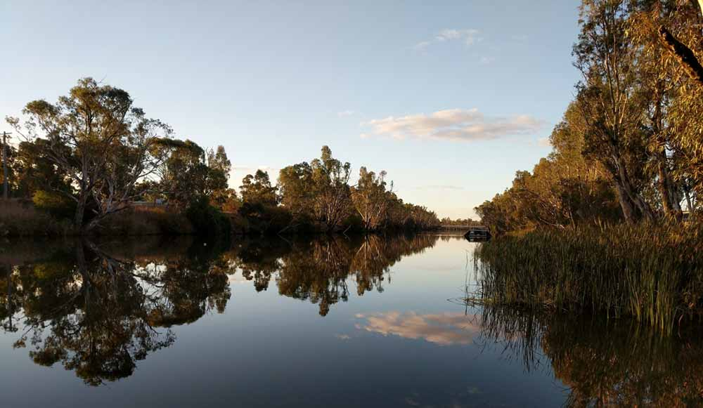
Above: Loddon River at Bridgewater, by North Central CMA

Community Highlights
  - Lake Boort
To enhance ecological outcomes and cultural values we’ve ‘Boort’ together all the great minds!
The Dja Dja Wurrung Clans Aboriginal Corporation (through Djandak) and North Central CMA are conducting vegetation monitoring and undertaking planting at the culturally significant Lake Boort site on the Loddon River floodplain.
A highly-significant area for Dja Dja Wurrung, this floodplain not only contains some of the highest densities of scarred trees in the world but numerous cooking mounds and other reminders of past productivity. This connection continues through to this day and is embedded in the plants, animals, Gatjin (water), Wi (fire) and Djandak (land). The vegetation monitoring program looks to inform the recovery of this landscape and its bountiful resources.
With funding from the VEWH to support the project, Dja Dja Wurrung and ecologists have collected plant surveys and recorded incidental animal observations such as frog, mammal, reptile and bird sightings. The project is a great example of Dja Dja Wurrung and western scientists continuing to share knowledge.
Nathan Wong, Natural Resource Program Manager at Djandak, says “Involving Dja Dja Wurrung in monitoring not only allows for people to share knowledge but also increases the understanding of the wetland system.”
“It is amazing to see through the monitoring that healing of Lake Boort is occurring and that the greater involvement of Dja Dja Wurrung is delivering this change. By working together, we will succeed and create lasting change in the landscape,” Nathan said.
While Gatjin can be distributed to the Boort wetlands using Loddon Valley Irrigation Infrastructure, the current environmental water management plan for Lake Boort involves long drying phases to mirror a more natural wetting and drying cycle and is consistent with the aspirations of Dja Dja Wurrung.
Kevin Mah, Environmental Water Reserve Officer at North Central CMA, said “We’re really pleased to be working with Dja Dja Wurrung at Lake Boort. Working with the Traditional Owners has helped build our understanding of the site, and has allowed us to share knowledge about managing this important wetland into the future.”
“Wetlands like Lake Boort need both wet and dry phases. As the wetland begins to dry vegetation species such as southern cane grass and common spike-sedge that grow and establish at wetland sites. The receding water levels also provide habitat and feeding opportunities for wading waterbird species including the little egret, which is critically endangered in Victoria.”

It’s not just about adding water
Progress on the Native Fish Recovery Plan – Gunbower and lower Loddon
The North Central CMA’s vision is to restore native fish populations, improve waterway health, and create a world-class native fishery in the Gunbower and lower Loddon region.
The Native Fish Recovery Plan – Gunbower and lower Loddon, involves the large-scale, long-term and holistic rehabilitation of the network of creeks, lagoons, wetlands and floodplains in northern central Victoria.
This integrated action plan was developed in collaboration with fish ecologists, and is being delivered in partnership with government agencies, Traditional Owners, and recreational fishing groups. 2018-19 saw significant progress in several of the key Recovery Plan initiatives. The following highlight boxes show some of the achievements of this plan.
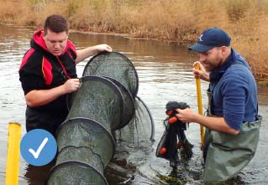

Threatened species recovery
Southern pygmy perch (Murray-Darling lineage) numbers have severely declined since the 1970s, and only three wild populations remain in north central Victoria. In partnership with Native Fish Australia, City of Greater Bendigo Council and Australia and New Guinea Fish Association, brood stock has been collected from the remaining populations and a captive breeding program has commenced, with the aim returning the species to managed Gunbower Forest wetlands.
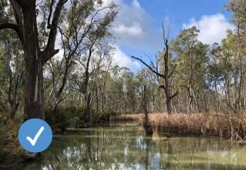

Gunbower Creek flows
Flows targeting Murray cod spawning and recruitment were delivered for the fifth consecutive year. Flows include a steady spring flow to keep Murray cod on their nests, some areas of permanent fast flowing water, and higher winter flows to provide habitat for juvenile cod. Juvenile cod recruitment has occurred annually since the flows have been implemented.
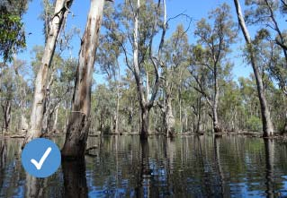

Gunbower Forest floodplain watering
An efficient forest floodplain watering not only provided refuge for waterbirds and helped maintain the health of this iconic red gum forest in dry conditions, it also provided important native fish populations with a boost, as vital food and nutrients flowed off the floodplain and back into our creeks and rivers in spring when they needed it most.
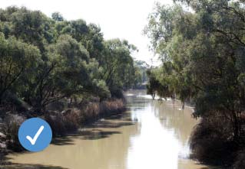

Little Murray River fishways
Fishways were installed at Little Murray Weir and Fish Point Weir through the Swan Hill Modernisation Project. Migrating fish species can now move ~180km from the Murray River through Little Murray River, lower Loddon River and Pyramid Creek to high quality nursery habitat in Kow Swamp.
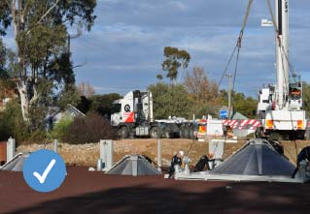

Cohuna fish screens installed
In an Australian first, Victorian-designed and made irrigation channel fish screens were installed on the Cohuna Irrigation Channel to prevent native fish from being lost to the irrigation channel system.

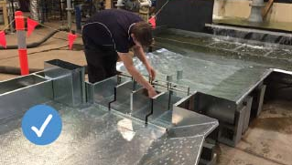

Koondrook Weir fishway
Detailed design commenced on a vertical slot fishway for the Koondrook Weir, and funding from a recent sale of water for the environment was committed to its future construction.
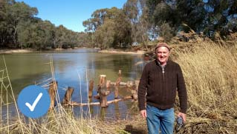

Instream habitat
More than 50 instream woody habitat structures were installed in Little Murray River and the Lower Loddon River creating habitat, resting points and feeding areas for threatened freshwater catfish, silver perch, Murray cod and wild populations of golden perch.
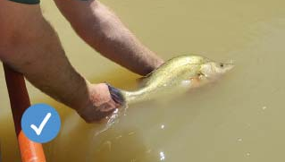

Loddon River and Pyramid Creek flows
Coordination of Loddon River and Pyramid Creek flows provided a trigger for target native fish species such as golden perch and Murray cod to move from the Little Murray and Lower Loddon River. Large numbers of golden perch were observed moving through the recently installed Box Creek Fish Lock into Kow Swamp.
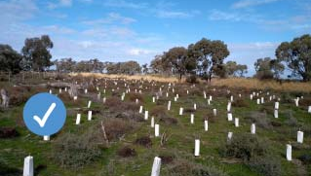

Streambank habitat
15 km of riparian fencing was installed, protecting stream banks from stock access.

Cohuna fish screens a win-win for community and
native fish
In an Australian first, countless numbers of native fish will be saved thanks to a Victorian-designed and made irrigation diversion channel fish screen. The screen, which is located between Gunbower Creek and the Cohuna Irrigation Channel, was funded by the Victorian Environmental Water Holder and is a key action in the North Central Catchment Management Authority’s Native Fish Recovery Plan for the Gunbower and lower Loddon system.
Each year, up to hundreds of thousands of native fish and larvae are lost from the Gunbower Creek and the Murray River system as fish move into irrigation channels. Once in irrigation channels, the fish are lost to the natural system forever, having a negative impact on breeding and population numbers of native fish.
Since early European occupation, native fish populations have decreased by 90 percent across the Murray-Darling Basin. In the Gunbower and lower Loddon, only 13 of 22 native fish
species are still present in the system today. And of these, six are listed as threatened.
Migratory Australian fish species, such as yellowbelly and silver perch, are particularly vulnerable to getting lost in irrigation channels. Whilst in the egg larvae stage, many species drift and are therefore just as vulnerable. Loss of native fish through irrigation infrastructure is one of the key factors behind the decline of native fish populations within the Gunbower Creek.
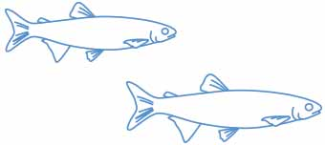

For example:
- During a tagging project in Gunbower Creek 20 percent of tagged young-of-year and adult golden perch were found to enter an irrigation channel but none were recorded returning to the creek.
- Surveys of the Cohuna Channel (before the construction of the fish screens) found that it traps up to 5,500 native fish larvae, including more than 160 Murray cod larvae, per day.
The screens act like a giant tea strainer – allowing water to pass into the channel so it can be used by irrigators but preventing fish larvae and eggs from passing through.
The Cohuna Irrigation Screen is a win-win-win project for native fish, irrigators, and the broader community. Native fish are kept in Gunbower Creek without compromising the delivery of water for irrigators. The screens are locally designed and made, supporting local jobs. Investments in fish habitat restoration, flows and fishways are enhanced, and more Murray cod and golden perch in the creek means better fishing opportunities for recreational fishers, supporting the local tourism and economy.
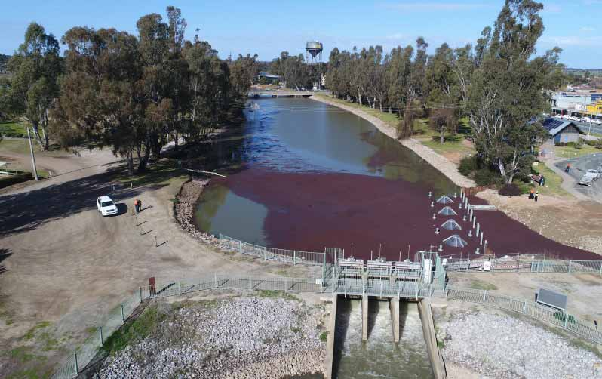
Above: Cohuna Irrigation Screen, by North Central CMA

Fish on the move at Koondrook Weir
Thousands of native fish will be able to freely move between the River Murray and the rich habitat of Gunbower Creek due to a funding boost from the VEWH’s autumn sale of water for the environment.
The Koondrook fishway will provide passage to native fish, such as the iconic vulnerable Murray cod and threatened golden perch, from the river into the creek for the first time in more than a century.
Key partners including the VEWH, North Central CMA, DELWP and Goulburn Murray Water have agreed to take the proposed Koondrook fishway into a detailed design and costing phase, and then through to construction.
Fish studies have shown that large numbers of native fish accumulate at Koondrook Weir trying to access the creek, but they cannot get past the weir.
“A fishway will dramatically improve connectivity for fish movement and migration and help boost native fish numbers in the creek,” North Central CMA CEO Brad Drust said.
“It will also add significant value to the fantastic wins we are already seeing with environmental flows and native fish recovery – such as Murray cod spawning in the Gunbower Creek and the critical fish food provided by flows through the Gunbower Forest.”
The detailed design is currently underway with a focus on ensuring the fishway is able to pass a wide range of species, both large and small, under a range of flow conditions. The design aims to ensure the most ecological benefit to the native fish population, whilst not impacting on the delivery of water to irrigators.
“Through the detailed design process, we will ensure that the solution works for everyone, including Torrumbarry irrigators that rely on the irrigation delivery system for their livelihood,” Brad said.
Victorian Fisheries Authority CEO Travis Dowling said the Koondrook fishway would provide a significant boost to native fish at Gunbower, and in turn, to tourism and recreation in the area.
“Enabling fish to move between Gunbower Creek and the Murray is a key to helping realise the vision of creating a world-class Murray cod fishery in north central Victoria, and in turn will lure recreational anglers from all over to try their luck hooking a big one and, in the process, the region will get a massive boost of tourist dollars.”
Victorian fishing peak body chairman Rob Loats said VRFish had worked closely with North Central CMA on the Native Fish Recovery Plan for Gunbower and the Lower Loddon, which earmarked a fishway at Koondrook weir.
“The Koondrook fishway will be a magnificent project to restore native fish numbers at Gunbower,” Mr Loats said.
“Recreational anglers see first-hand the benefits of sustainable fishing and improved fish habitats, and this fishway will open up Gunbower Creek to thousands of fish looking to move upstream there.”
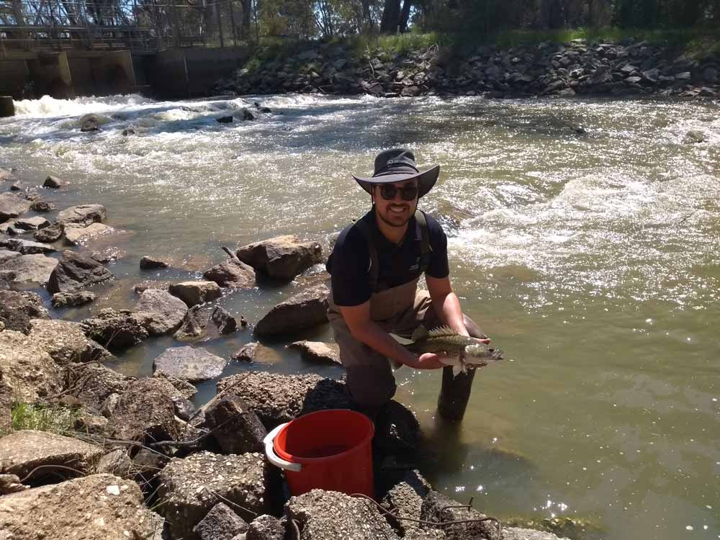
Above: Koondrook Murray cod - looking at fish accumulation below the weir at different flows, by North Central CMA

Glossary
Acid sulphate soils – Soils containing high quantities of naturally occurring iron sulphates. When these soils remain underwater they are stable, but if they are exposed to the air, sulphuric acid is generated and can result in severe environmental impacts.
Allocation (of water) – The specific volume of water allocated to water entitlements in a given water year or allocated as specified in a water resource plan.
Blackwater – A natural occurrence caused by the breakdown of plant matter resulting in the water discolouring. The water turns black in severe circumstances and can have very low dissolved oxygen levels, which can stress or kill fish and other animals that breathe underwater.
Bank slumping – A form of mass wasting in a river or stream that occurs when a coherent mass of loosely consolidated material or rock layers moves a short distance down a slope.
Carryover – Allows entitlement holders to retain ownership of unused water into the following season, according to specified rules.
Catchment management authority (CMA) – A statutory authority established to manage river health and regional and catchment planning and to manage waterways, floodplains, salinity and water quality.
Commonwealth Environmental Water Holder (CEWH) – An office that manages water entitlements recovered by the Australian Government through a combination of investments in water-saving infrastructure, water purchases and other water recovery programs. The entitlements are held by the CEWH.
Consumptive water – Water owned by water corporations or private entitlement holders held in storages and actively released to meet domestic, stock, town and irrigation needs.
Drawdown – Water released from a body of water (such as a reservoir) at the end of the irrigation season for dam operation and maintenance purposes.
Environmental water (water for the environment, environmental flows) – Water available for environmental purposes including entitlements held by the VEWH, passing flows and unregulated flows.
Environmental water entitlement – An entitlement to water to achieve environmental objectives in waterways including an environmental entitlement, environmental bulk entitlement, water share, section 51 licence or supply agreement.
Estuary – A partially enclosed body of water along the coast where freshwater from rivers and streams meets and mixes with saltwater from the ocean.
Fishway – A series of pools built like steps to enable fish to travel through a waterway, dam or waterfall.
Freshes – Small or short-duration peak-flow events which exceed the baseflow and last for one or several days.
Gigalitre (GL) – One billion (1,000,000,000) litres.
Groundwater – Water held underground in the soil or in pores and crevices in rock.
Hydrology – The study of the properties of water and its movement in relation to land.
Inter-valley transfers – The transfer of water between river systems to meet demands as a result of water trade between river systems.
Juvenile – A stage of life at which an animal or plant is not yet fully mature.
Land manager – An agency or authority responsible for conserving natural and cultural heritage on public land including parks and reserves.
Megalitre (ML) – One million (1,000,000) litres.
Millennium Drought – One of the worst droughts recorded in Australia since European settlement, it went from about 1997 to 2011.
Passing flows – Water released from storages to operate river and distribution systems (often to help deliver water for environmental or consumptive uses) and maintain environmental values and other community benefits. The volume of passing flows is generally determined by inflows to those storages.
Reach – A stretch or section of a river, generally defined in an environmental flows study.
Recruitment – The increase in plants or animals when they survive to the settlement or maturity stage.
Return flows – Any flows delivered for environmental purposes and then returned to the downstream system to be reused for other purposes. Returned flows may be captured and stored downstream for later reuse, although most commonly they remain within the waterway for instream reuse.
Riverbank slumping – A form of mass wasting in a river or stream that occurs when a coherent mass of loosely consolidated materials or rock layers moves a short distance down a slope.
Spawning – When fish release eggs for fertilisation. Spawning sites are the sites where they release the fertilised eggs.
Storage manager – Appointed by the Minister for Water to operate major water storages in a river basin to deliver to entitlement holders.
The Living Murray – An intergovernmental program, which holds an average of 500,000 ML of environmental water a year for use at six icon sites along the River Murray.
Trade – Water shares, allocations and take-and-use licences that can be traded in Victoria under rules the Minister for Water sets.
Unregulated entitlement – An entitlement to water declared during periods of unregulated flow in a river system: that is, flows that cannot be captured in storages.
Victorian Environmental Water Holder (VEWH) – An independent statutory body responsible for holding and managing Victorian environmental water entitlements and allocations.
Victorian environmental watering program – The overarching program by which all environmental watering actions are planned and delivered and in which all environmental watering partners are involved.
Water Act 1989 – The legislation that governs water entitlements and establishes the mechanisms for managing Victoria’s water resources.
Waterways – Rivers, wetlands, creeks, floodplains and estuaries.
Water entitlement – The right to a volume of water that can usually be stored in reservoirs and taken and used under specific conditions.
Water trade – The process of buying, selling or exchanging water allocation or entitlements.
Waterway manager – An agency responsible for the environmental management of catchments and waterways including CMAs and Melbourne Water.

Summary of water for the environment delivery 2018-19

Gippsland region
System | Site | Total (ML) | VEWH (ML) | TLM (ML) | CEWH (ML) | Other (ML)
Latrobe system | Latrobe River | 5,502.4 | 5,502.4 | - | - | -
Latrobe system | Dowd Morass | Water was diverted into Heart Morass from the Latrobe River
Latrobe system | Heart Morass2 | Water was diverted into Dowd Morass from the Latrobe River
Latrobe system | Sale Common2 | Water was diverted into Sale Common from the Latrobe River
Thomson system | Thomson River | 12,699.0 | 12,699.0 | - | - | -
Macalister system | Macalister River | 15,124.0 | 15,124.0 | - | - | -
Snowy system | Snowy River | 129,400.0 | - | - | - | 129,400.0
Gippsland region total |  | 162,725.4 | 33,325.4 | - | - | 129,400.0

Central region
System | Site | Total (ML) | VEWH (ML) | TLM (ML) | CEWH (ML) | Other (ML)1
Yarra system | Yarra River | 16,472.0 | 16,472.0 | - | - | -
Yarra system | Burke Road Billabong | Water was delivered into Burke Road Billabong from the Yarra River
Yarra system | Willsmere Billabong4 | Water was delivered into Willsmere Billabong from the Yarra River
Yarra system | Yering Backswamp | 46.0 | 46.0 | - | - | -
Yarra system | Tarago River | 1,210.0 | 1,210.0 | - | - | -
Tarago system | Pyrites Creek | 290.1 | 290.1 | - | - | -
Werribee system | Werribee River | 503.0 | 503.0 | - | - | -
Maribyrnong system | Upper Jackson Creek | 180.0 | 180.0 | - | - | -
Moorabool system | Moorabool River | 2,000.0 | 2,000.0 | - | - | -
Barwon system | Upper Barwon River | 1,019.9 | 1,019.9 | - | - | -
Barwon system | Hospital Swamps2 | Water was diverted into Hospital Swamps from the Barwon River
Barwon system | Reedy Lake2 | Water was diverted into Reedy Lake from the Barwon River
Central region total |  | 21,721.0 | 21,721.0 | - | - | -

Western region
System | Site | Total (ML) | VEWH (ML) | TLM (ML) | CEWH (ML) | Other (ML)1
Glenelg system | Glenelg River | 17,179.6 | 17,179.6 | - | - | -
Wimmera system | Wimmera River | 10,602.1 | 5,516.6 | - | 5,085.4 | -
Wimmera system⁷ | MacKenzie River, Burnt Creek and Bungalally Creek | 3,388.1 | 3,388.1 | - | - | -
Wimmera system⁷ | Lower Mount William Creek | 1,506.3 | 753.2 | - | 753.2 | -
Wimmera system⁷ | Upper Mount William Creek | 154.0 | 154.0 | - | - | -
Wimmera system⁷ | Ranch Billabong | Water was delivered into Ranch Billabong from the Wimmera River
Wimmera-Mallee wetlands | Forty-four wetlands watered | 150.3 | 150.3 | - | - | -
Western region total |  | 32,980.5 | 27,141.9 | - | 5,838.6 | -

Northern region
System | Site | Total (ML) | VEWH (ML) | TLM (ML) | CEWH (ML) | Other (ML)1
Victorian Murray system | Barmah Forest | 74,636.0 | 12,475.9 | 16,128.2 | 46,031.9 | -
Victorian Murray system | Gunbower Forest | 41,810.9 | 30,986.9 | 10,824.0 | - | -
Victorian Murray system | Gunbower Forest - Yarran Creek | 393.9 | 393.9 | - | - | -
Victorian Murray system | Gunbower Forest - Reedy Lagoon7 | 532.8 | 520.2 | 12.6 | - | -
Victorian Murray system | Gunbower Creek7 | 18,921.6 | - | - | 18,921.6 | -
Victorian Murray system | Johnson Swamp | 1,500.0 | 1,500.0 | - | - | -
Victorian Murray system | Lake Elizabeth | 1,080.3 | 1,080.3 | - | - | -
Victorian Murray system | Lake Murphy | 2,549.5 | 2,549.5 | - | - | -
Victorian Murray system | McDonalds Swamp | 230.0 | 230.0 | - | - | -
Victorian Murray system | Round Lake | 460.5 | 460.5 | - | - | -
Victorian Murray system | Lake Cullen | 7,790.0 | 7,790.0 | - | - | -
Victorian Murray system | Wirra-Lo wetland complex | Wirra-Lo wetland complex | 92.0 | 92.0 | - | -
Victorian Murray system | Hattah Lakes | Hattah Lakes | 274.1 | - | 274.1 | -
Victorian Murray system | Hattah Lakes -  Lake Kramen | Hattah Lakes -  Lake Kramen | 7.0 | - | 7.0 | -
Victorian Murray system | Brickworks Billabong | Brickworks Billabong | 250.5 | 250.5 | - | -
Victorian Murray system | Burra Creek North | Burra Creek North | 250.0 | 250.0 | - | -
Victorian Murray system | Burra Creek South | Burra Creek South | 747.3 | 747.3 | - | -
Victorian Murray system | Lake Hawthorn | Lake Hawthorn | 1,497.7 | 1,497.7 | - | -
Victorian Murray system | Lake Koorlong | Lake Koorlong | 56.8 | 56.8 | - | -
Victorian Murray system | Nyah Floodplain | Nyah Floodplain | 999.9 | 999.9 | - | -
Victorian Murray system | Vinifera Floodplain | Vinifera Floodplain | 664.6 | 664.6 | - | -
Victorian Murray system | Yungera Wetland | Yungera Wetland | 183.5 | 183.5 | - | -
Victorian Murray system | Wallpolla Island - Horseshoe Lagoon | Wallpolla Island - Horseshoe Lagoon | 737.3 | 737.3 | - | -
Ovens system | King River | King River | 73.0 | - | - | 73.0
Ovens system | Ovens River | Ovens River | 89.0 | 39.0 | - | 50.0
Goulburn system | Goulburn River - Reach 1 | Goulburn River - Reach 1 | 9,665.2 | 9,665.2 | - | -
Goulburn system | Goulburn River -  Reach 4 & 5 | Goulburn River -  Reach 4 & 5 | 215,914.5 | 15,000.0 | 26,467.7 | 174,446.8
Goulburn system | Reedy Swamp | Reedy Swamp | 500.3 | 500.3 | - | -
Goulburn system | Gaynor Swamp | Gaynor Swamp | 601.0 | 601.0 | - | -
Broken system | Broken River | Broken River | 250.0 | 250.0 | - | -
Broken system | Lower Broken Creek | Lower Broken Creek | 33,847.3 | - | - | 33,847.3
Broken system | Kinnairds Wetland | Kinnairds Wetland | 384.2 | 384.2 | - | -
Broken system | Black Swamp | Black Swamp | 80.0 | 80.0 | - | -
Campaspe system | Campaspe River | Campaspe River | 23,356.4 | 16,522.4 | 3,104.3 | 3,729.7
Loddon system | Loddon River | Loddon River | 14,772.2 | 12,136.0 | - | 2,636.2
Loddon system | Pyramid Creek | Pyramid Creek | 1,041.7 | 1,041.7 | - | -
Loddon system | Serpentine Creek | Serpentine Creek | 826.0 | 826.0 | - | -
Loddon system | Little Lake Meran | Little Lake Meran | 509.7 | 509.7 | - | -
Northern region total |  | 457,576.7 | 121,022.3 | 56,817.9 | 279,736.5 | -

Total water use
Total (ML) | VEWH (ML) | TLM (ML) | CEWH (ML) | Other (ML)1
675,003.6 | 203,210.6 | 56,817.9 | 285,575.1 | 129,400.0

© Victorian Environmental Water Holder 2019
This work is licensed under a Creative Commons Attribution 3.0 Australia licence. You are free to re-use the work under that licence, on the condition that you credit the Victorian Environmental Water Holder as author. The licence does not apply to any images, photographs or branding, including the Victorian Government logo and the Victorian Environmental Water Holder logo. To view a copy of this licence, visit https://creativecommons.org/licenses/by/3.0/au/deed.en
Designed and published by Marcus Lee Design, a certified supplier with Supply Nation.
Printed by Impact Digital, Brunswick (November 2019).
ISSN 2202-9796 (Print)
ISSN 2202-980X (Online)
Disclaimer
This publication may be of assistance to you, but the Victorian Environmental Water Holder and its employees do not guarantee that the publication is without flaw of any kind or is wholly appropriate for your particular purposes and therefore disclaims all liability for any error, loss or other consequence which may arise from you relying on any information in this publication.
Accessibility
If you would like to receive this publication in an
alternative format, please contact the Victorian Environmental Water Holder on (03) 9637 8951 or email general.enquiries@vewh.vic.gov.au.
This document is also available at www.vewh.vic.gov.au.
Victorian Environmental Water Holder
Telephone: (03) 9637 8951
Email: general.enquiries@vewh.vic.gov.au
Web: www.vewh.vic.gov.au

A report on research to explore Victorians’ knowledge of, and attitudes towards, environmental water, ORIMA Research (on behalf of the VEWH), 2017.
Includes passing flows delivered in the Glenelg (2,695 ML) and Wimmera (431 ML) systems.
Includes 2,695 ML of passing flows delivered in the Glenelg River.
Includes 431 ML of passing flows delivered in the Wimmera River system.
The volume delivered to Ranch Billabong, was reused from environmental flows released from Lake Lonsdale and Taylors Lake for the Wimmera River.
A small volume of water for the environment was used at Hattah Lakes for maintenance and testing of the Hattah pump station
Other source refers to water that was not accounted for under the environmental Water Holdings.
The VEWH’s environmental entitlements in the lower Latrobe and lower Barwon systems allow the diversion of water from the Latrobe and Barwon rivers into the wetlands at any time when specific river heights are met. The entitlements do not consist of a set volume and the volume of water diverted into the wetlands is not measured.
Environmental flows to the Snowy River are managed by the New South Wales Department of Planning,Industry and Environment, using water made available by Victoria and New South Wales.
Water used in Burke Rd Billabong and Willsmere Billabong was diverted from an environmental flow release in the Yarra River.
In 2018-19, water allocations co-purchased by Melbourne Water and the VEWH contributed to the delivery of 180.0ML of environmental water to meet environmental objectives in upper Jackson Creek, in the Maribyrnong system, where no permanent environmental Water Holdings are held.
Includes 2,695 ML of passing flows delivered in the Glenelg River.
Includes 431 ML of passing flows delivered in the Wimmera River system.
Water used in Ranch Billabong was diverted from an environmental flow release in the Wimmera River.
Delivery in these systems included reuse of return flows.

